

BA BUSINESS MANAGEMENT
Assignment 1

Module: Community engagement
Code: LCBB4002
Lecturer: Dr Akinseye Aluko
Name: Tanya Garabinska
Student ID:2129044

SUBMITTED ON THE 2^{nd of} December 2022

Table of Contents
Introduction 3
Running Club for Everyone 4
Engagement Through Social Media Platforms 7
Significance of Community Participation 10
Importance of Community Engagement 10
Community Engagement Approach 11
Conclusion 12
References 13

Introduction
Community engagement builds a bridge between the community people and the organizer who wants to make a project in the community. Community engagement creates a trustworthy relationship between the locals and the organizer and generates the best outcome (Cameron, 2019). Community engagement is essential because it implies those who are affected by the decisions in the decision-making process can improve the decisions. The Commonwealth games are one of the most influential games in the world which are organized between the commonwealth nations. It is one of the largest multi-sport games where thousands of athletes participate. The 22nd Commonwealth games were held in Birmingham on July 2022 (Canham, 2022). The organizer wanted to engage all the community members in the games and make the event a successful one and for that reason, they organized many events to encourage the local communities. Running Club for Everyone is one of them. This report will highlight the community engagement between the locals and the commonwealth organizer and how they make their approach to the locals. Also, the stakeholder's involvement and how they use social media platforms to engage the locals and spread the news of the event will be discussed in this report.

Running Club for Everyone
The Commonwealth game was first held in 1930 and since then it is running successfully every four years (Chowdhury, 2016). The Commonwealth game is one of the largest multi-sport game events and it is arranged between the commonwealth nations. Athletes from all the commonwealth nations come and showcase their talent in the games. The game is arranged by different nations in different seasons. This year the game was hosted by Birmingham, London. The 22nd Commonwealth game was held from July 28 to August 8. In 2017, Birmingham was announced as the host nation in December 2017. The 22nd Commonwealth was different from other years because this time the games issued more events for women than men. The game introduced some new events such as basketball 3x3, women's cricket T20, synchronized driving and many more games (Leo, 2022). To enhance the games and make people more engage many events were arranged in Birmingham. One of them is Running Club for Everyone. The organizer wanted to engage the community members to take part and collaborate in the game. That is why they took some initiative to maintain community engagement such as –
- The organizer first prepares their plans and does extensive research about the community. They did thorough planning, develop the design, and make sure the process serves both parties accordingly.
- The organizer gathers knowledge about the community's economic, political, and demographic trends to understand more about the community and its culture.
- The organizer went to the local communities to gain their trust and build a strong relationship with the community so that they come and participate in the event.
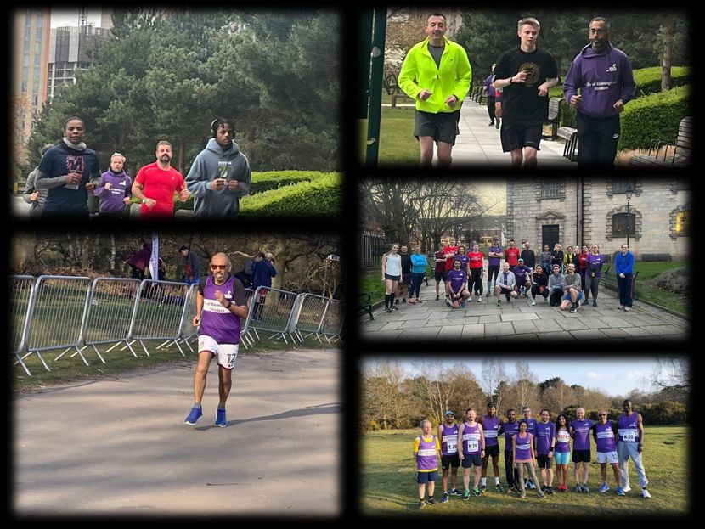
Figure 1: Running Club for Everyone Project
Source: (McIntyre, 2022)
City of Birmingham Striders is a running club that encourages all aged people to participate in together or do not have any collaboration in them (Oscar, 2017). running at all levels. There are so many running clubs in Birmingham, but they are not working There is dishonor among these clubs and these clubs charge a lot of money from the people to take part in the running event. People must pay 5K or 10K dollars to participate in the club but end up quitting because of do not know what to do next.
That is the reason the City of Birmingham Striders wanted to make an event that will connect all the running clubs in Birmingham and work collaboratively so that people who love to run feel encourage again. They aim to showcase that the running club are for everyone it can be changed by changing perceptions.
Stakeholders' participation is a very important aspect of any event or project. Stakeholders can be either group of people or individuals and they are the most important pillar for the success of an organization. It is necessary to involve stakeholders because they have all the resources that a project will need to successfully maintain its operations and having stakeholders can minimize all the distractions that may occur in a project (Owen, 2018). The most effective way to engage the stakeholders is to use social media platforms. For promoting an event and making people engage in that project, using social media platforms is the most efficient way. Social media platforms can easily spread the news about the project and highlight all the positive aspects of the event to attract the stakeholders and engage in the event. Recent studies show that more than 46 million people are engaged in social media platforms and more than 75% of people watch videos every day on different social media sites (Paul, 2016). So, social media are the best way to spread the news and attract stakeholders. Using social media platforms, organizers can easily gather people because people are always active on those sites and seeing the news about the running event will encourage many people to come and participate.
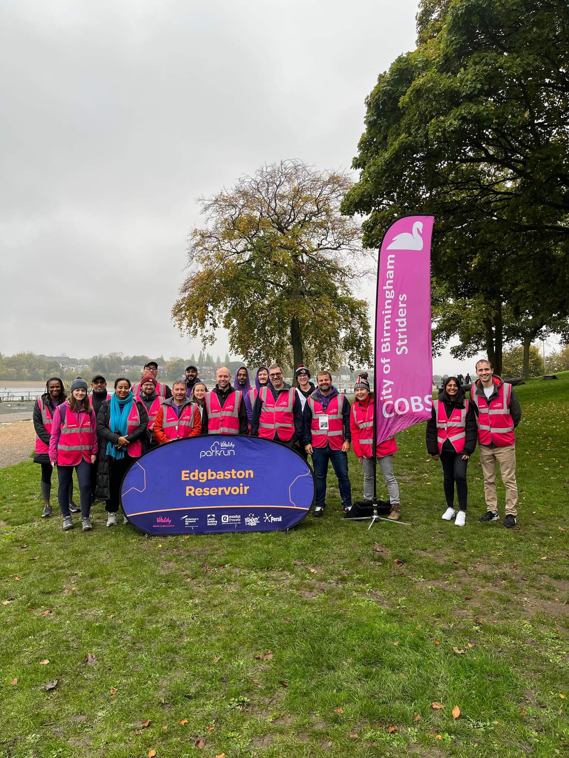
Figure 2: City of Birmingham Striders
Source: (Riley, 2022)

Engagement Through Social Media Platforms
There are so many social media sites available, and these sites are so powerful in terms of spreading news and gathering public attention. These sites are the biggest assets for the outreach of any kind of event. Everyday millions of people use social media platforms and engage themselves in doing different things (Rhys, 2022). So, it is the best way to let people know about the project and post different types of content and videos so that people investigate them and find themselves active in participating in the project.
Facebook
Facebook is one of the biggest social media platforms which has more than 2.93 billion people around the world. Millions of people from all around the world are active on Facebook every day and looking into different things. So, it is the best way to promote an event and encourage people to take part in it. Through Facebook, people can share pictures, videos, news, and many other things and this will be viewed by millions all around the world (Silva, 2018). Facebook can be used to spread the news about the running club projects and inspire people to come to take participate in them. The organizer can post pictures of the project, make videos about their running, and also can go live when the event is happening. All this will help the community and other people to know about the project.

Figure 3: Running Club Event in Birmingham
Source: (Team, 2022)

YouTube
YouTube is another biggest social media site which has more than 2.4 billion people from all around the world (Cameron, 2019). YouTube is the best way to engage people because videos from the event can be posted on YouTube and they will be viewed by millions of people. The organizer can make attractive videos about the project and post in on YouTube to spread the news about the project. People love to watch videos about different events and watching the videos of running club projects will inspire them about running.
Twitter
Twitter is another biggest social networking site where people can share their thoughts as small notes called tweets (Chowdhury, 2016). Twitter is used by millions of people including many influential people around the world. The organizers of an event always try to gain attention from influential people and Twitter is the best platform to do so. When the organizer will tweet about the project, it will be viewed by millions and many stakeholders come up and participate in the project which will make the more successful.
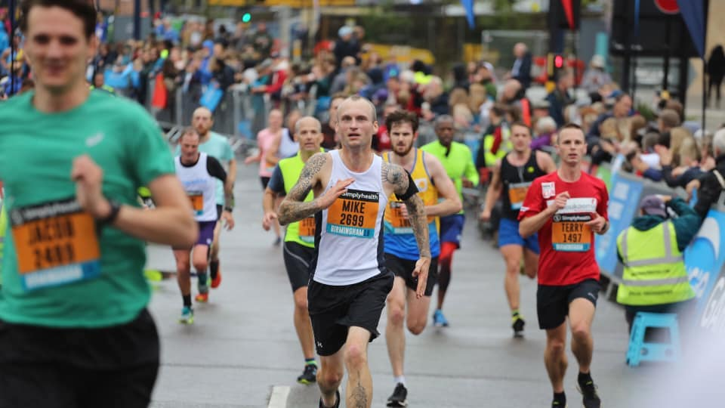
Figure 4: Birmingham Running Club Project
Source: (Canham, 2022)

Significance of Community Participation
The running for Everyone project was developed because of the issue that is affecting the Birmingham community people as people who love to run but cannot get the opportunity due to the Stigma among the running clubs in Birmingham (Oscar, 2017). The project was successful and generated huge participation because community people actively collaborate with the organizer. Community participation and collaboration are necessary because it enables social engagement. Community collaboration always brings the best outcomes for both parties.
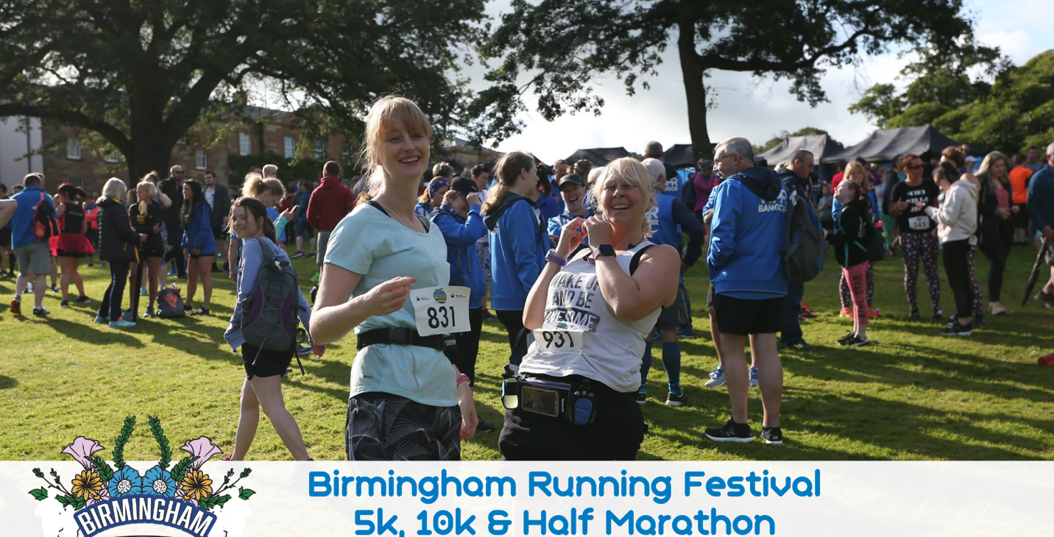
Figure 5: Community Collaboration in the Running Project
Source: (McIntyre, 2022)

Importance of Community Engagement
Community engagement is the collaboration between the local community members and the organizer who want to make a project in the community. Community engagement is necessary because it involves the development of the community. When big events like the Commonwealth games arrange in a city, it not only brings festive moments but also brings many internal and external factors which influence community development (Owen, 2018). When a big project occurs, it creates economic stability which later will be used in the community and for their betterment. That is why local people need to collaborate with the organizer and take participate in the event. Local people need to do their best to make the event successful because this will ultimately benefit them. Taking participation in the event not only makes the event successful but also helps them to develop their local community. So, it is the responsibility of the organizer to educate the community members about the project and how this will change their lives and make progress in their community. Before having them participate in the event, community people need to understand properly the things that will happen within the community (Paul, 2016). Engaging the community members and gaining their trust, requires some approaches from where they can learn about the project and clarify their doubts.

Community Engagement Approach
When an event is planned, the first thing organizer needs to be clear about is community engagement. It is important to take opinions about the community people because, without community engagement, the organizer cannot make a project successful. To understand the community, the best way is to approach them. The best way to make a community approach is to focus on community groups and talk to them (Riley, 2022). There are so many groups that stay in a community and each group have their point of view. When organizers focus on these groups, they can understand more about the community and can generate the best way to organize the event. Focus on the group encourages communication and the organizer can make the right approach towards the stakeholders. Active communication between organizers and community groups builds a strong relationship and enables the way of opportunities.

Conclusion
The success of a project lay behind the right community engagement approach. Community engagement is important because it creates many opportunities for both the organizer and the community people. Community engagement creates new policies for the community which ultimately help the community people and the organizer. Birmingham has so many running clubs but there is a stigma among these clubs. That is why the City of Birmingham Striders arrange a running club for every one project which aims to encourage all the people who love to run but cannot get the opportunity. The reason behind the success of the project is that community members actively participate in the project. This is because the organizer makes the right approach towards the community and gathers the right stakeholders. It also helps to create authentic connections which will help in future to organize more projects in Birmingham.

References
Cameron, J. 2019 How you can join a running club in Birmingham for free now, Birmingham Live. Available at: https://www.birminghammail.co.uk/special-features/how-you-can-join-running-11710924.
Canham, L. 2022 Group running clubs in Birmingham UK: A complete list by run of a kind, RUN OF A KIND - Running Tours of Birmingham UK. RUN OF A KIND - Running Tours of Birmingham UK. Available at: https://www.runofakindbirmingham.com/journal/run-clubs-in-birmingham-uk.
Chowdhury, S. 2016 Community engagement: Principles, strategies, and practices. 4th ed. Peterborough: Simon & Schuster.
Leo, J. 2022 City of Birmingham Striders Running Club, Twitter. Twitter. Available at: https://mobile.twitter.com/cobsrc1.
McIntyre, W. 2022 “Sport and the commonwealth games,” A Guide to the Contemporary Commonwealth, pp. 201–210. Available at: https://doi.org/10.1057/9781403900951_23.
Oscar, B. 2017 Community engagement guide. 3rd ed. Gloucester: Pan Macmillan.
Owen, L. (2018) “Birmingham Festival 2022,” The Lancet, 1(2), pp. 69–72. Available at: https://doi.org/10.1016/s0140-6736(01)18856-2.
Paul, J. 2016 The Commonwealth of Cricket. 4th ed. Lancaster: Pearson Education.
Rhys, M. 2022 Birmingham 2022 Commonwealth Games Sports Briefs. 2nd ed. Oxford: Oxford University Press.
Riley, C. 2022 Running Club for everyone, Commonwealth Games - Birmingham 2022. Available at: https://www.birmingham2022.com/united-22/2636828/running-club-for-everyone.
Silva, D. 2018 Social Media Platforms: Reasons why you could lose your job through the use of social media. 3rd ed. Lichfield: Bloomsbury.
Team, G.O.S. 2022 What is community engagement: Examples & models, GovOS. Available at: https://govos.com/blog/what-is-community-engagement/.

