IHG Hotel Group case study

Student name: Monica Roman
Student ID: 2128507
Module: BMIH5004 Management & Organisational Behaviour
Lecturer: Charlotte Joyner

Contents
Introduction 3
Organisation Structure, Culture, and Goals 4
Analysis of IHG's Organisational Structure 4
Examination of IHG's Corporate Culture 4
Evaluation of IHG's Goals 5
Recent Change Initiatives 5
Identification of Recent Change Initiatives 5
Impact Assessment 6
Management of Change Initiatives 7
Strategic Direction and Business Performance 7
Overview of IHG's Strategic Direction 7
Analysis of Current Business Performance 8
Comparison with Competitors 10
Recommendations 11
Enhancing Organisational Culture 11
Refining Change Management Processes 12
Strengthening Strategic Positioning 12
Conclusion 13
References 14

Executive summary
The present report provides an overview on IHG organisational structure, culture and goals and how this plays a major role shaping staff behaviour and influences guest experience and satisfaction, leading to brand loyalty and financial success for the company. Organisational structure gives the foundation for creating and implementing processes to build the business, defining roles, responsibilities and hierarchies. Strong organisational cultures lead to strong brand image, employee motivation and job satisfaction. This work aims to identify how IHG recognises the importance of a strong organisational culture and how it is implemented throughout its global portfolio in order to secure employee satisfaction, create guest loyalty and improve business performance.
Introduction
The IHG Hotel Group is one of the world’s leading hospitality businesses with 19 brands in its portfolio, covering all market segments in more than 100 countries across the globe. As one of the big players in the changing and dynamic setting of hospitality, IHG maneuvers itself through the complications of a constantly transforming market. This audit details important aspects of IHG’s organisational work, structure, culture and goals (Avelar, 2020). The report seeks to demystify the details of IHG’s decision-making models, cultural structures, and overall goals through a holistic assessment and help evaluate recent change initiatives, estimate their consequences and the way they were implemented. Further, the study will research the strategic way IHG is going, examining the scores of its current performance metrics and comparing them with those of competitors (Mirkamali and Rezaian, 2015). The aim of this report is not merely to provide the current image of IHG, but seek to give recommendations that will be actionable in the company’s future, and enhance the understanding of how organisational structure, culture and goals relate to each other, thereby enriching views on how effective management and leadership in the hospitality sector work.

Organisation Structure, Culture, and Goals

Analysis of IHG's Organisational Structure
IHG organisational structure is a pyramid shape with a decentralised decision-making approach. The organisation coordinates better when higher clarity is observable in division of authority (Tolbert and Hall, 2015). For the EMEAA region there is a decentralised structure, where local teams are supported by the expertise and power of the global brand. This allows a very quick and local market driven response (IHG, 2023). This structure makes it easy for individual units in IHG to make localised decisions, enhancing their adaptability to condition specific market. The hierarchy aids in smooth communication which leads to successful implementation of corporate strategies. Yet, with decentralisation can be hard to maintain standardisation among distinct units (Griffin, Phillips and Gully, 2020).

Examination of IHG's Corporate Culture
IHG has a corporate culture that is strongly rooted in commitment to core values and a progressive, open work environment. IHG promotes guest satisfaction, employee consideration, and environmental care. It wants to create the environment of world-class hospitality (Smith, Peters and Caldwell, 2016). The workplace is characterised by focus on diversity and inclusion, open communication lines and collaboration initiatives that stimulate creativity and get employees involved. This inclusive orientation is extended to all employees, at every level, who feel a sense of belonging and common purpose (Akpa, Asikhia and Nneji, 2021) allowing staff to deliver True Hospitality for Good (IHG, 2024).

Evaluation of IHG's Goals
In October 2023, IHG has announced an “extensive global brand evolution with new offerings and experiences, a fresh brand culture, unique brand differentiators, and a game-changing food and beverage and hotel design strategy tailored to the traveler of tomorrow” (IHG, 2023). IHG short-term objectives are associated with the improvement of operational efficiency, guest experience, and revenue optimisation (Grant and Jordan, 2015). These goals act as a point of reference in making daily decisions and evaluating performance. IHG’s vision for the future is to enter international markets using sustainable business models and as a leader in the industry, uses developments taking place in the overall industry as basis for anticipating changes and adapting to them. Constant tracking and adjustment of these targets are valuable in an evolving market (Burke and Noumair, 2015).

Recent Change Initiatives

Identification of Recent Change Initiatives
IHG has adopted modern technologies, and made a variety of improvements: reservation systems, mobile check-ins, green choices and smart room gadgets that enhance guest satisfaction but also boost productivity (Hanelt et al., 2021). “InterContinental Hotels & Resorts' global brand evolution embraces modernity, diversity and the desire for meaningful experiences, ensuring that guests can continue to explore the world while feeling right at home” (IHG, 2023). Among changing initiatives are “scientifically backed food and beverage programs” that will help reduce tiredness and ensuring meal choices satisfy guest needs during their stay. IHG Hotels offer their guests access to a jet lag app, Timeshifter, enabling travelers to quickly adjust to time zones using modern circadian science. InterContinental wants to revolutionise guestrooms by collaborating with Isabelle Sjovall, a neuroscience-based designer: “the goal is enhancing the restorative process needed for travel fatigue and reimagine other versatile physical spaces so they can seamlessly adapt to evolving needs at different times of the day” (IHG, 2023). Other changes will include the Concierge Galleries that will transform hotel lobbies into “epicentres of unrivaled local, cultural knowledge”. The brand-new Incredible Occasions programme and Celebration Suites will help guests enjoy unique moments of their lives with tailored packages and intimate settings according to preference and event.
IHG also addresses environmental responsibility through energy conservation, waste management programs, and partnerships with eco-friendly suppliers. These initiatives show that IHG is keen to remain one step ahead with a smooth and environmentally friendly future for guests and the entire ecology (Basten and Haamann, 2018).

Impact Assessment
As a result, the effects of IHG’s recent initiatives for change have a wide scope of influence, impacting different areas of the organisation, but for the better. These technologies have played a great role in improving operational efficiency and enhancing guest experiences, thus creating high satisfaction and loyalty (Helfat and Martin, 2015). However, there could be initial challenges with the implementation of such changes that would require careful management in order to avoid disruptions and minimise initial shock to the employees involved.
From environmental perspective, sustainability activities promote IHG’s corporate responsibilities and attract eco-conscious consumers. These initiatives not only lead to a clearer ecological footprint but also demonstrate that IHG is concerned with social responsibility (Chin, Tat and Sulaiman, 2015). The company is transparent about their ESG commitments and progress, and publishes the ESG Databook, admitting that some of the data was estimated but verified by a third party (IHG, 2022).

Management of Change Initiatives
The management of IHG’s change initiatives demonstrate a strategic orientation to running by technology updates and sustainable integration of the business. So effective communication strategies have been crucial in ensuring a smooth transition, and spreading correct and transparent information in every level of an organisation (Christensen, 2014). Such proactive communication significantly diminishes potential resistance and creates a common perception in which the changes have to offer some common good. Simultaneously, IHG has implemented reputable staff training programs that enable employees to work with the new systems with ease.

Strategic Direction and Business Performance

Overview of IHG's Strategic Direction
IHG’s strategic priorities are to highlight their expanded brand portfolio and allow guests to immerse in all the sophisticated technology and improvements that have been made to enhance guest experience. The group orients itself towards a proactive vision aimed at positioning as an international leader in an increasingly competitive hospitality sector, focusing on luxury brands in the US and global market expansion by identifying the main regions for growth, with Greater China being the fastest growing region. The sustainability commitment is part of the IHG strategy as more people are becoming aware of the issues that need to be addressed in relation to the environment (Massa, Tucci and Afuah, 2017). Moreover, technology integration contributes significantly to strategic IHG direction through improving both operational processes and guests’ experiences. If IHG continues to adopt a strategy of innovation and adaptability, it will not only address current problems in the industry, but also prepare the organisation for future disturbances.
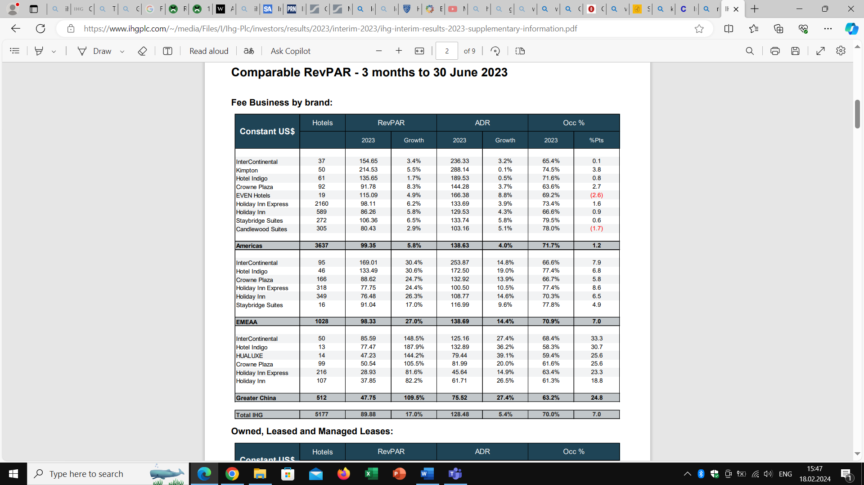
- Source (IHG, 2023)

Analysis of Current Business Performan1ce
The current business performance of IHG suggests a stable and robust strategic position in a competitive environment. Market share all over the world is significantly growing as indicated by financial ratios. Over the last year, IHG stock price has increased by +39.63% and the company made a profit of $375.00 milions (Stockanalysis, 2024). Consistency and strength in RevPAR for the company are also attributed to its particular branding and customer loyalty programs, showing that its myriad strategies to stand out from competitors is working. Customer retention and acquisition strategies become paramount in retaining profitability and demonstrate IHG’s ability to cultivate long-lasting relationships as well as aquire new clients (Hoverstadt, Loh and Marguet, 2023). The strategic emphasis on providing different and personalised guest experiences fits the contemporary consumer trends that foster a more pronounced attachment to the brand.
With over 100 million members, IHG One is one of the world’s largest and most successful hotel loyalty programs, helping the company retain and grow a large base of returning customers who drive a high-quality revenue growth. IHG One extends to events, major sports competitions, entertainment and airlines partnerships across the globe.
However, with every successful business, there are challenges that need to be addressed. The company has always needed to adapt to economic uncertainties and changing consumer dynamics. This will entail a detailed exploration of the nuances of these financial indices and their relationship to IHG’s strategic objectives (Adeneye and Ahmed, 2015). The overall picture of IHG’s business operation is incredibly bright and leaves the company as a strong player with a strategic approach towards dealing with all the nuances of the international hospitality market.

Comparison with Competitors
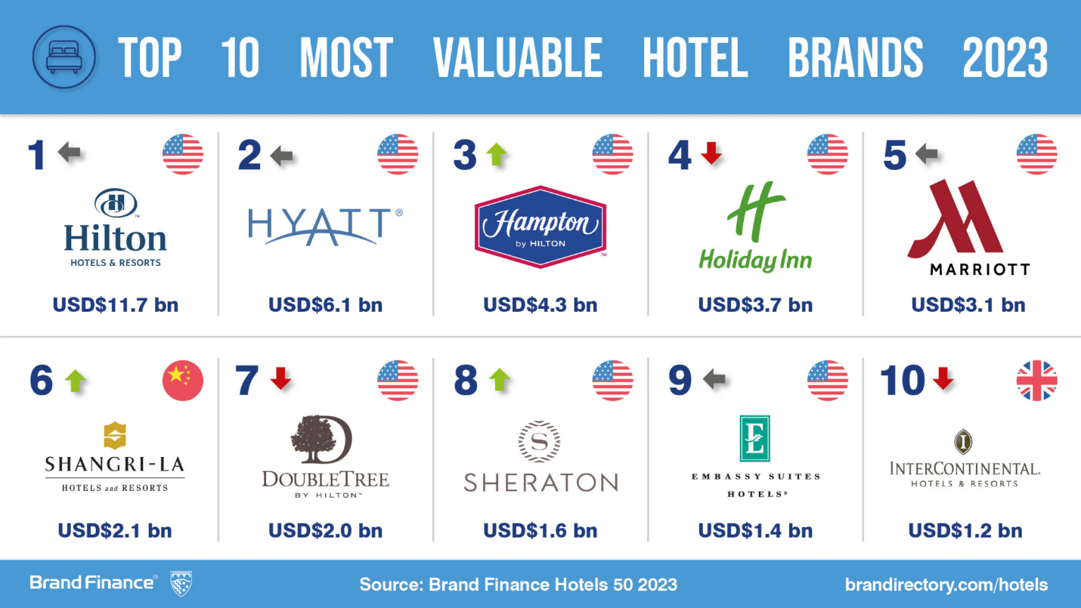
- (Brandfinance, 2023)
IHG has ranked in the top 10 Most valuable hotel brands in 2023, according to BrandFinance (2023). The group is distinguished through its strategic differentiation, diverse brand portfolio and its customer-focused development efforts.
A comparative study of major competitors such as Marriott and Hilton is an important component of IHG’s market positioning (Fleisher and Bensoussan, 2015). IHG has been able to catch a large portion of the global hospitality market: unique branding strategies and customer loyalty programs helping IHG distinguish itself from competitors.
To cope with dynamic consumer expectations, IHG uses differentiation strategies including targeted guest experiences and sustainability to position itself as a market leader. Comparing IHG performance with that of its industry peers provides great insights about its strengths and which are the areas where IHG can improve (Adom, Nyarko and Som, 2016). Continuous monitoring of performance is very important to ensure there is constant update of the strategic directions so as to ascertain that IHG is still competitive, as well as able to accommodate new trends.
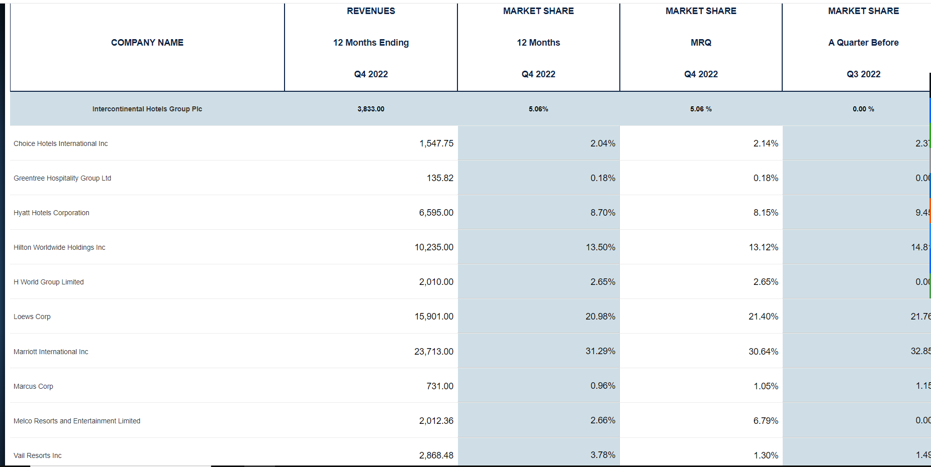
- (CSI Market, 2023)

Recommendations

Enhancing Organisational Culture
IHG should take certain initiatives to foster a more energetic and diverse organisational culture. Team-building activities and recognition schemes as part of the employee engagement programs foster feelings of belonging and common mission. Moreover, it will support diversity and inclusivity initiatives to make it an inclusive workplace that values diversity and enjoys differences for increased creativity and innovation (Rahimi, 2017). It is also important to set up regular communication avenues so employees can feel heard and appreciated. By enhancing the organisational culture, IHG will provide a work environment that will not only attract the best talents, but also increase all factors of overall employee satisfaction and performance.

Refining Change Management Processes
IHG has to improve its change management processes to address the challenges of technological upgrades and sustainability efforts. Establishing solid feedback loops to gather employees’ thoughts will provide valuable insights to allow for proactive adjustments of change strategies (Siebert, Paton and McCalman, 2015). Transparent communication about the reasons for changes and their expected effects is essential to winning the support of employees and keeping resistance to minimum. This approach to change management will make the organisation more agile and resilient.

Strengthening Strategic Positioning
A comprehensive approach will strengthen IHG’s strategic positioning. Regular market research should be conducted to identify opportunities for innovation and adaptation in emerging trends. IHG should start focusing on agility in adapting to market changes with cross-functional teams that monitor industry dynamics (Ansoff et al., 2018). Collaborations with local businesses and communities may help enhance a more sustainable and socially responsible brand. Constant improvement of brand differentiation strategies and customer loyalty programs will help IHG strengthen its distinctive position in the market. Transparency in sustainability efforts and third-party verification will contribute to an enhanced strategic positioning, meaning IHG stays at the cutting edge of industry activities and retains competitive advantage.

Conclusion
This audit of IHG Hotel Group sheds light on major areas of its organisational setup, culture, recent change programs, strategic direction, and business performance. The hierarchical yet decentralised structure, devotion to a diverse and inclusive corporate culture, and recent technological and sustainability initiatives display an intelligent approach for staying ahead. Financial metrics and market positioning analysis suggest that IHG performs well and has clear differentiators against competitors. The recommendations on improving organisational culture, making change management processes better, and solidifying strategic positioning provide suggestions to strengthen its position.

References
Adeneye, Y.B. and Ahmed, M., (2015) Corporate social responsibility and company performance. Journal of Business Studies Quarterly, 7(1), pp.151-166.
Adom, A.Y., Nyarko, I.K. and Som, G.N.K., (2016) Competitor analysis in strategic management: Is it a worthwhile managerial practice in contemporary times. Journal of Resources Development and Management, 24(1), pp.116-127.
Akpa, V.O., Asikhia, O.U. and Nneji, N.E., (2021) Organizational culture and organizational performance: A review of literature. International Journal of Advances in Engineering and Management, 3(1), pp.361-372.
Ansoff, H.I. et al. (2018) Implanting strategic management. London: Springer.
Avelar, P.A.S., (2020) Hotel industry growth trends–the case of Intercontinental hotels group (Doctoral dissertation). Available at: 1239178818-16088_Pedro_Alexandre_Santos_Avelar_2019-20_S1-33955-16-Pedro_Avelar_124450_439109737.pdf (unl.pt) (Accessed: 11 February 2024).
Basten, D. and Haamann, T., (2018). Approaches for organizational learning: A literature review. Sage Open, 8(3), p.2158244018794224.
Brand Finance (2023) Press release: Hilton checks in as the world’s most valuable hotel brand. Available at: https://brandfinance.com/press-releases/__trashed (Accessed: 12 February 2024). (Fig.2)
Burke, W.W. and Noumair, D.A., (2015). Organization development: A process of learning and changing. FT Press.
Chin, T.A., Tat, H.H. and Sulaiman, Z., (2015). Green supply chain management, environmental collaboration and sustainability performance. Procedia Cirp, 26, pp.695-699.
Christensen, M., (2014) Communication as a strategic tool in change processes. International journal of business communication, 51(4), pp.359-385.
CSI Market (2024) Stocks: IHG Group. Available at: https://csimarket.com/stocks/competitionSEG2.php?code=IHG (Accessed: 12 February 2024). (Fig.3)
Fleisher, C.S. and Bensoussan, B.E., (2015) Business and competitive analysis: effective application of new and classic methods. FT press.
Grant, R.M. and Jordan, J.J., (2015) Foundations of strategy. London: John Wiley & Sons.
Grant, A. M., Fried, Y., and Juillerat, T. (2011) Work matters: Job design in classic and contemporary perspectives. In S. Zedeck (Ed.), APA handbook of industrial and organizational psychology, Vol. 1. Building and developing the organization (pp. 417–453). American Psychological Association. Available at: https://doi.org/10.1037/12169-013 (Accessed: 11 February 2024).
Griffin, R.W., Phillips, J.M. and Gully, S.M., (2020) Organizational behavior: Managing people and organizations. CENGAGE learning.
Hanelt, A. et al. (2021) A systematic review of the literature on digital transformation: Insights and implications for strategy and organizational change. Journal of Management Studies, 58(5), pp.1159-1197. Available at: https://onlinelibrary.wiley.com/doi/full/10.1111/joms.12639 (Accessed: 12 February 2024).
Helfat, C.E. and Martin, J.A., (2015) Dynamic managerial capabilities: Review and assessment of managerial impact on strategic change. Journal of management, 41(5), pp.1281-1312.
Hoverstadt, P., Loh, L. and Marguet, N., (2023) Measuring the performance of strategy. Measuring Business Excellence, 27(4), pp.521-530.
IHG PLC (2022) ESG Databook 2022. Available at: https://www.ihgplc.com/~/media/Files/I/Ihg-Plc/investors/annual-report/2022-esg-databook.pdf (Accessed:18 February 2024). (Fig.1)
IHG Group (2024) Our strategy. Available at: https://www.ihgplc.com/about-us/our-strategy (Accessed: 05 February 2024).
IHG Group (2023) News. Available at: https://www.ihgplc.com/en/news-and-media/news-releases/2023/ihg-unveils-a-distinctive-global-brand-evolution#:~:text=InterContinental%20is%20collaborating%20with%20neuroscience,different%20times%20of%20the%20day (Accessed: 11 February 2024).
IHG Group (2023) Our strategy: Annual report. Available at: https://www.ihgplc.com/~/media/Files/I/Ihg-Plc/about-us/our-strategy/annual-report-2022-kpis.pdf (Accessed: 11 February 2024).
LinkedIn (2023) 2023 Global hospitality market share country specific. Available at: https://www.linkedin.com/pulse/2023-global-hospitality-market-share-country-specific (Accessed: 12 February 2024).
Massa, L., Tucci, C.L. and Afuah, A., (2017) A critical assessment of business model research. Academy of Management annals, 11(1), pp.73-104.
Mirkamali, S. and Rezaian, S., (2015) The Impact of Organizational Structure and Culture on Innovation: A Comparative Study in the Central Organization of Payame Noor, Scientific-Applied, Islamic Azad and Tehran Universities. Journal of Innovation Management Research, 4(1), pp.131-109.
Parmenter, D., (2015) Key performance indicators: developing, implementing, and using winning KPIs. Hoboken, New Jersey: John Wiley & Sons.
Rahimi, R., (2017) Customer relationship management (people, process and technology) and organisational culture in hotels: Which traits matter? International Journal of Contemporary Hospitality Management, 29(5), pp.1380-1402.
Siebert, S., Paton, R.A. and McCalman, J., (2015) Change management: A guide to effective implementation. Change Management, pp.1-336.
Smith, S.S., Peters, R. and Caldwell, C., (2016) Creating a culture of engagement–insights for application. Business and Management Research, 5(2), pp.70-80.
Statista (2023) Most valuable hotel brands worldwide. Available at: https://www.statista.com/statistics/732907/most-valuable-hotel-brands-worldwide/ (Accessed: 12 February 2024).
Stock Analysis (2024) Stocks: IHG. Available at: https://stockanalysis.com/stocks/ihg/statistics/ (Accessed: 14 February 2024).
Tolbert, P.S. and Hall, R.H., (2015) Organizations: Structures, processes and outcomes. New York: Routledge.

