Contemporary Challenges: Making a Difference

Blog 1 – What is the biggest threat to humankind?
From a viewpoint of a late teenager in 2023, I perceive poor health and well-being as the biggest threat to humankind. Throughout this blog I will discuss why this issue needs attention and sort of call to action. Before I begin discussing this, I will explain why this issue resonates with me and what health and well-being is defined as.

What is well-being?
What Works Wellbeing (2022) defines well-being as a collection of related factors. Physical health, relationships, community, finances, education, the economy, employment, religion, environment quality, and mental health are just a few of these elements.

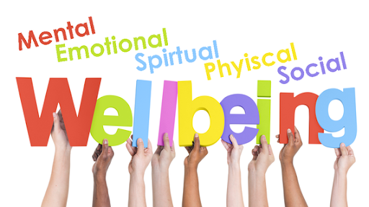
(Google.com, 2023)

How Is Well-Being Affecting Humankind?
Cancer is a global issue and can be a result of poor well-being. This could be a lack of physical care including lack of exercise, unhealthy eating, smoking or drugs. As it is a global issue, I believe well-being is severely affecting humankind. Global mortality rates are dominated by non-communicable diseases, with cardiovascular disease being the main killer (Ritchie and Roser, 2018). Cancers, cardiovascular conditions, diabetes, and chronic lung conditions are examples of non-communicable diseases. (Barbados, 2023). The main contributor to these disorders is physical inactivity. One third of deaths in underdeveloped nations are caused by smoking, poor diets, and inactivity. This is due to lifestyle factors and a rise in sedentary behaviour. More mortality rates are occurring more often as sedentary occupations are developed. Social media and technology are accountable for the rise of inactive jobs.
Not only are our physical well-being is being dominated, mental well-being plays a significant role in threatening humankind. In accordance with World Health Organisation (2022), 703,000 estimated suicides are made yearly. For every suicide, research shows there are 20 attempts made. Physical activity reduces the risk of anxiety and depression, enhances thinking and learning abilities as well as improving social health and wellbeing.

Inequality In Physical Activity
According to research (www.sparknotes.com, n.d.) it can be determined that the definition of physical inequality means to be discriminated due to natural differences such as mental disabilities, physical disabilities, ageism, health, strength, religion or race.

According to (Public Health Scotland, 2021) poverty has a significant impact on children and their physical health as children living in poverty will suffer greater health concerns such as obesity than their richer peers. They will experience a range of health issues including poor nutrition as they are unable to afford healthy eating habits, diseases and mental health issues. This puts a further strain financially on the family as they attempt to afford medicines. Children of lesser money, will struggle to gain access to sporting groups as they may not be able to afford it or there isn’t access to any in their communities due to lack of funding or facility access.
According to research (Butler, 2022) it can be estimated that fifteen point two billion people will be in poverty throughout two thousand twenty two and two thousand and twenty three which leads me to believe health and well-being is the biggest concern for humankind. With the cost of living crisis ongoing, these numbers are set to increase.

How To Improve Well-Being
The five components of well-being, according to Roger Williams University (2019), are physical, emotional, social, spiritual, and intellectual. Being active, eating healthy, and getting the recommended number of hours of sleep are all essential for maintaining good physical health. Currently, schools encourage this as they provide required physical education and deliver nutritious free meals. Maintaining a positive outlook, sharing our feelings with people we can trust, and finding a stress-relieving activity are essential in terms of our emotional well-being. Identifying friends and engaging in activities, especially sports, are crucial social wellbeing. Finally, intellectually, as important as it is to study academics, it is equally important to balance a health work/life relationship.

Blog 2- Evaluate Solutions You Will Need to Be Successful In Promoting Dealing With The Threat In Education
It is crucial to begin understanding issues before we try to solve them. In this instance, schools must teach children what well-being is and what it looks like in order to recognise and solve the global issue. In approaching this issue, one might encourage children to draw posters on what wellbeing is and put them around the classroom. This gives children the incentive to do independent research while making it fun. This could include healthy eating posters which are decorated in the canteens in many schools.

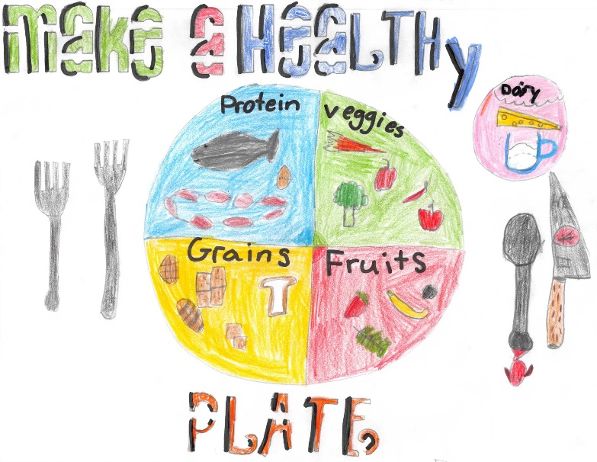
(www.wrps11.ca, 2019)

To tailor the learning to different age groups, teachers are able to incorporate learning into play. When children are playing in the kitchen area with plastic food and they are asked to demonstrate a healthy plate and unhealthy plate. As a teaching assistant, I recently achieved this in a reception class. They understood the concept of chocolate consisting of sugar which would subsequently have a negative impact on their teeth and that they must eat desert after they have eaten their healthy plate of food. Moreover, advertise to children to walk or cycle when possible and why that is. A school I recently attended, asked the children to decorate a bike and bring them into school. This encouraged children to cycle to school to benefit their wellbeing by exercising while enjoying it. Finally, it is beneficial to have a water station according to Zip Specifiers Portal (n.d.), as it inspires children to drink more water throughout the day. Dehydration is responsible for dizziness, headaches and fatigue. This can leave a child with lack of focus, productivity and motivation.

To tackle these concerns, we must identify the most valuable skills used throughout this process. These skills may include critical thinking, negotiation, decision making and managing conflict. I will discuss why I believe critical thinking and decision making are the most beneficial.

Critical Thinking
Critical thinking is the ability to actively analyse and evaluate information by observation, experience and communication (louisville.edu, 2023). In agreement, according to www.utc.edu (n.d.), critical thinkers ask questions while considering alternative solutions and communicated effectively to gather information.

To promote critical thinking in schools, it is essential to motivate children to ask questions, encourage decision making which can be achieved effectively in group work as they are able to incorporate different points of views. It is paramount that children are creative and brainstorm ideas (in.pearson.com, 2021).

In accord with Owens (2021), using games is a clever way to develop critical thinking in education as 4-in-a-row allow players to think analytically while examining information to make a logical judgement. Children can make well informed decisions and understand consequences. It permits children to identify patterns and think ahead. This can be integrated into classrooms as this game can be played when it is ‘wet play’ or simply as a reward for work completion.
Critical thinking is beneficial to a child’s wellbeing as they are able to inspect their own thoughts, feelings and ideas to question assumptions they make about the world. This means they can evaluate arguments and consider where evidence is valid.

Critical thinking helps children assess the information regarding their health, values, long-term happiness and wellbeing. This is a result of evaluating information and form a personal opinion. It can help to decide whether someone should eat veg instead of chocolate or walk instead of drive as well as understanding the reasoning behind it (Witmer, 2022).

Decision Making
According to Dartmouth (2021), decision making is the process of making choices by recognising a decision, acquiring information and evaluating a possible solution. Schools can encourage this in classrooms by teaching the use of lists and the pros and cons. However, it is important not to offer too many choices to prevent children from feeling overwhelmed (Stearns, 2023).
The introduction of the new curriculum has the aims of creating ambitious, independent and capable learners. Practitioners will have to provide rich and engaging activities that allow for decision making by each individual child (hwb.gov.wales, 2020).

Blog 3 – Design Thinking
As stated by Yu Siang (2009), design thinking the process of understanding others, challenges, redefine problems to create solutions that are able to be tested. There are five stages, empathise, define, ideate, prototype and test. This technique is designed to creates solutions to unknown issues.
Students use their knowledge to develop a system to tackle a real-life problem.

Wicked Problems
Problems that are ill-defined are also known as wicked problems. Wicked problems are complex which there is no single solutions.

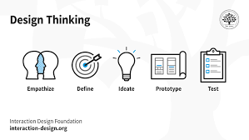
(Yu Siang, 2009)

Stage 1: Empathise
The first stage of design thinking process allows for an empathetic understanding of the problem that is trying to be solved. At this stage, it is possible to recognise target audience, what challenges they may face and their needs. To achieve this, effective communication is needed to acknowledge how they think, act and feel. This can be obtained through interviews or surveys. Once this information has been obtained, it is possible to move on to defining the problem, stage two.

Stage 2: Define
At this stage information must be accumulated from stage one. Analyse and observe to defined core issues that have been identified. This stage must be user orientated when creating the problem statement.

Stage 3: Ideation
At this stage, people must remain thinking openly, non-judgemental and have courage and collaborate. At this point, it is critical to gather a team and understand different viewpoints and new angles.

Stage 4: Prototype
This stage is also known as the experimental phase. The next step is to identify the best solution for each problem in the first three stages. Essentially, taking the problem and solve it. The best way to do this is to have a tangible prototype that can be given to other people for a better insight and feedback.

Stage 5: Test
This point in design thinking identifies more problems and seeks more solutions that work to create the best outcome. With these results, it is essential to try again with new information.

How To Implement Design Thinking into The Classroom
Students are to be encouraged to list problems they wish to solve. Pupils are then encouraged to design an app to solve these issues. To achieve this, they must interview each other, listening to all answers and sketch designs. Students then can test the effectiveness and usability. To enable creativity, students can complete this without the help of technology. Once feedback has been produced, students are then able to go back and adjust their original designs (Robin, 2016).

Limitations of Design Thinking
The disadvantages of design thinking can include the amount of requirement needed from the participant to complete the research and feedback. It is difficult to find people who are able to fully commit to the project however, most people have other obligations. Furthermore, while designing a solution that is human based, it is difficult to remember that people have different requirements. For example, people of an older ages trying to access the internet. Therefore, it is important to use a variety of people (Tsoi, 2021).

Advantages of Design Thinking
Design thinking teaches the designers about empathy. This emotion is critical for young students to learn. It allows them to understand the participant and different circumstances they may not have been considered before. Additionally, creativity is encouraged on how to solve problems I many ways. the benefits of many different solutions help the product to be client focused as the make-up of one solution may not be enough (Gonzalez, n.d.).

Reference List
Barbados (2023). Noncommunicable Diseases - PAHO/WHO | Pan American Health Organization. [online] www.paho.org. Available at: https://www.paho.org/en/topics/noncommunicable-diseases.
(Accessed: 28th March 2023).

Butler, P. (2022). 1 million more people in UK face poverty this winter, analysis shows. [online] The Guardian. Available at: https://www.theguardian.com/society/2022/sep/07/uk-poverty-winter-energy-prices-analysis-shows (Accessed 29th March 2023).

Dartmouth, U. of M. (2021). Decision-making process. [online] www.umassd.edu. Available at: https://www.umassd.edu/fycm/decision-making/process/#:~:text=Decision%20making%20is%20the%20process. (Accessed: 3rd April 2023).

Gonzalez, J. (n.d.). Student View: Design Thinking and its Importance for 21st Century Leaders | Magellan International School. [online] www.magellanschool.org. Available at: https://www.magellanschool.org/student-view-design-thinking-importance-21st-century-leaders/#:~:text=At%20the%20core%20of%20design. (Accessed: 3rd April 2023).

Google.com. (2023). Advertisement de redirection. [online] Available at: https://www.google.com/url?sa=i&url=https%3A%2F%2Fstlawrencesschool.org%2Fsafeguarding%2Fwellbeing-newsletters%2F&psig=AOvVaw2CmG-lTQWdgnNvHJAe0cz-&ust=1680626501889000&source=images&cd=vfe&ved=0CA0QjhxqFwoTCNDMmeOTjv4CFQAAAAAdAAAAABAJ (Accessed: 3rd April 2023).

hwb.gov.wales. (2020). Introduction - Hwb. [online] Available at: https://hwb.gov.wales/curriculum-for-wales/introduction/#the-curriculum-for-wales-framework. (Accessed: 3rd April 2023).

In.pearson.com. (2021). Strategies to Increase Critical Thinking Skills in students. [online] Available at: https://in.pearson.com/blog/2021/11/strategies-to-increase-critical-thinking-skills-in-students.html. (Accessed: 3rd April 2023).

Louisville.edu. (2023). What is Critical Thinking? — University of Louisville Ideas To Action. [online] Available at: https://louisville.edu/ideastoaction/about/criticalthinking/what#:~:text=Critical%20thinking%20is%20the%20intellectually. (Accessed: 3rd April 2023).

Owens, M. (2021). 5 Games for Building Critical Thinking Skills. [online] www.coolmathgames.com. Available at: https://www.coolmathgames.com/blog/5-games-for-building-critical-thinking-skills. (Accessed: 3rd April 2023).

Public Health Scotland (2021). Impact of child poverty. [online] Healthscotland.scot. Available at: https://www.healthscotland.scot/population-groups/children/child-poverty/child-poverty-overview/impact-of-child-poverty [Accessed: 29th March 2023].
‌
‌Ritchie, H. and Roser, M. (2018). Causes of Death. [online] Our World in Data. Available at: https://ourworldindata.org/causes-of-death. (Accessed: 28th March 2023).
Robin, U. (2016b). 8 Steps to Implementing Design Thinking in Your Classroom | Common Sense Education. [online] www.commonsense.org. Available at: https://www.commonsense.org/education/articles/8-steps-to-implementing-design-thinking-in-your-classroom. (Accessed: 3rd April 2023).
Roger Williams University (2019). Dimensions of Wellness | Roger Williams University. [online] Rwu.edu. Available at: https://www.rwu.edu/undergraduate/student-life/health-and-counseling/health-education-program/dimensions-wellness. (Accessed: 24th March 2023).
Stearns, C. (2023b). Promoting Decision-Making Skills in the Classroom. [online] Study.com. Available at: https://study.com/academy/lesson/promoting-decision-making-skills-in-the-classroom.html#:~:text=To%20help%20your%20students%20learn (Accessed: 3rd April 2023).
Tsoi, J. (2021). What are the flaws of Design Thinking? [online] Medium. Available at: https://uxdesign.cc/what-are-the-flaws-of-design-thinking-83e22213232a. (Accessed: 3rd April 2023).
What Works Wellbeing (2022). What is wellbeing? [online] What Works Wellbeing. Available at: https://whatworkswellbeing.org/about-wellbeing/what-is-wellbeing/. (Accessed: 24th March 2023).
Witmer, C.M., Jaclyn Lopez (2022). 6 tips for boosting critical thinking skills to avoid biases and make more informed decisions. [online] Insider. Available at: https://www.insider.com/guides/health/mental-health/critical-thinking#:~:text=But%20critical%20thinking%20can%20also (Accessed: 3rd April 2023).
World Health Organisation (2022). World Suicide Prevention Day 2022. [online] www.who.int. Available at: https://www.who.int/campaigns/world-suicide-prevention-day/2022. (Accessed: 28th March 2023).

www.wrps11.ca. (2019). ‘Healthy Eating’ Poster Contest - Winners! | Wetaskiwin Regional Public Schools. [online] Available at: https://www.wrps11.ca/trustees/whats-new/post/healthy-eating-poster-contest-winners (Accessed: 3rd April 2023).

‌www.sparknotes.com. (n.d.). SparkNotes: Discourse on Inequality: Important Terms. [online] Available at: https://www.sparknotes.com/philosophy/inequality/terms/. (Accessed: 29th March 2023).
www.utc.edu. (n.d.). Basic Elements of Critical Thinking | University of Tennessee at Chattanooga. [online] Available at: https://www.utc.edu/academic-affairs/walker-center-for-teaching-and-learning/faculty-programs/faculty-fellow-programs/faculty-fellow-program-development/basic-elements-of-critical-thinking. (Accessed: 3rd April 2023).
Yu Siang, T. (2009). What is Design Thinking? [online] The Interaction Design Foundation. Available at: https://www.interaction-design.org/literature/topics/design-thinking. (Accessed: 3rd April 2023).
Zip Specifiers Portal. (n.d.). 7 ways to promote health and wellbeing in schools. [online] Available at: https://specify.zipwater.co.uk/news-and-views/sustainability/how-to-promote-health-and-wellbeing-in-schools. (Accessed: 3rd April 2023).

‌

