IASH ALI
1708765
BMSW5001
DEVELOPING WORKPLACE CRITICAL THINKING
ERNEST OVIA

CONTENTS PAGE:

INTRODUCTION…
WORKPLACE BEHAVIOUR: BELIEF, ATTITUDES, VALUES….
MANAGEMENT THEORY WHITIN THE WORKPLACE….
THE X AND Y THEORY BY DOUGLAS McGregor….
DEVELOPING AND ARGUMENT OF MANAGEMENT SYSTEM….
CONCLUSION….
REFERENCES….
APPENDIX….

INTRODUCTION

In this assignment I have chosen my current workplace, which is Uber taxi company as my organisation that I will be relating to, this is where I am working as a partner driver, I will be aiming to show the workplace behaviour in this structure, which I will be covering the beliefs, attitudes, values that made an impact in the workplace behaviour and to break it down to what the explanation of it is, we will also show the theory that works under management of the organisation and how it relates to myself and where does the strength and weaknesses come under and how does it work with my workplace, this will allow me to use the x and y theory by Douglas McGregor on my work, which I believe, will be the ideal scenario for my arguments and which will show me the type of argument that’s needed to back it up as there are so many different theories used around the workplace, my aim is to find the best argument which have an impact on management choices and explain how is the theory is of today and by investigating the theory, how is it going to be my evidence that is going to be linking with my arguments.

WORKPLACE BEHAVIOUR: BELIEF, ATTITUDES, VALUES

Belief: Belief in workplace is how you approach your work and how you act in the role that you are working at and the organisation for whom you are employed with. “Something that is the truth or something in reality”. M. Webster (2019)
Ubers priority is safety of riders, as drivers background checks are properly checked, Uber have established them self’s through the years, making everyone get the respect, which allows them to connect with communities, riders and drivers that are always being there and welcoming people from all different backgrounds, this is where it makes Uber one of the diverse workplace environment.
The impact such beliefs have on my role as a taxi driver include being open and welcoming to people of all backgrounds. By building my confidence at my workplace It helps me to enjoy my work and it motivates me in doing my role at work which drives me forward with my task. When I first started I have made mistakes but learnt from those mistakes as the company’s beliefs have helped me improve my communication skills through the experiences I have gained working in a professional environment. For example, I picked up a wrong customer which I didn’t realise till halfway of the journey. The company’s belief in communication helped me improved my communication skills to not to make that mistake again.
I am always tested at my role as I must communicate with people from different background and I respect everyone from different religions as this is a part of my work. at this role I’m always thinking ahead and planning well and how my actions are, as I always fear of causing an offence by misunderstanding or discrimination at the workplace but in this case my reaction are quick to rectify the problem and respect the environment I am working at and also the diverse community that are important to my role.

ATTITUDE:
At the workplace, having a positive attitude boost your morale and helps building good abilities, cope better at difficult situation while at work and communicate effectively with co-workers for the organisation that you are working for and having that respect for others, also getting respect back from your co-workers and helping each other at times of difficulty. As in having a negative attitude at the workplace will cause destruction and losing trust with fellow employees and that is not good for the organisation moving forward.
Uber requires an attitude that’s professional and friendly towards the riders, where they require the drivers to greet the customers, making the customers feel welcome, have a great sense of humour, give the best possible service, not to have a negative attitude as Uber works on rating system for the drivers, which is given by the riders at the end of the journey, where they can rate the driver from one to five, if the rating is below five then the customer will have to explain why, as there are some options pop up on the customer Uber app and one of those option relates to attitude.
My behaviour at my workplace is about the feeling I get while working for Uber, as my impact of my attitude is a positive sign at the environment I am working at, being able to greet and smile towards the customers, this is where I build up a rapport with riders which then turns into a five star rating for me, this allows the organisation to see how is my attitude in the approach of work, I know at this organisation the customers is always right but to put in a great service with the positive attitude have gained trust with customers which then increases my morale for the organisation, my role involves driving riders to different place, this is where it shows me how I can react through the journey as there can be roadworks, accidents, traffic, but keeping my attitude calm and being patient and friendly takes me that extra mile, there is times riders don’t want to talk and at times they are very talkative, this where I have make them feel they enjoy the ride by being able to engage with them in a polite and pleasant way.
I know I have to always have that positive attitudes in my work role as it motivates me, having a negative attitude I will not be able to build that trust with the customers, which decreases my morale on the organisation and also lowers my rating on the system. “Strength of attitude can count on moderating effects of many individual differences.” Fazio (1995).

VALUES:

The work place is an important place that you work in and it is a place that values the right and the wrong and a guiding principles in making important decision and finding your career choices.
Uber’s values has a lot of impact on the organisation as building together all over as in everywhere globally, customer satisfaction is a part of their core values, as they are means of their business and customers are one of the main factor, which they are obsessed with, “ working hard to earn the customers trust and solving their problems to build the business” Kircher M (2019). Uber likes people from different backgrounds and knowing the differences to put to work. Doing the correct thing always, having ideas that value the importance over hierarchy. Uber values are higher as they like to act like owners.
Values is so important for me to accept at Uber as I am their partner driver, this makes an impact which takes into consideration in the actions that’s needed by me at work, to improve the business in different ways, honesty is one of my main aim to my organisation and for the customers, as taking them safely and the shortest route to their destination, Uber is more customer obsessed so my commitment is more dedicated to my role and increase more budget for the organisation, I am always loyal to the organisation, as I put my hard work in to the business and I want to be always a part of their success and I’m always putting the organisation first, which is why this principles are most important for me, in the way I work for the organisation and I have done that by having a higher rating which is valued by Uber and customers. “Individuals values are recognised as components in the progression of human mindfulness.” Postman, Bruner, Mcginnies, (1948).
Values are very important which helps us to grow in learning and helps us to develop more, have an influence on the decisions and actions and in the future, we can experience the means values. Making that difference in the workplace and taking out the responsibilities and being reliable of all things that’s needs focussing on.

MANAGEMENT THEORY WHITIN THE WORKPLACE

The management of my organisation Uber can be linked with x and y theory, according to the x and y theory, as there is two parts to it, x is talking about rewards at the workplace which relates to my organisation, rewards are used to motivate the employees which makes them work hard. And there is y which connects me to having satisfaction from my work and also says that without being supervised directly I can complete my tasks, managers who use this approach have the means for their people do their work by themselves with trust. “Theory x and y addresses strategies of management to motivate employees to increase worker productivity”. Smith, Shaumbwa, Evance, and peter. (2019)
At uber employees are motivated at work with the rewards that are provided, which there is the blue reward that’s starts off with first, this allows us to get cashback from our fuel purchases, cut price gym membership, vehicle interruption cover and a fully funded online short courses which is for you and your family, this are the first side of the rewards. And there is higher rewards as every trips we do, we get a point for that and every trip that’s taken on Fridays and Saturdays from ten in the night to four in the morning we get three points, this points adds up to unlock bigger rewards, as more the points are, we move to higher rewards which then turns into gold rewards and to even higher towards platinum and diamond rewards, this motivates us to do more work in the environment that we are at.
As the theory x and y relates to the workplace, the y is saying about being supervised by not seeing the work we are doing, as being a taxi driver, I’m not directly been checked as this is in my own time and in different destination, this is where after accepting my trips I am dealing with the customers face to face on my own, this makes me a leader and improves more on more on my skills that’s needed to handle various things at work on my own, which then if there is any problems occurring with customers they will get in contact with company through uber app or the support line and this makes me more productive in my workplace with no supervision, this also makes me more being professional at the workplace.
After looking at this management theory this works well with the employees regarding with all those benefits that are on offer which motivates us and makes us perform higher standards for the organisation. “When objectives are set, the most important thing in the performance management system is monitoring”. Simeons pivot resources (2019)
There is also pros and cons at this as well. As looking at the pros, uber generates the surge when it’s really busy, at times it doubles the fares, which in theory the drivers are making a lot of money out of it, but are assigned to do more trips as fast as they can, the more quicker we do the faster we get the next trip, while the surge last, also there’s no need to wear uniform at the workplace and its flexible for drivers which attracts us more knowing we can choose when we want to work and all the tips we get, we keep, we get to cancel trips that we don’t want to do and there’s the rating system which gives feedback from the riders which boosts our morale even higher on the positive side of the feedback which makes us more important , this is where you get to see your rating and the feedback on the uber drivers app, uber does consider us as one of the main shareholders and puts a lot of responsibilities on our self without them telling us what to do, making you your own boss. There’s also the rewards system that’s in place to get us going and we also have the safety tool box which makes us safe while we are working as we are always picking strangers, the safety tool box is located on the uber driver app which connects us to the local authority straight away.

Looking at the cons, Uber are taking 25 per cent commission from the drivers, which is a lot comparing to doing a small trips and doing them the miles increase which lowers the value of your car and increases the repair bill, as surges are only dispatched at given times and not all the time, that’s leaves us doing normal trips more often and low fares affect the drivers earnings, at sometimes some trips are given from miles away when there is no drivers around at that area and getting paid after they have deducted their percentages and payments are in a weekly basis, a lot of drivers will do a second job or work for a second taxi company due to high commission taken which makes them less motivated.

This is an image of x and y theory of management within the workplace.

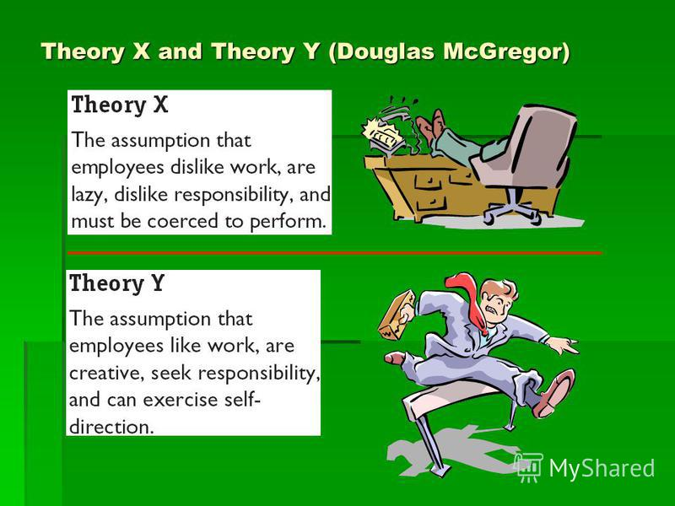

THE X AND Y THEORY BY DOUGLAS McGregor

This theory was created for people at work, on how to be motivated at the workplace and how management applied it in their sector of work which relates to human resources, as this shows us on the behaviour of humans at their workplace is and how they communicate well with different roles and management and how to develop you’re work ethic and this theory was created with two different approaches to manage people and this theory is still commonly used by management in their workplace.
The theory x explains how rewards make employees work harder and how they get motivated as this are things in a workplace makes us go further in doing our role. It also got tight supervision as you are watched all the time, where they record all your actions and take it in to careful consideration which makes some don’t want to be motivated to work and makes employees not even want to work, making the employees feel lazy and getting them to work forcefully and giving punishment to get that objectives of the organisation, which makes working with management of the x theory not so easy. “As theory x managers take a view of their people, who they believe are unmotivated and dislike work, as a result they think team members need to be prompted, rewarded”. Mind tools (2019).
The theory y is more getting in to how the jobs was satisfied and how the task was fulfilled with ease to get to that accomplishment, as the job was done correctly and timely and this also relates on employees doing the job on their own with taking full responsibility and there is no supervision on them as they can deal with the outcome of job without anyone telling them what to do or looking at their actions, this is more motivating for employees at the workplace as they enjoy their job and have creativity at an environment that is more enjoyable to work at and managers feel that they are high performing employees.
As of today, the x and y theory does relate at any workplaces. According to the theory x, there is at times we do dislike our work due to poor trips with lower fares and when it’s not busy, it makes us lazy, but having the organisation set with rewards at times, we start getting motivated to do our task.
Theory y relates to taking work on your own and getting job satisfaction, this falls under my category as I take my work as my ownership and responsibilities and this is how I believe I can do my work effectively.” That people in the work force are internally motivated, enjoy their labour in the company”. (Zendage, 2018)
I do believe this theory that was made long time ago, works in my workplace and other places of work nowadays, which shows that the motivated employee gets the job done and the not motivated employee are more lazy at work, who then turns to be motivated due to benefits, it also shows how the employee gets the job satisfaction without being watched and just as I do at my work place without supervision, I get a lot of job satisfaction.
Theory x strengths are by managing the employees with rewards which relates that the work will be done faster and making the employees work harder.
As for the weakness it has been said that the employees are less ambitious and dislike their work and are only doing it to make a living and the managers doesn’t have the trust of the employees as they don’t want to take responsibilities, which makes them need to be supervised at all times and put on a heavy punishment.
The strength of theory y is that employees are more relax in getting jobs satisfaction as they can work without getting supervised, this makes the employees feel more valued and happy at work and increase their morale for the organisation with the high level of skills they have, which then they boost their revenue more, employees reach their goals with their self-belief and having that potential.
The weakness of theory y is, there’s less freedom as being an employee, this makes them finishing the task of the jobs first and management wouldn’t allow to give freedom until the job satisfaction are met.
Concluding this theory, in my belief it is a good theory to relate to my workplace, as this has shown how managers actually motivate their employees and how this take in to consideration of their style of management that they have set out at the workplace.

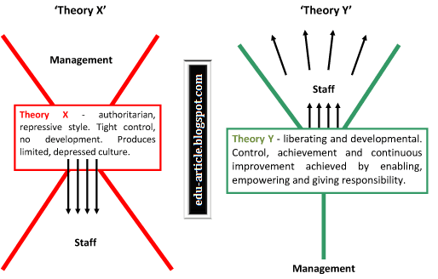

DEVELOPING AND ARGUMENT OF MANAGEMENT SYSTEM

At this argument I believe this is a strong claim of argument as the management of my organisation has the similar to what the theory that I am using is trying to say, I believe the managers agree with the x and y theory, as theory x says about the rewards to motivate employees, which we have in our organisation, where the managers has set for our work and the theory y explains the employees can work without supervision, which is not direct, this is what we do in our workplace, which the managers already set on the system, which is without face to face communication. “that argumentation is the umbrella under which all reasoning lies”. Kuhn and Uddell (2003)
Looking at the proof of my argument, I have investigated what the theory x and y do and how its working in my workplace and I will be adding the Hawthorne theory with it, as it is much similar evidence to my argument.
According to Douglas McGregor theory x is saying that employees don’t want to work as they feel lazy and punishments are given to the non-motivated employee but are given benefits of rewards to make them work. This is where when I take this in to consideration to my workplace, as there is times that we don’t want to work or just feel lazy due to cost of driving is very high and the fare is very low and don’t get enough credit in what we do, as we have a lot of responsibilities but the work makes us lazy due to circumstances of management style. That’s when Uber management sets out rewards in changing the platform to do more work as it motivates the employees and to do more, the more work we do, the higher the reward.
If I apply the Hawthorne theory according to Henry A. Landsberger, which is used by uber at some points, this can be related with similar to theory x, as the Hawthorne effect is a modification on employee behaviour, the employees know that they are being watched at the workplace, but the effect on uber with this theory were more ways of increases the employee productivity, as in examples of rewards given for employee motivation, as the moment you begin to increase on employee satisfaction, the workplace behaviour changes. “Looking at their behaviour of those being studied”. Mohan T, Fisher JA (2010)
On the basis of theory y, I believe this part relates very strongly and towards similar belief of uber, this falls under the employees workplace, as looking at the theory y it explains that without being supervised you can do your work on your own to get that job satisfaction and employees are more motivated as there is no one looking around you and control their own behaviour themselves. At uber we don’t have the managers supervising us, as everything by management are done on the app system, this is where our leadership skills are important as we lead our work on our own and this makes us feel happy to work as we are not watched and this motivates us to get our job satisfaction and makes us more creative and conditions are in our favour, we take responsibility in valuing the organisation and system of management style that’s already in place and for this y theory it is also been used at big companies like apple and google from my research, were this companies like creative people who can work on their own and come up with new ideas. If this y theory is working at big companies so in my belief this is working at my workplace.

According to Hawthorne theory, relating to the theory y, at Ubers belief they like high performing employees as this increase revenues for the organisation and makes the employees like their work, as they feel more secure and satisfied with their work.
I believe that the x and y theory is commonly is used at workplaces and at my workplace it relates more to it, which I believe the management in their belief works on the same way, as of the Hawthorne theory effect is used by management at my workplace which is somewhat similar to x and y, in my belief the argument is strong and that the x and y theory works within the company by looking at proof on both ways to form my evidence.
“Argumentation tools, could be especially applicable to model legal argumentations, to areas that evidence reason.” Walton, D. and Macagno, F. (2015)

CONCLUSION

To conclude this report I have evaluated beliefs, attitudes and values and showed how it impacts at workplace behaviour which are very important at being in any role of the job and in my belief this research has changed my attitude, we also analysed the management theory in the workplace and how it is working at around my workplace which I believe is working given the proof of my own work and relating to theory x and y which works on my workplace and this relates today to other organisation and in my research of x and y theory on my assignment it proofs to me to form a strong argument that I agree to with given evidence.

REFERENCES
Merriam-webster.com. (2019). Definition of BELIEF. [online] Available at: https://www.merriam-webster.com/dictionary/belief [Accessed 21 Nov. 2019].
Postman, L., Bruner, J.S., and McGinnies, E., 1948. Personal Values as Selective Factors in Perception. Journal of Abnormal and Social Psychology, 43, pp.142-154.
Kircher, M. (2019). Uber CEO Replaces Problematic Core Values with Friendlier-Sounding List. [online] Intelligencer. Available at: http://nymag.com/intelligencer/2017/11/ubers-list-of-new-core-values-are-friendlier.html [Accessed 21 Nov. 2019].Zendage, H. (2018).
Fazio, R.H. (1995) Attitudes as object – evaluation associates: Determinants, consequences, and correlates of attitude accessibility. In R.E. petty and J.A. kosnick (eds), Attitudes strength: Antecedents and consequences (pp. 247-82). Mahwah, NJ: Erlbaum.
Motiki, M., Smith, A., SHAUMBWA, L., EVANCE, N. and PETER, A. (2019). How to apply management theories at workplace | edu CBA. [online] EDUCBA. Available at: https://www.educba.com/how-to-apply-management-theories-at-workplace/ [Accessed 22 Nov. 2019].
Simeons Pivot Resources. (2019). Uber and Performance management system. [online] Available at: http://simeonspivot.com/blog-post/uber-taxi-experience-and-performance-management-system/ [Accessed 22 Nov. 2019].
Mindtools.com. (2019). Theory X and Theory Y: Understanding People's Motivations. [online] Available at: https://www.mindtools.com/pages/article/newLDR_74.htm [Accessed 22 Nov. 2019].
DOUGLAS MCGREGOR THEORY X AND Y. Scholarly Research Journal for Humanity Science & English Language, 6(26).
Kuhn, D. and Udell, W. (2003). The Development of Argument Skills. Child Development, 74(5), pp.1245-1260.
Monahan T, Fisher JA (June 10, 2010). "Benefits of 'Observer Effects': Lessons from the Field". Qualitative Research. 10 (3): 357–376. doi:10.1177/1468794110362874. PMC 3032358.
Walton, D. and Macagno, F. (2015). A classification system for argumentation schemes. Argument & Computation, 6(3), pp.219-245.

APPENDIX

In class activity.


