Enterprise Proposal Notes
Yogaki

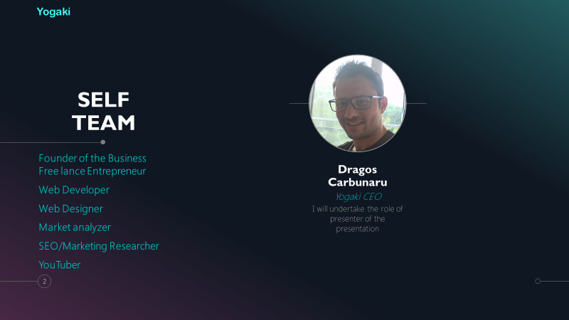
I started with my introduction page of the team.

Name of the business is Yogaki and name of the owner is Dragos Carbunaru
The business will be a click business, drop shipping to be more precise. The business will be available worldwide on the internet through a digital online shop. The business will be registered and run as limited liability company LLC. The business will sell yoga and fitness related items on a website online store.
In this type of business, I am responsible for building a website and my own brand and logo. I have the option to choose what products I think it will make sales based on marketing research. I am responsible for creating a profit price in order to have a good profit margin.

Why this type of business structure?
Because is easy to run and maintain. Drop shipping works like this: I, as a retailer, choose the product, set the price, put it in my online store and run advertisements to attract customers. When a customer sees my product and pays me my retail price, once that happens, I notify my supplier, pay them a wholesale price and they ship the product directly to my customer.
Drop shipping is an accessible and less risky business model in digital age to get into the world of e-Commerce. With drop shipping I can take advantage of these huge benefits and potential because it lets me get started with a small investment and I can generate passive income and work from anywhere. All I need is a computer using different applications and digital technology tools, an online store, marketing skills, market analysis, market research, internet access and £5,000.
It's a lot easier, since I don’t have to deal with packing and shipping, tracking inventory or paying for a warehouse, reason being, I don’t have to worry about some important functions that are time consuming and waste of money as a normal town centre shop business will have.
Typically, I buy the products from the trusted supplier with wholesale manufactured price and change it to 3 or 5 times more then the original supplier price. B2B price from a manufactured supplier are very cheap ergo the existence of drop shipping online stores success are very achievable if you sell the right niche product to a specific target customers, and the beauty of it is the huge potential to reach millions of potential customers on internet specially targeted on different social media platforms.

Mission statement, aim and objectives of business
My mission statement is to make our customers connect through our yoga clothing and products and have a light sensation and feel energized and comfy to rich high level of yoga and fitness goals.
The business objectives and aims is to offer comfortable yoga/fitness products and inspire others with our remarkable designs and availability with many different wonderful colours to choose from.

Product
The business will offer a selection of yoga and fitness items specially design that will provide flexibility and comfortability to perform any yoga exercise class indoors or outdoors. The online store can offer multiple of different yoga/fitness items and to give you basic example from the image above those are: Yoga mat anti slip exercise; Yoga pants fitness sport set; Heavy resistance band; Yoga stretch ring; Eco friendly PVC anti burst gym balance yoga ball; Acupuncture Yoga Massage Mat Body Heal and the list can go on.

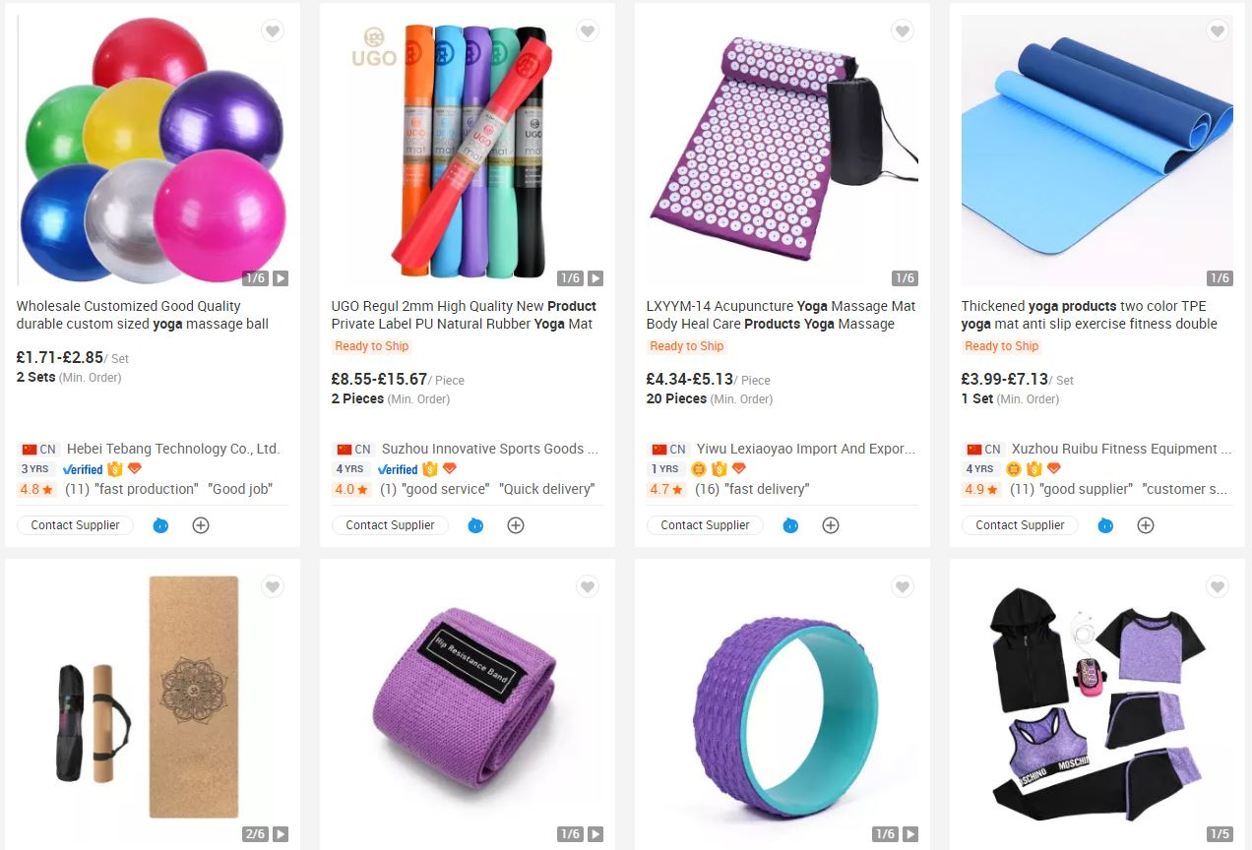

The 7 P’s
Product
Multiple yoga/fitness items

Price
3 to 5 times more than the whole supplier price

Place
My own website online store and accessible on internet world wide

Promotion
Paid Ads on different social media platforms like, Facebook, Instagram, Tweeter, LinkedIn, TicToc, Snapchat, WhatsApp, YouTube, Pinterest, Google AdSense

Process
Hosting a website online shop, advertising the products on internet, using different apps and digital tools, B2B supplier collaboration

People
Dragos Carbunaru
Responsible for running and maintaining the business

Physical Evidence
Stunning website design, attractive promotions and discounts, persuasive paid ads with eye vision impact

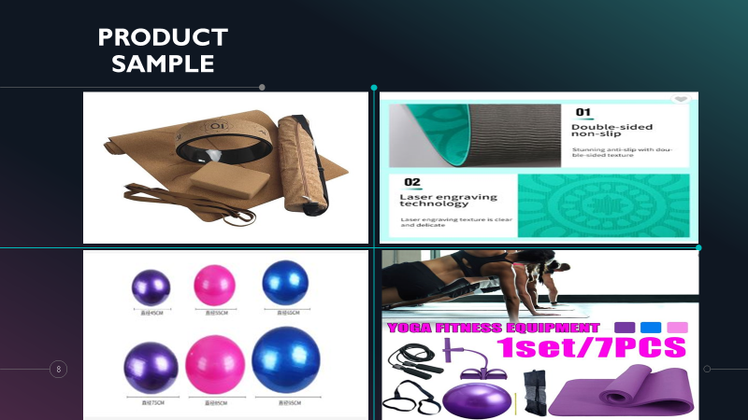

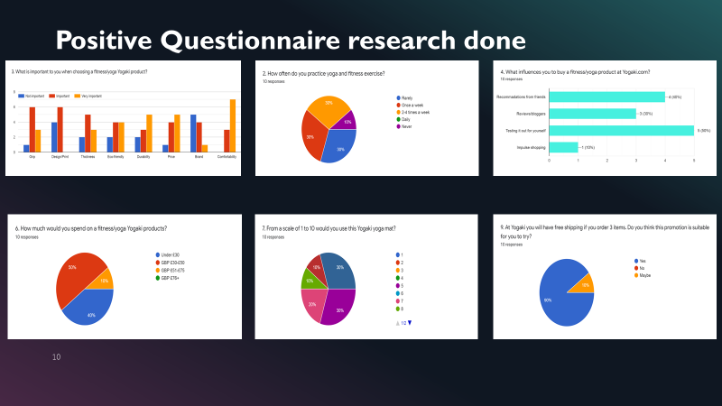

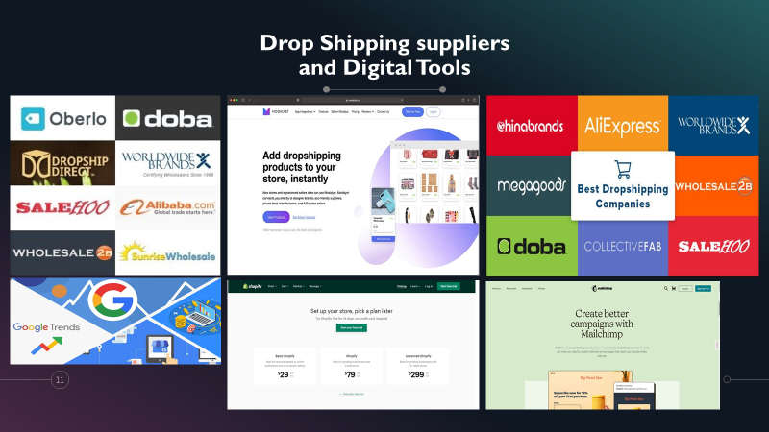

SWOT Analysis

Strengths
-easy to run
-less risky
-accessible
-save you time later
-no pay for packing, inventory, warehouse
-B2B cheap price form suppliers
-access to millions of customers on internet
-huge profits potential later

Weaknesses
-supplier errors
-to long time shipping process
-No internet access
-Expensive advertisement
-Product damage and faults
Opportunities
-New Brand
-New logo design
-24/7 Website functionality
- Can be run and maintain world wide
-Popularity

Threats
-Competitor
-Market change
-No sales
-Unsuccessful products
-Cyber Security attacks





