Programme: BA (Hons) Business Management
Module Title: Academic Skills
Module Code: LCBB4012
Module Leader: Dr Piyumika K. Gamage
Component 2: Coursework Group Written Report
Group Leader: Denisa-Amalia Torok 2410482
Member: Anamaria Bardut-Cristurean 2410481
Member: Diana-Alexandra Torok 2525589

Table of Contents
1. Introduction 3
2. Definition of Skills 3
3. Importance of Skill 1: Teamwork Skills 3
4. Importance of Skill 2: Presentation Skills 5
5. Strategies to Improve Skill 1: Teamwork Skills 7
6. Strategies to Improve Skill 2: Presentation Skills 8
7. Conclusion 10
8. References 11

1. Introduction
Essential skills are very crucial to success in both academic and work settings. Teamwork and presentation skills are also notable among them, as they enable cooperation and the effective communication of ideas. This report will concentrate on these two important academic skills by defining, discussing their relevance, and explaining how to improve them. This report aims to shed light on how these skills play out in academic performance and professional development. The report will consist of definitions of both skills and their relevance in various settings, how to improve them, and a conclusion, which will cover the main findings.

2. Definition of Skills
Teamwork skills are the skills related to collaboration with other people to reach a shared goal. These capabilities include proper communication, collaboration, conflict management, and mutual respecting one another in a team. Trust, shared responsibility, active listening, and adaptability are the major aspects of teamwork (Prada et al. 2022). Effective working in teams requires people to render their strengths as well as assist others so that the group's goals are achieved effectively.
Presentation skills can be referred to as the capability of conveying information clearly and effectively to an audience. Such skills are verbal skills, non-verbal skills in the form of body language and eye contact, content organization, and using visual aids. Good presentation skills are also associated with confidence, interaction with the audience, and succinctly putting across a message (Zainuri and Huda, 2023).
Both presentation and teamwork are paramount academic skills that transcend beyond the classroom. These will assist students to engage in teamwork, be able to share their ideas, and be ready to face the real professional world. By mastering these skills, the university will not only improve academic performance, but it will also increase employability since employer’s favour people who can work and communicate in a variety of environments.

3. Importance of Skill 1: Teamwork Skills
The skills required in teamwork are essential to academic success since most of the educational activities based on teamwork involve students working together on group projects, discussions, and collaboration tasks. Teamwork helps students distribute tasks and ideas, and finishing it more effectively. It also promotes critical thinking since people are exposed to a varied range of views, thus giving more holistic and innovative results (Magana et al. 2022). Moreover, collaboration enables students to acquire human skills, including communication and problem-solving skills, which are indispensable in the area of academic development.
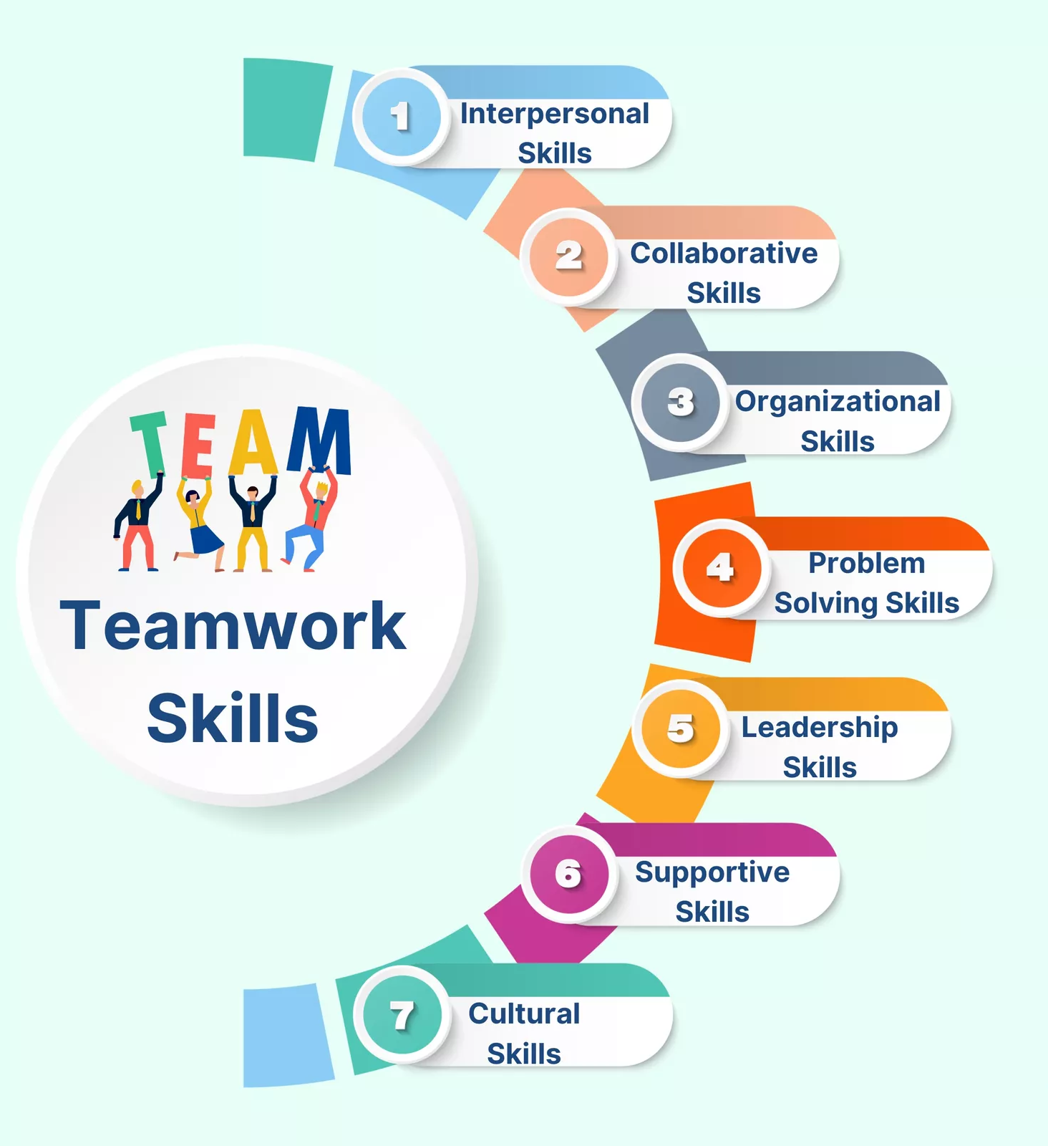
Figure 1: Teamwork Skills Importance
(Source: Magana et al. 2022)
Also, teamwork encourages accountability and responsibility. Every one of the group members has to contribute to the common work, and this is what makes the students have a feeling of being part of and dedicated to the work (Ekoh and Asuquo, 2025). This interactive strategy is also more effective in learning because students can learn from one another and the areas they do not find easy. A student strong in research can be supportive to the rest, and another student strong in writing can be supportive in organizing the final report. Teamwork is also an essential factor in professional life because most organisations are based on teamwork (Tushar and Sooraksa, 2023). Workers are commonly asked to collaborate in order to realise organisational objectives, address issues, and present endeavours. Good teamwork abilities enhance productivity at workplaces, since tasks are fulfilled faster and more efficiently when people collaborate.
Besides, teamwork leads to innovation in work. When people with various backgrounds work together, they can bring in different ideas, and hence they come up with creative solutions. It also serves to improve communication in organisations, minimising misunderstandings and boosting performance. Teamwork is a critical skill because employers believe that it leads to a good working atmosphere and the success of an organisation (Alsabri et al. 2022). When employees have the ability to communicate well with others, they are more likely to have good working relationships with their peer employees, manage conflicts, and embrace changing work environments. As such, teamwork skills are developed in academic coursework and can equip a person with a career in the future and make them more deployable in job markets characterized by strong competition.

4. Importance of Skill 2: Presentation Skills
Academic success cannot be achieved without presentation skills because they help them express their ideas and do so confidently. At the academic level, students are expected to give presentations, attend seminars, and defend their work to their colleagues and lecturers (Nga et al. 2025). Good presentation skills assist students to be able to arrange their thoughts, to arrange their content, and to present the information in a readable and interesting way. This is not only better at the level of understanding but also at the level of academic performance because clear communication is one of the major assessment criteria (Agbejule and Lehtineva, 2022).

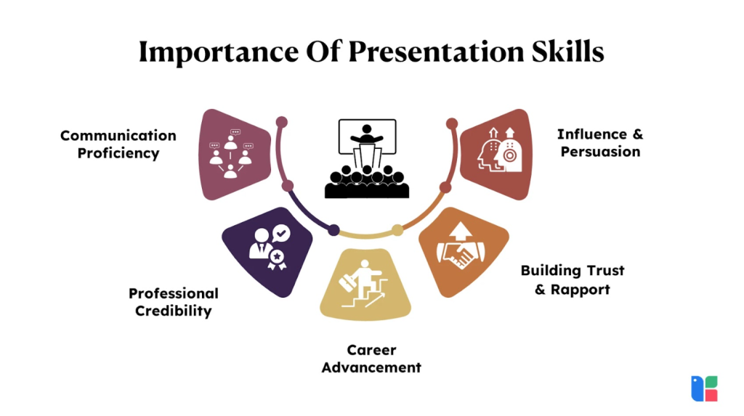
Figure 2: Presentation Skills
(Source: Agbejule and Lehtineva, 2022)
Moreover, presentation skills save confidence and anxiety when speaking in front of people. The more the students practise in addressing an audience, the more s/he gets comfortable in articulating their thoughts (Joshi and Patil, 2022). This trust has a positive level of influence on their general academic experience as they can engage more in discussions and group activities. Presentation skills are also very commanding in the workplace setting, as employees are often expected to share ideas, give reports, and deal with clients or other parties involved (Wong et al. 2022). Proper presentations may result in decision-making, persuasive situations, and professionalism. An example can be the presentation of the business, which was delivered well and achieved an effect of investments or client trust.
Also, effective presentation competencies are beneficial to leadership. Leaders should be able to pass vision, give direction, and inspire teams, and all these duties cannot be done without good presentation and communication abilities. Employee who has good presentation skills are considered to be more competent and would climb the career ladder. Good presentational skills also enhance the sharing of knowledge in organisations (Mwita et al. 2023). Clear and systematic communication helps information to be interpreted correctly, and there are no errors made, as well as improving productivity. In the present day and competitive global career approach, the communication of ideas clearly and confidently is a vital competence that is relevant not only in individual prosperity, but also organisational development.

5. Strategies to Improve Skill 1: Teamwork Skills
In order to enhance teamwork, one has to make a conscious effort and train on the important interpersonal competencies. A useful technique is the improvement of team communication (Sichterman et al. 2025). Effective communication makes all members know what to expect, what is expected of them, and their roles and positions. Frequent consultations and meetings can contribute to solving problems, presenting progress, and keeping the members of the team in tune. The other strategy to achieve is learning to be active listeners (Laari et al. 2022). Active listening is a way of listening to people and attentively to their opinions and responding accordingly. This assists in creating trust and respect in the team, which lowers conflicts and enhances teamwork. Team members would tend to contribute more when they feel heard and valued.
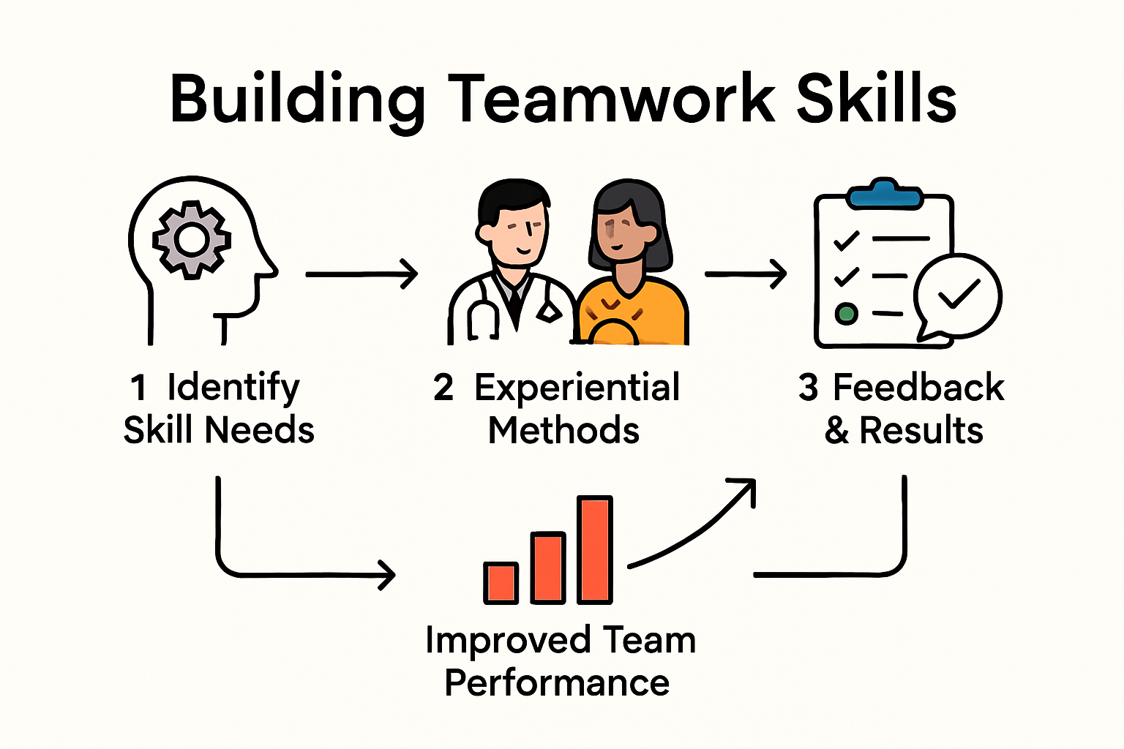
Figure 3: Building Teamwork Skills
(Source: Laari et al. 2022)
The other very important element to improve the skills of teamwork is conflict resolution. Confrontation is inevitable in a group, but it is acceptable to deal with conflicts constructively through debate and by understanding each other. Conflicts and other problems can be solved by developing problem-solving skills and having a positive attitude, which can fortify the relationships within the team (Hidayati et al. 2023). In teamwork, time management, and organisation are also vital. Delegating tasks under the principle of strengths and establishing definite deadlines allows for fulfilling the work effectively. A task list or project management software is a tool that can be used to keep the team organised and track progress.
The other task that works well towards the enhancement of teamwork skills is the adoption of team-building activities, which strengthen bonds and improve teamwork. Problem-solving exercises or group work are some of the activities that allow people to learn the work orientations of one another and establish better interpersonal relationships. Also, establishing clear objectives and team roles will illustrate that every member of the team knows what he/she is expected to do, and there will be no confusion or overlapping of roles. Team leadership development also plays an important role because having good leaders will help team members in areas of guidance, motivation, and coordination of work (Mahdi, 2022). The development of a vision of feedback in the team goes further to promote a culture of consistent enhancement and assist in keeping the workplace consistent and healthy.
Besides, teamwork also requires its members to build trust with each other. Reliability, honesty, and constant contribution can be used to build trust. Whenever members of the team have confidence in each other, they have more tolerance to work together and to show care towards each other. Lastly, consideration of team performance can be used to reveal where improvements may be made. Teams are then able to analyze what went well and what can be done better after completing a project (Domínguez et al. 2024). Such a never-ending learning plan enables people to be stronger team workers, as time passes, and they become effective team workers both at school and at work.

6. Strategies to Improve Skill 2: Presentation Skills
Presentation skills need to be honed through practicing, planning, and learning proper methods of communication. Preparation and organisation of content is one of the strategies. Organizing the presentation in the form of introduction, main body, and conclusion would help in delivering the message logically and effectively. Using note cards to prepare some main points will also aid in staying focused during the presentation. Another critical strategy would be the practice. Practicing presentations contributes to the effectiveness of presentation, time, and performance. Performing in front of colleagues or recording can also give good feedback and point out what can be worked on (Phan et al. 2022). This procedure will assist in making people more at ease with the idea of speaking in front of an audience and will also help them be free of nervousness.

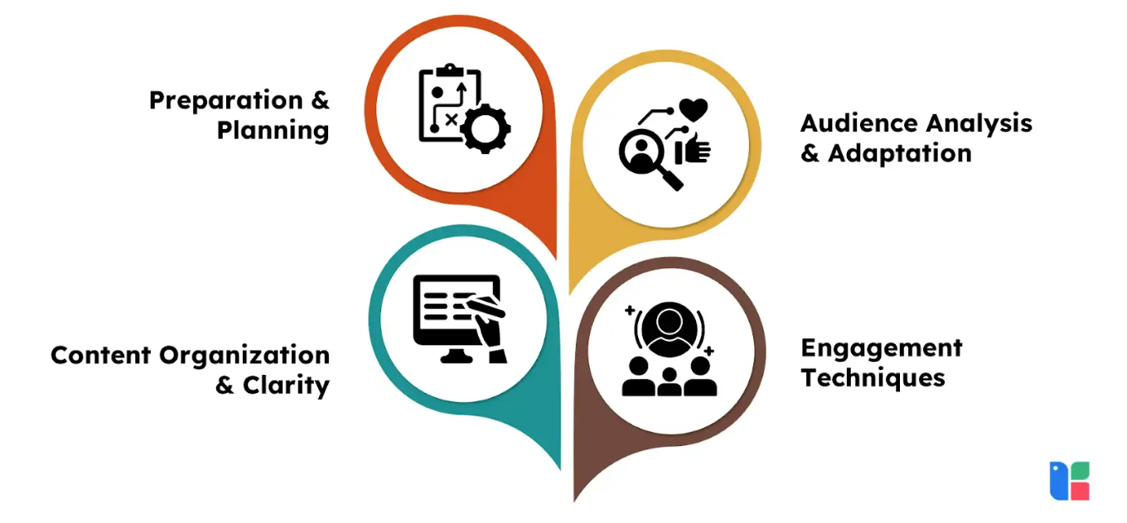
Figure 4: Strategies to Improve Presentation Skills
(Source: Phan et al. 2022)
It is also important to develop effective nonverbal communication skills. A distinct pronunciation, proper tone, and the rate of speaking boost verbal communication, whereas eye contact, gesture, and posture are useful in non-verbal communication. These are the things that enable to attract the audience and make the presentation more effective. Another trick of increasing presentation skills is the effective use of visual aids (Van Emden et al. 2025). The message can be supported by using such tools as slides, charts, and images, which will make the presentation more interactive. Nonetheless, the application of visuals should be done properly and not excessively in loading the slides with information.
Improving analysis of the audience is another effective practice of becoming more skilled in presentations. Knowing the needs and expectations of the audience as well as their level of knowledge enables presenters to shape their content to make the presentation more relevant and interesting. It is also possible to include storytelling techniques to enhance the interest and recall of a presentation. Also, learning and seeing experienced presenters, whether in working with online videos or live audiences, can help give some useful ideas on how to deliver effectively (Nguyen and Le, 2024). Delivery can be further improved with the help of technology, including presentation software or some virtual tools. One-on-one appraisal after every presentation is used to ensure that one is aware of the areas of polishing and practicing his or her general presentation style.
It is also important to get feedback in order to improve. Peer comments, educator or mentor feedback may be used to give feedback on strengths and weaknesses and enable an individual to develop their presentation abilities. Constructive criticism assists in the determination of areas that require improvement and motivates ongoing improvement. Lastly, it is quite necessary to handle anxiety and develop confidence in presentations (Fareen and Farhana, 2025). Deep breathing, positive thinking, and visualisation are some of the methods that can be employed to alleviate nervousness. Through practicing and training, one can attain good presentation skills that can lead to success in studies and careers.

7. Conclusion
Teamwork and presentation skills are other significant assets that can help an individual succeed in academics and in the workplace. Teamwork helps people work in the team, share knowledge, and accomplish common goals, whereas presentation skills provide the opportunity to discuss ideas clearly and confidently. The two are both important in personal and career growth, as both skills are highly valued in the learning field and the workplace. One can improve these skills by taking positive measures like communication improvement, practice, and receiving feedback. Finally, the cultivation of teamwork and presentation skills equips students with future challenges and opportunities in an ever-changing and competitive environment.
Moreover, life-long learning and flexibility, which come with the persistent progress in these skills, are crucial in the current changing academic and work surroundings. By participating in teamwork and making presentations, a person, in addition to acquiring better communication and collaboration skills, develops confidence, leadership traits, and critical thinking skills. The competencies help these people to react positively to challenges, collaborate with varying teams, and explain their innovative ideas clearly. Thus, it is important to invest time and effort in enhancing teamwork and presentation skills because it will help one to have the required resources to excel in the academic field and become successful in their future lives.

Introduction, definition and importance of teamwork skills wrote by Amalia Torok
Importance of presentation skills, strategies to improve teamwork wrote by Anamaria Bardut-Cristurean
Strategies to improve skills and conclusion wrote by Alexandra Torok

8. References
Agbejule, A. and Lehtineva, L., 2022. The relationship between traditional project management, agile project management and teamwork quality on project success. International Journal of Organizational Analysis, 30(7), pp.124-136.
Alsabri, M., Boudi, Z., Lauque, D., Dias, R.D., Whelan, J.S., Östlundh, L., Alinier, G., Onyeji, C., Michel, P., Liu, S.W. and Camargo, C.A.J., 2022. Impact of teamwork and communication training interventions on safety culture and patient safety in emergency departments: a systematic review. Journal of patient safety, 18(1), pp.e351-e361.
Domínguez, F., Eras, L. and Collaguazo, A., 2024. Insights on the Distribution of Nonverbal and Verbal Oral Presentation Skills in an Educational Institution. SN Computer Science, 5(5), p.491.
Ekoh, E.S. and Asuquo, E., 2025. LESSON PLANNING, PRESENTATION SKILLS AND BUSINESS STUDIES STUDENTS’ACADEMIC PERFORMANCE IN PUBLIC SECONDARY SCHOOLS IN AKWA IBOM STATE, NIGERIA. UNIUYO JOURNAL OF BUSINESS EDUCATION AND ENTREPRENEURSHIP, 1(1), pp.72-81.
Fareen, J.A.M. And Farhana, M.M.A.M., 2025. UNDERSTANDING STRATEGIES FOR DEVELOPING EFFECTIVE BUSINESS AND TECHNICAL PRESENTATION SKILLS. BODHI, p.1.
Hidayati, N., Zubaidah, S. and Amnah, S., 2023. Effective learning model bases problem based learning and digital mind maps to improve student’s collaboration skills. International Journal of Evaluation and Research in Education (IJERE), 12(3), pp.1307-1314.
Joshi, K.S. and Patil, M.A.S., 2022. DECISIVE ROLES OF LEARNING OUTCOMES AND RUBRICS IN ACQUISITION OF PRESENTATION SKILLS THROUGH FLIPPED LEARNING.
Laari, L., Anim-Boamah, O. and Boso, C.M., 2022. Soft skills the matchless traits and skills in nursing practice: An integrative review. Nursing Practice Today.
Magana, A.J., Karabiyik, T., Thomas, P., Jaiswal, A., Perera, V. and Dworkin, J., 2022. Teamwork facilitation and conflict resolution training in a HyFlex course during the COVID‐19 pandemic. Journal of Engineering Education, 111(2), pp.446-473.
Mahdi, D.A., 2022. Improving speaking and presentation skills through interactive multimedia environment for non-native speakers of English. Sage Open, 12(1), p.21582440221079811.
Mwita, K.M., Kinunda, S., Obwolo, S. and Mwilongo, N.H., 2023. Soft skills development in higher education institutions: students' perceived role of universities and students' self-initiatives in bridging the soft skills gap. International Journal of Research in Business & Social Science, 12(3).
Nga, L.T.T., Hang, N.T., Anh, P.N., Chon, V.T., Diem, P.T. and Trang, N.T.H., 2025. Applying Artificial Intelligence To Enhance English Presentation Skills For First Year Students Of The English Majors At Trade Union University.
Nguyen, T.K.C. and Le, P.T., 2024, May. Using video-based learning to improve presentation skills for fourth-year English majors at Hanoi Open University. In 20th International Conference of the Asia Association of Computer-Assisted Language Learning (AsiaCALL 2023) (pp. 52-64). Atlantis Press.
Phan, T.M.U., Nguyen, T.T.H. and Phan, T.X.D., 2022. Factors affecting oral presentation skills of English majored sophomores at Tay Do University, Vietnam. European Journal of English Language Teaching, 7(2).
Prada, E.D., Mareque, M. and Pino-Juste, M., 2022. Teamwork skills in higher education: Is university training contributing to their mastery?. Psicologia: Reflexao e critica, 35, p.5.
Sichterman, B., Banihashem, S.K., Verstappen, M., Schipper, M., Waisvisz, P., Noroozi, O. and van Ginkel, S., 2025. Can AI feedback stand alone for fostering students’ presentation performance? A comparison of AI-only versus teacher-supported AI feedback. Interactive Learning Environments, pp.1-18.
Tushar, H. and Sooraksa, N., 2023. Global employability skills in the 21st century workplace: A semi-systematic literature review. Heliyon, 9(11).
Van Emden, J., Becker, L. and Becker, A., 2025. Presentation skills for students. Bloomsbury Publishing.
Wong, J.Y.H., Ko, J., Nam, S., Kwok, T., Lam, S., Cheuk, J., Chan, M., Lam, V., Wong, G.T., Ng, Z.L. and Wai, A.K.C., 2022. Virtual ER, a serious game for interprofessional education to enhance teamwork in medical and nursing undergraduates: development and evaluation study. JMIR Serious Games, 10(3), p.e35269.
Zainuri, A. and Huda, M., 2023. Empowering cooperative teamwork for community service sustainability: insights from service learning. Sustainability, 15(5), p.4551.

