

Programme: MBA- Masters of Business Administration

Module: Entrepreneurship

Module code: LCMB7004

My name: Psalmist George N. K. KING

Student No.: 1606028

Topic: Enterprise and Entrepreneurship

Lecturer: Isaiah Oino

Date: 09/09/2022

Entrepreneurship at Starbucks
Introduction
Starbucks is a producer (roaster), retailer and marketer by nature. It is a public limited company. In this paper, an analysis of the dynamics of business prospects is done and this must begin with an examination of an entrepreneur's ability to identify, recognize, and evaluate potential business opportunities. A company's commitment to environmental stewardship has never been more critical than it is today. According to the study, environmentally conscious entrepreneurs are more likely to spot and seize on business opportunities that promote sustainable practices. They aren't just interested in the short-term financial rewards but also the long-term feasibility of the prospect. Identifying and developing business opportunities is a complex process involving several factors, including entrepreneurial consciousness, information asymmetry and prior knowledge, social networks, personality traits, and the nature of the opportunity.
The genesis of the notion of learning organisations is based on this attribute at the organisational level. Entrepreneurs are able to see opportunities when they are still in their infancy because of their knowledge. A business opportunity can become a business venture when an entrepreneur is able to take the necessary steps to make the right judgments.
Entrepreneurs typically need knowledge and resources that are outside of their control in order to pursue business prospects, and social networks play a critical part in this process. Entrepreneurs often see opportunities that they can't take advantage of without the help of others in their network.

Overview
Inexperienced enterprises are going bankrupt in quarantine these days; only those that have a budget-balancing approach have survived. Based on the examination of Starbucks, I researched in this paper the methods in which they have been successful businesses. Among the aspects of business organisations that I've mentioned in my report are the ownership and liability of the owners and the purpose of the company as well as its sector, scope of business, and functional areas.
Starbucks History
In 1971, Starbucks launched its first store in Seattle's Pike Place Market. After reading Moby Dick's novel, which is named after an early coffee trader named Moby Dick, He was inspired to name Starbucks after him. Its symbol is a Greek mythological mermaid with two tails. Jerry Baldwin, Gordon Bowker, and Zev Siegl came up with the idea. The three men who founded Starbucks had two things in common: they were all academics who also loved coffee and other hot beverages. Since then, Starbucks has grown into the world's largest coffee roaster and specialty retailer. Currently, 30,000 people in 80 countries (as of June 30, 2019) Starbucks sells a large choice of premium coffee drinks, teas, hot chocolate, gifts, and a small number of food items in addition to high-quality coffee beans. More than 30 different blends and single-origin coffees are offered, all of the highest quality. Because it has access to more information than its competitors do on any given topic, the corporation is able to benefit from information asymmetry. Thus, it is possible for the organisation to take advantage of new prospects.
Taking Charge of Creativity and Innovation
"Entrapreneurship" is the term used to describe the activity of entrepreneurs in the context of corporate innovation. An individual's efforts to foster innovation within a company are referred to as "intrapreneurship." They focus on internal opportunities or conditions that need a company to make adjustments in its operational structure. Since the activities of groups inside an organisation can also produce new ideas and products, innovation isn't just confined to individuals. Entrapreneurship is a term used to describe the joint efforts of a group of people within a company to improve the services and products they provide. There are three levels of innovation: "micro, meso, and mega".
At the smallest scale, it refers to the actions made by the organisation itself to ensure that its products and services are continually improved. An organization's supply chain and its immediate operating environment are both considered when discussing meso-level innovations in this context. Changes influence a company's ability to innovate at the macro level in the regulatory and legal frameworks in which it does business.
Starbucks has mastered the art of overseeing new product development. The company's entrepreneurial model is built on a solid foundation of innovation. Starbucks is making every effort to broaden its reach beyond the world of coffee. In fact, some have questioned whether Starbucks' focus on coffee is merely a front to increase profits. This is a reasonable question, given Starbucks' current and future product offerings, as well as the company's plans for expansion. Quality control, cost-cutting, and operational efficiency are no longer enough in today's business climate. Starbucks recognises that innovation must go beyond these three areas.
In the contemporary paradigm of innovation, the first focus is on the reengineering of business processes. Both internal collaboration and customer-driven market expansion are examples of this third type of innovation. The expansion of e-commerce and globalisation are major forces in driving innovation at the macro level. As a result of adopting these new approaches to innovation, businesses now have new competitors to contend with.
The partnership between Starbucks and PepsiCo to provide hot-on-demand coffee through vending machines is another example of the new philosophy of innovation at work in the Starbucks business model. Customers at Starbucks can choose from a variety of coffee options. When it comes to vending machines, PepsiCo has a huge network and has a lot of experience with the technology.
The collaboration between these two companies resulted in the development of hot-on-demand coffee. Starbucks provides the coffee for the network, while PepsiCo owns the technology. In this approach, the two companies may broaden their reach in the beverage industry and increase their market share.
Acting in the spirit of a for-profit corporation
To be described as an entrepreneurial company, one must have an active philosophy that promotes entrepreneurial behaviour within its ranks. Because international trade is so fierce, this is a critical consideration for today's businesses. Administrative or entrepreneurial organisational systems are both possible. Corporate entrepreneurship is considered to be practised by entrepreneurial organisations. Top executives' willingness to take risks differs greatly between administrative and entrepreneurial organisations. Administrative organisations choose low-risk, low-rewards options. On the contrary, entrepreneurial organisations favour the pursuit of higher risk/higher reward opportunities.
The ability to develop and launch new items ahead of the competition is a fundamental characteristic of an entrepreneurial organisation. This necessitates a high level of creativity and a willingness to take calculated risks. The ability of a corporation like Apple to develop and market new goods ahead of the competition is critical to its success. It is extremely difficult to maintain this skill if the company as a whole does not have an entrepreneurial mindset. There must be an entrepreneurial culture in order for a company that relies on innovation to be successful.
Role of Leadership
Enthusiastic leadership is critical to the success of any company looking to grow into an entrepreneurial one. An entrepreneurial organisation cannot be developed if its senior management is afraid of risk or lack entrepreneurial drive. Middle-level managers should have the freedom and support to try out novel approaches and systems. The organization's destiny is in the hands of its middle management. When an organization's entrepreneurial spirit is concentrated at the top, it is doomed to fail.
Howard Schultz, the CEO of Starbucks, is well-known for his pioneering spirit. Prior to Starbucks is a major corporation, Schultz worked for the company as an employee. He was in Italy when he was inspired to start a nationwide coffee retail network in the United States by the Italian coffee shops he visited. Schultz went on to build additional coffee retail locations called "Il Giornale" after Starbucks management refused to buy into his proposal.
After then, Schultz and Starbucks came to terms with the purchase of Starbucks. He decided to keep the Starbucks moniker when he expanded his business. Starbucks has always been in the hands of a very entrepreneurial boss, as this anecdote indicates. As a result, the company's knack for invention and innovation has been preserved. The CEO of Starbucks, Howard Schultz, is a very creative and risk-averse individual. Even while the company tries hard, it does not always succeed. No effort goes to waste because the organisation draws on the lessons learned through previous entrepreneurial endeavours. The corporation is adamant in its desire to hear from its customers. The company has an advantage since it solicits input from its employees and keeps tabs on what its customers and competitors have to say about it online.
A strong entrepreneurial culture
There is a strong entrepreneurial culture and a high level of risk tolerance seen in the company's activities. In contrast to many multinationals, the organisation prefers to release new items rapidly so that competitors can respond rather than refine them before releasing them to the market. Accordingly, Starbucks has a proven track record of generating new businesses. As a result, it has a high tolerance for danger. Risk-taking and innovation are tolerated by the company's culture, which has a strong emphasis on risk-taking.
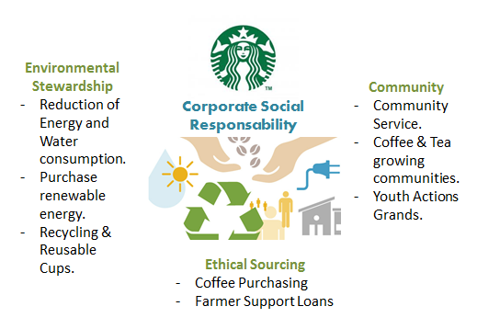
Figure 1: Corporate Social Responsibility.
It’s innovation management model incorporates current approaches to innovation, such as collaborating with other organisations to build new markets. As the last point, the company shows signs of corporate entrepreneurship in its operations. Howard Schultz, CEO of Starbucks, is a serial innovator and entrepreneur who advocates for corporate entrepreneurship. Ownership of a business It is critical to take into account the many types of businesses and ownership arrangements when attempting to define the phrase "business ownership." The term "ownership" refers to the ability of a company's management to control the organization's processes and activities. (up counsel, no timeframe given) To do business and own property, Starbucks has a legal entity that is separate from any individual employees. This legal entity is called a Corporation. There are downsides to Starbucks being a corporation, but there are also advantages. Many countries, including the United States, have seen tremendous growth because to Starbucks.'
A company's core business and the product or service it provides determine the sector in which it operates. Primary, secondary, tertiary, and quaternary sectors represent the four stages of the content creation process, from acquiring the raw materials to delivering the finished product to the customer.

Business Model
There are many ways to measure a company's scope. Generally speaking, Starbucks can be found in the primary or tertiary sectors, although not exclusively. In the secondary sector, it buys commodities like coffee beans and sugars, which are used to manufacture food and beverages, and it has more than 30.000 stores in more than 80 countries. With more than 1600 retail outlets in more than 150 countries across the world, Organizations use mission statements to communicate their goals in simple words. A company's culture, values, and ethics are generally encapsulated in a single sentence or short paragraph that serves as the mission statement.

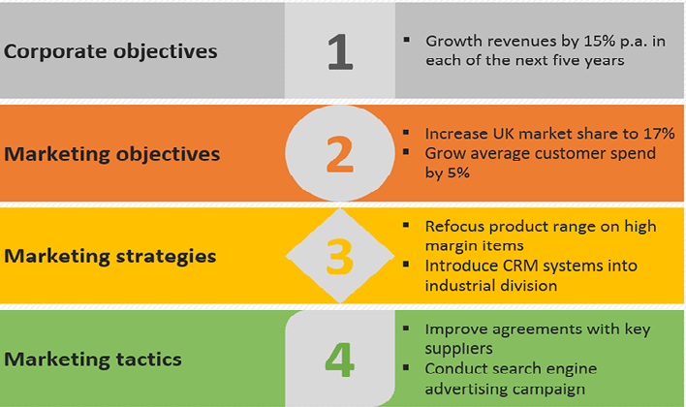
Employee motivation and investor confidence are two of the many purposes served by mission statements. (Investopedia, as of no date) 'To inspire and nurture the human spirit - one person, one cup, and one neighborhood at a time' is Starbucks' mission statement.

Figure 2:
‌

Statement of Purpose:
Vision statements can be as brief as one sentence or as long as a short paragraph, but they must clearly describe the goals of the organisation they are describing. It lays out what the company is seeking to accomplish and serves as a reference point for any future steps the organisation may take. It's important to understand what a business plan vision statement entails and how it differs from other crucial aspects. (the balances, no date given) Starbucks's mission is to "establish Starbucks as the preeminent provider of the world's finest coffee while upholding our uncompromising beliefs as we expand. The core principles or ideas that guide a company's operations are referred to as its "company values." They are the essence of your company's values and influence how and why you carry out your work. Despite the fact that plans and tactics for your organisation may evolve, the fundamental principles of your company will not. The principles of a company allow it to expand and prosper without losing sight of its core values. 'Acting with boldness, challenging the existing quo, and finding innovative ways to grow our organisation and each other' is one of Starbucks values. Being in the moment, interacting with honesty, respect, and a sense of dignity. 'Doing our best in all we do, and taking responsibility for our actions.

Aims of purpose and goals
All businesses have a set of goals and objectives that they strive to achieve. They give the business direction and explain why it does what it does every day. Rather than focusing on short-term aims, businesses should focus on long-term goals that will help the company achieve their long-term objectives. If you want to succeed, you'll need to focus on numerous different objectives. (BBC, no date given) Starbucks' plans for the future are detailed. On the 50th anniversary of Starbucks in 2021, the firm codify its 2030 environmental targets based on the lessons learned between now and then,' he said. Further market research and experiments to better understand customer behaviour and incentives to encourage the increased usage of reusable containers would be conducted in the coming year, Johnson stated specifically. (Story Starbucks, 2020). A high level of environmental performance is an important part of Starbucks' business plan. Davlatov 11 includes new stores, good procurement, cooperation to be a respected partner in the area, and communication of its CSR commitments are only some of the things that the company does. Starbucks has selected a corporate lead to underline the importance of reporting the strategy's development. There are numerous divisions inside Starbucks that are responsible for the production of its products and services.
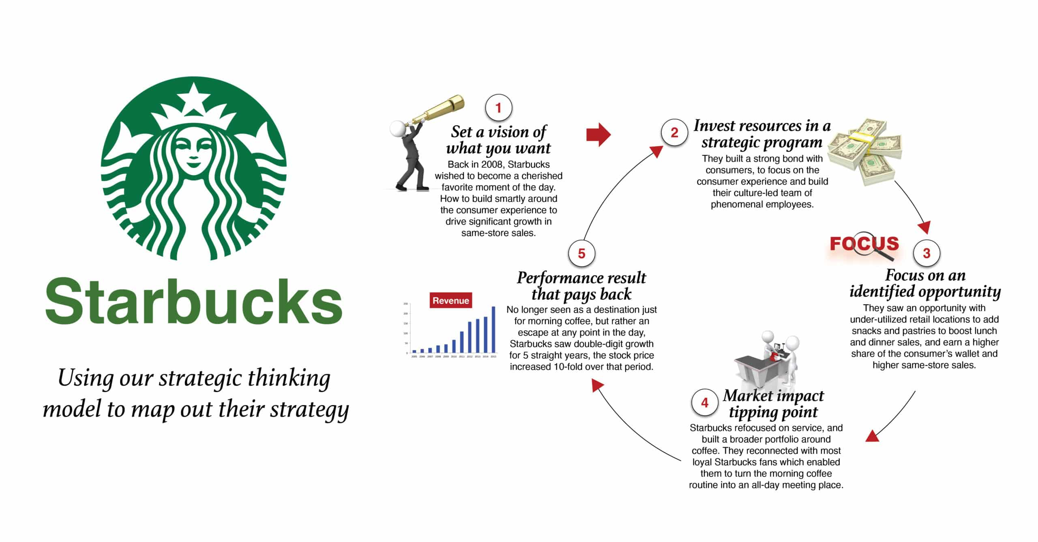
Figure 3: Strategic thinking allowed Starbucks to complete its turnaround plan. (Beloved brands 2022)

The structure of company
In order to achieve the organization's goals, these duties are organised in a specific way. The roles of each employee and how they fit into the wider framework are described by effective organisational structures. When it comes to organisational structure, centralised and decentralised systems provide different levels of autonomy for employees. In 2020, the company's structural design incorporates junctions between its many parts. It is not uncommon for functional groups and regional offices to cross over into product-based divisions of the company and vice versa. Their character attributes also influence entrepreneurs' pursuit of business prospects. Entrepreneurs may all be risk takers, but their tolerance for risk varies widely. In comparison to most of their competitors, Starbucks shows a stronger willingness to take risks. Personality traits of company leaders are responsible for this. Introverts and extroverts may have different approaches to handling business possibilities because of their personality type. Extroverted entrepreneurs have a bigger social network to draw from, whereas introverted entrepreneurs have a narrower number of trustworthy allies to call upon.

Risk Management
A risk-averse corporation like Starbucks may be characterised by its belief in rapid concept implementation, followed by meticulous evaluation and development of that idea over time. Prior to releasing a product, companies such as Apple guarantee that it has been thoroughly tested. When it comes to Apple's product development process, the company takes great care to keep things under wraps until the release of certain goods. Starbucks maintains a data collecting system that gathers information from its staff and consumers in order to maintain entrepreneurial alertness. In the event that a given action goes against the company's objective, employees are urged to write a letter to the company's executives.

Reasons of Success
Starbucks' success can be attributed to its ability to appeal to Not only is Starbucks one of the world's most successful enterprises, but it's also one of the most well-known. It is so popular because it was able to give an ambiance that transformed how most of the country thought about coffee shops and how more of us were consuming coffee outside of our homes because of this change in perceptions. Third site between home and work, where people may rest and have a cup of coffee and experience a welcome ambience has been established by Starbucks, Unlike other coffee companies, Starbucks does not compete with other movie theatres. Brands are being redefined by a small number of businesses.
Establishing and maintaining effective communication with key stakeholders Customers are regarded as one of Starbucks' most important stakeholders. It is important to this stakeholder group that they receive excellent service and high-quality products like coffee and other beverages. When it comes to specialty coffee, Starbucks is the world's most popular chain. The Starbucks mindset is shared with customers in Starbucks cafés, making them important participants in the company's success. Warm and pleasant interactions are emphasised in the workplace, including how baristas engage with clients. For example. As a result, Starbucks Coffee's CSR efforts meet the demands of this constituency.
Starbucks Coffee's purpose statement is too ambiguous to be applied to any future market conditions, which is a major flaw. Starbucks Coffee's mission statement is succinct, to the point, and full of hope for the company's future success in the coffee and coffee-related industries.

Conclusion
In this paper, I focused primarily on two firms' paths to success. Both firms' features and purposes and objectives are practically identical because they both want to enhance the environment for future generations. Starbucks' success can be attributed to a combination of high-quality coffee and excellent customer service. Starbucks, in my opinion, should use a variety of strategies to set itself apart from the competition, which might lead to a wide range of menu prices. Starbucks, as an illustration, might create a "savings menu" in which specific things are offered at a discount in order to entice even more people. They may attract a large number of customers if they decide to open in South Asia.

Reference

Ardichvili, A., Cardozo, R. and Ray, S., 2003. A theory of entrepreneurial opportunity identification and development. Journal of Business venturing, 18(1), pp.105-123.
Chung, Y.C., Liao, S.H. and Chang, W.J., 2018. Long live friendship? Relationships among friendship, trust and brand loyalty: a study of Starbucks. International Journal of Web-Based Communities, 14(4), pp.335-352.
Grant, R.M., 2021. Contemporary strategy analysis. John Wiley & Sons.
Jones, A.M., 2008. The innovation acid test: Growth through design and differentiation. Triarchy Press Limited.
Kenton, Will. “How Organizational Structures Work.” www.investopedia.com/terms/o/organizational-structure.
Krishna, C.G., 2018. Starbucks Communication Strategies–More Than Just a Cup of Coffee. IUP Journal of Soft Skills, 12(3), pp.23-53.
Lau, T.L., Shaffer, M.A., Chan, K.F. and Man, T.W.Y., 2012. The entrepreneurial behaviour inventory: A simulated incident method to assess corporate entrepreneurship. International Journal of Entrepreneurial Behavior & Research.
Patzelt, H. and Shepherd, D.A., 2011. Recognizing opportunities for sustainable development. Entrepreneurship Theory and Practice, 35(4), pp.631-652.
Pedersen, C.L. and Ritter, T., 2020. Preparing your business for a post-pandemic world. Harvard Business Review.
Place, K.R., 2021. “People are More than Just a Statistic”: Ethical, Care-based Engagement of Marginalized Publics on Social Media. Journal of Media Ethics, pp.1-13.
Robertson, G. (2014). Starbucks case study: The day the Starbucks brand almost collapsed. [online] beloved brands. Available at: https://beloved-brands.com/starbucks/#:~:text=Strategic%20thinking%20allowed%20Starbucks%20to%20complete%20its%20turnaround.
Sahaf, M.A., 2019. Strategic marketing: Making decisions for strategic advantage. PHI Learning Pvt. Ltd.
Shirdastian, H., Laroche, M. and Richard, M.O., 2019. Using big data analytics to study brand authenticity sentiments: The case of Starbucks on Twitter. International Journal of Information Management, 48, pp.291-307.
Sisson, D.C. and Bowen, S.A., 2017. Reputation management and authenticity: A case study of Starbucks’ UK tax crisis and “# SpreadTheCheer” campaign. Journal of Communication Management.
Starbucks Coffee Company, www.starbucks.com/about-us/companyinformation/mission-statement
Starbucks.” Starbucks.com, 2019, www.stories.starbucks.com/leadership/.
Starbucks.com, 2017, investor. www.starbucks.com/financial-data/annual-reports/default.aspx.
Starbucks Corp. - AnnualReports.com 2021. Available at: https://www.annualreports.com/Company/starbucks-corp
Thompson, A., 2017. Starbucks Coffee’s Stakeholders: A CSR Analysis. Panmore Institute.
Wyszomirski, A. and Olkiewicz, M., 2020. Environmental corporate social responsibility as a tool for creating the future of environmental protection. Rocznik Ochrona Środowiska, 22.

