

Computational Fluid Dynamics: MIRA Notchback Analysis

MSc Mechanical Engineering
M7X01380 – Simulation and Modelling

Prepared by:
Mr Aaron Hillam
P141233

Submitted to:
Mr Tim Tudor
School of Engineering
28/04/2019

Contents
- Figures / Tables 3
- Introduction 4
- Methodology 5
- Informed Literacy 6
- Optimising 7
- Optimised Setup 11
- Mobile Setup 15
- Analysis 16
- Evaluation 17
- References 18

Figures / Tables
- Figure 1: Mira Geometry 7
- Figure 2: First Simulation 7
- Figure 3: Quality Scale 8
- Figure 4: Skewness 8
- Figure 5: Orthogonal 9
- Figure 6: Standard Setup 9
- Figure 7: Optimized Mesh 11
- Figure 8: Velocity Regions 11
- Figure 9: Pressure Contours 12
- Figure 10: Pressure Distribution 12
- Figure 11: Pressure Distribution (MIRA) 13
- Figure 12: Vectors Pt 1 13
- Figure 13: Vectors Pt 2 14
- Figure 14: Mobile Contours 15

- Table 1: Octree Results 9
- Table 2: Delaunay Results 9
- Table 3: Inflation Layers 10
- Table 4: Optimised Data 11
- Table 5: Final Data 15

Introduction
This report has been created for the purpose of investigating computational fluid dynamic methodologies used to simulate aerodynamics on the Mira baseline geometry. (Lanfrit, 2005)
An analysis has been conducted through-out the investigation, using a variety of strategies such as vector plots, contour plots and path lines.
To verify how accurate the investigation is, the values of lift and drag will be used as indicators by comparing them with the Mira geometry specified as -0.0845 for lift and 0.2963 for drag (Lanfrit, 2005). To further validate the investigation, the optimised simulation method is used on a moving version.
The investigation focuses on refining the meshing strategy for the purpose of improving the accuracy of the results.

Assumptions
This geometry has been tested in the wind tunnel at Mira. This will help define the domain size and indicate the external environment. (Lanfrit, 2005)
It is assumed that the geometry is on a static floor during the optimisation of the simulation methods. (Lanfrit, 2005)
Due to the car being symmetrical and the airflow from the inlet to the front of the geometry flows uniformly, a symmetrical boundary condition can be applied to the model, reducing the domain by half, thus significantly reducing the computing time. (Lanfrit, 2005)
Neglected
Due to the initial geometry being static, and the tyres being pneumatic and an inaccurate representation. The model has been modified to represent a 10mm tyre deflection. (Lanfrit, 2005)
For the purpose of keeping the results simple. The timing of each calculation has been rounded up to the nearest second. However, this does provide small inaccuracies in computing time.

Methodology
The modelling approach for this report, consists of trial and error.
Initially, a base setup needs to be generated. This will be based on the dimensions of the climate wind tunnel two, based at Mira (HORIBA MIRA Ltd. 2019., 2019). This setup will help identify areas of interest in the model and where to focus the meshing. This setup will provide a fast setup and ensure the geometry is defined properly.
Informed literature will be used to modify the initial setup, this will consist of the domain size, density boxes and fluent models. (Lanfrit, 2005)This setup will provide the minimum efficiency for the simulation. The results of this setup are expected to be suitable, but improvements will be made to improve the efficiency, such as accuracy of the drag, lift and the reduction in time to setup. (Lanfrit, 2005)
The next stage will be to modify the previous model, using variations in fluent model, meshing size and density. The purpose of this would be to optimise the setup for future purposes. (Michael M. Resch, 2017)
The final model will use the same setup as the optimised model, however this will be based on a moving geometry and compared to the optimised model. The purpose would indicate how accurate the simulation setup is, how it can be adapted for variations in the model and how the air velocity from the inlet and the air velocity from the vehicle change the results.

Informed Literature
Computational fluid dynamics (CFD) uses numerical methods to model and solve various aspects of fluid dynamics. There are three discrete methods, finite volume method, finite element method and finite difference method. These methods ultimately break down the domain into small elements in order to solve a given problem. The results are then simulated, experimented and tested physically. (Yukio Tamura, 2013)The result of the physical test could mean success or failure which requires reruns of the programme to see why it went wrong and how to improve it. CFD provides a cheap and fast method of testing which can be applied to larger scales in a safe environment and provide quality information that can easily be repeated. (Yukio Tamura, 2013)
The governing equations for CFD focus on the continuity equation for conservation of mass, specifically the conservation law quoted as “the rate of change of a mass within a control volume is equivalent to the net rate of a mass flowing into the control volume” (Tey Wah-Yen∗, 2017). The mass conservation equation shows 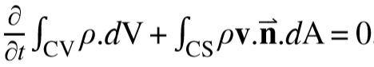. (Tey Wah-Yen∗, 2017)This is then transformed using the Gauss divergence theorem to show, 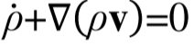. This was the basis of the general form of Navier-Stokes equation written as 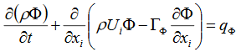. (Tey Wah-Yen∗, 2017)The Navier-Stokes equation, makes it possible to manually sold fluid dynamics. However, a computer needs to use a discretised form, previously stated. Navier-Stokes equation then applies an intergral to form 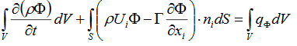. (Tey Wah-Yen∗, 2017)This equation makes it possible to approximate the volume and mass at the center of each element. Each surface is then approximated using the intergral 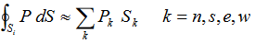. (Tey Wah-Yen∗, 2017) Essentially, by determining the approximate volume, mass and surfaces, it shows that Navier-Stokes equation satisfies every control volumn, in turn this means the entire domain is satisfied too. This makes the finite volumn method more effective and prefered. (Tey Wah-Yen∗, 2017)

Optimising
Initial Setup
Using the dimensions of climate wind tunnel two (CWT2), presented by Mira (HORIBA MIRA Ltd. 2019., 2019). The initial setup position of the Mira geometry is at the centre of the CWT2. The purpose of this is to demonstrate the overall setup procedure and to further validate the requirement of a standardised setup.
The CWT2 chamber dimensions are: Width 8.0m x height 6m x length 19.5m.
Figure 1 shows the Mira geometry being used in the investigation.
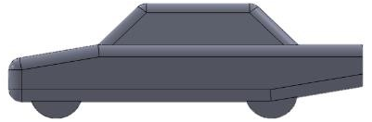
Figure 1: Mira Geometry
The ideal values of drag and lift for the Mira geometry are 0.2963 and -0.0845 respectively.
Figure 2 is a key indicator for areas of interest, P1 shows a change in pressure as the wind leaves the front of the vehicle. P2 shows the wake region, however the data is of poor quality. P3 shows that the wake region is cut off, the missing data is unacceptable. P4 indicates a region of interest as the airflow hits the front of the geometry and disperses. P5 shows the airflow below the vehicle.
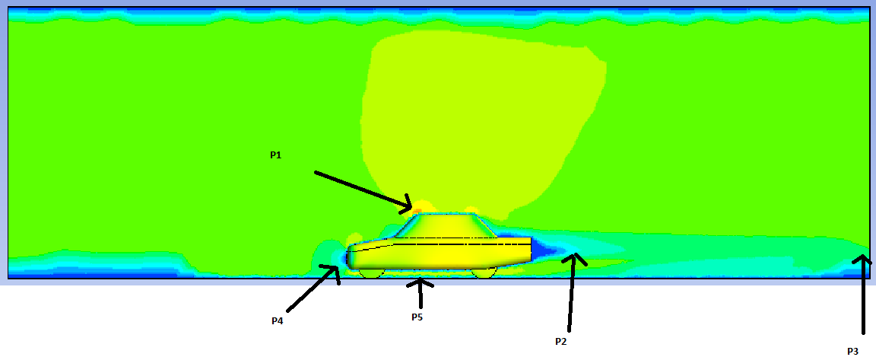
Figure 2: First Simulation
The initial setup proves why running physical tests are not always possible or accurate. To improve the simulation, the domain size needs to be increased to account for the missing wake region, P1, P2, P4, P5 need to be further refined using density boxes.

The document “Best practice guidelines for handling automotive external aerodynamics with fluent” by Marco Lanfrit, the standard setup for this type of investigation consist of:
Domain size should be 3 car lengths in front of the geometry, 5 car lengths behind the geometry. Additinally, the sides and upper regions should allow for a density box of half a car length in each direction plus 1 car length in the wake region.
This would make the half-domain size as 37.593m x 8m x 6m, naturally this dimension is not possible with the CWT2, hence the requirements of the simulation. Figure 3, uses the standard domain and density boxes.
During the standard setup, four mesh strategies have been used. The octree / all tri, octree/all quad, delaunay/ all tri, delaunay/ all quad. The strategies yield the same result within 4 decimal places. However, the octree method is faster to process than the delaunay method by 5 – 15 seconds. For this purpose, the optimised setup will use octree/all tri.
Skewness, Orthogonal quality and aspect ratio have been used to assess the quality of the mesh, Figure 3, gauges the ideal mesh.
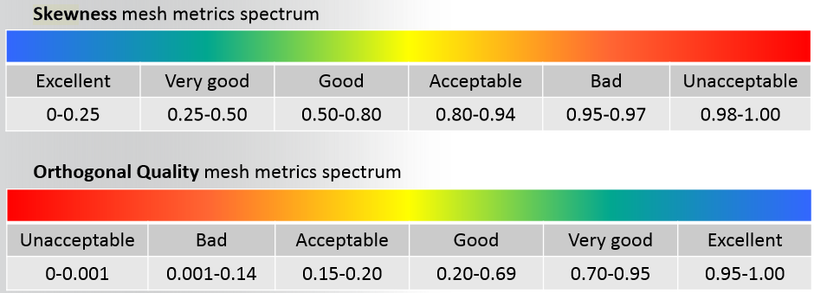
Figure 3: Quality Scale
The skewness is mostly of excellent quality and the lowest quality is still of good quality.
. 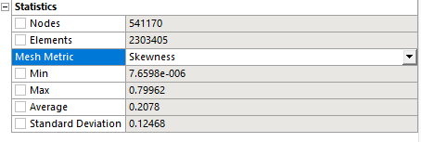
Figure 4: Skewness

The orthogonal quality is also of excellent quality, with the lower quality areas still of good quality.
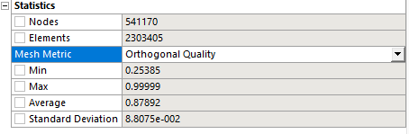
Figure 5: Orthogonal
Table 1 and 2 compare a variety of fluid models using the octree and delaunay meshing methods. For the Mira geometry used, the results on both tables, show that K-epsilon standard is the quickest fluid model. However, K-epsilon realizable is significantly more accurate with respect to the lift and drag. The Reynaulds stress model has been assessed using the pressure-strain, stress-omega and stress –BSL. The time to run the Reynolds methods is significantly higher and yields poor results, compared to the K-epsilon methods. For this reason, the optimised setup will use k-epsilon realizable.
Table 1: Octree Results

Table 2: Delaunay Results

The standard setup stated by Marco Lanfrit, has proved to be sufficient to run the simulation. However, when considering figure 6 it is evident that a lot of the domain can be removed.
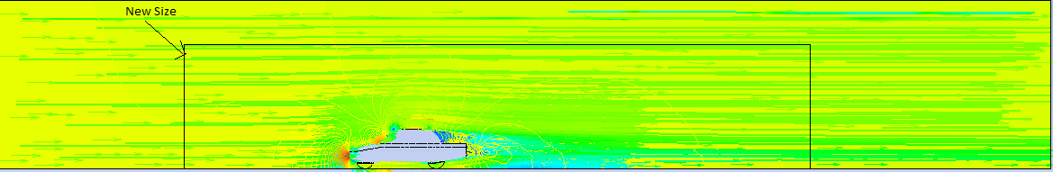
Figure 6: Standard Setup

To save calculation time, the optimised model will use a domain size of 1.5 car length in front, 3 car lengths to the rear, 1 car length above and at the sides of the model. This reduces the overall domain size from 1804.464$m^{3}$ to 400.826$m^{3}$, a 4.5x reduction in size.
A change of inflation layers has been evaluated, as shown in table 3. The data collected, shows no difference in efficiency. The only difference is the computation time, which reduces as the inflation layers are reduced. Dur to this, the optimised setup will use 1 inflation layer.
Table 3: Inflation Layers
From the investigation conducted, it has been determined that both time and accuracy can be improved. The optimised model will use a reduced domain size, better placed denisty boxes, using the octree/ all tri meshing strategy with 1 inflation layer on the floor and around the geometry. Additionally, the K-epsilon realizable turbulance model will be applied.
The expectations are that the optimised setup would run significantly faster than the standardised setup with the potential of better or at worst the same rate of accuracy.

Optimised Setup
As shown in figure 7, the domain size has been reduced, it has 1 inflation layer around the geometry and on the floor. The height of the density box in the wake region has also been reduced to further reduce computational time. Due to the reduction in computational time, it is possible to improve accuracy of the results, the domain and density boxes are denser.
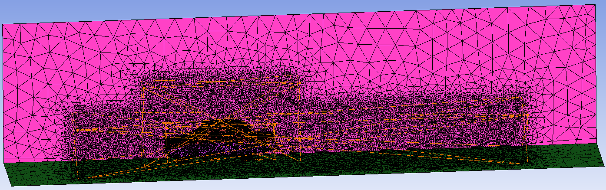
Figure 7: Optimised Mesh

Table 4: Optimised data
From the data collected in table 4, it shows that the optimised setup, although it has taken much more time due to the denser mesh, it has however, significantly improved the accuracy of the lift value within 4 decimal places of the ideal lift value.
During the postprocess, the velocity has been viewed. In figure 8, P1 shows the two turbulence wake regions, with the lower region being more intensified. P2 shows a high velocity rate, caused by the change in pressure as the airflow passes over the geometry. P3 shows a high velocity in front of the wheel, which is then reduced as the airflow reaches the rear wheel.
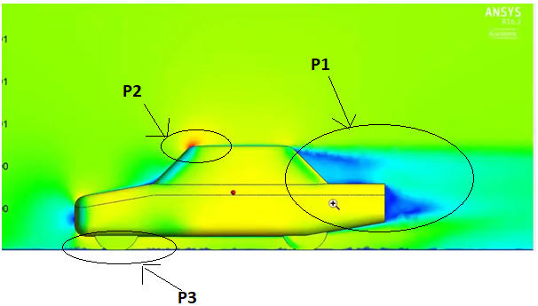
Figure 8: Velocity Regions

The pressure contours have been viewed on the geometry; this demonstrates how the vehicle is affected by the airflow. As shown in figure 9, P1 shows the highest-pressure concentration followed by P2. The purpose of this view is to help with optimising the vehicle geometry to reduce pressure and improve overall performance and efficiency.
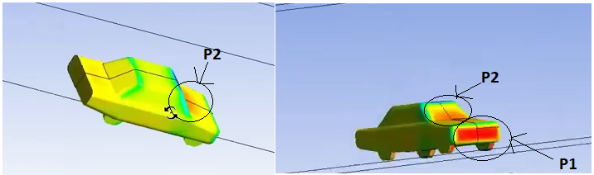
Figure 9: Pressure contours

Figure 10 shows the plotted pressure distribution and how and where the pressure is applied to the upper and lower surfaces.
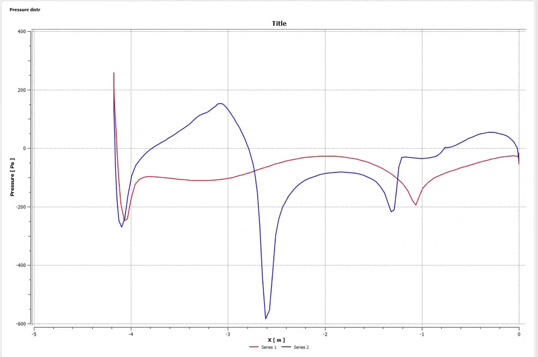
Figure 10: Pressure Distribution

Figure 11 is a copy of the pressure distribution graph, supplied for the MIRA Notchback. By comparing figure 10 and 11, it shows that the ideal pressure distribution is very close to the optimised model created during this study.
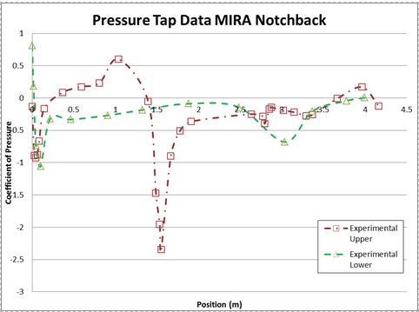
Figure 11: Pressure Distribution (MIRA)

The vectors help demonstrate how the airflow moves around the geometry. Figure 12 depicts how the air flows around various angles such as between the roof and side windows, roof to the rear window and the front window to the roof.
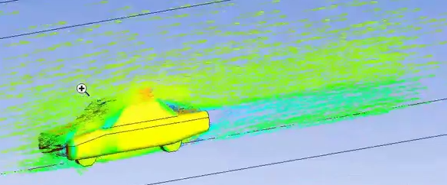
Figure 12: Vectors Pt 1

On figure 13, P1 highlights the three vortices forming at the rear of the vehicle.
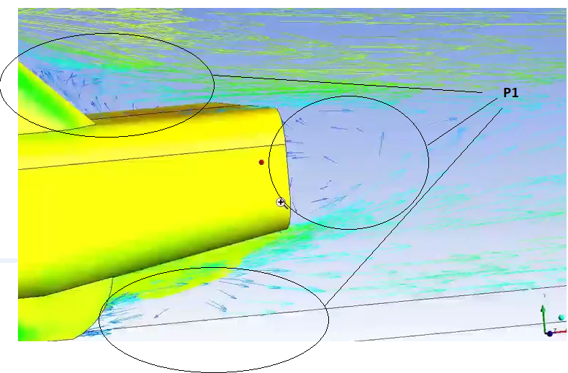
Figure 13: Vectors Pt 2

Mobile Setup
The mobile setup uses the same domain and meshing strategy as the optimised model. However, the boundary conditions have been modified. The airflow has been reduced to 20m/s but the floor has been changed to move at 20m/s, this equates to 40m/s.
The wheels have also been changed to rotating at 20m/s which equates to 65.57${rads}^{-1}$, by using the formula: $ω=\frac{v}{r}=\frac{20}{0.305}=65.57$.
Figure 14 depicts the vehicle in motion, the contours show that the wheels are spinning.
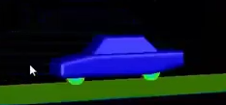
Figure 14: Mobile contour

Table 5 shows the data results of the standard setup, optimised setup and the motion setup. There is not much difference between the optimised / static setup and the motion setup up, apart from a bit more but at a cost of more inaccuracy.
Table 5: Final Data

Analysis
Model: While setting up the solver, a model consisting of viscous – k-epsilon, standard, realizable and Reynaud’s linear pressure strain, stress-omega and stress-BSL have been applied to gain a better understanding of how the wall function can alter the data.
Boundary conditions: For the static setups, the velocity inlet has been set at 40 m/s. For the mobile setup, the inlet velocity was set to 20m/s and the floor moving at 20m/s, effectively maintaining a 40m/s airflow.
Solution methods: The pressure velocity coupling has been changed to couple. The momentum, turbulent kinetic energy and the turbulent dissipation rate have all been changed to second order upwind, the purpose is to intensify the iterations.
Solution controls: The flow courant number has been set to 50, the momentum and pressure have both been reduced to 0.25 and the turbulent viscosity has been set at 0.95.
Monitors: The monitors created consist of drag in the direction of velocity inlet, lift which acts in the upwards direction.
Solution initialization: The solution has been left at hybrid.
Run calculations: 1000 iterations have been run to ensure convergence can be reached. The coefficients for lift and drag were then evaluated by using the forces report. These values were then deducted from the ideal values, to determine the rate of inaccuracy.

Evaluation
It has been determined that the range of turbulence models, make little difference when applied to a basic geometry such as the MIRA Notchback. However, the manipulation of the meshing strategy can have a massive effect on the calculation time and the accuracy of the results. On future setups, a more focused and constrained mesh will be applied, this would reduce setup time, and determine areas of interest earlier.
The postprocessing performed on the optimised setup, demonstrates how the vehicle is affected by air velocity. It also helps an analyst to determine how or where car improvements can be made.
To validate the results further, it would be more ideal to run a bigger range of simulations to compare how the inaccuracy of the coefficients affect the overall results. This will enable the analyst to determine an appropriate tolerance of accepted data.
More postprocessing techniques could be applied to further validate the results and provide more interpretations to a variety of simulations.
A further method of improving validity would require comparison of results from various other colleagues and independent data.

References

HORIBA MIRA Ltd. 2019. (2019). Climate wind tunnels (CWT). Retrieved from A Horiba Company MIRA: https://www.horiba-mira.com/our-services/climatic-wind-tunnels
Lanfrit, M. (2005, 02 09). Best practice guidelines for handling Automotive External Aerodynamics with FLUENT. Retrieved from Southampton university: http://www.southampton.ac.uk/~nwb/lectures/GoodPracticeCFD/Articles/Ext_Aero_Best_Practice_Ver1_2.pdf
Michael M. Resch, W. B. (2017). Sustained Simulation Performance 2017. Stuttgart: Springer international publishings.
Tey Wah-Yen∗, 1. Y.-Z. (2017). Governing Equations in Computational Fluid Dynamics: Derivations and A Recent Raview. Progress in Energy and Environment, 1 - 20.
Yukio Tamura, A. K. (2013). Advanced Structural Wind Engineering. Tokyo: Springer Japan 2013.

