University of Wales Trinity Saint David

Wales Institute of Science & Art



Design for X Project
Manufacturing Design (ACMA5002)

Joseph Carpanini
2211043
July 2024
Contents
2 Table of Figures iv
3 Task 1 1
4 Introduction 1
5 Customer Design Appraisal 2
5.1 QFD 2
5.2 Customer and End-User Needs 3
5.3 Public Perception and Aesthetics 3
6 Design and Development Work Undertaken 4
6.1 Failure Mode and Effects Analysis 4
6.2 SCAMPER 5
7 Design for X 7
7.1 Design Considerations 8
7.1.1 Gripper Arms (Blue Parts) 8
7.1.2 Main Body and Mounting Bracket (Grey Parts) 9
7.1.3 Fasteners (Bolts and Nuts) 10
7.1.4 Rotational Mechanism 10
7.1.5 Actuation Components 11
8 Conclusion 12
9 Bibliography 13
10 Task 2 14
11 Introduction 14
12 Design for Additive Manufacturing 15
13 QFD 16
14 DFMEA 17
15 Current Design 19
16 Improved Design 21
17 Manufacturing Process 23
17.1 Selected AM Process: Selective Laser Sintering (SLS) 23
17.2 Material Selection 23
17.3 Process and Material Alignment with Design 23
18 Conclusion 25
19 Bibliography 26

Table of Figures
Figure 1 – QFD for robot gripper 2
Figure 2 – Gripper FMEA 4
Figure 3 - Robot Gripper 8
Figure 4 - Robot Gripper (Exploded) 8
Figure 5 – Mounting bracket A 9
Figure 6 – Mounting Bracket B 9
Figure 7 – Mounting Bracket C 10
Figure 8 - Pick to light bracket QFD 15
Figure 9 - Pick to light bracket DFMEA 16
Figure 10 - Existing Bracket 18
Figure 11 - Improved Bracket 20
Figure 12 - Improved Bracket Assembly 20

Task 1

Introduction
This technical report focuses on the design, development, and manufacturing process of a robotic gripper assembly. The gripper is a crucial component in automation systems, responsible for handling various objects with precision and reliability. The report aims to provide a comprehensive overview of the conceptual design process, including consideration of customer and end-user needs, public perception, and aesthetics. Additionally, it delves into the development of a Quality Function Deployment (QFD) matrix and a detailed design specification.
The subsequent sections will outline the proposed manufacturing process, highlighting how it aligns with business needs and cost drivers while justifying the selected techniques for mass production. The report also documents the design and development work undertaken, detailing the methods used to generate new designs and features. This includes the application of assembly analysis techniques and risk management strategies such as Failure Modes and Effects Analysis (FMEA).
The overarching goal of this report is to demonstrate a systematic approach to the development of a robotic gripper assembly, ensuring it meets high standards of reliability, efficiency, and manufacturability. This approach not only addresses the technical requirements but also integrates customer feedback and market expectations to deliver a product that stands out in the competitive landscape of industrial automation.

Customer Design Appraisal

QFD
Organisations need to determine what influences consumers' perceptions of a product or service's worth or quality in order to stay competitive. They need to specify which product attributes—like dependability, style, or performance—affect the customer's assessment of the items' worth and quality. The Voice of the Customer (VOC) is gathered and integrated by many prosperous organisations into the product design and manufacturing process. They actively incorporate perceived worth and quality into the creation of their goods and services. These businesses use an organised approach to identify the requirements and desires of their clients, then translate those needs and desires into precise product designs and production schedules that meet the needs of the clients. They employ a procedure or instrument known as Quality Function Deployment (QFD). (quality-one, 2019)
The primary customer requirements identified were strong and precise gripping, easy maintenance and integration, safe operation, and cost-effectiveness. Corresponding technical requirements were determined, including the use of durable materials, a modular design for easy part replacement, compliance with safety standards, and competitive pricing.
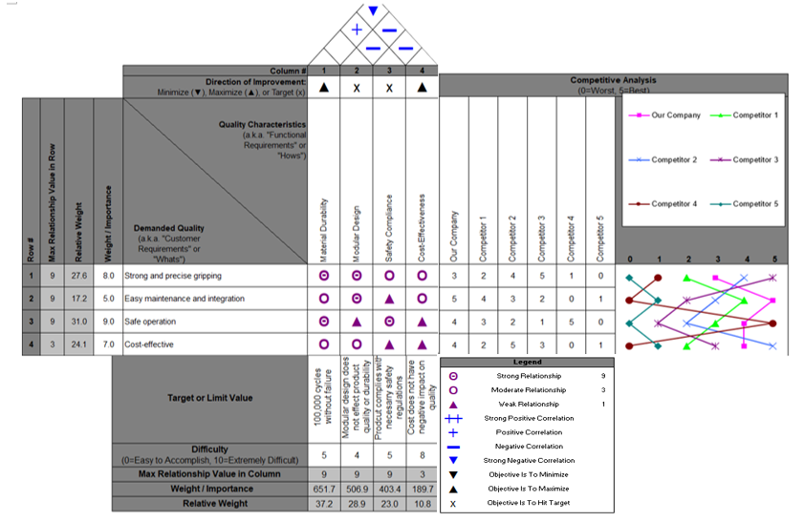
Figure 1 – QFD for robot gripper

Customer and End-User Needs
The primary customers for the robotic gripper include manufacturers and robotics integrators. Manufacturers are seeking advanced automation tools to enhance productivity and precision in production lines, while robotics integrators aim to incorporate grippers into various robotic systems for applications such as assembly, packaging, and material handling. The end-users of this gripper consist of assembly line workers, maintenance technicians, and engineers. Assembly line workers require reliable and consistent gripper performance, maintenance technicians need components that are easy to maintain and service, and engineers are interested in the customization and adaptability of the gripper for diverse applications.
Key needs identified for the gripper include functionality, durability, ease of use, safety, and cost-effectiveness. Functionality encompasses a high gripping force, precise control, and the ability to handle various objects. Durability refers to long-lasting components that are resistant to wear and tear. Ease of use involves simple integration and operation with existing robotic systems. Safety is critical, especially in environments where humans and robots collaborate. Cost-effectiveness entails an affordable initial cost and low maintenance expenses.

Public Perception and Aesthetics
Public perception is crucial for the successful adoption of the robotic gripper. The design is likely to be positively received if it demonstrates reliability, efficiency, and safety. However, concerns may arise regarding safety and potential job displacement. Effective communication of the gripper's safety features and its role in enhancing, rather than replacing, human jobs can mitigate these concerns.
While industrial design typically prioritizes functionality, the aesthetics of the gripper can enhance its perceived value. The current blue and metallic colour scheme suggests robustness and precision, aligning well with industrial applications. A sleek and modern look can further boost the appeal and perceived value of the product.

Design and Development Work Undertaken

Failure Mode and Effects Analysis
FMEA is a crucial method that improves the safety and dependability of complex systems by locating and removing known or possible faults. It also serves as a source of data for risk management choices. It is necessary to first build a cross-functional team to conduct an FMEA before analysing a particular product or system. The first stage in a fault mode and effect analysis (FMEA) is to conduct a systematic brainstorming session to discover every conceivable failure mode of the system or product. Subsequently, these failure modes undergo critical analysis, which considers the risk factors of occurrence (O), severity (S), and detection (D). FMEA's goal is to rank the product or system's failure modes in order of importance so that resources can be directed to the highest risk. (Liu, Liu and Liu, 2013)
Failure Mode and Effects Analysis (FMEA) was a critical part of the design process, systematically identifying potential failure modes and their impacts. Each potential failure was evaluated based on its severity, occurrence, and detectability, with a Risk Priority Number (RPN) calculated to prioritize risks. This analysis led to the implementation of several key improvements, such as using stronger materials for the gripper arms to prevent fractures and incorporating self-lubricating bearings to reduce the risk of seizure.
Figure 2 – Gripper FMEA

SCAMPER
The SCAMPER technique is a creative problem-solving method used to enhance product design by encouraging innovative thinking and exploring various possibilities. SCAMPER stands for Substitute, Combine, Adapt, Modify, Put to another use, Eliminate, and Reverse. By systematically applying these actions, designers can identify new opportunities for improvement and generate fresh ideas. Clearly defining the issue at hand is the first step in applying the SCAMPER approach. Once the problem is well understood, you may start utilising SCAMPER's various components to spark creativity and produce fresh concepts. (North, 2023)
Substitute:
Materials: Substitute the current materials with lighter or more durable alternatives. For instance, replace the aluminium body with carbon fibre composites to reduce weight while maintaining strength.
Actuation Method: Substitute pneumatic actuators with electric actuators to simplify the control system and reduce maintenance.
Combine:
Integrated Parts: Combine the mounting bracket and rotational hub into a single integrated unit to reduce the number of parts, streamline the assembly process, and improve structural integrity.
Sensors and Control Systems: Integrate force sensors directly into the gripper arms to provide real-time feedback and enhance grip precision.
Adapt:
Grip Adaptability: Adapt the gripper to handle a wider range of object sizes and shapes by incorporating flexible or adjustable gripping mechanisms.
Environment Compatibility: Adapt the design for various environmental conditions by using corrosion-resistant materials and adding protective coatings for operations in harsh environments.
Modify:
Gripper Shape: Modify the shape of the gripper arms to improve their ability to grasp irregularly shaped objects more securely.
Surface Texture: Modify the surface texture of the gripper pads to enhance grip on slippery or delicate items.
Put to Another Use:
Dual-Functionality: Adapt the gripper to perform additional tasks such as sensing object dimensions or weight during the gripping process, thus adding value without significant redesign.
Educational Tool: Utilize the gripper design in educational settings for teaching robotics and automation principles.
Eliminate:
Excess Components: Eliminate non-essential components or simplify the design to reduce weight and cost, and to improve ease of maintenance.
Redundant Features: Remove any redundant features that do not add significant value to the primary function of the gripper, such as unnecessary decorative elements.
Reverse:
Actuation Direction: Reverse the direction of actuation to explore new gripping mechanisms or improve the efficiency of the existing system.
Assembly Process: Reverse the order of the assembly process to identify potential efficiencies and streamline the production line.
By applying the SCAMPER technique, several innovative ideas and improvements can be identified for the robotic gripper assembly. Substituting materials and actuators can lead to weight reduction and simpler control systems. Combining parts can streamline assembly and enhance structural integrity. Adapting the design for flexibility and environmental compatibility ensures broader applicability and durability. Modifying the gripper shape and surface texture can improve functionality. Putting the gripper to additional uses can add value, while eliminating unnecessary components and reversing processes can enhance efficiency and reduce costs. This comprehensive approach helps ensure the robotic gripper assembly is robust, versatile, and well-suited for various industrial applications.

Design for X
Design for X (DfX) is a strategic approach in product development that emphasizes optimizing a specific aspect or attribute of a product, represented by "X," where X can stand for various objectives such as manufacturability, reliability, sustainability, cost, and user experience. This methodology integrates the considerations of the chosen focus area early in the design process to ensure that the final product meets the desired criteria efficiently and effectively. For instance, Design for Manufacturability (DfM) aims to simplify the production process, reduce costs, and improve quality by designing products that are easy to manufacture. Similarly, Design for Sustainability (DfS) focuses on minimizing environmental impact by considering factors like material selection, energy efficiency, and product lifecycle. By adopting DfX principles, companies can achieve better performance, cost savings, and customer satisfaction, while also addressing specific challenges and opportunities in the product's lifecycle. (Hessing, 2014)
Applying Design for X (DfX) principles significantly enhances the overall performance and efficiency of the robotic gripper assembly. By focusing on Design for Assembly (DFA), the gripper's assembly process becomes more streamlined and error-free, reducing labour costs and assembly time. This involves minimizing the number of unique components and using standardized fasteners, which simplifies training for assembly line workers and enhances production speed. Implementing Design for Manufacturability (DFM) ensures that the gripper can be produced at scale without compromising quality. The use of cost-effective and readily available materials, such as high-strength aluminium and injection-moulded polymers, helps in maintaining production efficiency and reducing material costs. Design for Reliability (DFR) enhances the gripper's durability by integrating robust materials and self-lubricating bearings, which decrease the need for frequent maintenance and reduce the risk of operational failures. This reliability is critical in industrial settings where downtime can be costly. Overall, the application of DfX principles not only improves the gripper's functionality and longevity but also ensures it is economically viable and easy to produce at scale, thereby meeting the high standards and demands of industrial automation.

Design Considerations
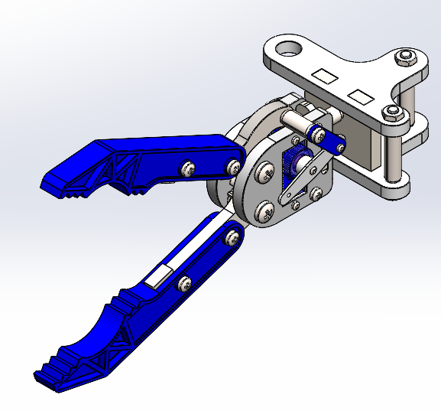
Figure 3 - Robot Gripper

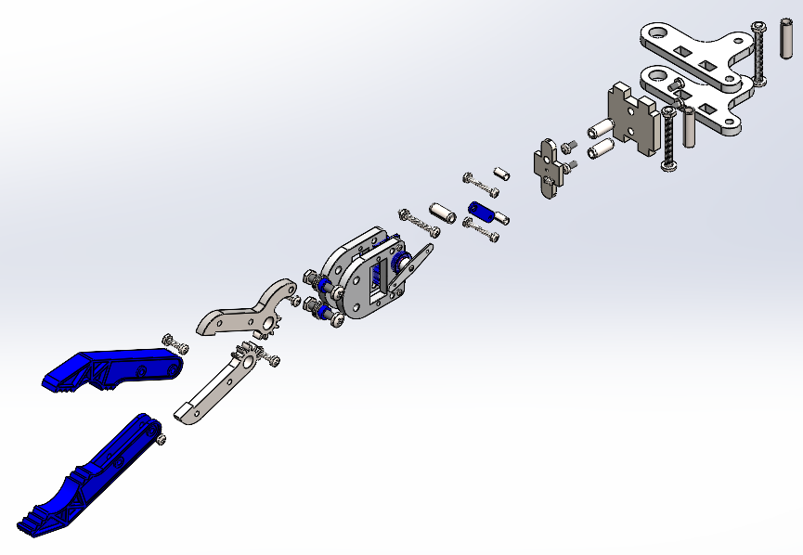
Figure 4 - Robot Gripper (Exploded)

Gripper Arms (Blue Parts)
Material and Manufacturing: If the gripper arms are currently machined, consider switching to injection-moulded plastic or die-cast metal to reduce costs and production time for large quantities.
Simplification: Simplify the design by reducing any unnecessary complex geometries or decorative features that do not contribute to functionality. This makes the manufacturing process easier and faster.
Interchangeable Design: Ensure both arms are identical and interchangeable to reduce the number of unique parts needed.
Gripper Arm to Body Attachment
Current Design: The gripper arms are attached using multiple bolts.
Improvement: Redesign the attachment point to use a snap-fit or dovetail slide mechanism that locks the arms in place without needing multiple fasteners.

Main Body and Mounting Bracket (Grey Parts)
Integrated Design: Evaluate if the main body can be a single piece or fewer pieces, possibly through casting or moulding, to reduce the number of assembly steps.
Modular Components: Make the mounting bracket a standardized module that can be used with different gripper designs or other robotic attachments.
Material Choice: Consider using materials that are strong yet lightweight, such as aluminium or reinforced polymers, to reduce material costs and ease the manufacturing process.
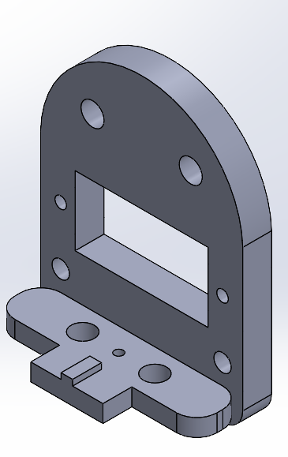
Figure 5 – Mounting bracket A
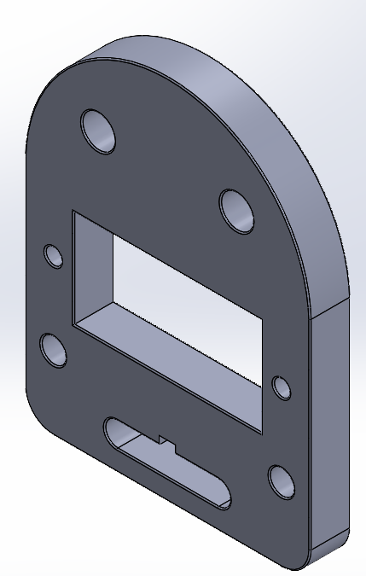
Figure 6 – Mounting Bracket B
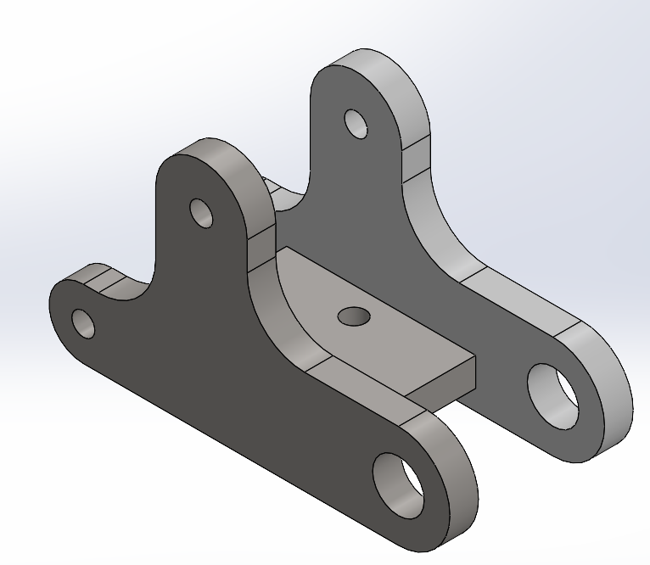
Figure 7 – Mounting Bracket C

Figures 2, 3 & 4 show how the design could be modified using an integrated design approach to some components. By consolidating multiple components into singular, multifunctional units, the design minimizes the number of parts required, thereby reducing assembly complexity and potential points of failure.
A key has also been added to the components in Figures 2 & 3. These parts could not be integrated due to the motor assembly, so to ensure that parts are put together in the correct orientation a poke yoke design has been created to ensure that they will only fit in a single rotation.
Due to the increased complexity of these designs after integration, injection moulding would be the best option to create these. If the material chosen was Aluminium, for example, these parts would have to be made using a CNC machine which would be very complex and introduce a lot of cost.

Fasteners (Bolts and Nuts)
Standardization: Use a single type and size of fastener throughout the assembly to simplify inventory and assembly processes.
Minimize Usage: Where possible, reduce the number of fasteners by using snap-fit designs or integrating parts to eliminate the need for bolts and nuts.
Self-Locating Fasteners: Use self-locating fasteners that can guide themselves into the correct position without requiring precise manual alignment.

Rotational Mechanism
Bearing Integration: If the rotational mechanism uses separate bearings, consider integrating bearing races into the main body parts or using self-lubricating bushings to reduce the number of parts.
Simplified Assembly: Ensure the rotational mechanism is easy to assemble, possibly pre-assembling this as a sub-component to be added to the main assembly.
Main Rotational Hub
Current Design: The hub is assembled from multiple parts using several bolts.
Improvement: Consider a design where the hub and surrounding structural support are cast or moulded as a single unit, reducing the assembly steps and increasing structural integrity.

Actuation Components
Pre-assembled Modules: Design the actuation mechanism (pneumatic, hydraulic, or electric) as a pre-assembled module that can be quickly attached to the main assembly.
Quick Connectors: Use quick-connect fittings for any pneumatic or hydraulic lines to reduce assembly time.
Alignment Features: Add alignment pegs or slots to parts to ensure they fit together correctly and easily during assembly.

Conclusion
In conclusion, the development of the robotic gripper assembly presented in this technical report shows how different techniques can be used throughout the design process do align with industry and customer needs. The design process began with a thorough assessment of customer and end-user needs through Quality Function Deployment (QFD), ensuring the gripper provides robust functionality, easy maintenance, and high safety standards.
The report highlights the use of methodologies such as Failure Modes and Effects Analysis (FMEA) and the SCAMPER technique to ensure reliability and create innovation. By identifying potential failure modes and applying creative problem-solving, the design was optimized for the gripper's performance and versatility across various applications.
Additionally, the application of Design for X (DfX) principles ensured that all aspects of the gripper assembly, from manufacturability and reliability to environmental impact, were carefully considered and optimized. Emphasizing Design for Assembly (DFA), Design for Manufacturability (DFM), and Design for Reliability (DFR), the gripper assembly meets industry standards, providing an economically viable and technologically advanced solution.

Overall, this technical report documents the meticulous development of a robotic gripper assembly, showcasing the integration of customer-focused design, rigorous engineering methodologies, and innovative thinking. As industrial automation progresses, this systematic approach ensures the robotic gripper assembly remains at the forefront of technological advancement, ready to deliver exceptional performance in the competitive field of industrial robotics.

Bibliography
Hessing, T. (2014). Design for X (DFX) | What you need to know for your Six Sigma exam. [online] Six Sigma Study Guide. Available at: https://sixsigmastudyguide.com/design-for-x-dfx/.
Liu, H.-C., Liu, L. and Liu, N. (2013). Risk evaluation approaches in failure mode and effects analysis: A literature review. Expert Systems with Applications, 40(2), pp.828–838. doi:https://doi.org/10.1016/j.eswa.2012.08.010.
North, J. (2023). The SCAMPER Technique for Creative Problem Solving. [online] The Big Bang Partnership. Available at: https://bigbangpartnership.co.uk/scamper/.
quality-one (2019). QFD | Quality Function Deployment | Quality-One. [online] Quality-one.com. Available at: https://quality-one.com/qfd/.

Task 2

Introduction
The development of Design for Additive Manufacturing (DfAM) is transforming the design and manufacturing of components. In this project, I will redesign a pick-to-light bracket using DfAM principles demonstrating the applications of these concepts in a practical scenario.
The objective is to improve the pick-to-light bracket—a crucial part of assembly and warehouse operations—by utilising DfAM. The redesigned product will prioritise the use of additive manufacturing's (AM) benefits, including material economy, design adaptability, and the capacity to produce intricate geometries.
Key design tools will include Quality Function Deployment (QFD) and Design Failure Mode and Effects Analysis (DFMEA). QFD will translate customer requirements into engineering specifications, ensuring the redesigned bracket meets all necessary criteria.

Design for Additive Manufacturing
Design for Additive Manufacturing (DfAM) is a set of principles and methodologies aimed at optimizing designs for the unique capabilities and constraints of additive manufacturing (AM) technologies, such as 3D printing. Key concepts of DfAM include topology optimization, which leverages the layer-by-layer construction method to create highly efficient structures with complex geometries that would be difficult or impossible to produce with traditional manufacturing methods. Another important concept is the use of lattice structures, which can significantly reduce weight while maintaining strength and stability. DfAM also emphasizes the consolidation of multiple parts into single, more complex parts to reduce assembly time and improve overall product performance. Additionally, it considers the orientation of parts during printing to minimize support structures and post-processing efforts. By applying these principles, designers can enhance the performance, functionality, and cost-effectiveness of existing designs, taking full advantage of the flexibility and innovation potential offered by AM technologies. (“What Is Design for Additive Manufacturing?”)
Additive manufacturing allows for the production of tailored products without the need for costly retooling, enabling mass customization and personalized designs. For example, in the medical field, prosthetics and implants can be custom designed to fit individual patients perfectly, improving comfort and functionality. Another advanced concept is the integration of multiple material properties within a single build, which can create components with varied characteristics, such as stiffness and flexibility, in different regions. This is particularly useful in creating parts that need to perform multiple functions or withstand diverse operational conditions. Additionally, DfAM encourages the exploration of new materials that are specifically designed for AM processes, such as composite materials and smart materials that can change properties in response to environmental conditions. By incorporating these advanced DfAM strategies, designers can push the boundaries of traditional manufacturing, achieving unprecedented levels of innovation, efficiency, and product performance.

QFD
Quality Function Deployment (QFD) is a strategic methodology designed to bridge the gap between customer needs and product development. It offers a structured approach for translating the voice of the customer into clear, actionable design requirements. By capturing and analysing customer expectations, QFD helps ensure that design efforts are focused on creating products that meet or exceed user demands. (“Quality Function Deployment (QFD) | Definition and Overview”)
QFD significantly influences design by aligning project objectives with customer expectations. It starts by identifying and translating customer needs into specific design goals. This alignment ensures that every aspect of the design process, from initial concept to final production, remains focused on delivering value to the customer. The matrix also helps design teams establish clear priorities, balancing factors like cost, performance, and feasibility to meet customer requirements effectively. (“Quality Function Deployment (QFD) | Definition and Overview”)
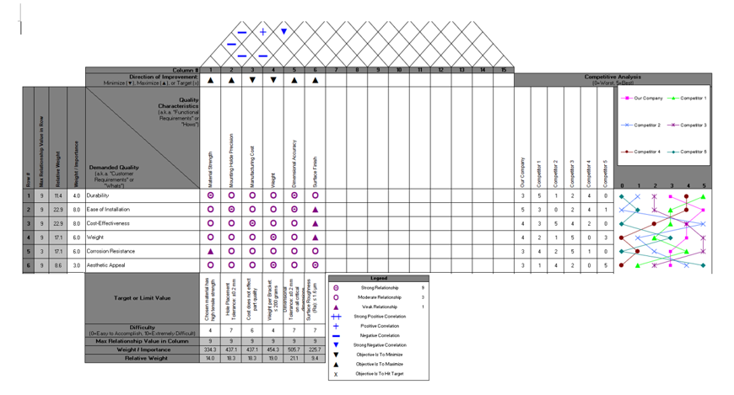
Figure 8 - Pick to light bracket QFD
The QFD matrix highlights that the most critical engineering characteristics for the original part are material strength, mounting hole precision, and manufacturing cost. These characteristics should be prioritized in the design and production process to ensure the part meets the key customer requirements of durability, ease of installation, cost-effectiveness, and compatibility. The added customer requirements like aesthetic appeal and corrosion resistance have also been considered, ensuring a comprehensive approach to fulfilling customer needs.

DFMEA
Design Failure Modes and Effects Analysis (DFMEA) is a structured and systematic approach used to identify potential failure modes in a product design and evaluate their impacts on the overall system. By focusing on potential problems during the design phase, DFMEA helps engineers and designers anticipate and address issues before they escalate into significant failures. This proactive method assesses each component’s potential failure modes, their causes, and effects on product performance, enabling teams to prioritize risks and implement effective design improvements. The process involves scoring the Severity, Occurrence, and Detection of each failure mode to calculate the Risk Priority Number (RPN), which guides decision-making and resource allocation. (Tarlengco)
Incorporating DFMEA into the design process offers several benefits, including enhanced product reliability, improved safety, and cost-effective solutions. By identifying and addressing potential issues early, DFMEA helps designers optimize the product’s performance and prevent costly redesigns or recalls. This method fosters collaboration among cross-functional teams, including engineering, quality assurance, and manufacturing, to ensure that all perspectives are considered in the design. Overall, DFMEA supports a thorough and methodical approach to design that aims to meet customer expectations, reduce risks, and deliver high-quality products. (Tarlengco)

Figure 9 - Pick to light bracket DFMEA
The Design Failure Modes and Effects Analysis (DFMEA) for the pick-to-light bracket identifies critical failure modes such as bracket breakage, mounting issues, and instability, each with varying severity, occurrence, and detection ratings. High-priority concerns include bracket strength and base stability, which could lead to light fixture instability and ineffective picking. The analysis recommends specific actions such as improving material strength, verifying hardware specifications, redesigning for angle adjustment, enhancing corrosion resistance, and refining electrical connections to mitigate risks. By addressing these failure modes, the DFMEA aims to ensure the bracket's reliability, safety, and performance.

Current Design
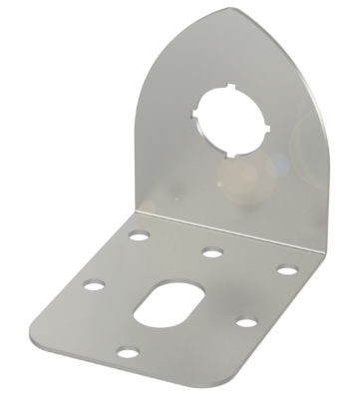
Figure 10 - Existing Bracket
The existing design of the pick-to-light bracket, shown in the figure 10, is a relatively straightforward metal component. It features a flat base with several cut-outs and holes for mounting and functional purposes. While effective, this design is optimized for traditional manufacturing techniques like stamping, cutting, or machining. When considering the transition to additive manufacturing, several areas for improvement and optimization become apparent:
Material Usage and Weight Reduction:
Current Design: The flat metal plate uses a continuous sheet of material, which can be heavy and material intensive.
Improvement: Introduce lattice structures or hollow sections in the base to significantly reduce weight and material usage without compromising structural integrity. Additive manufacturing allows for intricate internal geometries that can maintain strength while using less material.
Structural Optimization:
Current Design: The design uses a uniform thickness throughout the component, which may not be necessary for all areas.
Improvement: Use topology optimization techniques to add material only where it is needed for strength and remove it from low-stress areas. This approach can lead to a more efficient design that uses less material while maintaining or even improving performance.
Functional Integration:
Current Design: The design consists of separate parts and additional fasteners for mounting.
Improvement: Integrate additional features such as mounting clips, cable guides, or even electronic housing directly into the design. This reduces the need for additional parts and assembly steps, simplifying the overall system.
Customization and Complexity:
Current Design: The simple, flat design is limited in customization and complexity due to manufacturing constraints.
Improvement: Additive manufacturing allows for complex shapes and custom features tailored to specific needs or environments. This could include ergonomic adjustments, personalized fit, or integration of company branding.
Mechanical Performance:
Current Design: The cut-outs and holes are designed for traditional manufacturing processes, potentially leading to stress concentrations.
Improvement: Redesign these features with smooth transitions and fillets that are easier to produce with additive manufacturing. This can improve the mechanical performance by reducing stress concentrations and increasing durability.
Aesthetic and Functional Design:
Current Design: The bracket has a utilitarian look and may lack aesthetic appeal.
Improvement: Additive manufacturing can produce more aesthetically pleasing designs with smooth curves, organic shapes, and a more refined appearance, which can be beneficial in environments where the bracket is visible.
By addressing these areas, the pick-to-light bracket can be significantly improved through the use of additive manufacturing. The result would be a lighter, stronger, more integrated, and potentially more aesthetically pleasing component that uses the full capabilities of modern manufacturing technologies.

Improved Design
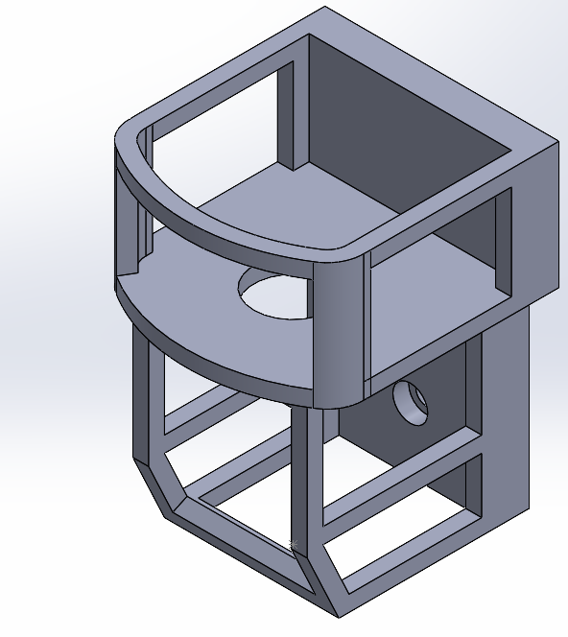
Figure 11 - Improved Bracket
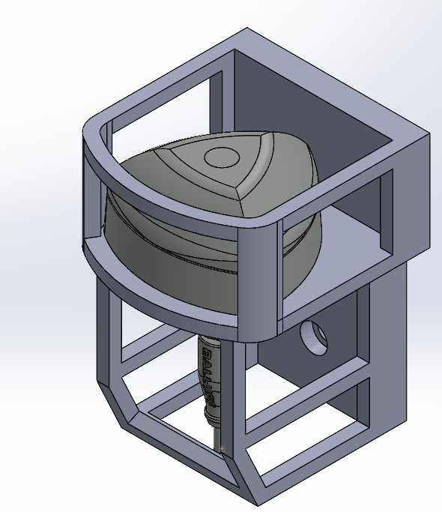
Figure 12 - Improved Bracket Assembly
The improvements made in the pick-to-light bracket design exemplify key Design for Additive Manufacturing (DFAM) principles, highlighting the shift from traditional manufacturing constraints to the opportunities provided by additive manufacturing. The original bracket, depicted in the figure 10, is characterized by a simple, flat metal plate with multiple cut-outs and holes. This design is optimized for traditional manufacturing methods such as stamping or machining, which are cost-effective for producing flat, uniform shapes but are limited in their ability to create complex geometries without significant additional processing.
In contrast, the new design in figures 11 and 12 leverages the capabilities of additive manufacturing by incorporating more complex geometries and a lightweight, lattice structure. Additive manufacturing allows for the creation of intricate designs that are not possible with traditional methods. The open lattice structure of the new bracket reduces material usage and weight while maintaining structural integrity, demonstrating the principle of material efficiency. This reduction in material not only lowers costs but also enhances the bracket's performance by making it lighter without compromising strength.
Moreover, the new design includes integrated features that enhance its functionality. For instance, the optimized shapes and improved mounting points are designed to better suit their intended applications, offering greater versatility and ease of use. These features highlight the DFAM principle of complexity for free, where the cost of producing complex structures is not significantly higher than that of simpler ones, allowing for greater design freedom and innovation.
Additionally, the new bracket design likely benefits from part consolidation, another DFAM principle. By integrating multiple functions and components into a single, cohesive part, the need for assembly is reduced, leading to lower assembly costs and fewer points of potential failure. This holistic approach to design results in a more efficient and reliable product.
In summary, the transition from the original, traditionally manufactured bracket to the new, additively manufactured design underscores the transformative impact of DFAM principles. By embracing the advantages of additive manufacturing, the new design achieves greater material efficiency, design complexity, and functional integration, ultimately resulting in a superior product that is lighter, stronger, and more versatile.

Manufacturing Process

Selected AM Process: Selective Laser Sintering (SLS)
Selective Laser Sintering (SLS) has been chosen as the appropriate AM process for the redesigned component. SLS is renowned for its ability to create complex geometries and intricate designs, making it ideal for the sophisticated structure of the modified component, which features lattice and cellular internal structures. One of the significant advantages of SLS is that it does not require support structures, unlike other AM processes. This feature is particularly beneficial for intricate and consolidated designs, as it eliminates the need for additional post-processing to remove supports. Furthermore, SLS is compatible with a variety of materials, including high-performance engineering thermoplastics and metals, which provide excellent mechanical properties suitable for functional parts. The process also ensures high dimensional accuracy and fine details, essential for maintaining the precision required in the redesigned component. (Guide to Selective Laser Sintering (SLS) 3D Printing)

Material Selection
Selected Material: High-Performance Engineering Thermoplastic
For the redesigned component, a high-performance engineering thermoplastic has been selected. This type of material offers a balanced combination of strength, flexibility, and impact resistance, which are critical for the structural integrity and functionality of the component. High-performance thermoplastics are also known for their durability and resistance to fatigue, making them suitable for components subjected to repetitive stress or load-bearing applications. Additionally, these materials often have excellent chemical resistance, which can be advantageous depending on the operational environment of the component. They typically provide a good surface finish directly from the printer, reducing the need for extensive post-processing and ensuring that the component meets necessary aesthetic and functional requirements. Moreover, high-performance thermoplastics maintain their properties over a wide range of temperatures, ensuring reliable performance in diverse operating conditions. (Hogan)

Process and Material Alignment with Design
The redesigned component leverages the advantages of the SLS process and the properties of high-performance engineering thermoplastic to achieve several key benefits. First, component consolidation is significantly enhanced, as the SLS process supports the integration of multiple parts into a single, cohesive design without requiring additional assembly. This integration is crucial for the complex design features incorporated into the new component. Second, the use of high-performance thermoplastics and SLS allows for the creation of complex internal lattice structures, optimizing the strength-to-weight ratio of the component. The precision of the SLS process ensures that the intricate design features and critical dimensions of the component are accurately maintained. Lastly, the mechanical properties of high-performance thermoplastics ensure that the redesigned component can withstand operational stresses and perform reliably in its intended application.
By selecting SLS as the additive manufacturing process and a high-performance engineering thermoplastic as the material, the redesigned component achieves an optimal balance of complexity, strength, durability, and functionality.

Conclusion
The redesign of the pick-to-light bracket using Design for Additive Manufacturing (DfAM) principles shows the potential of additive manufacturing (AM) in component development. Through this project, application of DfAM concepts have been demonstrated, significantly enhancing the bracket's design and performance.
By using DfAM, the redesigned bracket prioritizes material economy, design adaptability, and the ability to produce intricate geometries. The application of Quality Function Deployment (QFD) ensured that customer requirements were effectively translated into engineering specifications, while Design Failure Mode and Effects Analysis (DFMEA) allowed for the identification and mitigation of potential failure modes, enhancing the bracket's reliability and safety.
The original design, optimized for traditional manufacturing techniques, was a straightforward metal component with uniform thickness and separate parts. In contrast, the improved design incorporates lattice structures, optimized material distribution, and integrated features that improve functionality. This new design not only reduces weight and material usage but also improves mechanical performance and aesthetic appeal.
Selective Laser Sintering (SLS) was selected as the AM process, and a high-performance engineering thermoplastic was chosen for its useful mechanical properties, durability, and chemical resistance. This combination enabled the creation of a complex component with precise dimensions and minimal post-processing requirements.
In summary, the transition from a traditional to an additively manufactured pick-to-light bracket showcases the significant benefits of DfAM. The redesigned bracket achieves greater material efficiency, structural integrity, and functional integration, resulting in a superior product that is lighter, stronger, and more versatile. This project highlights the potential of additive manufacturing to revolutionize component design and manufacturing.

Bibliography
Guide to Selective Laser Sintering (SLS) 3D Printing. “Guide to Selective Laser Sintering (SLS) 3D Printing.” Formlabs, 2019, formlabs.com/uk/blog/what-is-selective-laser-sintering/.
Hogan, Madeline. “Types & Benefits of SLS Materials for 3D Printing.” Nexa3D, 21 June 2023, nexa3d.com/blog/sls-materials/.
“Quality Function Deployment (QFD) | Definition and Overview.” Www.productplan.com, www.productplan.com/glossary/quality-function-deployment/#:~:text=Definition%3A%20Quality%20Function%20Deployment%2C%20or.
Tarlengco, Jona. “DFMEA: Design Failure Mode and Effects Analysis.” SafetyCulture, 31 Jan. 2024, safetyculture.com/topics/dfmea-design-failure-mode-and-effects-analysis/.
“What Is Design for Additive Manufacturing?” Www.protolabs.com, www.protolabs.com/resources/guides-and-trend-reports/what-is-design-for-additive-manufacturing/.

