MSc Public Health and Social Care in Practice

Population Health and Digital Health Promotion

Student Name: Masumi Tandel
Student ID: 2243074
Table of Contents
Task 1: Blogs 3
Blog 1 3
Introduction 3
Addressing the Asthma Epidemic 3
Telemedicine in health promotion 3
Addressing the shortfalls 4
Blog 2 6
Addressing Diabetes 6
Describing New Designed Technology 6
AI-Driven Smart Glucose Patch 7
Impact of AI-Driven Smart Glucose Patch in Health Promotion 7
Addressing the Short Falls 7
Task 2: Poster Design 9
1. Background 9
The scale of the public health problem and why an intervention is Necessary. 9
Digital and non-digital technology intervention 10
Chosen digital health intervention 10
2. Health promotion values and principles 11
Health promotion values and principles 11
Aligning digital health technology intervention with health promotion values and principles 12
3. Behaviour change theory 13
4. Expected outcome 14
5. Conclusion 15
References 16

Task 1: Blogs

Blog 1

Introduction
Asthma is a chronic respiratory condition impacting millions of individuals globally, creating a significant public health challenge. Asthma is an important and common cause of disability and mortality particularly in low and middle-income regions, where access to efficient care and essential medicines is restricted (Dharmage et al., 2019). The use of telemedicine influences health care services remotely and it is a valuable tool to address the international concern of asthma to promote health equity and quality of life. Telemedicine as a digital technology in health promotion interventions aimed to mitigate the complexities in asthma management.

Addressing the Asthma Epidemic
Asthma is a chronic respiratory disease that impacts globally, millions of individuals are suffering from chronic asthma and it is very important to address the mitigation strategy of this chronic condition. Asthma causes the narrowing of the airways, and spreading inflammation leading to multiple symptoms including chest tightness, coughing, wheezing and shortness of breath (Dharmage et al., 2019). Asthma can be very challenging to handle and it increases its growth by multiple factors involving pollutants, stress, allergens, infections and exercise. The disease has no cure, but it can be maintained with proper guidance, medications and avoidance of triggers. The asthma epidemic requires an organised and structural framework and coordinated approach that includes patients, policymakers, healthcare providers, and researchers. According to the World Health Organisation (WHO), over 400,000 deaths each year are attributed to asthma, which impacts an estimated 339 million people (World Health Organization, 2023). The impact of asthma is not limited to its immediate medical consequences; it also includes financial expenses and a lower standard of living for sufferers.

Telemedicine in health promotion
Telemedicine uses multiple modalities including facilitating virtual visits (FVVs), e-consults, mobile health applications (mHealth), Direct-to-consumer (DTC), and remote patient monitoring (RPM) (Chongmelaxme et al., 2019). These modalities are playing a role of multifacet and important tools in asthma care. The size of the worldwide telemedicine market has been estimated to be 45.5 billion dollars in 2019 and is expected to grow to 175.5 billion dollars by 2030 (Statista, 2019).
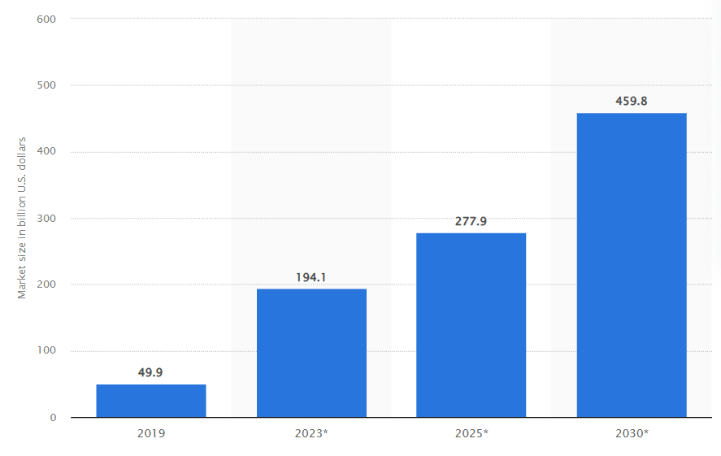
Global Telemedicine Market 2019-2030
Source: (Statista, 2019)
DTC visits provide flexibility and comfortability but it has some limitations that exist in physical examination. FVVs enable a facilitator, improving visit efficiency and are advantageous for critical asthma cases (Chongmelaxme et al., 2019). RPM allows constant monitoring, initial intervention and patient empowerment, E-consults use streamlined access to provide critical care and mitigate wait times.
Applications for mobile health serve as informative and supportive tools that encourage participation. Telecommunication medicine has advantages, but it also has drawbacks, including privacy issues, unpredictability, and technical difficulties in regulations. It is essential to assess and track the effects of telemedicine, highlighting its function as an additional resource rather than a replacement for personalised, personal health services. Managing technological, legal, and acceptance concerns is necessary to overcome obstacles and guarantee safe, efficient, and patient-focused telemedicine asthma therapy.

Addressing the shortfalls
It is essential to encourage digital inclusion, and programmes are required to provide access to telemedicine for more people, especially for underprivileged groups. A thorough approach to asthma therapy is guaranteed when telemedicine is combined with in-person appointments. Ensuring the protection of patient information requires strong data security protocols. Over 80% of patients are concerned about data privacy, highlighting the significance of improved security measures in the deployment of telemedicine (Statista, 2019).

Blog 2

Addressing Diabetes
There were 537 million diabetics in the globe in 2021. It is anticipated the figure will increase till at least 2045. By then, there are predicted to be 783 million people worldwide who have diabetes. By 2045, the prevalence of diabetes is expected to rise to almost 12 per cent due to an increase in the number of people with the disease (Elflein, 2023). This alarming rate of growth is fatal and is accountable for 1.5 million deaths each year as per WHO requires efforts to mitigate this issue (World Health Organisation, 2019). To address this, diabetes patients use insulin to reduce and glucose meters to measure and manage the disease.
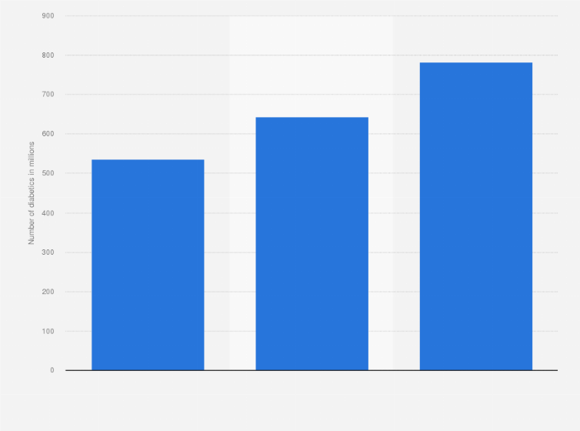
Figure: Global estimates for the number of diabetes in 2021, 2030, and 2045
Source: (Elflein, 2023)

Describing New Designed Technology
Combining AI analytics and neurofeedback sensors, the NeuroSyncro HealthPatch is a modern smart adhesive patch. In addition to monitoring blood sugar levels, it records brainwave patterns in real-time to predict and preemptively manage stress. Personalised stress reduction treatments and proactive suggestions are provided by the AI system, which has been taught to comprehend individual stress reactions. Users are led through brain training activities by a virtual AI health coach, and customised concepts for stress reduction addresses are offered by dynamic notifications. The software makes stress management entertaining with gamified features and shows glucose and brain statistics. Cortisol levels and other biochemical responses allow for a more detailed understanding of how stress impacts glucose metabolism (Terlouw et al. 2021).

AI-Driven Smart Glucose Patch
Proactively controlling stress in the setting of treatment for diabetes lowers the costs of medical care related to complications (American Diabetes Association, 2019). By allowing people to make informed lifestyle decisions, real-time data insights and AI-driven treatments may be able to lessen the societal impact of diabetes. It is an enjoyable and user-friendly application which motivates adherence to health practises and improves health outcomes on a large scale. Its potential integration with telemedicine systems additionally addresses disparities in health care through offering accessible healthcare, especially to underserved populations. The NeuroSyncro HealthPatch supports a proactive and comprehensive plan to enhance public health.

Impact of AI-Driven Smart Glucose Patch in Health Promotion
The NeuroSyncro HealthPatch offers real-time data and customised stress management, offering a paradigm change in the management of diabetes. Its benefits include better adherence, fewer problems, and proactive health therapies. However, there are disadvantages such as potential user dependence, concerns about confidentiality of information, and difficulties with accessibility. Ethical, security, and inclusiveness concerns must be carefully taken into account while boosting people's well-being to ensure that the technology will improve public health without exacerbating already-existing disparities or diminishing user liberty (‌Murphy et al. 2021).

Addressing the Short Falls
Ensuring inclusiveness in technological advances a voice, transparent user instruction on security methods, and strict data protection protections are required to solve any flaws (Rodrigues, 2020). Frequent updates should improve user autonomy by eliminating excessive reliance issues. By collaborating, medical professionals can reduce discrepancies by ensuring a balanced integration of the NeuroSync HealthPatch into current treatment frameworks. A multifaceted approach is used to reduce adverse consequences and maximise beneficial effects on both the public and individuals by encouraging an open discussion on ethical issues and continually enhancing the technology.

References

Blog 1
- Chongmelaxme, B., Lee, S., Dhippayom, T., Saokaew, S., Chaiyakunapruk, N. and Dilokthornsakul, P., 2019. The effects of telemedicine on asthma control and patients' quality of life in adults: a systematic review and meta-analysis. The Journal of Allergy and Clinical Immunology: In Practice, 7(1), pp.199-216.https://doi.org/10.1016/j.jaip.2018.07.015
- Dharmage, S.C., Perret, J.L. and Custovic, A., 2019. Epidemiology of asthma in children and adults. Frontiers in pediatrics, 7, p.246. available at:https://doi.org/10.3389/fped.2019.00246 [Accessed on 18 November 2023]
- Statista. (2019). Telemedicine market size worldwide 2019-2030 | Statista. [online] Available at:https://www.statista.com/statistics/671374/global-telemedicine-market-size/ [Accessed 18 November 2023].
- World Health Organization (2023). Asthma. [online] Who. int. Available at:https://www.who.int/news-room/fact-sheets/detail/asthma [Accessed 18 November 2023].

Task 2: Poster Design

1. Background

The scale of the public health problem and why an intervention is Necessary.
Asthma in 2019 was estimated to have impacted 262 million individuals and resulted in 455,000 fatalities (World Health Organisation, 2023). As of 2021, around 7% of youngsters in the United States were now suffering from asthma. Asthma prevalence was greater in females than males; around 9% of females now have asthma (Elflein, 2023). With a total incidence of 9.5%, the age group of 20 to 24 years old was found to have the greatest prevalence of current asthma in 2021 (Elflein, 2023). With millions of individuals globally affected by the concerning rise in asthma cases, intervention is essential. Since the rate of fatalities is rising, particularly among young individuals, swift action is needed to mitigate health hazards and prevent further deaths through technology and medications.

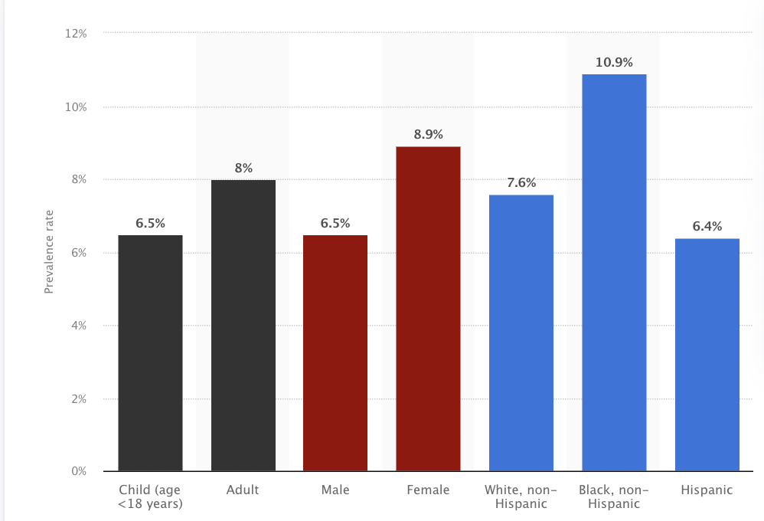
Figure: Prevalence of Asthma in the US by age, gender, and ethnicity 2021
Source: (Elflein, 2023)

Digital and non-digital technology intervention
Asthma-related public health initiatives involve digital platform-based educational campaigns, such as self-management applications and online tools. Non-digital solutions include educational events, workplace rules that promote asthma-friendly settings, and community-based programmes. Social media like Facebook and Twitter and mobile applications like “AsthmaMD” further facilitated digital engagement and offered online asthma education and management resources (Kouri and Gupta, 2023). Limits on the environment and air quality monitoring systems also aid in a decrease in triggers. By using combined digital and non-digital technology, these integrated efforts increase public health outcomes associated with asthma care and prevention.

Chosen digital health intervention
The worldwide telemedicine industry was estimated to be worth $50 billion as of 2019. It is anticipated that the market will expand dramatically in the next years, reaching a predicted valuation of around 460 billion dollars by 2030 (Stewart, 2021). Telemedicine for asthma involves the utilisation of phone or video conversations to facilitate distant consultations between patients and medical professionals. It improves access to individuals with asthma through the provision of real-time evaluation, control of medications, and personalised treatment. By improving tracking, instruction, and assistance, this digital health intervention helps individuals manage asthma efficiently and reduces healthcare inequities.
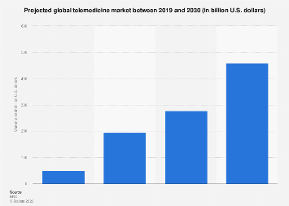
Figure: Worldwide telemedicine market size 2019-2030
Source: (Stewart, 2021)

2. Health promotion values and principles

Health promotion values and principles
The ideals and concepts of health promotion emphasise empowerment, participation, and equity, as part of an integrated approach to well-being (Srivastav et al. 2020). They recognise the socioeconomic determinants of health and emphasise prevention. These values, which depend on ethical concerns, support autonomy while offering individuals authority over their health decisions. Engaging with communities and recognising their diversity of culture is important. Health promotion is influenced by sustainability and social justice, with a view towards equitable resource allocation. Advocacy and other Ottawa Charter values enable modifications to policy which encourage health (Spencer et al. 2019). In general, the objectives of health promotion are to enhance the general health and quality of life of individuals and communities by giving priority to social justice, empowerment, inclusion, and prevention.
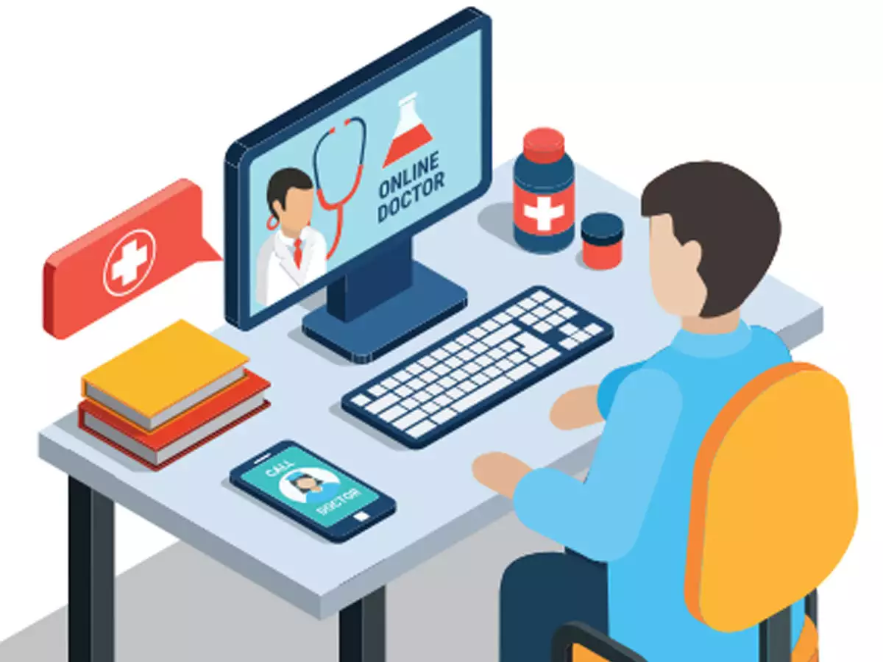
Figure: Telemedicine
Source: (ET HealthWorld, 2020)

Aligning digital health technology intervention with health promotion values and principles
By emphasising empowerment, accessibility, and prevention, telemedicine for asthmatic complies with the ideals and values of the promotion of health. Providing online consultations ensures that all individuals may get timely, high-quality treatment regardless of where they live and tackles health inequities. Through real-time monitoring and education, the technology gives patients greater autonomy and promotes self-management abilities. Because telemedicine allows patients to participate in making their own medical decisions, it complies with the participation principle (‌Talal et al. 2020).
Telemedicine facilitates proactive management in terms of prevention, enabling healthcare providers to see any flare-ups early on and treat them. This emphasises the value of avoiding health problems before they worsen, which is compatible with the preventive concept. Telemedicine improves healthcare fairness by overcoming geographic divides and maintaining social justice and equity ideals (Brown et al. 2022).
Asthma telemedicine use is another example of neighbourhood collaboration. It promotes a team strategy for treating asthma by fusing digital technologies with community health initiatives. In the setting of asthma medication, telemedicine essentially supports access, prevention, empowerment, equity, social justice, and community collaboration all of these are ideals which are in line with health promotion.

3. Behaviour change theory
A prominent behavioural change theory that studies how people make decisions regarding their health-related behaviours is the Health Belief Model (HBM). The Health Belief Model (HBM) was developed in the 1950s and indicates that factors such as considered risk of illness, perceived seriousness of the peril, perceived benefits associated with an action in particular, and perceived barriers associated with that action may all influence an individual's tendency to adopt a health-related behaviour (Luquis and Kensinger, 2019). Cues to action and self-efficacy are also essential elements of the concept. When people feel they are vulnerable to a health problem, believe it is serious, understand the benefits of being proactive, and believe there are not many barriers in their way, they are more likely to adopt healthy behaviour. The likelihood of behaviour change is further influenced by cues to action, such as health information or guidance, and self-efficacy, or the conviction that one can carry out the behaviour. By addressing these psychological factors, the HBM aids in the design of therapies that encourage positive choices and behaviours connected to health.
A mixed sight appears when the Health Belief Model (HBM) is integrated into asthma telemedicine. The HBM offers a formal framework to assess individual perspectives, matching therapies to values associated with health promotion, and effectively altering communications (Kim et al. 2022). Its focus on perceived danger and risk helps emphasise the value of proactive telemedicine asthma therapy.
But a critical analysis points forth its drawbacks. Individual beliefs frequently receive priority in the HBM, which may obscure larger socioeconomic variables that have a bearing on health behaviours. Due to its complicated aetiology, asthma needs an approach that is broader and takes systemic variables like socioeconomic inequality and access to healthcare into account. The HBM emphasises perceived benefits and drawbacks, but it could oversimplify the complex method of making decisions (‌Limbu and Gautam, 2023). Cultural differences as well as variations in access to technologies require careful attention, which makes the HBM's linear approach difficult. Furthermore, the approach reduces the effect of medical professionals and systemic problems on their suggestions by emphasising individual decision-making.
Concerns of adaptation are also highlighted by the HBM's linear viewpoint. The adoption of telemedicine represents just one of the many dynamic behaviours related to health that are impacted by shifting circumstances. The inflexibility of the paradigm could hinder the creation of solutions that change according to people's shifting demands and experiences over time. There are pros and cons to using the HBM in telemedicine for asthma patients. Its narrow application and lack of systemic consideration require a critical reevaluation, even though it provides a useful framework for comprehending individual views and altering solutions. For telemedicine projects to be effective, equitable, and responsive, it is imperative to strike an equilibrium between the capacity of the model and an expanded understanding of socioeconomic issues, cultural details, and the changing character of health habits (Dutta et al. 2023).

4. Expected outcome
It is intended that the integration of the Health Belief Model (HBM) into the telemedicine deployment for asthma will result in several positive and maybe limiting results. Positively, using the HBM may enhance the public's understanding of the advantages of telemedicine for the management of asthma (Crilly and Kayyali, 2020). People can be encouraged to take an active role in remote consultations and monitoring by tackling perceived threats and severity, thereby encouraging a proactive approach to asthma therapy. Furthermore, as individuals become more aware of the ease and advantages of real-time monitoring, telemedicine may grow in popularity as a result of the HBM's emphasis on perceived advantages. Better asthma control, fewer exacerbations, and overall better medical results can arise from this.
However, there are limitations, Due to its focus on individual views, the model could ignore systemic components that have an impact on behaviours related to health (Zitek and Schlund, 2021). Constraints on the desired results may arise if cultural nuances, socioeconomic distinctions, or limitations on access are not properly addressed. Furthermore, the HBM's linear approach could simplify the fluid nature of decision-making, which could result in an excessive emphasis on immediate outcomes without taking into account how individual desires and encounters change over time.

5. Conclusion
Healthcare policies need to be developed and modified to allow for distant care delivery due to telemedicine. Legislators need to take care of privacy laws, compensation plans, and licensing requirements to ensure seamless integration into the current healthcare systems. To promote the widespread implementation of telemedicine for asthma, it is necessary to establish clear policies on the security of data, telemedicine payment, and cross-state practice assistance.
For medical professionals to use telemedicine for the treatment of asthma efficiently, they require specific training. Technology competence, remote interaction with patients, and telehealth etiquette have been suggested to be included in training curricula. Patient education emphasises the proper application of telemedicine technologies, understanding of monitoring equipment, and the growth of self-management abilities, which is important. Initiatives in education have to be inclusive and readily available, taking account of cultural variances and a range of comprehension levels.
The development of telemedicine implies a shift in the focus of study. Research needs to assess the efficiency of remote asthma control by comparing the results with traditional medical approaches. The effects of telemedicine on long-term medical results, satisfaction among patients, and disparities in healthcare ought to be investigated in research. To optimise telemedicine's impact on asthma care, it is essential to do extensive research and continually evaluate and improve its tactics.

- American Diabetes Association, 2019. Standards of medical care in diabetes—2019 abridged for primary care providers. Clinical diabetes: a publication of the American Diabetes Association, 37(1), p.11. Available at:https://doi.org/10.2337/cd18-0105. [Accessed 18 November 2023].
- Elflein, J. (2023). Estimated number diabetics worldwide 2021 | Statista. [online] Statista. Available at: https://www.statista.com/statistics/271442/number-of-diabetics-worldwide/ [Accessed 18 November 2023].
- ‌Koeneman, M., Olde Bekkink, M., Meijel, L.V., Bredie, S. and de Galan, B., 2022. Effect of hypoglycemia on heart rate variability in people with type 1 diabetes and impaired awareness of hypoglycemia. Journal of Diabetes Science and Technology, 16(5), pp.1144-1149.Available at:https://doi.org/10.1177/19322968211007485 [Accessed 18 November 2023].
- ‌Murphy, K., Di Ruggiero, E., Upshur, R., Willison, D.J., Malhotra, N., Cai, J.C., Malhotra, N., Lui, V. and Gibson, J., 2021. Artificial intelligence for good health: a scoping review of the ethics literature. BMC medical ethics, 22(1), pp.1-1 Available at:https://bmcmedethics.biomedcentral.com/articles/10.1186/s12910-021-00577-8 [Accessed 18 November 2023].
- Rodrigues, R., 2020. Legal and human rights issues of AI: Gaps, challenges and vulnerabilities. Journal of Responsible Technology, 4, p.100005. Available at:https://doi.org/10.1016/j.jrt.2020.100005 [Accessed 18 November 2023].
- Terlouw, E.C., Picard, B., Deiss, V., Berri, C., Hocquette, J.F., Lebret, B., Lefèvre, F., Hamill, R. and Gagaoua, M., 2021. Understanding the determination of meat quality using biochemical characteristics of the muscle: stress at slaughter and other missing keys. Foods, 10(1), p.84. Available at:https://doi.org/10.3390/foods10010084 [Accessed 18 November 2023].
- ‌World Health Organisation (2019). Diabetes. [online] Who.int. Available at: https://www.who.int/health-topics/diabetes#tab=tab_1 [Accessed 18 November 2023].
Poster



