ACE – Digital - Session 2
Tuesday 20th October 2020

DIGITAL COLLAGE – ABSTRACT SHAPED STILL LIFE’S

Guggenheim Art Bot (@guggenheimbot) | Equestrienne by Albert Gleizes, 1916
Diego Rivera (Mexican, Guanajuato 1886–1957 Mexico City). Date: 1915.
(Cubist still life with bottles) by Maurice Warner
https://fotorelevance.com/still-life-photomontage-works-of-torrie-groening/

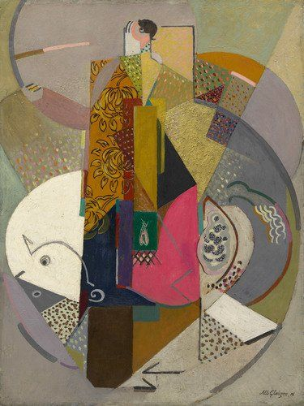
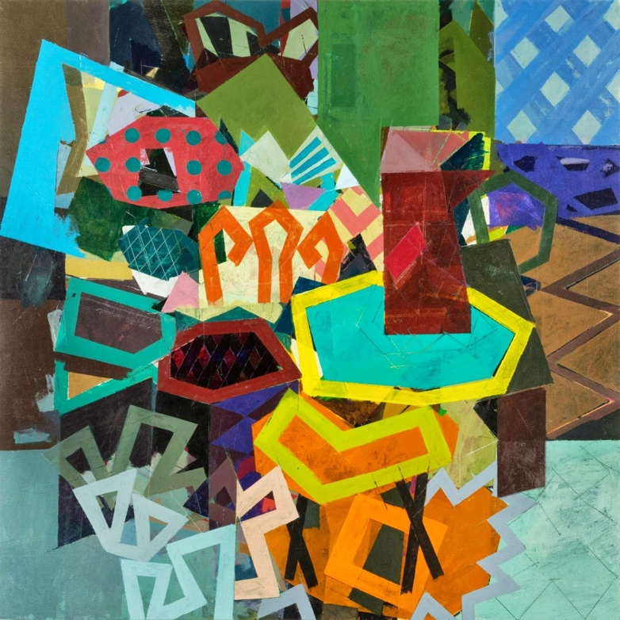

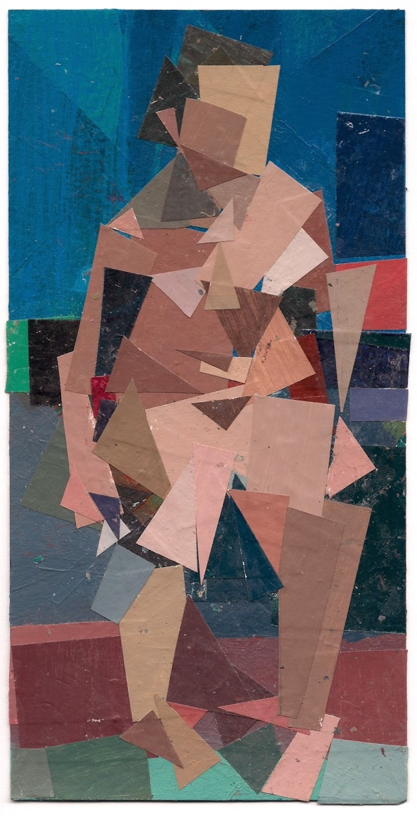

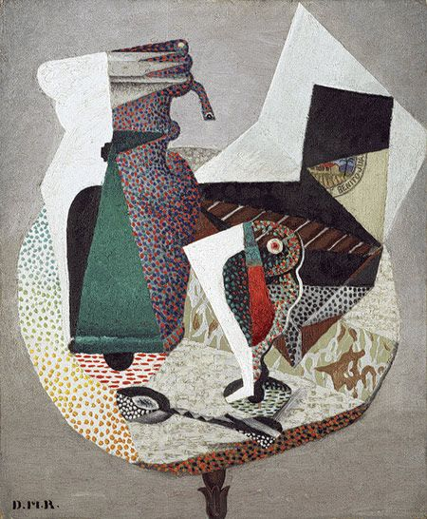

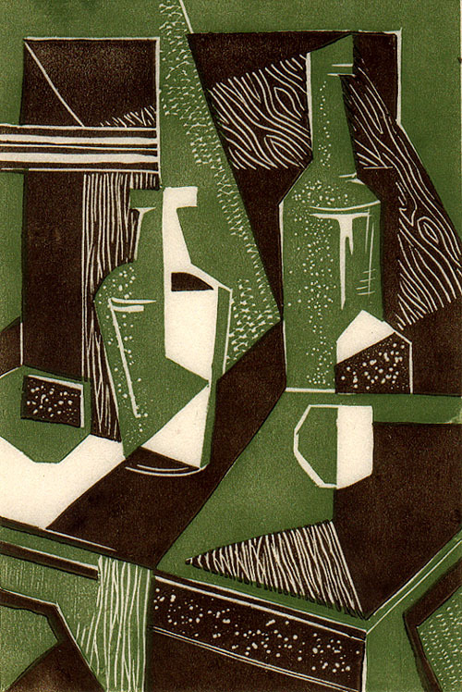
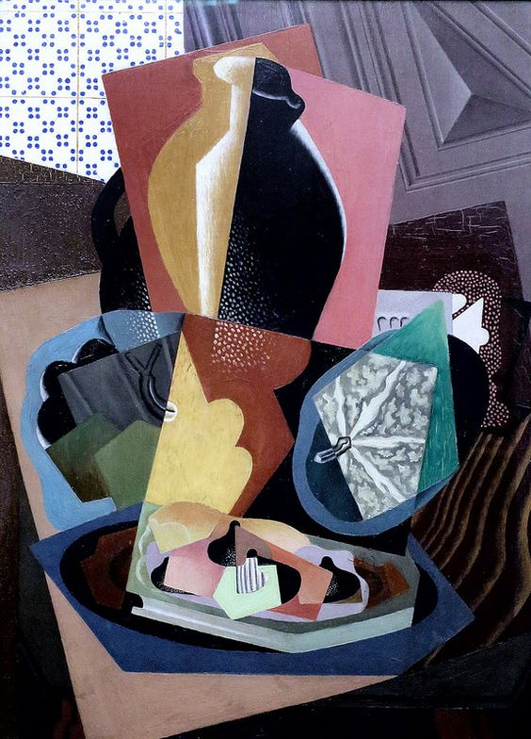

Use Adobe Photoshop CC and your own images to create a ‘digital’ still life for your advanced visual enquiry.

Create a File in Photoshop > A3 > Landscape.

Use selection tools to create Abstract Shapes and Layers to montage and collage imagery together.

Experiment with Opacity in the Layers Palette; stack multiple layers on top of each other!

Recolour imagery Black & White or a specific colour in accordance with your colour palette development.

MONTAGE
COLLAGE

SCAN DRAWINGS & ADD TO THE MIX

USE ABSTRACT SHAPES; think CUBISM, add elements of natural & man-made.

USE BRUSHES and the BRUSH SETTINGS to create texture.

File > Save As > .psd file @ 300dpi

File > Save As > .jpg file to print

