A CRITICAL ANALYSIS OF SUSTAINABLE FESTIVALS: IS THE DESCRIPTION ‘DIRTY FESTIVALS’ FAIR?
Nathan Stephens
1907774
2020

Declaration

This work has not previously been accepted in substance for any degree and is not being concurrently submitted in candidature for any degree.
Signed ……………………..
Sate ………………………..
STATEMENT 1
This dissertation is being submitted in partial fulfilment of the requirements for the degree of BA.
Signed ……………………..
Date ……………………….
STATEMENT 2
This dissertation is the result of my own independent work/investigation, except where otherwise stated.
Other sources are acknowledged by references. A bibliography is appended.
STATEMENT 3
I hereby give connect for my dissertation, if accepted, to be available for photocopying and for interlibrary loan, and for the title and summary to be made available to outside organisations.
Signed ………………..
Date ………………….
STATEMETN 4
I hereby give connect for my dissertation, if accepted, to be available on the university’s IT system to those who have consent to use the system.
Signed ………………
Date………………….

Acknowledgments

I dedicate this dissertation to my family who have supported me through the highs and lows of my university time in every way possible to help me complete my degree of the best of my ability. This includes my grandmother Irene Hitchens who passed away in 2016, but always believed in me.
I would like to thank the friends I have remained with through the whole of my education. These friends have supported me not only academically but in general life. As well as those I have gained in my university years.
I would especially like to thank Caroline Jawad for being the best possible advisor I could have worked with during this dissertation.

Covid-19 statement

After the UK implemented a 24-hour curfew in March 2020, UWTSD took steps to support the research student and research during the curfew and University building closures.
Formal supervision meetings continued as much as possible and arranged via suitable meeting software and documents shared electronically.
Some research was at greater risk to delays, for example projects requiring physical presence to undertake interviews, fieldwork or data collection. Supervisors and research students urgently reviewed their research plans. UWTSD understands that some students’ projects and dissertations were planned to require in-person research and data collection that is not possible in this period of remote learning. Digital research activities that advance the studies, were prioritised. If it was no longer possible to continue with the existing plan then consideration to changes to the project plan should be considered to offset, wherever possible, undue future delays to the project/dissertation submission. All fieldwork conducted by students occurred remotely using electronic means wherever possible.
The personal impact for me was threefold. Firstly, I had to conduct all interviews across a digital medium and that may have had an impact because it is likely I may have elicited more extensive responses face-to-face. Secondly, I am classified as a key worker, a Tesco employee and I was required to step up to considerably more shifts, and longer shifts at the store. I covered for numerous colleagues, both colleagues shielding and colleagues with Covid-19 symptoms. The majority of my shifts were night shifts, and this certainly had an impact on my ability to study, losing my regular sleep pattern. Thirdly, I was anxious about the pandemic, concerned for my family and friends during these very uncertain times. I will often wonder what I could have produced if things had not been shattered by Covid19, a lockdown and the tremendous fear factor.

Abstract

The overall aim of this dissertation was to gain an insight into the environmental impacts of festivals and evaluate the significance of minimising these impacts through discovered sustainable methods for festival goers to adopt. From this an evaluation of the term ‘Dirty Festivals’ was completed.
The researcher conducted a detailed literature review on gaining an understanding of the vast amounts of impacts music-festivals have on the environment. The findings and themes that emerged from the review enabled the researcher to underpin questions in the interview.
Specifically, online interviews were carried out using Facebook. The purposive sample consisted of two sets of participants, the first being festival-goers (12) and the second being festival-workers (3). The responses linked to the findings of chapter two. The themes concluded with the research which later allowed for recommendations were as follows:
Theme one, the overall thoughts and opinions of the festival-workers were practically identical to the festival-goers.
Secondly, cultural/social experience is a significant factor in this dissertation.
Thirdly, everyone needs to do more.

Contents
Chapter 1 12
1.1 Introduction 12
1.2 Impacts of ‘Dirty Festivals’ 15
1.3 Background 17
1.4 Demographics 20
1.5 Sustainability and music-fetsivals 22
1.6 Understanding the spectrums of sustainability 23
1.6 Rationale 24
1.7 Aims and Objectives 25
1.8 Structure 25
1.9 Conclusion 26
Chapter 2- Literature Review 27
2.1 Introduction 27
2.2 Sustainability 27
2.3 Environmental impacts 28
2.3.1 Transport 29
2.3.2 Waste 31
2.3.3 Energy 33
2.3.4 Land Damage 34
2.3.4 Noise pollution 34
2.4 Measuring environmental impacts, who does the measuring and why? 35
2.5 Festivals as a force for change 36
2.7 Conclusion 37
Chapter 3 Methodology 39
3.0 Introduction 39
3.1 The Research Onion 40
3.1.1 Philosophy 40
3.1.2 Research Approach 41
3.1.3 Research Strategy 41
3.1.4 Time Horizon 42
3.1.5 Techniques: data collection and analysis 42
3.2 Sample 49
3.3 Reliability and validity 50
3.4 Limitations 51
3.5 Ethical considerations 51
3.6 Conclusion 52
Chapter 4 Data analysis 53
4.0 Introduction 53
4.1 Data Analysis 53
4.2 Methods 54
4.3 Demographics 54
4.4 Festival attendance 55
4.5 Travel methods 56
4.6 Sleeping arrangements 57
4.7 Waste disposal 59
4.8 Environmental impacts 59
4.9 Sustainability 60
4.10 Festival responsibility and policies 62
4.11 Impacts 65
4.12 Initiatives 66
4.13 General comments and questions 66
4.14 Festival worker analysis 67
4.15 Findings 73
4.16 Conclusion 74
Chapter 5 Conclusion and recommendations 75
5.1 Introduction 75
5.2 The achievement of objectives; 75
5.3 Main findings 75
5.4 Recommendations 76
5.5 Limitations 77
5.6 Further research 78
5.7 Conclusion 78
Self reflection 80
Final summary 80
Bibliography 81
Appendices 89

List of figures

Figure 1.1 Pie chart of festival-goers reasons for attending music-festivals. Available from: Ticketmaster (2019). ………………………………………………………………10
Figure 1.2 Ranked filthiest UK Festivals. Available from: (SpaSeekers 2020). …..11
Figure 1.3 Perceptions of possible music-festival impacts on the environment. Available from: AGreenerFestival (2019). …………………………………………… 14
Figure 1.4 Waste diversion of music festivals. Available from: Transitions2Earth (2019). ……………………………………………………………………………………14
Figure 1.5 Glastonbury attendance over 40-year period. Available from: BBC News (2010). ………………………………………………………………………………………16
Figure 1.6 Glastonbury Ticket selling figures 1970-2017. Available from: Tomas (2018). ………………………………………………………………………………………17
Figure 1.7 Illustration of the age of festival goers compared to the UK average. Available from: Ticket Master (2019). …………………………………………………19
Figure 1.8 Differences in environmental concerns relative to age category. Available from: YouGov (2017). …………………………………………………………………….19
Figure 2.1 Visualization of the triple bottom line 3 components. Available from: University of Wisconsin (2020). ………………………………………………………..26
Figure 2.2 Glastonbury’s Energy Policy. Available from: Appendix ‘3’. …………27
Figure 2.3 Alternating transport modes emissions. Available from: Reality check (2019). ………………………………………………………………………………………29
Figure 3.1 ‘The Research Onion’. Available from: Saunders, et al (2016). ……….38
Figure 4.1 Festival attendance. ……………………………………………………….53
Figure 4.2 Most visited festivals of sample. …………………………………………54
Figure 4.3 Transport methods used by festival goers. ……………………………….55
Figure 4.4 Percentage of festival-goers who take their tent home. ………………56
Figure 4.5 Festival-goer knowledge on environmental impacts on music-festivals. .57
Figure 4.6 What a sustainable festival looks like/ means to festival-goers. ………59
Figure 4.7 Opinions on what a responsible music-festival looks like. ……………..61
Figure 4.8 Opinion of the most harmful impacts. ………………………………….63

List of tables

Table 1.1 Size and importance of the music-festival industry (Stephens,2020). ….18
Table 1.2 Sustainable practises at place in Glastonbury, Reading and Creamfields festivals (Stephens, 2020). Full details available from: Appendix’s 1-3. ……………22
Table 3.1 Festival-goers matrix. (Stephens, 2020). ………………………………….42
Table 3.2 Festival-workers matrix. (Stephens, 2020). ………………………………..44
Table 4.1 Matrix analysis of festival worker questions. (Stephens, 2020). …………65

Chapter 1

Introduction

Festivals are big business. Sweney (2019) stated that festival-going in 2019 was up 23% to 4.9m people and festivals are worth £1.1b to the UK economy. Also, in 2019, the Fast Company website used the term ‘the dirty festival business’ and asked the question if music festivals can go from being garbage generators to sustainable innovators. This dissertation seeks to understand and analyse experiences and perceptions of festival goers regarding music festivals as sustainable events. The Fast company website (2019) discusses that businesses, big and small, must demonstrate the value they bring to society and persuade everyone that they operate responsibly. This dissertation will explore the term ‘dirty festivals’ and seeks to make an unbiased judgment on the accuracy of this description.
With an increasing demand for UK music festivals, a growing concern for a sustainable planet earth and an awareness of responsibility, it is timely to conduct this investigation. In the Fast Company article, there is an acknowledgement that music festivals leave a bad ecological footprint (fast Company 2019) and it is vital to this dissertation that what both music festival management and festival goers can do and actually do. Therefore, this dissertation’s main focus is the phenomenon of the sustainable festival.
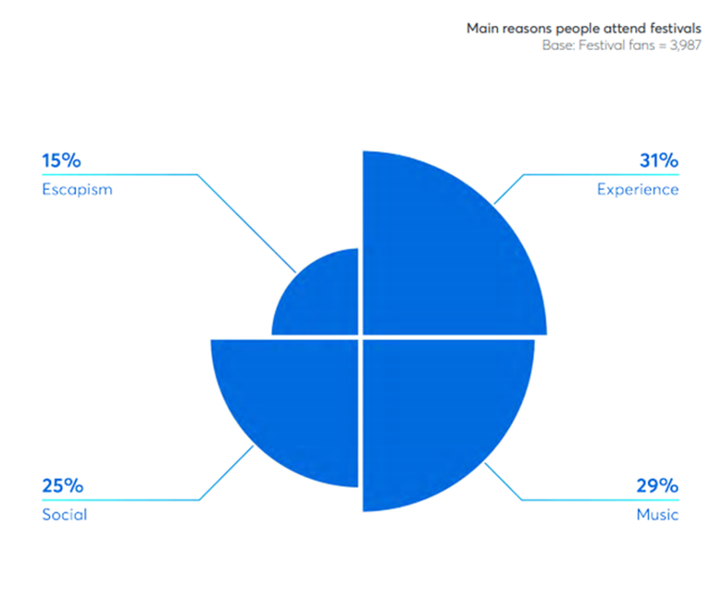

Figure 1.1 Pie chart of festival-goers reasons for attending music-festivals. Available from: Ticketmaster (2019).

One side of this dissertation that could have been explored in detail was the cultural aspect of the festival experience, the researcher has identified this as being a key topic area. Figure ‘1.1’ above supports this. However, due to time and word limitations this dissertation has not set out to explore this area and focus purely on the environmental aspect of festival implications.

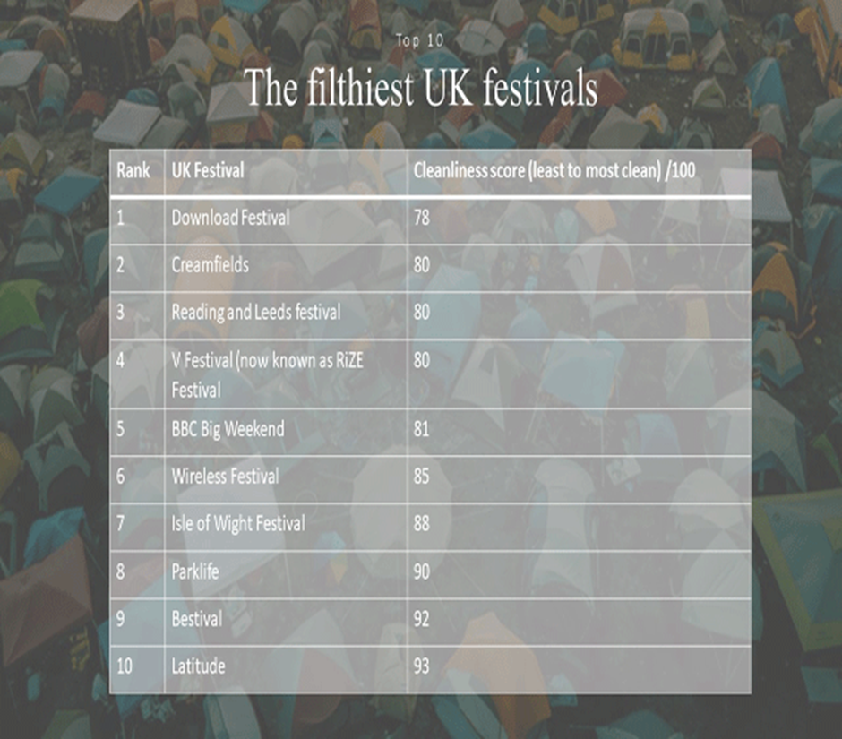
Figure 1.2- Ranked filthiest UK Festivals. Available from: (SpaSeekers 2020).
The figure above from SpaSeekers (2020) has helped this researcher focus on specific festivals relative to how ‘dirty’ they are. A nationwide survey of festival goers revealed the festivals where Brits stay clean the least (ibid). This dissertation will be exploring the term as not solely as being clean or unclean, but the degree to which these festivals act sustainably. As seen Creamfields and Reading are among the highest rated on this list, both scoring 80. This dissertation will seek to examine what literature means when describing these festivals as ‘filthy’. Notably Glastonbury is not listed above, no information was provided by the source on the festival. This could indicate it not being a ‘dirty’ festival. However, due to its sheer size in the market and relevance through a range of literature, the festival will be also focused on, meaning this dissertation can make its own judgment.
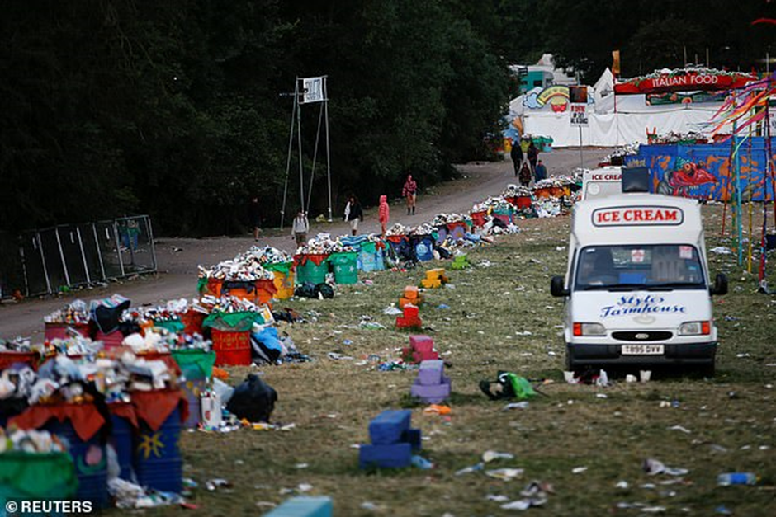
Image 1.1 Aftermath of Glastonbury. Available from: Atkinson (2019).
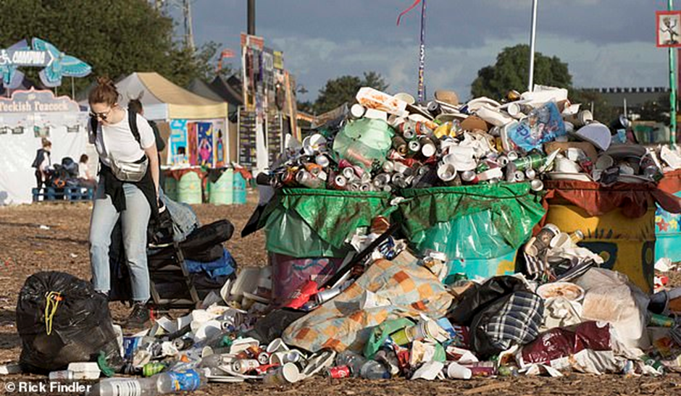
Image 1.2 Aftermath of Glastonbury. Available from: Atkinson (2019).
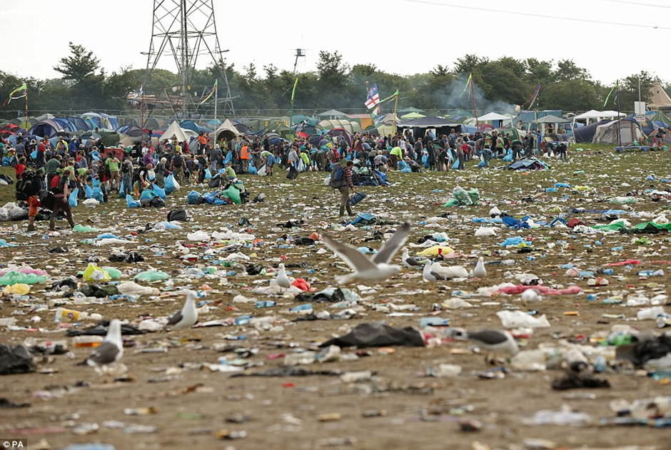
Image 1.3 Aftermath of Glastonbury. Available from: Atkinson (2019).
The above powerful images depict the significant waste that remained after the Glastonbury festival. The amount of waste left over not only looks considerable and ‘Dirty’ but has serious environmental implications later explored.

1.2 Impacts of ‘Dirty Festivals’

Waste is just one of the negative impacts of festivals. Although this impact is one of the main negative implications of music-festivals, this dissertation seeks to discover the full range of environmental Impacts. Figure ‘1.3’ below briefly describes a handful of the later explored impacts.
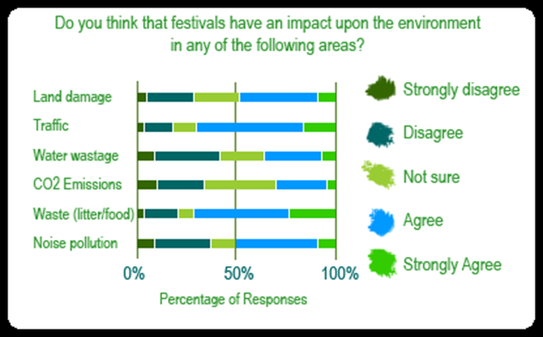
Figure 1.3 Perceptions of possible music-festival impacts on the environment. Available from: AGreenerFestival (2019).
Campaigners are calling for a £25 “tent tax” for summer festivals as thousands of festival-goers continue to leave behind their ‘Uber-cheap’ supermarket tents (and whatever detritus lies inside them) for others to clean up afterwards (Reading and Leeds festivals (2019). These tents are a large contributing factor to the overall amount of waste.
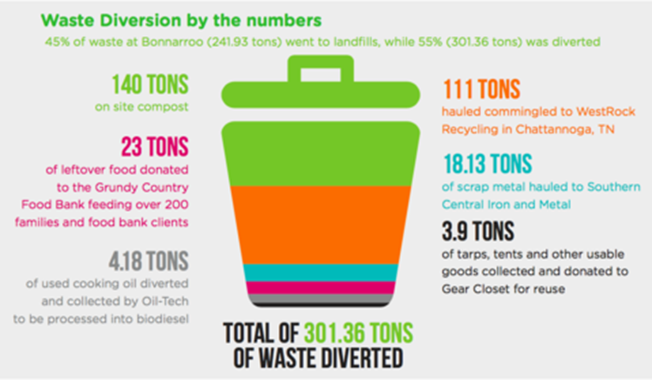
Figure 1.4 Waste diversion of music festivals. Available from: Transitions2Earth (2019).
Plant (2011) argues most festival goers can identity the positive externalities including social, economic and cultural benefits but the negative spill over effects of abandoned tents and camping equipment, waste, has a negative impact on the landscape, as well as the possible environmental impacts seen in Figure 1.2. Festival-goers’ private actions create high costs of running the festival, as litter and abandoned tents are destined for landfill and a high cost for the environment (ibid).
Concerns about the environment are now mainstream. There is a need for a revaluation of the way we enjoy festivals, in order to find the balance between tradition and environmental preservation. Market leaders like Glastonbury have seen their most environmentally friendly festival to date in 2019. With a trend of avoiding heavy plastic use and a large increase in tent re use compared to previous years (Mixmag, 2019).

1.3 Background

In 2018 Mintel estimates the value of the UK music concerts and festivals market to be £2,459 million. This growth is being driven by more festivals, higher ticket prices and a rise in the number of music tourists from overseas (Mintel, 2018). The large demand for music festivals also shows no signs of slowing, Live Nation Entertainment recently achieved nine consecutive years of growth, according to the company’s fourth quarter and full year 2019 earnings report (Forbes, 2020). The below figure demonstrates the markets growth through one of the market leaders Glastonbury festival.
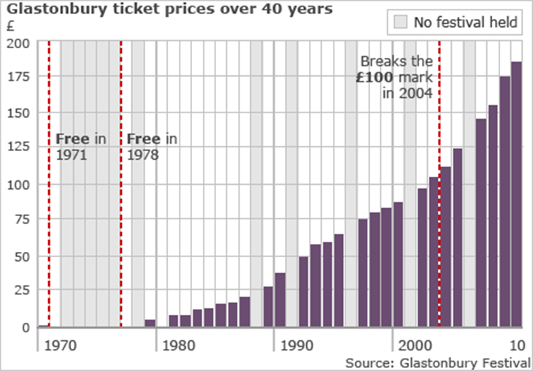
Figure 1.5 Glastonbury attendance over 40-year period. Available from: BBC News (2010).

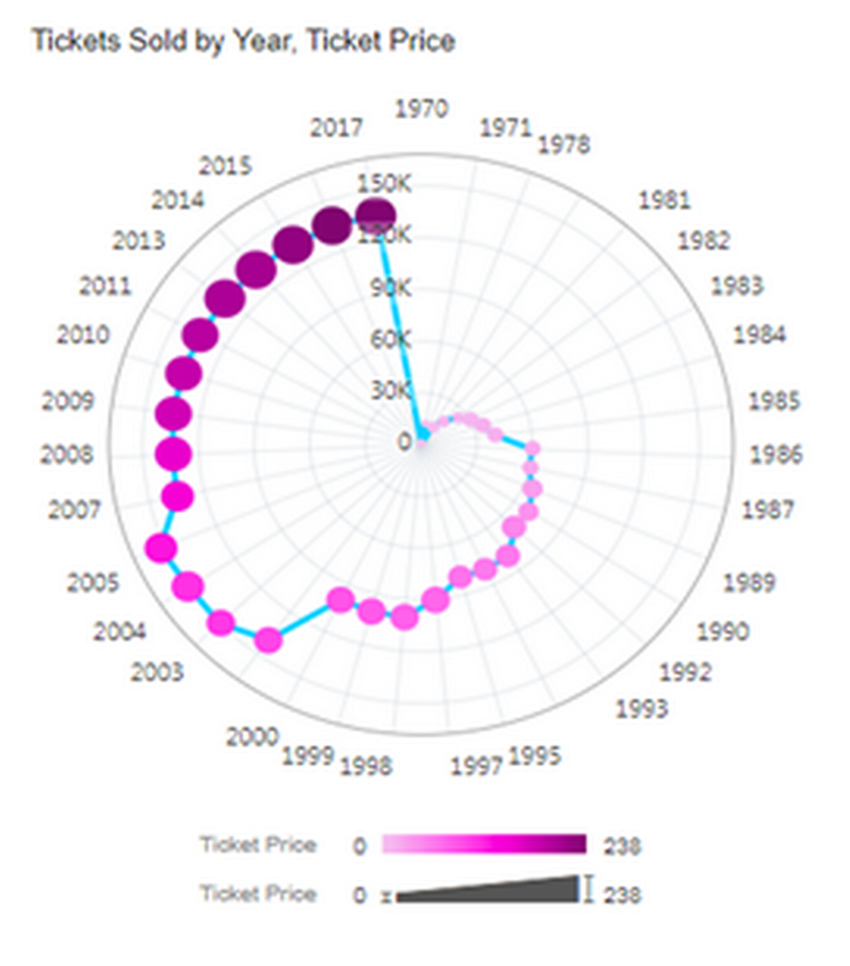
Figure 1.6 Glastonbury Ticket selling figures 1970-2017. Available from: Tomas (2018).
The above figure demonstrates the demand for festival tickets relative to price. As seen in recent years ticket prices have remained around the 120- 150 thousand mark while festivals are also maintaining a high-ticket price of around £238. Glastonbury festival specifically demonstrates the high market demand through how quickly tickets sell out each year. For 2020’s Glastonbury festival 50-year anniversary, tickets sold out in 34 minutes, with over 2.4 million people signing up for a chance to secure a ticket (Bakare, 2019).

Festival | Ticket Price | Capacity | Net worth
Creamfields | Ranging from £195 to £360 (depending on level of ‘luxury’ and days spent camping. | 70,000 | Creamfields Limited: £594,534.00
Reading | £232 (Varying on number of days) | 85,000 | Reading Festival Limited: N/A
Glastonbury | £248 (Varying on number of days) | 120,000 | Glastonbury Festival Events Limited: £6,591,865.00

Table 1.1 Size and importance of the music-festival industry (Stephens,2020).
A large factor that drives these large sales seen with the industry is down do repeat purchases within the market. IQ Map (2020) described the ‘Moderate’ festival-goers as someone who attends 2 festivals a year, making up 34 % of all festival-goers. Whereas ‘Festival Super Fans’ (28% of all festival goers) attend an average of four annually. The overall profit of these music-festivals also show no signs of slowing. A reported profit of reading festival for example being at £7.266,551 in 2018 up from £4.167,880 the previous year (Music Week, 2019). This adds to the relevance of their ability to be sustainable, generating such large sums of money businesses should give back. Each festivals profit would be included in the table, however a reliable figure for Glastonbury and Creamfields could not be found.

1.4 Demographics

It is important to take into consideration the basic demographics of these festival goers. This will allow this researcher to gain an insight into what age category is best suited for the primary research sample.

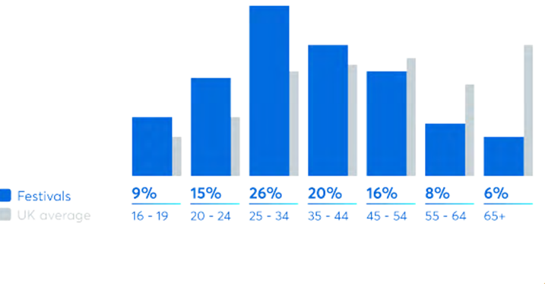
Figure 1.7 Illustration of the age of festival goers compared to the UK average. Available from: Ticket Master (2019).
This figure shows the ages of festival-goers who attend UK music-festivals. The sample of research participants will be drawn from the figure, using ‘20-24’ category and this will be discussed in chapter 3. This age group specifically aligns with the researcher who identifies with festival-goers from this age bracket, secure their participation and this will facilitate the objectives of this dissertation.
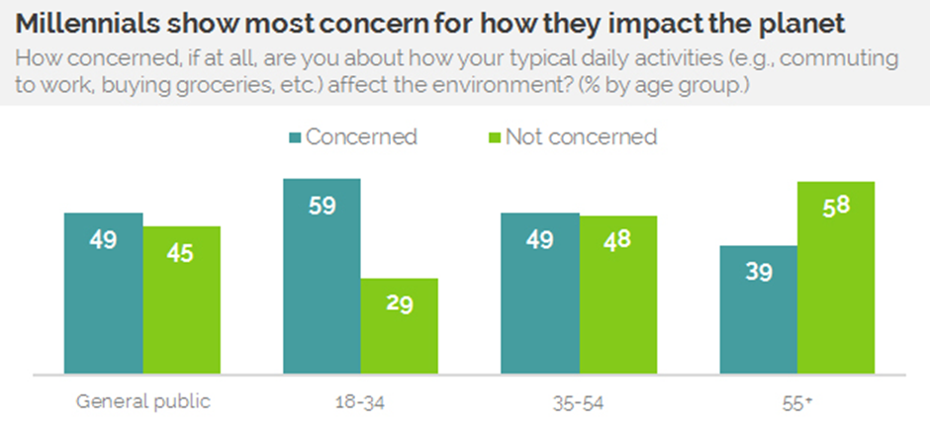
Figure 1.8 Differences in environmental concerns relative to age category. Available from: YouGov (2017).
As seen from the above figure, a trend of the generally the older you are the less you are concerned about the environment is seen. Specifically, the age of 18-34 has a much larger percentage concerned with the environment. This means the chosen sample will be expected to have a much more in-depth feedback that potentially an older sample.

1.5 Sustainability and music-festivals

Parkinson (2018) discusses that it is now the time for sustainability, highlighting the increased green significance of recent Glastonbury festivals in 2019- key environmentalists Sir David Attenborough and Greta Thunberg, attended Glastonbury. They both made use of the large platform to speak about the need to be sustainable in the current climate, specifically looking at single use plastic and waste. Sir David Attenborough stated “And now this great festival has gone plastic-free. It means that a million bottles of water have not been drunk by you in plastic bottles, Thank you” (Hall, 2019). Although Greats speech was not mentioned, there were murals of her face with the slogan: “What would Greta do?” (ibid). Zifkos (2015) considered sustainable festivals as conceptually different––although quite akin––to “green” cultural events, because sustainability should mean much more than merely embedding “green” or “eco-friendly” practices into the festival management.
Festivals have been attempting to incorporate sustainability into the practices of festival goers. An example of this includes a Norwegian multinational recycling company partnering up with UK retailer Co-op to improve festival sustainability by launching a deposit-return scheme trial with reverse vending machines at Co-op pop-up stores at seven major UK music festivals this summer, including Reading, Glastonbury and Creamfields. To participate in the trial, festival-goers pay a mandatory 10p deposit when they purchase plastic bottles, and when this is returned they can either turn the 10p into a voucher or donate to a selection of environmental agencies (Williams, 2019).

Bristol Green Capital (2015) highlights the significance of these smaller and simpler scaled solutions to sustainability. Events are fast paced, high intensity operations which require considerable planning, meaning event organisers chose the path of least resistance to delivery events on time and budget. Although environmental concerns are becoming increasingly important they still appear lower down the list than many other considerations.

1.6 Understanding the spectrums of sustainability

Sustainability has been defined in many ways, but the most frequently quoted definition is from Our Common Future, also known as the Brundtland Report: "Sustainable development is development that meets the needs of the present without compromising the ability of future generations to meet their own needs." (Reid, 2013). Applying this to festivals would be to understand the needs of these festival goers while ensuring minimum impact of the environment and thus future festivals. Further, sustainability will be explored in more depth in chapter 2.
It is important to examine the definitions, as employed by different festivals. It is also important to evaluate what sustainability looks like at festivals and furthermore, it is important to evaluate what sustainability means in the festival environment. In the UK alone there are more than a thousand festivals taken place annually, the vast majority being music festivals (Financial Times, 2017).
Festival | Quote | Primary sustainable policies/ initiatives | Number of online pages dedicated to sustainability and the environment | Star Rating out of 5
Glastonbury | For Glastonbury Festival to be sustainable, we all have a duty to make sure the land on which it stands is looked after. | Using water responsibly (turn off taps and bring water bottles), encouraged to take tent equipment home and encouraged to use toilets | 11 | 3
Reading | However, instead of worrying about the future, we can start making it better if we work together! | Single use plastics, Public transport usage and campsite waste recycling including tents | 14 (Smaller pages) | 2
Creamfields | Empowering the Earth’ is our approach to reduce our environmental impacts. | Inclusion of green suppliers minimising food waste, re use of grey water and public transport usage | 1 | 1

Table 1.2- Sustainable practises at place in Glastonbury, Reading and Creamfields festivals (Stephens, 2020). Full details available from: Appendix’s 1-3.

1.6 Rationale

The researcher conducted a content analysis of the information produced by the above-named festivals. A content analysis is a research method that can be used to find patterns in text (Krippendorff, 2018). Whilst this information is normally best-suited to analysis, it was necessary to find out through early fieldwork, how festivals were engaging with sustainability practices. Creamfields has significantly less information on policies and initiatives available, the festival is the only one out of the three to include more information on what the organisers themselves are doing over what we as festival-goers can do. In the appendix each of the three festivals sustainable policies can be found. All these festivals are based in the UK and are well established in the market. The usage of these festivals will allow this researcher to narrow the focus and gain a more detailed case study like approach to the research. The usage of the three festivals avoid generalizing from a single case, allowing for a more valid set of results and being more appliable to scientific development (Flyvbjerg, 2006).
As festivals have increased popularity, academics have gained an interest in events and music festivals, and around their impacts in particular. With many focusing research on their management and evaluation (Collins, et al, 2017). A Google Scholar Search shows approx. 95,000 results on sustainable festivals (Google Scholar, 2020).
Along with the increase in demand for music-festivals, there is an increased awareness and demand for sustainable festivals that leave little damage, minimal waste, and minimum impact on the environment (Perrett, 2019).There is little clarity however on what a sustainable music-festival should look like, what responsibilities the festival-management and festival-goers have, and this is where this dissertation seeks to contribute a greater understanding to. There are no government directive on what a sustainable festival should look like. It is important to understand if festivals are just making this up as they go along or not. Generating such large sums of money these festivals have a responsibility to contribute to environmental progress accordingly and not half-heartedly.

1.7 Aims and Objectives

The overall aim of this dissertation is to gain an insight into the environmental impacts of festivals and evaluate the significance of minimising these impacts through discovered sustainable methods for festival goers to adopt. From this an evaluation of the term ‘Dirty Festivals’ can be completed.
Objective1- To conduct an extensive literature review around the topic area of environmental impacts seen from music festivals.
Objective 2- To conduct primary research to understand festival-goers and festival-workers perceptions on dirty/sustainable festivals.
Objective 3- To synthesise extant literature and primary research to make overall recommendations for festival goers to adopt.

1.8 Structure

Chapter two will follow, analysing available academic literature around the topic area and thus identifying any gaps that can be furthered explored through the primary research. This will overall result in the answering of objective 1.
Chapter three will include a detailed methodology of the research that will be conducted from the literature review. The most appropriate methodology approach will be undertaken to conclude the most valid set of data responses. This researcher will be looking at the perceptions of festival goers.
Chapter four will involve the analysis of the data collected through online interviews, making use of programmes like ‘NVivo’ and thus complete the answering of objective 2.
Chapter five will finalize this dissertation concluding overall ideas and themes while answering objective 3. Further research potential will also be added in this chapter.

1.9 Conclusion

This chapter has allowed an initial insight into the topic area of music festivals while including a rationale for the proposed research. Aims and objectives of this dissertation have been included also to allow the reader an insight into the purpose of this research. Finally, the structure of the remaining dissertation has been detailed to allow navigation to the reader.

Chapter 2- Literature Review

2.1 Introduction

The purpose of this chapter is to carry out a review of available literature regarding the chosen topic area of music festivals focusing on the environmental impacts that they produce. This will allow the researcher to develop an understanding of the range of impacts music-festivals have on the environment and not just those mentioned in chapter 1. Upon completion of this chapter, objective 1 will be successfully achieved:
To conduct an extensive literature review around the topic area of environmental and social impacts seen from music festivals.
A range of sources will be made use of to complete this objective, including academic journals, relevant textbooks and newspaper articles. Notably, all sources will be relevant and of a formal nature to ensure an appropriate literature review is conducted. A consideration of the literature in this chapter will also allow the researcher to design the chosen data collection method of primary research within chapter three.

2.2 Sustainability

The theory of sustainability comes under the Corporate Social Responsibility (CSR) umbrella. A growing number of companies develop their corporate social responsibility in response to a variety of social, environmental and economic pressures (Colombo and Gazzola, 2013). This dissertation will focus on the environmental element of this theory. These pressures will be identified in this literature review as impact examples in the form of environmental implications festivals provide, ignoring the already well-established economic area of festival literature, and the often-sensitive social side. The goals of CSR are typically aimed at improving organisations like festivals triple bottom line (TBL), referring to 3 types of performance metrics: economic, social and environmental (ibid). For music -festivals to achieve a positive environmental performance metric, organisers will need to understand and adapt to the large number of environmental pressures listed in this chapter.
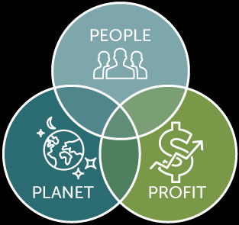
Figure 2.1- Visualization of the triple bottom line 3 components. Available from: University of Wisconsin (2020).
The figure above visualises the concept of John Etheridge’s TBL, with the arrow marking where sustainability would be achieved. Although chapter one established the profitability of music-festivals relating to the profit performance metric (which was originally the intention of the TBL model through accounting), this dissertation and chapter in particular will explore the ‘Planet’ performance metric only, to gain an insight into the environmental pressures. It is argued that both the worth of an event, and its impacts, should be evaluated using a triple‐bottom‐line (TBL) approach (Getz, 2009). The concept of measuring/ calculating the TBL can be difficult, however. The 3Ps do not have a common unit of measure, however the focus of this dissertation is only environmental, so an appropriate method would be either be to consider ecological footprint or carbon footprint later explored in chapter ‘2.4’.

2.3 Environmental impacts

Not all environmental impacts can be explored due to the time and word limit of this dissertation. However key ones in the researchers subjective decision making linked to the ‘dirty’ element will be analysed and further explored with primary research.

2.3.1 Transport

Researchers such as (Stone, 2009) describe transport as being a large contributing factor of environmental damage. Transport is deemed as ‘large’ due to its significant impact compared to a lot of alternate environmental impacts that may not contribute as much (ibid). Notably, the exploration of transport will be only applied to festival goers travelling to and from these festivals and not taking into consideration the less significant travel aspects of management transportation for example. Travelling to and from music festivals had environmental impacts (ibid). However, this article does highlight the attempt made by Glastonbury in suggesting car sharing as a method to deal with emissions. The average car occupancy to festivals was between 2.36 to 2.77 people per car with the average found to be 2.6 (Julies Bicycle, 2009). Wright (2020) looks into how much transport adds to the UK’s Carbon Footprint, transport is described as the country’s most polluting sector. According to (ibid), decarbonising transport would eliminate 26 per cent of UK CO₂ emissions. This means if festivals were to attempt a level of transport decarbonising, their overall carbon footprint is likely significantly reduce similarly.
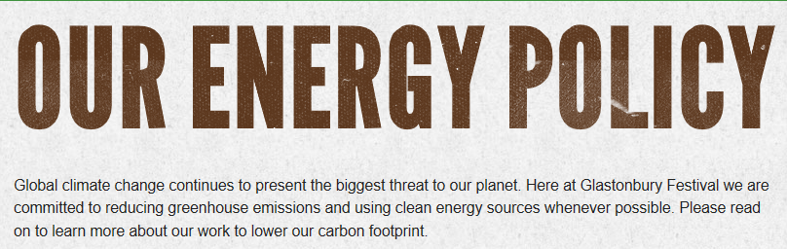
Figure 2.2 Glastonbury’s Energy Policy. Available from: Appendix ‘3’.
One area of transport that is particularly harmful to the environment that has been highlighted by literature is the congestion that comes with events. Fernando (2019) describes event congestion as ‘non-recurring’ compared to the everyday rush hour congestion roads are familiar with, meaning additional consequences and complications will follow. When the number of vehicles (density) increases on the road, the speed decreases, and the time of displacement is prolonged. This results in an additional emission of air pollution as well as noise pollution. (ibid). Planned events are often held in short periods of the time, therefore, traffic impacts caused is temporary, so solving transportation problems caused by planned special activities will not require a permeant increase of road capacity (ibid). This means alternative temporary methods will need to be used. Glastonbury made use of laying 4 km of stone farm tracks and changing layouts to reduce congestion in 2017 (Echo, 2019).
There are alternate methods of reducing transport environmental damage festivals have made use of. The vast majority of festivals promote and encourage green transport methods, this can be seen from the festivals environmental polices (Appendix’s 1-3). Predominantly festivals encourage using coaches as transport to and from the festival locations. ‘Big Green Coach’ for example is the official travel partner of Creamfields (Big Green Coach, 2020). The company provides transport to many main stream, events including a range of festivals like Creamfields. Not only will this decrease congestion and emissions, for every customer who books to travel with Big Green Coach, the company sponsors and protect 5 square foot of Amazonian Rainforest for 10 years. This has resulted in over 1,200,000 square foot of Rainforest in Peru being protect by Big Green Coach for the next 10 years since the commitment was started in 2009 (ibid).
Neale, G. (1999) has highlighted the significant positive of train transport as a green alternative to festivals due to their middle to long travel distances. Trains may be more suited for festival consumers due to the previous point being made of festivals being primarily located long distances away from larger populated areas.
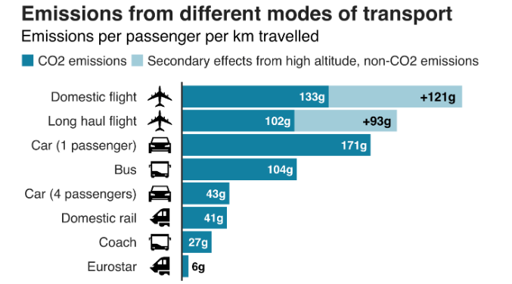
Figure 2.3 Alternating transport modes emissions. Available from: Reality check (2019).
Notably the three travel methods highlighted with arrows that have been previously discussed to be sustainable methods of transport for festival goers to adopt, are all listed as low emitters. Although the more polluting transport methods listed in the figure such as flights would not be used as much by festival-goers, some festival-goers still make use of them to travel to overseas festivals, this is demonstrated later in the research findings. This dissertation also focuses purely on UK festivals, so all these lesser emitting transport methods in figure 2.3 will be more commonly used by UK festivals, deeming them as potentially more sustainable compared to overseas festivals relative to transport. Reality check team (2018) looks into the consumer behaviour of not wanting to take public transport due to the significance of the number of items taken into the festivals and the burden on these consumers. This could mean an expected lower number of festival goers adopting the more sustainable public methods like domestic rail.

2.3.2 Waste

As mentioned in chapter 1, waste is one of the negative impacts from festivals leading to the description of ‘Dirty festivals’. By waste this dissertation uses the term to cover the left-over general waste from festival-goers and not alternative understandings such as faeces Roughly 23,500 tonnes of general waste are produced annually at UK music festivals (Reality check team, 2018). Although many festivals will have recycling efforts in place, the article goes on to highlight around a third is recycled, while the rest goes into landfill. To put this in comparison, Wales had the highest UK recycling rate in 2017 at 57.6%. It is the only UK country to exceed the EU's target to recycle at least 50% of waste from households by 2020 (BBC News, 2019).
A waste survey on music festivals conducted by campaigners supports this point of the non-recyclable aspect of waste generated. The largest amount of waste generated was residual waste followed by food and kitchen waste and then packaging waste (Martinho, G. Et al. 2019). Although this survey was conducted on a number of green festivals, many researchers support that residual (non-recyclable) waste is the largest waste section from music festivals (ibid). Campsite waste contributes to 86% of total music festival waste, while 71% of this waste can cause ‘lasting land damage to the native flora of the festival sites (Resource, 2014).

2.3.2.1 FG behaviour towards tent waste

According to Ticket Master (2019), camping remains the top accommodation choice for fans (44%). A survey conducted by ‘Love your Tent’ highlighted festival consumer habits towards waste. 60 per cent who said they had camped at festivals admitted to discarding their tents at the event. (Resource, 2014). More than 250,000 tents have been left behind in UK fields from Glastonbury to Reading and Leeds (Reality check team, 2019). The primary reason for this being due to the inexpensiveness and poor quality of tents, almost half of those surveyed (46 per cent) said they paid less than £75 for their tent (ibid). This problem is worsened as when asked if they would change their behaviours in future, 36% said they were ‘unsure’ if their behaviour would ever change, with a similar amount (35%) saying they would ‘never’ change their behaviour (ibid).
The specific problem with this is that tents cannot be recycled due to their complex making of a mix of materials mainly including on-recyclable plastic. The average tent is mostly made of plastic - which is equivalent to 8,750 straws or 250-pint cups (Reality check team, 2019). To tackle this issue, many festivals promote the action of leaving behind used tents to be re used by the less fortunate. However, this is described as a ‘ common misconception’ (Ward, 2018). Although there are attempts of reusing the tents for local charities, ‘Up to 90% gets left behind’ (ibid). Alternatively, ‘Camplight’ is a company that provides pre pitched tents at festivals to stray away from the traditional camping for £7.50 per night. This allows people to travel lighter and also are provided with an air mattress and sleeping bag. On the website, most festival including Glastonbury, Reading and Creamfields can be booked. This would relive all the negative impacts seen from left over tents, as the tents are then collected by representatives (CampLight, 2020). However, this company seems to be under marketed with the researcher personally being previously unaware and little social media presence.

2.3.3 Energy

Peters (2008) compares large scale festivals like Glastonbury and Reading to a city in relevance to the vast amounts of energy they require. Although this source may be seen as outdated, with the increase in demand with the festival market (highlighted on page 9), festivals will need even more energy to adapt. The degree to which a music festival effects the environment through energy requirements comes down to the source of the energy and being energy efficient. Energy efficiency means using less energy to provide the same service (Clark, 2012). However, this simplistic understanding of the term does not take into consideration the range of demands from different festival experiences. Creamfields festival for example is known for its electronic themes and light shows that will specifically require more energy that most traditional festivals.
Glastonbury has been highlighted in a range of literature sources to be leading the way in sourcing clean energy and being more energy sufficient (Blue and Green Tomorrow, 2020). One of the most impactful changes was the installation of 1500 square meters of solar panels on the roof of the cattle shed of the farm, which saves around 100 tonnes of CO2 emissions each year. Additionally, another 10-12% of the festival’s fuel is biofuel, which saved another 150 tonnes of emissions in 2015 (ibid). From literature, energy seems to be an impact that festival management are responsible for are and including lack of information on what festivals goers can do themselves. The only notable habit a festival goer can adopt to reduce energy consumption is relative to making use of re-usable chargers for phones.

2.3.4 Land Damage

A more simplistic and direct consequence of music festivals is the damage caused to the areas of land the festivals are based. As previously mentioned by Gibson and Wong (2011) the land the festivals are situated on are usually of a delicate and more vulnerable state. This is because music festivals usually opt for larger greener spaces over more urbanised ones.
One example of this is seen from the 2008 ‘V-Fest’ festival that took place in Weston Park. Two Point-to-Point race meetings that were celebrating their 25h anniversary had been ‘scrapped’ after the ground was left churned up by the festival. The specific problem was that there was a plentiful amount of rainfall during the weekend which allowed for the 85,000 visitors to ‘flock’ the area and destroy the land (Black, 2008). A Greener Festival (2020) makes note of possible methods to minimise the land damage outcome, using trackway to minimise damage of vehicle movement on site and where possible to enhance the environment by planting trees and preserving nature are such examples.

2.3.4 Noise pollution

Unwanted music from outdoor events is considered a form of noise pollution (Parnell and Sommer 2018). The noise pollution form music festivals are described as unique compared to standard form like traffic (ibid). The unique form of noise pollution is said to be down to the fact that a minimum level of noise is required from music festivals to not negatively affect consumer experience. Revisiting the previous discussion of music festivals being traditionally based in more rural landscapes over urban environments. Parnell, J. and Sommer, R., (2018) also discuss the significant difference between the two through noise guidelines. Music festivals are set guideline levels relevant to the nearest residence.
Glastonbury Festival is an example of a festival with a complicated history with noise complaints and locals. NME (2018) made note of the complaints from locals regarding not enough ticket applications being saved for locals in assurance for the consequences locals face from the festival, specifically highlighting the noise complaints. In contrast, Goulding (2017) looked into the problem of Sunfall Festival in London receiving consumer complaints of not getting a high enough level of noise due to restrictions set, addressing the previous point made by Parnell, J. and Sommer, R., (2018) regarding the uniqueness of music festival noise pollution. Sunfall festival is now actually looking to relocate to a more rural setting. Music festivals will inevitably create noise, so the organisers and stakeholders have to assess if the noise disruption is worth the money generated from these festivals.

2.4 Measuring environmental impacts, who does the measuring and why?

Understanding the available measuring techniques for the addressed environmental impacts will allow the researcher to gain an insight into how this can be applied to festival goers in the minimisation of these impacts. Gibson and Wong (2011) discusses that there is no one single methodology of adequately describing and quantifying the range of environmental impact from music festivals, and that a range of techniques should be used especially by large scale festivals.

Ecological footprint is one measuring method. Galli Et Al. (2014) describes this method of analysis as measuring the biologically productive land and sea area that a population requires to produce the renewable resources and ecological services it uses. From this, the large number of festival goers would be the population that require the ecological assets. ‘Ecological Footprint analysis can provide valuable information for festival organisers and policymakers on factors influencing the scale of a festivals’ environmental impact, and the types of strategies needed to reduce the effect of visitor travel’ (Collins and Crispin 2017). This is seen as especially essential for music festivals as they provide a vast range of demands on the environment such as food consumption and waste disposal. The Ecological Footprint is described as a valuable communication and awareness-raising tool as it personalises sustainability by assessing the impact of consumption from a consumer perspective (ibid).
Wiedmann, and Minx, (2008) defines Carbon Footprint as a measure of the exclusive total amount of carbon dioxide emissions that is directly and indirectly caused by an activity. Carbon Footprint measurement can be seen as a vital tool to be made use of in particular to festivals due to the significance of carbon emissions from travelling previously looked at. In the UK, transport accounts for most greenhouse gas emissions at 26%, according to the Office for National Statistics (Reality check team, 2018). The specific problem with the event industry that festivals are within, is that these one of events people typically travel greater distances for over sporting events for example where many support their local teams. A third of festival-goers travel between 25-100 miles for each festival they attend (Ticket master (2019).
Carbon dioxide is harmful to the environment as it is one of the major greenhouse gases. However, the gas is not harmful directly, too much is what is damaging the environment disrupting the sun’s rays and thus heating our planet (Schmidt, Gavin, and David Archer, 2009). Oxford university researchers have analysed the environmental impact of 500 UK festivals and found that, combined, they emit around 84,000 tonnes of CO2 a year (Edwards, 2010). Green Earth Appeal (2020) describes planting trees as a hugely beneficial method to offset the Co2 festivals emit. However, upon evaluating the three case studies of Creamfields, Reading and Glastonbury’s Green policies found in the appendix, there is no mention of this method.

2.5 Festivals as a force for change

In contrast these large-scale festivals can be seen as a platform to increase environmental awareness. The gigantic number of festivalgoers represents a powerful platform to spread a green message (Peters, 2008). Gibson and Wong, (2011) also makes note of the capability music festivals have of spreading a green message. Festivals can provide unique opportunities for people to come together in the celebration and promotion of environmental causes (ibid).
However, this does not necessarily mean that these festivals are applying a positive message to ‘spread’, or even attempting to. Brennan Et,al. (2019) overall discusses the environmental benefits from music festivals, and that some festivals, particularly large outdoor music festivals, are leading in greening their events. The article also addresses the environmental platform point made by Peters (2008), how events might be a vehicle for promoting sustainable behaviour.

2.7 Conclusion

Firstly, an area that is under investigated and explored in the literature was the idea of responsibility regarding the discovered impacts. The idea of whose job it is to make a change with the sustainability of music-festivals is not highlighted. Whether these methods of minimising the environmental impacts is down to the festival-management or festival-goers themselves needs to be addressed.
Secondly, through the range of literature sources, two main areas were addressed in the vast majority of literature, these being waste and travel. Waste was primarily mentioned as a common well known and thought of environmental consequence due to its tangibility. Waste was also mentioned in chapter 1, being a major factor for the description of ‘Dirty festivals’. The consequences of waste seen on many news articles headlines and on social media. Data collection will collect perceptions of waste from festival-goers. However, many sources although highlighted the emissions from transport as being one of the worst factors if not the worst for the environment, it was not as well thought of by consumers.
Thirdly, although there are many mentioned solutions to negative consequences on the environment, there are a limited number if any direct positives from music festivals seen from the literature on the environment. A range of literature describes the indirect capability music festivals have of being a force for change and potential to spread a green message. Research may be needed to look into the degree to which these festivals are actually attempting to spread a sustainable message to its consumer base.
Lastly, the degree to which a music festival effects the environment is largely down to consumer behaviour and not just the festivals themselves, this was a common trend in the literature. More research may also be needed specifically looking at consumer behaviour and willingness to adopt environmentally friendly practises like greener transport methods.

Chapter 3 Methodology

3.0 Introduction

The purpose of this chapter aims to achieve the second objective of this dissertation:
To conduct primary research to understand festival-goers perceptions on dirty/sustainable festivals.
To meet this objective the researcher identified the most suitable methods and methodology to conduct the planned primary research.
Research can be defined as a ‘systematic investigation, including research development, testing, and evaluation, designed to develop or contribute to generalizable knowledge’ (Wipke-Tevis, Deidre, 2001). Due to the sheer broadness and importance of research methodology, Sahay (2016) discusses the importance to conduct it in a strategic manner, the planning and designing stage of research is most important.

3.1 The Research Onion
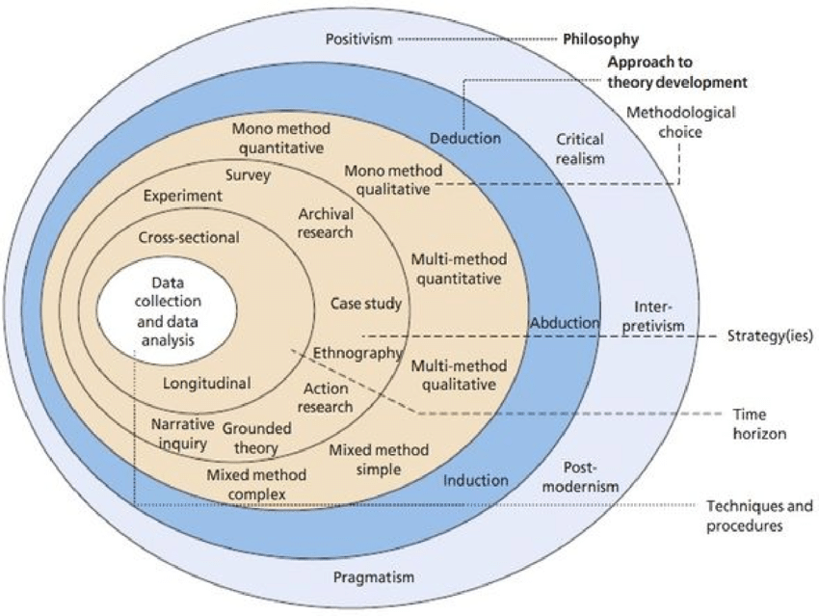

Figure 3.1 ‘The Research Onion’. Available from: Sahay (2016).

As shown in 'figure 3.1' The research onion outlines 'layers' of research that outline different sections of research that have to be taken into consideration for the researcher (Saunders, et al 2016). The researcher has also highlighted in figure 3.1 the 4 steps made in this dissertation. Sahay (2016) describes the onion as crucial to the development of an appropriate research design which is coherent with the objectives and the research questions. This dissertation has considered various stages of the model to plan a sustainable methodology.

3.1.1 Philosophy

Researchers argue there are two main philosophies to address when conducting and planning research, 'Positivism' and 'interpretivism'. Positivism resulted from foundationalism and empiricism; positivists value objectivity and proving or disproving hypotheses. Interpretivism is in direct opposition to positivism; it originated from principles developed by Kant and values subjectivity (Ryan, 2018). In this research a Mono Method has been selected, avoiding the mixed methodology approach of combining both philosophies. Specifically, interpretivism is the most ideal for this study due to the open-ended questions that will be used in the planned interviews providing qualitative data as a result. Qualitative data is non-numerical and refers to the meanings, concepts, definitions, characteristics, metaphors, symbols, and description of things (Mihas, 2019). Due to this dissertation aiming to understand opinions, reasons and motives of festival-goers, interpretivism is key. Interpretivism prefer to generate a deeper and richer understanding of the phenomenon and behaviour (Calhoun, Et, al. 2007).

3.1.2 Research Approach

Deduction entails moving from the general to the particular, as in starting from a theory, deriving hypotheses from it, testing those hypotheses, and revising the theory (Locke, 2007). Induction, on the other hand, involves moving from the particular to the general, as when making empirical observations about some phenomenon of interest and forming concepts and theories based on them (ibid). In this investigation, the theory will be drawn from the research into the topic, resulting in an Inductive approach being used. Specifically, this dissertation aims to make theories-based festival-goers behaviours drawn from the planned research. As mentioned in chapter 1, there is a lot to be answered surrounding the understanding of festival-goers behaviours and attitudes towards environmental impacts and sustainability, so theory could not be previously made thus avoiding the unsuitable deductive approach.

3.1.3 Research Strategy

Saunders, et al., (2016) describes research strategy as to how the researcher intends to carry out the research and by what means in terms of the tools and techniques are utilised to facilitate this process. A number of online interviews will be used to gather the primary qualitative data in this research. Kajornboon (2005) describes interviews an interchange of views between two or more people on a topic of mutual interest, this interest being the dissertation topic of music-festivals. Kajornboon (2005) also goes on to discuss that interviews are ways for participants to get involved and talk about their views. This is essential to this research as due to the inductive approach; the interviewees views will form the theory of this dissertation. Online interviews were specifically chosen primarily due to convenience. With a nothing-special laptop and an internet connection, you can converse with people around the world (Salmons, 2011). It may be unrealistic to make time to conduct 15 in person interviews relative to the cross-sectional time scale this dissertation finds itself. The set questions have been formed from the range of literature conducted in chapter 2. The use of both festival-goers and festival-workers with festival experience will provide a more in-depth insight into the subject area from two different viewpoints.

3.1.4 Time Horizon

Within the research onion the time horizon indicates the time taken to conduct research and data collection. Due to the short-term nature of this study (Several months) cross sectional would be the most suitable time horizon.

3.1.5 Techniques: data collection and analysis

3.1.5.1 Interview design

Opdenakker (2006) describes interviews as one of the most dominant techniques in the field of qualitative research. Specifically highlighting the rise in the computer mediated communication methods (chat boxes and emails) due to the advancements in communication forms. The researcher will make use of Facebook messenger as the platform to host these interviews. Janghorban Et, al. (2014) outlines the benefits of online interviews as overcoming time and financial constraints, geographical dispersion, and physical mobility boundaries, which have adversely affected onsite interviews. Notably, the set questions in the interviews are based on the literature review conducted in chapter 2.
The format of the online interview will originate with consideration of ethics and reassuring participants of the confidentiality and anonymous nature of the interview. Scott (2004) outlines that assuring confidentiality typically promotes more truthful communications and responses from participants. This means the data will be more of a valid picture of what festival goers actually think and do. The interviews will consist of 20 open ended questions ensuring rich data responses. The first 2 questions will be used to gather basic demographic data on the interviewee. The following 17 questions will be oriented around the core focus of the research gaining feedback of festival related questions. The final question will be of a comment format, informing the interview of the chance to ask any questions or make any final remarks regarding the interview and topics mentioned. The interview will conclude with an appreciation of the interviewees time and help in this study. Notably, the interviews will be of a somewhat informal nature and semi structured, where participants can add to answers later on in the interviews and can make use of a more relaxed informal responses for example. Semi-structured interviews also allow informants the freedom to express their views in their own terms, meaning interviews can provide more reliable, comparable qualitative data (Cohen and Crabtree, 2006).
A second set of interviews will then be conducted on samples with festival work experience. The set of questions will alter slightly to the original, allowing for a small number of adjustments to be made to cater for relative festival experience. This will allow for a comparison of the 2 data responses. From this, mentioned themes in chapters 1 and 2 can be specifically answered regarding the difference viewpoints on sustainability of the 2 interviewee types.

3.1.5.2 Pilot study

Pilot studies were conducted to ensure the set questions were appropriate and demonstrated clarity to the interviewees. Pilot studies represent a fundamental phase of the research process (Leon, 2011). Initially a pilot study was conducted using convenience sampling to ensure general understanding. Concluding this a purposive sampling was used to ensure the participant had festival experience and could feedback on the more festival focused questions. By doing this any highlighted questions could be amended or adapted.

3.1.5.3.1 Questions and Literature review matrix

Festival goers matrix

Questions in Interview | Relevance and relation to chapter 2
Q1 What Gender are you?  Q2 How old are you? | Questions 1+2 are demographic, gaining initial basic information on participants.
Q3 How many festivals have you been to?  Q4 Have you been to Creamfields, Reading and or Glastonbury festival? If so which ones. | Questions 3+4 will underpin how valid future data responses will be from the participants by gaining an insight into their festival experience. Specially looking at the 3 festivals commonly focused on in this dissertation.
Q5 Have you previously or are planning to make use of any of these travel methods to and from music festivals?  -Car sharing  -Train  -Coach  If any alternatives can you please state. | These three travel methods were found to be more of a sustainable travel method.  Travelling to and from music festivals had environmental impacts (Stone. C 2009).
Q6 Do you usually camp at the festivals you attend? If not, what alternate arrangements do you make? | “Camping remains the  top accommodation choice for fans  (44%)” (Ticketmaster, 2019).
Q7 If you do camp, do you take your tent home with you? | A survey conducted by ‘Love your Tent’ highlighted festival consumer habits towards waste. (Resource, 2014).
Q8 How do you dispose of your waste at festivals? For example, cans and plastics. | Campsite waste contributes to 86 per cent of total music festival waste, while 71 per cent of this waste can cause ‘lasting land damage to the native flora of the festival sites (Resource, 2014).
Q9 Do you use emergency charges at music festivals? | Peters, M. (2008) compares large scale festivals like Glastonbury and Reading to a city in relevance to the vast amounts of energy they require.
Q10 Are you aware that festivals have environmental impacts? if so do know of any? | The general theme of this dissertation is the environmental impacts that result from a festival. This researcher my gain additional research on various impacts not previously brought up.
Q11 What does a sustainable festival mean or look like to you? | Sustainability is the key theory in the literature review, basing all of the impacts around the understanding of the term.
Q12 Do you agree that corporations, like music festivals should be sustainable? | An important theme of this research is weather festival goers even believe in sustainability and environmental practises.
Q13 Would you say sustainability best relates to economic, Environmental or Social factors? | The three terms accumulate all the CSR ‘pressures’ corporations face. (Colombo and Gazzola, 2013)
Q14 What does a responsible festival mean or look like to you ? | This umbrella term of sustainability (CSR) allows for a more focused understanding of sustainability.
Q15 Were you aware of the green policies in place at the festivals you have attended? | Table 1.2 outlines the Sustainable practises at place in Glastonbury, Reading and Creamfields festivals
Q16 Out of the following, which impact would you say has the biggest environmental significance?  Transport, waste or energy consumption. | These impacts formed the bulk of the environmental side of the literature, partly answering objective 1.
Q17 What sustainable initiatives have you noticed?  Q18 Can you suggest any sustainable initiatives for festivals? | Festivals provide a huge opportunity to spread a positive sustainable message. Gibson, C. and Wong, C. (2011)
Q19 How committed would you be to ensure you personally adopt sustainable practises? Such as recycling your waste and taking home your tent. | A common trend found in the literature review was the significance of festival goers adopting impact minimisation methods.
Q20 Any questions or comments relating to the topics in this survey would be welcomed. | This open-ended question will gain a qualitative response regarding any themes that participants want to further discuss, or any relevant topics not touched on.

Table 3.1 Festival-goers matrix. (Stephens, 2020).

3.1.5.3.2 Festival workers matrix

Questions in interview | Relevance and relation to chapter 2
Q1 what gender are you ?  Q2 how old are you? | Questions 1+2 are demographic, gaining initial basic information on participants
Q3 How many festivals have you worked at?  Q4 Have you worked at Creamfields, Reading and or Glastonbury? If so Which ones. | Questions 3+4 will underpin how valid future data responses will be from the participants by gaining an insight into their festival experience. Specially looking at the 3 festivals commonly focused on in this dissertation.
Q5 In your opinion, how did most festival goers get to and from the festival in terms of transport? | Travelling to and from music festivals had environmental impacts (Stone. C 2009).
Q6 What are you views on the camping arrangements at festivals in terms of facilities? | “Camping remains the  top accommodation choice for fans  (44%)” (Ticketmaster, 2019).
Q7 Regarding tents, why do you think many festival goers do not take their tents home with them? | A survey conducted by ‘Love your Tent’ highlighted festival consumer habits towards waste. (Resource, 2014).
Q8 What facilities are you aware of for waste disposal – cans, plastics, others? | Campsite waste contributes to 86 per cent of total music festival waste, while 71 per cent of this waste can cause ‘lasting land damage to the native flora of the festival sites (Resource, 2014).
Q9 What environmental impacts of festivals are you aware of? Which ones are the biggest problem in your opinion? | The general theme of this dissertation is the environmental impacts that result from a festival. The researcher may gain additional research on various impacts not previously brought up.
Q10 What does a sustainable festival mean or look like to you? | Sustainability is the key theory in the literature review, basing all of the impacts around the understanding of the term.
Q11 Do you agree that music festivals should be sustainable? | An important theme of this research is weather festival goers/workers even believe in sustainability and environmental practises.
Q12 Would you say sustainability best relates to economic, Environmental or Social factors? | The three terms accumulate all the CSR ‘pressures’ corporations face. (Colombo and Gazzola, 2013)
Q13 Were you aware of the green policies in place at the festivals you have worked at? Can you give me an example? | Table 1.2 outlines the Sustainable practises at place in Glastonbury, Reading and Creamfields festivals
Q14 Out of the following, which impact would you say has the biggest environmental significance? Transport, waste, or energy consumption | These impacts formed the bulk of the environmental side of the literature, partly answering objective 1.
Q15 What sustainable initiatives have you noticed?  Q16 Can you suggest any sustainable initiatives for festivals? | Festivals provide a huge opportunity to spread a positive sustainable message. Gibson, C. and Wong, C. (2011)
Q17 How committed would you be to enforce sustainable practises? Such as ensuring festival goers recycle waste and take home their tents | A common trend found in the literature review was the significance of festival goers/ workers adopting impact minimisation methods.
Q18 Any questions or comments relating to the topics in this interview would be welcomed. | This open-ended question will gain a qualitative response regarding any themes that participants want to further discuss, or any relevant topics not touched on.

Table 3.2 Festival-workers matrix. (Stephens, 2020).
The two sets of questions remain similar; however, 2 questions have been removed for the festival worker set. As well as this a rewording of the reused questions were needed to address the different set of samples appropriately.

3.1.5.4 Analysis

Data analysis is an important step in seeing if the research questions can be answered (Blaikie, 2003). Due to the qualitative nature that the vast majority of questions will provide from the open-ended questions in the online interviews, NVivo software is the most appropriate analysis tool to aid the researcher. NVivo can provide more thorough and rigorous coding and interpretation, and provide researchers with enhanced data management (Jones, 2007). In comparison, the initial few questions, such as the demographic feedback won’t produce a qualitative response, so alternate software such as excel will analyse the more numerical data. Before the analysis of the data however, the process of transcribing the data is made simply by copying and pasting the responses from Facebook messenger a new word document and then transferring over to NVivo. The transcripts and full responses can be found in the appendix list.

3.2 Sample

Due to constraints such as those associated time and costs, and the fact that most populations are impractical in terms of their size, most researchers seek to conduct their research on a sample population (Saunders et, al. (2016). A purposive sample was used in this research. Tongco (2007) explains this method as a process of the researcher deciding what needs to be known and sets out to find people who can and are willing to provide the information by virtue of knowledge or experience. Applying this understanding to this dissertation, the sample consisted of participants that have festival experience and also participants that have festival work experience. If alternative sampling methods were adopted in this research, the samples would be unable to answer the majority of specific festival-based questions, voiding the whole research. This purposive sample is based on the theory of lived experience. Jawad (2016) describes lived experience as personal life stories of people (festival-goers and festival-workers) that provides rich insights into behaviour. This is necessary for this research as a multidimensional analysis will allow a deeper understanding of festival-goers behaviours, each festival-goer will have their own experience of MF, so it would be inappropriate to generalise their experiences.
As mentioned in chapter 1, the researcher has also obtained a sample age demographic of 20-24-year olds. This age category was identified by figure ‘1.3’ to be a large representation of festival goers but also an age category that the researcher can identify with, allowing an easier process of locating possible samples. Notably this age category was also highlighted by figure 1.7 as the most environmentally concerned age category.
In terms of sample size, 12 participants conducted the first set of festival-goer questions, leading to the use of 3 participants with festival work experience (an overall sample of 15 participants). This is a relatively small sample size, however due to the specific requirements the sample must have, it is unrealistic and difficult to obtain a larger sample. This is because the chosen sample does not represent the majority of the population who have not been to a festival or even more specifically worked at one. No amount of analysis can make up for improperly collected data (Tongco, 2007).

3.3 Reliability and validity

According to Golafshani (2003) for research to be reliable, results must be consistent overtime, accurately represent the total population and have a similar set of results under an alternate methodology. To ensure reliability the researcher has selected a sample that consists of the appropriate festival-based requirements to ensure a credible set of results. As well as ensuring the sample is varied relative to male and female participants that represent the festival-goers category.
Validity determines whether the research truly measures that which it was intended to measure or how truthful the research results are (Golafshani, 2003). To ensure validity, the researcher has considered a number of procedures. Firstly, a pilot study was used to ensure the set questions in the proposed interviews are appropriate and focused. As well as this, by reassuring participants prior to the conduction of the interviews, a more honest set of results can be obtained.

3.4 Limitations

Limitations are important to understand for placing research findings in context, interpreting the validity of the scientific work, and ascribing a credibility level to the conclusions of published research (Ioannidis, 2007). It is important to note that the researcher has provided a method that had been used to overcome these limitations or ones that the researcher intends to apply for future studies if needed.
Firstly, one limitation the researcher could come across is the problem of being unable to get participants that are willing to conduct the interviews. To overcome this the sample is made up of an age demographic that are typically comfortable with Facebook, the platform for the interviews. As well as this, the researcher has assured confidentiality to ease the participants.
Secondly, the wording of one of the interview questions could have been changed to make it more understandable for the interviewees. Q9 Do you use emergency charges at music festivals?. The term ‘emergency charges’ is often confused and not understood. To overcome this the researcher during the interview explained and reworded to ‘portable chargers’ to help the participant and gain a reasonable answer.
Thirdly, the secondary data chapter 2 relies on, a number of sources can be seen to be relatively out of date. This could in question be argued to negatively affect the validity of the information gathered, questioning if the sources are appliable to modern day. However, a large number of these out of date sources were used for factual events and not theory. For example, the use of (Black, 2008), was used to describe a land damage event that previously happened.

3.5 Ethical considerations

Ethics is a vital element that needs great consideration for anyone who is conducting research as it refers to the formation and rationale of the research topic, the design of research, data collection, process and the storage of data and research findings must be complete in a responsible and moral way (Saunders, et a., 2009).
The use of the UWTSD ethics forms requires approval from the co-ordinator and supervisor, assuring ethical considerations were adequate. Specifically, the use of the interviews made ethical limitations limited due to their online nature. The sample participants all assured they would volunteer and were all over the age of 18 going by the 20-24 age category. Participants were also made aware at the beginning of the interviews they could withdraw at any stage and the interview would be abandoned. However, due to the anonymous and confidential nature no participants withdrew. As well as this, questions were based around not getting to personal and assuring participants were not made to feel uncomfortable.

3.6 Conclusion

To conclude, this chapter has successfully identified and explained the methodology used in the research, basing sub chapter 3.1 around Saunders, et al (2016) research onion. Justifications of all chosen methods, techniques and strategies have been included to assure the best possible outcome form the research, aiding in the completion of objective 2:
To conduct primary research to understand festival-goers and festival-workers perceptions on dirty/sustainable festivals

Chapter 4 Data analysis

4.0 Introduction

This chapter seeks to contribute to the answering of the overall aim of this dissertation, to gain an insight into the environmental impacts of festivals and evaluate the significance of minimising these impacts through discovered sustainable methods for festival goers to adopt. Specifically, this chapters purpose is to answer objective 2:
To conduct primary research to understand festival-goers perceptions on dirty/sustainable festivals
Interview data was collected from two samples (festival-goers and festival-workers), this chapter will present and analyse results sequentially .This is because the data was also collected in a sequential manner, with the initial festival-goers set of questions leading to the festival-worker set. The online interviews were complete by an overall of 13 people, this means all intended interviews were completed allowing for a successful response rate. If this research’s sample were to have fell short, it would be more invalid to generalise the acquired data to festival-goers as a whole. Generalizability refers to the ability to apply the theory discovered in research from the study universally (Thomson, 2011). Large sample sizes are key in many contexts, e.g. rocket science, where precision is key, making small data meaningless. In contrast this dissertation actually strives towards the use of small data. (Jawad, 2016). Small data connects people with timely, meaningful insights, organized and packaged — often visually — to be accessible, understandable, and actionable for everyday tasks (ibid). This is appropriate for a study that aims to gain insights into the lived experiences of participants and thus produce qualitative. Large sample sizes in such detailed research would be unrealistic.

4.1 Data Analysis

Simon, (2011) outlines the stages of qualitative data analysis; Working with data, organizing it, breaking it into manageable units, synthesizing it, searching for patterns, discovering what is important and what is to be learned, and deciding what you will tell others. The analysis in this chapter considered the overall aim and objectives to allow for a more focused and topic related response.

4.2 Methods

A range of software has been used in the analysis, providing appropriate analysis. The software includes Excel mainly for the initial questions that provided less in-depth numerical data such as demographics. As well as this NVivo was utilised to explore the more qualitative data the open-ended questions allowed. NVivo allows for more efficiency, the ability to conduct deeper analysis and the capability of defending your rich findings (NVivo 2020). Not all the questions provided useful information, so certain ones were not analysed in detail or even left out of the analysis completely. All interview transcripts can be found in appendix ‘5’ of this dissertation, while maintaining an anonymised nature. All participants gave consent to be involved in the interview and confidentiality and anonymity was assured prior.

4.3 Demographics

There were two demographic questions which provide a limited information because it was the intention of the purposive sample of festival goers was to be homogeneous. This has been discussed in chapter 1 (Page 11). Gender cross-tabulation was conducted to see if it had any effect on responses. This could allow for a consideration if one gender is typically ‘dirtier’ than the other. Ticket Master (2019) published that the gender profiles of UK FG showed no sign of a gender imbalance. To comply with this the sample in this research consisted of 7 Females and 5 Males . Secondly, the use of question 2 assured that the participants ages range between the set category of 20-24. All 12 festival goers were between these ages with the most common age being 21. This age category was mentioned in chapter one to be the ages where people usually considered their environmental implications more.

4.4 Festival attendance

The purposive sample not only assured participants were suited to age and gender, but also required to have at least some festival experience. Results followed this acquirement with all participants having attended at least one festival in their time. Figure 4.1 below displays this in more detail.
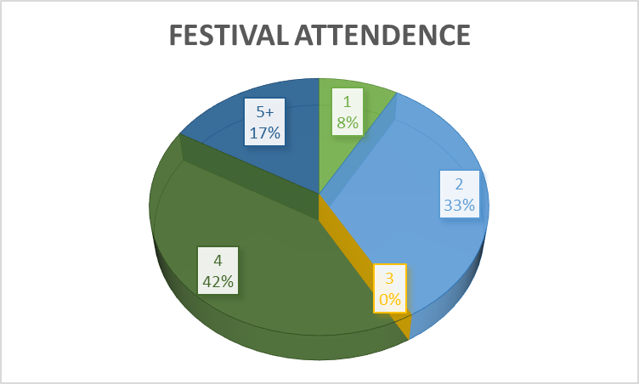
Figure 4.1 Festival attendance.
Creamfields, Glastonbury and Reading were focused on in this dissertation due to their naming and shaming in relevance to being ‘Dirty’ in figure 1.2, but also due to their market dominance. The three festivals are in the top 5 most popular festival in the UK (Consultancy UK, 2017). Figure 4.2 supports this with only 3 people stating they had been to any ‘other’ festival. The sample in this research can be described as a ‘Superfan’ (28% of all festival goers) that attend an average of four annually (IQ Map, 2020).

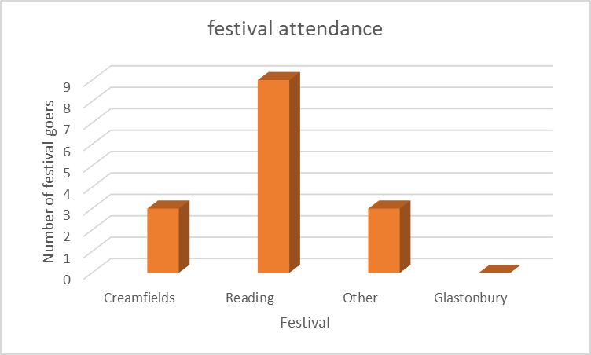
Figure 4.2 Most visited festivals of sample.
Reading festival Is the most popular by far visited by the sample with 9 people saying they had previously attended. However, it could be argued that this is an unfair picture of the overall UK market as the majority of the sample are based in Swansea, with Reading being the closest and easiest to travel to making use of the M4. However, it is not relevant to this research which festivals had been visited, but it was relevant that the participants had the lived experience of festival attendance. lived experience is personal life stories of people (festival-goers and festival-workers) that provides rich insights into behaviour (Jawad, 2016).

4.5 Travel methods

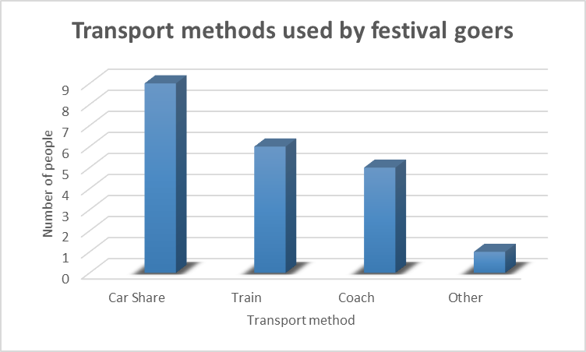
Figure 4.3 Transport methods used by festival goers.
Transport was identified as seminal to understanding of the most harmful environmental impacts highlighted in chapter 2. Stone (2009) describes transport as being a large contributing factor of environmental damage. The usage of car sharing, train and coach was down to their less environmentally impacting nature highlighted in chapter 2. Festivals such as Glastonbury, Reading and Creamfields all support the use of the big green coach for example to minimise their indirect environmental impacts (Big Green Coach, 2020). As seen from figure 4.3, festival-goers do in fact make use of these greener travel methods, with only participant ‘1’ stating they had travelled through an alternative method (Via Plane). Notably the use of these travelling methods are down to the festival-goers themselves and only encouraged by festival organisers. This is because most mainstream festivals don’t provide their own transport and can only advertise companies like the ‘Big green coach’ for festival-goers to make use of.

4.6 Sleeping arrangements

Ticket Master (2019) describes camping as the top accommodation choice for fans (44%). This is evident in the sample as all 10 participants stated they had camped at least once. Notably alternate options participants made use of was hotels and Airbnb’s, but this was said to be due to the festivals being located abroad where camping would be unsuitable. The environmental complication noted in chapter 2 relating to camping was that these non-recyclable tents are often left behind. The Fast Company (2019) referred to ‘Dirty’ as a number of factors involving ecological footprint and sustainability. This information led to the use of question 7, identifying the sample percentage that rakes home their tent.
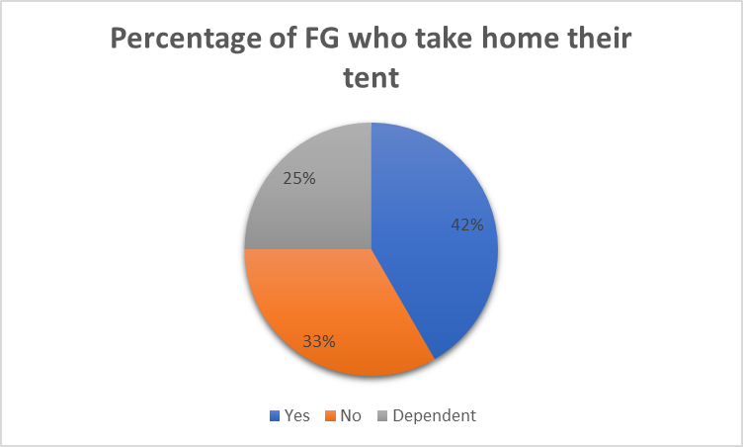
Figure 4.4 Percentage of festival-goers who take their tent home.
Resource (2014) found that 60 per cent who said they had camped at festivals admitted to discarding their tents at the event. A much smaller number of festival-goers discard their tents in this sample as seen with the above figure. Notably many participants described if they take their tent home or not down to two factors: cost of the tent and condition (level of damage). This was previously identified in chapter 2, the primary reason for a large number of tent abandonments being down to the inexpensiveness and poor quality of tents (Resource, 2014). These left-over tents were identified in chapter 2 as being a specific waste problem due to the incapability of recycling them as they are made of on-recyclable plastic. The less tents left behind leaves a better image for these festivals, as well as having less of an environmental impact.

4.7 Waste disposal

The specific problem with waste is down to how its recycled. Reality check team (2018) discovered only a third of the large quantities of waste produced from festivals are recycled. Question 8 allowed an insight into festival-goers habits towards recycling their waste. Generally, participants made at least some effort to recycle. The vast majority made use of bin liners to collect their campsite waste. Campsite waste contributes to 86 per cent of total music festival waste (Resource, 2014). Most participants also noted of the struggles they faced to locate waste disposal points around the campsites and main arenas, this meant a large amount of them stating they did not end up recycling their waste. One participant stated:
‘I would try to use a bin but truthfully I usually just leave them anywhere on the floor in the field because there’s never enough bins or the ones there are full’ participant 1.
This left-over waste can have a severe impact on the environment as discovered in chapter 2, left over waste can create lasting land damage to the native flora of the festival sites (Resource, 2014).

4.8 Environmental impacts

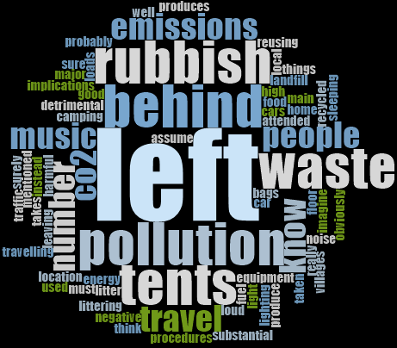
Figure 4.5 Festival-goer knowledge on environmental impacts on music-festivals.
Question 10 was intended to grasp what environmental impacts festival-goers were aware of if any. Figure 4.5 was created using an NVivo, displaying a word cloud of the relevant key words. All the impacts participants were aware of have been mentioned in chapter 2. Left over waste and transport were the key two topics participants were aware of, these two impacts were seen to be the most harmful identified in chapter 2. This means festival-goers are in fact aware of these key harmful impacts, so any environmentally friendly factors they practise are justified. As seen with previous data such as figure 4.3 where participants opted for car sharing over more polluting alternatives. However, this could be down to festival-goers saving money by car sharing and not actually using the method for sustainable reasons. In contrast, the sample age of 18-34 had a much larger percentage concerned with the environment seen with figure ‘1.8’.

4.9 Sustainability

Although this dissertation only focuses on the Environmental impacts of music-festivals, Question 13 was included to understand if festival-goers purely thought of the sustainability as one dimensional like this dissertation does, or if their opinions cover all 3 aspects included in CSR. Results showed that the majority of participants (8) understood the concept of sustainability as an environmental one. Notably no one understood the term as involving solely Economical, with 1 participant understanding it in a social way and the rest (3) believing sustainability links all 3 aspects. This can be seen with the analysis of question 11, and the below figure.
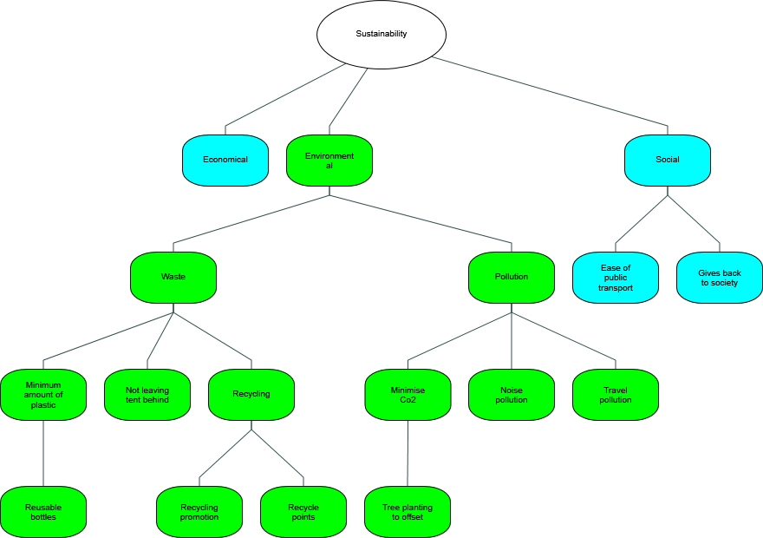
Figure 4.6 What a sustainable festival looks like/ means to festival-goers.
Making use of NVivo’s mind map tool where question 11 has be visualised regarding festival-goers opinions on what a sustainable festival mean/looks like to them. Mind mapping can allow researchers to make rapid and valid transcriptions of qualitative interviews (Tattersall Et al, 2007). As seen above the majority of thoughts were around the environmental aspect of sustainability. The vast majority of environmental points made have been mentioned in chapter two, such as the recycling of tents and minimising plastic use. However, areas such as the planting of trees to offset carbon and minimising noise pollution were also mentioned that have not been previously brought up by the range of literature in chapter two. These points made stray away from the common policies festival-management have in place at festivals, such as waste minimisation. This can be seen with the analysis of question 15 later on, as no participant made note of noticing any of these points. Zifkos (2015) described sustainability as meaning much more than merely embedding “green” or “eco-friendly” practices into the festival management. This also links to the social elements mentioned by one participant:
‘Giving back to society’ Participant 6.

4.10 Festival responsibility and policies

Question 12 asked participants if they believed corporations like music-festivals should be sustainable, all stated yes. As well as this question 13 demonstrated festival-goers associate sustainability with environmental factors. This means there are environmental pressures associated with CSR shown from festival-goers. A growing number of companies develop their CSR in response to a variety of social, environmental and economic pressures (Colombo and Gazzola, 2013).
To further analyse this question 14 participants were asked what they believed a responsible festival looks like to understand if their environmentally sustainable beliefs seen in figure 4.6 links to what they belief music-festival responsibility looks like, feedback can be visualised in the below mind map.
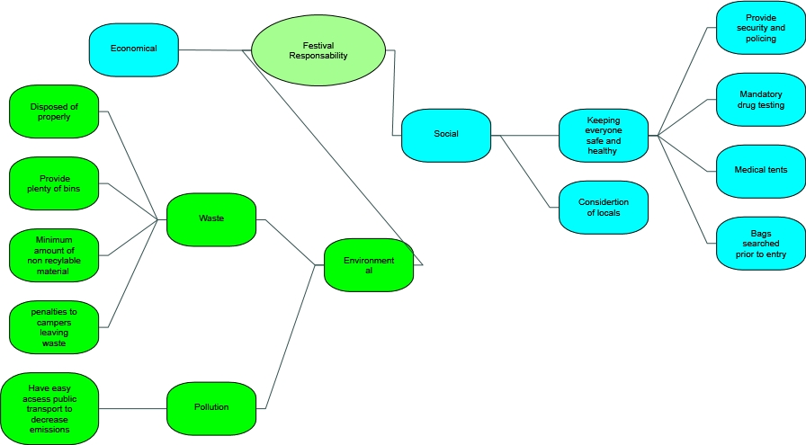
Figure 4.7 Opinions on what a responsible music-festival looks like.
The impact of waste was depicted in chapter one as being a large contribution to the description ‘Dirty festivals’. Waste was mentioned in chapter two to be a factor that festival-goers themselves create from leaving behind tents and not recycling. More than 250,000 tents have been left behind in UK fields from Glastonbury to Reading and Leeds (Reality check, 2019). Waste is a factor however mentioned in chapter two to be dealt with by festival-goers and also festival-management. Chapter two highlighted the benefit of festival goers being able to make use of ‘Camplight’, where festival-goers can be provided with pre pitched recyclable tents. As well as festival—management having the ability to provide more recycling points.
Three participants stated that a combination of Environmental, Economical and Social factors should be a festival responsibility. As well as this participant 10 stated:
‘It would be a very thorough, thought through process’ Participant 10.
This could indicate a difficult process for festival-management in creating a ‘Responsible’ festival, and this difficulty should be considered when judging the festivals link to being ‘Dirty’ and overall success.
Question 15 looked into the awareness festival-goers had of the environmental policies in place at the music-festivals they had attended. Gibson and Wong (2011) makes note of the capability music festivals have of spreading a green message. Only 3 of the participants had no knowledge of the green policies. The remaining 9 had at least some knowledge ranging from deposit schemes for rubbish to reduce waste and the previously mentioned Big Green Coach to reduce travel emissions. Notably, all these mentioned ‘policies’ consisted of festival-goers input and were not solely managed and conducted by festival-management. Participant 10 added:
‘It’s mainly down to the people that that attend the festival’ Participant 10.
The areas of festival responsibility festival-goers mentioned in 4.6 were previously mentioned to be of mixed responsibility. Comparing this to the policies festival-goers actually noticed under question 15 being ones festival-goers themselves have to take responsibility does not display a good image for these festivals and stray away from the ‘dirty’ description. The policies of the three concentrated on festivals that were also the ones that the majority of participants had stated they had been to can be found in the appendices.

4.11 Impacts

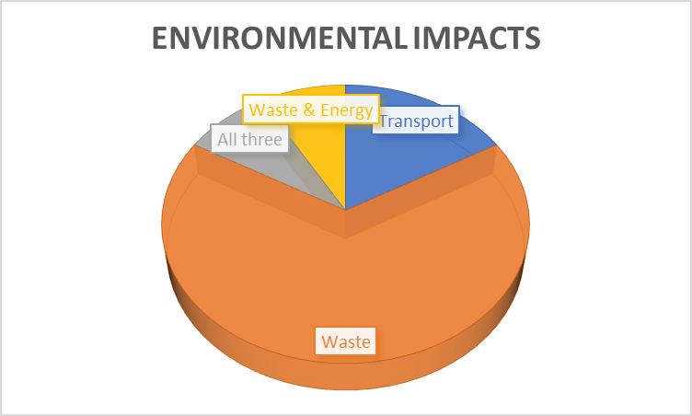
Figure 4.8 Opinion of the most harmful impacts.
Question 16 allowed an insight into the opinions of festival-goers regarding what they deemed the most impactful aspect of environmental significance. The selection of these 4 areas were derived from the literature review highlighting them as the most impactful with a range of sources making note of their harmful outcomes. As seen from the above figure, waste dominated the responses with 8 participants suspecting the impact to be the most harmful. Waste was the first touched upon impact in this dissertation, as well as a dominant factor that participants believed best described a ‘responsible’ festival in figure ‘4.7’.The literature review discovered in detail how waste is such an impactful environmental factor. Roughly 23,500 tonnes of general waste are produced annually at UK music festivals (Reality check team, 2018). However, as mentioned in chapter 2, waste although being a harmful factor, the impact it has is permanently down to festival-goers behaviour towards recycling and where they dispose of their waste. Information on festival-goers behaviour with recycling was discovered in the analysis of question 7 (chapter 4.7).

4.12 Initiatives

The inclusion of question 18 exploring festival-goers ideas of sustainable initiatives is important as the festival-goers themselves seem to be the ones to be conducting these policies. The answering of question 18 also specifically relates to objective 2:
To conduct primary research to understand festival-goers and festival-workers perceptions on dirty/sustainable festivals
The ‘perceptions’ of festival-goers can be understood through their personal ideas in the answering of question 18. Again, the majority of ideas raised centred around the idea of waste, specifically zero waste. The initiatives also revolved around the festival-goers themselves having to take charge of the impacts caused by music-festivals. Participant one actually made this clear with :
‘To pay to offset the carbon emissions the festivals produce even if this meant the ticket price rising slightly’ Participant 1.
There is a clear selfless willingness for festival-goers to tackle the environmental problems raised in this dissertation at their own cost. This was expected however as the sample is of the age range identified in chapter 1 to be more considerate of the environment, so any ideas are more likely to be meaningful and thought out.
The objective of question 19 asking participants how committed they personally would be to adopt environmental practises was to evaluate their levels of consideration of the environment and willingness to go out of their way to do so. All 12 participants stated they would be committed, with the majority being ‘Extremely committed’. However, chapter 2 highlighted festival-goers commitments towards recycling as being the opposite. When asked if festival-goers would change their behaviours regarding a large percentage abandoning their tents 35 per cent stated they would never change their behaviour (Resource, 2014). In contrast, the sample used by Resource (2014) differed in age, where wider ages were sampled compare to the more environmentally engaged 20-24-year olds in this sample.

4.13 General comments and questions

Objective 2 involved the understanding of the festival-goers perceptions, meaning the final question can gain any additional comments on the topic that may have been previously missed, allowing festival-goers perceptions to be analysed in detail. One theme that can be seen from the answering of question 20 is that there is a strong demand from festival-goers for MF to be environmentally mindful.
‘I feel like this is a topic that should be talked about more as it is definitely impacting our environment’ Participant 3.
This demand however was expected as the sample included a younger age category highlighted by figure 1.8 to be more environmentally mindful. In contrast, participant 7 believed the topic was not thought of enough by younger ages, the participant believed festival-goers were more concerned with getting home than worrying about waste from example. Chapter 1 mentioned the increasing attempt for music-festivals such as Glastonbury to be sustainable in recent times. Participant 9 supported this belief by stating:
‘Festivals put plenty of measures in place for attendees to follow in order to make the place more sustainable and friendly’ Participant 9.
This adds to the theme of festival-goers having to comply with festival-management policies and not actually reducing the impacts themselves. The research gap derived from the literature review was need to greater understand the idea of whose job it is to actually make a change regarding sustainability of music-festivals.

4.1.4 Festival worker analysis

Questions | Theme | Participant 1 | Participant 2 | Participant 3
What gender are you? | Demographics | Female | Male | Male
How old are you? | Demographics | 23 | 22 | 21
How many festivals have you worked at? | Festival experience | 3 | 2 | 1
Q4 Have you worked at Creamfields, Reading and or Glastonbury? If so Which ones. | Festival experience | I haven’t worked in any of the above | Glastonbury | Reading

Q5 In your opinion, how did most festival goers get to and from the festival in terms of transport? | Transport | The punters tended to go by bus or lift. But the employees usually arranged their own transport | In a car | I’d say coach
Q6 What are you views on the camping arrangements at festivals in terms of facilities? | Facilities | The facilities at the employee campsites were all really good. We all had showers, our own campsite and catering | I Think that they are suitable for festival goers, but the toilets could be improved. There’s busses to and from different campsites as the festival is the same size as a small town and disabled sites for those who wouldn’t be able to experience the festival otherwise. | I feel like it’s pretty cost effective because people bring their own tents , reading should definitely have more water stations and toilets . I’ve only seen drug testing in one festival as well I think that that’s a facility that missing
Q7 Regarding tents, why do you think many festival goers do not take their tents home with them? | Tent waste | After a heavy weekend of drinking, many festival goers can’t be bothered to take down tents and carry them | I think people leave their tents because they simply don’t have room to store their tents as they have bought them especially for the festival, last year Glastonbury recycled all the tents left behind | People are lazy, they have the mentality of “I’ll just get a new one” + a lot of tents get broken during
Q8 What facilities are you aware of for waste disposal – cans, plastics, others? | Waste recycling | There were just general waste bins | Everything that is used is recycled and there is a scheme in place where you can bring your rubbish in a black bag and get paid for doing so | There are bins every few hundred yards are so, all labelled as to what materials should go where
Q9 What environmental impacts of festivals are you aware of? Which ones are the biggest problem in your opinion? | Understanding opinions on the most harmful environmental impacts. | Environmental impacts was definitely the littering on the floor and leaving behind tents. I think the biggest problem was punters not disposing their waste | Transport pollution is a huge problem as trucks and cars wait in traffic all around the Glastonbury area causing disruption and environmental problems | I’d say general waste , along with pollution because of the many food trucks and generators that are being used , along with the amount of fuel being used to get to the festival
Q10 What does a sustainable festival mean or look like to you? | Sustainability | A sustainable festival to me looks like clean grounds with lots of opportunity to dispose waste appropriately (different bins for recycling, and general waste) | I think a sustainable festival is one where it is run in an eco-friendly way and doesn’t harm any of the remaining land when it’s finished | One where it’s compulsory to take tour stuff home with you , tents chairs etc. If festivals got people to bike there , and getting vendors to use biodegradable cutlery , plates cups
Q11 Do you agree that music festivals should be sustainable? | Sustainability | Absolutely | Yes | 100%
Q12 Would you say sustainability best relates to economic, Environmental or Social factors? | Tribble bottom line concept of sustainability | Environmental | I would say environmental | Id say economical
Q13 Were you aware of the green policies in place at the festivals you have worked at? Can you give me an example? | Festival management | We were aware because we worked there, and our role focused on environmental factors. The general policies for the festivals that I worked at was put your things in the bin. Also, portable ashtrays were given out at boom town to reduce the number of cigarettes thrown on the floor. | Yes, there’s one called water aid and they give you a water bottle and you can go to any of the stations around the festival for refills, this means less plastic is used as everyone is using the same bottle | I wasn’t made aware of any no
Q14 Out of the following, which impact would you say has the biggest environmental significance? Transport, waste, or energy consumption | Chapter two highlighted these as being the most significant impacts. | Waste | I would say that waste has the biggest impact on the environment as a lot of people’s rubbish and tents are left leaving strain on the environment to recover | Transport
Q15 What sustainable initiatives have you noticed? | Sustainability | Honestly, the only sustainable initiative I saw was ensuring everyone disposed of their waste appropriately, along with litter pickers | In Glastonbury they have recycled the majority of all the tents left there last year as it was the first year to be put in place | Festivals giving water in cans as they’re easier to recycle , the big green coaches that head to reading, that encourage people not to drive up
Q16 Can you suggest any sustainable initiatives for festivals? | Sustainability | More variety of bins to help waste get disposed appropriately and imposing fines on those who leave their tents and campsites a mess. Another initiative for sustainability was the eco bond. Punters get £10 when they turn in a bag of litter | I think there could be a way in which festivals could give people tickets for volunteering to collect people’s rubbish from their tents in black bags | I’d like to see festivals using more solar panels instead of generators , so say that they’d have to make a target to teach a certain percent of power through renewable energy
Q17 How committed would you be to enforce sustainable practises? Such as ensuring festival goers recycle waste and take home their tents | Responsibility towards sustainability | Yeah I’d be very committed! | I would be very committed as it would mean festivals would be a much cleaner and better place | Quite committed , if I can see that someone’s about to leave a big pile of rubbish on the floor I’d most likely try to offer them a rubbish bag or something
Q18 Any questions or comments relating to the topics in this interview would be welcomed. | Summarising and gaining general opinions | I have none. | When working festivals, I’ve noticed a rise in environmental relevance as they are trying to become less harmful to the environment by enforcing eco-friendly schemes | . I just remembered that in boomtown although I haven’t worked there they have this thing where when you buy a ticket they charge ten pound extra for the clean up afterwards although you can get the money back if you take a either a full bag of waste or recycling to these allocated places , makes for pretty good way to get people to clean up after themselves

Table 4.1 Matrix analysis of festival worker questions. (Stephens, 2020).

4.15 Findings

The themes that emerged from analysis of the interviews with festival-workers tie in with the themes that were derived from the interviews with festival-goers. These themes are as follows…
Theme one, the overall thoughts and opinions of the festival-workers were practically identical to the festival-goers. Similar ideas such as the recognition of waste being a major impact and the need for festivals to be more sustainable overall were shared. This could indicate the sample chosen for festival-workers were not high up enough regarding employment position to deem them being part of the festival management who come up with the polices.
Secondly, cultural/social experience is a significant factor in this dissertation. Although this area under the social element of CSR was not the intentional focus of this dissertation, as a researcher it is still a factor to be considered.
Finally, everyone needs to do more. This including both festival-goers and festival-management. Festival-goers are largely to blame considering the impact they have such as the waste left behind. As well as this, and potentially an even more need to do more is festival management, considering the large profits they generate there is a responsibility to give back. Impacts were the result of both festival-management and festival-goers, so should be dealt with together. There was a common trend for festival management to pass this responsibility to the festival-goers.

4.16 Conclusion

The objective of this chapter has successfully been achieved by analysing the data collected from the interviews and presenting the findings. Three main themes were identified as a result of chapters 1-4.

Chapter 5 Conclusion and recommendations

5.1 Introduction

Upon the completion of analysing the data collected from the interviews in chapter 4, objective 2 has been met. Themes explored in chapter 4 that were derived from the data can now be considered to complete objective 3 of this dissertation:
To synthesise extant literature and primary research to make overall recommendations for festival goers to adopt.
This chapter will not only provide several recommendations but also conclude, explore limitations of this study and discuss any potential need for future academic studies. The recommendations have been constructed relative to the in-depth literature research as well as the data collected from interviews.

5.2 The achievement of objectives;

Objective1- To conduct an extensive literature review around the topic area of environmental impacts seen from music festivals:
Previous academic research has been thoroughly explored in chapter 2.
Objective 2- To conduct primary research to understand festival-goers and festival-workers perceptions on dirty/sustainable festivals:
Chapter 4 achieved this making use of software such as NVivo and Excel.

5.3 Main findings

The main findings of this dissertation have been collected not only from the primary research but the literature review also. These findings have been constructed into four themes under chapter ‘4.15’. The underlying question of this dissertation was:
Is the description ‘dirty festivals’ fair?. Although the answering of this question is of a subjective nature, the researcher believes the description to be accurate and a representation of what’s been discovered in this dissertation. However, there is much evidence of not only a demand to be more sustainable, but evidence that these festivals such as Glastonbury are now starting to try and be accountable for the vast impacts they produce. There is definitely change occurring, but relative to the amount of environmental implications that come with music-festivals, progress needs to be pushed even more. The opportunity these festivals have with their large vast audiences (discovered in chapter 2) is a way of sufficiently making a change, combined with polices that can be implemented to their festivals. However, change will ultimately come down to the festival-goers themselves, as seen in this research the majority of policies and sustainable measures are geared towards the festival-goers, recommendations have will be constructed relative to this theory.

5.4 Recommendations

The following recommendations have been constructed taking account the themes derived from chapter 4. Firstly, festival goers must carry on with pursuing sustainable demand. Demands were seen to be expected in environmental ways through the analysis in chapter 4. Ultimately change will be down to pressures from festival-goers (CSR) and force festival-management to make a change.
Secondly, although this dissertation focused on the environmental side of sustainability and of overall festival impacts, the idea of being sustainable should be considered under the social element of CSR also, this will allow for festivals to meet overall sustainability more adequately and appropriately. Sensitive topics under the social understanding of sustainability such as drugs, although could not be ethically researched, themes still emerged in chapter 4.
Thirdly, although the intensions of the recommendations were intended to be geared towards what festival-goers themselves can implement into their practises, festival-management should also be contributing to the impact minimisation. With such large amounts of money generated, festivals could easily distinguish their negative environmental image by focussing less on policies that require practically no costing such as providing more recycling points, and more on areas like carbon offsetting that can require more time and finance.
Finally, although the vast majority of festival-goers were in fact implementing sustainable practise such as car sharing and recycling general waste, the negative results of festival-goers not re-using their tents is still an area that needs to be improved. This theme was proven to be the case in chapter 4 as well as chapter 2. Festival-goers need to either purchase tents more suited for reuse or make use of under advertised methods like ‘Camplight’ where pre pitched tents are assured to be recycled (Camplight, 2020). Left over tents can be seen to be a large factor that gives festivals this ‘dirty’ name.

5.5 Limitations

One limitation that has arisen in this dissertation is relative to the sample base. The purposive sample of 20-24-year olds could be seen as an unfair representative of the overall demographics of festival-goers. This limitation however was expected as these participants were chosen to partly because of their environmental engagement.
Secondly, also linked to the sample base was the use of the festival-workers. These participants were expected to have a different viewpoint regarding the topics in this dissertation and were chosen because of this, however this was not the case as findings when compared were seen to be extremely similar. This is likely due to their employment not being high up enough in the decision-making process of festival-management, and as an outcome can be seen practically as festival-goers themselves.
Thirdly, the underlying question of this dissertation was the idea of if the ‘Dirty festivals’ description was fair. The question itself is subjective as an understanding of dirty could be analysed in different ways. This dissertation focused on the term relative to the concept of responsibility (the lack of it) specifically waste being the reason for the description. Where some unmentioned research sources had differing viewpoints. This includes the one of the original sources (Spaseekers, 2020) also depicting the term as relative to the amount of seep festival-goers get.
Finally, this dissertation made note in the first chapter of it not setting out to gain an understanding of the cultural side of music-festivals as well as environmental. This can be seen as a limitation as this topic may did arise many times in this dissertation, meaning a potential for a greater understanding of the overall topic may have been missed.

5.6 Further research

Due to this dissertation successfully achieving all its objectives and overall aim, further research specifically relating to this topic of sustainability as well as responsibility within the sector may be unnecessary. However, a potential for future research regarding the more social/ cultural experience of festival-goers may be required. Getz (2009) proposed the overall sustainability of a business is achieved in the balance of all three ‘pressures’; environmental, economical and social. There were vast amount or research available regarding the environmental side of this theory, however the social element is yet to be looked at regarding sustainability. There is a demand from festival goers to have their sustainability/ responsibility met regarding social elements seen in figures ’4.6’ and ‘4.7’. When asked about which of the three ‘pressures’ under CSR participants most associated sustainability with, participant one stated:
‘Most of all is related to social factors as that is the cause of most environmental problems’ Participant 1.
Not only does this participant believe social is the most important element, but they believe the environmental implications studied in this dissertation is the result of these social factors.

5.7 Conclusion

This study has not only achieved its purpose of meeting its objectives and overall aim, it has explored areas of the wider spectrum of themes in the dissertation, from this a set of recommendations has been provided. The researcher is hopeful that it may contribute to minimising environmental impacts by the reader adopting and applying what they have learned. The researcher will also apply what they have learned towards their own experiences with music-festivals.
This dissertation has answered the underlying question of the degree to which music festivals are ‘dirty’. This has been achieved in every chapter of this dissertation. Firstly chapter 1 explored the rationale behind the topic of the need to answer the question by providing brief insights to environmental impact and a background to the popular market. Secondly, chapter two explored these impacts in detail while discovering a gap in the research which the primary research was based upon. Chapter three outlined the method and methodology that is most suited to this study and gaining quality data. Chapter four then analysed the comprised sets of data to provide underlying themes linked to the overall aim of this dissertation.
In conclusion, this dissertation had deemed the underlying question to be accurate for now.

Self reflection

The researcher is personally invested with the concept of environmental awareness and sustainability, the researcher wanted to gain a greater understanding on the topic. The chosen topic has educated the researcher in their personal interests to the point where their own music-festival practises have been evaluated and planned to change to be more sustainable in the future.
This dissertation has been difficult; however, this was expected. By gaining a greater understanding of a topic the researcher is interested in has made it all worth it. This dissertation has been rewarding and enjoyable. The researcher will potentially invest more time into future studies that need to be addressed previously mentioned.

Final summary

This dissertation started out saying that festivals are big business. Covid19 has meant there will be no festivals in 2020 and this will have a significant impact on jobs and potential future festivals. This dissertation has chosen to not focus on the cultural importance of festivals, their emotional and social importance but has highlighted the reliance of the potential need for future studies addressing this topic. Going forward, it is suggested that it is possible to have a great experience, but it can’t be at the expense of our planet.

Bibliography

A Greener Festival (2020). ‘Land Damage’. Available from: https://www.agreenerfestival.com/land-damage/
AGreenerFestival (2019). ‘SUMMARY OF RESEARCH’. Available from: https://www.agreenerfestival.com/knowledge-base/
Atkinson (2019). ‘What stinking hypocrisy! They cheered David Attenborough like a god at Glastonbury, but as the crowds headed home, they left a squalid mess that makes a mockery of their eco-posturing’. Mail online. Available from: https://www.dailymail.co.uk/news/article-7202513/Glastonbury-crowds-left-squalid-mess-makes-mockery-eco-posturing.html
Atz, Fernando. "LOGISTICS MANAGEMENT PRACTICES IN ROAD FREIGHT TRANSPORT COMPANIES." International Journal of Entrepreneurship 23.3 (2019): 1-16. Web.
Bakare (2019). ‘Glastonbury tickets sell out in 34 minutes’. The Guardian. Available from: https://www.theguardian.com/music/2019/oct/06/glastonbury-tickets-sell-out-in-34-minutes
BBC News (2010). ‘Glastonbury gates open to Festival Goers’. Available from: https://www.bbc.co.uk/news/10387611
BBC News (2019). ‘Where does recycling and rubbish from the UK go?’. Available from: https://www.bbc.co.uk/news/science-environment-49827945
Big Green Coach (2020). ‘Creamfields’. Available from: https://www.biggreencoach.co.uk/events/creamfields-festival-tickets-coach-travel
Big Green Coach (2020). ‘How are we green?’. Available from: https://www.biggreencoach.co.uk/why-are-we-green
Black (2008). ‘Races off after V Festival land damage’. Shropshire star. Available from: https://www.shropshirestar.com/news/2008/09/25/races-off-after-v-festival-land-damage/
Blaikie, N., 2003. Social research and data analysis: Demystifying basic concepts. Analysing quantitative data.
Blue and Green Tomorrow (2020). ‘Celebrating the Impressive Shift Towards Sustainable Festivals’. Available from: https://blueandgreentomorrow.com/sustainability/celebrating-impressive-shift-towards-sustainable-festivals/
Brennan, Matt, Angela Connelly, and Gemma Lawrence. "Do Music Festival Communities Address Environmental Sustainability and How? A Scottish Case Study." Popular Music 38.2 (2019): 252-75. Web.
Bristol green capital (2015). ‘European Green Capital Award 2015’. Available from: https://bristolgreencapital.org/who-we-are/european-green-capital-award/
CampLight (2020). ‘Hire a tent, travel light and camp with friends’. Available from: https://www.camplight.co.uk/
Clark (2012). ‘What's energy efficiency and how much can it help cut emissions?’. The guardian. Available from: https://www.theguardian.com/environment/2012/jun/08/energy-efficiency-carbon-savings
Cohen, D. and Crabtree, B., 2006. Qualitative research guidelines project.
Collins, A. and Cooper, C., 2017. Measuring and managing the environmental impact of festivals: The contribution of the Ecological Footprint. Journal of Sustainable Tourism, 25(1), pp.148-162.
Collins, Andrea, and Crispin Cooper. "Measuring and Managing the Environmental Impact of Festivals: The Contribution of the Ecological Footprint." Journal of Sustainable Tourism 25.1 (2017): 148-62. Web.
Collis, J. & Hussey, R., 2014. Business Research: A practical guide for undergraduate and postgraduate students. 4th ed. Basungstroke: Palgrae Macmillan higher education.
Colombo, Gianluca, and Patrizia Gazzola. "AESTHETICS AND ETHICS OF THE SUSTAINABLE ORGANIZATIONS." European Scientific Journal (2013): European Scientific Journal, Dec 2013. Web.
Company Check (2020). ‘Creamfield limited’. Available from: https://companycheck.co.uk/company/02299003/CREAMFIELD-LIMITED/companies-house-data
Company Check (2020). ‘Glastonbury festival events limited’. Available from: https://companycheck.co.uk/company/04348175/GLASTONBURY-FESTIVAL-EVENTS-LIMITED/companies-house-data
Company Check (2020). ‘Reading festival limited’. Available from: https://companycheck.co.uk/company/02493976/READING-FESTIVAL-LIMITED/companies-house-data
Consultancy Uk (2017). ‘Top 10 largest music festivals in the UK’. Available from: https://www.consultancy.uk/news/13576/top-10-largest-music-festivals-in-the-uk
Creamfields (2020). ‘Tickets’. Available from: https://www.creamfields.com/tickets
Echo (2019). ‘Glastonbury Festival traffic - tips for avoiding the congestion, best routes and more’. Available from: https://www.liverpoolecho.co.uk/whats-on/music-nightlife-news/glastonbury-festival-traffic-tips-avoiding-16479808
Edwards (2010). ‘Festivals like Glastonbury and Leeds need to curb their carbon emissions’. The guardian. Available from: https://www.theguardian.com/environment/green-living-blog/2010/may/05/festivals-glastonbury-leeds-carbon-emissions
Fast Company (2019). ‘Can music festivals go from generators of garbage to sustainable innovations?’. Available from: https://www.fastcompany.com/90421665/can-music-festivals-go-from-generators-of-garbage-to-sustainable-innovators
Financial Time (2017). ‘Has the UK’s festival scene reached saturation point?’. Available from: https://www.ft.com/content/622d56e2-157f-11e7-b0c1-37e417ee6c76
Flyvbjerg, B., 2006. Five misunderstandings about case-study research. Qualitative inquiry, 12(2), pp.219-245.
Forbes (2020) ‘Live Nation Announces Ninth Year Of Consecutive Growth - Will The Trend Continue?’. Available from: https://www.forbes.com/sites/andreazarczynski/2020/03/02/live-nation-announces-ninth-year-of-consecutive-growthwill-the-trend-continue/#359a7b2b3113
G.Zifkos. ‘Sustainability Everywhere: Problematising the “Sustainable Festival” Phenomenon’. School of Performance and Cultural Industries.
Galli, Alessandro, Mathis Wackernagel, Katsunori Iha, and Elias Lazarus. "Ecological Footprint: Implications for Biodiversity." Biological Conservation 173 (2014): 121-32. Web.
Getz, D., 2009. Policy for sustainable and responsible festivals and events: Institutionalization of a new paradigm. Journal of Policy Research in Tourism, Leisure and Events, 1(1), pp.61-78.
Gibson, C. and Wong, C., 2011. Greening rural festivals: Ecology, sustainability and human-nature relations. Festival places: Revitalising rural Australia, pp.92-105.
Glastonbury (2020). ‘Ticket Prices’. Available from: https://www.glastonburyfestivals.co.uk/search/ticket+price/
Golafshani, N., 2003. Understanding reliability and validity in qualitative research. The qualitative report, 8(4), pp.597-607.
Golafshani, N., 2003. Understanding reliability and validity in qualitative research. The qualitative report, 8(4), pp.597-607.
Google Scholar (2020). ‘Sustainable Festivals’. Available From: https://scholar.google.co.uk/scholar?q=SUSTAINABLE+FESTIVALS&hl=en&as_sdt=0,5&as_vis=1
Goulding (2017). ‘Sunfall Festival 2017 review: Local noise restrictions means a stellar line-up goes to waste’. The independent. Available from: https://www.independent.co.uk/arts-entertainment/music/reviews/sunfall-festival-review-2017-line-up-acts-goes-to-waste-brockwell-park-london-summer-a7898056.html
Green Earth Appeal (2020). ‘Tree planting and festivals’. Available from: https://greenearthappeal.org/tree-planting-and-festivals/
Hall (2019). ‘Sir David Attenborough makes surprise appearance at Glastonbury Festival’. The telegraph. Available from: https://www.telegraph.co.uk/music/news/sir-david-attenborough-came-stage-glastonbury-thank-attendees/
Ioannidis, J.P., 2007. Limitations are not properly acknowledged in the scientific literature. Journal of clinical epidemiology, 60(4), pp.324-329.
Iqbal and Harris (2019). ‘Festivals claim the description 'festival tent' implies they're single-use’. BBC news. Available from: https://www.bbc.co.uk/news/newsbeat-48184756
IQ-Map (2020). ‘Understanding Festival Fans’. Available from: https://www.iq-mag.net/wp-content/uploads/2016/08/DS01-UK-Music-Festival-Superfans.pdf
Janghorban, R., Roudsari, R.L. and Taghipour, A., 2014. Skype interviewing: The new generation of online synchronous interview in qualitative research. International journal of qualitative studies on health and well-being, 9(1), p.24152.
Jawad (2016). A Pragmatic Mixed Methods Analysis of Experiences, Behaviours and Perceptions of Gamblers.
Jawad (2020). Dissertation lecture.
Jones, M.L., 2007. Using software to analyse qualitative data.
Julie’s Bicycle (2009). ‘Part 1: Audience Travel Emissions from Festivals’. Available from: https://juliesbicycle.com/wp-content/uploads/2019/10/Summary_Jam_Packed_Festival_Audience_Report_2009.pdf
Kajornboon, A.B., (2005). Using interviews as research instruments. E-journal for Research Teachers, 2(1), pp.1-9.
Krippendorff, K., 2018. Content analysis: An introduction to its methodology. Sage publications.
Leon, A.C., Davis, L.L. and Kraemer, H.C., 2011. The role and interpretation of pilot studies in clinical research. Journal of psychiatric research, 45(5), pp.626-629.
Martinho, G., Gomes, A., Ramos, M., Santos, P., Gonçalves, G., Fonseca, M. and Pires, A., 2018. Solid waste prevention and management at green festivals: A case study of the Andanças Festival, Portugal. Waste management, 71, pp.10-18.
Mintel (2018) Music festivals and concerts- Uk.
Mixmag (2019). ‘WAS 2019 THE MOST ENVIRONMENTALLY FRIENDLY GLASTONBURY EVER?’. Available from: https://mixmag.net/feature/was-2019-most-environmentally-friendly-glastonbury-festival-ever
Music Week (2019).’Festival Republic reveals £7.3 million profit for 2018’. Available from: https://www.musicweek.com/live/read/festival-republic-reveals-7-3-million-profit-for-2018/076695
Neale, G., 1999. The green travel guide. Earthscan.
NME (2018) ‘Frustrated Glastonbury residents demand more local tickets. Available from: https://www.nme.com/news/music/glastonbury-residents-demand-local-tickets-2393860
NVivo (2020). ‘Unlock insights in your data with powerful analysis’. Available from: https://www.qsrinternational.com/nvivo-qualitative-data-analysis-software/home
Opdenakker, R., 2006, September. Advantages and disadvantages of four interview techniques in qualitative research. In Forum qualitative sozialforschung/forum: Qualitative social research (Vol. 7, No. 4)
Parkinson (2018). ‘Revelry and rebellion: is this the greenest Glastonbury yet?’. Available from: https://www.theguardian.com/music/2019/jun/30/greenest-glastonbury-david-attenborough-climate-crisis-plastic
Parnell, J. and Sommer, R., 2018. Setting noise objectives for outdoor music festivals in rural locations. In Proceedings of ACOUSTICS (Vol. 7, No. 9).
Perrett (2019). ‘FANS WANT MORE SUSTAINABLE FESTIVALS, MAJOR STUDY FROM TICKETMASTER FINDS’. Live Nation. Available from: https://www.livenationentertainment.com/2019/06/fans-want-more-sustainable-festivals-major-study-from-ticketmaster-finds/
Peters, M., 2008. The Green Issue: Festivals Fly the Eco Flag. Billboard - The International Newsweekly of Music, Video and Home Entertainment, 120(13), pp. 32-33.
Plant (2011). ‘Glastonbury's army of volunteer litter-pickers’. BBC news. Available from: https://www.bbc.co.uk/news/uk-13917286
Reading and Leeds festivals (2019). ‘Reading and Leeds 2019: Festival-goers 'should pay tent tax'. BBC news Available from: https://www.bbc.co.uk/news/uk-49494957
Reading Festival (2020). ‘2020 tickets’. Available from: https://www.readingfestival.com/tickets
Reality check (2019). ‘ Climate change: Should you fly, drive or take the train?’. BBC news. Available from: https://www.bbc.co.uk/news/science-environment-49349566
Reality check team (2018). ‘Can music festivals go green?’. BBC news. Available from: https://www.bbc.co.uk/news/science-environment-44549392
Reid, Mike. "Sustainability vs. Local Knowledge." Freeman 63.1 (2013): 16-18. Web.
Resource (2014) ‘SURVEY HIGHLIGHTS LASTING WASTE DAMAGE FROM FESTIVALS’. Available from: https://resource.co/resource-use/article/survey-highlights-lasting-waste-damage-festivals
Ruwangi Fernando. "The Impact of Planned Special Events (PSEs) on Urban Traffic Congestion." EAI Endorsed Transactions on Scalable Information Systems 6.23 (2019): EAI Endorsed Transactions on Scalable Information Systems, Oct 2019, Vol.6(23). Web.
Ryan, Gemma. "Introduction to Positivism, Interpretivism and Critical Theory." Nurse Researcher (2014 ) 25.4 (2018): 14-20. Web.
Sahay, A., 2016. Peeling Saunder's Research Onion. Research Gate, Art, pp.1-5.
Salmons, J., 2011. Cases in online interview research. Sage Publications.
Saunders, M.N., Lewis, P., Thornhill, A. and Bristow, A., 2015. Understanding research philosophy and approaches to theory development.
Schmidt, Gavin, and David Archer. "Too Much of a Bad Thing." Nature 458.7242 (2009): 1117-118. Web.
Scott, C.R., 2004. Benefits and drawbacks of anonymous online communication: Legal challenges and communicative recommendations. Free speech yearbook, 41(1), pp.127-141.
Simon, M., 2011. Analysis of qualitative data. Dissertation and Scholarly Research: Recipes for Success. Seattle: LLC.
SpaSeekers (2020). ‘Revealed: The filthiest UK festivals and where to go to get the most (and least) sleep’. Available from: https://www.spaseekers.com/guides/destinations/revealed-the-filthiest-uk-festivals-and-where-to-go-to-get-the-most-and-least-sleep
Stone, C. (2009). The British pop music festival phenomenon. International perspectives of festivals and events, pp.205-224.
Sweney (2019). ‘Value of UK's live music scene hits record high’. The Guardian. Available from: https://www.theguardian.com/business/2019/nov/20/value-of-uk-live-music-sector-hits-11bn
Tattersall, C., Watts, A. and Vernon, S., 2007. MIND MAPPING AS A TOOL IN QUALITATIVE RESEARCH:▪ This is a summary: the full paper can be accessed atnursingtimes. net. Nursing Times, 103(26), pp.32-33.
Thomson, S.B., 2011. Qualitative research: validity. Joaag, 6(1), pp.77-82.
Ticket Master (2019) ‘State of play: Festivals UK’. Available from: https://business.ticketmaster.co.uk/wp-content/uploads/2019/10/State-of-Play-Festivals-UK-2019.pdf
Tomas M, (2018). ‘Glastonbury Festival: Statistics reveal the average Glasto-goer’. Somerset Live. Available from: https://www.somersetlive.co.uk/whats-on/music-nightlife/glastonbury-festival-statistics-reveal-average-1952547
Tongco, M.D.C., 2007. Purposive sampling as a tool for informant selection. Ethnobotany Research and applications, 5, pp.147-158.
Transitions2Earth (2019). ‘Can Music Festivals Be Environmentally Sustainable?’. Available from: https://transitions2earth.com/blogs/news/can-music-festivals-be-environmentally-sustainable
University of Wisconsin (2020). ‘The triple bottom line’. Available from: https://sustain.wisconsin.edu/sustainability/triple-bottom-line/
Ward (2018). ‘Thousands of tents abandoned in fields because festival goers think they will go to charity’. The telegraph. Available from: https://www.telegraph.co.uk/news/2018/08/28/festival-goers-abandon-tents-mistaken-belief-go-charity-experts/
Wiedmann, T. and Minx, J., (2008). ‘A definition of ‘carbon footprint’. Ecological economics research trends’. 1, pp.1-11.
Williams, D (2019) ‘UK festival plastic bottle deposit return scheme trial set to launch’. Packaging Gateway. Available from: https://www.packaging-gateway.com/news/festival-sustainability-drs/
Wipke-Tevis, Deidre D. "What Is Research?" Journal of Vascular Nursing 19.2 (2001): 63-64. Web.
Wright (2020). ‘The impact of transport on climate is more complicated than it seems’. The independent. Available from: https://www.independent.co.uk/news/long_reads/science-and-technology/climate-transport-hs2-impact-train-high-speed-rail-flight-a9341976.html
YouGov (2017). ‘Most youth show concern for how their daily lives affect the planet’. Available from: https://today.yougov.com/topics/science/articles-reports/2017/04/18/Most-youth-show-concern-for-how-their-daily-lives
Zifkos, G., 2015. Sustainability everywhere: Problematising the “sustainable festival” phenomenon. Tourism Planning & Development, 12(1), pp.6-19.

Appendices

Appendix 1; Creamfields’s environmental policies.
Creamfields (2020). ‘Sustainability’. Available from: https://www.creamfields.com/sustainabilitycharter
Appendix 2; Reading’s environmental policies.
Reading Festival (2020). ‘Staying Green’. Available from: https://www.readingfestival.com/information-category/staying-green
Appendix 3; Glastonbury’s environmental policies.
Glastonbury Festival (2020). ‘Our Green policies’. Available from: https://www.glastonburyfestivals.co.uk/information/green-glastonbury/our-green-policies/
Appendix 4; A Google Scholar Search shows approx. 95,000 results on sustainable festivals.
Google Scholar (2020). ‘Sustainable Festivals’. Available From: https://scholar.google.co.uk/scholar?q=SUSTAINABLE+FESTIVALS&hl=en&as_sdt=0,5&as_vis=1
Appendix 5; Copy of Festival-goers raw data results.
Q1 what gender are you ?
Female
Female
Male
Male
Female
Male
Female
Female
Female
Female
Male
male
Q2 how old are you?
21
20
19
22
20
22
21
20
19
21
21
21
Q3 how many festivals have you been to ?
I have been to 4 festivals
1
2
2
2
4
7
2
4
5
4
4
Q4 Have you been to Creamfields, reading and or Glastonbury festival ? If so which ones.
I have been to Reading festival once.
Reading
Reading and Creamfields
Vfest and board masters
Reading
Reading, Creamfields and vfest
Reading
I have not
Reading
Creamfields and reading
Reading twice
Q5 have you previously or are planning to make use of any of these travel methods to and from music festivals: car sharing, train and coach. If any alternatives can you please state.
I have used all three, but I have also had to get a couple of planes and boats to one of the festivals I went to.
Car share
Car sharing
. I’ve used both coach and car sharing
Car sharing and train
Car sharing and train
I’ve used all travel methods previously and probably stick to using coaches and car sharing
Coach
. previously used a mini bus, car shared and took a train
Yes, ive used all of them
Car share
Car sharing and train
Q6 do you usually camp at the festivals you attend? If not, what alternate arrangements do you make ?
I usually camp but I have also stayed in a rented-out holiday home and a hotel which I prefer
Yes, I camp
Yes, both festivals I have been to, I have camped in the festival using a tent.
Yes, usually camp
I’ve camped once and stayed in a hotel once
Yes, I camp
Usually camp, prefer to camp I’ve been to festivals that were not camping and just stayed in hotels and it wasn’t as enjoyable as camping festivals
Usually camp
Usually yes, however, previous festivals I’ve been to I have stayed in a nearby hotel
Yes, I usually camp but if there's no option to then I use a train
I camp
have camped at 2 rented Airbnb for one
Q7 If you do camp, do you take your tent home with you?
No, never I always leave the tent there. I will only buy a cheap tent for the festival because I know I won’t be bringing it back with me.
No, I leave my tent as its less to carry
Yes, I feel like it’s a waste of money leaving the tent, as well as it being damaging to the environment leaving it there.
Heavily dependent on the condition of the tent
Yes
Yes
Sometimes depends how expensive it is and if I’m sharing it with loads of people
No
Yes, I do
Most times yes, sometimes the tent is damaged, so we leave it at the festival
Yes, I try to
I would like to, but it usually end up getting broken so leave it there
Q8 How do you dispose of your waste at festivals? For example, cans and plastics.
I would try to use a bin but truthfully I usually just leave them anywhere on the floor in the field because there’s never enough bins or the ones there are full.
Using the correct recycling bins provided Or I dispose of plastic bottles by giving them to the people who work at the festival, walking around collecting rubbish
I try to dispose everything in the bins, but i do occasionally leave the odd bit of rubbish on the floor
I try to use the facilities at the festivals if not around the campsite
In bins or recycling points
Try my best to put them in bags and not litter, but bins are hard to come by on the campsite
We take big bin bags and sometimes leave one or two bags there so it’s easy for festival volunteers to collect or take a bag home in the car with us
Use a bin liner
. in the festivals I’ve been to they have supplied us with black bags which in return if you give in, you had £5. So, I’ve used black bags to collect all my rubbish
We put them in the bins provided throughout the festival but when it comes to the end then we just put the rubbish in plastic bags
Collect in bin bags
Yes, I use recycling bins as I feel bad in regard to the environment. You see lots of cans and stuff lying around. so, I make sure I dispose of mine properly
Q9 Do you use emergency charges at music festivals?
Yes, I do I take a couple of them with me, they are handy as there’s never anywhere to charge your phones at festivals.
Yes, I have once or twice
I prefer using charging stations at the Festival as they’re more reliable for charging your phone.
I usually bring portable chargers if not I’ll pay and use the chargers at the festivals
I took my own portable charger bar
Only if my chargers run out and it’s a last resort
Yes always
Prefer always having a phone to use
No
I take portable chargers as in a lot of festivals they don’t have any charging ports. However, a festival I went to before allowed you to hire chargers and take them back and exchange it for a different one when it ran out which was good
I have a portable charger and when that runs out then I buy the daily charge from the festival stalls
No
I use chargers so I can contact my friends at all times.
Q10 Are you aware that festivals have environmental impacts? if so do know of any?
I’m not too sure what impact they have on the environment and I don’t really think about it but considering the number of people that attend I would guess that they’re not having a good impact.
No, I was not aware
Yes, the main impact I am aware of is the waste left after the festival has finished.
I’d assume due to the amount of camping equipment left at festivals it will have a detrimental impact upon landfill instead of reusing tents or sleeping bags
Well obviously fuel emissions from travelling to and from the festival but also energy used for lighting, music, food and probably loads more
I would imagine they would cause litter, car pollution, noise pollution and also light pollution
I know they have some impact, but I am not aware of any major impacts
Yes, rubbish left over from festival-goers. Music is loud which impacts the local villages. Traffic going in and leaving the festival, co2 from there.
I am aware yes, due to the amount of rubbish that is left behind from people who have attended the festival. It’s very harmful to the environment as the amount left behind is substantial
Yes, I know the amount of general waste they produce from tents, rubbish on the floor and most things aren't recycled. It produces high co2 emissions from the number of cars that travel to that certain location
Yes I am. Waste left behind, and tents not taken home
yes. as I mentioned, the littering at festivals must surely have a negative effect on the environment. I guess the travel procedures everyone takes to attend the festival also have implications
Q11 What does a sustainable festival mean or look like to you?
I have no clue what it looks like but if I was too guess I would say that they would attempt to be carbon neutral, the festival could pay for the same number of trees to be planted to balance the amount of CO2 being omitted.
A sustainable festival to me means that it serves its purpose and also has social, economic and environmental benefits
A festival that uses a minimum amount of plastic.
An initiative to reduce camping waste
Reusable water bottles, taking rubbish to recycling points and not leaving your tent behind
A festival which minimises waste and pollution and gives back to society in a positive way
I am not aware of what it looks like because I don’t feel I’ve seen the difference between a sustainable one and a non-sustainable one
A green festival, less waste and rubbish left over. Cleaner and eco friendly
A lot of festivals do try and be more sustainable, however, it is difficult to maintain it as most festivals create a lot of waste such as food waste, rubbish waste and greenhouse gas emissions. So, they need to monitor these in order to become more sustainable
Where public transport is easy access to and from the festival and where there are a lot of recycling bins so people can recycle their rubbish
festivals that promote recycling and leaving zero waste
just a festival that manages pollution correctly, whether that be noise or travel or litter. a festival that has large consideration for the environment basically
Q12 Do you agree that corporations, like music festivals should be sustainable?
Yes, I do agree.
Yes, it’s important that they are sustainable and work to provide Benefits for the environment and economy as it reduces the risk of any further damage such as pollution or a loss in profit’s
Yes
Yes
Yes definitely
Yes
Yes, I feel like they should be sustainable, but I think as long as everything’s cleaned up at the end it’s okay
Yes, I do
Yes, it’s vital for the environment
Yes, I agree, it would be better for the environment
Yes 100%
yes, as the environment should be considered more.
Q13 Would you say sustainability best relates to economic, Environmental or Social factors?
I would say that it has an impact on all three but most of all is related to social factors as that is the cause of most environmental problems
All three
Environmental
Environmental
Environmental
Environmental
I think environmental I wouldn’t usually associate the two with the word sustainability
Environmental
all three. More so to do with the environment though, like trying to go plastic free and making all eating utensils biodegradable. In relation to economic and social, festivals could be made more sustainable by being in close proximity for transport
Mostly environmental but I believe it can be all three looking at it from different perspectives
Social mainly
Environmental
Q14 What does a responsible festival mean or look like to you ?
They leave the area where they are based the same way they found it, as well as limiting all unnecessary pollution.
A responsible festival should work to keep everyone safe and healthy during their time there
They should also be providing plenty of bins and making sure they use a minimal amount of non-recyclable materials.
Mandatory drugs testing facilities to ensure the safety people attending the festival
Having good safety, have security guards or police where needed, medical tents in case people become ill, searches for weapons or illegal substances before entry, no firearms allowed
A festival which is aware of these sustainable factors and does its best to minimise its negative affect both, environmentally, economically and aims for the best social outcome for the festivals Goers
A responsible festival to me looks like a festival that takes all 3 main factors into play such as listed above, economic, environmental and social factors because they are the only main factors that really matter
A festival with rules and regulations in place and procedures to monitor them
in all honesty, festivals can’t be too sensible otherwise they wouldn’t be as enjoyable. However, it is important they are responsible to some sort of degree, such as monitoring drug use as you’re never going to be able to stop individuals bringing in drugs so it’s best to monitor it so that people are safe. Again, waste is a big part too. Making sure all waste is disposed of properly
It would be a very thorough, thought through process. The festival should think about all of their impacts to the environment and also the towns or cities around it. Festivals should have easy access using public transport which can decrease emissions. They should organise penalties for campers leaving their belongings. The festival would need to be thought through from every angle for good execution.
Boomtown or Board masters are great examples of promoting zero waste. Boomtown slogan (leave no trace)
a festival that has high considerations for the environment, along with the safety of the festival goers
Q15 Were you aware of the green policies in place at the festivals you have attended?
No I am not, I don’t know if this is a green policy but one festival I attended they had a deposit scheme on cups so you had to pay an extra five euro for a cup which ensured there was little to no littering at the festival.
Yes, I know that they aim to cut down on plastics and waste and also reducing carbon emissions as much as possible
There are some signs around the festival explaining their policies, but I’d like to see more around the festival.
No
In Reading you could collect 10 plastic cups or bottles and get £1 in return, there were taps to refill water bottles and recycling bins everywhere
I was indeed. Something I notice when buying my tickets for that festival
Yes, I was aware of some green policies endorsement, but I don’t think they endorse it enough to people that it will give an effect on them enough. Some examples I’ve seen in reading festival is the green coach and the recycling stall in the arena where people can collect 10 cups for £1 to help reduce littering
Yes, in one of the festivals they took a deposit which you got back after handing in a bag of rubbish
yes, I’m aware, it’s more or less to do with how you look after the festival Taking your tents home, using reusable water bottles etc
No, I'm not aware, I know the festivals that I've been to try and implement procedures to become more green but it’s mainly down to the people that that attend the festival, they should take more responsibility to make less mess
Yes
relatively, they had like posters and signs up and there was a little bit of info on the websites but nothing that stood out
Q16 Out of the following, which impact would you say has the biggest environmental significance? Transport, waste or energy consumption.
I would say transport considering the number of people at the festivals and knowing how far I am willing to travel to get to a festival.
I’d say all three have significant impact on the environment
Waste, as it’s the impact that could be prevented the most
Waste
Transport
Waste, as I feel transport can be restricted between groups, but each individual is accounted for their own waste, over a 5 day festival, if each person consumed 3 meals, each in a carton, threw 2/3 those cartons on the floor, that would be 10 cartons over the 5 days, and if this is accounted for each person who attends the festival, the affect it could have environmentally is extravagant. This reflects on my question 13 answer, where I feel it most applies to environmental factors
I think the biggest impact in my opinion is the waste because it’s what I’ve seen in person whereas I don’t physically see the impacts of transports and energy consumptions
waste, some of the waste doesn’t get recycled which means it could go into landfill
they all have a significant impact on the environment, so it’s quite hard to say. But I’d say it’s between waste and energy consumption
waste definitely
waste
waste 100% the amount of litter you see on the last day is crazy especially in the camping areas on the dance floor

Q17 What sustainable initiatives have you noticed?
The deposit scheme that I previously mentioned, and also to get to and from apartments to the festival shuttle busses were used which could carry a 100 people at a time. Although both these were in festivals abroad I haven’t seen anything in UK festivals
Going zero waste
The ability to re-use your cup when you buy from a bar and the festival providing bins with labelling explaining what goes in each bins.
Using unwanted camping equipment to shelter homeless people
Car sharing and big green coach
When you take a full rubbish bin to a tent and get a financial incentive in return
Just the green policies for a better outcome on the environment like the green coach etc
Festivals are putting on coaches to lessen the cars travelling up to the festival. Festivals are also encouraging collecting waste through using deposit schemes
A lot of festivals tend to use the same initiatives such as the use of bin bags and handing them in to receive £5 for every bag they fill. This encourages waste to be cleaned. Another initiative I have noticed is taking away the use of glitter painters at festivals to discourage anymore waste of small plastic as micro plastics are cluttering festivals which is an environmental hazard, even though it’s small
Festivals use recyclable cups, you can recycle your phone chargers, there are a lot of people litter picking
Cleaning up waste, using litter bonds
increased recycling bins more people being employed to pick litter up not much other than that
Q18 Can you suggest any sustainable initiatives for festivals?
I would suggest festivals to all use the deposit scheme as well as encouraging car sharing for travellers and also promising to pay to offset the carbon emissions the festivals produce even if this meant the ticket price rising slightly.
Potentially getting rid of car parks so less people are travelling individually & have to use coaches that can fit 40+ people on them instead
They could come up with an incentive for cups as they produce a large amount of waste in festivals. For example, bring your cup back, get a drink free etc.
Having the ability to donate camping equipment, also having larger recycling facilities at the venue
Offering discount for car sharers or those using public transport
Possibly having a discounted ticket for the festival the year after if you take your tent and rubbish home with you, this could be monitored by staff as you leave the festival and a code could be given to the person who leaves the festival.
I think for a festival to be more sustainable would be simple to be more environmental and that would be to do so on social media. If more people are shamed of not being environmentally stabled on social media people will listen more. Getting celebrity’s and social media stars to campaign how important it is more people will listen and feel it would be considered more ‘cool’ to be more environmentally stable Celebrity’s that are linked to more the ages of 18-30 that are necessarily more likely to go to festivals than environmentalists I.e. David Attenborough that people wouldn’t listen to as much
Encouraging reusing bottles/cups through giving discounts on drinks in the festivals
introducing less plastics and more reusable or biodegradable cups and utensils This would make a massive difference to festival
I think if every group is allocated a certain section the field to pop up their tents then at the end of the festival, if no waste is left in that area, then they can get some money back afterwards
Making the attendees pay more (10 pounds) that can be refundable if they return a set amount of rubbish the cost is compulsory and is added onto the ticket price
Re-usable festival cups or maybe something like a bullseye or hole you have to throw your litter and cans into from a distance
Q19 How committed would you be to ensure you personally adopt sustainable practises? Such as recycling your waste and taking home your tent.
I would say that I am very committed at home at recycling as it is something that the council in my area enforces, but in other areas such as taking my tent home where there is no penalties or anyone to tell me it’s wrong I am not committed at all.
I would commit to recycling however would still leave my tent at the festival especially if it were broken
I am very committed. I feel like everyone in that festival has the responsibility to keep that festival clean.
I think they would be sustainable outcomes to achieve
Very committed
I know the impact it has environmentally and the work load that’s put-on staff to clear up the mess behind, so very committed
Before answering these questions I wouldn’t think of recycling waste as much or taking home my tent but now thinking about the impacts and the domino effect that could happen I will be more likely to always take home my rubbish bags with me and more likely take my tent home but not 100% about the tent because I have heard that the tents left behind in festivals are donated to homeless people
Definitely now in the future
Personally, I’d be very committed, if everyone were to have the same mindset in regard to recycling their waste and cleaning up behind themselves, the effect festivals have on the environment wouldn’t nearly be as bad
Such as recycling your waste and taking home your tent. I’ve always been committed, every festival I'm the one nagging people to put their rubbish in a bag but I usually end up doing it for them at end once we pack up. I will carry on doing this in every festival that I go to
out of 10? 8 I’ll keep my camp clean and use the bins around me . I will commit to taking my tent home
7/10 I think it’s important I have tried my best at previous festivals
Q20 Any questions or comments relating to the topics in this survey would be welcomed.
No, I am happy with what has been asked.
What do you suggest is the most sustainable initiative for festivals and why???
Just that I feel like this is a topic that should be talked about more as it is definitely impacting our environment
Firstly, I appreciate the opportunity to have this discussion, after reflecting on some aspects of camping experiences at festivals I will definitely consider making a more conscious effort to dispose of litter and ensure that my tent is brought back with me.
I definitely think there’s been a lot more awareness raised about environmental sustainability in the recent years, not only in festivals but in general in terms of plastic use with ocean pollution and harsher restrictions on home recycling
I feel there is no limit to sustainability and the more festivals adapt these systems in place, the more enjoyable the festivals will be, it has to be easier to recycle and use bins, the more there are, the more people will use them
I think that it is a major impact that isn’t brought up a lot to young people because young people as of once the festival is other with young people care about very little about the festival they’re main head set is about getting home and not about the state of the camping fields so I think a little encouragement in any way will make a big help
Personally, I don’t think big festivals push on festival-goers enough about the environment. They should advertise and persuade festival-goers to think more about the environment before and during them
overall, in relation to the topic, I feel as though the biggest impact there is environmentally from festivals, comes from the people who actually attend them. Most, if not all, festivals put plenty of measures in places for attendees to follow in order to make the place more sustainable and friendly, however, a lot of people do not follow these which in result has a massive impact on the environment and the economy surrounding. In future, festival goers do need to consider their actions more and realise what impacts they have. And that if they all did their little bit to contribute to helping festivals, then it would make a massive difference and would be more beneficial.
I believe this is a good questionnaire to hopefully inspire people to think about the environmental impact that festivals have. Thank you!
None
What do you and your friends from Pontardduilias do to be eco-friendly at festivals?
Answer - Interestingly, what made me personally chose this topic for my dissertation was a result of my environmental commitment at festivals. By this I mean I inherit I’d say a less committed response with being sustainable at festivals due to my surroundings. Seeing so much waste for example made me lazy with my recycling for example.
Appendix 5; Copy of Festival-workers raw data results.
Q1 what gender are you ?
Female
Male
Male
Q2 how old are you?
23
22
21
Q3 How many festivals have you worked at?
3
2
1
Q4 Have you worked at Creamfields, Reading and or Glastonbury? If so Which ones.
I haven’t worked in any of the above
Glastonbury
Just reading
Q5 In your opinion, how did most festival goers get to and from the festival in terms of transport?
The punters tended to go by bus or lift. But the employees usually arranged their own transport
In a car
I’d say coach
Q6 What are you views on the camping arrangements at festivals in terms of facilities?
The facilities at the employee campsites were all really good. We all had showers, our own campsite and catering
I Think that they are suitable for festival goers, but the toilets could be improved. There’s busses to and from different campsites as the festival is the same size as a small town and disabled sites for those who wouldn’t be able to experience the festival otherwise.
I feel like it’s pretty cost effective because people bring their own tents , reading should definitely have more water stations and toilets . I’ve only seen drug testing in one festival as well I think that that’s a facility that missing
Q7 Regarding tents, why do you think many festival goers do not take their tents home with them?
After a heavy weekend of drinking, many festival goers can’t be bothered to take down tents and carry them
I think people leave their tents because they simply don’t have room to store their tents as they have bought them especially for the festival, last year Glastonbury recycled all the tents left behind
People are lazy, they have the mentality of “I’ll just get a new one” + a lot of tents get broken during
Q8 What facilities are you aware of for waste disposal – cans, plastics, others?
There were just general waste bins
Everything that is used is recycled and there is a scheme in place where you can bring your rubbish in a black bag and get paid for doing so
There are bins every few hundred yards are so, all labelled as to what materials should go where
Q9 What environmental impacts of festivals are you aware of? Which ones are the biggest problem in your opinion?
Environmental impacts was definitely the littering on the floor and leaving behind tents. I think the biggest problem was punters not disposing their waste
Transport pollution is a huge problem as trucks and cars wait in traffic all around the Glastonbury area causing disruption and environmental problems
I’d say general waste , along with pollution because of the many food trucks and generators that are being used , along with the amount of fuel being used to get to the festival
Q10 What does a sustainable festival mean or look like to you?
A sustainable festival to me looks like clean grounds with lots of opportunity to dispose waste appropriately (different bins for recycling, and general waste)
I think a sustainable festival is one where it is run in an eco-friendly way and doesn’t harm any of the remaining land when it’s finished
One where it’s compulsory to take tour stuff home with you , tents chairs etc. If festivals got people to bike there , and getting vendors to use biodegradable cutlery , plates cups
Q11 Do you agree that music festivals should be sustainable?
Absolutely
Yes
100%
Q12 Would you say sustainability best relates to economic, Environmental or Social factors?
Environmental
I would say environmental
I’d say economical
Q13 Were you aware of the green policies in place at the festivals you have worked at? Can you give me an example?
We were aware because we worked there, and our role focused on environmental factors. The general policies for the festivals that I worked at was put your things in the bin. Also, portable ashtrays were given out at boom town to reduce the number of cigarettes thrown on the floor.
Yes, there’s one called water aid and they give you a water bottle and you can go to any of the stations around the festival for refills, this means less plastic is used as everyone is using the same bottle
I wasn’t made aware of any no
Q14 Out of the following, which impact would you say has the biggest environmental significance? Transport, waste, or energy consumption
Waste
I would say that waste has the biggest impact on the environment as a lot of people’s rubbish and tents are left leaving strain on the environment to recover
Transport
Q15 What sustainable initiatives have you noticed?
Honestly, the only sustainable initiative I saw was ensuring everyone disposed of their waste appropriately, along with litter pickers
In Glastonbury they have recycled the majority of all the tents left there last year as it was the first year to be put in place
Festivals giving water in cans as they’re easier to recycle , the big green coaches that head to reading, that encourage people not to drive up
Q16 Can you suggest any sustainable initiatives for festivals?
More variety of bins to help waste get disposed appropriately and imposing fines on those who leave their tents and campsites a mess. Another initiative for sustainability was the eco bond. Punters get £10 when they turn in a bag of litter
I think there could be a way in which festivals could give people tickets for volunteering to collect people’s rubbish from their tents in black bags
I’d like to see festivals using more solar panels instead of generators , so say that they’d have to make a target to teach a certain percent of power through renewable energy
Q17 How committed would you be to enforce sustainable practises? Such as ensuring festival goers recycle waste and take home their tents
Yeah I’d be very committed!
I would be very committed as it would mean festivals would be a much cleaner and better place
Quite committed , if I can see that someone’s about to leave a big pile of rubbish on the floor I’d most likely try to offer them a rubbish bag or something
Q18 Any questions or comments relating to the topics in this interview would be welcomed.
I have none.
When working festivals, I’ve noticed a rise in environmental relevance as they are trying to become less harmful to the environment by enforcing eco-friendly schemes
I just remembered that in boomtown although I haven’t worked there they have this thing where when you buy a ticket they charge ten pound extra for the clean up afterwards although you can get the money back if you take a either a full bag of waste or recycling to these allocated places , makes for pretty good way to get people to clean up after themselves

