
Health, Wellbeing and Sustainable Development.
Written Report- Component 1

Name: Natalie Tully
Student number: 2025743
Module code: BMHP6021
Lecturer’s Names: Chloe Harries and Joanne Davies

Contents Page

Introduction
The healthcare sector is vital in advancing the wellbeing of both individuals and society. Yet, it's crucial to acknowledge that healthcare alone cannot suffice in today's world. Sustainable development that addresses economic, social, and environmental factors must be prioritised to ensure a healthy and prosperous future for all. (United Nations, 2023).
This report assesses health, wellbeing, and sustainable development within the UK's healthcare sectors. The intended audience is the Chief of the National Health Service, and the report evaluates explicitly the progress made towards achieving the Sustainable Development Goals of Zero Hunger and No Poverty, as set forth by the United Nations. This report also offers recommendations for strategies to advance these critical goals further.
The report is divided into three sections. The first section discusses the concepts and keywords related to the goals and their significance. The second section identifies the challenges the UK faces in achieving these goals and assesses the feasibility of the 2030 target. The final section outlines strategies and recommendations to help the UK move towards accomplishing these Sustainable Development Goals.
Concepts
Wellbeing
The Department of Health and Social Care (2014) defines wellbeing as comprising two key components: feeling good and performing well. This includes a person's perception of their life and how their circumstances compare to societal norms and values.
There are two dimensions to wellbeing: Subjective wellbeing, which involves how a person thinks and feels about their wellbeing, and Objective wellbeing, which focuses on human needs and rights such as food, physical health, education, and more. To advance wellbeing, the World Health Organisation collaborates with member states in promoting societal wellbeing within the 17 sustainable goals. Promoting societal wellbeing at the local, national, and global levels contributes to developing vibrant, resilient, and sustainable communities better equipped to respond to natural disasters. Wellbeing is essential in giving individuals a sense of purpose, longer life expectancy, and a sense of meaning (World Health Organisation, 2022).

Sustainable Development
According to Aparicio-Martínez, Martinez-Jimenez, and Perea-Moreno (2022), sustainability can be defined in various ways. At its core, it involves promoting the long-term well-being of individuals by preserving, adapting, or restoring ecological systems while considering social, environmental, and economic factors. Technology and innovation are increasingly crucial in achieving sustainability, impacting overall population health and prosperity.
Berke and Conroy (2000) also highlight that sustainable development is a form of development that meets the needs of the present generation without jeopardising the ability of future generations to meet their own needs while protecting the environment.
It's important to note that sustainability is a core component of all 17 sustainable development goals. A noteworthy trend is the simultaneous growth of e-health and smart cities, which heavily rely on ICTs (Information and Communication Technologies) to improve city residents' living standards. These initiatives prioritise vital factors such as energy efficiency, social sustainability, healthy mobility, and health. The term "smart health" has emerged from this movement, as intelligent cities utilise various sensors to promote the health and well-being of their inhabitants (Aparicio-Martínez, Martinez-Jimenez, and Perea-Moreno, 2022).
Health
According to the World Health Organisation (2019), the definition of health encompasses complete physical, mental, and social wellbeing. However, this definition has been criticised for needing to be more specific and excessively broad. To address this, a new concept of health was introduced: the ability of an individual or group to achieve aspirations, meet needs, and adapt to the environment.

At its core, health is not the only objective in life but is an integral part of living a satisfying and fulfilling life. It is a valuable resource that positively impacts our daily lives. While some may view health as the mere absence of illness, it is a multidimensional concept considering personal and social factors. Ultimately, good health is something to strive for and a crucial ingredient for a confident and prosperous existence.

The United Nations Sustainable Development framework places significant emphasis on health. This is reflected in the One Health approach, which strives to enhance global health security by tackling shared health risks at the human-animal-environment interface. Although many countries have adopted this approach and seen positive outcomes, gathering country-level data is vital to ensure sustainability and efficient resource allocation. Despite this, identifying precise impact indicators for evaluation has proven difficult for the One Health community (Sinclair, 2019).

Sustainable Development Goals
In 2015, the United Nations adopted the Sustainable Development Goals (SDGs), the Global Goals. These goals serve as a universal call to action to end poverty, protect the planet, and ensure peace and prosperity for all people by 2030. All 17 SDGs are integrated, recognising that progress in one area will impact outcomes in others. Development must balance social, economic, and environmental sustainability. Countries are committed to prioritising progress for those who are furthest behind. The SDGs aim to eliminate poverty, hunger, AIDS, and discrimination against women and girls. To achieve the SDGs in every context, creativity, know-how, technology, and financial resources from all of society are necessary (United Nations Development Programme, 2023).
17 Sustainable Developments are shown in Figure 1 below.
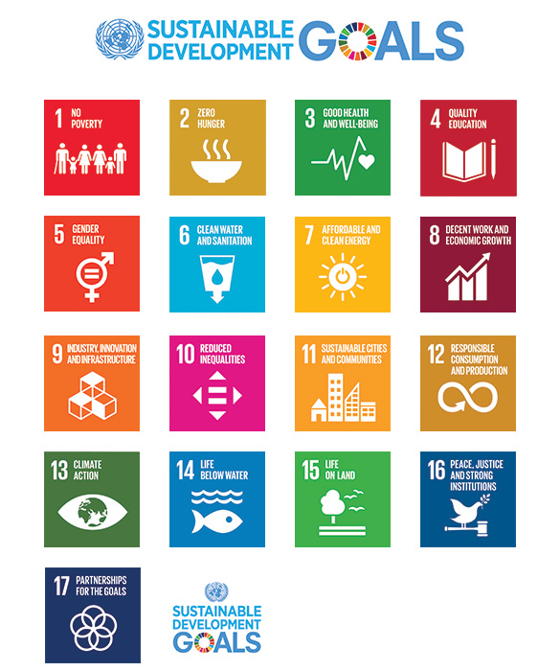
Figure 1 (Renewpower.in, 2023).

Goal 1 - No poverty
The COVID-19 pandemic has worsened the already existing global inequalities, with poverty being hit the hardest. The United Nations has set a goal to end extreme poverty by 2030 through its SDG 1 initiative, which focuses on eliminating poverty in all its forms, offering social protection, and improving access to essential services, particularly for vulnerable children and young adults. Although some progress has been made, there is still a significant distance to cover, with an estimated 575 million people expected to live in extreme poverty. As a result, 105 countries have implemented nearly 350 social protection measures in the past year to combat the rising cost of living (United Nations, no date).

To tackle this issue comprehensively, we must invest in quality education, healthcare, social safety nets, economic empowerment, gender equality, and discriminatory practices. Government policies and regulations are critical in creating a supportive environment for entrepreneurship and small business growth. By addressing systemic issues, we can work towards a fair and sustainable future where poverty and vulnerability are eliminated, and everyone has an equal opportunity to flourish (Office for Health Improvement and Disparities, 2022).

According to Kabeer (2016, p. 55-58), the world's interconnectedness requires a new social agreement that addresses the problems of poverty and social exclusion, rather than merely focusing on personal troubles. Global structural inequality is the root cause of these problems. The SDG agenda highlights every nation's responsibility towards the planet's future, emphasizing sustainability. Addressing inequality and prioritizing social justice and sustainability can unite nations and promote genuine cooperation across international, national, and subnational borders.

UK strategies
Strategy 1 - Living Wage Implementation
The UK's Living Wage is essential for tackling SDG1 on No Poverty. Employers who pay it ensure a minimum wage higher than the statutory wage. Unfortunately, many governments set minimum wages too low, leading to over 630 million people worldwide living in working poverty. COVID-19 has worsened this problem (Barford et al., 2022).

The implementation of a Living Wage has the potential to boost income and improve the health of individuals with low earnings. However, further investigation is necessary to assess its true effect on income disparities, considering the influence of the benefits system. The success of this initiative hinges on the widespread adoption by employers and should be integrated into a comprehensive strategy aimed at poverty reduction and attaining Sustainable Development Goal 1.
Figure 1. How living wages contribute to human rights and sustainable development goals.
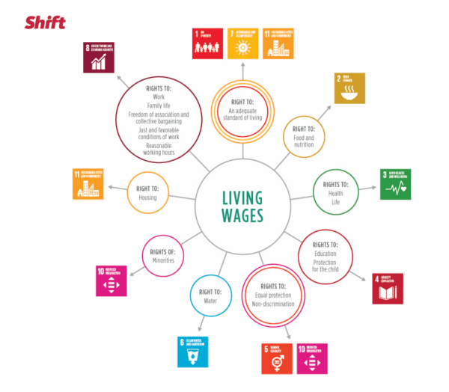
(Barford et al., 2022)

Living on a low income can have negative health impacts due to material or psychosocial factors. Material deprivation can lead to poor health outcomes and social isolation. Psychosocial factors such as stress and reduced autonomy can also cause ill-health. Income inequality and economic hardship can negatively impact health (Local Action on Health Inequalities, 2014).
Benefits
It's important to note that implementing the Living Wage has several benefits. Firstly, it directly increases the take-home pay of low-wage workers, which helps to reduce income poverty and improve their standard of living. Secondly, it incentivises individuals to seek and maintain employment, as the Living Wage often exceeds the statutory minimum wage. Thirdly, companies implementing the Living Wage often report benefits such as improved employee morale, lower turnover, and an enhanced public reputation, making it an attractive option for socially responsible employers. Finally, implementing the Living Wage helps to reduce wage disparities and income inequality, contributing to greater economic fairness (The Living Wage is good for business, no date).

‌
Challenges and Considerations
When implementing the Living Wage, some employers may argue that it could increase labour costs, leading to job cuts, reduced working hours, or even increased consumer prices. It's important to note that the impact of the Living Wage varies across sectors and regions and may not address all aspects of poverty. Additionally, since it's voluntary, not all employers choose to adopt it, which limits its reach and impact (Johnson, Koukiadaki and Grimshaw, 2019).

Another potential challenge of the Living Wage is indexation, as it may need to be periodically adjusted to keep pace with changing living costs, which can pose challenges for both employers and workers. Ensuring compliance with the Living Wage can also be challenging, as it relies on employers voluntarily adopting and maintaining the wage rate.

Despite these challenges, implementing the Living Wage is still considered a valuable strategy to address poverty in the UK, as it directly increases the incomes of low-wage workers. However, its effectiveness depends on employers' widespread adoption. It should be considered part of a broader set of policies and initiatives, including affordable housing, access to education, and social safety nets, to create a more comprehensive approach to poverty reduction and achieve SDG 1 (D’Arcy and Finch, 2019).

Strategy 2 - Social Housing Investment
Social Housing Investment is a program in the UK that aims to address SDG1 (No Poverty) by investing in the construction and maintenance of affordable and social housing units. The program's main objective is to offer safe and inexpensive housing options to individuals and families struggling with high housing costs. To achieve this goal, the program works closely with housing associations and local authorities to provide subsidised housing for those in need (yieldinvesting, 2023).
Benefits
Increasing the supply of affordable housing through Social Housing Investment can positively impact various aspects of our society. Firstly, it can help reduce the number of people living in poverty due to high housing costs, thereby tackling the issue of housing affordability. Secondly, it provides individuals and families with more excellent stability and security, reducing the risk of homelessness and housing-related financial stress. Thirdly, investment in housing construction and renovation can boost the construction industry, create jobs, and stimulate economic growth. Fourthly, access to safe and stable housing is closely linked to improved physical and mental health outcomes, which can reduce the burden on healthcare services. Lastly, affordable housing can free up income for other essential needs, such as education and healthcare, helping to reduce income inequality.
Challenges and Considerations
Regarding Social Housing Investment, governments must find ways to balance the investment with other budgetary priorities, as it requires substantial funding. Additionally, implementing a one-size-fits-all approach can be challenging due to the regional disparities in housing needs and costs. Furthermore, increasing the supply of affordable housing may not necessarily lead to immediate improvements in affordability, as market forces also play a role. Ensuring the quality and maintenance of social housing units is crucial to prevent substandard housing from creating new pockets of poverty. Finally, it's important to consider policies that promote social inclusion and integration within communities, as social housing is meant to provide affordable housing options and not create further social exclusion( RSH identifies key risks facing social housing sector in 2022 and beyond).

‌

‌
An

To sum up, investing in social housing is a crucial step towards alleviating poverty in the UK by providing affordable housing options. While it can improve the living standards of many individuals and families, it should be implemented carefully considering funding, regional discrepancies, and long-term maintenance. It should be considered part of a comprehensive strategy to combat poverty, including income support, education, and healthcare access.

Recommendations

.

Goal 2 - Zero Hunger
The current hunger crisis is a significant challenge faced by the world. As such, the United Nations' Zero Hunger initiative is tirelessly working towards eradicating hunger, promoting sustainable agriculture, and improving nutrition by 2030. The initiative also aims to tackle malnutrition and support small-scale farmers, which has led to significant progress in many developing countries. Regions such as Central and East Asia, Latin America, and the Caribbean have made remarkable strides in eliminating extreme hunger (UNDP, 2023).

Despite these efforts, hunger and malnutrition remain a significant obstacle to development in many countries. According to recent estimates, over 768 million people are suffering from chronic undernourishment, mainly due to environmental degradation, drought, and biodiversity loss. Shockingly, globally, 149.2 million children under the age of five are dangerously underweight. In recent times, undernourishment and severe food insecurity have increased in almost all regions of Africa and South America (United Nations, 2021).
Food security is influenced by four main factors: availability, access, utilisation, and stability. It is essential to tackle these factors to ensure everyone can access safe and nutritious food.

According to Chiesa (2023), it is imperative that the nutrition funding allocated for the year 2022 under the N4G initiative is utilised for carefully planned and executed nutrition-sensitive programs across various sectors. This commitment must be reinforced and evaluated in preparation for the 2024 N4G to meet the global nutrition targets set by WHO by 2025 and SDG 2 by 2030. Additionally, allocating more resources to countries facing fragile situations that result in severe hunger and malnutrition is crucial to tackling these urgent challenges effectively.
The issue of food insecurity is a critical global challenge that demands immediate attention. The UK is taking a commendable step by publishing a white paper detailing the nation's strategy to collaborate with other countries to address extreme poverty and climate change. This approach goes beyond the conventional method of providing aid money. The primary factors contributing to food insecurity include climate change, conflict, the enduring effects of COVID-19, and the impact of Russia's invasion of Ukraine on the global food supply (GOV.UK, no date).

According to the UK government (no date), Andrew Mitchell, the Minister of International Development, stated that. “Many children go to bed hungry and malnourished. At this summit, the UK and its partners will be united in our determination to change that. Cutting-edge science and innovative partnerships will help Britain create a healthier, more secure, and prosperous world”.
According to the UK's global contribution to the sustainable development goals (2022), 17% of households in the UK were food insecure in June 2023, an increase from 8.8% in 2022. This is why more families rely on food banks, as evident in the figures below.
Fig 2 and Fig 3 (Trussell Trust, 2022)
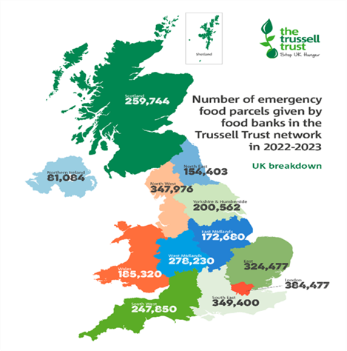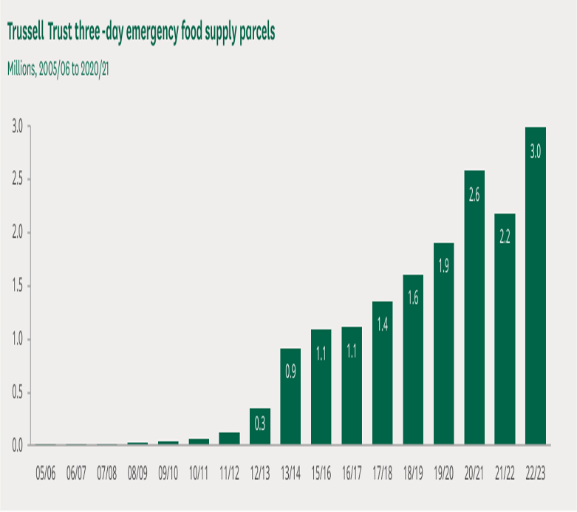

UK Strategies
Strategy 1 – National food
The UK is dedicated to fulfilling Sustainable Development Goal 2 (SDG 2), which strives to eliminate hunger, enhance food security, and advance nutrition. To achieve this, the National Food Strategy for England has been established to improve the food system and ensure everyone has access to safe, nutritious, and sustainable food. Furthermore, it aims to encourage sustainable agricultural practices that can reduce the environmental impact of food production and contribute to developing a more resilient food system. By implementing this strategy, the UK is taking significant strides towards achieving its SDG 2 target and creating a more equitable and sustainable food system for all (UK government, 2023).

Benefits
The National Food Strategy has several benefits for the nation. It promotes sustainable agricultural practices, which help protect the environment and ensure food production while reducing harmful pesticides. By improving dietary choices, reducing diet-related diseases, and enhancing overall wellbeing, the strategy can lead to a healthier population and reduced healthcare costs. Reducing food waste addresses hunger and has positive environmental and economic impacts. Additionally, community engagement and local food systems foster resilience and food security at the local level, promoting self-sufficiency and reducing dependency on external food sources (National Food Strategy, 2021).
Challenges and Considerations
Implementing the National Food Strategy at both policy and practical levels is crucial for its success. However, the complexity of the food system can pose a challenge.
Another challenge is ensuring access to nutritious food for vulnerable populations, particularly those facing poverty and food insecurity. This requires implementing targeted policies and support (Miller, 2023).
Promoting sustainable food choices and changing dietary habits can also be challenging, requiring extensive education and public awareness campaigns. The strategy may necessitate significant investments and changes in economic incentives, which can face resistance from stakeholders in the food industry.
The table below shows possible threats and challenges to UK food security. 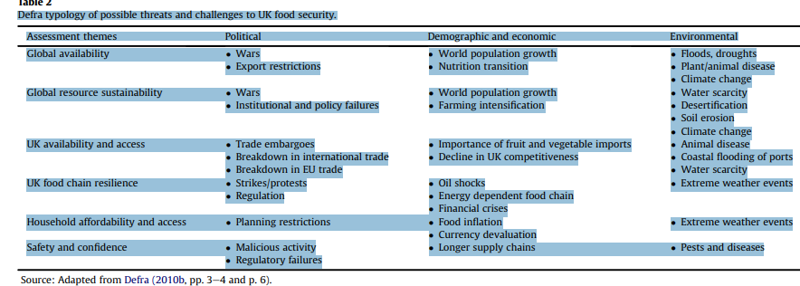Fig 1 (Kirwan and Maye, 2013)
Furthermore, the success of the National Food Strategy is closely linked to the achievement of other sustainable development goals since it aligns with multiple SDGs.
In conclusion, the National Food Strategy for England presents a promising approach to addressing SDG 2 by transforming the food system to ensure access to safe, nutritious, and sustainable food for all. However, successfully implementing the strategy requires overcoming challenges related to policy execution, equity, behavioural change, and economic considerations. Monitoring and adapting the strategy over time will be essential to achieve its goals and contribute to a more sustainable and food-secure future in the UK.
The strategy's success hinges on its ability to navigate the complex landscape of policy implementation, which requires a coordinated effort from all stakeholders. Additionally, ensuring equity in access to safe and nutritious food is a critical consideration, as is the need to promote behavioural change among consumers. Economic factors, such as the cost of production and distribution, must also be considered to ensure the strategy's viability.

Considering these challenges, monitoring and adjusting the strategy over time is imperative to ensure its effectiveness. This will require ongoing evaluation of the strategy's impact and identifying areas for improvement. By doing so, the National Food Strategy for England can contribute to a more sustainable and food-secure future for the UK.

Strategy 2 – School Meal Programme
Improving food security and nutrition among children in the UK is most important. To achieve this objective, various programmes have been implemented to provide nutritious meals to students throughout the school day, especially those from low-income backgrounds. These programmes ensure that children can access healthy food options and meet their dietary needs. By prioritising food security and nutrition in this way, we can help promote children's overall health and wellbeing across the UK and ensure they are equipped to succeed both in the classroom and beyond (Guio, 2023).

The implementation of school meal programmes can serve as a multifaceted solution to address a range of challenges. These programmes have the potential to significantly enhance the education, health, and nutrition of children, thereby contributing to the overall wellbeing of the community. Furthermore, they can serve as a vital safety net while strengthening food systems and economies. School meal programmes can be considered a strategic investment in developing a healthy and prosperous society (World Food Programme, 2019).

Benefits
Providing children with balanced and nutritious meals is crucial for their healthy development.
School meal programs are instrumental in achieving this objective, offering several benefits such as improved nutrition, reduced hunger, better academic performance, healthier food choices, and reduced food waste.
School meal programs can enhance children's overall health and wellbeing, alleviate hunger, and positively influence their dietary habits and food preferences by providing healthy and nutritious meals.
Also, school meal programs can help reduce food waste by providing meals that are pre-planned and prepared in the right quantities.
Overall, school meal programs are crucial in promoting healthy development, reducing educational outcomes linked to hunger disparities, and ensuring children have access to balanced and nutritious meals (World Food Programme, 2023).
Challenges and Considerations
It is worth noting that school meal programs have a limited scope, as they solely address food security and nutrition during school hours. This implies that the potential for food insecurity remains during evenings, weekends, and holidays for some children.
Maintaining nutritional standards and ensuring high-quality meals can pose a challenge, necessitating rigorous oversight.
Expanding and sustaining school meal programs could be costly, where significant budget allocation and sustained funding are necessary.
Also, some vulnerable children may need to meet the eligibility criteria for free school meals, leaving them without essential support. Encouraging parental engagement to promote healthy eating habits outside school hours is also vital for program effectiveness (Parnham, Millett and Vamos, 2022).

The evidence shows that school meal programs are critical to achieving SDG 2 in the UK. During school hours, these programs provide essential nutrition to children, particularly those from disadvantaged backgrounds. They promote food security and nutritional wellbeing and positively impact educational outcomes. However, school meal programs have limitations, such as their limited scope to the school day and challenges, such as maintaining high-quality meals, eligibility criteria, and costs. Therefore, it's essential to supplement school meal programs with broader strategies to address food security beyond school hours and encourage healthy eating habits in and out of the school environment.

Recommendations
Experts have recommended three practical steps to ensure that children from low-income households can access a "nutritional safety net". One of these measures involves providing free school meals to all children under 16 from families that receive Universal Credit or similar benefits. Additionally, the Holiday Activity and Food (HAF) program will be expanded to cover all regions in England so that all children who benefit from free school meals can access summer holiday support. The Healthy Start scheme will also be extended to all pregnant women and households with children under four years old where the parent or guardian receives Universal Credit or similar benefits, and the voucher value will be increased to £4.25 per week (The National Food Strategy, 2020).

Conclusion

References

education.nationalgeographic.org (no date) Opinion: We Can End Hunger, Here’s How. (online) Available at: https://education.nationalgeographic.org/resource/opinion-we-can-end-hunger-heres-how/.

‌Trussell Trust (2022). The Trussell Trust - End of Year Stats. The Trussell Trust. Available at: https://www.trusselltrust.org/news-and-blog/latest-stats/end-year-stats/ (Accessed: 20th November 2023).
International Development Committee (2013) Extreme Poverty and the Sustainable Development Goals. (online) Parliament UK. Available at: https://publications.parliament.uk/pa/cm5803/cmselect/cmintdev/147/report.html (Accessed: 23rd November 2023).

Office for Health Improvement and Disparities (2022) Health Disparities and Health inequalities: Applying All Our Health. (online) GOV.UK. Available at: https://www.gov.uk/government/publications/health-disparities-and-health-inequalities-applying-all-our-health/health-disparities-and-health-inequalities-applying-all-our-health. (Accessed:27th November 2023).

‌
‌ Institute for Fiscal Studies (no date) The impact of the National Living Wage on wages, employment and household incomes. (online) Available at: https://ifs.org.uk/publications/impact-national-living-wage-wages-employment-and-household-incomes (Accessed: 1st December 2023).

‌United Nations (no date). Goal 1 | Department of Economic and Social Affairs. (online) sdgs.un.org. Available at: https://sdgs.un.org/goals/goal1#:~:text=Goal%201%20calls%20for%20an (Accessed: 1st December 2023).

‌ yieldinvesting.co.uk. (2023) Investing In Social Housing: Pros & Cons - Yield Investing. (online) Available at: https://yieldinvesting.co.uk/investing-in-social-housing/#:~:text=Social%20housing%20is%20usually%20a (Accessed:1st December 2023).

‌

sdgs.un.org. (no date) Goal 1 | Department of Economic and Social Affairs. (online) Available at: https://sdgs.un.org/goals/goal1#:~:text=Goal%201%20calls%20for%20a (Accessed: 1st December 2023).

‌

United Nations (2021) Food. (online) United Nations. Available at: https://www.un.org/en/global-issues/food (Accessed: 20th November 2023).

‌
United Nations (2023) The 17 Sustainable Development Goals. (online) United Nations. Available at: https://sdgs.un.org/goals (Accessed: 8th November 2023).

UNDP (2023) Sustainable Development Goals | United Nations Development Programme. (online) UNDP. Available at: https://www.undp.org/sustainable-development-goals/zero-hunger (Accessed: 20th November 2023).

The Living Wage is good for business (no date). | Living Wage Foundation. (online) Available at:https://www.livingwage.org.uk/good-for-business#:~:text=What%20are%20the%20business%20benefits (Accessed:1st December 2023).

‌ D’Arcy, C. and Finch, D. (2019) The calculation of a living wage: the UK’s experience. Transfer: European Review of Labour and Research, 25(3), pp.301–317. https://doi.org/10.1177/1024258919847313.

‌
‌
Department of Health and Social Care (2014) Wellbeing and health policy. (online) GOV.UK. Available at: https://www.gov.uk/government/publications/wellbeing-and-health-policy (Accessed: 8th November 2023).

‌ Aparicio-Martínez, P., Martinez-Jimenez, M.P. and Perea-Moreno, A.-J. (2022). Health Environment and Sustainable Development. International journal of environmental research and public health, (online) 19(13). https://doi.org/10.3390/ijerph19138175.

Berke, P.R. and Conroy, M.M. (2000) Are We Planning for Sustainable Development? Journal of the American Planning Association, 66(1), pp.21–33. https://doi.org/10.1080/01944360008976081

‌World Health Organization (2019) World Health Organization(WHO) Definition Of Health - Public Health. (online) Public Health. Available at: https://www.publichealth.com.ng/world-health-organizationwho-definition-of-health/ (Accessed: 19th November 2023).

‌Renewpower.in. (2023) Available at: https://renewpower.in/sustainable-development-goals/images/sdg_banner.jpg (Accessed: 20th November 2023).
Kirwan, J. and Maye, D. (2013) Food security framings within the UK and the integration of local food systems. Journal of Rural Studies, (online) 29, pp.91–100. https://doi.org/10.1016/j.jrurstud.2012.03.002.

‌
‌ Local Action on Health Inequalities (2014) Living wage health inequalities. https://fingertips.phe.org.uk/documents/Living_wage_health_inequalities.pdf Public Health England

‌

United Nations Development Programme (2023) Sustainable Development Goals. (online) Sustainable Development Goals. Available at: https://www.undp.org/sustainable-development-goals (Accessed:19th November 2023).

‌ Johnson, M., Koukiadaki, A. and Grimshaw, D. (2019) The Living Wage in the UK: testing the limits of soft regulation? Transfer: European Review of Labour and Research, 25(3), pp.319–333. https://doi.org/10.1177/1024258919845768.

‌

Sinclair, J.R. (2019). Importance of a One Health approach in advancing global health security and the Sustainable Development Goals. Revue Scientifique Et Technique (International Office of Epizootics), (online) 38(1), pp.145–154. https://doi.org/10.20506/rst.38.1.2949.

‌

‌ World Food Programme (2019) School feeding | World Food Programme. (online) Wfp.org. Available at: https://www.wfp.org/school-meals.

‌ Chiesa, M (2023) Ending preventable deaths starts with nutrition | Bond. (online) Bond | The international development network. Available at: https://www.bond.org.uk/news/2023/11/ending-preventable-deaths-starts-with-nutrition/ (Accessed: 28th November 2023).

‌Guio, A. (2023) Free school meals for all European poor children: An important and affordable target? Children & Society. https://doi.org/10.1111/chso.12700

‌ Association, N.E. (n.d.). Child Nutrition | NEA. [online] www.nea.org. Available at: https://www.nea.org/advocating-for-change/action-center/our-issues/child-nutrition.

‌wfp.org. (2023) Ready to learn and thrive: School health and nutrition around the world - 2023 | World Food Programme. (online) Available at: https://www.wfp.org/publications/ready-learn-and-thrive-school-health-and-nutrition-around-world-2023

‌Parnham, J.C., Millett, C. and Vamos, E.P. (2022). School meals in the UK: ultra-processed, unequal, and inadequate. Public Health Nutrition, 26(1), pp.1–12. https://doi.org/10.1017/s1368980022002336.

National Food Strategy (2021) National Food Strategy Independent Review. (online) Available at: https://assets.publishing.service.gov.uk/media/61684fe3e90e071979dfec4a/national-food-strategy-the-plan.pdf (Accessed: 28th November 2023).

‌The National Food Strategy (2020). Available at: https://assets.publishing.service.gov.uk/media/61532f32d3bf7f718695a61b/national-food-strategy-part-one.pdf (Accessed: 28 November 2023).

‌Miller, L.J. (2023) The Perfect Fit. Sociological Forum. (online) https://doi.org/10.1111/socf.12930.

‌ GOV.UK. (no date) UK summit to boost food security through science and innovation. (online) Available at: https://www.gov.uk/government/news/uk-summit-to-boost-food-security-through-science-and-innovation (Accessed: 28th November 2023).

‌
Barford, A., Gilbert, R., Beales, A., Zorila, M. and Nelson, J. (2022) THE CASE FOR LIVING WAGES. The case for living wages. (online) https://doi.org/10.17863/CAM.80370.

GOV.UK. (n.d.). RSH identifies key risks facing social housing sector in 2022 and beyond. [online] Available at: https://www.gov.uk/government/news/rsh-identifies-key-risks-facing-social-housing-sector-in-2022-and-beyond.

‌
‌ Livingwage.org.uk. (2023) Real Living Wage could boost UK economy by £1.7billion | Living Wage Foundation. (online) Available at: https://www.livingwage.org.uk/news/real-living-wage-could-boost-uk-economy-%C2%A317billion

