Luke MacDonald (2100654)

Water Quality Monitoring and Global Water Resource Management

Table of Contents
1. The Growing Impact of Sewage Discharges on UK Water Quality 2
2. Nitrate/Solute Concentration Calculation 6
Introduction 6
Calculation 6
Discussion and Significance 7
3. Global Water Conflict Hot Spots and Sustainable Water Management 8
4. Dissolved Oxygen Calculation 14
Stream A 14
Stream C 14
Estimating Stream B 14
Discussion and Significance 14
References 16

1. The Growing Impact of Sewage Discharges on UK Water Quality
Rivers, lakes and coastal waters are essential natural resources that support biodiversity, provide drinking water and contribute to recreation and tourism throughout the United Kingdom. However, sewage discharges into these water bodies have become a serious environmental issue in recent years. Reports from the Environment Agency and environmental organisations have highlighted the ever-growing number of untreated sewage releases that are entering rivers and coastal areas (See figure 1), particularly during periods of heavy rainfall. Concerns in terms of declining water quality have increased attention in both public and political aspect on the management of wastewater systems and the environmental performance of UK water companies. This article investigates the causes and impacts of sewage pollution in the UK and discusses possible solutions to improve long-term water quality management.
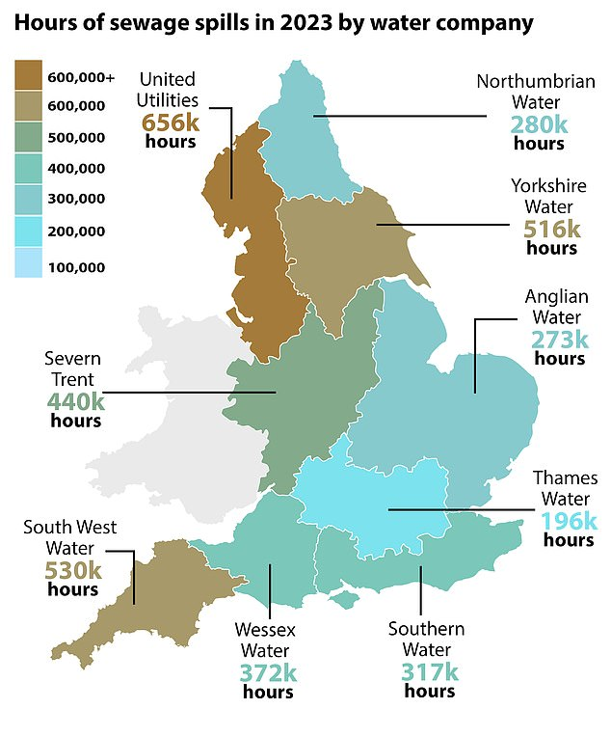

Figure 1: Reported sewage discharge incidents across England (Daily Mail, 2024).

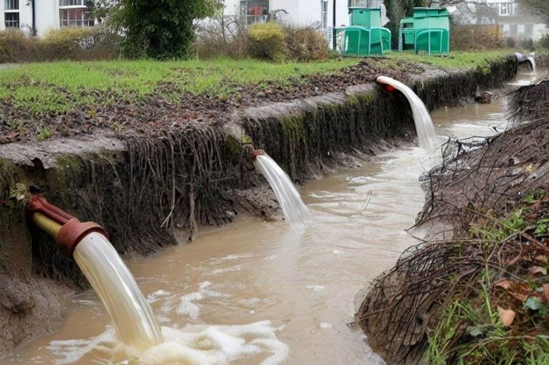
One of the main causes of sewage pollution in the UK is the wide use of Combined Sewer Overflow (CSO) systems. Many sewer systems were initially constructed during the Victorian era and were designed to carry both rainwater and sewage through the same pipes. During periods of intense rainfall, treatment works and sewer networks can be overwhelmed, forcing untreated sewage to be released directly into rivers, lakes and coastal waters (See figure 2) to prevent flooding of homes and streets. Population growth, more housings and increased development have placed even more pressure on these old systems. Furthermore, climate change has contributed to more frequent and intense storm events, increasing the likelihood of overflow incidents. Critics have argued that poor investment in wastewater infrastructure by some water companies has also contributed to the deterioration of water quality across the UK.

Figure 2: Combined sewer overflow discharging into a UK river system (SomersetLive, 2023).
Sewage discharges can have severe environmental consequences for aquatic ecosystems. Untreated wastewater contains high concentrations of nutrients such as nitrogen and phosphorus, which contribute to eutrophication in rivers and lakes. Excessive nutrient concentrations result in rapid algal growth, reducing light penetration and damaging aquatic plant life. As algae decompose, dissolved oxygen concentrations decrease, which can result in fish kills and reduced biodiversity. In addition, sewage pollution may contain harmful bacteria, viruses, pharmaceuticals and microplastics that negatively affect aquatic organisms and ecosystem. The long-term degrading of water quality threatens important ecosystem services and the ecological status of rivers across the UK.

The impacts of sewage pollution also extend beyond the natural environment and can affect human health and local economies. Untreated sewage may contain pathogens such as E. coli and other harmful microorganisms that pose risks to swimmers, anglers and other users of rivers and coastal waters. In recent years, several popular beaches and wild swimming locations in the UK have experienced temporary closures due to poor water quality. Tourism and recreational industries may suffer financial losses where pollution incidents reduce the attractiveness of affected areas. Furthermore, public confidence in water companies and environmental regulators has reduced as awareness of sewage discharges has increased through media reporting and environmental campaigns.
Several measures could be implemented to reduce sewage pollution and improve water quality across the UK. Large investment is required to modernise ageing sewer infrastructure and increase the capacity of wastewater treatment plants. Upgrading Combined Sewer Overflow systems and separating stormwater from sewage networks could massively reduce the frequency of untreated discharges. Stricter environmental regulations and increased financial penalties could encourage water companies to improve performance and comply with environmental standards. In addition, real-time water quality monitoring systems could improve transparency and provide the ability to catch pollution incidents early.
Nature-based solutions may also help reduce pressure on sewer systems. Sustainable Drainage Systems (SuDS), including permeable pavements, green roofs and wetland restoration, can reduce surface runoff entering drainage networks during heavy rainfall. Public awareness campaigns promoting a responsible water use and the correct disposal of waste products could support improvements in water quality management further. Better cooperation between government agencies, environmental organisations and water companies will also be important in developing sustainable long-term solutions.

In conclusion, sewage discharges are a major threat to the environmental and ecological health of UK rivers, lakes and coastal waters. Ageing infrastructure, population growth and climate change have increased the problem, while poor wastewater management has contributed to declining water quality. However, through good investment, stricter regulation, improved monitoring and sustainable drainage solutions, significant improvements can be made. Protecting UK water resources will require long-term cooperation between government, industry and the public to ensure a more sustainable future for aquatic ecosystems and communities.

2. Nitrate/Solute Concentration Calculation

Introduction
Monitoring nitrate concentrations within river catchments is important for assessing water quality and identifying pollution sources. High nitrate levels are commonly associated with agricultural runoff, sewage discharge and industrial pollution. Excessive nitrate concentrations may contribute to eutrophication, reduced dissolved oxygen levels and ecological degradation within freshwater systems. Calculating solute concentration per km² allows environmental agencies and catchment managers to assess pollutant loading across a river basin and evaluate the effectiveness of water quality management strategies.

Calculation
Time (s) | Discharge m³ S⁻¹ | Nitrate – N mg L⁻¹ | Load (Q x C)
18:00 | 2.18 | 3.22 | 7.02
19:00 | 2.15 | 3.31 | 7.12
20:00 | 2.10 | 3.34 | 7.01
21:00 | 2.18 | 3.39 | 7.39
22:00 | 2.35 | 3.36 | 7.90
23:00 | 2.29 | 3.39 | 7.76
00:00 | 2.29 | 3.39 | 7.76
01:00 | 2.35 | 3.40 | 7.99
02:00 | 2.38 | 3.36 | 8.00
03:00 | 2.55 | 3.37 | 8.59
04:00 | 2.55 | 3.40 | 8.67
05:00 | 2.61 | 3.42 | 8.93
06:00 | 2.61 | 3.45 | 9.0
07:00 | 2.69 | 3.45 | 9.28
08:00 | 2.80 | 3.48 | 9.74
09:00 | 2.97 | 3.40 | 10.10
10:00 | 3.14 | 3.45 | 10.83
11:00 | 3.37 | 3.47 | 11.69
12:00 | 3.60 | 3.40 | 12.24
13:00 | 3.09 | 3.36 | 10.38
14:00 | 2.61 | 3.37 | 8.80
15:00 | 2.10 | 3.45 | 7.25
16:00 | 1.95 | 3.5 | 6.83
17:00 | 2.01 | 3.60 | 7.24
Total Solute Load | - | - | 207.52

Catchment area = 321 km²
Solute Concentration per km² = 207.52/321 = 0.65
The total solute concentration per km² for the 321 km² catchment is approximately,
0.65 mg L⁻¹ km⁻²

Discussion and Significance
This exercise shows the importance of water quality monitoring in river catchments. Measuring nitrate concentrations and discharge rates allows scientists and environmental areas to estimate pollutant loading entering river systems over time. Raised nitrate levels are usually associated with agricultural fertiliser runoff, sewage discharge and industrial activity. Excessive nutrient concentrations could contribute to eutrophication, resulting in algal blooms, oxygen depletion and degradation within freshwater environments.
The results show that nitrate loads increased during periods of higher river discharge, particularly during late morning and midday when flow rates were highest. This shows the relationship between river flow and pollutant transport within catchments. Understanding these relationships is essential for effective environmental management and policy making.
Monitoring solute concentrations per km² also allows the comparison between different catchments and helps identify areas experiencing larger pollution pressure. This information can support the development of mitigation measures such as improved wastewater treatment, sustainable agricultural practices and more strict pollution controls. Therefore, long-term water quality monitoring plays an important role in protecting aquatic ecosystems and ensuring sustainable freshwater resource management.

3. Global Water Conflict Hot Spots and Sustainable Water Management
Freshwater resources are becoming increasingly vulnerable due to population growth, climate change, industrialisation and rising agricultural demand. Although water covers most of the Earth’s surface, only a small percentage is available as accessible freshwater suitable for human use. As global demand for water increases, many regions around the world have been labelled as major water “hot spots”, where political, environmental and social conflicts have developed over access to water resources. Water scarcity, pollution and unequal distribution have increased tensions between countries and communities, while climate change has increased pressure on vulnerable river basins and ecosystems further, as proven by stars4water (2025) who state that climate change has a major impact on freshwater systems. This report investigates major global water hot spots across different continents, analyses the nature of the conflicts and discusses possible sustainable solutions for future water management.
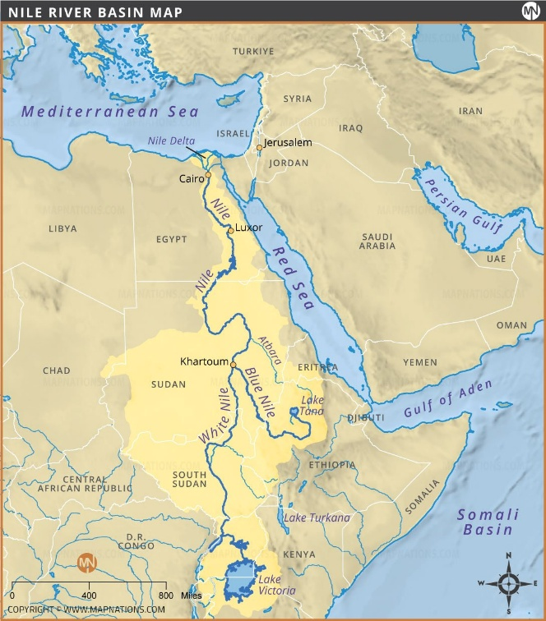
One of the most significant water conflict zones in Africa is the Nile River Basin. The Nile is shared by several countries (See figure 3), including Egypt, Sudan and Ethiopia, and is massively important for agriculture, drinking water and hydroelectric power generation. Tensions have increased following Ethiopia’s construction of the Grand Ethiopian Renaissance Dam (GERD) on the Blue Nile. Ethiopia argues that the dam is necessary to support economic development and energy production, while Egypt fears that reduced downstream river flow could affect its national water security This is helped by BBC (2020) who mention that Egypt fear this project would allow Ethiopia to control the flow of the river. Egypt relies heavily on the Nile for freshwater supply, with much of its population concentrated around the river. Climate change and increasing water demand have increased concerns regarding future shortages. This conflict shows the importance of international cooperation and shared river basin management. Long-term solutions may include negotiated agreements regarding water release schedules, cooperative monitoring systems and regional partnerships focused on sustainable resource management.
Figure 3: Countries sharing the Nile River Basin in Africa (MapNations, no date).
In Asia, the Indus River Basin shows another major water conflict between India and Pakistan. Both countries heavily depend on the Indus River system for irrigation, agriculture and water supply. Although the Indus Waters Treaty was established in 1960 to regulate water sharing between the two nations, political tensions and population growth continue to place pressure on the river system. Climate change has accelerated glacier melting within the Himalayan region, affecting seasonal river flows and increasing uncertainty in regards to future water availability, as proven by United Nations (2025) who mention that the accelerated melting of glaciers now threatens large populations who rely on the rivers. Water insecurity in this region threatens food production, economic stability and regional security. Improved diplomatic cooperation, investment in efficient irrigation systems and joint monitoring of water resources could help reduce tensions and support more sustainable management of the basin.
In Europe, the Danube River Basin faces large environmental pressures associated with industrial pollution, agricultural runoff and urban wastewater discharge. The Danube flows through numerous countries, making water management particularly complicated due to the need for international coordination. Pollution from fertilisers, sewage and industrial waste has contributed to declining water quality and ecological degradation in some sections of the river. This shows how water conflicts are not always caused by physical shortages but can also result from poor water quality and conflicting economic interests. The European Union Water Framework Directive has encouraged cooperation between countries to improve river management and reduce pollution; this is supported by Environment Europa (2024) who mention that it allows countries and the EU to cooperate on water management issues and ensure the river is managed and used sustainably. Continued investment in wastewater treatment infrastructure and stricter environmental regulations will remain important in protecting the ecological health of the basin.
The Colorado River is one of the most heavily exploited river systems in North America. The river supplies water to several US states and parts of Mexico, supporting agriculture, industry and large urban populations. However, long-term drought conditions, climate change and excessive water extraction have largely reduced river flows and reservoir levels (See figure 4), this is supported by Congress.gov (2025) who state that consumptive use and other water losses exceed flows, coupled with long-term drought has heavily affected the basins water supplies. In some years, parts of the river no longer reach the sea due to overuse. Agricultural irrigation accounts for a large proportion of water consumption within the basin, while fast urban development has increased demand further. The Colorado River conflict shows the challenges associated with unsustainable water consumption in barren environments. Possible solutions include stricter water conservation measures, improved irrigation efficiency, wastewater recycling and revised water allocation agreements between states and neighbouring countries.
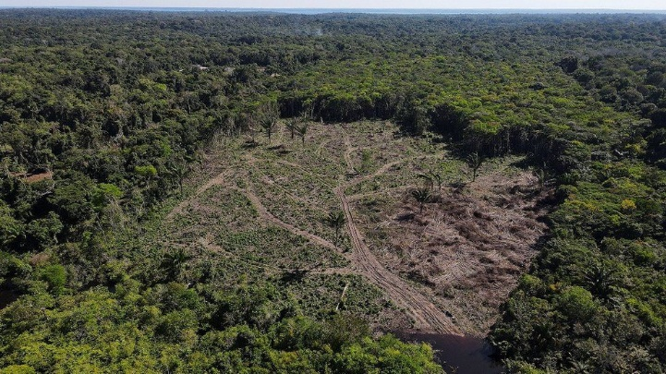
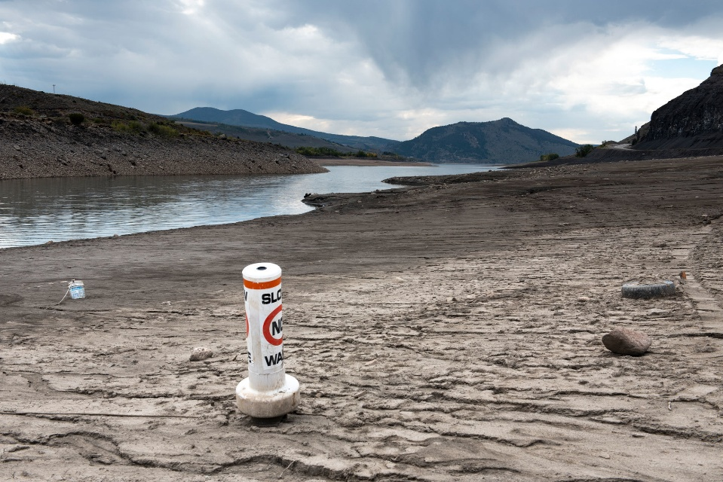
In South America, the Amazon Basin faces growing environmental pressures linked to deforestation, mining activities and hydropower development, as proven by The Nature Conservancy (2026) who state that it faces erratic water levels as a result of deforestation, wildfires and water pollution. The Amazon River system contains one of the world’s largest freshwater ecosystems and supports great biodiversity. However, large-scale deforestation (See figure 5) has disrupted natural water cycles and increased sedimentation within river systems. Mining operations have also contributed to water pollution through the release of harmful chemicals such as mercury. These environmental pressures threaten native communities and wildlife that rely on healthy freshwater ecosystems. Sustainable solutions may include stronger environmental protections, reduced deforestation, improved regulation of mining activities and international cooperation focused on protecting tropical rainforest ecosystems.
Figure 5: Deforestation impacts within the Amazon (BBC, 2022).
Figure 4: Declining water levels within the Colorado River Basin (Yale Environment 360, 2019).
Australia’s Murray–Darling Basin is another major water hot spot affected by drought and competing demands for water resources. The basin supports a large proportion of Australia’s agricultural production, particularly irrigation farming. However, excessive water extraction and prolonged drought conditions have contributed to declining river flows, habitat destruction and ecosystem degrading, this is supported by Australian National University (2025) who mention that excessive and increasing irrigation water extractions recently have added to the major threat of climate change. Water allocation issues between agricultural users, environmental groups and government authorities have become increasingly common. Climate changes and rising temperatures are expected to put further stress on the basin in the future. Sustainable management strategies may include improved irrigation technology, stricter water allocation policies and wetland restoration projects designed to improve ecosystem resilience.
To use water more sustainably, governments, industries and communities must adopt more efficient management strategies and reduce unnecessary consumption. Agriculture accounts for most of the global freshwater use, meaning improved irrigation systems such as drip irrigation could massively reduce water wastage, this is supported by IERE (2025) who state that drip irrigation minimises evaporation, by delivering water directly to the soil surface. Wastewater recycling and rainwater harvesting may also reduce pressure on freshwater supplies, particularly in urban environments, this is helped by The Renewable Energy Hub UK (2026) who state that the biggest ecological benefit of this is the reduction of use of mains water resulting in less use of water being drawn from the environment. Sustainable Drainage Systems (SuDS) and wetland restoration projects can improve natural water filtration and reduce flood risks. In addition, stronger international cooperation will be essential for the fair and sustainable management of river systems that travel through countries. Public education campaigns promoting water conservation and pollution reduction could further support long-term sustainability goals. As climate change continues to affect global water availability, adaptive management strategies will become more important in reducing future water insecurity.

In conclusion, water hot spots across the world show the growing pressures placed on global freshwater resources. Climate change, population growth, pollution and political tensions have intensified conflicts over water availability and quality in many regions. From the Nile River Basin in Africa to the Colorado River in North America, these examples show the environmental, economic and political importance of sustainable water management. Although the challenges are significant, improved cooperation, investment in sustainable technologies and stronger environmental protections could help reduce future water issues and protect freshwater ecosystems for future generations.

4. Dissolved Oxygen Calculation
Stream | Q (mg/L) [Flow] | Temp. C | D (Oxygen Deficit) | DO (Dissolved Oxygen)
A | 3.7 | 21 | 4.49
B
C | 6.2 | 19.4 | 3.58
Chloride Concentration = 0 mg/L
DO = DO_{sat} – D

Stream A
21C = 8.9mg/L
Given D = 4.49,
8.9 – 4.49 = 4.41
Therefore, DO_{a} = 4.41 mg/L

Stream C
19.4 = 9.2mg/L
Given D = 3.58,
9.2 – 3.58 = 5.62
Therefore, DO_{c} = 5.62 mg/L

Estimating Stream B
Stream B values missing, use streams A and C to estimate:
(4.41+5.62)/2 = 5.02
Dissolved oxygen concentration of Stream B is approximately:
5.02 mg/L

Discussion and Significance
Dissolved oxygen concentration is one of the most important indicators of river water quality and ecosystem health. Fish, invertebrates and aquatic plants need sufficient oxygen concentrations to survive. Low dissolved oxygen levels are usually associated with sewage pollution, eutrophication and high biological oxygen demand caused by decomposing organic matter.

The results show relatively moderate dissolved oxygen concentrations within the streams. Stream A displayed the lowest dissolved oxygen concentration due to a higher oxygen deficit, suggesting larger levels of organic pollution or oxygen consumption. Stream C had a slightly higher dissolved oxygen concentration, indicating improved water quality conditions.
Temperature also has a large influence on dissolved oxygen levels because warmer water holds less oxygen than colder water. This means rivers could become increasingly vulnerable to oxygen depletion during warmer periods or under climate change conditions.
Monitoring dissolved oxygen concentrations allows environmental agencies to assess ecological health, identify pollution impacts and support sustainable water quality management strategies. Rivers with consistently low dissolved oxygen concentrations could experience biodiversity loss, fish mortality and long-term ecosystem degradation.

References
Australian National University (2025) Darling Rivers decline due to excessive water extractions, not only drought. Available at: Darling River's decline due to excessive water extractions, not only drought - ANU Policy Brief (Accessed on: 1th May 2026)
BBC (2022) Amazon Rainforest: Highest Deforestation Rate in Six Years. Available at: Amazon Rainforest: Highest deforestation rate in six years - BBC News (Accessed on: 8th May 2026)
BBC (2020) Egypt-Ethiopia row: The trouble over a giant Nile dam. Available at: Egypt-Ethiopia row: The trouble over a giant Nile dam - BBC News (Accessed on: 9th May 2026)
Congress.gov (2025) Management of the Colorado River: Water Allocations, Drought, and the Federal Role. Available at: https://www.congress.gov/crs_external_products/R/PDF/R45546/R45546.41.pdf (Accessed on: 11th May 2026)
Daily Mail (2024) Every river in England is polluted, new Environment Secretary Steve Reed warns as he backs ‘severe fines’ for utilities illegally pumping sweage into lakes and waterways. Available at: Every river in England is polluted, new Environment Secretary Steve Reed warns as he backs 'severe fines' for utilities illegally pumping sewage into lakes and waterways | Daily Mail Online (Accessed on: 5th May 2026)
Environment Europa (2024) Danube Day: Shining a spotlight on EU cross-border water cooperation. Available at: EU cross-border water cooperation in spotlight on Danube Day - Environment (Accessed on: 10th May 2026)
IERE (2025) Does Drip Irrigation Save Water? Available at: Does Drip Irrigation Save Water? - The Institute for Environmental Research and Education (Accessed on: 12th May 2026)
MapNations (No date) Nile River Map. Available at: Nile River Basin Map – Course, Tributaries, Basin Countries and Major Cities (Accessed on: 5th May 2026)
The Nature Conservancy (2026) Amazon in Peril. Available at: Amazon River Basin Climate Challenges (Accessed on: 12th May 2026)
The Renewable Energy Hub UK (2026) Benefits on Rainwater Collection in the UK. Available at: Benefits of Rainwater Collection in the UK (Accessed on: 12th May 2026)
SomersetLive (2023) Government must pressure Wessesx Water to clean up sewage discharge in Somerset. Available at: Government must pressure Wessex Water to clean up sewage discharges in Somerset | Somerset Live (Accessed on: 5th May 2026)
Stars4Water (2025) Climate Change Impacts: Water Challenges of European River Basins. Available at: BASINS (Accessed on: 9th May 2026)
United Nations (2025) ‘On thin ice’: UN chief sounds alarm over rapid Himalayan glacier melt. Available at: ‘On thin ice’: UN chief sounds alarm over rapid Himalayan glacier melt | UN News (Accessed on: 10th May 2026)
Yale Environment 360 (2019) On the Water-Starved Colorado River, Drought Is the New Normal. Available at: On the Water-Starved Colorado River, Drought Is the New Normal - Yale E360 (Accessed on: 6th May 2026)

