Student Name: Janis Skodins
P Number: 1702635
Programme of Study: Automotive Design
Module: M4X01559

EXHIBITION OF WORST CARS EVER MADE

The event would take place in Petersen Automotive Museum located in Los Angeles, USA.

“Our Mission: To explore and present the history of the automobile and its global impact on life and culture” Petersen Automotive Museum mission statement
(Petersen Automotive Museum Official Website. 2018.)

This Exhibition strives to showcase failed attempts of designing a successful automobile throughout the history and to explore its consequences based on context.
for educational and historical purposes. Major part of this exhibition will focus on symbols that these cars portray, and key figures of the time, that have influenced and link to certain events in worlds history.

The exhibition will contain the following exhibits in historical order:

- Horsey Horseless (known to be created in 1899) Designer:

- BMW Isetta (1955) Designer: Ermenegildo Preti and Pierluigi Raggi

- AMC Gremlin (1970), Designer: Richard A. Teague, and stylist Bob Nixon

- Ford Pinto (1971), Designer: Robert Eidschun

Trabant 601 (1975), Designer: Werner Lang

- Hummer H2 (2003), Designer: Clay Dean

The aim of Above exhibits is to touch up on following theories:

- 1st Oil Crisis (1973) Price of fuel increased by 400% causing many long and short term effects in global politics and global economy.

- Iron Curtain: the boundary dividing Europe into two areas from the end of World War II until the end of the Cold War. -

- Aftermath of bombings in Munich after WW2 that almost caused BMW to shut down.

- Suez Crisis 1956.

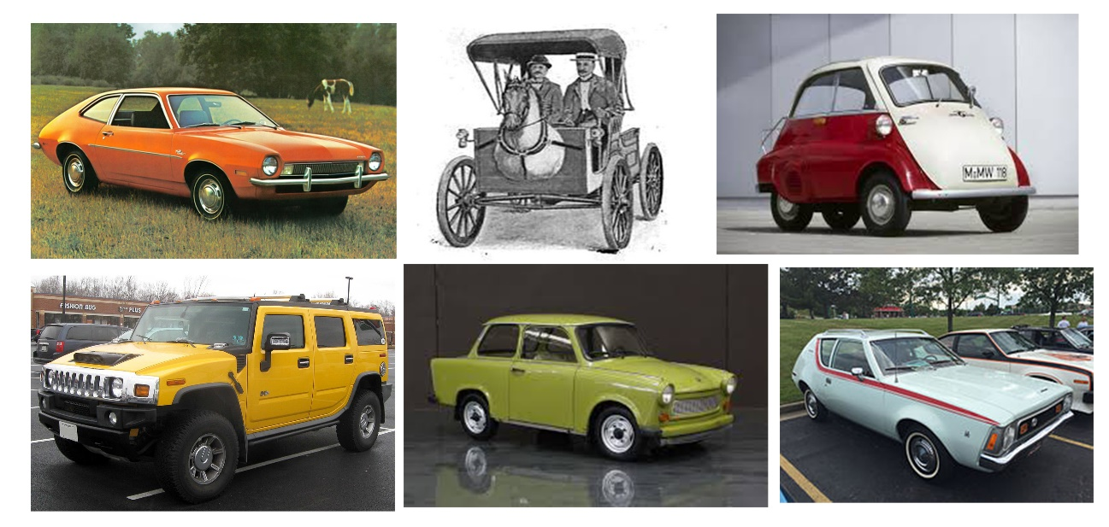



Context:

This exhibition will focus on theories such as, different environmental, economic and political situations that affect and have affected countries that practice automotive industry and simply stupid mistakes that made their way from drawing board to finished product resulting in useless cars that would not appeal to user. This exhibition will focus on designers of these cars and key figures that influenced automotive industry at the time.

The purpose of this exhibition is not to show how bad these cars are, but to show consequences of certain events that led to manufacturing or failing of these cars. To explore history and ideas of designers and key figures of certain periods. The aim is to show what happened and why. Most of these exhibits are symbols of political events, and therefor are important pieces of history and education.

From 1886 the birth year of the modern car till modern day where sitting in traffic jams people spend more than two months of average lifetime based on INTRAX global traffic monitoring, we can surely agree on fact that modern car has become a sustainable part of human life and will forever be one of greatest inventions.

“Everything in life is somewhere else, and you get there in a car.”
(Forman,R, 2002.)

“Roads and driving are so entwined that appearance of one leads to other.”
(Forman,R, 2002.)

Reason of using cars as exhibits to tell their stories is universal, the context and meaning of a car is known to everyone and does not require people to be educated in certain art forms to understand it, they are simple and pack a lot of history and symbolisms that can attract different types of audience.

Can these exhibits be valued as art pieces? I personally believe that they are more informative than expressive. Apparently true art can have no practical application.

A Designer can sometimes be considered an Artist, but an Artist is not considered a Designer, if artwork is not mass-produced, Artists use their work to make a visual statement of something.
Designers aim to mass produce and to solve problems given to them using artistic methodology as a tool to plan.

“Our guiding principle was that design is neither an intellectual nor a material affair, but simply an integral part of the stuff of life, necessary for everyone in a civilized society.”

Walter Gropius (Margolin & Buchanan, 1996, p.4)
Automobiles are designed in a way that evokes emotional reaction from user, but their intent is purely functional, therefore it would not qualify as "true art".

It would only make sense to host this exhibition in Peterson Automotive Museum,
it would have enough physical space to display selected exhibits and appropriate staff to ensure safety of exhibits, along with educating visitors all needed information.

Exhibition would take place on “History floor”.

“an extraordinary venue where automobiles tell stories and every story has a place in history. (Petersen Automotive Museum Official Website. 2018.)
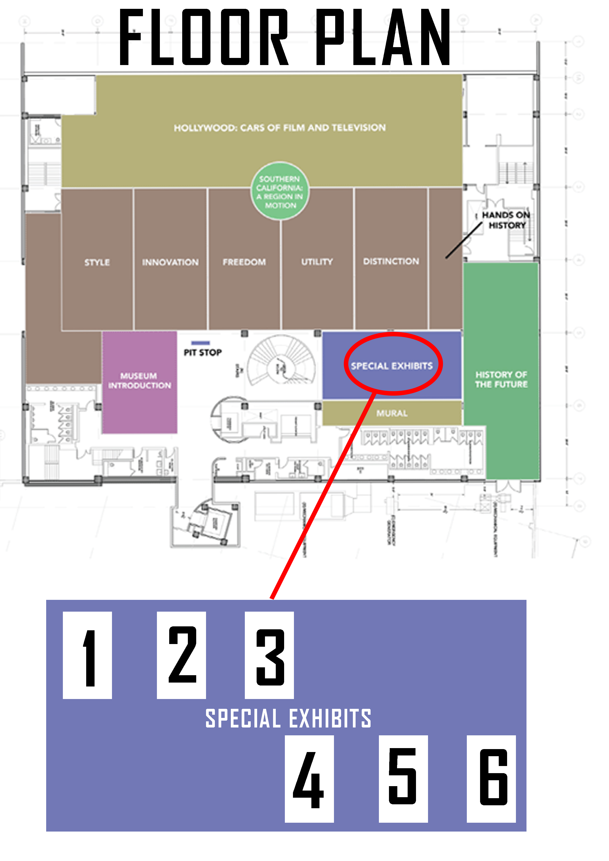
(Exhibits are displayed in historical order stated above)

Designers and Their work:

1.Horsey Horseless (1899)

Known to be designed in 1899 by inventor Uriah Smith.
“the brainfart of inventor Uriah Smith” Was a horseless carriage designed to “Soothe the skittish nerves of our equine servants” a wooden piece shaped as horsehead was attached to the front of the vehicle that resembled carriage.

“The live horses would think of another horse” said smith “and before he could discover his error and see that he had been fooled, the strange carriage would be passed.” (Georgann, N., 1996.)

It is not known if this crazy concept evolved into a finalized product, but this definitely shows how hard it was to conceptualize early automobiles and the problems of the time such as sharing roads with horses

2. BMW Isetta (1955)

After WW2, BMW was in decline and factories were damaged during
Bombing, four of the factories were located in territory under control of SWAG.
Only in 1951 BMW had produced its first post-war car, it was expensive and non-profitable, BMW acquired rights to produce Isetta from Italian fridge company in 1955, Unreliable but simple design, however cheap and successful in market, it came to fame in 1956 during Suez Canal crisis that led to fuel shortage in number of countries. This car has become symbol of short-term solution for post-war energy crisis.

3.AMC Gremlin (1970) and Ford Pinto (1971)

AMC gremlin and Ford Pinto were first attempts of fuel efficient cars made in America in 1970’s when the members of the Organization of Arab Petroleum Exporting Countries proclaimed an oil embargo on number of countries including USA, due to limited resources and lack of time cars were poorly designed visually and functionally,
They are known to be one of the ugliest cars of all times. Ford Pinto was a disaster in safety, car would burst in flames when rear-ended, Ford ended up
Paying 3.5 million of dollars to families of 24 people that died during fuel cell issues of
ford Pinto before car was recalled. These cars reflect the situation in USA during first oil crisis, they were dangerous and very poorly designed on low budget but people would risk to buy them in order to save money.

4.Trabant 601(1963 -1990)
most common vehicle in former East Germany, symbol of Iron curtain,
It was first produced in 1963 and produced till the end of Soviet Union.
The design would have minor design changes during the period, when other
Side of the country was producing progressive and modern cars such as BMW
And Mercedes Benz, Trabant would still be most common car on the other side of curtain, people would wait in line to get what they called “spark plug with roof.”
It is most symbolic thing of the time, since it ended with the fall of curtain.

5. Hummer H2

Worst vehicle at a worse time, introduced shortly after 9/11.
Hummer H2 would send all the wrong signals, as the car that it’s design was based on was sent to war in Iraq, known as HMMWV. Hummer was to militarised looking, too big and
Would have fuel consumption of a tank, sometimes 10 miles per gallon.
In 2009 Hummer becomes most polluting car in the world, General Motors is forced to stop producing Hummers. PR catastrophe and natural disaster.

BIBLIOGRAPHY:

Cagle, G., 2018. Scenes from an Automotive Wonderland: Remarkable Cars Spotted in Postwar Europe. 1st ed. USA: McFarland.

Forman,R, 2002. Road Ecology: Science and Solutions. 1st ed.: island Press

Neckermann, L., 2015. The Mobility Revolution; Zero Emissions, Zero Accidents, Zero Ownership. Troudador Publishing.

Georgann, N., 1996. The American Automobile: a centenary. USA: Smithmark

Petersen Automotive Museum Official Website. 2018. Venue. [ONLINE] Available at: https://www.petersen.org

Margolin, V & Buchanan, R (1996). The Idea of Design. (1st ed.). London: MIT press.

