KNOWLEDGE AND INFORMATION MANAGEMENT SKILLS FOR THE WORKPLACE
Lecturer | TANJA NATHAN
BMSK5006
Junior Richard (1605599)

Table of Contents
Introduction 2
Knowledge management (KM) 2
Data to Knowledge 3
Individual knowledge vs organizational knowledge 6
Knowledge assets 7
Knowledge process and systems 8
Knowledge creation 9
Knowledge storing 10
Knowledge distribution 11
Knowledge application 11
Intellectual property rights 12
Dixons Knowledge sharing & Culture 12
Conclusion 14
References 15
APPENDICES 18
Appendix A 18

Introduction
According to Bell (1973), knowledge is a vital resource of the economy. Many organisations face competition on a global scale as well as dynamic surroundings, therefore they are being instructed to bring together different individuals with different talents and also to engage their knowhow to be able to seek access to newer markets and technology (Bhat, 2002). Many philosophers and scientists have always been anxious on how to create, acquire, and communicate knowledge and by what method to improve the re-utilization of knowledge. Nevertheless, during the last decades a distinctive field has emerged named “knowledge management” (KM) (King, 2009). It is believed that KM is founded on the principle that, individuals cannot reach their full intellectual potential and organisations find it hard to utilize the knowledge which they possess. This report intends to evaluate the various extensive channels and means for consumers to be able to obtain information that many would think that KM strategy is not significant to any further extent. In fact, it has the opposite effect and KM currently is more imperative than before (Hall, 2010). By using academics literature this report has been assigned to choose a company to where this report will evaluate, analyse its KM and conclude to see if there is a better way to manage the knowledge within that organisation. Therefore, in this report we will discuss in detail of the company of choice which is Dixons. Through KM, organisations try to find ways to create or obtain possible knowledge and try to make this knowledge available to those within the business so that they can use it at a suitable time and place to achieve effective usage of knowledge to be able to influence the firm positively. According to academics it is commonly believed that an organisation can increase the way they effectively utilize knowledge by a small margin, and this will result in great benefits. So, in this report firstly will evaluate the concept of KM as well as the importance of KM within the context of an organisation. By identifying Dixons knowledge assets this report will show modelling techniques to be able to identify the assets as well as discussing how Dixons gains data, information and knowledge and the relationship in-between them. Secondly this report will explain how Dixons create, store and implement their knowledge and how they also protect their knowledge from others. Lastly, by considering the requirements of knowledge within Dixons this report will evaluate their framework to which they share knowledge to derive to any improvement suggestions to that framework.

Knowledge management (KM)
Various organisations have recognised knowledge as a domineering new strategic and the utmost well-known example is ‘knowledge is power’ (Chakravarthy, et al., 2015). Consequently, meaning Dixons or individuals within Dixons will have to store it and retain it to be able maintain an advantage over others. Therefore, the common attitudes of various individuals are to grasp on to one’s knowledge, as that what makes an individual an asset to the organisation (Chakravarthy, et al., 2015). For instance, within Dixons, most staff are a bit knowledgeable, but some have more know-how, the staff who are more know-how seem to be the management team as they have more knowledge of what is happening within the company. Knowledge to this date is well thought-out to be huge power within an organisation like Dixons, but the way organisations such as Dixons perceive this has transformed substantially as the belief now is for Dixons knowledge should be shared for growth. Various organisations and Dixons have shown that sharing their knowledge amongst their team members can result into growth as well as becoming more competitive. In Figure 1 the definitions of KM as well as the description in different perspectives will be illustrated.
Dixons is known as a leading electrical specialist retailing group to which sales and manufactures consumer electricals and appliances. The organisation spans over 14 countries, with over 1000 stores and employs 36000 employees. Dixons is a combination of various brands such as Currys Pc World, Dixons Carphone and others across Europe.
Figure 1: Codification of KM definitions.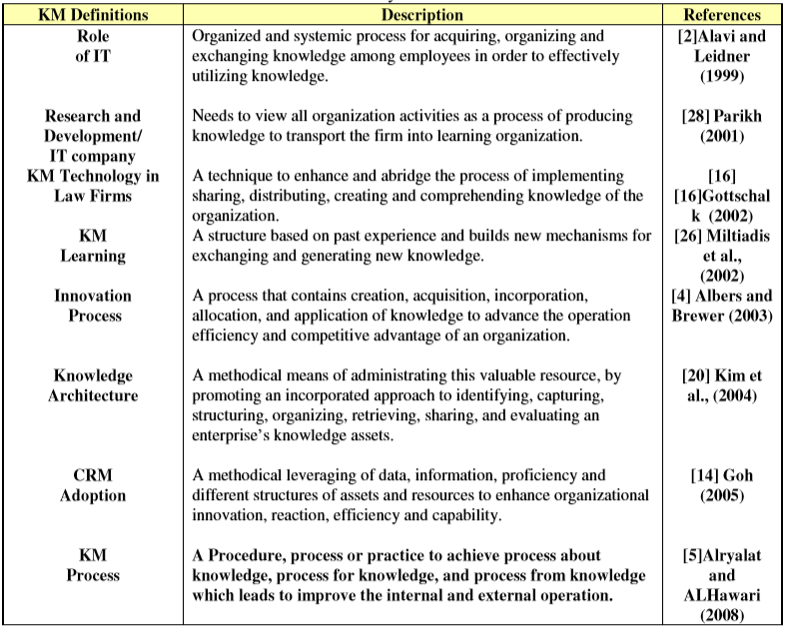
Source: (Karadsheh, et al., 2009)

Data to Knowledge
Albert Einstein (1954) once said to Dispintiere (1954) "Wisdom is not a product of schooling but of the lifelong attempt to acquire it”. Moreover, T.S. Eliot (1934) an academic poet stated in a play "Where is the wisdom we have lost in knowledge? Where is the knowledge we have lost in information?” (Eliot, 1934). These words from T.S Eliot (1934) show his perception that suggests there is a link between wisdom and knowledge as well as knowledge and information. This can be also seen in Figure 1 where data is acquired firstly and then that data is then converted into useful information by understanding the relations. Once the relevant information has been acquired then by understanding this information you can gain knowledge. To achieve wisdom Figure 1 shows that you must recognise the principles the knowledge you have acquired. In KM literature various academics have noted that the relation between knowledge, information and data is imperative and every so often misinterpreted. For instance, according to Davenport & Prusak (1998) “Knowledge is neither data nor information, though it is related to both, and the differences between these terms are often a matter of degree…Confusion about what data, information, and knowledge are—how they differ, what those words mean—has resulted in enormous expenditures on technology initiatives that rarely deliver what the firms spending the money needed or thought they were getting” (Ahsan & Shah, 2006). Although, Sveiby (1997) argues that “Some of the present confusion concerning how to do business in the knowledge era would probably be eliminated if we had a better understanding of the ways in which information and knowledge are both similar and different. The widespread but largely unconscious assumption that information is equal to knowledge and that the relationship between a computer and information is equivalent to the relationship between a human brain and human knowledge can lead to dangerous and costly mistakes”. Figure 2 illustration defines the data, information, knowledge and wisdom (DIKW) and the next paragraphs will present the explanation between data, information and knowledge.
Figure 2: Codification of DIKW definitions.
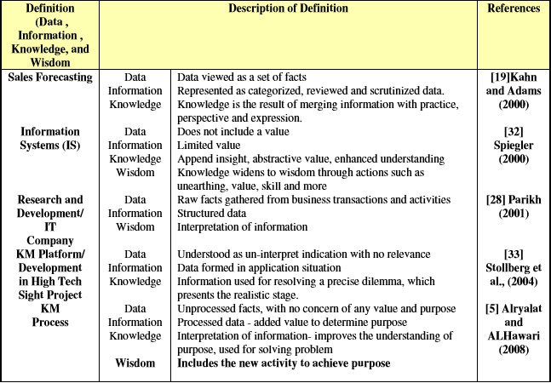
Source: (Karadsheh, et al., 2009)
Having illustrated the codification of the definitions of DIKW in Figure 2 this report shall now be discussing the relationship between data and information as well as the relationship between information and knowledge and why they are regarded as interchangeable. To be able to understand the complex relationship between DIKW this report will analyse academic theorists on their perspectives of the DIKW term. According to Spiegler (2000), data is a set of facts. Information is signified as considered, studied and analysed data. Knowledge is the total outcome of the integration of information by means of practice, perception and expression, resulting in implication as well as approaches and strategies on which decision is based on (Karadsheh, et al., 2009). In addition, Stollberg et al. (2004) described as data is established into information additional value is added, to which changes information into knowledge by adding perception as well as improved understanding. Consequently, knowledge broadens to wisdom via actions such as detection, skill and value. Parikh (2001), points out that data is raw facts which are collected from Dixons transactions alongside activities. Information is described as organised data. Correspondingly, data is administered and observed over a specific filter or through information; whilst the concept knowledge is defined as an understanding of information. Once information is put into context, adopted and assessed through an intellectual model or global interpretation, knowledge is created (Karadsheh, et al., 2009). Stollberg et al. (2004) described data as uninterpreted indication to which has no significance, whilst information is data moulded in an application circumstances and knowledge is information utilized for determining predicaments, which presents the realistic stage. Lastly, Alryalat & Al-Hawari (2008) described data as facts which are not processed and raw numbers acquired from Dixons operations and application, without any concern of any value as well as purpose. However, information is seen an administered data with additional value to determine purpose. To interpret information in order to enhance the understanding of purpose is known as knowledge and could be used for problem solving. Furthermore, wisdom is the inclusion of new actions in order to achieve purpose (Karadsheh, et al., 2009).
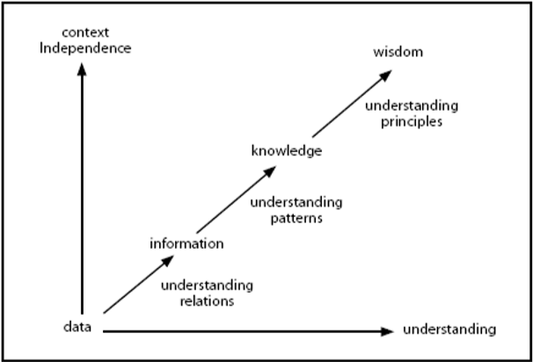
Figure 3: Illustration or development and relationship of DKIW.

Source: (Chakravarthy, et al., 2015)
As demonstrated in Figure 2, the cataloguing of the definitions of DIKW permits academics to be able to relate and analyse the classifications that pact with KM. Therefore, these definitions and Figure 3 demonstrate and conclude the relationship between data, information, knowledge and wisdom. These novelists describe ‘Data’ as facts which are not processed and has no purpose, value as well as meaning. ‘Information’ in contrast is exploited organised data, with minute value and can be off the record, organised and structured for practice. ‘Knowledge’ is known to be considerate as well as thoughtful information that could be used for problem solving. Lastly, ‘Wisdom’ is an extend of knowledge through value as well as skill combined with additional actions and activities (Karadsheh, et al., 2009).

Individual knowledge vs organizational knowledge
According to Weick (1978) in addition Simon (1976), they believed organisations such as Dixons do not have learning capabilities. Therefore, the individuals within Dixons are the ones that learn. Though, academics such as Starbuck (1983) as well as Nelson & Winter (1982) suggests Dixons develop through their learning capabilities (Bhat, 2002). According to Nelson & Winter (1982), through routines that are embedded within Dixons history is where organizations like Dixons learns and acquires their knowledge. Moreover, Barney (1986), asserted that knowledge of different repertoires or practices is integrated as well as innovative knowledge is made by Dixons history along with culture (Barney, 1986). Using this perception, Dixons is stated as a problem-facing and problem-solving entity. Education within the Dixons is knowingly effected by the difficulty of tasks as well as the environment within the workplace (Bhat, 2002). It is claimed that individual knowledge as well as organisational knowledge are dissimilar yet dependent on each other to the extent of each individual interactions with the other rests on organisational culture. This perspective is taken because currently in this environment, individuals within Dixons must make rapid verdicts to be able to resolve customers problems. As opposed to the use of policies directed from the hierarchy, employees must make judgements in order to solve Dixons complications effectively (Bhat, 2002). Alternatively, in complex circumstances to which Dixons tasks are extremely inter-reliant and team members do not have the capacity or level of know-how to be able to resolve interdisciplinary complications, individuals are obligated to work together with others to share their knowledge and skills. Furthermore, with the agreements on mutual presumptions as well as logical frameworks, individuals within Dixons can manage a wide range of activities alongside solving the company’s diverse complex complications. According to Bhat (2002), numerous tasks are confronted by specialized organisations, to which their individuals possess skill and knowledge in a subject, because of the individuals academic background and work practice. On the condition that employees in specialized organisations confront tasks which be located inside their areas of know-how so that without difficulty they can implement tasks without the requirements of communicating with others. Nevertheless, when tasks are complex, requirement of know-how from quite a few interdisciplinarity areas; employees require raised levels of collaboration with others, in addition to being able to access Dixons knowledge (Bhat, 2002).

Knowledge assets
Figure 4: Author’s Illustration of actual knowledge assets in Dixons
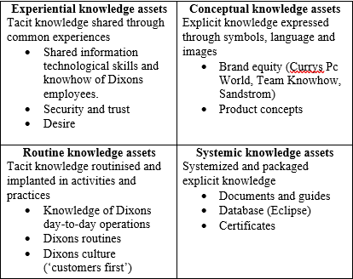
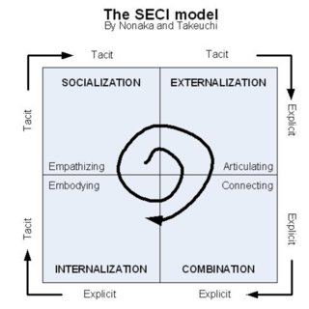
Source: revised from (Nonaka, et al., 2000)
Knowledge assets are referred to as possessing a controlling character in the knowledge creation process. Nonoka et al. (2000) developed Boisot’s (1998) dimension of the cataloguing of knowledge assets by introducing an additional two dimensions, therefore sorting knowledge assets into four aspects (see Figure 4). Firstly, experiential is the skills, expertise acquired by employees within Dixons as well as Dixons employee’s emotional knowledge, care, trust, love is characterized as experiential knowledge assets. Experiential category contains the shared tacit knowledge of Dixons workers and since experiential knowledge assets remain tacit, it is said to be problematic in order to assess, manage and trade (Chou & He, 2004). Alternately, conceptual knowledge assets have tangible forms to which contains explicit knowledge expressed through images, signs and language. Systemic knowledge assets, however, contain structured explicit knowledge such as Dixons workplace manuals, products, conditions and information technology. Lastly, routine knowledge assets are tacit knowledge routinised as well as rooted in Dixons daily operations, routines and culture within the company (Chou & He, 2004). The illustration above identifies the actual as well as potential knowledge assets within Dixons.
To be able to make manage and utilize knowledge assets efficiently Dixons ought to be able to identify and measure these capitals. According to Nonaka et al.(2000), an organisation have to map their knowledge assets whilst bearing in mind the dynamism, and sets of potential knowledge can be created from the current ones. Carlucci & Schiuma (2006) developed a model known as knowledge asset value spiral in order to classify and improve knowledge assets (Kamasak & Yucelen, 2010).
The Knowledge Asset Value Spiral seen illustrated above consist of four aspects:
- Defining Dixons key performing targets by first defining the problems of Dixons value creation and identifying the individuals related to managing those assets.
- Analysing knowledge asset drivers by implementing a knowledge asset value creation map (see Appendix B).
- Define the management process of knowledge by analysing which knowledge process is necessary to maintain or improve the knowledge asset drivers.
- Assess the performance improvements to which the assets are evaluated according to the organisations performance.

Knowledge process and systems
Figure 5: KM process and requirements for each phase.
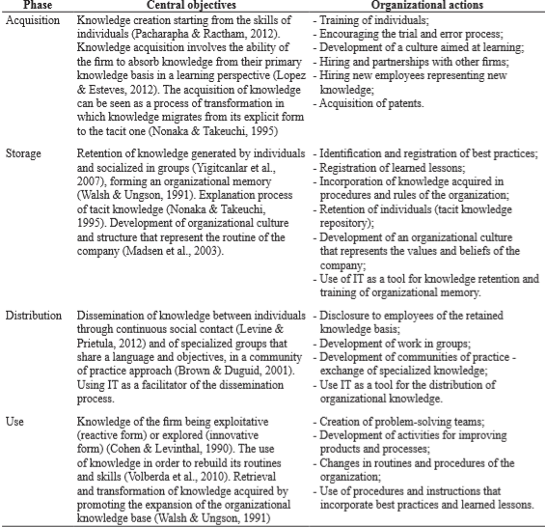
Source: (Gonzalez & Martins, 2017)
This section will demonstrate the importance of KM process in the context of organisational development. Moreover, this section intends to describe what is required to create, store, apply and integrate knowledge as well as considering the impact intellectual property rights. Moreover, by considering KM systems which are used for the application or utilization of KM within Dixons. This report will consider the numerous types of systems and their main purposes, which are to store in addition retrieve important data, information and knowledge. Furthermore, this report will discuss the systems other purpose which is to collaborate data, locate different sources of knowledge, enhance the KM process as well as the data mining. First off, this section will describe the range of processes used to manage knowledge including the process to create, store, apply and integrate knowledge. KM processes are the way the organisations like Dixons handles knowledge at different phases of its cycle life (KM cycle). These KM processes are made up of 4 main aspects and each aspect includes two sub processes (see Appendix A) (Fernandez & Sabherwal, 2010).
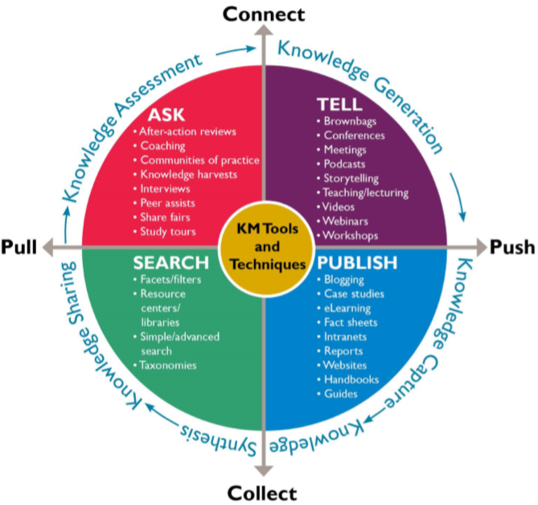
Source: (KM Training, 2018)

Knowledge creation
Creating knowledge could be well-defined as growth of new tacit or explicit knowledge that derives from data as well as information or from the combination of previous knowledge. The creation of new explicit knowledge depends on the mixture, whereas the creation of new tacit knowledge depends on socialisation (Fernandez & Sabherwal, 2010). Fresh explicit knowledge are revealed via grouping, in which the various forms of explicit knowledge (data/information) is produced to generate new, complex groups of explicit knowledge (Nonaka, 1994). This materializes via communication, integration and the systemization of numerous channels of explicit knowledge. The existing explicit knowledge, information as well as data are re-constructed, re-characterized and re-contextualised towards producing new explicit knowledge (Fernandez & Sabherwal, 2010). For instance, Dixons data mining methods could be adapted to discover new relationships amongst explicit data that could be central to generate analytical or considered models that generate new knowledge which in turn could impact the organisation positively. However, tacit knowledge process is the combination of numerous streams for the creation of new knowledge which happen via the instrument of socialisation (Nonaka, 1994). According to Fernandez & Sabherwal (2010), socialisation is the combination of tacit knowledge across Dixons workers and it is generally via shared activities instead of in print or verbal instructions. For instance, by Dixons creating an environment to which employees spend most of their time together transferring concepts and images, employees help the new starters see how others think and feel. Within this process there are knowledge creation systems designed to support the development of new tacit or explicit knowledge from data and information or from the combinations of previous knowledge. These systems also support the combination and socialisation subprocess of knowledge creation. Having discussed the two subprocess, socialisation as a means of knowledge creation is a common practice within Dixons and the mechanism which they use are brainstorming sessions and research conferences. However, Fernandez & Sabherwal (2010) not only mechanisms can enable socialisation and combination across Dixons there is also information technology. Information technologies such as data mining can enable the creation of knowledge. These systems are information technology (IT) systems which enable Dixons to improve their decision making and assist in helping train new staff as well as conducting their orientation, with also promoting sales with Dixons. The following list are examples of KM systems within Dixons:
- Simulation tools
- Intranet
- Artificial Intelligence (AI) tools
- Data warehousing & mining
- Document management systems
Data mining likewise is recognised as knowledge discovery databases is the method of determining and understanding a pattern from data, to which involves the application of set of rules to understand the pattern produced by these set of rules (Fernandez & Sabherwal, 2010). For instance, because of the rise of computing power data mining techniques have been easier to apply within companies and customer relationship management (CRM) is an instrument and information technologies used within Dixons to manage the exchanges between them and its customers. CRM applications are categorised as operational as well as analytical.
- Operational (CRM) – this is the inclusion of automated systems, call centres, websites and data accumulation systems that support the company in various processes.
- Analytical (CRM) – this is the use of data mining methods in order to discover customer intelligence that assists to better recognise and assist the customer.

Knowledge storing
Knowledge storing phase discusses Dixons memory development process to which knowledge is warehoused within physical memory systems as well as informally engaged as values, policies and principles to which is linked to culture and Dixons structure. The significance of knowledge storing is highlighted by Alavi & Leidner (2001) when they described companies’ memory “stored information from an organization’s history that can be expressed to bear on present decisions”. For instance, this is the stored information of Dixons past which is measured in results. Grant (1996) pointed out the key role for companies like Dixons is integrating individuals specialized knowledge as well as the hierarchical management of the company’s failures within the integrating process. Dixons stores their knowledge in various ways and Walsh & Ungson (1991) determined five aspects of knowledge repositories. Firstly, founded on experiences and direct observations of employees who make up the company. Secondly, culture outlines the way of thinking and feeling the complication by employees. Thirdly, transformation process to which occurs via development, selection as well as examination of new methods with the workplace, which is then socialized. The fourth knowledge repositories are the policies, regulations, hierarchies and qualities to which describe the functional model of Dixons. Lastly, ecology also supports the sharing process within organisations (Gonzalez & Martins, 2017). According to Lin (2007), storing knowledge indicates conversion process including the organisation, structuring, storage as well as the blend of knowledge so that it enables future usage by individuals concerned. Therefore, IT is seen as a tool required in storing knowledge, contributing three applications;
- Encoding as well as knowledge distribution.
- Formation of Dixons knowledge manuals.
- Formation of knowledge networks (Alavi & Leidner, 2001).
On the other hand, Huysman & Wulf (2006) diminished the significance of IT in knowledge storing explaining that companies are required to generate a culture to which enables knowledge sharing. Rowley (2001) stated some tacit knowledge ought to be altered into explicit, since the both forms of knowledge match and interdependent (Gao, et al., 2008). Rowley (2001) in discussions considered three main principles for the requirement of storage:
- The significance of employees as a tacit knowledge retaining device
- Organisational structure as well as culture as retaining vehicles.
- Information Technology.

Knowledge distribution
Knowledge sharing refers to the method to which explicit and tacit knowledge is transferred to additional entities within Dixons such as;
- the delivery of presentations.
- individuals interacting together in the cafeteria.
- mentoring new employees.
- shadowing experts.
Therefore, depending on which type of knowledge of being shared (explicit/tacit) the exchange or socialization method is being used. Exchange is required to communicate or transfer explicit knowledge amongst employees, groups as well as Dixons. Furthermore, knowledge sharing systems (KSS) assist the method to which knowledge (tacit/explicit) is transferred to others. KSS are referred to as knowledge repositories and the two main systems for explicit knowledge are the expertise locator system and lessons learned system. On the other hand, tacit knowledge sharing is supported by systems utilized by communities of practice (Fernandez & Sabherwal, 2010).
Organisation memory is invented from the combined intellectual assets of Dixons and known as the mixture of explicit and tacit knowledge. Loosing organisational memory normally occurs when there is a lack of suitable technology within the organisation as well as the exchange of documents. Moreover, employees leaving their roles permanently due to retirement is another contributor to organisation memory. Therefore, the requirements within the process of storage is to develop an application to which will prevent loss of any organisational memory. For instance;
- Incident report databases
- Alert systems
- Lessons-learned system
- Best practice database
- Expertise locator system

Knowledge application
Knowledge application refers to the usage of knowledge that is available in order to make decisions as well as accomplish responsibilities through direction and routines. Direction is the process to which the individual possesses knowledge and guides the actions of others without transferring to others the knowledge fundamental to the direction. It is not only just an individual who possesses knowledge advices another. For instance, direction process is utilized when warehouse colleagues within Dixons demands an expert in order to resolve a specific complication by means of a machine and then proceeds to resolve the complication based on the instructions specified by the expert. However, routines include the use of knowledge implanted with Dixons procedure, policies, norms and methods that guides future behaviour. Both direction as well as routine are appropriate to tacit or explicit knowledge. Individuals applying the knowledge in knowledge application do not require to understand the knowledge (Fernandez & Sabherwal, 2010). At this phase is knowledge application systems are requirements within Dixons in order to assist with the phase through Dixons employees using other individuals’ knowledge without obtaining or learning that knowledge. To apply knowledge within Dixons the requirements is to have IT that supports the direction and routines of Dixons such as
- Decision support system
- Fault diagnostic system
- Help desk systems
- Expert system

Intellectual property rights
The impact of intellectual property rights is important as it enable free flow of energy in order to improve invention as well as research. Intellectual property rights give incentive to employees for new concepts. Furthermore, it also gives acknowledgement to those creators and inventors. The laws provides them means and incentives in order to generate new work, products as well as services. Intellectual property rights within Dixons enhances innovation as well as creativity through protecting inventors as well as artists rights. for example, because patents requires disclosure of information that enables others to replicate inventors discovery, others could utilize and build upon this shared knowledge in order to generate newer or better products. Moreover, Narayanan (2010) stated intellectual property rights guarantees the accessibility of original and genuine products and also the rights such as patent and copyright are very important ways for Dixons to protect their innovative investments. According to Sharma (2014), intellectual property rights can be seen as supportive towards resolving global challenges such as alternate energy sources, new products for IT specialists and development of low cost products for not so wealthy individuals. Also intellectual property rights is also seen as important in order to inspire economic growth within Dixons and encourages trading fairly to which contributes towards economic as well as development (Sharma, 2014).

Dixons Knowledge sharing & Culture
In this section we will consider Dixons framework in enabling knowledge sharing within the workplace. Dixons utilises and approach called Communities of practice to which was developed by Etienne Wenger to be able to establish the importance of less formal knowledge sharing which happens between peers as well as within teams. Community of practice is also Dixons way to be able to distributes their knowledge to their employees who have a passion about the same topics. This enables individuals to learn from others knowledge as well as experience. Community of practice individuals with in Dixons discuss without restrictions the complications they are in. These individuals tend to share their aspirations they also identify needs and also generate an action focused on view. These individuals within the community of practice discuss innovative ideas for Dixons workplace as well as generate a common practice within their field. Dixons common of practice is virtual and is considered large with links to external partners. Common practice within Dixon’s has many strengths as well as benefits such as it
- Connects Dixons formal as well as informal mechanisms together.
- It is significant to Dixons organisation learning.
- Enables new concept testing as well as enables the development of context specific common practices
- Produces new knowledge to resolve specific complications.
- Leads to specialised knowledge sharing as well as making it not so difficult to recognise individuals in a field.
- An efficient way to manage knowledge.
Tiwana & Ramesh (2001) stated intranet is appropriate to use a strategic tool within knowledge management because of its capacity to assist in sharing, connecting and publish knowledge to individuals in Dixons. These writers also stated that intranet ought to be understood as fundamental to Dixons knowledge management systems. Consequently, Dixons intranet (Eclipse) ought to be considered and personalised in order to improve Dixons knowledge sharing tasks. Intranet is said to produce a common communications and information sharing system to which Brelade & Harman (2003) suggested that intranet could be utilized on a ‘push’ and ‘pull’ basis.
• “Push” technology are utilized the minute it is significant with the aim of presenting specific material to individuals in the workplace. Ensuring that nothing occurs while waiting for all information to be assessed appropriately.
• “Pull” technology enables individuals within Dixons to choose when to extract information from Eclipse which they want to see. The “views of the end users are more important than in most other studies” (Skok & Kalmanovitch, 2005).
In order to deliver a simple and user friendly experience between various pages on Eclipse, Eclipse information can only be accessed by Dixons employees over Microsoft Edge browser.
Eclipse is a tool to support communities of practice and this has been established as a valuable tool for producing a home page for community of practice so there for others can utilise. Eclipse also provides a collaborative environment to which could be utilised by community of practice individuals especially those with in a different demographic location. In evaluating Dixons intranet it is also a mechanism that offers the output of community of practice so that it can be displayed to the rest of the organisation through effective methods such as web blogs. Community of practice has a significant element to which the group embraces responsibilities of stewardship of knowledge within the domain. According to Wenger (2000), this includes the generation of most form of knowledge base. Once knowledge is acquired it is then distributed to other areas of Dixons to which may face the same challenge or it is to be stored for future references. Dixons knowledge base is constructed using numerous dissimilar technologies such as wikis, collaborative environments, and content management systems. The community of practice within Dixons focuses on individuals interacting with in the workplace and is supported through efficient environment and infrastructure. This report has Illustrated the enablers of knowledge sharing within Dixons and has summarised that Eclipse within Dixons is vital in allowing and fostering communities of practice.
Eclipse within Dixons is utilized in order to drive cultural changes. The use of Eclipse is utilized in order to distribute information about projects through pages or through the news section. After evaluating Dixons Eclipse it has more function than just a socialization platform as it can be used within Dixons in order to support cultural changes. Eclipse also has an impact on the organizations culture through images and storytelling which is demonstrated on there. For instance, when Currys Pc world and Dixons merged, each organization had their own culture, the challenge then was for them to generate a singular platform for all employees to use and implement a singular culture and how they achieved this was through the creation of Eclipse.

Conclusion
KM’s development is an important organisational as well as management encounter. Pressures in global knowledge-based economy as well as recognising knowledge as vital and intangible assets that make efficient management of knowledge a significance. Knowledge based economy in the technological age is moving rapidly forward, especially the role played by information and community technology to which performs as a substance of developing knowledge. Knowledge management model has become a spectacle in terms of playing a significant role in the successfulness of a company on a global scale. KM supports Dixons in shaping their technological and organisational innovations in order to have greater impact on operations and therefore enable Dixons to compete with their competitions as well as survive.

References
Ahsan, S. & Shah, A., 2006. Data, information, knowledge, wisdom: A doubly linked chain. [Online]
Available at: http://citeseerx.ist.psu.edu/viewdoc/download?doi=10.1.1.89.5378&rep=rep1&type=pdf
[Accessed 06 December 2018].
Alavi, M. & Leidner, D. E., 2001. Knowledge management and knowledge management systems: conceptual foundations and research issues. Management Information Systems Quarterly, 25(1), pp. 107-136.
Bhat, G. D., 2002. Management strategies for individual knowledge and organizational knowledge. Journal of Knowledge Management, 6(1), pp. 31-39.
Chakravarthy, S. A., Vajre, A. H. & Deshmukh, A. M., 2015. Utilization and Evaluation of Knowledge Management Tools in Information Technology Industry. IOSR Journal of Business and Management , 17(2), pp. 41-52.
Chou, S.-W. & He, M.-Y., 2004. Facilitating Knowledge Creation by Knowledge Assets, Hawaii: Hawaii International Conference on System Sciences.
Eliot, T. S., 1934. The Rock. 1st ed. London: Faber & Faber Limited .
Fernandez, I. B. & Sabherwal, R., 2010. Knowledge Management: Systems and Processes. New York: M.E.Sharpe.
Gao, F., Li, M. & Clarke, S., 2008. Knowledge, management, and knowledge management in business operations.. Journal of Knowledge Management, 12(2), pp. 3-17.
Gonzalez, R. V. D. & Martins, M. F., 2017. Knowledge Management Process: a theoretical-conceptual research, São Carlos: Gest. Production.
Grant, R. M., 1996. Toward a knowledge-based theory of the firm.. Strategic Management Journal, Volume 17, pp. 109-122.
Hall, C., 2010. Knowledge Management: The Holy Grail for Today’s Economy. [Online]
Available at: file:///C:/Users/JNR/AppData/Local/Packages/Microsoft.MicrosoftEdge_8wekyb3d8bbwe/TempState/Downloads/Knowledge-Management-November-December-2010_2339%20(1).pdf
[Accessed 6 December 2018].
Karadsheh, L. et al., 2009. A Theoretical Framework for Knowledge Management Process: Towards Improving Knowledge Performance. Communications of the IBIMA, Volume 7, pp. 67-79.
King, W. R., 2009. Knowledge Management and Organizational Learning, Pittsburgh : Springer Science+Business Media, LLC .
KM Training, 2018. KM Training. [Online]
Available at: https://www.kmtraining.org/sites/kmtraining.org/files/km-matrix-updated.pdf
[Accessed 2018 December 27].
Knowledge Management Tools, 2018. Defining Knowledge, Information, Data. [Online]
Available at: http://www.knowledge-management-tools.net/knowledge-information-data.html
[Accessed 06 Decemeber 2018].
Liew, A., 2007. Understanding Data, Information, Knowledge And Their Inter-Relationships. Journal of Knowledge Management Practice, 8(2).
Lin, H.-F., 2007. A stage model of knowledge management: an empirical investigation of process and effectiveness. Journal of Information Science, 33(6), pp. 643-659.
Marr, B., Schiuma, G. & Neely, A., 2004. Intellectual capital – deﬁning key performance indicators for organizational knowledge assets. Business Process Management Journal , 10(5), pp. 551-556.
Nonaka, I., 1994. A Dynamic Theory of Organizational Knowledge Creation. The Institute of Management Sciences, 5(1), pp. 14-37.
Nonaka, I., Toyama, R. & Konno, N., 2000. SECI, Ba and Leadership: a Unified Model of Dynamic Knowledge Creation. Long Range Planning, 33(1), pp. 1-170.
Parikh, M., 2001. Knowledge Management Framework for High tech Research and Development. Engineering Management Journal, 13(3), pp. 27-34.
Sharma, D. K., 2014. INTELLECTUAL PROPERTY AND THE NEED TO PROTECT IT. Indian J.Sci.Res, 9(1), pp. 2-4.
Spek, R. v. d. & Spijkervet, A., 1997. Knowledge Management: Dealing Intelligently With Knowledge. s.l.:Knowledge management network.
Spiegler, I., 2000. Knowledge Management: A New idea or a Recycled concept. Communication of Association for Information System, 3(14), pp. 1-24.
Stollberg, M., Zhdanova, A. V. & Fensel, D., 2004. H-Tech Sight A Next Generation Knowledge Management Platform. Journal of information and Knowledge management, 3(1), pp. 47-66.
Walsh, J. P. & Ungson, G. R., 1991. Organizational Memory. Academy of Management Review, 16(1), pp. 57-91.

APPENDICES

Appendix A
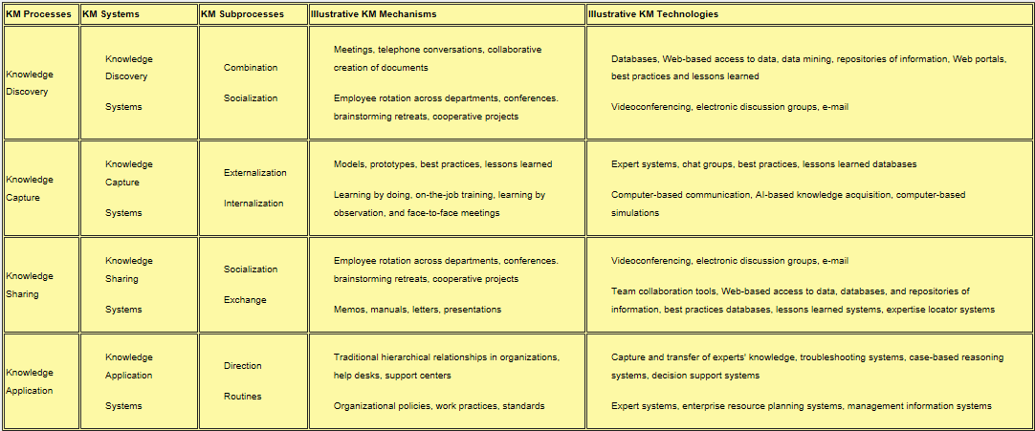
Source: (Fernandez & Sabherwal, 2010)

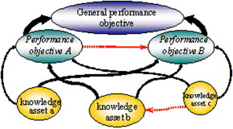
Appendix B

Source: (Carluccia & Schiumaab, 2007)

