Research Proposal
How does consumer trust in AI personalised marketing influence purchase intention in UK online beauty behaviour

Student name: | Rajwinder Kaur
Student ID number: | 2214604
Programme: | BA (Hons) Business Management
Module: | Independent Project
Module code: | LCBB 6014
Assignment Title: | Component 1: Coursework – Written Research Proposal | Word count | 1099

Table of Contents
Chapter 1: Introduction ……………………………………………………………………. 3
Chapter 2: Literature Review …………………………………………………….……….. 4
Chapter 3: Research Methods and Methodology ……………………………..………….. 5
Chapter 4: Conclusion …………………………………………………………...………… 6
Chapter 5: References ……………………………………………………………...……… 7

Chapter1:Introduction
Artificial intelligence is major part of modern business management in these days because it is allowing businesses to personalise their services for customer to customer, improve productivity and create more responsive customer experiences (Department for Science, Innovation and Technology, 2025a). In UK beauty sector, cosmetic brands and retailers increasingly use AI personalised product recommendations, virtual try on tools, chatbots and targeted promotional content for improve their customer experience (Boots, 2026; L’Oréal Paris, 2026). This topic originated from current business debate which is that whether AI personalisation improve online shopping or creates consumer concerns about privacy, transparency and trust (Aydin, 2026; Utami and Aimin, 2026; Srivastava and Gurme, 2026; Rahman, 2026).
The problem is that UK online cosmetic businesses may use AI for improve engagement and sales but customers may not be fully trust AI personalised marketing if they do not understand how exactly their data is collected, analysed and used (Aydin, 2026; Rahman, 2026; Srivastava and Gurme, 2026). This real problem creates a practical business issue that is AI may increase purchase intention only when customers believe the marketing is transparent, safe and trustworthy.
This proposal focuses on UK market because the UK Government promotes AI adoption as the driver of growth and productivity, while also recognise need for responsible innovation and for trust (Department for Science, Innovation and Technology, 2025a; 2025b; Statista, 2026a; 2026b).
Aim:
To examine how AI-personalised cosmetic marketing influences consumer trust and purchase intention in UK online beauty retail.
Objectives:
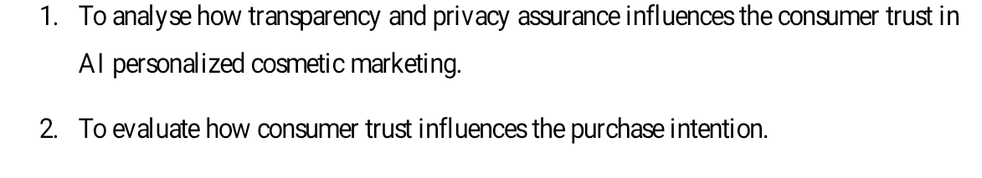
Research questions:
RQ1: How is the relationship between transparency/privacy assurance and consumer trust discussed in existing academic and industry literature on AI personalised cosmetic marketing?
RQ2: What evidence do existing sources provide on the link between consumer trust in AI personalised marketing and purchase intention in the UK online beauty retail context?

Chapter 2: Literature review
The literature shows four connected themes which four are AI personalisation, beauty technology, transparency and privacy and purchase intention. Firstly, AI personalisation is increasingly used for provide customers with more relevant online experiences. Utami and Aimin (2026) argue that AI enabled customer experience create value through personalisation, but this value depends on balance the usefulness with privacy. Similarly, Rahman (2026) finds that ethical AI personalisation in digital retail is strongly linked with transparency, privacy assurance, consumer trust and purchase intention of customers. McKinsey & Company (2021) also suggest that the personalisation can increase loyalty and business value, but in opposite, poor personalisation of customers may damage customer relationships with brand. These sources support RQ1 because they show that personalisation alone is not enough and customers must also be feel protected.
Second, beauty technology is particular relevant because cosmetics are personal, visual and identity related products. Perret and Schwientek (2025) explain that AI and augmented reality cosmetics tools can be improved customer experience, satisfaction, purchase intention and loyalty. Brand examples also show that this is already happening in practice because Boots promotes virtual beauty tools in the UK while the L’Oréal Paris offers virtual makeup try on where customers can test their products digitally before purchasing for themselves (Boots, 2026; L’Oréal Paris, 2026). However, these tools may also raise questions about whether virtual results are realistic and whether customer images or preferences are used responsibly.
Third, transparency, privacy and trust are central point of AI marketing in business. Privacy Calculus Theory is relevant because it suggests that the consumers weigh perceived benefits of sharing data against to perceived privacy risks before deciding whether to trust and use digital services (Dinev and Hart, 2006). In this study, benefits may be include convenience, personalised recommendations and improved product discovery, while risks may are include unclear data use, surveillance concerns and loss of control. Aydin (2026) supports this argument by show that AI driven ecommerce personalisation create wellbeing privacy trade off. Srivastava and Gurme (2026) also connect AI enabled social media marketing with personalisation, trust and privacy concerns. This is important for cosmetic marketing because many of beauty consumers interact with brands through Instagram, TikTok, online adverts and retailer websites. UK Online Advertising Taskforce further supports this issue by identify transparency and accountability as key challenges in digital advertising (Department for Culture, Media and Sport, 2026).
Fourth, consumer trust appears to be bridge between AI marketing and purchase intention. Rahman (2026) suggest that transparency and privacy assurance strengthen trust which can be then support buying behaviour. Perret and Schwientek (2025) also link beautytech experience with loyalty and purchase intention. However, research gap is that existing studies discuss AI personalisation, privacy and trust broadly but only fewer studies focus specifically on UK online cosmetic retail. This study addresses that gap through a secondary analysis of academic, government, market and industry sources.

Chapter3:Research Methods and Methodology
This study will use pragmatic research philosophy because it focuses on practical business problem: how AI personalised cosmetic marketing can build consumer trust and support purchase intention in UK online beauty retail (Saunders, Lewis and Thornhill, 2019). The research paradigm will be interpretive pragmatic because study will interpret existing academic and industry literature while also focus on practical business meaning (Bell, Bryman and Harley, 2019). The research approach will be abductive as study will move between existing theory and industry evidence for identify patterns and explain findings (Saunders, Lewis and Thornhill, 2019). The research methodology will be secondary research because it will analyse existing academic and professional sources rather than collect primary data from participants (Saunders, Lewis and Thornhill, 2019; Bell, Bryman and Harley, 2019). The research strategy will be desk-based structured literature review which suitable for comparing current knowledge on AI personalisation, privacy, transparency, trust and purchase intention (Snyder, 2019; Utami and Aimin, 2026).
The sampling method will be purposive sampling as sources will be selected according to relevance, credibility, recency and connection to research questions (Saunders, Lewis and Thornhill, 2019; Snyder, 2019). Data will be collected from peer-reviewed journals, Statista reports, UK Government publications, McKinsey reports and brand examples such as Boots and L’Oréal Paris (Statista, 2026a; Statista, 2026b; McKinsey & Company, 2025; Boots, 2026; L’Oréal Paris, 2026). The data will be interpreted using thematic analysis and organised into themes: AI personalisation, privacy assurance, transparency, consumer trust and purchase intention (Snyder, 2019).
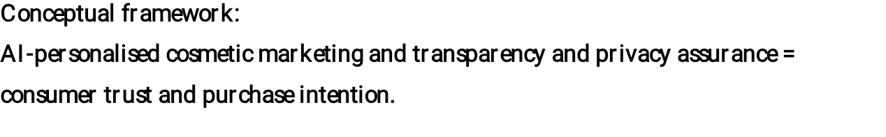A six week Gantt chart will guide it. As no primary data will be collected, the study is low risk, but an ethics checklist will still be completed (Saunders, Lewis and Thornhill, 2019).
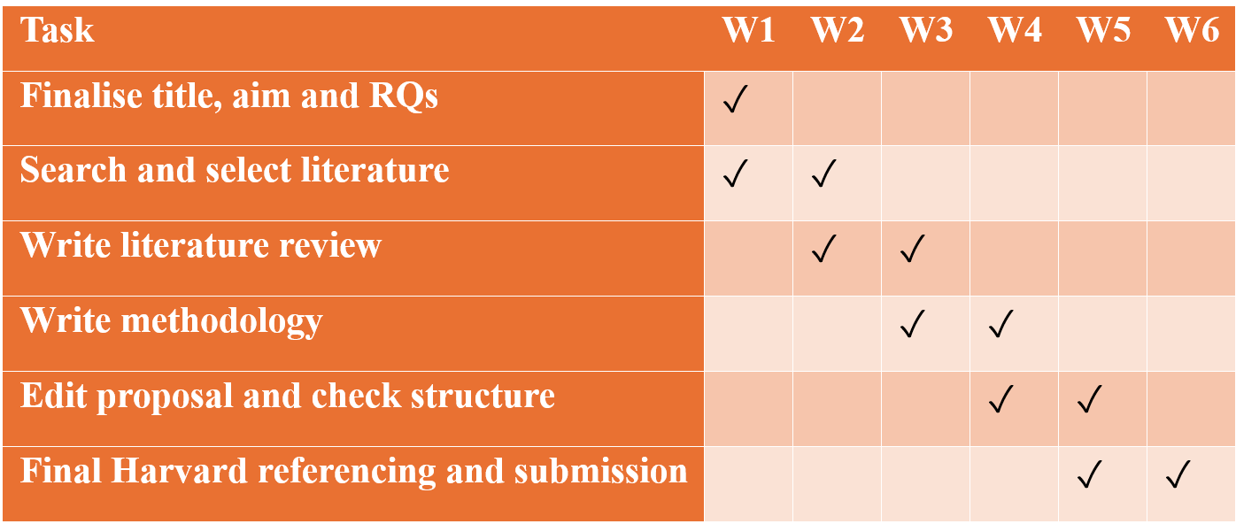
Chapter 4: Conclusion
This proposal outlines focused secondary research study on AI personalised cosmetic marketing in UK online beauty retail. By linking transparency, privacy assurance, consumer trust and purchase intention, study offer clear dissertation plan with academic, business and policy relevance.

Chapter 5: References
Aydin, S., 2026. Brand trust in AI-driven e-commerce personalization: The well-being–privacy trade-off. Sustainability, 18(2), p.1073. Available at: https://doi.org/10.3390/su18021073 [Accessed 2 June 2026].
Bell, E., Bryman, A. and Harley, B., 2019. Business research methods. 5th ed. Oxford: Oxford University Press.
Boots, 2026. Virtual Beauty. Available at: https://www.boots.com/beauty/virtual-beauty?srsltid=AfmBOoqwUOXRF2jBhGf6hXlZazgiw4YJQJti5kcHGh-Ne7_eUXtMaflm [Accessed 1 June 2026].
Department for Culture, Media and Sport, 2026. Online Advertising Taskforce: Progress Report 2025. Available at: https://www.gov.uk/government/publications/online-advertising-taskforce-progress-report-2025/online-advertising-taskforce-progress-report-2025 [Accessed 3 June 2026].
Department for Science, Innovation and Technology, 2025a. AI Opportunities Action Plan. Available at: https://www.gov.uk/government/publications/ai-opportunities-action-plan [Accessed 3 June 2026].
Department for Science, Innovation and Technology, 2025b. AI Opportunities Action Plan: Government Response. Available at: https://www.gov.uk/government/publications/ai-opportunities-action-plan-government-response/ai-opportunities-action-plan-government-response [Accessed 3 June 2026].
Dinev, T. and Hart, P., 2006. An extended privacy calculus model for e-commerce transactions. Information systems research, 17(1), pp.61-80.
L’Oréal Paris, 2026. Virtual Makeup Try-On. Available at: https://www.loreal-paris.co.uk/service-detail-pages/make-up-try-on-detail-page [Accessed 1 June 2026].
McKinsey & Company, 2021. The value of getting personalization right—or wrong—is multiplying. Available at: https://www.mckinsey.com/capabilities/growth-marketing-and-sales/our-insights/the-value-of-getting-personalization-right-or-wrong-is-multiplying [Accessed 9 June 2026].
McKinsey & Company, 2025. How beauty players can scale gen AI in 2025. Available at: https://www.mckinsey.com/industries/consumer-packaged-goods/our-insights/how-beauty-players-can-scale-gen-ai-in-2025 [Accessed 9 June 2026].
Perret, J.K. and Schwientek, J., 2025. Beauty Tech—Customer experience and loyalty of augmented reality- and artificial intelligence-driven cosmetics. Digital, 5(2), p.21. Available at: https://doi.org/10.3390/digital5020021 [Accessed 9 June 2026].
Rahman, W., 2026. Ethical AI personalization in digital retail: The roles of transparency, privacy, and consumer trust. Strategic Business Research, 2(1), p.100020. Available at: https://doi.org/10.1016/j.sbr.2025.100020 [Accessed 6 June 2026].
Saunders, M., Lewis, P. and Thornhill, A., 2019. Research methods for business students. 8th ed. Harlow: Pearson.
Snyder, H., 2019. Literature review as a research methodology: An overview and guidelines. Journal of Business Research, 104, pp.333–339. Available at: https://doi.org/10.1016/j.jbusres.2019.07.039 [Accessed 12 June 2026].
Srivastava, R.K. and Gurme, V., 2026. Artificial intelligence and consumer behaviour on social media: A study of personalization, trust, and privacy. Measurement: Digitalization, 5, p.100021. Available at: https://doi.org/10.1016/j.meadig.2025.100021 [Accessed 5 June 2026].
Statista, 2026a. Beauty and personal care e-commerce in the United Kingdom (UK) – statistics & facts. Available at: https://www.statista.com/topics/10598/beauty-and-personal-care-e-commerce-in-the-uk/ [Accessed 7 June 2026].
Statista, 2026b. E-commerce in the United Kingdom (UK) – statistics & facts. Available at: https://www.statista.com/topics/2333/e-commerce-in-the-united-kingdom/ [Accessed 7 June 2026].
Utami, R.D. and Aimin, W., 2026. Balancing personalization, privacy, and value: A systematic literature review of AI-enabled customer experience management. Information, 17(2), p.115. Available at: https://doi.org/10.3390/info17020115 [Accessed 4 June 2026].

