

BMMB7007

Improving 360-Degrees Feedback Performance Appraisal To Enhance Performance Management At Tesco Plc UK

Major: Human Resource Management
Enrollment Time:10/2022
Student ID:2218750
Full Name: Yu Shenghua
Instructor: James Moore

Completion Date: 23/03/2023

Table of Contents

Executive Summary 4
- Introduction 5
- Organizational Overview 5
- HRM Priority Area: Performance management 5
- Current Shortfalls at Tesco………………………………………………………………………………………..7
- Strategic HRM 8
5.1 Ulrich and Brockbank Model………………………………………………………………………………8
5.2 Harvard Model 10
- Meeting Employees Needs through Performance Feedback 11
Maslow’s Hierarchy of Needs Theory……………………………………………………………………….11
- Impact on Employee and Organization 12
- Benefits of 360-Degrees Feedback as a Performance Appraisal Method 12
- Conclusion 13
- Recommendations 14
- Reference List 15

List of Figures
Figure 1.The Performance Management Cycle……………………………………..…7
Figure 2. Ulrich and Brockbank Model……………………………………………….8
Figure 3. Harvard Model of HRM……………………………………………………10
Figure 4: Maslow’s Hierarchy of Needs Model………………………………………11

Executive Summary
This report aims to assess the implementation of 360-degree feedback as a performance appraisal method to improve performance management at Tesco. The report analyzed the performance management issue in Tesco and the associated impacts of 360-degree feedback on employees and organization using the existing literature. The significant finding of this analysis is that Tesco has a 360-degree feedback process in place, but the system focuses more on development plans with little or no attention to performance appraisal methods that boost employee performance which determines the overall organizational performance. The report concluded that Tesco's 360-degree feedback system positively impacts managerial development, but the framework does not support the employees’ performance by appraising what they have done in achieving the objectives. Hence, it is recommended that Tesco should embrace 360-degree feedback to motivate its employees to perform better.

- Introduction
Today's organizations are facing numerous challenges, retaining employees and maximizing performance has become a challenge as companies are now handling employees from different countries with different cultural backgrounds (Douglas et al., 2021). As a result, performance management becomes necessary for a long-term sustainable competitive advantage. Managers and supervisors work together to manage their employees' performance since the main focus of performance management is on organizational performance, employees, and organizational areas that lead to employee productivity (Berry, 2017). So, the ultimate purpose of performance management is to improve employee performance, hence organizational performance (Bayraktar and Şencan, 2017). This report will discuss performance management in Tesco, its weaknesses regarding performance management, and the impacts it has on employees and the organization in general. Since Tesco is trying to regain its market share in the U.K. retail market to outdo its competitors such as Sainsbury (Ghrmay, 2017), the company needs to address the issue of poor management of employee performance.
- Organizational Overview
Tesco is the third largest supermarket, with its headquarters in the UK (Ghrmay, 2017). Tesco sold many kinds of products, such as fresh food, drinks, clothing, entertainment products, household appliances and consumer electronics (Bedford, 2022). By the 2000s, Tesco website serves more than twenty million customers per month (Tesco PLC, n.d.). As a leading multinational retailer with more than 345,000 employees, Tesco has been aiming to serve customers daily with health, affordability, and sustainability so that they can enjoy a better life quality and a simple living (Tesco PLC, n.d.). In 2022, Tesco had about 354,744 employees. Tesco has a human resources function referred to as the People team, which ensures living by the company's values and initiating great relationships with people across the business (Tesco PLC, n.d.). Tesco has an H.R. office with H.R. professionals and representatives from the Board of Directors who offer relevant H.R. information needed to improve performance.
- HRM Priority Area: Performance management
Tesco PLC has its own ways of managing performance in different departments of the organization. Tesco has used the Steering Wheel Philosophy for more than 20 years to measure performance. Although Tesco boss Dave Lewis later launched a Big Six approach to replace the Steering Wheel in measuring performance, the latter has been the driving force for the company's success. The Steering Wheel had four quadrants divided into KPIs, including customers, people, operations, and finance (Quinn, 2022). For instance, if the key performance indicator is performance, then the organization has to try its best to maintain its position in the market. So, the board members of the organization will maximize their time reviewing the performance of the employees and then give the results to the top managers, who then deliver the results to the involved employees. In such a case, it would be easy and possible to set company standards that depend on key performance indicators to set the salaries of senior managers (Dahlmann, Branicki, and Brammer, 2019). In addition, communicating the performance with all the internal (such as management, administrators, employees, and so on) and external (such as suppliers, investors, community groups, and government organizations) stakeholders in the organization can help the organization and employees navigate the future. The main reason why Tesco communicate with stakeholders about organizational and employee performance is to ensure that they understand what is beneficial to them and hence take their position in the current market (Tan and Olaore, 2021). As illustrated in figure 1 below, performance management is a four-cycle process that begins with planning where the company decides what to do and how to do it. The second process is acting, which involves performing the work required for plan implementation, followed by a monitoring process to check on what is being done and assess the progress. The last process is reviewing which involves considering what has been done and identify what more needs to be done as long as performance does not coincide with the plan (U.S. Office of Personnel Management, n.d.). According to Kandpal et al. (2018), there are many tools that organizational leaders can choose for performance evaluation and development. 360-degree feedback is one of the best approaches for monitoring, evaluating, and identifying areas of improvement in an employee’s performance. According to Siddiqui (2017), 360-degree feedback involves collecting and giving feedback on performance to an individual employee or a group based on their performance. Tesco has a wide knowledge of the importance of 360-degree feedback and has been utilizing it in a managerial position to enhance the development and improvement of its management skills. In all stages of improvement and development, feedback is needed to offer better performance.

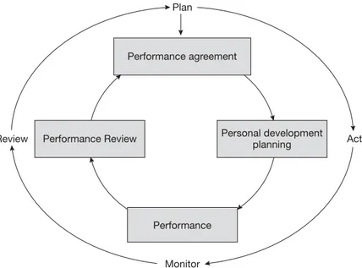
Figure 1: Performance Management Cycle
- Current Shortfalls at Tesco
Tesco has been using a 360-degree feedback system for only developmental purposes and as a tool for organizational change. However, using 360-degree feedback for performance review is a gap that Tesco needs to consider. As a performance feedback process, the 360-degree feedback approach allows employees to receive feedback from their colleagues, management, subordinates, and other essential stakeholders in the organization (Meyer-Leive, 2022). After receiving the feedback, the employee goes through a self-assessment process by comparing the feedback with the required standards, with the aim to develop and improve their behaviors and processes. This will help in identifying areas that need further development, hence improving performance.
Another shortfall is the use of an informal approach to improve employee performance. Tesco asks its employees to write things they believe to be good and those they believe they can do better (ETS, 2017). Consequently, the employees end up identifying areas they can do better. However, this is not an effective solution to performance improvement because motivated employees would want to work in an environment where they feel inspired and listened to by their management. So, 360-degree feedback is the most effective approach to knowing employees’ strengths and areas of improvement.
- Strategic HRM

5.1 Ulrich and Brockbank Model
Ulrich and Brckbank model is a mode by helping organizations organize roles and responsibilities across all the departments. Ulrich’s and Brockbank model states that HR functions include being a change agent, employee champion, strategic partner, and administrative expert. An administrative expert is involved in HR processes such as recruiting and hiring, an employee champion focuses on people at the operational levels, a change agent facilitates departmental change to maintain the company’s competitiveness, and a strategic partner adjusts HR practices and strategies to fit business strategies (Ngo, 2011).
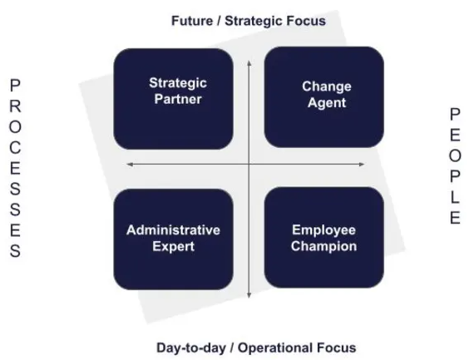
Figure 2: Ulrich and Brockbank Model
Source: (O'Donoghue, 2021)
In our case scenario, the current shortfall in Tesco is on employee performance feedback, which according to the Ulrich and Brockbank model should be addressed by the employee champion. As stated by Bruyn & Roodt (2009), the effectiveness of the Ulrich and Brockbank model can be measured not by inputs but by results. Therefore, the effectiveness of the model in Tesco can be measured by employee performance, which is enhanced by performance feedback. As an employee champion, HR will develop programs and processes that will meet the personal needs of the employees, have time to listen and respond to the employees, and maintain employee morale. Consequently, there will be an increase in employee performance to meet the company’s target. For instance, in 2022, Tesco’s key performance indicators of “Great place to work” (where colleagues recommend Tesco as the best place to work) decreased to 80% from 82% in 2021, while the “Great place to shop” measure (colleagues recommend Tesco as the best place to shop) reduced from 44 points in 2021 to 41 points in 2022 (Tesco PLC, 2022). Implementing the employee champion concept from Ulrich and Brockbank’s model in Tesco would improve employee morale through the response they get from their HR managers, thus recommending the company to others as the best place to work and shop. Therefore, applying Ulrich and Brockbank model in Tesco PLC, the HR roles would be as indicated in the table 1 below.
Tesco’s HR Roles based on Ulrich and Brockbank Model | Description
Strategic Partner | As a strategic partner, HR will help Tesco accomplish its business goals.  Also, HR professionals will be active participants in business planning.
Change Agent | Tesco’s HR change agents will ensure processes and programs enhance the company’s ability to change.
Employee Champion | As an employee champion, the HR professionals will work towards improving employee morale.  Giving timely feedback to the employees.  Taking care of employee personal and professional needs.
Administrative Expert | Tesco’s administrative experts will ensure HR process are efficiently administered for effective organizational performance.

Table 1: Tesco’s HR Roles based on Ulrich and Brockbank Model

5.2 Harvard Model
The Harvard Model is a crucial model of human resource. As illustration below, the Harvard Model focus on four different HR areas including stakeholder interests, situational factors, strategic HRM, and long-term consequences (Thakur, 2022). In our case scenario, long-term consequences will be the main focus to address the employee feedback shortfall experienced in Tesco PLC. Applying the Harvard model to the shortfalls in Tesco PLC, the dimension of long-term consequences would help the company meet the needs of the employees such as timely feedback that would enhance their performance. Usrof (2018) stated that there is a connection between stakeholder interests and situational interests that go through the long-term consequences on employee performance, skills, and attitudes. Therefore, implementing the Harvard Model at Tesco will help investigate the HRM’s long-term consequences on employee feedback, performance, skills, and attitudes to understand HRM aspects with a high likelihood to yield the greatest performance outcomes.
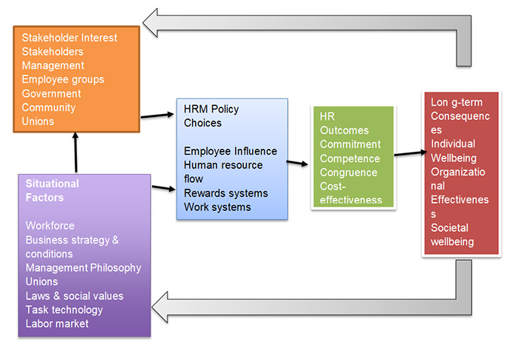
Figure 3: Harvard Model of HRM
Source: (Thakur, 2022)
- Meeting Employees Needs through Performance Feedback

Maslow’s Hierarchy of Needs Theory
Maslow’s hierarchy of needs is a motivational theory developed by Maslow to meet psychological needs. The theory consists human needs in a five-tier model as illustrated in figure 3 below, where the needs at the lower levels must be satisfied before an individual can meet the higher level needs (McLeod, 2018).
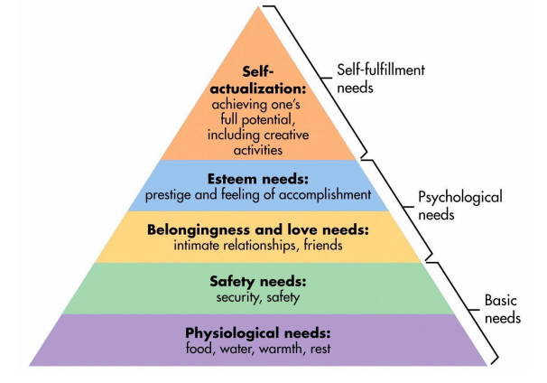
Figure 4: Maslow’s Hierarchy of Needs Model
Source: (McLeod, 2018)
Applying Maslow’s Hierarchy Needs Theory to the shortfalls at Tesco PLC, employee feedback for performance review falls under the category of esteem needs. Performance feedback gives an employee feeling of accomplishment, hence improving the overall job performance. By implementing Maslow’s theory, Tesco will improve employee performance and general organizational productivity.
- Impact on Employee and Organization
The indicated shortfalls have impacts on the employees and the organization in general. For instance, compared to peers, subordinates, and management feedback ratings, self-rating can be higher because an employee is likely to offer herself or himself a higher mark. In such cases, if the supervisors do not use effective feedback skills, Tesco faces defensiveness and alienation. This was the case between Tesco and its suppliers. BBC News found black holes in the company's accounts and unreasonable supplier payment delays. As a result, the company remains under investigation by the Serious Fraud Office (SFO) following the alleged irregularities in the company's accounts (Simpson, 2016).
Performance evaluations done by peers are effective for developmental purposes but may not be the most appropriate approach for promotion, pay, and job retention purposes due to different opinions from peers. So, instead of creating cooperation and support in the workplace peer evaluations create tension and breakdown (Mukhopadhyay, 2016). For example, in cases of unfair results or biased performance appraisals, there is a high likelihood for the employees to quit their jobs (Murray, 2018). Additionally, unrecognized and unappreciated employees become demotivated, resulting in lower performance rates. In order to combat this problem, Tesco ensures the anonymity of the raters to assure honest feedback.
Tesco believes that retaining employees is less expensive than recruiting new ones. So, 360-degree feedback has helped the organization retain employees by improving their skills and capabilities in their areas through performance evaluation. In return, the employees become motivated to lead to improved productivity. Further, using 360-degree feedback, Tesco is able to communicate its values and culture, improve customer service, and identify development and learning needs (Kandpal et al., 2018).
- Benefits of 360-Degrees Feedback as a Performance Appraisal Method
The 360-degree feedback model creates a workplace atmosphere for continuous learning. At the same time, it offers holistic feedback that improves employee performance and increases organizational growth by getting feedback from a multi-source rating, an individual does a self-rating to identify deficiencies and take necessary actions (Kandpal et al., 2018). Self-assessment allows an employee to be more positive, valuable, and productive to the organization. From the management perspective, giving real-time feedback enables managers to improve capabilities, create better roles, push for better targets, and create a positive work environment where employees feel valued, happy and inspired to perform better (Dasgupta, 2017).
Another benefit of the 360-degrees feedback system is that it promotes constructive open communication (Singh, 2021). Feedback from all stakeholders in the organization who are required to communicate the feedback to the employee being rated. In order to offer effective knowledge with the required skills and work requirements, open communication is fostered, so that the employee can understand what is required of them. simultaneously, open communication facilitates collaboration between employees and managers as they must consult each other regardless of their job positions (Dayarathna et al., 2019).
360-degree feedback boosts workplace relationships. Besides boosting employees’ morale to work on the deficiencies, 360-degree feedback creates better work relationships between the employees and the management, hence improving productivity (Singh, 2021). Feedback given in the organization can help create a team with mutual goals to achieve the main objectives of the organization since the organization measures the performance of employees and links it to the achievement of organizational performance (Dayarathna et al., 2019).
360-degree feedback plays a crucial role in motivating employees to do their best in filling the improvement gaps identified during performance evaluation. Motivated employees work hard toward achieving their goals and objectives (Forson et al., 2021), hence job satisfaction and improved performance (Forson et al., 2020). However, this means an organization must pay more attention to how employees can be motivated and offer an environment that helps them deliver results as expected by the management (Forson et al., 2021). In this sense, implementing a 360-degree feedback process will motivate the employees to improve their performance to get positive feedback from the stakeholders involved in the process.
- Conclusion
Performance management is a human resource tool aiming to develop the organization's potential capabilities. Organizations ensure that their performance management aligns with their long-term policies and can manage employee efforts depending on the performance outcomes. Tesco PLC is not an exemption, as it has put all its efforts into managing performance. 360-degree feedback is one of the approaches implemented by organizations for performance appraisals and developmental purposes. This report discussed the gaps in the 360-degree feedback as implemented in Tesco and offered a variety of its benefits to the employee and the organization. Towards the end, the report highlighted some recommendations to enhance performance improvement in the company through 360-degree feedback performance appraisal.
- Recommendations
For 360-degree feedback to be an effective performance appraisal method, Tesco needs to:
- Articulate the purpose and make a strategic decision on what the company want to achieve using 360-degree feedback (Center for Creative Leadership, 2020). Tesco should ensure that the 360-degree assessment selected for the organization aligns with the company’s competency model and business outcomes. With this in place, Tesco will ensure that an individual's performance is consistently measured against the organization's objectives and targets.
- Tesco should also evaluate the various stakeholders involved in giving feedback. Subordinates, customers, and peers can be biased and offer negative appraisals of employee performance. Consequently, an employee may gain considerable anxiety of feeling that everyone in the company is against them (Kandpal et al., 2018), and this may lead to reduced performance that will influence the overall organizational productivity.
- 360-degree is a feedback process that needs a lot of communication. So, it is recommended that Tesco should ensure effective communication among the involved stakeholders so that they understand what they are expected to do.
- Another recommendation is Tesco’s managers should ensure role clarification. According to Nduati and Wanyoike (2022), role clarification includes authority, responsibilities, work technique, task substance, timeliness in work completion, and operational priority. Therefore, it becomes the role of a manager to know which employee fits into which job because performance management is achieved when communication between the management and employee comes to an understanding of the work to be done, how it will be done, and how it will progress towards the desired results. Kundu et al. (2019) found that role clarity positively correlates with the driving force for workplace engagement and creative work practices. When employees understand what is expected of them, they are less likely to receive negative feedback from the 360-degree process.
- Lastly, after the implementation of the 360-degree feedback process, it is recommended that the employees should not be expected to fix all the issues at once. The information disseminated from the questionnaire leaves the employees with numerous suggestions on areas of improvement. It will be overwhelming to deal with all this data at once, so it should be handled bit by bit.

- Reference List
Bayraktar, O. and Şencan, H. (2017) Employees' approaches to human resources from the asset–resource concepts perspective. International Journal of Business and Social Science, 8(9), pp.116-127.
Bedford, E. (2022) Tesco Group employees by region 2021-2022, Statista. Available at: https://www.statista.com/statistics/490890/tesco-group-number-of-employees-worldwide/ (Accessed: February 19, 2023).
Berry, J. (2017) Achieving competitive advantage through people, TimelessTime. Available at: https://timelesstime.co.uk/knowledgebase/competitive-advantage-through-people/ (Accessed: February 20, 2023).
Bruyn, L. and Roodt, G. (2009) “Applying the criteria of Ulrich and Brockbank for the assessment of the role of Human Resources as a strategic business partner in a Mining Company,” SA Journal of Human Resource Management, 7(1). Available at: https://doi.org/10.4102/sajhrm.v7i1.200.
Center for Creative Leadership (2020) How to implement an organizational 360 feedback initiative, CCL. Available at: https://www.ccl.org/articles/leading-effectively-articles/how-to-implement-360-feedback-initiative/ (Accessed: March 10, 2023).
Corporate Finance Institute (2022) Key performance indicators (kpis), Corporate Finance Institute. Available at: https://corporatefinanceinstitute.com/resources/management/key-performance-indicators-kpis/ (Accessed: February 20, 2023).
Dahlmann, F., Branicki, L. and Brammer, S. (2019) Managing carbon aspirations: The influence of corporate climate change targets on environmental performance. Journal of business ethics, 158, pp.1-24.
Dasgupta, B. (2017) Tesco Bengaluru announces changes to Performance Management Review System, The Economic Times. Available at: https://economictimes.indiatimes.com/tech/ites/tesco-bengaluru-announces-changes-to-performance-management-review-system/articleshow/56753701.cms?from=mdr (Accessed: February 19, 2023).
Dayarathna, D.K., Dowling, P.J. and Bartram, T. (2019) "The effect of high performance work system strength on organizational effectiveness," Review of InternationalBusiness and Strategy, 30(1), pp. 77–95. Available at: https://doi.org/10.1108/ribs-06-2019-0085.
Douglas, S. et al. (2021) "Systemic leadership development: Impact on organizational effectiveness," International Journal of Organizational Analysis, 30(2), pp. 568–588. Available at: https://doi.org/10.1108/ijoa-05-2020-2184.
ETS (2017) Tesco 360 degree feedback case study, ETS. Available at: https://www.etsplc.com/case-studies/tesco-360-degree-feedback-case-study (Accessed: March 10, 2023).
Forson, J.A. et al. (2020) "Innovation, institutions and economic growth in sub-Saharan africa – an IV estimation of a panel threshold model," Journal of Economic and Administrative Sciences, 37(3), pp. 291–318. Available at: https://doi.org/10.1108/jeas-11-2019-0127.
Forson, J.A. et al. (2021) "Employee motivation and job performance: A study of basic school teachers in Ghana," Future Business Journal, 7(1). Available at: https://doi.org/10.1186/s43093-021-00077-6.
Ghrmay, T.M. (2017) "Tesco: Losing ground in the U.K.," European Journal of Business and Management, pp. 239–254. Available at: https://doi.org/10.4324/9781315745565-28.
Kandpal, J., Baroda, D.S. and Sharma, C. (2018) “360-degree feedback appraisals- an innovative approach of Performance Management System,” INTERNATIONAL JOURNAL OF MANAGEMENT & INFORMATION TECHNOLOGY, 1(2), pp. 53–66. Available at: https://doi.org/10.24297/ijmit.v1i2.1447.
Kundu, S.C., Kumar, S. and Lata, K. (2019) "Effects of perceived role clarity on innovative work behavior: A multiple mediation model," RAUSP Management Journal, 55(4), pp. 457–472. Available at: https://doi.org/10.1108/rausp-04-2019-0056.
McLeod, S. (2018) Maslow's hierarchy of needs , Cañada College. Available at: https://canadacollege.edu/dreamers/docs/Maslows-Hierarchy-of-Needs.pdf (Accessed: March 23, 2023).
Meyer-Leive, M. (2022) 360-degree performance appraisal system with the focus on employee learning and development: A comparison of feedback systems used in organizations and education (Bachelor's thesis, University of Twente).
Mukhopadhyay, K. (2016) 360-degree appraisal–A performance assessment tool. Researchgate, Kolkata.
Murray, N. (2018) Poorly-implemented performance management will cost your organisation., LinkedIn. Available at: https://www.linkedin.com/pulse/poorly-implemented-performance-management-cost-your-norman-murray (Accessed: February 19, 2023).
Nduati, M.M. and Wanyoike, R. (2022) Employee performance management practices and organizational effectiveness. Int. Acad. J. Hum. Resour. Bus. Adm, 3, pp.361-378.
Ngo Thi Vo, H. (2011) The impact of E-HR on the roles and competencies of HR.
O'Donoghue, L. (2021) The david ulrich HR model explained (a 2023 guide), Test Candidates. Available at: https://www.testcandidates.com/magazine/the-david-ulrich-hr-model/ (Accessed: March 23, 2023).
Quinn, I. (2022) Dave Lewis ditches Tesco Steering Wheel in favour of Big Six, The Grocer. The Grocer. Available at: https://www.thegrocer.co.uk/supermarkets/dave-lewis-ditches-tesco-steering-wheel-in-favour-of-big-six/517182.article (Accessed: February 18, 2023).
Siddiqui, S.T. (2017) “Impact of 360-degree feedback on employee and organization growth: With reference to Higher Education Institutes of Pakistan.,” International Journal of Advanced Research, 5(4), pp. 27–32. Available at: https://doi.org/10.21474/ijar01/3778.
Simpson, E. (2016) Tesco knowingly delayed payments to suppliers, BBC News. BBC. Available at: https://www.bbc.com/news/business-35408064 (Accessed: February 19, 2023).
Singh, M. (2021) Advantages and disadvantages of 360 degree feedback, mettl. Available at: https://blog.mettl.com/advantages-disadvantages-of-360-degree-appraisal/ (Accessed: March 10, 2023).
Tan, F.Z. and Olaore, G.O. (2021) "Effect of organizational learning and effectiveness on the operations, employees productivity and management performance," Vilakshan - XIMB Journal of Management, 19(2), pp. 110–127. Available at: https://doi.org/10.1108/xjm-09-2020-0122.
Tesco PLC (n.d.) About, Tesco PLC. Available at: https://www.tescoplc.com/about/ (Accessed: February 19, 2023).
Tesco PLC (2022) Annual report 2022, Tesco PLC. Available at: https://www.tescoplc.com/investors/reports-results-and-presentations/annual-report-2022/ (Accessed: March 22, 2023).
Tesco PLC (n.d.) Our history, Tesco PLC. Available at: https://www.tescoplc.com/about/our-history/ (Accessed: February 19, 2023).
Tesco PLC (n.d.) People | tesco careers, Tesco Careeers. Available at: https://www.tesco-careers.com/office/corporate-functions/people/ (Accessed: February 19, 2023).
Thakur, S. (2022) Harvard model of HRM: Complete detail with diagram, Huge Reference Manual. Available at: https://101hrm.com/harvard-model-of-hrm/ (Accessed: March 23, 2023).
U.S. Office of Personnel Management (n.d.) Performance management cycle, U.S. Office of Personnel Management. Available at: https://www.opm.gov/policy-data-oversight/performance-management/performance-management-cycle/ (Accessed: February 19, 2023).
Usrof, H. (2018) The Impact of Developing HRM Harvard Model on Employee’s Attitude, and Skills: A Case of Sharjah Municipality UAE Appraisal.

