Chamber Leak Tester Project Analysis
22/05/2023
Reflective Project Report
Taylor Davies
2214080

Table of Contents
Introduction 3
Project Research 4
Background Information on RenAM 500ML 4
Health and Safety Issue 5
Problem Measurement & Analysis 5
Design Specification of Leak Tester 6
Project Management Tools 7
Design Tools and Techniques 8
Methodology Of Analysis 10
Analysis of Project 11
Project management tools 11
Useability, Functionality and Technical Analysis 12
Questionnaire: 12
Technical and Functionality 14
Stakeholders Requirements and Aesthetics 15
Conclusion 16
References 17

Introduction

This report will be analysing a project that I was personally involved in at Renishaw PLC. Renishaw is a British based company with more than 79 offices in 37 different countries, with the head office being New Mills which is situated in Wotton-Edge, Gloucester. Renishaw has over 4,400 employees with more than half being employed in the UK. The UK sites are majorly involved in research and development and manufacturing (plc, n.d.).

Renishaw is known for first inventing the touch trigger probe which its gateway product into the engineering world. The touch trigger probe was invented by current executive Chairman David McMurtry and Non-Executive Chairman John Deer; Since then, the company has explored several different fields of engineering varying from Medical, Metrology and even additive manufacturing.
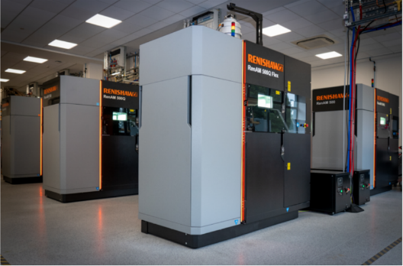
The project that I will be analysing is the Design and Manufacturing of a Leak Tester for the chambers of the Additive Manufacturing machines that Renishaw offers. Renishaw offers 4 variants of Additive Manufacturing machines these are the AM500Q (Quad Laser), AM 500S (Single Laser), AM Flex 500Q, AM Flex 500S (the Flex Machines do not come with a recirculation system) (plc, n.d.).

Figure 1 - (Renishaw,2020)

The Project was initiated from a Health and Safety action which was raised by our service team. The problem description stated that a machine at customer site had a leak at the chamber which was dispersing Argon into the room at customer, the customer did not have any oxygen sensors present in the room therefore unable to tell how much argon have filled the room, this was seen as a major health and safety risk from Renishaw’s perspective and containment needed to be put in place to prevent this from happening again. Argon is a noble gas and the health implications it can have consist of dizziness, nausea, vomiting, loss of consciousness and even death if inhaled excessively.

The AM current products Team at Miskin then decided that the chambers need to be tested to the same conditions to how the machines run when inert. The machines become inert when it is in the build process, oxygen in the chamber can affect the build quality of parts that are being produced. However, as the chamber is the first module which is added to the Machine base it is not productive to only test the machine when fully built, therefore a tester needs to be designed and manufactured to test the chambers once they have been fully populated and ready to leave the cell for the next part of the process.

The aim of this project is to analyse the project discussed to see what benefits come from the completion of the project and if there is anything that can be improved. I will be analysing this project from a design standpoint and any management-based issues that occurred throughout the completion of this project.

Project Research

Background Information on RenAM 500ML

The RenAM 500ML line is a production line which produces 4 different variants of Additive Manufacturing machines; these consist of the Ren AM 500Q, 500S, Flex Q and Flex S, these consist of quad laser and single laser machines. All Machines are built up of five modules and 1 collection of outer wrap panels. The 5 modules are built in each cell and then fitted to a base which is moved throughout the production line. The five modules involve:

- Chamber Module
- Electrical Module
- Filter and powder recirculation module
- Optical Module and Gas Recirculation
- Pump Module

The RenAM production line consists of 6 Manufacturing Cells and 6 Commissioning Cells. Each Module has its own Cell to work in and once the Module has been fitted to the base the machine then flows down the line for the other modules to be added. However, the first-time power is applied to the machine is in function commissioning Cell 7 which means the machine has not been tested until it has reached this stage (Not Practical for Rework). Below is a diagram of the floor diagram of the AM production line, in the diagram you can see each cell has been labelled with what modules are manufactured in each cell and the different stages of commissioning.
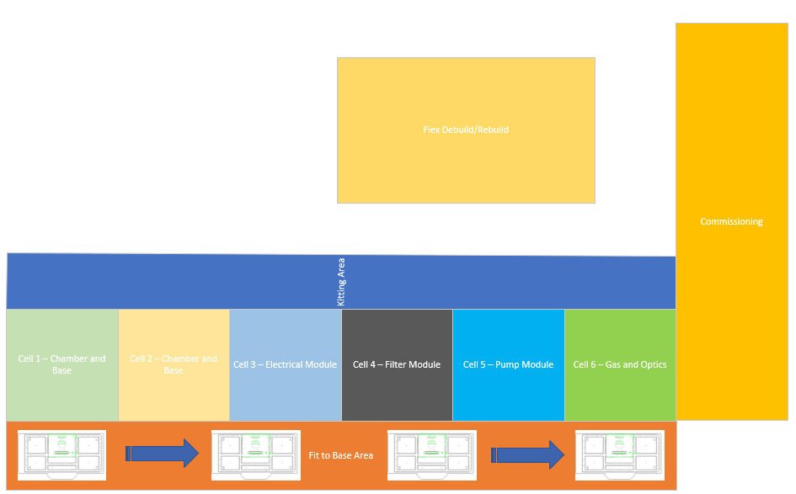

Figure 2 – (Davies, 2023)

Health and Safety Issue

A corrective action report was raised to highlight a health and safety issue that has occurred at a customer site. The issue stated that there was a leak on the chamber, which was causing an argon leak into the atmosphere, however the machine was in a small room, and it had potential to fill up with argon if there were no oxygen analysers in the room to warn there was an issue. From this issue Current Products AM was assigned a task to create a leak testing unit to ensure all machines and completely leak proof and able to hold a vacuum of -960mb (the machine specification). At this point current containment for the leaks on the chamber relied on a small vacuum test which takes places in commissioning using the vacuum pump on the machine, however the main issue with this is that the machine is fully built resulting in countless hours of rework as the chamber is the centre of the built resulting in no access to bellows and other connection to the chamber which could be the issue.

Problem Measurement & Analysis

To measure the current failure rate with the leaks per machine we have recorded all results over 3 months to detect how much hours of rework is involved per machine due to chamber leaks. These issues were recorded by AM’s production technicians through rework on the job, this allowed to get an average rework time per machine, the production technicians also stated what the fault with the chamber was in the rework text on syteline also. As the table below shows there is rework on the chamber every single machine over 11 machines over a 3-month period, this rework time also costs productions productivity and efficiency: this backs for the project. See Fault Log below:

Machine | Rework Time | Root Cause
1 | 2 | Leak on Bellow Fitting
2 | 3 | Incorrect Seal
3 | 6 | Door Seals
4 | 1 | Leak on Bellow Fitting
5 | 1 | Incorrect Seal
6 | 5 | Leak on Powder Doser
7 | 8 | Door Seals
8 | 1 | Incorrect Seal
9 | 2 | Leak on Bellow Fitting
10 | 1 | Incorrect Seal
11 | 8 | Door Seals
Figure 3 – Internal Document displayed in Table Format

From the results above an Ishikawa diagram was carried out to brainstorm of all potential reasons for the issues arising. There are various reasons why Engineering team Created these diagrams, it allows Team members to communicate and exchange ideas more efficiently, it allows them to view complex informational in a simpler visual format and it highlights root causes of problems (Safety Culture, 2023). Image below is from the project folder within Renishaw:

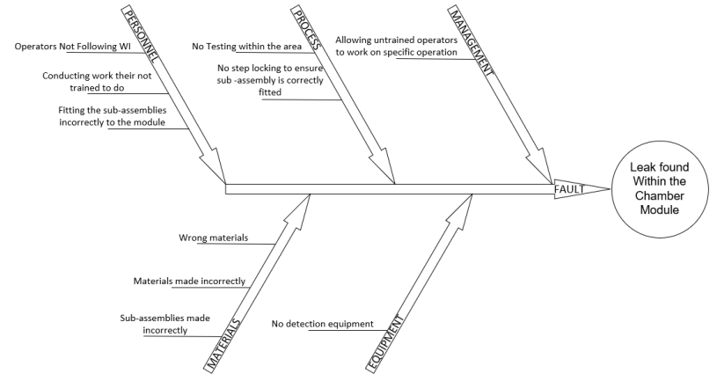
Figure 4 – Internal Document

Design Specification of Leak Tester

From the Ishikawa Diagram it highlighted that there is no detection in place for leaks on the chamber at module build. This then allowed the team to create a design specification which specified everything the test rig required, this involves functional requirements, rig footprint and operational requirements, safety requirements and legal requirements. The table below was part of the technical folder built up for design of the rig:

Functional Specification
Requirement | Specification
Complete Vacuum Test | -960 mb
Complete Overpressure Test | 300 mb
Test Electrical Cluster | PASS
Rig Footprint
Requirement | Specification
Rig must not be greater than 2000 x 1400mm | Keep the tester within Cell 1
Rig Supply & Health and Safety Specification
Regulated Air Supply | Air regulator to be fitted inline
Mains Voltage | 240v for PLC + Vacuum Pump
E-Stop | To stop the machine in case of emergency
Renishaw Standard PLC equipment | Omron/ Siemens Equipment
Must conform to CE | To ensure use on Production Line
must conform to RoHS | To ensure use on Production Line
Figure 5 – Internal Document displayed in Table Format

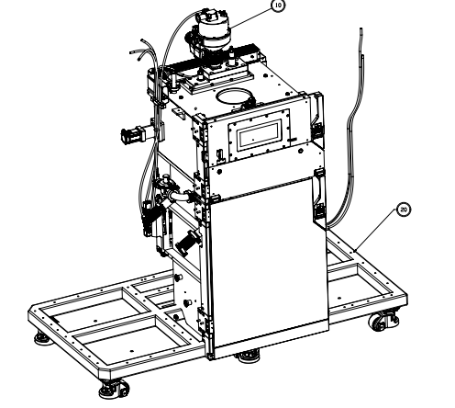
The image below is a diagram of the chamber, which is being tested, it is important that all equipment used for this build is fit for purpose, if cheap poor equipment is being used then it could result in in accurate results during verification stage. The chamber is a steel welded chamber which gets tested at manufactures site, the means that all chambers are serialised and have certificates provided, this rig must be able to test in comparison to manufactures accuracy to be in line with all results from them also.

Figure 6 – Internal Image

Project Management Tools

Once the project is ready to start the design and manufacturing process several project management tools were used. Project management is a tool that can assist your team in keeping track of all the work being completed in order to complete a project on schedule. There are, however, more types, processes, and approaches that fall under the umbrella term of project management (Martins, 2020).

A GANTT chart's objective is to provide the team with the resources needed to manage every facet of the project. A GANTT chart can be used to plan, delegate, and monitor project work from the start to finish. Because of its horizontal layout, it's simple to observe how work accumulates over time so you can actively track progress as you go (Gilmore, 2016). The GANTT chart was beneficial for the AM Engineering Team as it helped everyone understand what stage in the project they were in the project and for management to see the progress on the project. The GANTT Chart used in this project is displayed below:
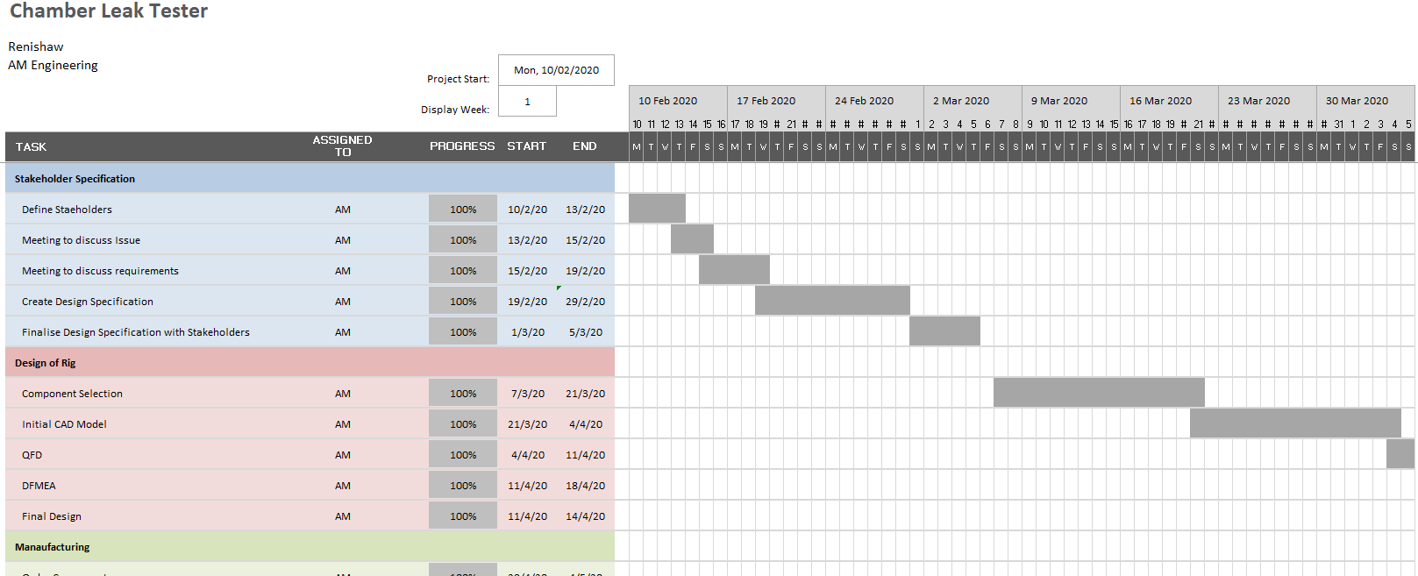

Figure 7 – Internal Image
In addition to a GANTT chart the AM Engineers used PERT throughout the project. The duration of a specific task or activity is determined using the Project Evaluation Review Technique, or PERT. It is a mechanism that aids in the accurate planning and synchronisation of every task during a project. It also aids in monitoring the overall project's progress—or lack thereof. The US Navy created the Project Evaluation Review Technique in the 1950s to oversee the Special Projects Office's Polaris submarine missile programme (CFI Team, 2022).

Finally, the last project management tool used throughout this project was Critical Path Method (CPM). Finding the series of tasks and dependencies in a project that take the longest to complete is done using the critical route method. The critical path and the actions that make up it are referred to as critical activities. The bare minimum amount of time required to finish a whole project is the overall duration of the critical path. The length of the project will be increased if important tasks are delayed (Donato, 2022).

The benefits of CPM include increased scheduling flexibility and accuracy, greater stakeholder and project manager communication, and simpler work prioritisation. CPM is frequently used in tandem with the Programme Evaluation and Review Technique (PERT) by project managers. PERT considers unpredictable events while CPM concentrates on predictable activities, resulting in three potential timelines: the most optimistic, the most pessimistic, and the most realistic (Ramos, 2022).

Design Tools and Techniques

When in the design process a number of tools and techniques were used throughout. The design consisted of a Rig build with an aluminium extrusion frame 1200 x 400mm x 1500. This frame can hold the electrical panel which is running the vacuum pump, HMI and the electronic shadow board. There was only one design created at the start of the project and this was the final design. An image below is a CAD model created by the engineers in AM:

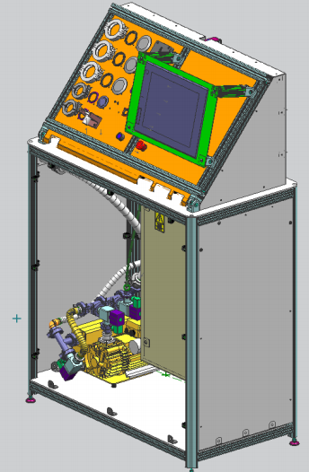

Figure 8 – Internal Document

The test rig was designed with a mindset of ‘No Faults Forward’; Essentially, it means that errors should be discovered immediately as they occur rather than later (Nausley, 2018). This is beneficial for the engineering production team as this prevents any rework further in the process which is reducing the areas Cost of Quality.

Design engineers employ the Design Failure Mode and Effects Analysis (DFMEA) process to make sure that products fulfil user needs and carry out their intended functions. For the purpose of identifying potential failure modes and causes, DFMEA assesses the overall design of product systems and components (Safety Culture, 2022). Failures in design occur unintentionally throughout the Product Design & Development phase of a new product project. Without DFMEA, most failures would go undetected until validation and trial production, and some might not even be found until after production has begun. The price of creating countermeasures, however, is significantly more now than it was then. With DFMEA, countermeasures will be considered virtually simultaneously with the failures (Hartwell, 2018). An example of DMFEA created by the engineers in the AM department is shown below:

HOQ is the abbreviation for ‘House of Quality’. Pugh, 1990 tells us that HOQ are broken down into four stages:
- Customer Planning Requirements – this involves customer expectations, competitor analysis, technological forecasts and specific product characteristics.
- Customer requirements plan that has been developed by product specifications.
- Process and quality control plans to help recognise process and design parameters.
- Process sheets – These are the outcome from the process and quality control plan.

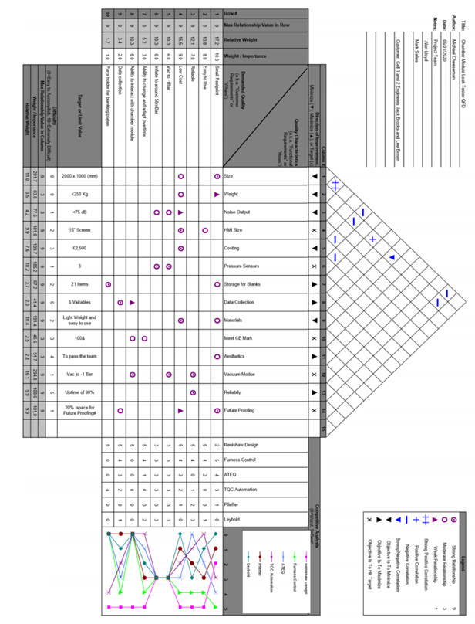
HOQ is a great tool for design tests rigs for a production line as it allows production to specify exactly what they require, once the specification has been agreed then the design engineer can follow the four steps above this will allow them to ensure that the product their producing is competitive in all aspects to other products on the market.

Figure 9 – Internal Document

Methodology Of Analysis

A design project's success is ensured by analysing several factors, including project management tools, user needs, usability, aesthetics, functional, technological feasibility, and stakeholder requirements. This methodology will help recognise what was successful throughout the project and what could have been done different throughout the project to result in a better outcome.

First, an analysis on project management tools will be carried out. This will involve analysing how beneficial or not the project management tool was to the project, in addition to this I will also be discussing other types of project management tools that can be used to help manage the project.

Following on to get an understanding of how the test rig is working and if it is doing what is required a short questionnaire (5 questions) will be created to hand out to the operators on the AM production line to get their opinion as they are the end users. This data will then be collected and analysed to see if all operators are happy with the product or if there is anything that can be improved on.

Furthermore, a comparison will take place for a functional analysis purpose, this will entail comparing the design specification to the functionality of the test rig. This will break down into accuracy of the rig and whether the rig is preventing faults going forward down the production line. This will also aim to identify any discrepancies in the test rig (WikiBooks, 2021). Also linked in with the functional analysis I will be conducting a technical analysis which will involve the feasibility of the design and other technical requirements that may not be covered in the functional analysis.

Analysing stakeholder requirements is also a vital part of project analysis, it is important to identify and analyse the various stakeholders in the project; it is important to look at their needs and expectations and how they impacted the project. It is important also to receive feedback from all the stakeholders and breakdown their feedback to see where they feel areas of the project were completed well and where areas of the project could have been improved.
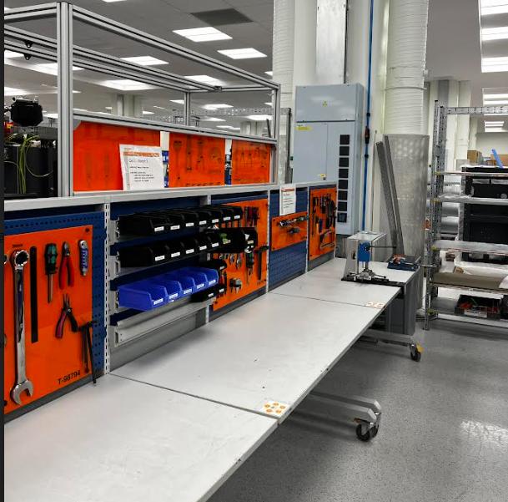
Finally, I will look at the aesthetics of the design. Aesthetics has no functional or technical benefit however it is a massive part of the design process. Senior management constantly observe how aesthetically pleasing their production lines look. Within the AM line there are various tooling boards across the production cell to minimise the amount of clutter across the workspace, the test rig being designed also needs to fit into the production line to ensure that visitors are impressed when visiting the AM production line. The Additive Manufacturing is a flagship product for Renishaw, so Aesthetics is always being looked at amongst the department. The image (Figure X) is an example of how organised and aesthetically pleasing the production line is.

Figure 10 – (Davies, 2023)

Analysis of Project

Project management tools

Throughout the project three project management tools were used; these were GANTT Chart, Performance Evaluation Receive Technique and Critical Path Method.

A Gantt Chart was great project management tool used by the AM Engineers as it allowed them to structure the project and set milestones throughout. The main benefit which the Engineers have noticed is the visual aspect of a Gantt Chart as it easy to follow as it helps portray dates and time frames much easier. Gantt Charts also have a percentage of completion per task, this allows the engineers to know how close they are to the next milestone, the benefit of this is that it can allow the engineers to prepare for the next task when the realise the current task is almost complete. Finally, the Gantt Chart is a great tool for presenting progress during team meetings; they will allow senior management who may not have much involvement in the project themselves to understand the current progress throughout the project (Analysistabs, 2023). On the other hand, there are disadvantages to using Gantt Charts for example after discussing with the engineers they told us the negative to using Gantt Chart was that there was not enough detail outlined per task meaning that under skilled employees involved on the project may struggle to complete some tasks due to lack of information also the creation time of the Gantt Chart can be very long due to the size of the project (Donato, 2018).

In addition to GANTT Chart, ‘Performance Evaluation Receive Technique’ and Critical Path Method. Both these tools are great project management tools which were highly praised by the AM Engineers. One of the benefits that was brought up was the ability PERT had to maximise the use of resources, in addition to this it also made project planning simpler (CFI Team, 2022). Furthermore, CPM method was also used throughout the project and it helped gain an understanding of the most efficient method of completing the project; once again this was beneficial as it allowed the project team to present the initial plans to senior management allowing senior management to have an idea of time frames and all critical tasks that are vital throughout the project t (Ramos, 2022).

On the other hand, if there are any recommendations that would be put forward for how the project team could have improved in the future it would be to include a risk management tool, for example a risk matrix. Businesses and managers can use a risk matrix as a tool to comprehend the risks associated with a specific project or business decision. A risk Matrix typically comes in the form of a grid that if five by five (indeed, 2022). There are numerous benefits to using a risk matrix, for example they are typically easy to understand and use, it allows for a more visual representation of any risks, and it helps strategists plan for risks and prioritise the biggest risks. On the other hand, risk matrixes are based on qualitative data assessments, this may lead to a sense of false security around these risks. Overall, I think the use of a risk matrix would have been beneficial throughout this project as most of the material was supplied and delivery performances were typically low throughout the project (Cascade Team, 2022)

Useability, Functionality and Technical Analysis

Questionnaire:

I created a five questionnaire which was handed out to the 5 operators on the production to get their general feedback on the test rig, the reason I only done five simple questions was due to the time production was given by middle management. I have put the questionnaire that was used below:

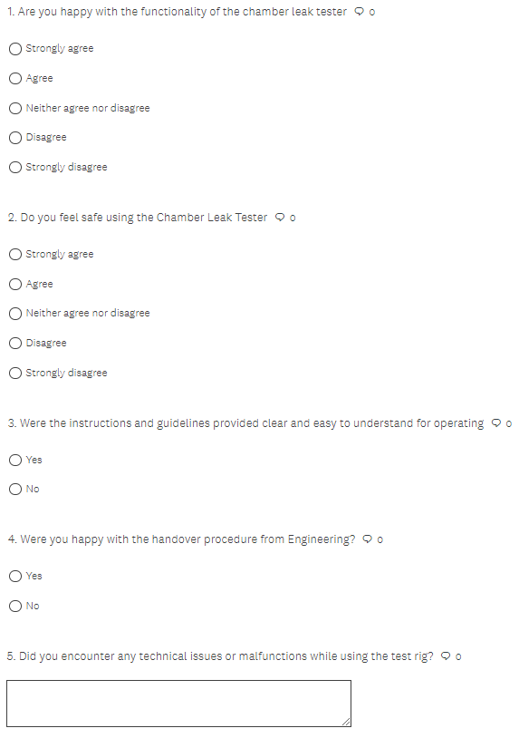

Figure 11 – (Davies, 2023)

The results that come back from the survey were very positive, the results stated:

Question 1 Results:

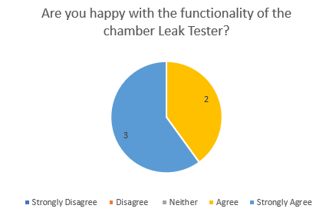

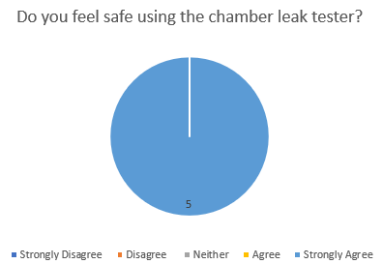
Question 2 results:

Question 3 results:

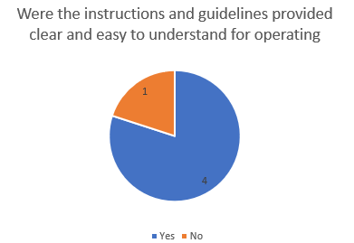

Question 4 Results:
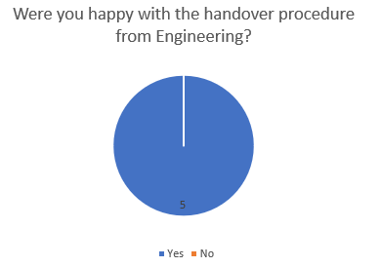

Question 5 Results:

There were 2 Technical issues which were mentioned in the open-ended question, the other 3 answers stated ‘N/A’. The two technical issues stated:
- In accurate results from pressure sensors – required calibration.
- Vacuum pump struggling after 1 year.

From these results we can infer that the majority of the answers are positive, Question 3 had a negative answer which was actioned, the reasoning for ‘No’ was that the PMI had not been shown to the lead operator to carry out before the start of each test; this was quickly rectified by providing documentation to production for Preventive Maintenance and Initial start up procedure.

The reason why questionnaires are so beneficial in the engineering industry is that they are practical inexpensive. Questionnaires are typically used to target certain groups; in this instance the end users of the test rig were the AM production line operators. As mentioned, questionnaires add an aspect of practicality to it, and this is a great way to engage an audience that is a practical dominant industry (Debois, 2022). Overall, the use of questionnaires for this project was great and it provided some good feedback.

Technical and Functionality

To analyse the functionality and technical aspect of the test rig I compared results which production have been collecting. The test rig has so far prevented zero machines from leaving the cell which is resulting in a Cost of Quality saving as to before the rig there was rework time allocated to every machine. This backs up that the test rig is functional preforming in comparison to the design specification.

However, as the project was undergoing there was regular failures which occurred which entailed the electrical components on the chamber (Door Interlock and Cluster). During the design process there was only 1 design which was completed however during the brainstorming stage there was suggestions to include an electrical test rig incorporated in one test rig; this could have been considered if there was a design matrix created for three potential test rigs. A design matrix is a matrix that contains information on various traits of various people or objects. Each column represents a quality, and each row represents a person. The outcome of the matrix is decided by the highest scoring concept. A test rig with multiple features that could prevent multiple faults forward involving the same components would have scored higher than a test rig with only one purpose, this is why the engineering team should have considered more design planning tools at the start of the project (Taboga, 2021).

Stakeholders Requirements and Aesthetics

Stakeholder management and engagement are perhaps the most crucial project delivery factors, although they are frequently seen as ancillary activities or tasks that may be delegated to business-as-usual services. Project managers rely on stakeholders to acknowledge the results and advantages they provide. People only react when they are actively involved (APM, 2014).

The stakeholders required a test rig to ensure that no Health and Safety issues to do with chamber leaks arise again in the future. The test rig has provided this, and it has resulted in no faults forward on the production line. However, feedback from the employees backed up this statement via the questionnaire carried out. On the other hand, production management team felt like they were out of the loop during the project so therefore in the future regular weekly/bi-weekly meetings could be scheduled with production management to ensure they are up to date with the projects.

The rig met all legislation requirements stated in the design specification which included conforming to CE and RoHS. When a manufacturer places the CE marking on a product, he or she is certifying that the item complies with all applicable regulatory criteria. As a result, the manufacturer is assuring that product authenticity (Gov.uk, 2022). This was required by AM production as the AM machine is CE marked so production wanted all test rigs to be CE marked also. The AM production line also requested for the rig to be RoHS compliant, this rig to have:

- possess accompanying technical documentation (often referred to as a technical file).
- Declaration of Conformity.
- Be labelled with all correct information.
- display the proper conformity marking for the GB and/or NI markets.
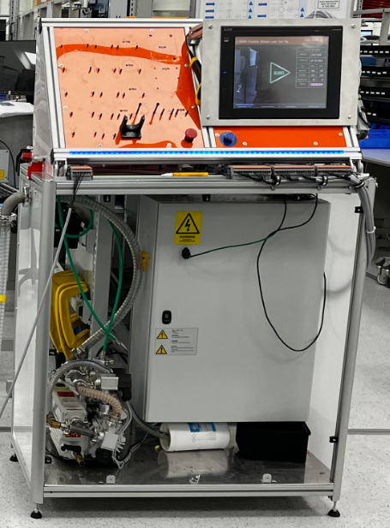
Finally, the stakeholders required for the rig to be aesthetically pleasing. The rig was designed to fit in with the production lines colour scheme with the standard ‘Renishaw Orange’ as described by the stakeholders. As discussed in the research AM is a flagship product and lots of visits and tours take place on the production line. Overall, the rig looks very professional as it has been designed with thought. The stakeholders had chances to voice their opinion on how the rig looks aesthetically and this helped a lot throughout the design process. The image below shows the completed state of the Chamber Leak Tester:

Figure 12 – (Davies, 2023)

Conclusion

The analysis of the chamber leak test project has shed important light on several project-related issues, including stakeholder expectations, technical viability, user requirements, and risk management. Throughout important judgements were made that will guide the project's design and execution by carefully studying these elements.

The project was managed by using various project management tools, this was carried out efficiently and effectively throughout the project. It was brought to attention that there were no project risk analysis tools used throughout; this is an area for improvement.

There were also a number of design tools used throughout the project and this helped the design team work efficiently as they were all on the same page throughout the project. The use of House of Quality really benefitted the team throughout the project. It was also recognised that the engineers have a wide variety of skill sets throughout the project ranging from mechanical to software design.

The analysis first and foremost emphasised the significance of comprehending user requirements. We learned a lot about the intended functionalities, performance requirements, and usability considerations for the chamber leak test from user research and feedback. The research received through the questionnaire provided the engineering team satisfaction that all requirements were met.

The various parts of the chamber leak test were well understood thanks to functional and technical analysis. The engineers were able to optimise the overall functionality of the system by dissecting the design into its functional components and examining their interactions and dependencies, although it was realised that an electrical tester could have been added.

The visual appeal and design components of the chamber leak test were the subject of aesthetic analysis. The team made sure the design was aesthetically pleasant and aligned with the company identity by carefully analysing colour schemes and layout.

The requirements and expectations of the project's stakeholders were identified and addressed thanks to stakeholder analysis. The team made sure that the chamber leak test design matched the needs and interests of the stakeholders by interacting with them and taking their opinions into consideration during the analysis. On the other hand, it was brought to light that the stakeholders could have been interacted with more throughout the project as they felt out of the loop.

In conclusion, a thorough grasp of numerous facets of the design and execution process was supplied by the study of the chamber leak test project. The project team was able to optimise the design utilising design procedures and make informed selections by employing analysis techniques. The preparation and execution of the chamber leak test were successful because to the analytical process' facilitation of efficient teamwork and communication among stakeholders.

References
Analysistabs (2023). Advantages & Disadvantages of Gantt Charts. [online] ANALYSISTABS - Innovating Awesome Tools for Data Analysis! Available at: https://analysistabs.com/gantt-chart/advantages-disadvantages/#:~:text=The%20main%20benefits%20of%20Gantt%20Charts%20are%3A%20easy [Accessed 20 May 2023].
APM (2014). Key principles. [online] Apm.org.uk. Available at: https://www.apm.org.uk/resources/find-a-resource/stakeholder-engagement/key-principles/ [Accessed 21 May 2023].
Cascade Team (2022). Risk Matrix: How To Use It In Strategic Planning. [online] www.cascade.app. Available at: https://www.cascade.app/blog/risk-matrix-guide#:~:text=Pros%3A%20Risk%20matrix%20frameworks%20are%20customizable%20and%20adaptable%2C [Accessed 21 May 2023].
CFI Team (2022). Project Evaluation Review Technique (PERT). [online] Corporate Finance Institute. Available at: https://corporatefinanceinstitute.com/resources/management/project-evaluation-review-technique-pert/ [Accessed 17 May 2023].
Davies, T. (2023a). AM production Cell.
Davies, T. (2023b). Chamber Leak Tester.
Davies, T. (2023c). Simplified Cell Layout - AM Production.
Debois, S. (2022). 10 Advantages and disadvantages of questionnaires . Pointerpro. [online] 8 Mar. Available at: https://pointerpro.com/blog/questionnaire-pros-and-cons/ [Accessed 21 May 2023].
Donato, H. (2018). Advantages and Disadvantages of Gantt Charts. [online] Project-Management.com. Available at: https://project-management.com/advantages-and-disadvantages-of-gantt-charts/ [Accessed 20 May 2023].
Donato, H. (2022). What Is Critical Path? A Comprehensive Guide 2022 | PM. [online] Project-Management.com. Available at: https://project-management.com/what-is-critical-path/ [Accessed 17 May 2023].
Gilmore, N. (2016). The Purpose of Gantt Charts in Project Management | TeamGantt. [online] Teamgantt.com. Available at: https://www.teamgantt.com/blog/10-benefits-of-using-a-gantt-chart-of-your-next-project [Accessed 15 May 2023].
Gov.uk (2022). CE marking. [online] GOV.UK. Available at: https://www.gov.uk/guidance/ce-marking#overview [Accessed 21 May 2023].
Hartwell, J. (2018). DFMEA - Complete Guide to the Design FMEA. [online] IQASystem. Available at: https://www.iqasystem.com/news/dfmea-complete-guide/ [Accessed 19 May 2023].
indeed (2022). What Is a Risk Matrix. [online] indeed. Available at: https://uk.indeed.com/career-advice/career-development/what-is-risk-matrix [Accessed 20 May 2023].
Martins, J. (2020). 5 benefits of project management anyone can adopt — asana · asana. [online] Asana. Available at: https://asana.com/resources/benefits-project-management [Accessed 15 May 2023].
Nausley, G. (2018). A Rose by Any Other Name…. [online] www.sme.org. Available at: https://www.sme.org/technologies/articles/2018/june/a-rose-by-any-other-name/#:~:text=%E2%80%9CNo%20Fault%20Forward%E2%80%9D%20is%20the%20hot%20new%20catchphrase [Accessed 17 May 2023].
plc, R. (n.d.). Renishaw: Heritage. [online] Renishaw. Available at: https://www.renishaw.com/en/heritage--32458 [Accessed 22 May 2023].
Pugh, S. (1990). Total design. Addison-Wesley.
Ramos, D. (2022). Advantages & Disadvantages of Critical Path Method | Smartsheet. [online] smartsheet. Available at: https://www.smartsheet.com/content/critical-path-advantages-disavantages [Accessed 17 May 2023].
Safety Culture (2022). DFMEA: Design Failure Mode and Effects Analysis. [online] SafetyCulture. Available at: https://safetyculture.com/topics/dfmea-design-failure-mode-and-effects-analysis/ [Accessed 19 May 2023].
SafetyCulture (2023). Ishikawa Diagram: Guide on How to Use It. [online] SafetyCulture. Available at: https://safetyculture.com/topics/ishikawa-diagram/ [Accessed 15 May 2023].
Taboga, M. (2021). Design matrix. [online] www.statlect.com. Available at: https://www.statlect.com/glossary/design-matrix [Accessed 21 May 2023].
WikiBooks (2021). 4.1 - Functional Analysis & Allocate Requirements - Wikibooks, open books for an open world. [online] en.wikibooks.org. Available at: https://en.wikibooks.org/wiki/Seed_Factories/Functions#:~:text=Functional%20analysis%20is%20the%20next%20step%20in%20the [Accessed 20 May 2023].

