

MBA – Master of Business Administration
Digital Marketing
LCMB7010

DIGITAL MARKETING APPLICATION OF CURRYS PLC

Student name: Ranul Thotagamuwa
Student ID: 2132228

Table of Contents
Table of figures 2
Executive summery 3
1.Digital impact on the marketing mix 4
1.1 Introduction to the Currys PLC 4
1.2 Insight for Digital marketing 5
1. Application of Digital Marketing Strategies -Currys PLC 6
Social Media marketing 11
1.4 Importance of digital marketing on the Currys PLC 14
1.6 Impact of digital marketing on the consumer behavior 18
1.7 The Changing Landscape of Digital Marketing in Retail Industry 19
1.8 Proposed KPIs in digital marketing for Currys PLC 21
1.9 Balance between internal and external communication structure. 22
2. Machine Learning and Artificial intelligence on Digital marketing 23
What is machine learning 23
Impact of the machine learning on the digital marketing 23
Application of Machine learning for digital marketing 26
Consumer decisions and machine learning 27
3.Conclusion 29
References 30

Table of figures
Figure 1: Currys PLC logo 4
Figure 2 :Website Currys PLC 7
Figure 3: Customer Accounts registration interface 9
Figure 4: Content Marketing 12
Figure 5: Face book - Currys PLC 12
Figure 6 : Instagram -Curry PLC 12
Figure 7: Digital marketing Mix - 7 Ps 17
Figure 8:Digital Marketing Mix - 4 PS 17

Executive summery
With the technological and the digital revolution of the business world, the customers is given a vast opportunity in one click. With the growing penetration nature attached to the internet and digital channels of communication, new digital devices as well as wider networks deliver the high value to the target segments by making them more informative and aware on the company’s products. The utmost objective of this study is to deliver an insight understanding of the application of the digital marketing on the retail business industry. For the purpose of the study, Currys PLC is chosen. Currys PLC is a well reputed British electrical retailer as well as a famous electrical repairer for home electronics and home appliances in UK as well as in Ireland. The study is focus on the digital marketing application of the Currys for the retention in the competition. The main focus is given on the digital impact of the marketing mix of the Currys as the digital marketing is a sub segment of the marketing mix. The digital presence of the Curry is derived many implications and the study will attentive on the digital approach and the take an insight look on digital marketing strategies of the Currys. Since the Currys PLC is a technological company, the digital approach provides wider platform to grow with the advanced digital assets . The advanced digital technology will not derive expected outcome unless they are unbale to meet the customer preferences as well. further the study will evaluate the Machine learning and its application in advanced as it has become a revolution in the retail business industry.

1.Digital impact on the marketing mix


1.1 Introduction to the Currys PLC
Figure 1: Currys PLC logo
Currys PLC is a reputed pioneer in Consumer Electronics & Computers Retail industry , delivering its service through 850+ online stores across 8 countries. Mainly in United Kingdom and Ireland the Curry is a market leader while presenting under the brand of Kotsovolos in Greece and Nordics under the Elkjøp brand in the Nordics. The Currys is engaged in the distributing consumer electronics, mobile technology products and repairing services, mainly through physical outlets or online channels. The operations of the Curries are carried out under main 3 segment: UK & Ireland, Nordics and Greece (Currys, 2022).
UK & Ireland operational segment are committed on operations of the Currys ID Mobile, Carphone warehouse and business to business (B2B) operations. Nordics operations are spreaded across Finland ,Norway, Denmark and Sweden with franchise business located in Iceland and Greenland as well as Faroe Islands. In Greece, entailing of its current operations in Greece and Cyprus. 35,000+ are working under the Currys chain. The Currys’ comprehensive digital platform enables customers to discover and enjoy the right product for them . Further the operations of the Currys are mainly supported from the Hong Kong’s sourcing office with expanded distribution network to deliver the customer requests at earliest (Currys, 2022).

1.2 Insight for Digital marketing
Digital marketing can be defined as a method of direct marketing which interconnect the buyers and sellers on electronic platform with the support of interactive technologies such as social media network, websites, emails, online forums, mobile communication, television etc. (Bala & Verma, 2018). Digital marketing of facilitated with many to many communication and digital media are widely use as a promotion tool due to its inherent nature of cost effectiveness. The Digital marketing being the latest trend in the market, delivers the customized as well as mass distribution at the same time to accomplish the wider marketing goals of the industry (Kannan, 2017). Advanced technological convergence and the availability of the digital channels have led the businesses to make their marketing function more comprehensive and effective (Yasmin, et al., 2015). The digital marketing platforms and strategies are offer greater potentials for the brand as well as the overall business in the areas of branding, relevant advertising, completeness, community connections as well as interactivity (Desai, 2019).
Why the digital marketing is important compared to the traditional marketing.
Comparison between the digital marketing and traditional marketing (DM & TM)
- Bidirectional Communication platforms is in Digital Marketing as businesses can interact with customers in return they can raise queries or place suggestions as well.
- Digital marketing involves powerful digital channels mainly including social media platforms, chatbots, websites etc.
- With the latest and advanced technology channelizing Digital Marketing tools and campaigns are comparatively easier.
- Digital marketing enables to reach wide audience at a cost-effective manner.
- Through digital analytics tools the effectiveness of the digital marketing campaign can be timely measured .

1. Application of Digital Marketing Strategies -Currys PLC

Digital Marketing startergy
A digital marketing strategy can be defined as a systematic plan of outlining the business’s attempt of accomplishing the marketing goals with the presence in the digital channels and search media (Morris, 2009). The digital marketing strategies outline the tactics of the businesses to derive the optimum results .
Omnichannel approach is Currys’s strategy of creating seamless performance across all the marketing channels :both online and physical. The key objective behind the omnichannel marketing approach of the Currys PLC is to deliver customers with easy and fast shopping experience in 24/7. Digital assets own by the Currys PLC play vital role in digital marketing startergy. This ensures the customers are connected with the Currys and their purchasing and information requirements are fulfilled and ultimately enhanced customer value is delivered via all the aspects of the digital channels of the Currys PLC.
Digital Assets
In building and expanding businesses across the globe, the digital assets are being played vital role in marketing. The main objective of the application of the digital asset s to minimize the human intervention . In capacity of Currys PLC, digital marketing assets refers to the approaches that the Currys PLC’s online presence and the visibility is increased in digital platforms. The website contents, Social media profiles of the Currys PLC,E mail themes, Digital music, patents and trade secrets and video contents are the key digital assets hold by the Currys PLC and embedded to the digital marketing strategies with the objective of enhancing the digital marketing performances. The below outlined the application of the digital startergy embedded with digital assets .

Strong website design& SEO .
The key digital platform of the Currys PLC is its website. Website is the powerful key channel, provides better platform to launch the other online digital marketing campaigns
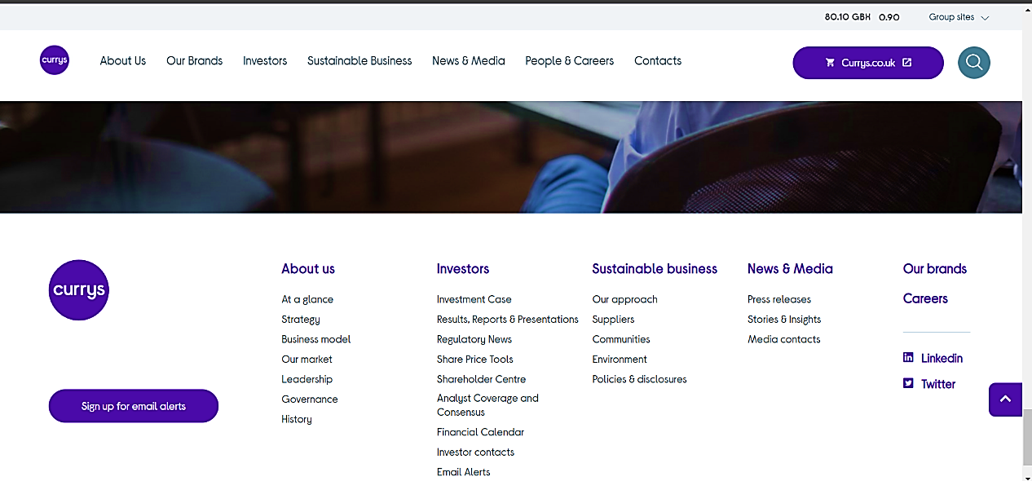
as well. The Currys Plc’s website delivers information on brand, products, latest news as well as career details. The SEO (Search Engine Optimization) is the key aspect of digital marketing and the online presence of the Currys PLC is primarily done by its website Since the majority of the trading is taken place through online orders the website plays a vital role in Currys PLC.

Figure 2 :Website Currys PLC

SEO can be defined as a process of improving the company’s website in a way of ranks higher in search engine among the results for specific keywords and phrases related to the business (Grappone & Couzin, 2011). The Curry’s key competitors being XPS Pensions Group (XPS), Halfords Group (HFD), Redde Northgate (REDD), Mitie Group (MTO), Baltic Classifieds Group (BCG)a s well as Learning Technologies Group (LTG) are among the top search results for the key works related to the computer and electronic retail industry.
Customer Account Creation
In further to the above information facility provided with website, the worldwide customers are facilitated to create their own account and get fulfilled all their requirements with Currys PLC with minor effort. Accordingly, this account enables customers with all the delivery and return information, Payment options , and mainly the customers can track their orders as well. The Currys PLC offers special payment options subject to the different credit limits for the customers who hold Currys accounts. Below illustrated the Account creation interface of Currys PLC.

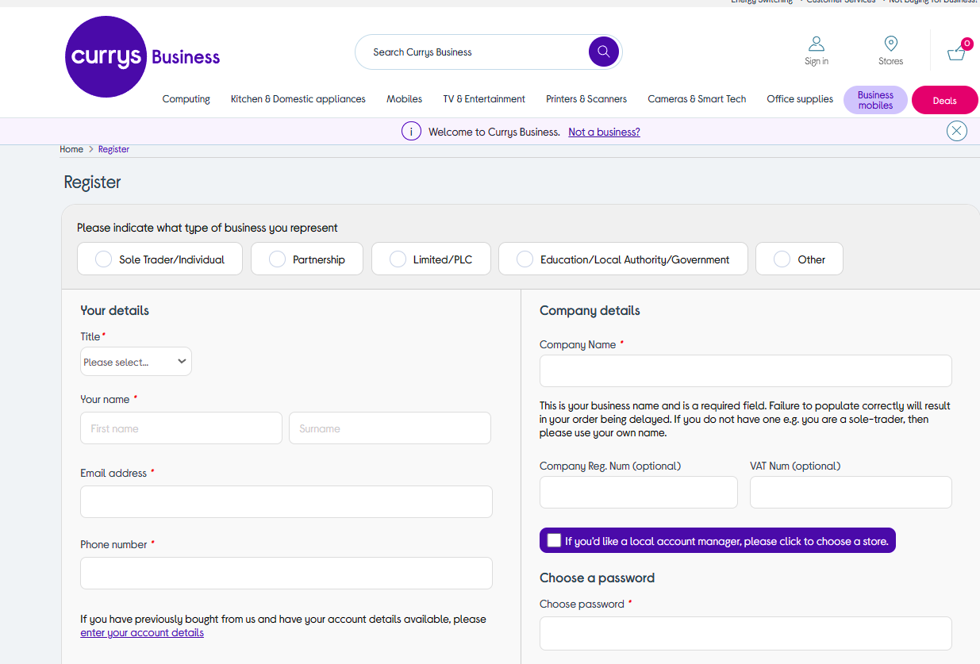
Figure 3: Customer Accounts registration interface
Further Currys PLC captures the purchasing patterns of the customers in respect to the changes in their preferences timely. This purchasing behavior will use for the potential targeting and segmenting purposes and formulating the respective marketing strategies as well. The certain marketing KPIs such as speed of changing customer preferences, income, customer loyalty as well as churn ration would further supportive with formulating and planning the potential marketing activities which are easily captured with this account.
Digital Business model of Currys PLC.
The business model of the Currys PLC focuses on make available their technology solutions to the everyone across the globe. As a result, the Currys PLC tend to expand it’s consumer market share mainly through the E-commerce website. The E -commerce website enable customers to choose right product with the experts’ advices . The Omnichannel model of the Currys PLC facilitates the customers with purchase the products online, Instore , Place the order online and pick up the order physically instore as well as with the Shoplive feature of the Currys PLC website.
Use of Digital data
The Omnichannel model and the digital infrastructure of the Currys PLC combination is committed delivering the personalized shopping experience to the customers. With the recurring transformations followed customer preferences, it is essential to have a updated digital data bank of each customer segment. The customer accounts are the direct base of data which enable Currys PLC to align it’s operational and marketing function with the purchasing behaviors of customers. Further having such digital customer data base connect distinct customer behaviors across digital channels as well. This will speed up the customer journey with the Currys PLC. In the increased digitized markets, the Currys PLC online touchpoints to link with customers and deliver the real-time customer experience. The adherence of the GDPR is timely assess in respective to the Currys’ digital data base as the violence of the data privacy breach leads to the heavy legal implications potentially.
Use of E-CRM as a part of digital marketing startergy
E- CRM (electronic customer relationship management) refers to the approach of CRM via the digital technologies such as , emails, websites, chatbots and all other digital channels that the Currys PLC use to reach foe the target audience. The Currys PLC maintains a well-structured collaborative CRM approach mainly via the live shop , chat bots and the customer accounts. The inquiries , search histories and the previous purchasing behaviors and payment histories are automatedly captured by the marketing team. As discussed in the account creation and the inquiries, the distinct customer preferences are tracked and store for enhance the customer experience
Content marketing
Content Marketing refers to the creation and publishing the digital contents with the objective of the improve the SEO ranking, enhancing the brand awareness of the Currys products and services as well as increase the brand visibility with the high target audience interest (Baltes, 2015). Since Currys PLC is mainly operating on online platforms across 8 countries, this is the most viable way of reaching to the target market as the foreign customers are who given less chances to physically check the product prior to the purchase.

Under content marketing, Currys PLC shares its presence under multiple forms including Video, blogging, podcasts, Info-graphics and email, etc., Since Content is considered as a highly versatile option.
Figure 4: Content Marketing
Despite it all, the content marketing being a key digital marketing strategy is to increase traffic and generate conversions. From a technical perspective, content marketing also attentive on optimize the content for search engines to enhance the Currys PLC’s visibility in search results.

Social Media marketing
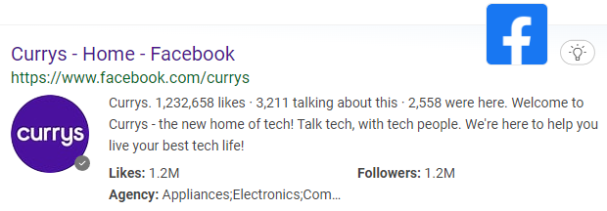
Social media platforms are used as a key digital marketing channel of Currys PLC. Social medial Ads are bought to reach out to an existing and new target audience. Face book is the Curry’s main social media platform with the 1.2 Mn of followers worldwide.
Figure 5: Face book - Currys PLC
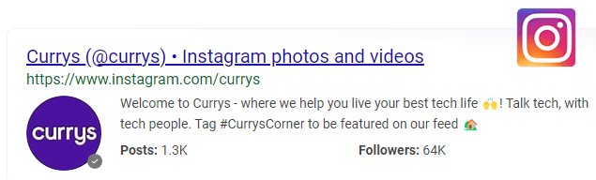

Figure 6 : Instagram -Curry PLC
Currys PLC’s social media policy and the digital startergy aims on increasing the brand awareness and increase in trading as the Currys’s social media platform is embedded to the E-commerce site.
Currys PLC is given with the three avenues to engage with the target audience through the social media.
Network targeting: direct advertising campaign can be carried out towards Currys PLC’s consumers with specifically designed advertisements based on their preferences shown in social networks
Social advertising: Based on the customer interest displaying in the Facebook and other social media, the Currys PLC formulate distinct social media marketing strategies to the target customer segments.
Viral marketing: known as peer-to-peer marketing in which the current customer is actively contributed with the spreading the brand awareness through word of mouth. Another form of viral marketing is shared through creating visual or video and sharing them across social media platforms. Through this the Currys PLC expects to get increased a business’s reputation, make share , customer engagement sales, and brand awareness.
Accordingly , out of the existing digital tools of the Currys PLC, contribution of the social media channel is significance .
Mobile marketing
Mobile marketing is reach to the existing and potential target audience through the mobile via mobile specific tasks (Tong, et al., 2020). Such as texting, social massaging apps and in app advertising. The Currys PLC is executing the mobile marketing by targeting the younger audience.
New launches of new products, flexible payment plans as well as price changes are shared with the customers through mobile marketing. Further weekly credit card offers , discounts are communicated with the target audience as it is the most direct and the viable way of reaching the target customer base.
E- Mail Marketing
Email marketing refers to a personalized way of reaching to the target customers. When customer visits to the Currys PLC’s website or business outlet, Currys PLC invite them to join to the email subscriber list. With their consent, Currys PLC sending emails to the distinct target audience about sales, special offers, special events, and new product releases as well . E mail marketing make customers to feel as they are given the high recognition and prestige . This leads Currys PLC to expose for large count of loyal customer base with cost effective manner.

1.4 Importance of digital marketing on the Currys PLC
Application of the effective digital marketing tools and techniques derive many potentials to the company. Internet driven customer base has been increased over the years for the Currys PLC and it has enhanced its digital presence and expanded the digital channels accordingly to achieve the below specified objectives.
Competitive advantage
Since the technological disrupts highly impacting on the industry , the consumer behavior is subject to change parallel with the dynamic market conditions (Agung & Darma, 2019). The Curry PLC is currently in physical presence across 840+ stores (Currys, 2022). The digital channels enable the Curry PLC to go live across many counties at a lower promotional cos t. The high brand visibility and the customer awareness derive competitive advantage on the Curry products as it’s functioning in the retail industry (Bruce, et al., 2009).
Improved brand metrics
The use of correct digital channels to address the distinct market segments, brand awareness and high brand image are the possible branding metrics for Currys PLC and this enable to beat the competition as well as to create significant influence on the customers’ s purchasing decision (Leeflang, et al., 2014).
Deliver enhanced customer experience
Greater customer experience will make customers to consider the repetitive purchases with Currys PLC. The well-defined and effective marketing startergy links with the both pre and post buying behavior of the Currys PLC’s existing and potential customers.

More opportunities for growth
With digital marketing, retailers are given more opportunities for growth than ever before. Such companies can now get leads that are not bound by proximity. This helps with reducing the unnecessary marketing cost as well.
High conversion.
Right digital marketing startergy enable Currys PLC to reach the prospects in the correct time at the right way digitally. Direct interactions between the customers also cause with their perching decisions with Currys PLC as well.
1.5 Digital impact on the marketing mix of the Currys PLC
Marketing mix
The marketing mix is defined as the set of marketing tools and combined set of marketing components that are supported with selling out the product or service (Borden, 1964). Simply the marketing mix illustrates the right positioning of the product/service , evaluating and deciding the right place to sell and the viable price as well as the right time to execute the sale (Waterschoot & Bulte, 1992). The product will be sold in adherence to the marketing startergy. The main components of the marketing mix 4Ps is Product, Price, Place, and Promotion. With the digitization and the latest technology, the marketing mix is highly impacted with the digitalization and the customers preferences on marketing mix is already changed accordingly (Jackson & Ahuja, 2016).
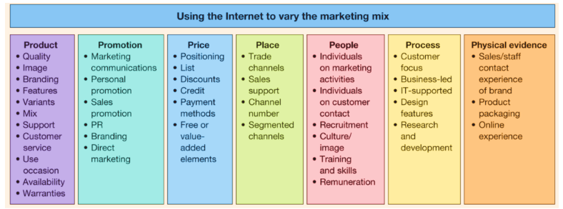
Figure 7: Digital marketing Mix - 7 Ps
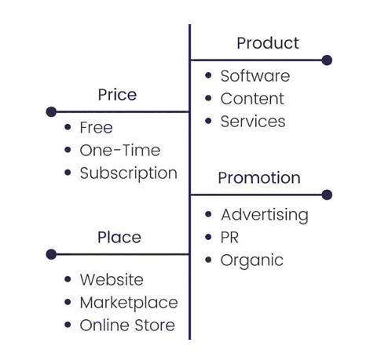
Since the Currys PLC’s sales are mainly made through the online platforms , the marketing mix has upgraded with the modern digital features and technologies. In order to formulate most effective online digital marketing startergy, the comprehensive understanding is essential on how the marketing mix components connects with the digitalization. Further the marketers should ensure the responsiveness of the business model to the digital marketing mix as well. Below illustrated the basic 4ps of online digital marketing mix.

Figure 8:Digital Marketing Mix - 4 PS

Product
The product’s, features, purpose and flow of innovations influence the rest of the components of the digital marketing mix (Singh, 2012) . The Curry PLC is being a proud partner across world’s largest innovative technological brands of electronic devices such as foldable mobile phones, food preservation refrigerators, cloud gaming technology, smart security options , laptops as well as TV. When creating a digital marketing platform, it should be consider all the aspects that potentially help to deliver the expected quality of the product and optimize the customer value by delivering the right product. The key approach that the Curry PLC follows to redefine the innovative new products and business model to the digital platform is video stream. Via this the customers get a chance to review the features of the product and physical experience prior to the purchase has changes in to the completely digital experience.
Price
Price in digital marketing mix represent the cost of the product the customer is supposed to pay (Londhe, 2014). Customers’ perceived value of the product and the lead time for the product delivery after the customer place an order via digital platform are the key determinant of the digital pricing startergy. The Currys plc is considering on Incorporating the digital analytical tools such as machine learning to the digital marketing platform in order to der derive the most accurate market value of the product as such tool derive the best par price by analyzing dynamic market conditions and the competitor’s pricing startergy .

Place
Place in the online marketing refers to the channels of distributing the products. Goal of the place aspect of the marketing mix is the convenience of the customers (Talpau, 2014). The Currys PLC has global presence across 8 countries and continuously fulfilling the electronic retail needs of the global customers. Accordingly, Currys PLC is chosen Omnichannel startergy for its technology and retail services.
Promotion.
Promotion of the digital marketing mix refers to the combined use of of online marketing tools to reach your target audiences. The digital promotional mix is determined by the nature of the product, market share, location and technology. Below outlined the digital promotional mix in place in the Currys PLC
- Search Engine Optimization (SEO)
- Content Marketing
- Search Engine Marketing (Google, Bing)
- YouTube
- Social Media Advertising
- LinkedIn
- Facebook
- Email Marketing

1.6 Impact of digital marketing on the consumer behavior
Consumer behavior refers to the pattern that the consumers are displaying in terms of searching, evaluating, purchasing, consuming and disposing the products in a way of satisfying their needs. The digital marketing plays vital role in relation to the customer’s purchasing behavior as it directly impacting in the mindset of the customer with the internal (money, time & efforts ) and external stimulus (Ramesh & Vidhya, 2019).
With the digital marketing tools , marketing department of the Currys PLC induce on the consumer behavior in terms of price, place , product and promotions. In the phase of customer is searching for a product , digital marketing supports to customer with evaluating their needs, providing comparative information of the competitive products. After the purchasing decision, the digital marketing create vast influence on the repetitive purchasing decisions as well.

1.7 The Changing Landscape of Digital Marketing in Retail Industry
Current trends.
In the computer and electronic retail industry is going through continuous changes due to dynamic technological advances as well as due to the dynamic customer preferences resulted of changing market conditions. Below identified the current trends of the consumer retail industry that the Currys PLC is in operating.
Due to the busy life styles of the customers there is a growing tendency for the e commerce platforms over physical stores. The omnichannel model is more attractive with the customers as it offers less face to face engagements. The majority of the leading retailer brands are adopting with automated marketing solutions to support complex customer journeys across multiple devices.
Consumers purchasing patterns are influenced drastically with the adverse monitory conditions such as inflation and as a result, customers are tend to go for thrifting and second-hand devices across the digital platform. This has made a significant impact on the reduction of the sales for the Currys PLC.

Future trends
Omni Channel retail method tend to grow and currently the competitive companies in the electronic retail market is exploring the avenues for create personalized shopping experience with the features of order by text service, product suggestions and sending timely reminders to the customers.
Further the Augment reality technology is expected to arrive to the digital marketing platforms, in which the customers are given the opportunity to virtually see the electronic device they are planning to purchase.
As a result of Artificial intelligence and Augmented reality rolling out, the in-person experience is expected to give more space in the retail industry. The customers will become more powerful and the brands required to ensure human interactions are genuine and rooted with empathy.

Proposed KPIs in digital marketing for Currys PLC
KPI in digital marketing is used for evaluated the company’s performance in digital arena , across all the digital channels of the company (Saura, et al., 2017). The primary objective of formulating the digital KPI is to monitor the digital presence of the marketing channels and their contribution towards the achieving corporate objectives of the company. Since the technologies and digital process are evolving constantly, Accordingly KPI framework requires to update in order to derive the clear image of the digital performance of the marketing channel. Below outlined the KPI measures in place in the Currys to monitor and control the behavior and enable to grow as a market leader.
- Session & average session duration of customers on Curry’s social media pages
- Number of followers for each social media platform.
- Social media engagement
- Website traffic- Number of followers visiting to the website
- Channel Mix
- Social media mentions
- Viral Coefficient
- Net Promotor score (NPS)- Frequency of referring the products by customers.

Balance between internal and external communication structure.
Success of the businesses relied on the effective communication as it increases the productivity and improve the compliance in the industry, attract and retain the customer base as a key part of the marketing startergy. The digital exposure has enhanced the quality of the internal and external communication with the range of stakeholders rather than shareholders and customers.
When the businesses are maintained solid internal communication startergy in place, the health employment engagement accelerate the company to ultimate objectives. Since the Curry PLC currently owns 33,000+ employees across the 8 countries the digital platform of the Currys PLC should ensure all the employees are interconnected to make effective and fast decisions, to transfer confidential documents as well as on building up in a balanced team to optimize the contribution of the staff. Further the limited access to the digital communication tools to the staff will ensure the confidential information of the Currys PLC not outflow in unauthorized manner. Having Artificial Intelligence features embedded to the internal digital communication platform and customized mobiles apps will reduce the time of circulating a massage and improves the speedy decision-making ability by preventing waiting times from the superior’s approvals. The internal communication directly links with the digital marketing mix, the quality and the features of the products, R & D activities and manufacturing function is a highly linked with the internal staff engagement. To make the effective and competitive pricing strategies, the speed of the logistic, the lead time of the delivery and the collective effort of the marketing team on the promotional campaign of the Curry PLC is determined by the internal communication process. The accuracy, speed, completeness of the the outcomes have been enhanced with the collective engagement through the digital platform. The digital marketing tools are considered as the external communication structure. The quality of the digital marketing tools is determined by the internal communication function and the results.
For the internal communication with the staff and the investors, the Currys Plc is introduced internal platform where all the outlets, operational divisions, and all the staffs are interconnected across the globe. For the seamless communication and the fast decisions makings in order to enhance the speed of the oper5ation, this platform play a major role. Further the main decisions, policies and procedures are communicated through a very standard manner, mainly in a staffcom emails as well. Further the timely staff meetings and general meetings ensure the all the staff are aware of the ongoing issues and recent cooperate news of the Currys PLC. The internal communication channels are highly monitored in order to ensure the adherence to the GDPR .
External communication is done mainly through the digital assets which discussed above.

2. Machine Learning and Artificial intelligence on Digital marketing

What is machine learning
Machine learning is a key aspect of artificial intelligence (AI) as well as a prime segment of the computer science which is attentive on using algorithms and data to imitate the human behavior on learning (Mitchell, et al., 1990). Simply it enables computers to learn from the prior experiences by using computational approach. The algorithms paly crucial role of adaptively increasing the performance as they are trained to perform classifications, predictions as well as to discover the insights in data mining activities. Such insights are eventually led key business decisions and competitive moves as well.

Impact of the machine learning on the digital marketing
Machine learning derive many positive opportunities in marketing. Artificial intelligence and the application of machine learning has become a latest tread of the digital marketing arena. Embedded this machine learning application in to the marketing startergy of the companies are enable with personalization the marketing approach, big data management as well as delivering maximum customer experience (Ullal, et al., 2011).
Machine learning get the access to the larger set of big data and the insight analysis of such data provides the companies to find the patterns in customer activities and behavior in websites and other digital channel. This provides greater opportunities for marketing team as below discussed.
I) Personalization and client recommendation
With the previous preferences of the customer , the machine learning identifies the user and suggests the search options in digital platforms, especially in the web sites. Personalized recommendations enable businesses to distinctly identify the customer segments based on their preferences. From the customer perspective personalized recommendation enhances the customer loyalty as they feel they are recognized by the company.
ii) Accurate market prediction.
With the distinguished market segmentation, the data collection is too much to manually analyze. The machine learning collects such segment data , gain the insight understanding of the customer patterns and make the clear future predictions based on such previous patterns. This provides greater support with formulating digital marketing strategies for each identified segment, subject to the distinct customer behavioral patterns and preferences. Furthermore, such accurate strategic decision ensures the business is in line with the market changes.

iii) Automation of marketing process.
Machine learning is embedded to marketing function to minimize the human intervention by automating the processes such as repetitive marketing campaigns. As the machine learning separately identifies the customer behavior patterns with the respective market segment, and automation addresses the dynamic patterns by timely changing the marketing campaign.
iv) Dynamic Product and Service Pricing
The pricing is the crucial aspect of the marketing function. With the dynamic marketing conditions, the market prices are subject to change. The machine learning analyzes the dynamic marketing conditions as well as the competitors’ prices for the identical products, assigns par price for the company’s products and services accurately.
v) Ad Fraud detection
Ad frauds are the results of the robbing attempts of the digital advertising efforts by the criminals. Digital ad fraud detection is a complicated process attached with analyzing huge data set from several sources. Accordingly, machine learning system simultaneously investigate and compare data by seeking ad engagement trends as well as ad timing trends etc. . Once the machine learning detects the ad fraud , it will block automatically form company’s digital marketing platforms.
vi) Enhanced and productive customer service.
Machine learning directly lines with the customer data and delivers faster and responsive service to the customers 24/7. With the chatbot option given under the machine learning, the customer life style has been streamlined with the quick responses with zero wait time. Furthermore, chatbots allow any time to convert the live chat in to the human intervention by transferring the call to the customer agent.

Application of Machine learning for digital marketing
Machine learning tool enable marketing team to focus on their core activities rather than data analysis. The application of machine learning on digital marketing lead to expand the understanding of target audience by optimizing the customer interaction which leads to higher customer loyalty and brand awareness as well. Machine learning is possibly to use across all the digital marketing aspects. Including search engine optimization (SEO), social media marketing, email marketing and content marketing as well. Below outlined the examples for the application of gather Artificial intelligence & machine learning in digital marketing startergy (Miklosik, et al., 2019 ).
Content marketing
The latest trend of the marketing is creating contents on the products and the services to engage with the targeted market segment with the customer tesmonial videos, informative blog posts, recorded webinars etc. The machine learning tool uncover the market data and track the customer trends timely . This ensure the company’s capability of reaching more leads with the contents that are audience relevance the ability of trigger the customer response quickly.
Pay per click campaign
To measure the customer interactions with the digital platforms , pay per click (PPC) campaigns are initiate. The machine learning tools enables to make effective digital marketing strategies by considering the top performance drivers.
Search engine optimization (SEO)
SEO is considered as a key aspect of any well-designed digital marketing startergy, across major search platforms the SEO algorithms are tend to change and thanks to the AI & Machine learning the searchable contents can make more relevant and easily visible compared to searching by the key word. Machine learning ensures web pages and other digital channels are maintained their ranks at top on search engines. The machine learning previous searching contents of the users will be stored for the future reference.
Content management
To maintain high brand awareness and enhanced customer engagement, the digital marketing team requires to maintain close and effective relationship with customers, prospects as well as leads. In order to optimize the digital presence across multiple digital platforms and channel, the machine learning is immensely supports with analyzing data content of distinct target audiences of the company.
Chatbots
Chatbots can be defined as a virtual robot that engage with interacting with the customers via voice commands, texts or both. Many companies have already embedded the live chatbots in to the digital marketing startergy to facilitate for the quick inquiries of the customers. Further chatbots are already incorporated to the social media platforms as well in order to enhance the brand visibility as a part of the marketing startergy.

Consumer decisions and machine learning
The impact of the machine learning in digital marketing strategies are directly and significantly impacting in the consumer behavior as well as the purchasing decision. The consumer’s purchasing decision process entails the stages consumer undergo prior, during as well as post behaviors’ upon making the purchase.
Recognition the need: identification of the actual need of the product is most crucial task.
Research :Once the customer is recognized his need for the required product, he seeks for an information across many search engines , prices, features etc.
Comparison, evaluation and purchase :by considering the multiple digital platform and channels the customer choose the most viable option available for his need.
Post evaluation :evaluation of the customer on the features and the quality of the product. This is the key determinate which impact on the repetitive purchasing decisions.
Throughout this entire customer decision process machine learning plays vital role. When the customer is searching the product for the first time, the search engine results are highly prioritizing on the purchasing decision. During the phase of comparison. the personalization and recommendation aspect of the machine learning would support with categorizing the new customer to the e existing market segments. Since the customer is seeking comprehensive knowledge on the product, the machine learning would facilitate the customer with sending personalized e mails with required information after analyzing the customer’s searching patterns. E commers sites mainly prioritizing and promoting the recommendation aspect of the machine learning to convince that the customers are one click away from the most quality product at a lower price.

3.Conclusion
The digitization has created a vast impact on the businesses and the consumer behavior. This resulted marketing function expanded across digital arena. Digital marketing model of the business expects to accomplish enhanced loyal customers with expanded brand visibility . Compared to the conventional marketing models, digital marketing aspect has streamlined consumer live styles while offering greater potentials for the brand as well as the overall business in the areas of branding, relevant advertising, completeness, community connections as well as interactivity. This study depicts the role of the digital marketing in the electronic and computer retail industry, in terms of the Currys PLC as it being the pioneer brand among the innovative electronic giants across the globe. Strategic application of the digital marketing tools is more crucial as such tools are delivering distinct results over the business. Further, objectives of digital marketing application in the companies in retail Industry is vary with the nature of the products and their corporate goals and vision. Formulating effective KPIs ensure the digital marketing behavior drives the business to the expected goals and competitive edge. Further, Machine learning has become a latest aspect of the AI (Artificial intelligence) and derive personalized marketing experience to the customers by evaluation the past consumer behaviors. Machine learning as a part of digital marketing startergy expect to deliver a prestige marketing experience to the customer in order to reach the competitive edge of the industry.

References
Agung, N. F. & Darma, G. S., 2019. Opportunities and challenges of Instagram algorithm in improving competitive advantage. International Journal of Innovative Science and Research Technology, 4(1), pp. 743-747.
Bala, M. & Verma, D., 2018. A critical review of digital marketing.. A Critical Review of Digital Marketing. International Journal of Management, IT & Engineering, 8(10), pp. 321-339.
Baltes, L. P., 2015. Content marketing-the fundamental tool of digital marketing.. Bulletin of the Transilvania University of Brasov. Economic Sciences. Series V,, 8(2), pp. 110-124.
Borden, H. N., 1964. The concept of the marketing mix. Journal of advertising research, 4(2), pp. 2-7.
Bruce, L., Bondy, K. & Street, R., 2009. Channel evolution: How new multichannel thinking can deliver competitive advantage.. Journal of Direct, Data and Digital Marketing Practice, 10(4), pp. 329-335.
Currys, 2022. Currys. [Online].
Desai, V., 2019. Digital marketing. International Journal of Trend in Scientific Research and Development,, 5(5), pp. 196-200.
Grappone, J. & Couzin, G., 2011. Search Engine Optimization. s.l.:John Wiley & Sons.
Jackson, G. & Ahuja, V., 2016. Dawn of the digital age and the evolution of the marketing mix.. Journal of Direct, Data and Digital Marketing Practice, 17(3), pp. 170-186.
Kannan, P. K., 2017. Digital marketing: A framework, review and research agenda.. International journal of research in marketing,, 34(1), pp. 22-45.
Leeflang, P. S., Verhoef, P. C., Dahlström, P. & Freundt, T., 2014. Challenges and solutions for marketing in a digital era. European management journal, 32(1), pp. 1-12..
Londhe, B. R., 2014. Marketing mix for next generation marketing. Procedia Economics and Finance, 4(1), pp. 335-340.
Miklosik, A., Kuchta, M. & Evans, N., 2019 . Towards the adoption of machine learning-based analytical tools in digital marketing.. 5(3), pp. 11-30.
Mitchell, T., Buchanan, B. & DeJong, G., 1990. Machine learning.. Annual review of computer science, 4(1), pp. 417-433.
Morris, N., 2009. Understanding digital marketing: marketing strategies for engaging the digital generation.. 3(4), pp. 21-40.
Peterson, R. A., Balasubramanian, S. & Bronnenberg, B. J., 1997. Exploring the implications of the Internet for consumer marketing.. Journal of the Academy of Marketing science, 25(4), pp. 329-346.
Ramesh, B. & Vidhya, B., 2019. Digital marketing and its effect on online consumer buying behavior.. Journal of Services Research,, 19(2), pp. 61-77..
Saura, J. R., Sánchez, P. & Cerdá Suárez,, L. M., 2017. Understanding the digital marketing environment with KPIs and web analytic. 9(4), p. 76.
Singh, M., 2012. Marketing mix of 4P’s for competitive advantage. IOSR Journal of Business and Management, , 3(6), pp. 40-45.
Talpau, A., 2014. The marketing mix in the online environment. Bulletin of the Transilvania University of Brasov. Economic Sciences, 7(2), p. 53.
Tong, S., Luo, X. & Xu, B., 2020. Personalized mobile marketing strategies. Journal of the Academy of Marketing Science,, 48(1), pp. 64-78.
Ullal, M. S., Hawaldar, I. T. & Hawaldar, M., 2011. The role of machine learning in digital marketing. 4(11).
Wang, H., Lee, M. K. & Wang, C., 1998. Consumer privacy concerns about Internet marketing. Communications of the ACM,, 41(3), pp. 63-70.
Waterschoot, W. V. & Bulte, C., 1992. The 4P classification of the marketing mix revisited.. Journal of marketing, 56(4), pp. 83-93.
Yasmin, A., Tasneem, S. & Fatema, K., 2015. Effectiveness of digital marketing in the challenging age. International journal of management science and business administration, 1(5), pp. 69-80.

