Report on Personal Career Development
University of Wales Trinity Saint David
Code of the Module: BMSW4005
Lecture:Anita Nan
Student:Martin Naydenov 2022271

Table of Content
1.Introduction……
2.Job Interview……
3.Reflection of the learned from the University ….
4.Role Play….
5.Self Motivation ……
6.Learning Style……
7.Swot Analysis……
8.Conclusion…..
9.Appendix….
10.References……

Introduction

This report is assignment for my University, for the Personal Career Development.It will contain different topics,related to my personal skills,what learner I am to how I can improve my skills gap.It will contain and my personal reflection on the role play,and my career development plan.This module helped me to understand,which type of learner I am,how to improve my skills,develop my career,how better to introduce myself on job interview and so on.In this report I will discuss and about the self-motivation,what my employer expect from me like a worker.
After we graduated,we try to have a successful career.We have to know how to develop our career.To make that possible we need to have the right skills,to improve our knowledges and gap skills,to be highly motivated.So that report will clearly explain what are the steps for successful career.

Job Interview
A job interview is a method of determining if a job candidate possesses the requisite knowledge, skills, and abilities to perform the job. It may also be used to determine whether the candidate and the company are culturally and value-wise compatible. In this session, we'll go over some of the many sorts of interviews that companies use to find the right person for the job.
It have a serval types of interviews.
Initial interview, unstructured interview, structured interview and Etc.
Personally I prefer an unstructured interview,which is an informal, non-standardized interviews. The interview method and questions will vary from one candidate to the next. This isn't a good sort of interview since it doesn't provide you a fair comparison of job candidates because each one is asked different questions, in different orders, and in different ways.
The job interview was one of the main subject,which was mentioned at my University.

Reflection of learned from the University
The employer expect from me a good customer service skills!Customers have to be always happy from the service,to come back again!
To manage my time!I have to be always on time,because our manager have to be sure we are enough people for that shift and he can continue with him other stuffs,instead of helping us!
Teamwork is other essential requirement from the employer!In a restaurant if you are not a team co-worker, then is not possible to work properly!You have to understand with your colleagues,who which table will serve!
Work Safely!Is essential,when you work in restaurant.If the work is not safely,it can cause an accident!
I am able to provide the most requirements,but still working on the time management,as is still happen to be late one or two minutes sometime!
I understood and how exactly I can develop my career or ask my manager for rising the salary, or provide me a better work position.
Learned also how to act on a job interview or as manager.What is the employer looking in every candidate.How to make a good first impression.

Role Play
At the University we had a Role Play,which helped us to practice and show what new knowledges we had gained as employer and employee in a Job Interview.We prepared about that assignment in advance.First we learn how to create the best job application.What exactly we have to write to grab the attention of the employer.How is supposed to be structured the application and what mistakes usually make the applicants.After me and my colleagues create an Application form and we exchanged them and read.Based on that we made a 5 typical question for one job interview which usually the Manager ask.We were advised by our lecture what are the best question which we can ask and how we can better answer of them.After all of the practice we made that role play and based on the feedback we clearly understood what we done good and what we have to improve as employer and employee.
In my opinion that assignment was one of the most useful from all which I have done this year.It help to improve our presenting at Job interview, which for sure it will be helpful in our future career to find a better job and Etc.Also we learn how to talk as well.And as we practice like managers,we know how to make a interview,what we have to looking in every applicant what skills and knowledges, and how to understand if someone is laying on interview.
It is very important not to laying on interview, at some point the person is gonna be caught.
On the role play I learned also is important always to ask the employee a questions, which is showing that we are interested In the current position,and we didn’t apply just because we need a job.
On a job interview always the both sides have to be very positive and have a welcoming body language.
After the Role play I feel much more confident about going on interview.

Self motivation
Motivation drives us to attain our objectives, feel more satisfied, and enhance our overall quality of life.
Self-motivation may help you take charge of many other elements of your life if you understand and cultivate it.
One of the three categories of personal talents that make up emotional intelligence is motivation.
Self motivation is one of the most important things in our life!Is starting with the wake in the morning to go to sleep in the night,to can have a energy for the next day!Is it about how we can push our selfs,as it have a people,which prefer to be pushed!
There are some elements of self motivation.
You could think of a personal drive to achieve as ambition, or perhaps personal empowerment. However, it is also worth thinking about it in terms of mindset.
There are two types of mindset, fixed and growth.
Those with a fixed mindset believe that talent is ingrained, and that we cannot change our level of ability.
Those with a growth mindset believe that they can improve their skills through hard work and effort.
Research shows that those who believe that they can improve—that is, who have a growth mindset—are far more likely to achieve in whatever sphere they choose. A growth mindset is therefore an important element in a personal drive to succeed.
Even if most of it is anecdotal, there is substantial evidence that goal-setting is vital to our overall well-being.
Initiative is the capacity to seize chances when they present themselves.
It's all too easy to put off making a decision, and then the chance may pass you by. The classic adages "see before you leap" and "fools rush in where angels fear to tread" have a lot of truth. It's also crucial to think things through and make sure you're making the best option possible.
As a result, initiative might be defined as a mix of bravery and risk management:
Risk management is required to guarantee that you select the correct chances to explore and that they are risky enough for you; and courage is required to overcome the dread of the unknown that comes with new prospects.
Optimism is defined as the capacity to see the bright side of things or to think optimistically. The capacity to 'bounce back' after a setback or remain positive in the face of adversity is referred to as resilience. Both are closely related, yet they are not identical.
That were the elements of the self motivation p,
Personally i am motivated by couple of stuffs!Some of them are,my wish for enjoying the life,taking always the maximum of every single day,so i know i did a lot of stuffs,and i was productive!Other motivation for me are the money,and one my biggest motivations is actually to know i have booked trip to some other country as that is my hobby!I can work even a 60 hours per week and study at the same time,if i know in 2-3 months i will go to some new place,where i will explore a new culture,or do something interesting!I am and motivated even from small stuffs like if i wake up now i will have more time to drink a coffee and smoke a cigarette!
Learning style
It have 3 learning styles,which help to understand how easier and faster we can learn,which is very useful for starting at new workplace!
I am a person who learn very fast,but when i don’t have training,instead of that i start to work immediately and with the practice i know already how to do everything!From long time i know my 2 methods of learning!The other is to listen!Only if i learn visual i cannot learn fast!So i am a Kinaesthetic learner,and an auditory!A good example from my own experience is,at my previous job i learn everything for 2 days,just because they didn’t provide a long training,instead of that i start immediately to work!And in a other workplace it took me over a week to learn the menu,and all of the stuffs,cause they didn’t allow me to work until i don’t know everything!

Swot Analysis
A SWOT analysis is a technique for evaluating these four areas of your business. SWOT stands for Strengths, Weaknesses, Opportunities, and Threats.
SWOT Analysis is a basic tool that can assist you in analysing what your organisation does best right now and developing a successful future strategy. SWOT analysis can also uncover company areas that are holding you back or that your competitors could exploit if you don't defend yourself.
We look at how to conduct a SWOT analysis and how to put your findings into action in this article, video, and infographic. We've also included a worked example and a template to get you started on your own SWOT analysis.
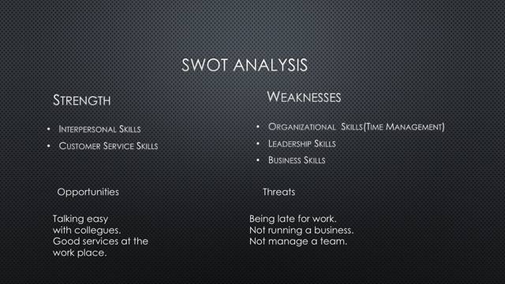
That is short introduction what is a SWOT analysis.Based on that I did my own Swot Analysis,which help me to improve myself and to meet the requirements of my employer.

That is my SWOT Analysis.In the last months I focused mostly to improve my Time Management, I am always late, also working 6days in a week and studying any spare minute,cause of well organized time is worth.I learned more about the Time Management at the University.

Conclusion.
As a conclusion I can say one of the most important things for successful career is the first impression.Always to start a new job, the first step is to go on Job Interview.When a person is a good prepared, the application form and the Cv is well structured and know how to talk always can take the attention and even have the job even without an experience.
It is also important and to know what are our strengths and weaknesses so we can improve them and become a better position at the Workplace or rise our income.But to be all that possible first we have to work about our Self Motivation.We have to think about what is the think which motivate me mostly.Then why that is important.Even one simple I have to stand from the bad so I can go to work and earn money is a Self Motivation or I need to not be late for work so I will keep my job and after the probation I will earn more money.
The University helped me a lot to learn more exactly about all that things.For example with the Role Play, which we have done I am much more prepared for a Job interview and how to make the perfect CV. As well when learned and made a Swot Analysis, I found my strength and weakness.I learned also at class what type of learner I am so I know how easier I can study or do some training at work.I am very satisfied with my decision to study that course, all of the Skills and Knowledges which I gained, so I can’t wait to start the second year at the University.

Appendix.

1.Application form:
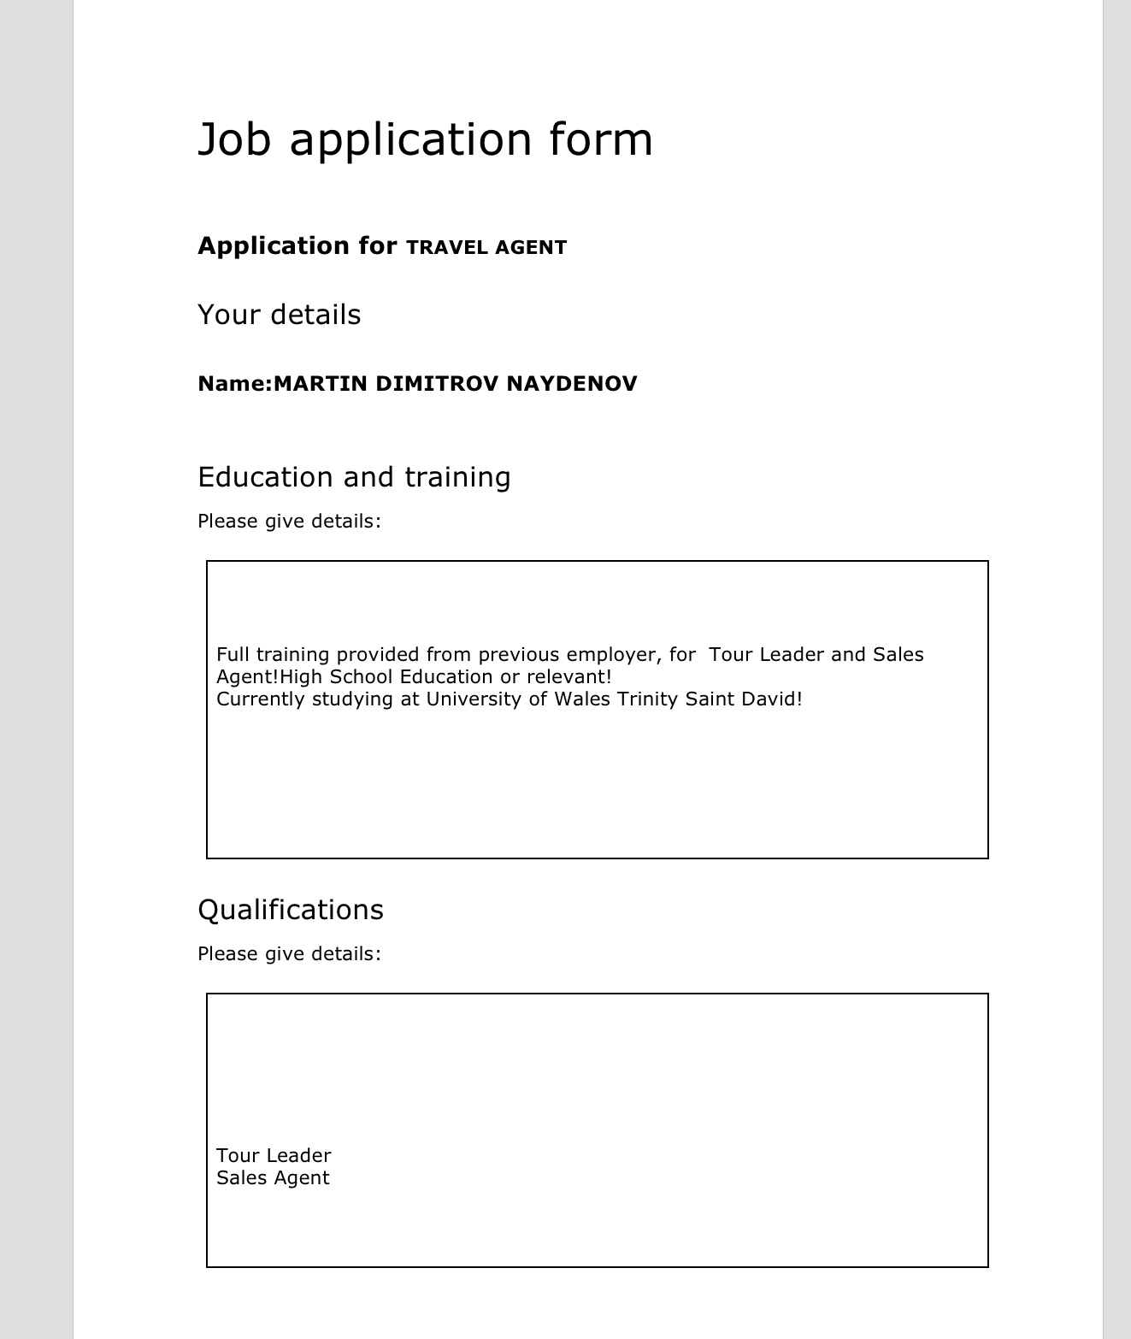
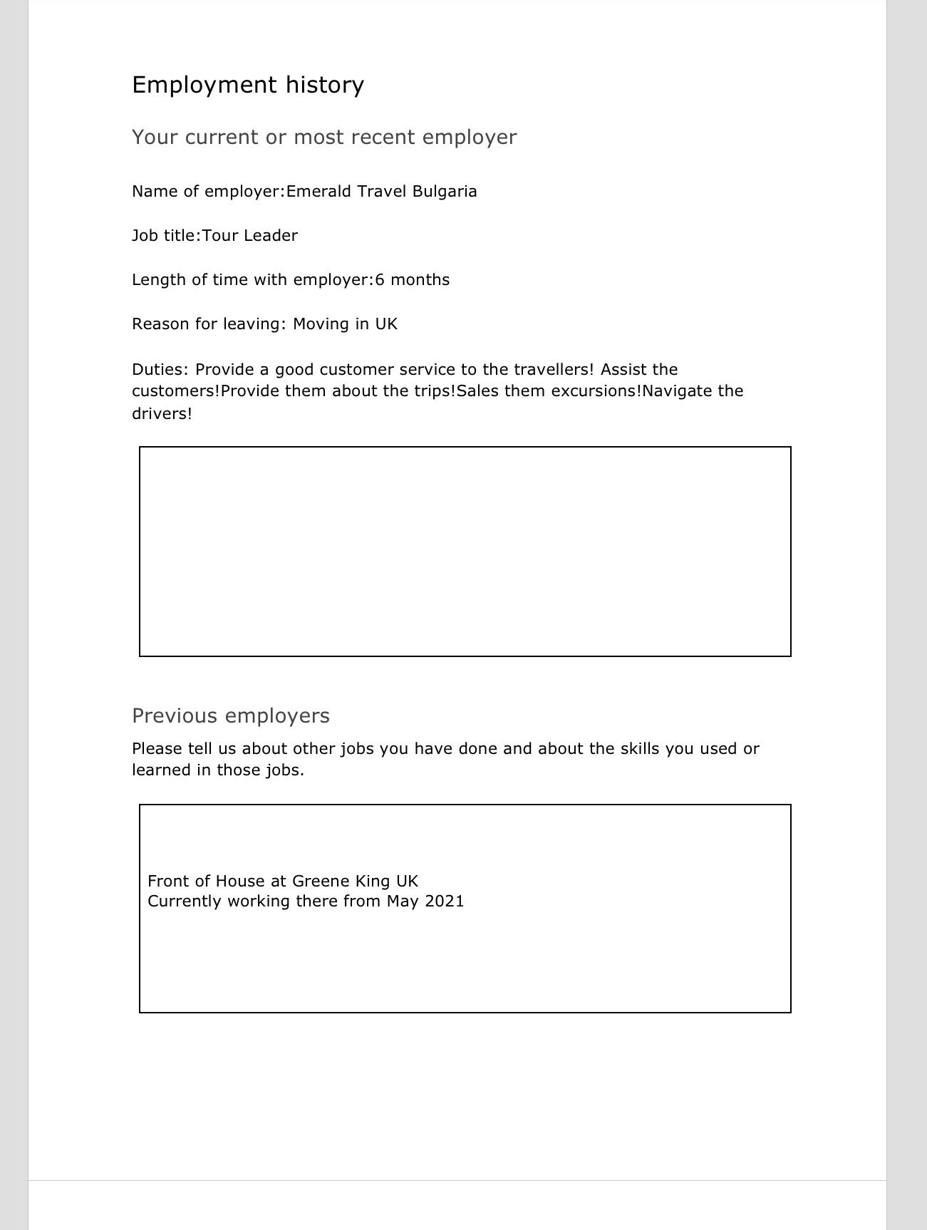

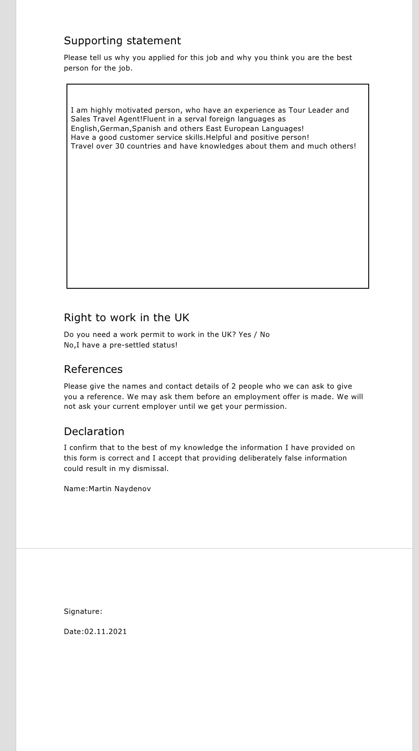
2.Appendix:Questions
Tell me more about yourself?
Why do you want to work at that position?
Why we should hire you?
What do you think about working in a team?
Where do you see yourself in 5 years?

References:

1. | SWOT Analysis: Strengths, Weaknesses, Opportunities, Threats
 | Mindtools.com
https://www.mindtools.com/pages/article/newTMC_05.htm
[Accessed 20.10.2021]

2.
Self-Motivation | SkillsYouNeed
Skillsyouneed.com
https://www.skillsyouneed.com/ps/self-motivation.html
[Accessed 05.11.2021]

3. https://study.com/academy/lesson/job-interviews-types-common-questions-quiz.html
[Accessed 14.12.2021]

