Programming Report (ACCA4020)
Daniel Jones

Contents
Flowchart 3
Question 1 4
Question 2 5
Question 3 6
Question 4 8
Question 5 12
Question 6 17
Question 7 18

Flowchart
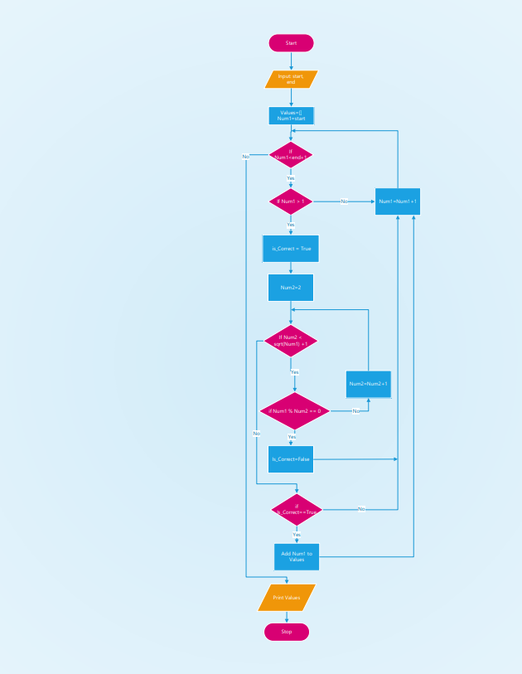

Question 1
1a. Describe the purpose of the flowchart. What problem or task is the flowchart designed to address?
The purpose of the above flowchart is to outline the steps of an algorithm that is used to identify and output a list of prime number values within a user-defined range. The algorithm is designed to check each number and determine which numbers are prime and which are not between a given start value inputted by the user and a given end value also inputted by the user.
The flowchart is useful to help visually display the step-by-step process of the algorithm, showing the logic behind the algorithm and providing the developer with a skeleton plan for the program. It helps layout the input and output values the program requires as well as each process. Additionally, it reveals the flow of the code in terms of the conditional if statements as well as the loops that are required to make the program work as intended.
By following a structured decision-making process, the algorithm is able to determine which numbers are valid prime numbers and therefore are able to store said numbers within a list which will eventually be printed at the end of the program once the range of numbers has been fully met.
1b. Identify the number of loops used in the flowchart and explain the role of each loop.
There are two main loops used within this flowchart to allow the algorithm to work properly. The two loops used in the flowchart were both labelled as conditional if statements that, depending on certain criteria, would loop back onto themselves.
The first of said loops is a while loop, “while Num1 < end + 1:” and it is used in the context of this algorithm to ensure that the program only determines prime numbers between the user-defined start value and the user-defined end value. Additionally, this loop is essential to this algorithm, as it prevents the logical error of the start value being higher than the end value, which would not make sense in the context of this program.
The second loop used within the algorithm is also a while loop, “while Num2 < math.sqrt(Num1) + 1:” and it is used to check if the Num1 value is divisible by any number other than 1 and itself. This loop's purpose is to perform a division test to determine whether the current number being checked, which in this case would be stored within the Num1 variable, is indeed a prime number.
By only checking up to the square root of the Num1 value, the algorithm improves efficiency, as any non-prime number will have at least one factor less than or equal to its square root. If a divisor is found within this loop, the number is marked as a non-prime by using the Is_Correct Boolean variable, and the loop breaks early.

Question 2
2a. Explain how the termination conditions of the inner loop affect the outer loop's processing. What happens when the inner loop exits early?
As mentioned in the previous question, the inner loop is responsible for determining whether or not the current number stored within the num1 variable is divisible by any number between 2 and the square root of itself. Its termination condition is met in two ways; one way is that if its upper limit is met, meaning the num2 variable is no longer bigger than “math.sqrt(Num1) + 1”.
The second way the termination condition is met is if a divisor is found for the current number; this would mean the current number is illegitimate as a prime number, and so the Boolean variable “Is_Correct” would be set to False and the inner loop would exit early due to the “break” keyword.
The “break” keyword used inside the inner loop is not essential for the program to work; however, it is good practice, as it improves the efficiency of the outer loop by avoiding unnecessary checks for numbers that have already been flagged up as non-prime.
2b. Identify the Boolean variable used in the flowchart, and what is the role of this Boolean variable?
The Boolean variable used in the flowchart and subsequently the program itself was the Is_Correct variable. The role of Is_Correct within the flowchart and the program is to track whether or not the current value within Num1 is a prime or non-prime number. Every time the program loops to a new value to check within Num1, the first thing that happens is the Is_Correct variable is set to true, which represents the value being a prime number.
If, however, the program finds a divisor other than the number 1 and the value itself, it will then set the Is_Correct variable to false, representing that the value within Num1 is indeed not a valid prime number and therefore should not be allowed to be added to the list of prime numbers within the program.
After the inner loop has been completed within the program, the algorithm will check if the Is_Correct variable is equal to “True”. If it is, then the value is added to an list of prime numbers; however, if it is not equal to “True”, then the value is not added to the list, and the program goes to the next value.

Question 3

3. Consider the following conditional statements used in the program:
- If Num1 > 1
- if Num1 % Num2 == 0
- if Is_Correct == True

3a. Explain the purpose of a conditional statement in programming.
A conditional statement in programming, as the name suggests, is used to make decisions within a program based on whether a specific condition is met or not. It allows the program to set certain criteria that, when met, execute specific blocks of code.
Conditional statements are essential for programming, as they allow programs to be dynamic to different inputs or situations. Common conditional statements include if, else, and elif, and they help programs perform tasks like validating input, making comparisons, and handling different cases or outcomes throughout a program.
Without conditional statements, programs would only be able to run in a straight line without any flexibility or intelligent decision-making. With conditionals, a program can choose between different actions, repeat certain steps only when necessary, or react differently depending on the values it processes.
As an example of how important conditional statements are, when writing the code for the generate_special_numbers program, conditional statements are used to check if a number is greater than 1 (since primes must be greater than 1) and to determine if a number is divisible by any smaller number. These decisions are crucial to ensure the correct numbers are identified as prime and stored. This shows how conditional logic is not only useful but also critical for making programs function properly and solve real-world problems.

3b. Explain each of the above three conditional statements and discuss how these conditional statements contribute to the final results of the program.
if Num1 > 1
The condition “if Num1 > 1” is used to check whether the current value within Num1 being tested is greater than the integer value of 1. The reason for this conditional statement is that prime numbers are defined as natural numbers greater than 1 that have no divisors other than 1 and themselves.
This condition helps to filter out numbers that are 1 or below, which, as defined above, would not be valid prime numbers, ensuring only valid candidates are tested. Without this check, the program might incorrectly evaluate numbers that are 1 or below as potential prime numbers, which would be inaccurate.
if Num1 % Num2 == 0
The condition “if Num1 % Num2 == 0” checks whether the value within the Num1 variable is divisible by the value within the Num2 variable without a remainder. If this condition is true, it means that Num1 has a divisor other than 1 and itself, which would disqualify it from being a prime number. When this condition is true, the program will set the Boolean variable Is_Correct to “False”, which represents that the current value is a non-prime. Additionally, the break keyword would trigger, which will exit the inner loop early, avoiding unnecessary further checks.
if Is_Correct == True
The condition “if Is_Correct == True” is used after all possible divisors have been checked and the inner loop has been completed to check if the current value within the Num1 variable is still a prime number or not.
By checking if Is_Correct == True, it validates the value before appending it to the list of prime numbers. If Is_Correct does equal true, then the value is prime and then subsequently is added to the list; however, if Is_Correct is equal to false, then the number is not added to the list and instead is just skipped.

Question 4
4a. Write a Python program named, generate_special_numbers that implements the logic described in the flowchart.
This Program should:
- Accept two inputs, start and end, which define the range of numbers to be processed.
- Implement the logic to filter numbers according to the criteria described in the flowchart
- Print a list of numbers that meet the criteria.

Screenshot
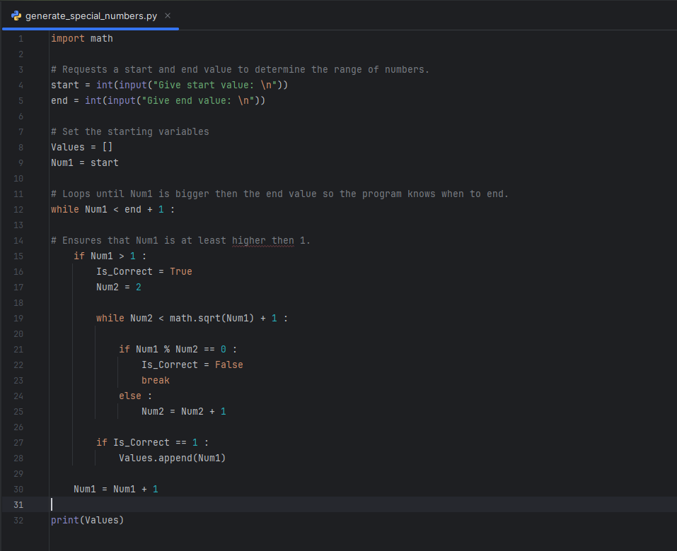

Program Code
import math
# Requests a start and end value to determine the range of numbers.
start = int(input("Give start value: \n"))
end = int(input("Give end value: \n"))
# Set the starting variables
Values = []
Num1 = start
# Loops until Num1 is bigger then the end value so the program knows when to end.
while Num1 < end + 1 :
# Ensures that Num1 is at least higher then 1.
if Num1 > 1 :
Is_Correct = True
Num2 = 2
# Ensures that the value in num1 is not divisible by any number other then 1 and itself.
while Num2 < math.sqrt(Num1) + 1 :
if Num1 % Num2 == 0 :
Is_Correct = False
break
else :
Num2 = Num2 + 1
if Is_Correct == 1 :
Values.append(Num1)
Num1 = Num1 + 1
print(Values)

4b. Test the generate_special_numbers program with the following inputs and display the results.
- start = 3, end = 16
Screenshot
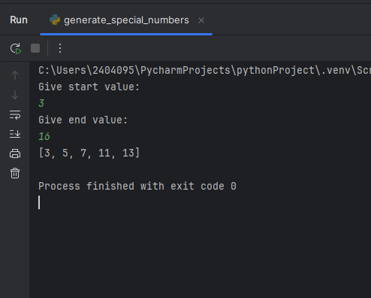
Program Output
Give start value:
3
Give end value:
16
[3, 5, 7, 11, 13]
Process finished with exit code 0

- start = 25, end = 42
Screenshot
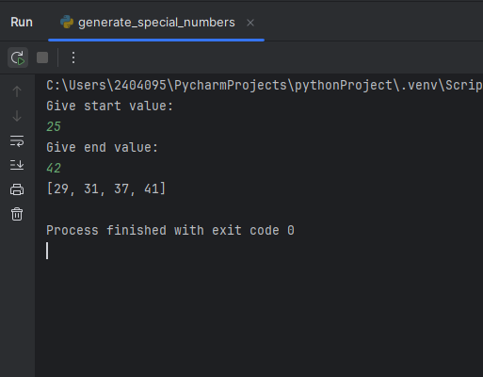
Program Output
Give start value:
25
Give end value:
42
[29, 31, 37, 41]
Process finished with exit code 0

Question 5
5. It is important to validate the generate_special_numbers program by using different test cases. Consider the following test cases and describe the results of each test case and explain how the program handles these test cases.
5a. Test case 1: start = 12 and end = 22
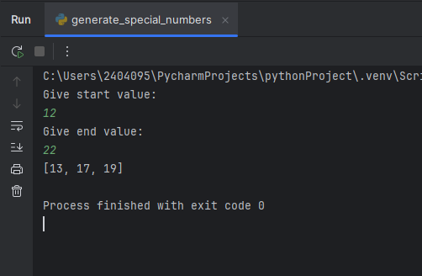
When the program runs with the start value of 12 and the end value of 22, the program seems to check every number between 12 and 22 to find all possible numbers between this custom range.
It seems to have skipped the numbers “12, 14, 15, 16, 18, 20, and 21”, which are all divisible by numbers other than 1 and so would not be valid as prime numbers, which is perfect to see.
It instead listed the numbers “13, 17 and 19”, which have no divisors other than 1 and so are valid prime numbers, which is also perfect to see, as it means the program seems to be working as intended.

5b. Test case 2: start = 30 and end = 8
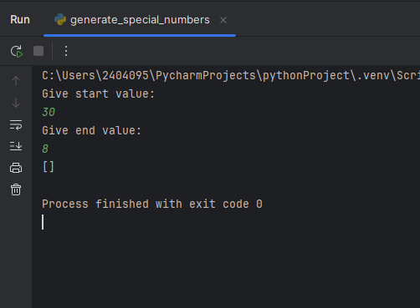
When the program runs with the start value of 30 and the end value of 8, it appears to not output any values this time. Which is great to see, as it would not make logical sense for any values to be outputted when the start value is larger than the end value within this program.
The reason for this result seems to be due to the outer loop condition that defines that it will loop until Num1 is bigger than the end value + 1, and as the Num1 variable is equal to the inputted start value, this condition is met and the loop is therefore skipped before any numbers can be checked and/or added to the list of prime numbers.

5c. Test case 3: start = - 11 and end = 9
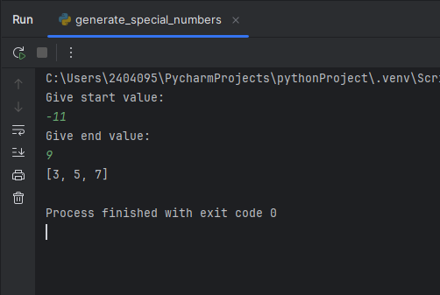
When the program uses a start value of -11 and an end value of 9, the program seems to still function as intended. It outputs the values 3, 5 and 7, which is perfect, as it seems to have skipped any numbers equal to or less than 1, which would not be valid prime numbers.
However, this test has found a fault with the code, as it seems that the number 2 is not recorded within the list of prime numbers, which is a mistake, as 2 meets the criteria of a number that is not divisible by any number other than 1 and itself.

W5d. Test case 4: start = 24 and end = 27
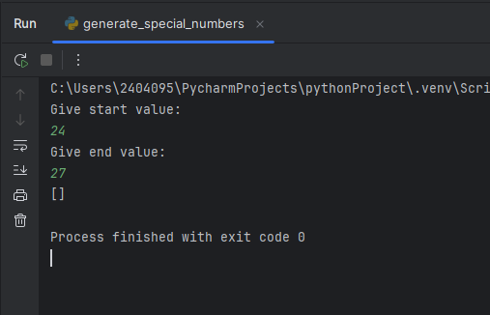
When the program is run again with the start value of 24 and the end value of 27, the program outputs no values, which again is correct, as 24, 25, 26 and 27 are all numbers with divisors other than 1 and itself, and therefore none of them would be valid prime numbers.

5e. Test case 5: start = 13 and end = 13
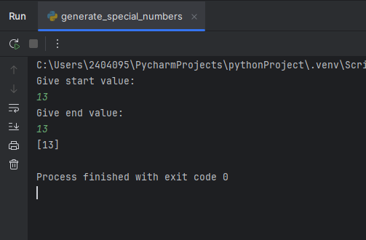
Finally, when the program is run with a start value of 13 and an end value of 13, it outputs a single value of 13 within the list of prime numbers, which is great, as it means the program is correctly running at least once even if the start value is equal to the end value due to the “+ 1” used in the outer loop “while Num1 < end + 1 :”.

Question 6
6. Identify any optimization techniques used in the given program, generate_special_numbers. Explain how these optimizations affect the program’s performance, particularly in terms of time complexity. Include an example to illustrate the impact of the optimization.
Throughout the generate_special_numbers program, there have been a number of techniques that have been implemented to optimise the algorithm. One of these techniques was used for the inner loop “while Num2 < math.sqrt(Num1) + 1:”, where the program was checking for factors only up to the square root of the current value rather than checking every single possible division up to the current value, which would take the program a lot longer to do, especially when dealing with larger values. By only checking up to the square root of the current value, the program cuts down considerably the number of checks it needs to make, improving efficiency overall.
As an example, suppose we were checking if a value like 97 was a prime number. Without the optimization, the program would need to check the divisibility of all numbers between 2 and 97, which is around 95 checks. On the other hand, if the square root optimization technique was used instead, we would only need to check up to 10, as √97 ≈ 9.8, and so this would only take 8 checks to do, which, as you can see, is much more efficient.

Question 7

7. Reflect on your learning journey in this module. What specific programming concepts did you find most challenging, and how did you overcome these challenges? Provide examples of how you applied these concepts in your assignment.
Throughout this module I have learnt a lot about the basics behind the Python programming language. I've learnt how to program basic algorithms in and outside of lectures in Python due to this module, and due to my past experience with programming, I have also learnt what Python does differently from other common programming languages, which did take me a bit to get used to, as some functions and syntax are widely different from the ones I'm used to using; however, I seem to have quite a strong grasp on how Python works now, especially throughout this assignment, and I look forward to pursuing it and other programming languages in the future.
During this module, one of the programming concepts I found the most challenging was working with nested loops, especially when it comes to understanding how the inner loops and the outer loops interact with each other. I found it confusing at first to figure out when each loop would start and finish when nested within each other. I believe I was able to overcome this challenge by drawing up flowcharts and walking through the algorithm step by step to help myself visualise how the code should be looping, how the inner and outer loops interact and give me a much better plan when writing the code.
By practising and better understanding loops through flowcharts, I was able to implement an outer loop and an inner loop for the generate_special_numbers program. By using these loops and following the logic outlined in the assignment flowchart, I was able to make a working program that looped through incremental values one by one to ensure all numbers are covered throughout a given range, and I was able to make an inner loop that checked if the incremental value was divisible by any number other than itself and 1.
Another challenge I ran into, especially when it came to this assignment, was math and numerical functions, like the “math.sqrt()” function that was used on the inner loop within the generate_special_numbers program. I mainly struggled to understand the need for a sqrt() function within the program until I did some research and realised it was an optimisation technique used to make the code more efficient in the context of this program, so I managed to overcome this challenge by researching this and further Python program functions, especially those within the math library, to get more comfortable with them and to gain a better idea of how they could help implement and optimise future programs I make.

