Unit Name: - EFFECTIVE TEAM WORKING & COMMUNICATION

Unit Number: - BMSK4002

Name : Shibbir Ahmed
Student Number : 1706689

EFFECTIVE TEAM WORKING & COMMUNICATION

Communication works for those who work at it—John Powell
(http://www.azquotes.com/quote/536785)

Introduction
Nowadays the Effective Team Working & Communication is an essential and vital process in every spare of life. Lasswell's Maxim defines communication as “who says what to whom in what channel with what effect” (http://bbgcommunication.blogspot.co.uk/2008/11/what-is-lasswells-maxim.html). Effective Team Working & Communication is an exchanging of information from one point of the management team to the other Team Working in an efficient manner that it should be able to work done properly. However, The word communication is derived from the Latin word communis, which means common. When we communicate, we are trying to establish “commonness” with someone. That are the ways, we are communicating and sharing information those are idea, or an attitude among the team involved.

To be honest there are anywhere and everywhere communications are live. If we seen with keen interest that we found that nature is constantly giving us communications. The sun is give the effecting communications for day, trees are giving us for weather and seasons. We are dealing with effective communication knowingly and unknowingly. Even human bodies are sending communication about heath and goods. The emotions are also main obvious to communicate rest of the parts of the body.

We are in the state of effective Team Working and communication. However, Communication is not an absolute and finite anyway. To do this effectively, the needs to consider all the factors such as different realities and possibilities which is a verbal communications and non-verbal communications, but bad communication is not effective which may lead to failure of the Team Working.

If there is a task within team Working to manage Team Working on the point the effective communication and non effective communication process contribute to the necessary of the of effective communication. The process of effective communication is a cycle that helps to maintain the sender a message, encoding, technical situation, receiver message, decoding and feedback (Kelley, 2013). So that, the effective communication is a management process that needs to be efficient and effective manners whatever it is.

To understand the Communications system there is figure how communication works depending on several factors.

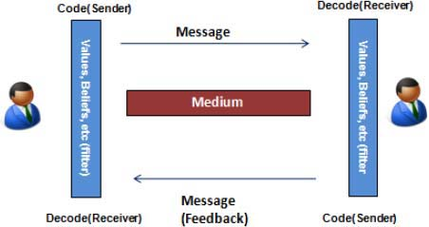

Figure 1. The Communications Process
Source: Rajkumar, S. (2010).

The communications process requires a sender and receiver.

Sender: This refers to the person who first initiates the communication. Let's say a document related to the project is being faxed by the project manager.
Encoder: This device encodes the message to be sent. In this case, it is the fax machine.
Medium: This is the device or technology to transport the message between the encoder
and the decoder. Here it is the telephone line.
Decoder: This device decodes the message to be received. Here it is the fax machine itself.
Receiver: This refers to the person who receives the communication finally. The receiver may interpret the information, make a comment, and send it back to the sender.
Feedback: The communication may be disrupted by noise and misinterpret the message. A part of the message may be faded out or discoloured etc. This would have been caused by the distortion of phone line.

Similarly, there may be many reasons for misinterpretation of information within the project team. In order to avoid this, each project manager should follow some basic steps to be effective in this communication process. Let us see how in the further sections.

Effective Communication and active Communication
Communication is a vital element of a well-managed project. There are two main groups of people with whom the project manager needs to ensure clear and effective communication, the stakeholders and the project team. Every project will be sponsored by a part of the business with a stake in the outcome. They will likely be represented on the project board, which sets the objectives for the project and monitors progress over time. The project board will include others with a stake in the outcome, for example, those who will need to implement the project outcomes and those who will need to supply resource once the project outcomes have been met. All of these stakeholders will need regular updates, and it is imperative that communication with them is regular, clear and complete.

In addition, projects often involve the need for the project manager to coordinate the work of a large group of people working on different aspects of the project (often referred to as work streams). The project manager is required to ensure that everyone is clear about what he or she must achieve and he or she also needs to clearly report on progress to the project board and/or project sponsors. There are many opportunities for things to go badly wrong if an effective communication is not established and maintained.

Process for Effective Communication
The team leader or manager and the task team work together to identify who needs what information. In other words, project management needs to know what the requirements of successful communications are in order to plan on how to achieve those requirements.

First, the team to whom communication is essential needs to be determine the number of channels of communication possible using the communication formula as illustrated in A Guide to the Project Management Body of Knowledge, (PMBOK® Guide)—Fourth Edition (Project Management Institute [PMI]. 2008) This is a very simple equation programmes and project manager should know which is: N (N-1)/2.

Identify Communication

The following figure is most useful to recognise identifying communication.

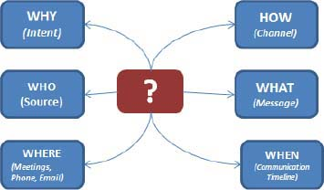
Figure 2. The 5 “W's” and 1 “H”
Source: Rajkumar, S. (2010).

There are obviously some Identifying methods which are the 5Ws and 1H
(Why, What, When, Where, Who How)
Who - who sends the communications.
What - what communications was sent.
When - when the Team Working starts and planning and completion time.
Where - the workplace where the Team Working force will do the allocated task.
Why - impotency of the tasks so that Team Working force will able to understand the importunacy of the job.
How - to considering above the Team Working force can be able to decide how the task can be done more efficiently.

Therefore the above are the vital example for the effective Team Working and communication.

Some other factors effective Team Working and communication
The following are to be imperative factors for effective Team Working and communication.

Political and laws: there are political issues and law and regulations in the workplace to be deal with workforce, so that Team Working are involve with some limitation such as the tasks should not to be given beyond Team Working abilities and on the hand there are safety requirements which is a counterproductive within the Team Working.

Cultural: cultural diversity within the Team Working such as differences in fluency of language or social attitudes and behavioural manner.

Linguistic: speakers need to be understood in the sense of words and attrutute used by different disciplines such as accounting, IT, marketing, etc. the different back grounds speakers may communicate their traditional sense that may be jargons to communicate to the work force team.

Effective communications are happening within team works in the following ways:
In person: Communicating in face-to-face. Allocating a fairly task to the team and their responsibilities within the team.

Telephone: The smiling tone of the voice into the telephone, which may uphold a feeling of pleasure and confidence in the effective Team Working.

Videoconferencing: This is using now a day to communicate and monitoring the Team Working.

There are written communication under verbal communication such as letter writing, memo, report etc which are most essential to run and business as well as effective Team Working. Effective communications are used in the following systems.

E-mail: this is a modern way of using now a day’s which is alternative methods of communication is effectively. It is also an easy to communicate with some specific guidelines and allocating the tasks which will help the efficiency of communication to the team work force as well intended parties.

Mobile Texting: it is very useful to communicate each other and currently is is used very frequently to one to others. It’s a quick process to get the team or parties instantly. Is a strengths for communicating and weakness is that the sender do not know whether the receiver find it or not. So something this is not an effective communication.

Other communication factors
Para lingual: The pitch, tone, and inflections in voice that effective communication within the Team Working.

Feedback: The team force’s feedback which is most essential for effective Team Working and communication.

Active and Effective listening: The Team Working force should need to active listening to be effective communication.

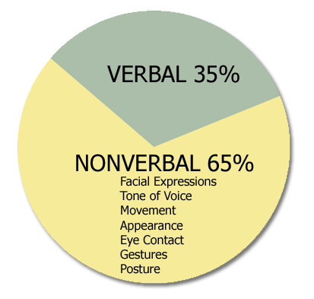
Figure 3: Verbal & Non-verbal communication
Source: (Kelley, 2013)

Non-verbal communication
In recent days, the non-verbal communication is an important communication process which is 65% of the communication. The non-verbal communication which is a body expression such as facial expression, Tone of Voice, Movement, Appearance, eye contact, gestures, posture etc. It is side by side working in conjunction with verbal communication or also it is Team Working to be meaningful communication. It uses nonverbal communication more useful than a verbal communication for effective communication (Effective communication, 2012).

For an example most of the business establishments is used around 65% communication as nonverbal communication including Marks & Spencer. It seen that most of the shop displaying design articles which is definitely non verbal communication.

Importance of Communication in Diverse Working Groups
Work forces today reflect diverse backgrounds, experiences, and perspectives. However, while the term diverse includes a larger range of differences: economic level, educational level, lifestyle, sexual orientation, geographical and regional differences, plus many other descriptors. The presence and acknowledgment of these kinds of differences in people can help a work group communicate effectively and work productively.

However, communication within a diverse Working group can create complex and challenging situations. People with varying perspectives and experiences have different meanings and contexts for words and phrases. They also use nonverbal expressions differently. What is appropriate to one person may be offensive to another.

Effective Communication
Figure 4. Mechanics of Basic Communication

Successful communication in diverse Working force extends to the communication which is the mechanics of basic communication (Figure 4).

It is a learning process to understand and effectively and using words and phrases if possible. In this way the Effective Team Working force is feeling an easy knowledge about the tasks that gives effectiveness which may build a positive Team Working attitude between them.

Conclusions
The Effective communication is strongly suggests that for a successful Team Working is needed effective communication between them. To do the effective Team Working and communication is needed proper and realistic communication between each other and management department whether it is department to department or team to team.

Therefore, the realistic communication can be managed by quality & languages according to the instructions of management (CROWN, 2013). The simple, easy and direct interaction of managers through verbal and non-verbal communication can contribute to the effectiveness of management by ensuring an effective communication.

It may save time and money of the management, makes life easier to the Team Working, makes more profitable for the trade, and it just makes work done by effective Team Working and communication.

References
Project Management Institute. (2008). A guide to the project management body of knowledge (PMBOK®Guide) (4th ed.). Newtown Square, PA: Project Management Institute.
http://www.azquotes.com/quote/536785
http://bbgcommunication.blogspot.co.uk/2008/11/what-is-lasswells-maxim.html
Kelley, M. (2013). Non-Verbal and Verbal Communication. The English Journal, 64(1), p.72.

Rajkumar, S. (2010).
CROWN, S. (2013). NON-VERBAL COMMUNICATION: Non-Verbal Communication. The British Journal of Psychiatry, 123(5), pp.602-603.
Effective communication. (2012). [Emmitsburg, Md.?]: FEMA, Emergency Management Institute.

Further reading
Key, M. (2013). The relationship of verbal and nonverbal communication. Berlin: De Gruyter Mouton.
Key, M. (2015). The Relationship of Verbal and Nonverbal Communication.
Mahmud, M. (2014). Non-verbal communication in the classroom: students’ perspectives. Journal of Language and Literature, 5(3), pp.352-358.
O'Rourke, J. (n.d.). Effective communication.
Rai, U. and Rai, S. (2014). Effective Communication. New Delhi: Himalaya Pub. House.
Rai, U. and Rai, S. (2015). Managerial communication. Mumbai [India]: Himalaya Pub. House.
Vijayavalsalan, B. (2012). Verbal & Non-Verbal Intercultural Communication Styles Influence on Learning. Global Journal For Research Analysis, 3(5), pp.52-55.
Fielding, M. (2013). Effective communication in organizations. Kenwyn: Juta.
Kehoe, D. (2011). Effective communication skills. Chantilly, VA: The Teaching Company.

