Gyorgy Vegyinas 1817909
Reflective report

Table of content

Table of content ________________________________________________ page 2
Introduction ________________________________________________ page 3
Reflective report ________________________________________________ page 3
Conclusion ________________________________________________ page 6
Referencing ________________________________________________ page 7
Appendixes _________________________________________________page 8

Introduction
The purpose of this reflecting report is to analyse my own employability skills such as CV and cover letter writing, reflecting writing, time management, analytical and critical thinking and presentation which I have required along my studies. For each topic above I will use different reflection models, such as Borton’s development framework, Kolb’s experiential learning cycle, Gibb’s reflective cycle and Driscoll’s model and I will include in class exercises together with my lecturer feedback as appendix, to list my improvements in my areas that I need to work. In my first part of the assignment I will reflect to my mistake in regard with my CV and cover letter writing through Borton’s development framework. The second reflection will highlight my first interaction with reflecting writing and my progress from the beginning stage to better stage through Kolb’s experiential learning cycle. My third part of the assignment will reflect to my poor time management skill, and I thought that this module is not for me using Gibb’s reflective cycle. In my fourth and last part of this assignment I will reflect to my analytical and critical thinking and my presentation skills via Driscoll’s model.

When I heard first about the CV and cover letter writing, I was convinced that I am so good in this area, due that before I wrote a lot of CV and cover letter for myself. Therefore, in class I felt that is not too much what I can improve on it, but when the lecturer has asked about the personal brand or the meaning of attributes of CV and about the elements of the cover letter, I was confused. My thoughts were swirling, and I had questions such as ‘’ I was wrong? how it happened? ‘’. I just sat in a class and I realised that my knowledge is tiny, and how I could have imagined it that without knowing the basis or the structure of the material, I can be so good. Of course, before I had experience, but without content, I just threw the facts to the paper, but without form and power, and probably this it was the reason why it was not successful. As Morgan (2017, pp.339) states, in order to have a successful application, there is an important general attribute: we must to adjust our CV and covering letter. However, the recognition that I can improve myself, it gave me the decision to do everything, to be able to grow, both in mind as in experience. I tried to make notes as much as I can, I opened my mind to memorise the main points, I collaborate with my classmates who had advantage of the natal language, I done in class exercises both alone ( see appendix 1) and in group. After that I finished the second term, I understand that it could be a measure about my improving of performance between theory and practice. I realised too that will really be helpful in my future, especially when I finish my study and achieve a manager job. The most important point of it is, to be able to learn from my previous mistakes, first to not think too much about myself and the second to understand that always I can, and I must to improve my knowledge. ( StandOut CV, 2018) comments that, before to start writing our CV, we must to research, to structure to please recruiters, to form it for a professional outlook, to write a profile that will grab recruiters attention and to detail our work experience and education.

Before starting my studies at university, I never heard about reflective writing, unless about the change in direction of a wave front at an interface between two different media. However, when I got in touch with this module in the first term, not only did I not understand anything about it, but I not understood clearly too why it is good for me or what benefit I will have on it. In the second term I felt the same, but how the module has been opened better and better and how it was discussed in class, together with exercises, I could feel the thought closer to master it. I realised the necessity of the reflective writing, first because my assignment must to be a reflective report and second, if I would like to continue my studies it will be a helpful skill. However, after that I memorised the theory, I had to throw myself into experience. How I mentioned before, I had in - class exercises in both terms. Is interesting, how I think on it, in the first term my reflection writing it was disaster, but in the second term it was better, and right then I felt proud myself, not because I would be so good but because I felt that it was much better than the first term exercise, I felt some kind of happiness about what I achieved. Then I understood the importance of practicing, because this is the single way how I can improve my skill, how I can become expert in this field. Expert is a bit strong wording but at least to be able to make a good mark in my assignment and if it does, it will be the best proof for myself that I am on the good way. McLeod mentioned that effective learning is when a person progresses through a cycle of four stages: 1. Having an evident experience, 2. Perception of and reflection on that experience, 3. The formation of synthesis notion (analysis) and generalisations (consequences), 4. Used to assay assumption in future situations, resulting in new experiences. (McLeod, 2017 www.simplypsychology.org)

When I heard first about time management in the first term, I did not know that this is the area where I will must to improve a lot, because always I had problems to manage the time, both in my private life and at my work place too. I had difficulties, because I felt that there is a lack of time for everything, I do not have to run because the life is short and anyway everything will be sorted out. I believed that this is the better way to remain calm and objective, because everybody who is been run is busy, over helmed and stressed. I felt that to be late for any reason is acceptable because the whole life is busy (at that time my life wasn’t). However, when I started to study about time management, I was convinced that this module is not for me, because my life is good as it was and otherwise, I would not like to become some busy leader. Therefore, how I advanced in the module, I find out that is so helpful to have this skill (of course not about the running and busy people) but about to see clear your outcome of the day through a good time plan. I realised that if I do not want to be one of the running people this skill will help me planning my day, my week or even my month in that way in what I will be able to achieve more with less effort. I understood that with good time management I was able to arrive in time to university, to my workplace and so on. My worst experience it happened during the first term when once that I arrived late, I started to blame the transport company, the traffic and so on. However at this point I stopped this behaviour and reflect about the reasons and finally I concluded that I was wrong and it was my mistake that I started late from my workplace to university and then I realised and understood, this is the essence of time management. I learned from this outcome a big lesson, be ready to adapt yourself to a new plan if is require, be realistic and if you must change the plan to be achievable. According to (The Daily Telegraph 2013), education must now evolve to allow students to interact with the world around them. We must let them create and learn from their own ideas and their own mistakes. Let them run their own enterprise. Let them learn by doing. I expanded this knowledge in my private life too and in this way, I have more quality time to be with my family and I working hard to be able to maintain this level. If I think back to my previous point of view, I just laughing on me and I ask how and from where it was coming in my mind that theories about running peoples. Stoilov (2012) mentions that the [time management is a worthy goal of many human activities. It concerns variety problems related to goals definition, assessment of available resources, scheduling of decisions].

During my studies in the second term I had opportunity to hear and learn about analytical and critical thinking. When first in my life I heard about critics it was related with movies and due that I love to watch movies, I thought it would be good to be critic because then I could watch movies for free and after I would have told my opinion…great idea. Otherwise I had no ideas what it could be to think critically and analytical thinking. I thought that analytical thinking is to analyse something maybe data, information, whatever. In a meantime I realised that is a complex science, close to mathematic point of view, a process of breaking down complex information or comprehensive data into smaller parts. From this point began to be interested because I love logical puzzles, IQ tests and so on. Of course, is a bit something else but I realised if I cannot think critically not only can I analyse my own behaviour, but also others. This skill is helpful in my academic studies because it gives me the tools to be able to analyse a lack of information what I would like to use in my assignment. Furthermore, in future will be more adequate when I will work for a company, example like manager and I will need to sort out data, information, diagnostics and so on. I would like to improve as much as I can this skills because will help me to became a better problem solver and I will be able to see a problem from more point of view, to observe, to analyse, to evaluate, to reflect. According to (Morgan, 2017, p.69) concludes [that developing critical thinking abilities is at the heart of what university education is about – which is why those who think critically are able to get the higher marks].
I felt my presentation skill well enough due that I like to talk, sometimes more that is required. When I done the in-class exercise (see appendix 2) I felt myself so confident however it was good to have marks from my classmates too, to know their objective point of view. I had learned more in regard with the gestures, facial expressions, body language, eye contact and movements. I am sure that this skill will be helpful both during my academical studies as during my future manager life. In addition (Doyle 2019) mentioned [ that it is important for any office employee to know what steps go into creating an effective presentation and what presentation skills are most important to employers].

Conclusion
In this reflective report I tried to review my first two term of academic studies. During these two terms reflected my expectations and my in-class exercises, skills that were developed and how I can increase my employability, exceeded my weaknesses and working on my strengthening. In order to develop my academic skills, I learned that I need a strong engagement to encounter my undergraduate years. I found out more about my weakness and strengths and what I learned is just the beginning, and I know I will have more to improve to be able to cope with my weakness and increase my strenght.

Referencing
A, Doyle (2019) Important presentation skills for workplace success. Available at: https://www.thebalancecareers.com/list-of-preparation-skills. (Accessed: 02 January 2020).
McLeod, S.A. (2017, Oct.24) Kolb – learning styles. Simply Psychology. Available at: https://www.simplypsychology.org/learning-kolb.html. (Accessed: 30 December 2019).
Melanie A. Jasper (2005) Using reflective writing within research. Available at: https://journals.sagepub.com/doi/abs (Accessed: 30 December 2019).
P, Morgan (2017) The business student’s guide to study and employability. 1st edn. Sage publications.
StandOut CV (2018) How to write a CV in 2020 [video]. Available at: https://www.youtube.com/watch?v=_fP43gcBywU (Accessed: 29 December 2019).
The Daily Telegraph (2013) Learning by doing. Available at: https://search-proquest-com.ezproxy.uwtsd.ac.uk. (Accessed 30 December 2019).
T, Stoilov (2012) Time management .Available at: https://www.intechopen.com/books/timemanagement. (Accessed 02 January 2020).

Appendix 1

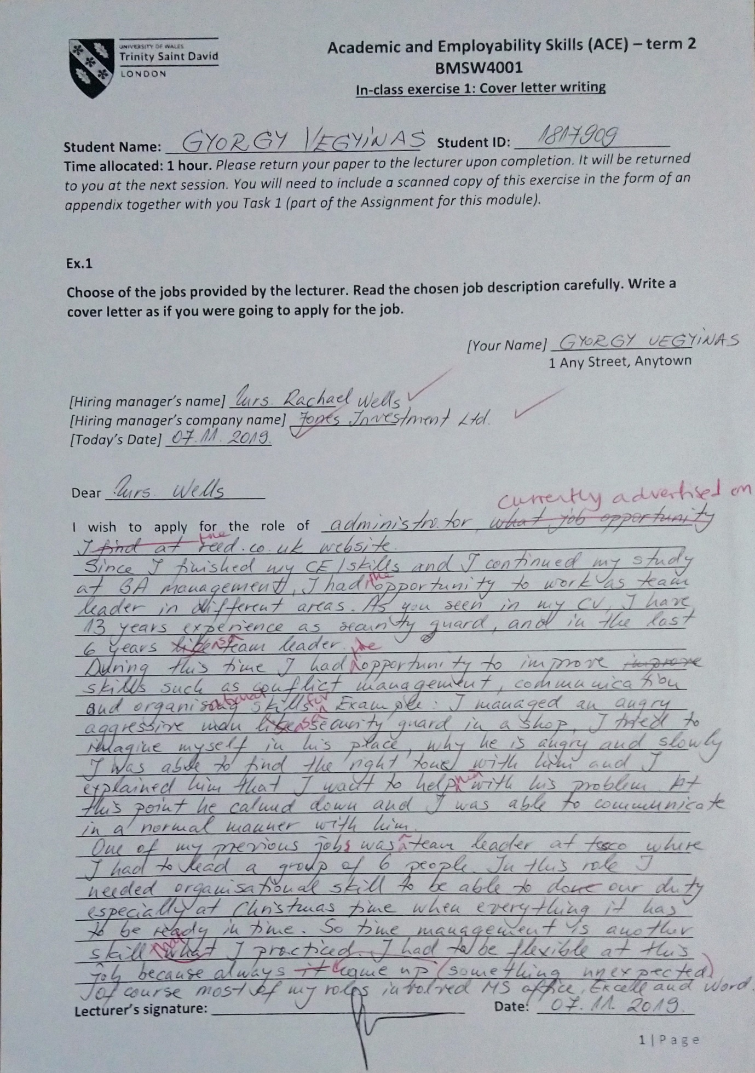
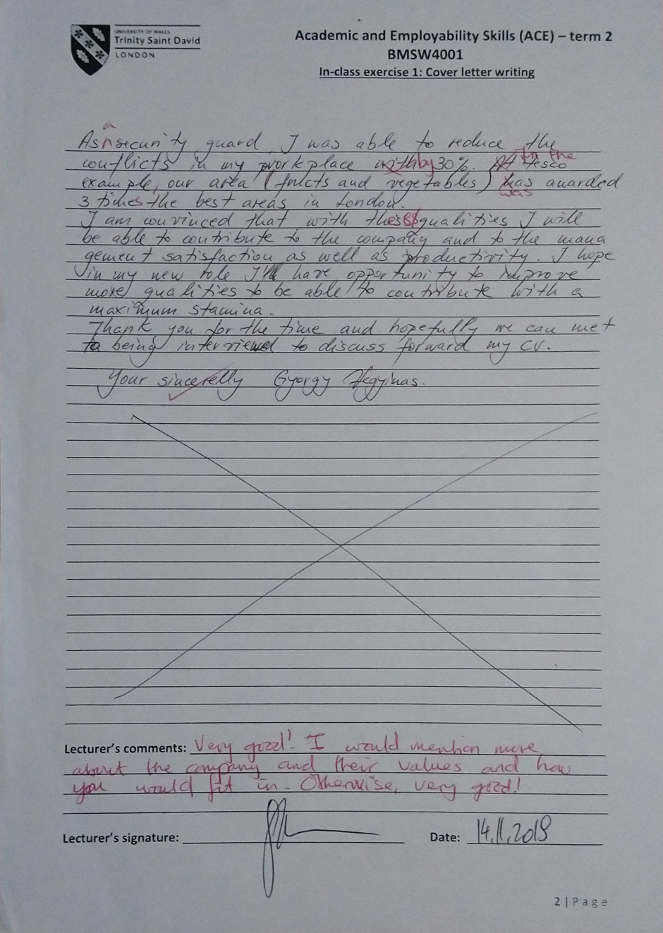

Appendix 2

