University of Wales Trinity Saint David
School of Engineering
Development and Application of Manufacturing Automation
Michael Corish
2115171
Advanced Manufacturing Operations
19/04/2024
L5 – Control & Automation ACMA5001



Table of Contents

1 Introduction 1
2 Main Findings 2
2.1 Fixed Automation 2
2.1.1 Automotive Manufacturing 2
2.1.2 Chemical Manufacturing 3
2.1.3 Advantages and Disadvantages of Fixed Automation in Manufacturing 3
2.1.4 Fixed Automation Control Systems and Process Variables 4
2.2 Programmable Automation 4
2.2.1 Programmable Logic Controllers 4
2.2.2 The Use of Programmable Automation in Steel Rolling Mills 6
2.2.3 Advantages and Disadvantages of Programmable Automation 6
2.3 Flexible Automation 7
2.3.1 History of Flexible Automaton in Manufacturing 7
2.3.2 Industrial Examples of Flexible Automation in Manufacturing 8
2.3.3 Advantages and Disadvantages of Flexible Automation 8
2.3.4 Suitability of Flexible Automation in the Flat-Packed Furniture Industry 9
3 Bibliography 10

Table of Figures
Figure 1 - Ford Motor Company conveyor belt system used in 1925 (Rare Historical Photos, 2022). 2
Figure 2 - Distillation process used during Second World War before introduction of automatic turntable in 1953. 3
Figure 3 - Diagram of the Programmable Logic Controller system (Bolton, 2015). 4
Figure 4 - Similarities between previously used relay ladder diagram and PLC ladder logic (Lander, 2019). 5
Figure 5 - Modern day PLC - Mitsubishi Compact FX3U (Bolton, 2015) 5
Figure 6 - Schematic drawing of hot rolling process (Jiang & Yin, 2017). 6
Figure 7 - Diagram of flexible automation system in a manufacturing process (Kostal & Velisek, 2011). 7
Figure 8 - Comparison of cost per unit against volume of product mix (Cross Company, 2020). 8
Figure 9 - An example of flexible automation being used in the furniture manufacturing industry (iGoldenCNC, 2021). 9

Introduction

Automation is used in industry through utilising advancement in technology to enhance production efficiency, monitor processes and their products via internal control systems. The advancement in machines performing tasks automatically has reduced the demand for human assistance on production lines. Therefore, improving a business’ health and safety figures, process efficiency and product quality, while reducing labour costs to help with profitability.
The purpose of this report is to investigate the three commonly used types of automation – Fixed, Programmable and Flexible. To understand each of these, research has been carried out to review the history and highlight a few of the industries where these processes have been implemented over the years. Also, evaluating the benefits and limitations to each and individually capturing the control systems and process variables associated.

Main Findings

Fixed Automation

A manufacturing production line with a fixed automation process or otherwise known as hard automation, involves a set up configuration designed to produce a single design output through sequenced assembly or processing. Although the operations within the sequence tend to be simple, the integration and coordination of many operations into a single piece of equipment renders it to be complex and not easily altered (Aurora, 2018). Ultimately, the reason for the process being ‘fixed’ and producing a particular product that requires minimal set up alterations.

Automotive Manufacturing

The first instance of a fixed automated system being introduced to an automotive manufacturing process was in 1913 by the Ford Motor Company in the USA. An automatic conveyor belt system was used in an assembly line process, to increase productivity (Fig.1). Also, in the 1920’s single purpose machines were introduced for mechanical processing of metal parts, this developed into NC machines in the 1940’s and led to CNC machining in the 1970’s. Through the use of an assembly line, the company was able to mass produce cars and increase company profits. During the decades of the 1970’s and 1980’s car body construction processes were automated by the introduction of welding jigs, welding robots and press lines (Krzywdzinski, 2020). This ultimately led to a decrease in manual labour and therefore, an increase in productivity. Before this was introduced cars were built by skilled workers resulting in an assembly time of 12 hours per car compared to an improvement of 1.5 hours per car, through the introduction of using fixed automation in manufacturing (Boisset, 2018).

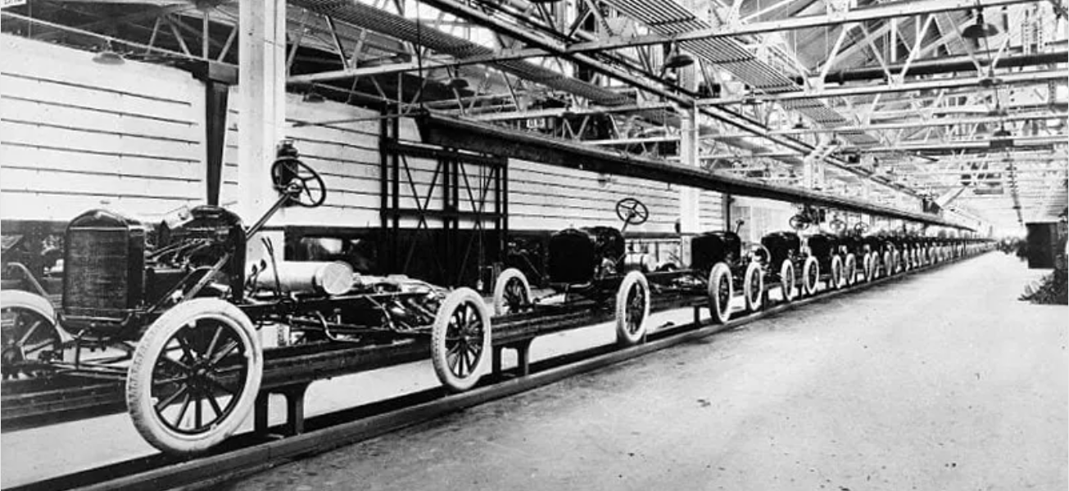
Figure 1 - Ford Motor Company conveyor belt system used in 1925 (Rare Historical Photos, 2022).
Although, the United States of America were not the only leading country in automated automobile manufacturing, after their defeat in the Second World War Japan decided to undergo an industrial rebuilding program. This led to the development of innovative technologies such as protective relays, precise electrical timers and solid state proximity switches, which all contributed to them being a global leader in fixed automated manufacturing. Honda, Nissan and Toyota were companies that were able to mass produce high quality but also highly reliable cars which contributed to their success (Boisset, 2018).

Chemical Manufacturing

In the chemical industry, there were a small number of processes that showed signs of using automation before the Second World War typically through siphons, floats and reservoirs using a drip technique for distillation (Fig.2). Although, fixed automation in chemical manufacturing gained popularity after the war in the 1950’s. The early process controls used for distillation were obsolete after an advancement in technology. Mader and Mader in 1953 placed a glass reservoir and siphon assembly on a rocking arm so that as the reservoir filled, the arm rocked, a mercury switch activated, and the turntable advanced as the siphon drained the reservoir into an Erlenmeyer flask (Olsen, 2012). Then in 1960, Van Duuren introduced electronic control valves on the siphons to automatically drain liquid when timer limits had been reached.
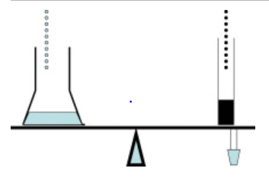

Figure 2 - Distillation process used during Second World War before introduction of automatic turntable in 1953.

Advantages and Disadvantages of Fixed Automation in Manufacturing

The benefits of using a fixed automation manufacturing process includes the high efficiency rate of mass producing the desired specialised product, due to the fixed sequence of assembly. Although, the set up configuration does negatively affect the production of any design alterations to the product. The high levels of efficiency and productivity has advantageous impacts on company profits by creating a product with a low unit cost. Also, in fixed automation, material handling improves from one processing machine to another due to the speed and efficiency of moving product through the manufacturing process e.g. conveyor belts. Work-in-Progress (WIP) is then ultimately reduced due to the continuous flow of product through the process. However, initial investment into implementing a fixed automation process is expensive due to equipment requirements (Gupta & Arora, 2011).

Fixed Automation Control Systems and Process Variables

Equipment used in a fixed automation manufacturing process, use a modular or building block methodology, meaning that each piece of machinery on the production line has their own individual job in the process. To automate the process, control systems consisting of sensors and actuators allow machinery to carry out a specific set of instructions and when the machinery is required to perform these. (Batlle, 2021) highlights an example from a paint and coating manufacturer, describing process variables that can be controlled such as volume, temperature, flow rate and pressure. The use of dispersers, agitators and filling machines allow specific tasks to be performed while controlling process variables by cleaning pipelines and incorporating solids by vacuum in dispersers are just a few examples.

Programmable Automation

Programmable automation unlike fixed automation, allows greater flexibility through a set of instructions programmed into the system to automatically determine the actions required. The program specifies what the automated system should do and how its various components must function in order to accomplish the desired result (Groover, 2024). The introduction of programmable automation into manufacturing began with the use of Programmable Logic Controllers otherwise known as PLC’s (Fig.3).
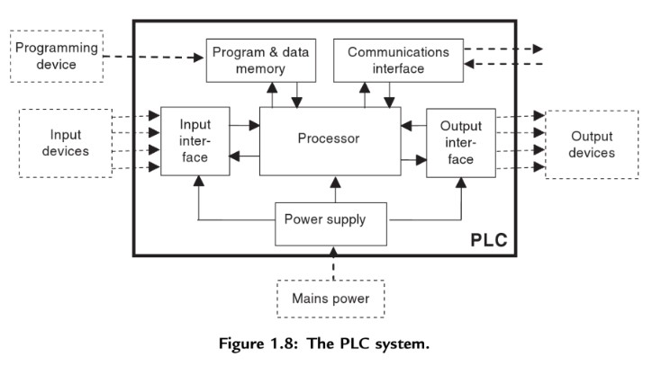

Figure 3 - Diagram of the Programmable Logic Controller system (Bolton, 2015).

Programmable Logic Controllers

The development of the first PLC was undertaken in 1968 by Richard E. Morley. A year later in 1969 General Motors Company installed the Modular Digital Controller to their manufacturing process, resulting in a 60% reduction in production downtime. Previously, multiple relays were required to control process machinery and complex wiring between relays were essential to machinery working to its full potential. If just one relay malfunctioned, the entire system would stop working, and troubleshooting could, at times, take hours to complete. Furthermore, implementing changes posed another set of challenges as they often required reconfiguring the entire system (Process Solutions Inc., 2020). The introduction of the Modicon 084 (the first PLC) meant the old relay system could be removed, creating more space and also, the PLC had enough memory storage to save programmed commands for carrying out a variety of tasks at a reduced changeover time. To display programmed commands, ladder logic was used to provide familiarity for engineers due to the similar visual display used for previously installed relay systems (Fig.4).
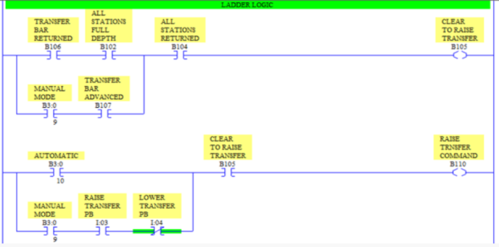
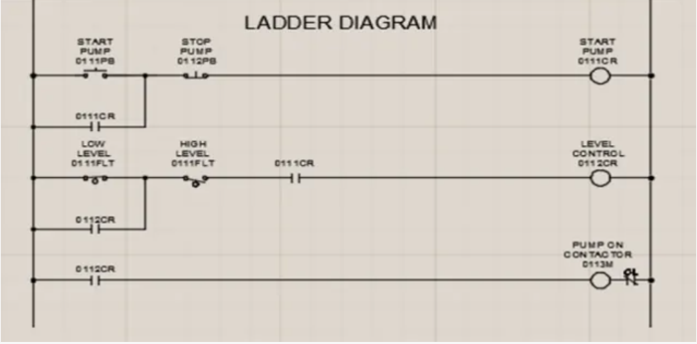

Figure 4 - Similarities between previously used relay ladder diagram and PLC ladder logic (Lander, 2019).

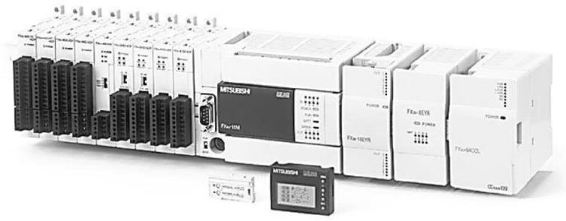
During the 1970’s, digital communications became a key development to the advancement of PLC’s. The original PLC’s were designed to perform a specific set of instructions for a singular machine as an isolated control system. (Walker, et al., 2010) explain that the developments in transistor and integrated circuit technologies in the 1970s, it became feasible to locate individual Analogue to Digital Controllers (ADCs) on separate scattered items of controlled equipment; this reduced the potential for electrical interference. The rise of digital communication allowed data exchange between the control system and Human Machine Interfaces (HMI’s) to recognise and alarm error signals. From personal experience, the use of PLC’s and HMI’s are still in use to this current day in the steel industry through carrying out a specific set of instructions but also, allowing the operator to input control system offsets from feedback signals. The modern day PLC, still has the basic concepts of when it was first created but has gained greater process capabilities whilst reducing in size (Fig.5).
Figure 5 - Modern day PLC - Mitsubishi Compact FX3U (Bolton, 2015)

The Use of Programmable Automation in Steel Rolling Mills

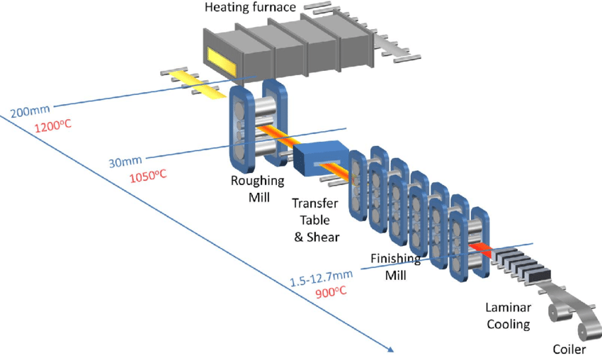
The steel rolling process involves mass producing steel coil from slab, it is essential to have a programmed set of instructions for each piece of processing equipment to produce the desired result. Although, each product may look similar there are multiple process variations depending on gauge, width, length and grade of steel. These product variations have an effect on equipment speed, force, positioning and temperature. The programmable logic controller is a widely used control system when rolling steel due to the variety of customer specifications. The controller allows automatic changes to equipment set up configuration to provide a continuous work flow of product and meet customer quality requirements. (Walker, et al., 2010) highlights the importance of PLC’s as a control system in the steel industry, due to the severe conditions of the process environment such as high ambient temperatures, dust ingress, vibration and electrical noise. The reliability and robustness of the PLC can be relied upon due to there being no moving parts and requires no additional cooling such as fans.

Figure 6 - Schematic drawing of hot rolling process (Jiang & Yin, 2017).

Advantages and Disadvantages of Programmable Automation

The benefits of using programmable automation for manufacturing products includes the ability to change process outputs if required. Also, these products can be made in batches although at a lower level as previously stated when reviewing fixed automation. The initial investment cost in implementing a programmable automation process can be high and changeover times of product can lead to increased downtime. Although, the PLC control systems used with this type of automation have multiple benefits such as reliability, ease of replacement, robustness and cost-effectiveness.

Flexible Automation

(Wadhwa, 2012) describes flexible automation as a process that allows rapid reconfigurability of the production system in order to manufacture several different products, achieving high degree of machine utilisation, reduction of in-process inventory, as well as decrease in response times to meet the changing customer preferences. The use of a flexible automation system allows multiple products to be manufactured simultaneously through central computer control systems.

History of Flexible Automaton in Manufacturing

The first concept of applying flexible automation to a manufacturing system was created by Jerome H. Lemelson in the 1950’s, he was an inventor and industrial engineer from the United States of America. (Hayes, 2023) highlights the patents and original design idea by Lemelson as a robot-based system that could perform riveting, welding, quality inspection and measuring. Although, Lemelson was unable to put his ideas into application due to the lack of technological advancement during this time period. It was during the late 1960’s where technological advancement allowed numerical control (NC) machines to be introduced onto shop floors. (Stecke & Parker, 2000) reveal the first fully fledged flexible manufacturing system was implemented by the Sunstrand Corporation in 1965. The system involved eight multiple tool NC machines with a computer aided roller conveyor for material handling. In 1971 the role of computers in the manufacturing industry, led to the development of the Computer Numerical Control (CNC) machine with a program memory storage and the ability to communicate with other controllers (Dorasila & Mamilla, 2011). During the 1990’s, (Stecke & Parker, 1997) flexible manufacturing systems in automation had the ability to interface with a variety of ancillary machine tool equipment such as robot arms, tool exchangers, automated pallet changers, inspection equipment, conveyors, CAD/CAM and Automated Guided Vehicles (AGV) to provide greater flexibility to the process (Fig.7).
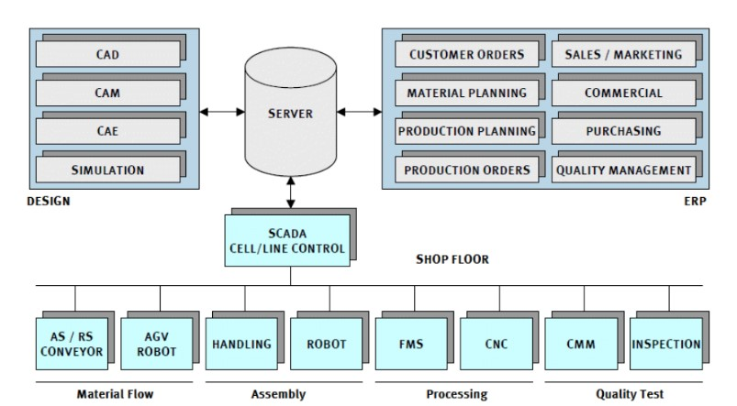
Figure 7 - Diagram of flexible automation system in a manufacturing process (Kostal & Velisek, 2011).
In recent years, industrial developments to digital transformation of manufacturing has been named Industrial 4.0. The main aim of Industry 4.0 is to fully automate the production process through Cloud Computing, Artificial Intelligence and Virtual Reality. (Mohd, et al., 2022) describes flexible automation as complex systems that need significant initial investment and rely on trained employees and costly robots to adjust to a specific set of process parameters. Manufacturers are hesitant to pay additional costs to make significant modifications once they are in place. Companies are increasingly enabling flexible automation with Industry 4.0 technologies to attain this aim.

Industrial Examples of Flexible Automation in Manufacturing

The use of flexible automation in manufacturing has become essential in the modern day market due to its ever changing demand for customisation. This demand for customisation also requires manufacturing efficiency because customers are not willing to wait for their product, meaning the flexible automation approach is a popular modern day manufacturing process. Here are some examples of different industrial sectors using flexible manufacturing systems:
- Automotive Industry – Automated Welding, Painting and Assembly – Mercedes-Benz
- Clothing Industry – Fabric Cutting, Packaging and Quality Inspections - Nike
- Toy Industry – Sorting, Painting and Packaging - Lego
- Food Industry – Packaging, Labelling and Palletising
- Medical Industry – Machine Tending, Sorting and Product Testing - Medtronic
- Electronics Industry – Circuit Board Assembly, Product Testing and Packing - Canon
(Owen-Hill, 2023)

Advantages and Disadvantages of Flexible Automation

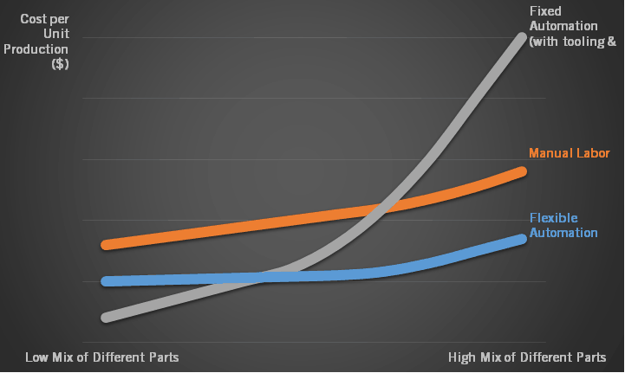
The key advantages of applying flexible automation to a given manufacturing process revolves around end product variety. The use of this type of automation allows flexibility to undertake design variations in the product and also, can produce customised products at an efficient rate to deal with the rapidly changing marketplace. The disadvantages linked to flexible automation include the high initial investment required to integrate an automated system into a manufacturing process, similar to fixed and programmable automation which have been previously highlighted. Also, unit cost is higher compared to fixed and programmable automation. Although, depending on a companies product mix demand, this can positively affect the price per unit cost of flexible automation compared to other types of automation due to the amount of investment and time lost through tooling changes (Fig.8).

Figure 8 - Comparison of cost per unit against volume of product mix (Cross Company, 2020).

Suitability of Flexible Automation in the Flat-Packed Furniture Industry

The use of flexible automation would be most suitable in a flat-packed furniture manufacturing business because of the high variety in product mix to create a piece of furniture. Each part of the product may require different dimensions for cutting and also, drill hole locations may differ for assembly fixings such as dowels and screws. There are also requirements for coating, sorting and packaging. With each process requiring a different set up configuration due to the variety in finished product. The benefit of using flexible automation in this industry is that no time is lost through process change requirements, resulting in higher production efficiency compared to fixed and programmable automation when there are a variety of different parts. This has a direct effect on company finances by reducing the cost per unit when higher product mixes are in focus. An example of flexible automation in an unmanned furniture manufacturer from China, includes Industry 4.0 technology controlling cutting equipment, multi-axis handling robots, edge-sealing rotary line systems, power transmission lines, gantry grabs, six-sided CNC drilling machine and automatic sorting systems (Fig.9).
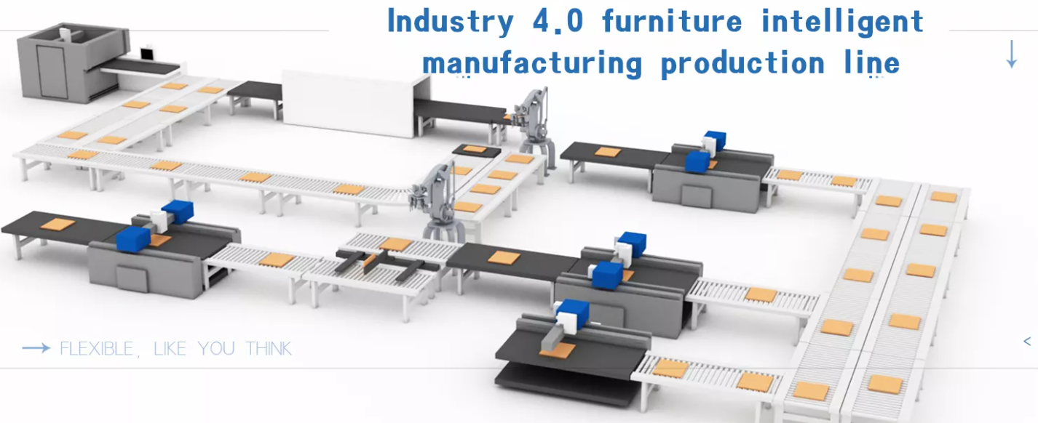
Figure 9 - An example of flexible automation being used in the furniture manufacturing industry (iGoldenCNC, 2021).

Bibliography

Aurora, 2018. The Three Different Types of Automation in Manufacturing. [Online]
Available at: https://aurora-process.com/the-three-different-types-of-automation-in-manufacturing/
[Accessed 02 04 2024].
Batlle, O., 2021. INDUSTRIAL AUTOMATION: HOW TO OPTIMISE MANUFACTURING PROCESSES. [Online]
Available at: https://oliverbatlle.com/en/industrial-automation/
[Accessed 04 04 2024].
Boisset, F., 2018. The History of Industrial Automation in Manufacturing. [Online]
Available at: https://www.automate.org/editorials/the-history-of-industrial-automation-in-manufacturing
[Accessed 02 04 2024].
Bolton, W., 2015. Programmable Logic Controllers. 6th ed. Oxford: Elsevier.
Cross Company, 2020. Technical Guide: Improve Efficiency with Flexible Automation. [Online]
Available at: https://www.crossco.com/resources/technical/fixed-versus-flexible-automation/
[Accessed 13 04 2024].
Dorasila, S. & Mamilla, V. R., 2011. Development of Flexible Manufacturing System in Automation. Global Journal of Meachanical Enignerring and Computational Science, 1(3), pp. 66-69.
Groover, M. P., 2024. History & Society: Automation. [Online]
Available at: https://www.britannica.com/technology/automation
[Accessed 09 04 2024].
Gupta, A. & Arora, S., 2011. Industrial Automation and Robotics. 2nd ed. New Delhi: University Science Press.
Hayes, A., 2023. Flexible Manufacturing System (FMS): Definition and How It Works. [Online]
Available at: https://www.investopedia.com/terms/f/flexible-manufacturing-system.asp
[Accessed 12 04 2024].
iGoldenCNC, 2021. CNC Furniture Making Machine Production Line with Auto Feeding. [Online]
Available at: https://www.igoldencnc.com/cnc-furniture-production-line.html
[Accessed 15 04 2024].
Jiang, Y. & Yin, S., 2017. Recent results on key performance indicatororiented fault detection using the DB-KIT toolbox. Harbin, Research Gate.
Kostal, P. & Velisek, K., 2011. Flexible Manufacturing System. Research Gate, 77(1), pp. 825-829.
Krzywdzinski, M., 2020. Historical Development of Automation and Digitilization Approaches. Automation, Digitalization, and Changes in Occupational Structures in the Automobile Industry in Germany, the United States and Japan, 10(1), pp. 13-14.
Lander, A., 2019. Programmable Logic Controllers: The Evolution of a Disruptive Technology. [Online]
Available at: https://www.engineering.com/story/programmable-logic-controllers-the-evolution-of-a-disruptive-technology
[Accessed 09 04 2024].
Mohd, J. A., Abid, H. A., Ravi, P. S. B. & Rajiv, S. C., 2022. Enabling flexible manufacturing system (FMS) through the applications of industry 4.0 technologies. Internet of Things and Cyber-Physical Systems, 2(1), pp. 49-62.
Olsen, K., 2012. The First 110 Years of Labrartory Automation: Technologies, Applications and the Creative Scientist. SLAS Technology, 17(6), pp. 469-480.
Owen-Hill, A., 2023. 10 Fantastic Examples of Flexible Manufacturing. [Online]
Available at: https://robodk.com/blog/10-examples-of-flexible-manufacturing/
[Accessed 12 04 2024].
Process Solutions Inc., 2020. A Brief History of Programmable Logic Controllers (PLCs). [Online]
Available at: https://processsolutions.com/a-brief-history-of-programmable-logic-controllers-plcs/
[Accessed 09 04 2024].
Rare Historical Photos, 2022. Amazing Vintage Photos Show the Ford Assembly Lines Mass-Producing Model T Cars, 1910s-1920s. [Online]
Available at: https://rarehistoricalphotos.com/ford-assembly-lines-vintage-photos/
[Accessed 03 04 2024].
Stecke, K. E. & Parker, R. P., 1997. Cells and Flexible Automation: History and Synergistic Application, Michigan: University of Michigan Business School.
Stecke, K. E. & Parker, R. P., 2000. Encyclopedia of Production and Manufacturing Management. 1st ed. Boston: Springer.
Wadhwa, R., 2012. Flexibility in manufacturing automation: A living lab case study of Norwegian metalcasting SMEs. Journal of Manufacturing Systems, 1(31), pp. 444-454.
Walker, M., Bissell, C. & Monk, J., 2010. The PLC: A Logical Development. Measurement + Control, 9(43), pp. 280-284.

