

Prince Isidahomen (2509813)
[COMPANY NAME] [Company address]
BUSINESS SKILLS FOR THE WORKPLACE.

MODULE CODE: LCLM4006
MODULE NAME: ENTERPRISE AND ENTREPRENEURSHIP
ASSESSMENT : BUSINESS PLAN
STUDENT NAME: PRINCE JIMOH ISIDAHOMEN
STUDENT NUMBER: 2509813
LECTURER`S NAME: DR. EJIKE UDEOGU

Executive Summary.
EcoBites African Kitchen Ltd will be a start-up food business based in Birmingham, United Kingdom. The business will sell African-inspired meals priced between £5 and £10 via takeaway, delivery and collection, as well as online pre-order. It will initially be run as a small kitchen business instead of a full restaurant. Running costs will be kept low by prioritising takeaway and efficient service over facilities.
The business will aim to attract students, professionals, families and African Caribbean customers in Birmingham who appreciate food from different cultures. Birmingham is home to young and ethnically diverse communities, which makes it suitable for EcoBite’s products. There are already several African food businesses operating in Birmingham. EcoBite will only be successful in this market if it has a unique selling point that differentiates it from competitors.
EcoBite’s unique selling point will be that it is affordable, offers meal deals, allows digital ordering and emphasises zero-waste packaging, reduced food waste, and giving back to local communities. Waste will be minimised by using recyclable/compostable packaging, keeping a fixed menu to help predict customer demand and allowing customers to preorder meals. Once the business is stable, EcoBite will donate 1-2 meals per week to low-income students or vulnerable locals through a meal support scheme.
EcoBites African Kitchen Ltd will be registered as a private limited company limited by shares. The start-up costs for the first month of trading is estimated to be £8,500. £3,500 will be used from the owner’s savings, and £2,000 will be taken as a start-up loan. Social media, WhatsApp Business, a streamlined website, Google Business Profile and select delivery platforms will be used to reach customers.

Contents
Executive Summary 1
Contents 2
1. Overview of the business 3
2. Legal Format 5
3. Environment Analysis 7
4. Marketing Strategies 9
5. Statement of Cash Flow 10
6. References 13

1. Overview of the business.
EcoBite African Kitchen Ltd is a start-up takeaway food business offering African-inspired meals through collection, delivery and online pre-order services in Birmingham, UK. The business adopts a takeaway-only model to reduce fixed operating costs, including restaurant rent, interior furnishing and front-of-house staffing. This lean approach enables EcoBite to provide affordable weekly meal bundles while responding to increasing consumer demand for convenient, technology-driven food services. The menu will include popular African-inspired meals, sides and meal-prep options prepared consistently and packaged safely. Target customers include university students, working professionals, families, African and Caribbean communities, and consumers seeking culturally diverse cuisine.
Birmingham provides a favourable market for EcoBite due to its large, youthful and ethnically diverse population. The city has over 1.1 million residents with a median age of 34 years, significantly younger than the national average, while around 40% of residents identify as Black, Caribbean, African or Asian (Office for National Statistics (ONS), 2025). Younger consumers are more likely to use online ordering and takeaway services, increasing demand for EcoBite's business model. Existing African restaurants demonstrate established demand for this cuisine, but EcoBite will differentiate itself through affordable meal bundles, online meal-prep boxes, recyclable packaging and a focused menu that minimises food waste. The business will also introduce a community initiative offering discounted meals to low-income students and vulnerable residents. These features create a distinctive value proposition within Birmingham's competitive takeaway market. Therefore, EcoBite is well-positioned to achieve commercial sustainability while also delivering social and environmental benefits.
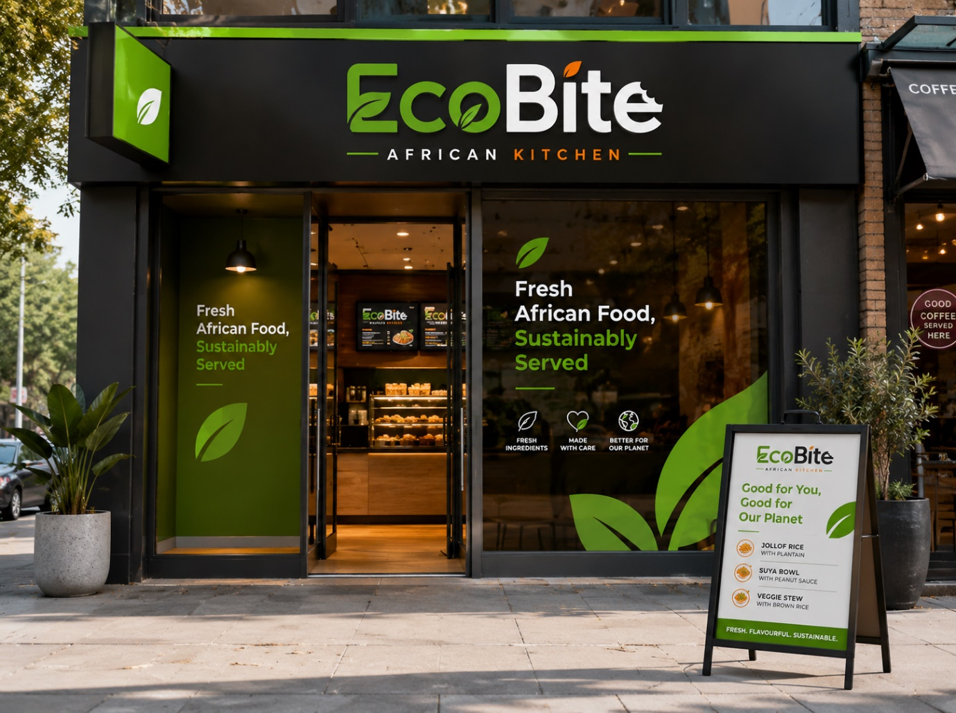
Figure 1: Proposed physical storefront concept for EcoBite African Kitchen Ltd

2. Legal Format
EcoBite African Kitchen Ltd will operate as a private limited company limited by shares because this legal structure best supports the business's long-term growth and financial security. A private limited company has a separate legal identity from its owners, enabling it to own assets, employ staff, enter contracts and assume responsibility for business liabilities (Alfridi, 2025). This structure is particularly suitable for EcoBite because food stock, kitchen equipment, packaging and supplier contracts will be held in the company's name rather than the owner's. Unlike sole traders, company directors generally have limited personal liability for business debts, reducing financial risk while enhancing organisational credibility (Companies House, 2018). Consequently, this legal form provides a stable foundation for sustainable business development. The company will be limited by shares, allowing the founder to retain ownership while creating opportunities to attract future investors as the business expands (Lerner and Leamon, 2023). This flexibility improves access to finance and supports future growth beyond a small independent takeaway. In addition, suppliers, banks and delivery partners often perceive limited companies as more reliable than sole traders, strengthening commercial relationships and market confidence (Robé, 2011). However, these advantages are accompanied by greater administrative responsibilities. EcoBite must maintain accurate financial records, submit annual accounts, pay Corporation Tax and comply with Companies House reporting requirements (Elumilade et al., 2022). Although these obligations increase regulatory demands, the benefits of limited liability, enhanced credibility and greater investment potential outweigh the additional administrative burden, making this the most appropriate legal structure for EcoBite.
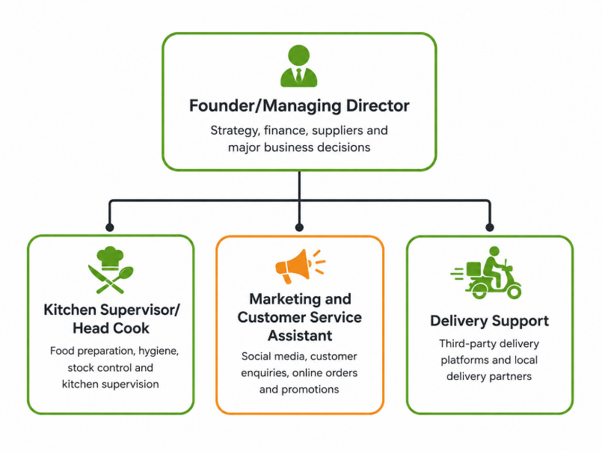
Figure 2: Management Structure of EcoBites African Kitchen Ltd.

3. Environment Analysis.
EcoBite African Kitchen Ltd operates within a favourable but competitive external environment. Politically and legally, the business must comply with UK food hygiene, licensing and employment regulations, making regulatory compliance essential for maintaining customer trust and avoiding penalties. Economically, the takeaway-only model reduces fixed costs such as restaurant rent and front-of-house staffing, enabling EcoBite to offer affordable meal bundles despite rising food, packaging and energy costs. Socially, Birmingham's large multicultural population and growing demand for convenient, culturally diverse meals create a strong customer base, particularly among students, working professionals and African and Caribbean communities. Technological factors also support the business, as online ordering, digital payments and delivery platforms enable customers to access food conveniently through smartphones. Environmentally, EcoBite will reduce food waste through a focused menu and use recyclable packaging, responding to increasing consumer expectations for sustainable business practices. Collectively, these external factors support the commercial viability of EcoBite while highlighting the importance of regulatory compliance, cost control and digital innovation. Despite favourable market conditions, EcoBite will compete with established businesses, including Wolof Flavours, Oriri Grills, Suya Lounge, African Village Restaurant, Afrikana Birmingham, Blue Nile Restaurant, Dinigs Kitchen and Bankys Kitchen. The presence of these competitors demonstrates established demand for African cuisine but also increases competitive pressure. EcoBite will therefore differentiate itself through affordable weekly meal bundles, online pre-ordering, consistent food quality, reliable packaging, reduced food waste and a community support scheme offering discounted meals to selected customers. These strategies create a distinctive value proposition that strengthens competitiveness and supports sustainable long-term growth.
Figure 3: PESTEL analysis for EcoBite African Kitchen Ltd

SWOT analysis.
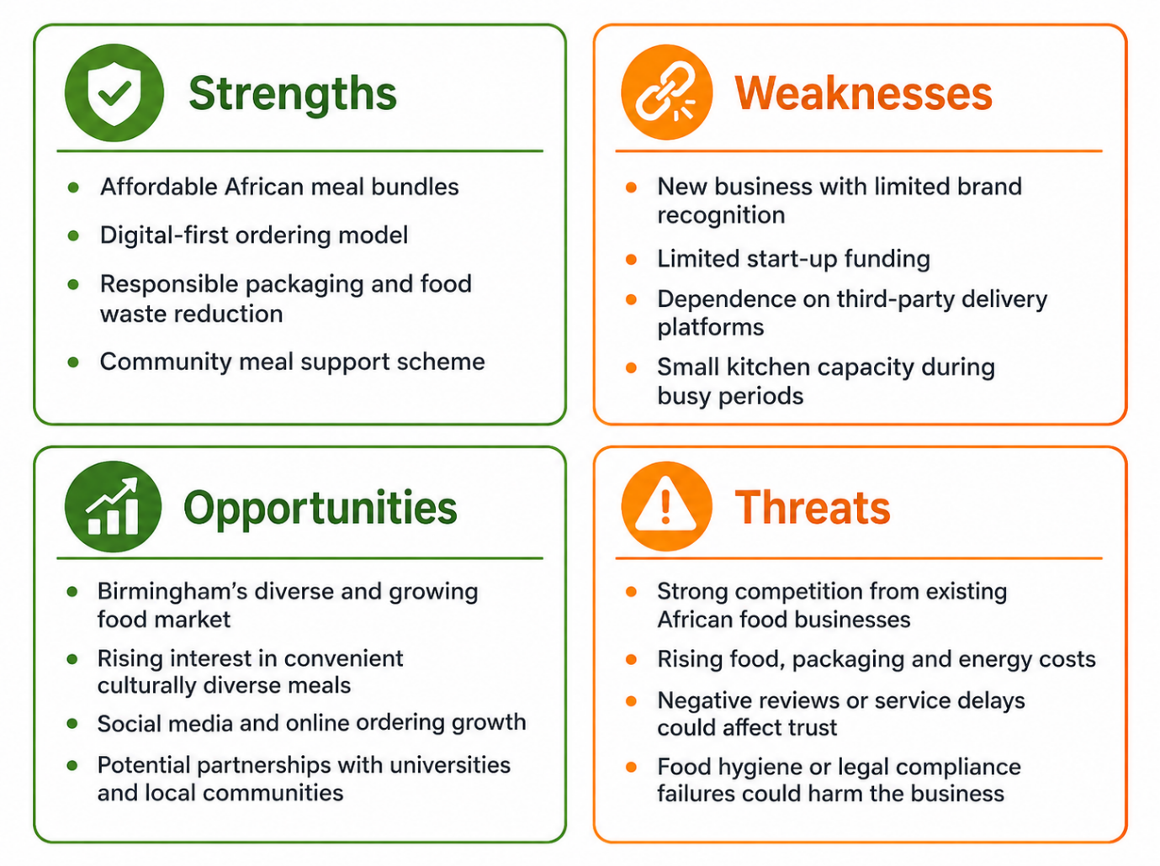

Figure 4: SWOT Analysis of EcoBite African Kitchen Ltd
EcoBite will also face competition from existing African and West African food businesses such as Wolof Flavours, Oriri Grills and Suya Lounge, African Village Restaurant and Late Bar, Afrikana Birmingham, Birmingham Blue Nile Restaurant, Dinigs Kitchen and Bankys Kitchen (Google, 2026). This shows that there is already demand for African food, but it also means that EcoBite cannot rely on cuisine type alone. Its competitive advantage will begin with affordable African meal bundles, but this will be supported by online pre-ordering, a focused menu, consistent packaging, reduced food waste and a small community support scheme.

4. Marketing Strategies.
EcoBite African Kitchen Ltd will adopt a digital-led marketing strategy because takeaway, delivery and online pre-order services are central to its business model. Evidence suggests that greater access to online food outlets is associated with increased use of online food delivery services in the UK (Keeble et al., 2021). This is particularly relevant for EcoBite's target market of students, working professionals and families, who increasingly rely on digital channels for convenient food choices. Social media platforms, including Instagram, TikTok and Facebook, will promote meals through short videos and customer testimonials, while a Google Business Profile and delivery platforms will expand visibility. Positive reviews are especially important for establishing trust in new food businesses and encouraging purchase decisions (Keeble et al., 2021). Therefore, a digital-led approach provides the most effective means of building brand awareness and driving repeat orders for EcoBite.

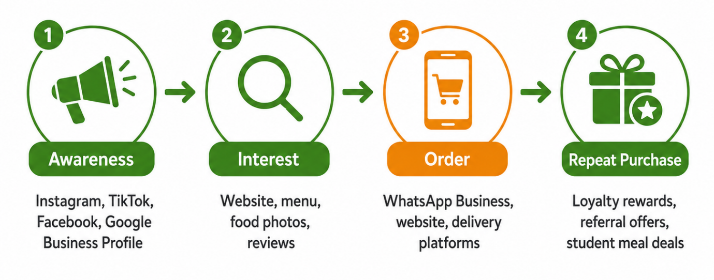
Figure 5: Marketing Strategy for EcoBite African Kitchen Ltd

EcoBite will select premises based on delivery coverage, accessibility and rental costs rather than dine-in visibility, as this supports the takeaway-only business model. This lean approach reduces fixed operating costs while ensuring efficient logistics for both delivery and collection customers (Alfridi, 2025). Delivery coverage and transport links are particularly critical, as they determine how quickly meals reach customers and how easily collection customers can access the premises. Similarly, parking availability and rental affordability directly impact operational efficiency and profit margins. Consequently, this location strategy ensures EcoBite can effectively serve its target market while supporting sustainable long-term growth, without incurring unnecessary costs associated with prime high-street retail locations.
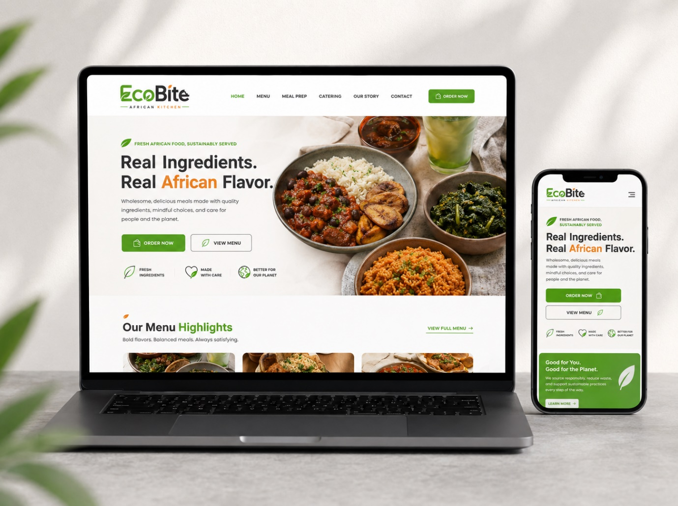
Figure 6: Proposed digital ordering platform for EcoBite African Kitchen Ltd

5. Statement of Cash Flow.
EcoBite African Kitchen Ltd requires £8,500 in start-up capital to finance its first month of operations and establish sufficient working capital. As shown in the projected cash flow statement, these funds will cover essential expenditure, including kitchen equipment (£1,800), initial food stock (£1,200), recyclable packaging (£800), marketing (£600), transport and delivery (£700), business administration and food hygiene training (£550), together with premises, utilities and an emergency reserve. Adequate working capital is essential for new businesses because it enables daily operations, maintains cash flow and reduces the risk of early financial difficulties. Consequently, securing sufficient start-up finance will allow EcoBite to commence trading without disrupting service quality or operational efficiency.
EcoBite will finance these costs through a combination of personal investment and external borrowing. The founder will contribute £3,500 from personal savings, demonstrating financial commitment while reducing reliance on debt. The remaining £5,000 will be obtained through a Start Up Loan or similar government-backed scheme designed to support businesses with limited trading history. This option is more appropriate than conventional bank lending because new businesses often lack the financial records required for commercial loans (Elumilade et al., 2022). Based on projected first-month sales of 25 orders per day at an average value of £8, EcoBite expects total cash inflows of £14,500 and a positive net cash flow of £6,000. Therefore, this financing strategy provides adequate liquidity, preserves ownership control and creates a financially sustainable foundation for future growth.
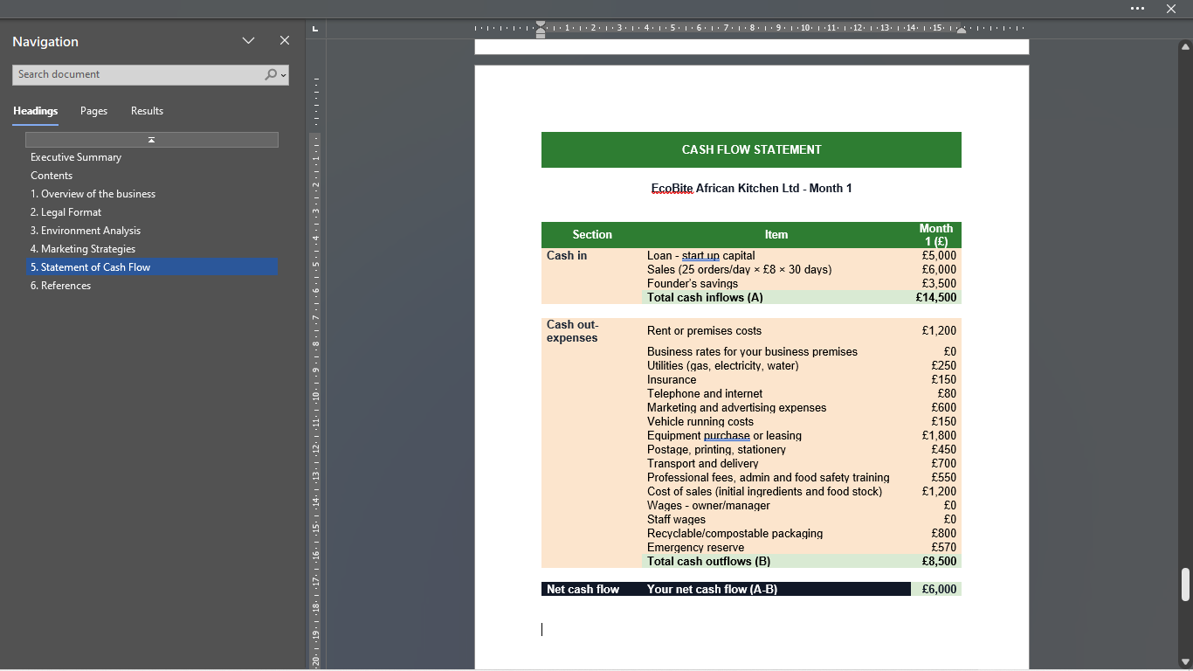
Figure 7: Cashflow for EcoBite African Kitchen Ltd

6. References.
Alfridi, A. (2025) ‘Corporate liability and the concept of limited liability’, International Journal of Law and Policy, 3(10), pp. 37–57. doi: 10.59022/ijlp.386.
Burns, P. (2022) Entrepreneurship and small business: start-up, growth and maturity. 5th edn. London: Red Globe Press.
Companies House (2018) Choosing the right business structure. Available at: https://companieshouse.blog.gov.uk/2018/07/18/choosing-the-right-business-structure/ (Accessed: 15 June 2026).
Elumilade, O.O., Ogundeji, I.A., Achumie, G.O., Omokhoa, H.E. and Omowole, B.M. (2022) ‘Optimizing corporate tax strategies and transfer pricing policies to improve financial efficiency and compliance’, Journal of Advance Multidisciplinary Research, 1(2), pp. 28–38. Available at: https://www.synstojournals.com/multi/article/view/147 (Accessed: 25 June 2026).
Keeble, M., Adams, J., Vanderlee, L., Hammond, D. and Burgoine, T. (2021) ‘Associations between online food outlet access and online food delivery service use amongst adults in the UK: a cross-sectional analysis of linked data’, BMC Public Health, 21(1), article 1968. Available at: https://doi.org/10.1186/s12889-021-11953-9.
Lerner, J. and Leamon, A. (2023) Venture capital, private equity, and the financing of entrepreneurship. Hoboken: John Wiley & Sons.
Office for National Statistics (2023) How life has changed in Birmingham: Census 2021. Available at: https://www.ons.gov.uk/visualisations/censusareachanges/E08000025 (Accessed: 14 June 2026).
Robé, J.P. (2011) ‘The legal structure of the firm’, Accounting, Economics and Law: A Convivium, 1(1). Available at: https://sciencespo.hal.science/hal-04212777/ (Accessed: 25 June 2026).
WRAP (2013) Overview of waste in the hospitality and food service sector. Banbury: Waste and Resources Action Programme. Available at: https://www.wrap.ngo/resources/report/overview-waste-hospitality-and-food-service-sector (Accessed: 14 June 2026).

