

Building Your Personal Brand for Sustainable Employment

Student Name:Tazeem
Student Number:
Module Code: BMHP5015

Task 1 – Personal Brand
I am developing my personal brand as a compassionate, dependable and reflective future health and social care practitioner. I want to be seen as a person who respects people, listens to people, communicates respectfully, and who works with people. These qualities are important as health and social care jobs involve working in a vulnerable capacity; the qualities are necessary for the trust, responsibility and sensitivity required (Gallegos et al., 2023).
My strengths right now are empathy, patience, teamwork and willingness to learn . These are seen as vital employability skills for effective professional practice and career development (Thapa, 2024). I make efforts to identify needs before passing judgement and feel this aids me in developing good relations with service users and colleagues. But I also recognize the need to enhance my personal brand. I want to be more confident in professional communication in groups, giving opinions and presenting ideas. I also need to enhance my digital professional identity, keeping my CV, LinkedIn profile and evidence of training updated.
To build my brand, I will define my career goals, seek feedback, take required training, and review my development. I will also be searching for experiences to gain from in health and social care or volunteering to apply skills in real life. Enabling me to have greater confidence, communication, professionalism, and appearance will make me more employable and better prepared for future career. My long-term aim is to be trusted, adaptable and committed to providing inclusive, person-centred care.

Task 2 - Network Map and Rationale

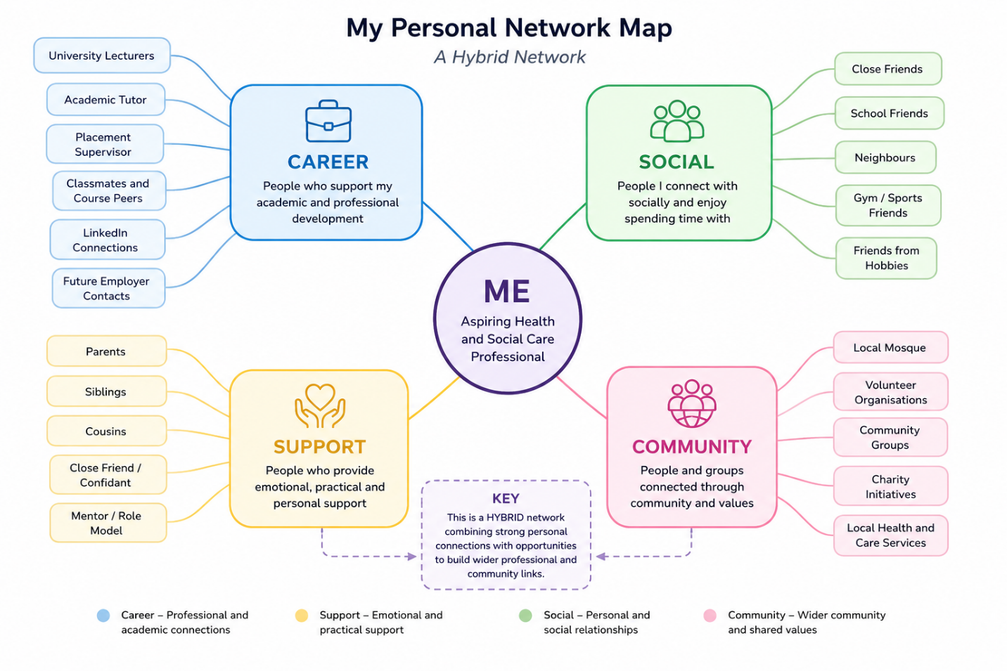

Rationale

Availability of my personal network is “hybrid” as it has both a closer personal network and a broader academic, social and community network. These strong connections that I have are with my family, close friends and class mates who emotionally motivate, encourage, give me support and help. These relationships show strong bonding social capital because they are based on trust, shared experiences and regular communication (Kasperski and Blau, 2020).

My network also consists of career-related contacts including lecturers, tutors, placement staff and LinkedIn contacts. These links are significant as they may assist me with my academic progress, professional development and future employability in health and social care (Healy et al., 2023). My social and educational network, however, is still growing as I don't have a lot of friends outside my typical settings. This may limit my exposure to new ideas, opportunities and professional experiences.

My linking social capital could be developed too as I don't have much direct contact with those in positions of authority, like a care manager, senior health workers or employers. To do this, I have to get better at networking and engaging in events that introduce me to individuals in the field.

To build up my network, attend University career events, improve my LinkedIn profile and make more contact with people who are working in health and social care and volunteering. This will enable me to build bridges and linking bridges as well as keep the existing support. In sum, enhancing my network will benefit my personal brand and my next steps in employment.

Task 3- Blog
Young Minds Matter: Mental Health Support for Young Adults.

Introduction
Care of the mind has been included in the same category as care of the body for young adults in the UK (Punton, Dodd and McNeill, 2022). University pressures, financial concerns, family obligations, social media and a lack of clarity about the future can enhance wellbeing (Slimmen et al., 2022). This blog is for young adults (ages 18 to 25) who might be silently struggling with today's issues or helping a friend.
Challenges and Solutions for Young Adult Mental Health
Mental health problems can affect confidence, sleep, relationships, motivation and daily routines (Yang et al., 2025). Some young people may not feel supported or confident enough to seek help, despite needing it, as they fear they will be discriminated against (McKinlay et al 2022). This is why its critical to provide early support. Talking to someone you trust, your GP, a GP at the university or a mental health charity is ways to feel more in control of a problem before it gets too big.

One of the big problems is that it's not always that support is easily available. Limited services and awareness and long wait times can prevent young adults from getting help quickly. Others also experience other barriers, including language challenges, cultural discrimination, and other disabilities, or simply not knowing where to start. Digital support and mental health apps or NHS information pages may be helpful, but should not be a way to replace face to face care where more intensive help is needed (Lattie, Stiles-Shields and Graham, 2022).

Small and everyday things can contribute to young adults' wellbeing. Maintaining social connections, having a routine, sufficient sleep, good nutrition, and regular exercise can make a difference. But mental health is not just the responsibility of the person (Zabek et al., 2022). Colleges, universities, employers and health services need to provide safe spaces for young people to share their worries. Families and friends are also key, listening and recognizing changes in behaviour and encouraging individuals to seek help if needed.
Conclusion
Youth mental health service provision must be sensitive, accessible and accepted. No one should feel 'on their own'. Don't hesitate to ask for help – it is a positive step towards recovery, confidence and a healthier future. Discussing things openly, sharing and challenging stigma can make younger people more resilient and improve their well-being.

Task 4- NHS Equality, Diversity and Inclusion Quiz

- What is the primary goal of the NHS Equality, Diversity, and Inclusion Improvement Plan?
The overall objective is to increase equality, diversity and inclusion of NHS staff and develop a greater sense of belonging for staff. This should enhance the working life of staff and enhance care.

- How does the NHS EDI Improvement Plan propose to tackle the gender pay gap?
It aims to address the gender pay gap through recruitment, progression, flexible working and equitable access to opportunities, and talent pipelines.

- What is meant by the term ‘intersectionality’ as used in the NHS EDI Improvement Plan?
Intersectionality recognises that individuals may be disadvantaged in multiple ways at the same time, such as by race and gender, disability and class (Wickenden, 2023).

- Why is it important for the NHS to create a psychologically safe work environment?
Psychological safety is relevant as staff must feel safe in order to: Speak up, Ask questions, Raise concerns, Admit mistakes without fear (Wright and Kernen, 2025).

- How does the NHS EDI Improvement Plan suggest improving the experience of internationally recruited staff?
Opportunities to enhance the experience of internationally-recruited staff through induction, onboarding, development and support.

- What role does leadership play in advancing EDI objectives according to the NHS Improvement Plan?
Leadership is important, as managers and senior leaders set the example for inclusive behaviors and ensure EDI activities are adhered to (Seijts and Milani, 2022).

- Identify one way the NHS EDI Improvement Plan aims to reduce health inequalities within the workforce.
This can be done by developing staff health and wellbeing and tackling inequalities that may be experienced by groups of staff.

- Why does the NHS EDI Improvement Plan emphasise the importance of collecting and analysing data on protected characteristics?
Data on protected characteristics helps NHS to understand inequalities, track progress, and make better decisions.

- Explain how flexible working policies can contribute to equality and inclusion in the NHS workforce.
Flexibility principles can help equality thus allowing staff to balance caring responsibilities, disability, health and personal circumstances with work.

- What is one strategy mentioned in the NHS EDI Improvement Plan to combat bullying and harassment in the workplace?
A first step is to minimize bullying and harassment by improving and promoting reporting, leadership accountability and a safer work culture.

Task 5- A Letter to Yourself

Dear Younger Me,
I realise that you are facing some tough times due to financial challenges. Stress and worry about fulfilling your responsibilities are often part of your financial worries. On certain occasions it can result in anxiety and uncertainty about the future. I know you can't take this in all at once, but please remember that this challenging time will not always be like this.
Hindsight is always 20/20, I now realize how much emotional intelligence was needed during this time. Develop awareness of emotion and thus the impact of stress on thought patterns. You might have shared with trusted individuals and, when it was available, asked for support what you were feeling. When you learned how to cope with your emotions in a healthy manner, the pressure you put on yourself was lowered.
Being resilient was also a key factor. Some of the financial challenges proved to be challenges, but also valuable lessons, in determination, patience and problem solving. Having this resilience would help you to course correct a setback and prevent it from being a failure. It would have propelled you forward and kept you on track when things were hard.
Do believe in yourself, what it doesn't mean is that you come here and that is the stepping stone you are on, it means that you believe in yourself, you will find the right stepping stone while moving onwards and upwards with your faith in God. Concentrate on the things you can control, take one step at a time and reward yourself for your progress
These events will build you as a person and a professional in the future. They will enhance your EQ, resilience, and empathy/compassion toward others.
Yours sincerely,
Your Older Self

Task 6- GANTT Chart

Activities to Achieve My Future Employment Goals | Month 1 | Month 2 | Month 3 | Month 4 | Month 5 | Month 6
Identify career goals within Health and Social Care | ✓
Review strengths and areas for development | ✓ | ✓
Update CV and personal statement | ✓ | ✓
Create and improve LinkedIn profile | ✓ | ✓
Go to career workshops and networking events |  | ✓ | ✓ | ✓
Gain volunteering or work experience |  | ✓ | ✓ | ✓ | ✓
Complete relevant training and certifications |  |  | ✓ | ✓ | ✓
Build professional network and seek advice from professionals |  | ✓ | ✓ | ✓ | ✓ | ✓
Develop interview and communication skills |  |  |  | ✓ | ✓ | ✓
Apply for Health and Social Care positions |  |  |  |  | ✓ | ✓
Review progress and set new career goals |  |  |  |  |  | ✓

GANTT Chart Explanation

This is a Gantt chart that shows the set of actions that I will do in order to realize my future work objectives in health and socio care services. This initial section is about my career goals, an assessment of my strengths, and enhancing my CV & LinkedIn page. The next steps include networking events and taking on volunteering or work experience opportunities. As I continue to develop I will undertake appropriate training to build working partnerships within the industry. In the latter part I will concentrate on interview techniques and appropriate workplace opportunities. Continous review of progress will ensure that I am organised, motivated and focused in my abilities to achieve sustainable employment within health and social care.

Task 7- Making Changes- Report

Introduction
In my role as manager in a care home I would implement digital care records as opposed primarily to paper-based recording. This change is required as provision of safe person centred care is dependent upon accurate and up to date information. Digital records facilitate communication between staff, missing records and easier access to care plans.

Implementation
Apply a planning model using Lewin's change model (Ahmed, Kassem and Sleem, 2022). During Unfreezing, I would fill staff in on the rationale for the change; for example, delays in information seeking, risks due to unclear notes. During the changing phase, I would gradually roll one unit at a time, starting with one before building out across the care home. All staff to be trained, demonstrated and given time to practise. During the refreezing stage, digitally monitoring, feedback and updated policies would become part of every day actions.

Skills Required
There would need to be strong leadership to ensure staff and confidence precedes the transition period. Communication would enable to communicate expectations and to listen to staff concerns (Kamal, Sakrani and Maidin, 2023). Problem solubility will also have an impact, particularly in case of issues with the devices and fear of error on the part of the colleagues (Hawes and Arya, 2023). This all requires team work as the care assistants, the nurses and the managers have to use the system regularly.

Possible Barriers
Staff resistance to change, including those who are more comfortable with paper may be the biggest obstacle (Hubbart, 2023). When working shifts are very busy, it may also be difficult to train. The other obstacle could be that of confidentiality and data protection. All these questions can be addressed in training, guidance with the system, swiping systems and password protection and reassurance that they are being used to improve the care and not to sweep staff.

Conclusion
Digital care records would enhance organisation, communication and accountability within the organisation of the care home. It can assist in safer care, minimising errors, and help staff to offer more responsive care to residents, and improve standards of professional practice across the service, if managed appropriately.

Reference List
Ahmed, A., Kassem, A. and Sleem, W. (2022). Applying Lewin’s Change Management Theory to improve patient’s discharge plan. Mansoura Nursing Journal (MNJ), [online] 9(2), p.2022. Available at: https://journals.ekb.eg/article_295591_2e01c440a7769101b9fd53066f06f65c.pdf.
Gallegos, D., Durham, J., Rutter, C. and McKechnie, R. (2023). Working towards the Active Participation of Underrepresented Populations in Research: A Scoping Review and Thematic Synthesis. Health & Social Care in the Community, 2023, pp.1–26. doi:https://doi.org/10.1155/2023/1312525.
Hawes, D. and Arya, A. (2023). Technology Solutions to Reduce Anxiety and Increase Cognitive Availability in Students. IEEE Transactions on Learning Technologies, pp.1–16. doi:https://doi.org/10.1109/tlt.2023.3239985.
Healy, M., Cochrane, S., Grant, P. and Basson, M. (2023). LinkedIn as a pedagogical tool for careers and employability learning: a scoping review of the literature. Education + Training, [online] 65(1). doi:https://doi.org/10.1108/et-01-2022-0004.
Hubbart, J.A. (2023). Organizational change: The challenge of change aversion. Administrative Sciences, [online] 13(7), pp.162–162. doi:https://doi.org/10.3390/admsci13070162.
Kamal, N., Sakrani, S.N.R. and Maidin, A. (2023). Communication Barriers in Work Environment: Understanding Impact and Challenges. International Journal of Academic Research in Business & Social Sciences, 13(11), pp.1489–1503.
Kasperski, R. and Blau, I. (2020). Social capital in high-schools: teacher-student relationships within an online social network and their association with in-class interactions and learning. Interactive Learning Environments, 31(2), pp.1–17. doi:https://doi.org/10.1080/10494820.2020.1815220.
Lattie, E.G., Stiles-Shields, C. and Graham, A.K. (2022). An overview of and recommendations for more accessible digital mental health services. Nature Reviews Psychology, 1(2), pp.87–100. doi:https://doi.org/10.1038/s44159-021-00003-1.
McKinlay, A.R., May, T., Dawes, J., Fancourt, D. and Burton, A. (2022). ‘You’re just there, alone in your room with your thoughts’: a qualitative study about the psychosocial impact of the COVID-19 pandemic among young people living in the UK. BMJ Open, 12(2). doi:https://doi.org/10.1136/bmjopen-2021-053676.
Punton, G., Dodd, A.L. and McNeill, A. (2022). ‘You’re on the Waiting list’: an Interpretive Phenomenological Analysis of Young Adults’ Experiences of Waiting Lists within Mental Health Services in the UK. PLOS ONE, [online] 17(3). Available at: https://journals.plos.org/plosone/article?id=10.1371/journal.pone.0265542.
Seijts, G.H. and Milani, K.Y. (2022). The application of leader character to building cultures of equity, diversity, and inclusion. Business Horizons, 65(5), pp.573–590. doi:https://doi.org/10.1016/j.bushor.2021.07.007.
Slimmen, S., Timmermans, O., Mikolajczak-Degrauwe, K. and Oenema, A. (2022). How stress-related Factors Affect Mental Wellbeing of University Students a cross-sectional Study to Explore the Associations between stressors, Perceived stress, and Mental Wellbeing. PLOS ONE, [online] 17(11). doi:https://doi.org/10.1371/journal.pone.0275925.
Thapa, H.S. (2024). Development of Employability Skills through Work-Based Learning. Journal of Technical and Vocational Education and Training, 18(1), pp.102–111. doi:https://doi.org/10.3126/tvet.v18i1.62750.
Wickenden, M. (2023). Disability and other identities?—how do they intersect? Frontiers in rehabilitation sciences, [online] 4(4). doi:https://doi.org/10.3389/fresc.2023.1200386.
Wright, M.Imelda. and Kernen, K. (2025). Speaking Up: Exploring the Role of Psychological Safety. Journal of PeriAnesthesia Nursing, 40(2), pp.451–453. doi:https://doi.org/10.1016/j.jopan.2025.01.003.
Yang, Y., Bulut, S., Bukhori, B., Piskorz-Ryń, O. and Chikwe, C. (2025). The Role of Family Routines in Promoting Child Mental Health: A Qualitative Study. Journal of Research and Health, [online] 15(2), pp.175–184. doi:https://doi.org/10.32598/jrh.15.2.2474.1.
Zabek, F., Lyons, M.D., Alwani, N., Taylor, J.V., Brown-Meredith, E., Cruz, M.A. and Southall, V.H. (2022). Roles and functions of school mental health professionals within comprehensive school mental health systems. School Mental Health, 15(1), pp.1–18. doi:https://doi.org/10.1007/s12310-022-09535-0.

