

BA Leadership and Management
LEVEL 5

Managing Projects in the Organisation
BMSW5009-CARD

Report
Project Title: The Little Food Trailer

Module Lead: Lan Zhang

Name: Andreea Tanasa

Student Number:2332157

Total word count: 2140 Submission Deadline:08.07.2026

AI Statement: Acknowledgement
I confirm that I have not presented any AI-generated materials as my own work

Executive Summary
This report critically assesses the project management tools and techniques used to plan The Little Food Trailer project. The project purpose is to convert three used horse trailers into mobile kitchens for culinary workshops for children aged 6–11 from the Wiltshire community. The project runs from January 2027 to June 2027, giving a clear six-month time period and a fixed end point. Each trailer is expected to cost £1,000 to purchase, with a total cost of approximately £2,500 per trailer once converted, giving an estimated overall cost of £7,500 for three completed trailers.
The report critically discusses scope management, aims and objectives, deliverables, stakeholder analysis, communication planning, the Work Breakdown Structure, Gantt chart, risk management and mitigation planning, the Iron Triangle, and team roles (Belbin). These tools gave the project structure, helped the team organise tasks, and supported decision-making. However, the report also identifies real limitations, including uncertain conversion costs, the possibility of hidden trailer damage, supplier delays, and safeguarding requirements that were not built into the original scope.
The project was planned in a structured way, but future improvement should focus on more realistic budgeting, stronger risk control with named owners and review dates, clearer communication records, and more detailed scheduling with contingency time.

Contents
Executive Summary 2
1. Introduction 4
2. Findings 6
2.1 Critical Discussion of Project Management Tools and Techniques in General 6
2.2 Critical Discussion of How the Tools Were Used in the Project 7
2.3 Communication and Stakeholders 12
3. Conclusion 14
4. Future Improvement 16
References 17

1. Introduction
The Little Food Trailer project is a six-month project to convert three used horse trailers into mobile kitchens for children’s culinary workshops in Wiltshire. The workshops are aimed at children aged 6–11, giving the project a clear community and educational purpose. A project is normally temporary and created to deliver a unique product, service or result (Project Management Institute, 2021).
The scope covers sourcing, converting, and safety-checking three specific trailers and preparing them for workshop use, while running the workshops themselves, transporting children, and providing full catering services are explicitly excluded.
The time is fixed and short: January 2027 to June 2027, a defined six-month window rather than an open-ended commitment. The endpoint is concrete and checkable: three trailers that have passed safety and hygiene checks, with a completed handover, rather than a vaguer outcome such as “improved community engagement” that would be harder to know when it had been achieved.
Aim: To create safe, practical and child-friendly mobile kitchens between January 2027 and June 2027.
Objectives:
- Source and inspect three second-hand horse trailers against agreed structural and safety criteria within the first six weeks of the project.
- Design a child-friendly kitchen layout (safe movement space, controlled equipment access, wipe-clean surfaces) and have it reviewed before conversion work begins.
- Complete structural, electrical, plumbing and hygiene conversion work on all three trailers within the six-month timeframe, phased through the Gantt schedule.
- Keep the total converted cost at or below approximately £2,500 per trailer, including a contingency allowance for hidden repairs.
- Maintain a risk register, with a named owner and review date for each risk, reviewed at agreed intervals throughout the project.
- Agree and follow a safeguarding, hygiene and supervision plan before any child-facing workshop activity takes place.
- Complete a handover checklist for each trailer, confirming safety, hygiene and usability, before workshop use begins.
These objectives depend on assumptions, so they should be treated as a working plan to be tested and reviewed rather than a fixed commitment (Bjerke and Renger, 2017).

2. Findings

2.1 Critical Discussion of Project Management Tools and Techniques in General
Project management tools and techniques are useful because they help teams turn ideas into organised plans, but they should not be treated as paperwork only: tools are most useful when they support better decisions, clearer responsibilities and stronger control (Pellerin and Perrier, 2019), and project management is about exercising judgement under uncertainty rather than simply completing templates (Morris, 2013; Meredith, Shafer and Mantel, 2021).
Crawford and Pollack (2004) argue that projects often contain both “hard” elements, such as schedules and budgets, and “soft” elements, such as communication, teamwork and stakeholder expectations.
Scope management is important because it defines what is included and excluded from a project. This helps prevent scope creep, in which extra work is added without additional time, cost, or resources (Lock, 2020). Scope management can be weak, however, if a project’s boundaries are defined too broadly, or if sensitive areas such as safety, hygiene, supervision, or safeguarding are treated as add-ons rather than built into the scope from the outset, particularly when a project involves children or other vulnerable groups.
Objectives are useful because they make a target specific, measurable, achievable, relevant and time-bound, which supports monitoring and evaluation, but can become unrealistic if the targets are based on weak cost or time estimates rather than tested evidence (Bjerke and Renger, 2017), and applying the SMART test to a project’s overall aim, rather than to a set of more specific supporting objectives, risks producing an aim that sounds measurable without actually being broken down into checkable steps.
Stakeholder analysis is important because projects affect different groups in different ways (Freeman, 1984). Stakeholder analysis should not simply list stakeholders; it should explain their influence, interest, and communication needs (Bourne and Walker, 2005), and because those needs can shift as a project progresses, stakeholder management is best treated as an ongoing activity rather than a one-off exercise carried out only at the start (Eskerod and Lund Jepsen, 2016).
Communication planning sets out who needs which information, at what level of detail, and through which channel. Without a communication plan, informal channels can carry decisions that are never properly recorded, and different stakeholders, who may need very different levels of detail, can end up receiving the same generic updates (Burke, 2013).
A Work Breakdown Structure divides a project into smaller work packages, which supports task allocation, costing, and control (Project Management Institute, 2019).
A Gantt chart then places tasks on a timeline; it is useful because it shows sequencing and deadlines, but it can become unreliable if task durations are estimated too optimistically (Kerzner, 2022).
Risk management identifies uncertain events that could affect time, cost, quality or scope (Hillson, 2024). A risk register is a useful tool, but only when each risk has a mitigation action, an owner and a review date; without these, it is easily reduced to a static list rather than an active management tool (Pinto and Slevin, 1987).
The Iron Triangle focuses on time, cost and quality or scope. It is useful for showing trade-offs, but it is limited because project success cannot always be judged on those three areas alone; wider measures such as stakeholder confidence and community value often matter just as much, particularly on projects with a strong social purpose (Atkinson, 1999; Shenhar et al., 2001).

2.2 Critical Discussion of How the Tools Were Used in the Project
The project aimed to create three safe, practical and child-friendly mobile kitchens between January 2027 and June 2027.
The time-bound and measurable elements are strong: three trailers, a fixed six-month window, and a target cost of roughly £2,500 per converted trailer are all concrete enough to check.
The specific and achievable elements are weaker: “design a child-friendly kitchen layout” and “complete the conversion work” are directional rather than fully specific, and their achievability depends on cost and condition assumptions that have not yet been tested against real supplier prices. This matters because objectives are only as useful as the evidence behind them (Bjerke and Renger, 2017).
The intended scope covers trailer sourcing, layout planning, conversion work, hygiene surfaces, basic kitchen areas, child-friendly design, safety planning, stakeholder communication and final handover; long-term workshop operation, transporting children, full catering services and unrelated community events sit outside this scope. The main deliverables – three converted trailers, child-friendly layouts, hygiene and safety planning, a communication plan, a risk register and a handover checklist – give the project a clear end point, but a deliverable such as “child-friendly kitchen layout” needs a firmer quality standard than an attractive design: safe movement space, controlled equipment access, wipe-clean surfaces and clear hygiene arrangements all need to be specified as acceptance criteria, not left implicit.
The WBS split the project into initiation, trailer sourcing, inspection, design, conversion, equipment layout, safety planning, testing, communication and handover, which usefully showed that this was not one simple conversion job. “Conversion work” remained too broad a package, however; splitting it into structure, flooring, wall cladding, ventilation, plumbing, electrical work and final inspection would improve costing and reduce confusion (Maylor and Turner, 2022).
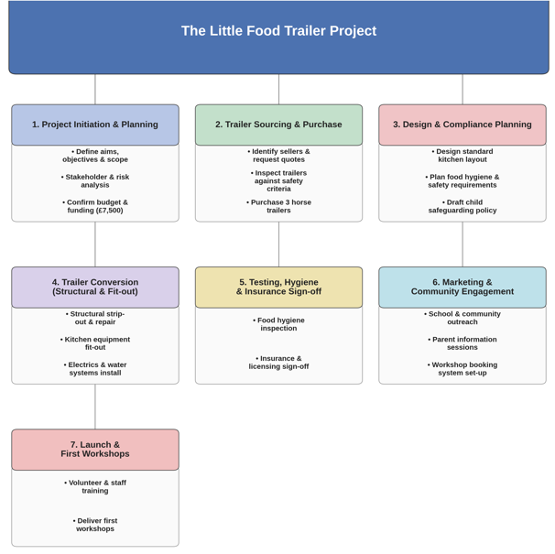

The Gantt chart phased the six months into planning and sourcing (January), design and early conversion (February–March), fitting and safety checks (April–May), and testing and handover (June), which gave the project a visible timeline. As with any schedule of this kind, the chart is only as reliable as the estimates behind it: used trailers may hide damage that only appears on inspection, and supplier delays are a realistic risk, so the schedule should carry contingency time rather than assume every stage happens exactly as planned (Larson and Gray, 2021).
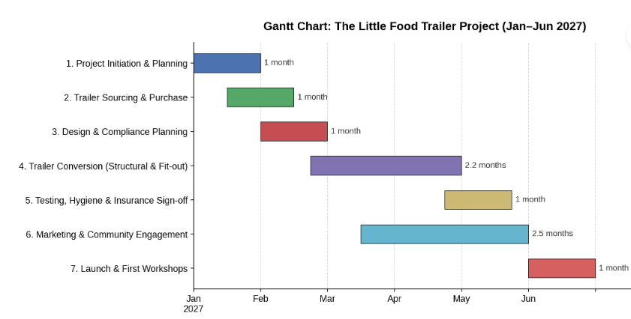
Risk management was one of the most important tools used on this project, because it combines used trailers, practical conversion work, a limited budget, children and food-related activity – several sources of uncertainty at once, rather than one. The risk register identifies hidden structural damage, budget overrun, supplier delays, electrical or plumbing faults, hygiene issues, safeguarding concerns, and poor communication, each paired with a mitigation, an owner, and a review point.
This moves the plan from optimism to practical control; without the owner and review columns, however, the register would risk sliding back into a static list of concerns rather than an active tool (Pinto and Slevin, 1987).
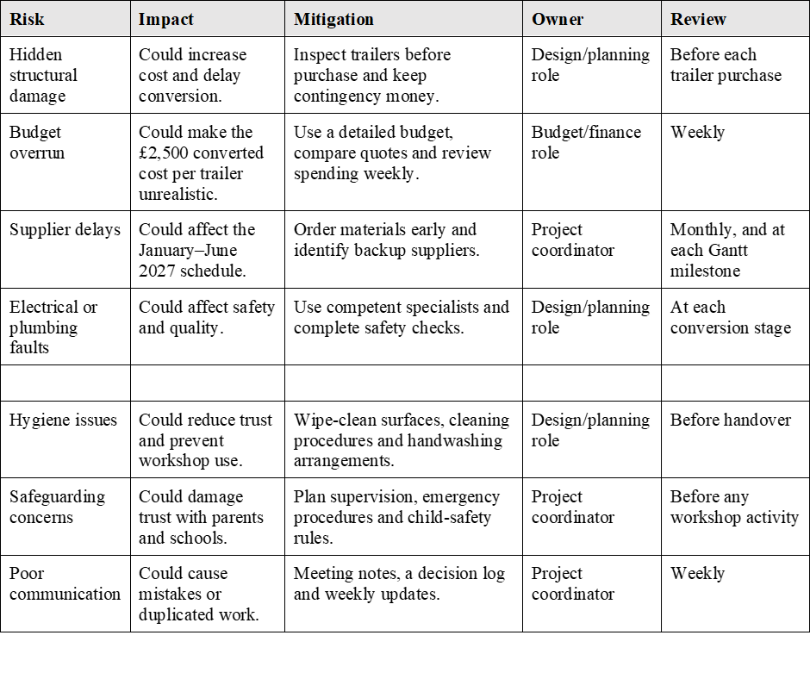

The Iron Triangle sets out the trade-off between the six-month time constraint, the roughly £7,500 cost constraint, and the requirement for genuinely safe, child-appropriate quality. This is useful for making trade-offs visible, but it says nothing about whether parents, schools or the Wiltshire community will trust the finished trailers, which is arguably the factor that determines whether the workshops ever take place; that is a stakeholder and communication question, not a time-cost-quality one, and is exactly why the Iron Triangle needs to be read alongside stakeholder analysis and risk management rather than on its own (Shenhar et al., 2001).
Within the team, the Plant role (Belbin, 2010) supported the creative, child-friendly design thinking the project needed, but creativity alone does not produce a workable schedule or budget, which is why it had to be balanced by the more structural tools – the WBS, Gantt chart and risk register.
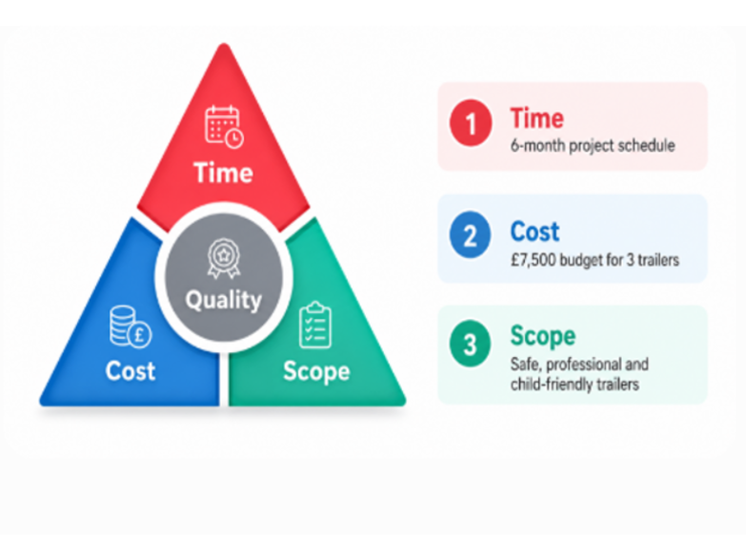

2.3 Communication and Stakeholders
The project had both internal and external stakeholders.
Internal stakeholders – the project team, project coordinator, and the budget/finance and design/planning roles within it – sit inside the organisation delivering the project and have strong influence because they control tasks, costs, decisions, and communication.
External stakeholders sit outside the delivery team but are still affected by or able to influence the project: children aged 6–11, parents or guardians, Wiltshire community groups, schools, trailer sellers, suppliers, skilled tradespeople, local authorities and insurance providers.

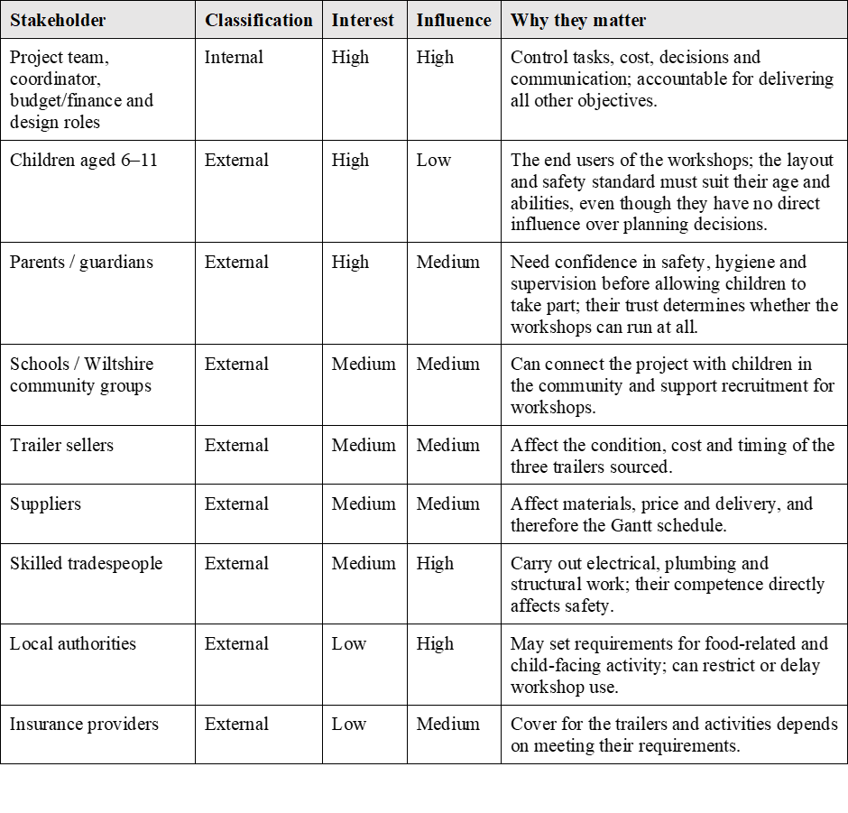

Children have high interest but no real influence over planning, so their needs are represented through parents, schools and the design of the layout itself rather than through direct consultation.
Parents and guardians combine high interest with real influence, since without their trust and consent the workshops cannot happen, so they need clear, reassuring information rather than technical detail.
Local authorities and insurers have lower day-to-day interest but strong influence, since they can restrict or delay activity if requirements are not met, so they need early, formal engagement rather than a late notification once the trailers are built.
The communication methods were matched to what each stakeholder actually needed, not simply chosen by habit: fast, informal channels where decisions could be revisited, and written, evidenced channels wherever trust, consent or legal compliance were at stake.
The main gap is not the choice of channel but the lack of a supporting record: a stakeholder register, decision log and weekly progress report would turn these individual conversations into a single, checkable communication plan, which would also make it easier to show local authorities and insurers that the project’s decision-making, not just its intentions, is under control (Burke, 2013).

3. Conclusion
This report has revealed that no one project management tool was sufficient by itself to plan.
The objectives of the Little Food Trailer needed a stronger evidence foundation before they could be considered completely precise and achievable.
The WBS needed the Gantt chart to add a deadline; and both needed the risk register to flag what could still derail them.
Along with these more technical methods, scope management, stakeholder analysis, and communication planning gave the project its social and communal dimension.
The aim, objectives, WBS, Gantt chart, risk register and stakeholder analysis all followed recognised project management logic, but conversion cost, trailer condition, supplier timing – are still assumptions, not facts, and safeguarding was addressed as a risk rather than built into the scope from the outset. The WBS and risk management forced the team to confront the real scale and uncertainty of the work; the weaker areas were budgeting and the formal recording of communication and risk ownership.

4. Future Improvement
Future improvement should focus on five areas:
- Safeguarding, hygiene and supervision should be part of the scope from the start, not treated as optional extras or left as risks to be managed later.
- The £2,500 converted cost per trailer is a reasonable target, but it should carry an explicit contingency for repairs, equipment, safety checks, insurance and supplier price changes, confirmed against real quotes rather than a single estimate.
- The January–June 2027 timeline is clear and appropriately short, but the team should allow extra time for trailer inspection, hidden damage, supplier delays and final testing, rather than assuming each stage will run exactly to plan.
- Risk management should assign an owner and a review date to every risk.
- Communication should be more formal and better recorded: a stakeholder register, decision log and weekly progress report would reduce the risk of losing decisions in informal channels such as WhatsApp, and would give parents, schools and local authorities clearer evidence that the project is under control.

References
Atkinson, R. (1999) ‘Project management: cost, time and quality, two best guesses and a phenomenon, its time to accept other success criteria’, International Journal of Project Management, 17(6), pp. 337–342. Available at: https://doi.org/10.1016/S0263-7863(98)00069-6. (Accessed: 27 June 2026).
Belbin, R.M. (2010) Team roles at work. 2nd ed. Oxford: Butterworth-Heinemann.

Bjerke, M.B. and Renger, R. (2017) ‘Being smart about writing SMART objectives’, Evaluation and Program Planning, 61, pp. 125–127. Available at: https://doi.org/10.1016/j.evalprogplan.2016.12.009. (Accessed: 19 June 2026).

Bourne, L. and Walker, D.H.T. (2005) ‘Visualising and mapping stakeholder influence’, Management Decision, 43(5), pp. 649–660. Available at: https://doi.org/10.1108/00251740510597680. (Accessed: 24 June 2026).

Burke, R. (2013) Project management: planning and control techniques. Fifth edition. Chichester, West Sussex, United Kingdom: Wiley.

Crawford, L. and Pollack, J. (2004) ‘Hard and soft projects: a framework for analysis’, International Journal of Project Management, 22(8), pp. 645–653. Available at: https://doi.org/10.1016/j.ijproman.2004.04.004. (Accessed: 01 July 2026).

Eskerod, P. and Lund Jepsen, A. (2016) Project Stakeholder Management. 0 edn. Routledge. Available at: https://doi.org/10.4324/9781315245881. (Accessed: 04 July 2026).

Freeman, R.E. (1984) Strategic management: a stakeholder approach. Boston: Pitman (Pitman series in business and public policy).

Gray, C.F. and Larson, E.W. (2021) Project management: the managerial process. Eighth edition. New York, NY: McGraw-Hill Education.

Hillson, D. (2025) Managing risk in projects. Second edition. London; New York: Routledge, Taylor & Francis Group.

Kerzner, H. (2022) Project management: a systems approach to planning, scheduling, and controlling. Thirteenth edition. Hoboken, New Jersey: Wiley.

Lock, D. (2018) Project management. 11th edition. London: Routledge.

Maylor, H. and Turner, N. (2022) Project management. Fifth edition. Harlow, England; New York: Pearson.

Meredith, J.R. and Shafer, S.M. (2022) Project management: a strategic managerial approach. Eleventh edition. Hoboken, NJ: Wiley.

Morris, P.W.G. (2013) Reconstructing project management. Chichester, West Sussex, UK: John Wiley & Sons Ltd.
Pellerin, R. and Perrier, N. (2019) ‘A review of methods, techniques and tools for project planning and control’, International Journal of Production Research, 57(7), pp. 2160–2178. Available at: https://doi.org/10.1080/00207543.2018.1524168. (Accessed: 28 June 2026).

Pinto, J.K. and Slevin, D.P. (1987) ‘Critical factors in successful project implementation’, IEEE Transactions on Engineering Management, EM-34(1), pp. 22–27. Available at: https://doi.org/10.1109/TEM.1987.6498856. (Accessed 03 July 2026).

Project Management Institute (ed.) (2019) Practice standard for work breakdown structures. Third edition. Newtown Square, Pennsylvania: Project Management Institute, Inc.

Project Management Institute (ed.) (2021) The standard for project management and a guide to the project management body of knowledge (PMBOK guide). Seventh edition. Newtown Square, Pennsylvania: Project Management Institute, Inc.

Shenhar, A.J. et al. (2001) ‘Project Success: A Multidimensional Strategic Concept’, Long Range Planning, 34(6), pp. 699–725. Available at: https://doi.org/10.1016/S0024-6301(01)00097-8. (Accessed:02 July 2026).

Singh, H. and Williams, P.S., 2021. A guide to the project management body of knowledge: PMBOK (®) guide. In Project management institute (pp. 1-8).

