Fundamentals of Construction Technology
ACBA4001
Construction Detailing

Contents Page
Introduction…………………………………………………………………………………3
Ground Floor………………………………………………………………………………3,4
First Floor………………………………………………………………………………….4,5
Eave Detailing & Roof Coverage……………………………………………………….5,6
Main Roof Structure……………………………………………………………………….6
Openings – Lintels, Sills and Jambs…………………………………………………...6,7
References & Sources…………………………………………………………………….8
Appendix A – Ground Floor
Appendix B – Ground Floor – Cross Section
Appendix C – Suspended Timber Floor
Appendix D – Partial Fill Cavity Wall
Appendix E – Roof Coverage
Appendix F – Closed Eave
Appendix G – Roof Structure – Queen Post Roof Truss

Introduction
A planning consent has been received to build a single, two-storey detached domestic building with a loft room. The main objective of this assignment is to produce the construction details of the whole building including the ground floor, first floor, second floor and the main roof structure, along with the relevant building regulations, materials and methods used.
Ground Floor
The building is to be built on a level, Greenfield site which has 450mm of topsoil above firm subsoil with a low clay content which is above the water table. As seen in Appendices A, B and C, the ground floor can be built using suspended timber flooring. The drawing portrays the cavity wall and load bearing wall on the left which supports the floor and overall structure. There are gaps within the walls to allow for natural ventilation throughout the building which will avoid moisture and condensation from the ground to cause any damage to the flooring. The gap between the bottom of the wall and the concrete should be at least 150mm. There is a DPC (Damp Proof Course) within the cavity walls and sleeper walls, as well as having natural ventilation throughout the building, DPC also reduces the risk of dampness throughout the building. Dampness can cause various problems such as mould growth which is a cause of respiratory allergies, mildew, decay and corrosion of the building fabric. The DPC acts as a barrier which is typically placed 150mm above ground level to eliminate damp rising through the walls. (DesigningBuildings.co.uk, Damp-proof course DPC, 2020). Approved Document C provides guidance on how to tackle dampness and where DPC can be placed to allow for maximum effect. (The Building Regulations 2010, Site preparation and resistance to contaminants and moisture).
The structure of the flooring consists of joists with hangers which are supported by sleeper walls placed horizontally with relation to the floor plans. The reason as to why the hanger method is used over the built in method is because it eliminates the potential of two different materials being used when they both have different elements about them and preform differently. The total amount of joists to be used and spacing measurements can be calculated using Table 1. Table 1 is from the BS EN 336:2013 standards for structural timber. For the ground floor on this particular building, the spacing between the joists would be 400mm due to the dead load being no more than 2.5kN/m². (British Standards Institution, 2013)
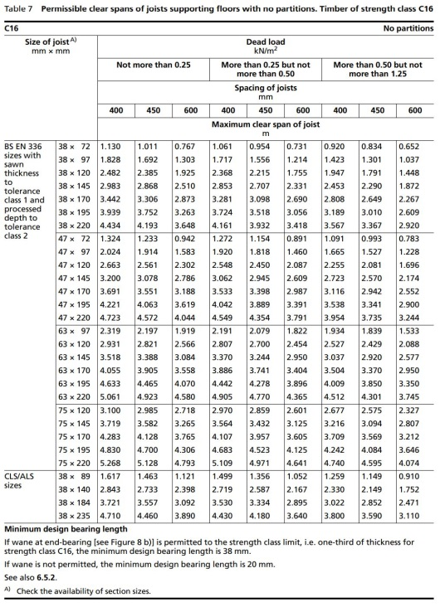

Table 1 – Permissible clear spans of joists supporting floors with no partitions.
Joist clear span (m) | Number of rows of strutting | Positioning
Up to 2.5 | None | N/A
2.5 to 4.5 | One | At the joist mid span
Over 4.5 | Two | At the joist one-third span
Appendix C shows struts placed in between joists to provide additional support, after determining the number of joists needed, the number of struts can then be figured out. Table 2 indicates the amount of struts needed and their positions.
Table 2 – Strutting required
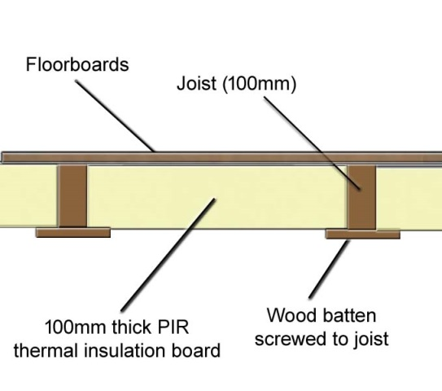
A problem found in Appendix B is that the insulation is located underneath the joists which could lead to the insulation not being continuous, however to solve this, the insulation should be placed in between joists. Insulation should be supported by battens which are screwed to the joist, as seen in Image 1. Due to height restrictions and considerations, insulation would not be able to be placed on top of the joists.

Image 1 – Insulation support diagram
After the joists, sleeper walls, struts etc. have been constructed, a subfloor would be placed, dry, flat and level before the actual timber flooring. A foam underlay can be used on top of the sub-floor to provide additional insulation if needed. The timber floorboards can either be nailed or glued onto the sub-floor. All this with accordance Approved Document A – Structure which covers all structural elements including foundations, walls, roofs and floors.
First Floor
Similarly to the ground floor, joists, sleeper walls, struts etc. can also be used for the construction of the first floor. The design is the same however, the spacing of the joists will be determined in another table due to the partitions on the first floor. Table 3 is also from the BS EN 336:2013 standards for structural timber. There are various solutions when a non-load-bearing partition is parallel to a joist such as adding another joist next to the joist where the partition is parallel to it, adding a noggin of a basic size of 38mm by 47mm to provide support for the partition.

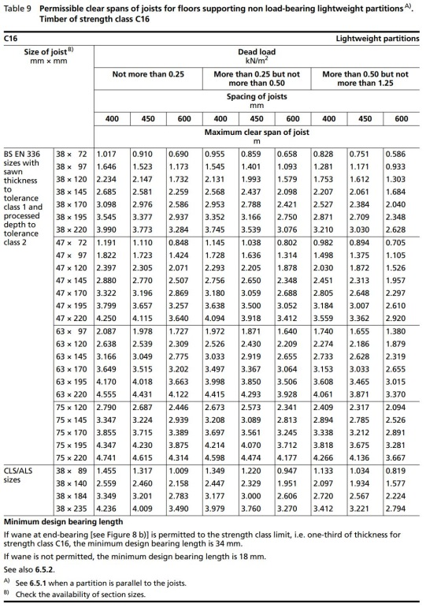

Table 3 – Permissible clear spans of joists for floors supporting non load-bearing lightweight partitions
Another difference between the construction of the ground floor and first floor is the construction of the finalised part of the flooring. Traditional solid timbers with tongue and groove softwood flooring are to be used for the upper floors. Tongue and groove fitting is similar to a jigsaw puzzle, whilst if cut correctly it should fit together smoothly. If any of the floorboards become loose, problems will occur especially to do with noise. To prevent this, similarly with the ground floor it can be nailed or glued down to a foam layer for a more secure fitting.
The external walls of the building are of a standard wall cavity construction with partial fill cavity insulation and a smooth render externally. The decision to use these walls was due to the weather protection, thermal insulation and noise attenuation they provide. Appendix D provides a diagram of the external walls to be used. It shows two walls, outer and inner, joined by metal ties with two weep holes visible at the bottom and partial fill cavity insulation next to the inner leaf. DPC is also constructed within the wall to prevent groundwater from being absorbed by capillarity action. The weep holes at the bottom allow air into the cavity whilst allowing water to drain out. External walls are defined in Regulation 2A of the Building Regulations 2000.
Eave Detailing & Roof Coverage
Appendices E and F provide information and diagrams of the roof coverage and the eave detailing of this building. The roof is to be covered in natural slate with closed eaves. A breathable membrane is to be placed under the roof battens and the slate shingles are to be nailed to the battens. The pitch of the slate shingles are at 40° and every slate is to be double nailed either at the top or in the centre. At the verges of the roof, half slates are traditionally used and the larger slates are used towards the lower part of the roof. British standards BS 5534:2014+A2:2018 gives recommendations for the design, installation and performance of new build pitched roofs. (British Standards Institution, 2014 & 2018). To determine the size of the battens, Table 4 is from BS 5534:2014+A2:2018.

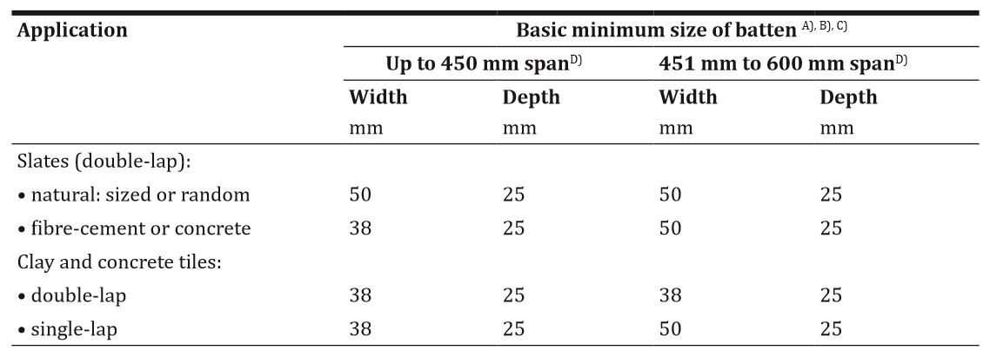

Table 4 – Minimum timber batten sizes
The eave detailing can be seen in Appendix F, the eave chosen was to be completely boxed in (closed eave). The purpose for having eaves is that it prevents weather elements from causing damage to the building fabric as it directs elements like snow and rain away from the building. Soffits are used in the roof as they provide a both aesthetic and functional purpose. They cover the eaves and prevent the rafter beams from being fully exposed. They also protect the rafters from weather elements and vented soffits allow air to flow through the building.
Main Roof Structure
Appendix G portrays a diagram of the roof structure, queen-post truss. The roof structure is to be trussed rafters at a 40° pitch; trussed rafters have support between one and three purlins and a ridge beam at the top. The advantages of trusses are that they can cover large spans and there is less of a need for intermediate load-bearing internal walls. The construction of them is typically quicker and they provide an economic use out of the material and provide minimal waste.
The queen posts are the tension members which will prevent the tie beam from sagging. The queen posts are kept in position by the straining beam and the straining beam keeps the junction in a stable position. The straining sill opposite the straining beam and is fixed on the tie beam, the purpose of it is to reduce the movement from the struts. The purlins are horizontal wooden members which are laid on the principal rafters on wall-to-wall to support the common rafter. In comparison to other trusses, the queen-post truss is lighter in weight and does not put weight on the centre of the main beam. Due to there being the need for storage area in the loft, queen-post trusses are the most suitable. They are also low in cost and can be made to fit any size or slope of roof. (Gharpedia.com/blog/queen-post-truss)
Openings – Lintels, Sills and Jambs
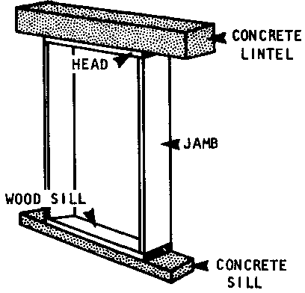

Image 2 – Diagram of a window opening
The windows and external doors are to be light oak wood with uPVC with sealed doubled-glazed units. The lintel is the horizontal part on the top that connects to both vertical supports, also known as the jamb. The sill is at the foot of a window opening.
Timber lintels will cover the whole span and will be supported at the jambs. It is more flexible than masonry and can bend without breaking, however, maintenance is essential. Stone lintels are similar in construction with timber but they are much heavier, no essential maintenance is required however, it is fragile and easy to break. Metal lintels are the fastest and cheapest solution but there can be problems with thermal bridging if not installed correctly. Metal lintels are also the best to use in cavity walls which would be practical as the external walls are cavity walls. Guidance on the lintel specification can be found in Building Regulations Approved Document Part M.
There are various materials that can be used for window sills such as wood, limestone, stone etc. Stone is the best as it is very moisture resistant and resists damage from sunlight. It is much easier to clean and has very little maintenance. Even though wood is the classic material for window sills, they are very vulnerable to water damage and are prone to damaging in sunlight. (https://www.doityourself.com/stry/window-sill-materials)

References
BSI Standards Publications, Slating and tiling for pitched roofs and vertical cladding, code of practice, 2015
BSI Standards Publication, Structural timber – Sizes, permitted deviations, 2013
https://www.designingbuildings.co.uk/wiki/Damp-proof_course_DPC
https://www.doityourself.com/stry/window-sill-materials
Gharpedia.com/blog/queen-post-truss
HM Government, The Building Regulations 2010 - Site preparation and resistance to contaminants and moisture, 2004 Edition, Approved Document C
Image 1 - https://great-home.co.uk/underfloor-insulation-of-suspended-timber-floors/
Image 2 - http://www.nzdl.org/gsdlmod?e=d-00000-00---off-0hdl--00-0----0-10-0---0---0direct-10---4-------0-1l--11-en-50---20-about---00-0-1-00-0--4----0-0-11-10-0utfZz-8-10&a=d&cl=CL1.16&d=HASH0120e3be1fcef504939676c2.5.5.1.3
Sources
https://www.ecologicalbuildingsystems.com/post/best-practice-approach-insulating-suspended-timber-floors
https://www.planningportal.co.uk/info/200130/common_projects/17/extensions/4
Ministry of Housing, Communities & Local Government, Structure: Approved Document A, 2013
http://www.legislation.gov.uk/uksi/2000/2531/contents/made
https://www.specialtydesign.com/blog/what-is-soffit-and-why-is-it-important-to-a-house/
https://www.designingbuildings.co.uk/wiki/Eaves
HM Government, Approved Document M: Volume 1 – Dwellings, 2016

