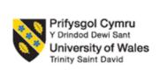
MBA International Business

LCMB7026
International Marketing: Principles and Practices

Assessment component 1

Individual report

Submitted by-
Name- Fatema Akter
ID-2519958

Submission Date: 13th August 2026
AI Acknowledgement
Category | Description | Allowed (Yes/No)
Research | For this assessment, you can use Generative AI to support you in research and data analysis. | Yes
Structure | You have permission to use Generative AI to assist you with structuring your submission here, such as providing a draft argument structure, finding parts and headings etc. | No
Proofreading | Grammatical or syntactical errors will also be acceptable for this evaluation if they were made by using the developed Generative AI to self-correct your text/creation, including rephrasing. | Yes
Writing | Text is created for submission for this assessment, and you may use Generative AI. | No
Creative | Generative AI can be used for creating creative materials (e.g., images) for this assessment. | No
Programming | Generative AI is allowed to generate and test code for this assessment. | Yes
None | For this assessment, you are not allowed to use any type of Generative AI support. This includes research support, structure support, writing/proofreading support and creative support.

Abstract
This report is a detailed study of Toyota Motor Corporation's marketing strategies in the international markets, a comparative study of Toyota motor Corp's marketing strategies in U.S and India. The study discusses macro environment using PESTLE and cross culture influences with Hofstede's cultural dimensions approach affecting Toyota's market approach. A detail analysis of Toyota's market segmentation, targeting, positioning strategies, evaluation of the 7Ps marketing mix, and the company's joint ventures for market entry in India has also been included. The ethics of marketing practices are critically evaluated, and examples of good sustainability efforts are identified, but there are also concerns about the transparency of emission claims. It has been shown how Toyota is achieving consistency in its global brand by leveraging its Quality, Durability, Reliability (QDR) strategy yet taking into consideration the different market-like characteristics—such as India's collectivist culture, which prizes affordability and relates to the family; and the individualistic, innovation-loving market in America. They lay special stress on the need for increased electrification, digitised interaction and improved marketing – always within an ethical framework. The reflective section captures personal learning through Gibbs' Reflective Cycle, noting increased analytical skills, ability to apply theory, and future needs to develop time management and academic writing skills.

Table of Contents
Abstract 3
Section 1 6
1. Introduction 6
1.1 Background of Toyota Motor Corporation 7
2. Comparative Macro-Environmental Analysis Using PESTLE Framework 8
2.1 Political Factors 9
2.2 Economic Factors 10
2.3 Social Factors 11
2.4 Technological Factors 14
2.5 Environmental Factors 15
2.6 Legal Factors 16
3. Cross-Cultural Analysis Using Hofstede Framework 18
3.1 Power Distance 18
3.2 Individualism vs. Collectivism 20
3.3 Masculinity vs. Femininity 21
3.4 Uncertainty Avoidance 22
3.5 Long-term Orientation 23
3.6 Indulgence vs. Restraint 23
4. Segmentation, Targeting And Positioning (STP) Analysis 24
4.1 Segmentation Strategies 24
4.2 Targeting Strategies 25
4.3 Positioning Strategies 25
5. International Marketing Mix (7ps) Analysis 27
5.1 Product Strategy 29
5.2 Price Strategy 30
5.3 Place (Distribution) Strategy 30
5.4 Promotion Strategy 32
5.5 People Strategy 34
5.6 Process Strategy 35
5.7 Physical Evidence Strategy 35
6. Market Entry Strategy Analysis: Toyota In India 37
6.1 Joint Venture Plan of entry 37
6.2 Manufacturing Investment Strategy 38
7. Ethical Marketing Evaluation 39
7.1 Ethical Marketing Practices 39
7.2 Unethical Marketing Practices 40
8. Recommendations for Future International Marketing Strategies 41
8.1 Recommendations for India 41
8.2 Recommendations for the USA 42
8.3 General Recommendations 42
Section 2: Reflective Account 44
Gibbs Reflective Cycle 44
Description 44
Feelings 45
Evaluation 45
Analysis 46
Conclusion 47
Action Plan 47
References 49

Section 1

1. Introduction
Founded in Japan in 1937 by the late Kiichiro Toyoda, Toyota Motor Corporation has grown to become one of the world's top auto manufacturers, competing in many global markets with different cultural, economic and regulatory environments (Toyota, 2026). The analysis is done based on various strategic models that measure Toyota's current position in the market and effectiveness of the operational management. The PESTLE framework is used to analyze the various factors that affect the business decision-making process in both countries, namely political, economic, social, technological, environmental, and legal factors (Kumar and Brar, 2024). Understanding the differences in the two markets in terms of consumer behaviours, communication styles, and brand image is gained through Hofstede's cultural dimensions. Under an STP analysis, it is observed that Toyota customizes the market by considering the demographic, geographic and psychographic factors of each country. Toyota has been successful internationally through a balance of both global standardisation and local customisation, which can be shown through the 7Ps marketing mix framework (Product, Price, Place, Promotion, People, Process, Physical Evidence) (Nathaniel et al., 2023).
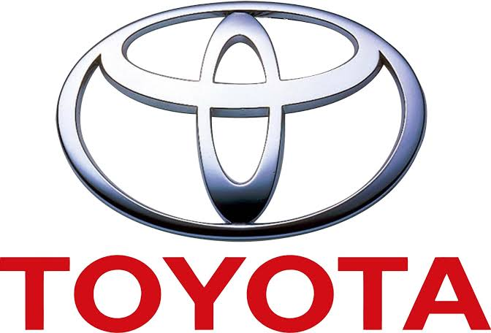
Figure: Toyota Motor Corporation (Toyota, 2026).

This report is a critical analysis of Toyota's market entry strategies, focusing on joint venture in India, which brings up both advantages and disadvantages, such as acquiring the local knowledge and mitigating risk and cultural conflict and the lack of the strategic control (Contractor and Lorange, 2023). Ethical marketing practices are discussed, reciprocating the idea that Toyota is committed to the environment but that the implications surrounding emission claims, transparency and price communication is of concern (Javalgi and Russell, 2018). The findings culminate in strategic recommendations for the future international marketing program, including the necessary diversification of the electric vehicle portfolio, the improvement of brand loyalty programs and digital engagement. Personal learning throughout this research process has been captured in a reflective component through Gibbs' Reflective Cycle which highlights the enhanced abilities to analyze, apply theory and to develop further to pursue international marketing.

1.1 Background of Toyota Motor Corporation
Kiichiro Toyoda established Toyota Motor Corporation on August 28, 1937 in Toyota City, Aichi Prefecture, Japan. The company initially began as a division of Toyoda Automatic Loom Works. Toyota made its initial market entry in the United States in 1957 (imported) and in India in 1997 (joint venture) and formed Toyota Kirloskar Motor (Toyota, 2026). The mission of the company oriented on creating the reliable vehicles which may serve to society, and the vision of the company directed to the development of innovative technologies (Attard-Frost et al., 2023).
Mission
The mission of Toyota is to be able to produce reliable cars that serve the society to establish value by innovation and sustainable mobility solutions (Toyota, 2026).
Vision
The objective of the company is to be the first in the world to create pioneer technologies that will attract environmental sustainability and carbon neutrality in 2050, as well as provide a sense of safety, quality, and consumer satisfaction (Toyota, 2026).

2. Comparative Macro-Environmental Analysis Using PESTLE Framework
Macro-environment: It is a broad externally based knowledge and factors that impact on the strategic choices and the operations of an organization and refers to forces and conditions that are highly external in nature like political, economic, social, technological, environmental and legal factors which are beyond the direct control of the company (Pascucci, Savelli and Gistri, 2023).
PESTLE Framework: It is a strategic analytical tool employed to analyse and assess the macro-environmental factors influencing a business systematically, divided into six essential factors called the six-factor framework, or more generally, external factors: Political, Economic, Social, Technological, Environmental and Legal (Kumar and Brar, 2024).
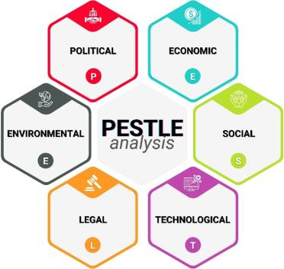
Figure: PESTLE Framework (Pascucci, Savelli and Gistri, 2023).

2.1 Political Factors
Definition: Political factors are government policies, trade policies, political calmness, foreign investment policies and foreign relations that can modify the conduct of business and market appeal (Kumar and Brar, 2024).
India
The political landscape of India is characterised by a stable democratic framework where the government has put favourable foreign direct investment policies, making it possible to invest 100% in the automotive industry (Kumar and Brar, 2024). The expansion of the interest in electric vehicle production in India with the help of such policies as Faster Adoption and Manufacturing of Hybrid and Electric Vehicles (FAME) scheme suits the sustainability strategy that Toyota pursues (Nathaniel et al., 2023). It could be favarable for one or both
Favourable: Healthy democratic government, 100 percent FDI right in the automobile sector, PLI system of hi-tech automobile technologies, India-Japan CEPA commerce accord.
Example: In 2021, the Production Linked Incentive (PLI) scheme was introduced to give financial aid to EV production, which will benefit the sustainability of Toyota (Nathaniel et al., 2023).
USA
The US has a stable federation and has Buy American policies, which sometimes face foreign manufacturers such as Toyota, with complexities, such as trade policies that impact import tariffs and regulations on environmental emissions and safety standards (Pascucci, Savelli and Gistri, 2023). The US offers a stable business environment due to political stability as a long-term business can be planned with considerable predictability; however, state-wide regulations need to be navigated with caution, especially in states with harsher regulations such as the state of California.
Unfavourable: Buy American measures, state-based differences in regulations, complicated importation tariffs.
Example: Section 177 of the Clean Air Act places stricter regulations on the emission levels of the state of California, forcing Toyota to tailor its cars to the state-level, making it a bit more complex to operate (Pascucci, Savelli and Gistri, 2023).

2.2 Economic Factors
India
The Indian economy has shown a strong growth with a rising number of middle-income consumers in the country that has a rising purchasing power in automotive products (Nathaniel et al., 2023). Indian automotive market has developed considerably, but price sensitivity is one of the crucial aspects of purchasing decisions. Infrastructure development and growth of the economy of the country have also led to a rise in consumer confidence and their willingness to spend on cars (Nathaniel et al., 2023).
Unfavourable: More sensitive to prices, income distribution, medium inflation (4-6 percentage range), risk due to currency fluctuations (INR/USD fluctuations affecting the prices of imports), and problems in the current account deficit.
Example: Inflation pressures in India (4.5-5.5% on average) escalate the costs of raw materials and components, and the depreciation of INR versus USD adds more costs in terms of importation of Toyota parts that are imported.
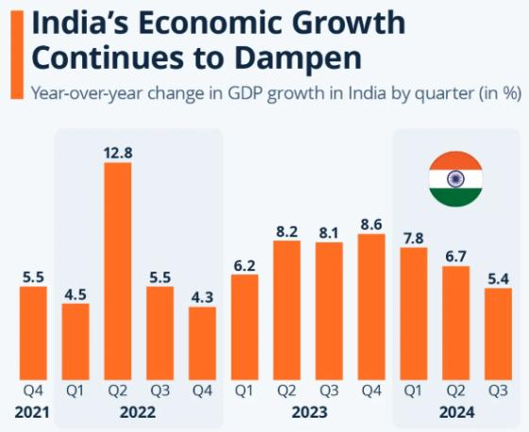
Figure: Economic Environment in India (Nathaniel et al., 2023).

USA
The US has the largest economy in the world and a high buying power of high quality and technologically advanced cars (Menzies et al., 2024). The US auto market is highly developed with most of the consumers favouring the SUVs, trucks and crossovers thus leaving Toyota with prospects in the high margin market segments. The more value and premium segment opportunities of Toyota are seen in the mature US economy (Filipovic and Arslanagic-Kalajdzic, 2023).
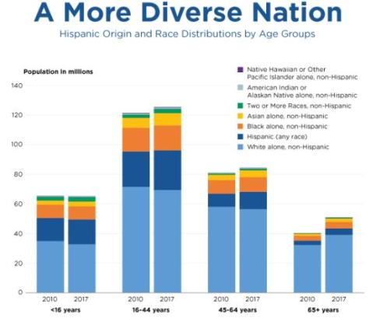
Figure: Social setting in United States (Leonisdou, Gruber and Schlegelmilch, 2022).
Unfavourable: Market saturation, inflation pressures (2-4% is moderate but varies) interest rate effects (high rates have negative effect on auto financing)
Example: The inflation in the United States (averaged 3-4% in 2024-25) has also raised the costs of producing vehicles but Federal Reserve changes in interest rates (shall be between 5.25-5.50 percent) also raised the cost of auto loans, which affect consumer affordability.

2.3 Social Factors
India
India is characterized by a young population that has formed a dynamic consumer group with growing car ownership dreams and an inclination to modern, innovative cars (Ong, 2025). The evolving position of women in the Indian society, rise in urbanisation, and transition to nuclear families have shifted preferences in the vehicles, establishing a need of compact cars and SUVs, which embodies feelings of utility and social standing (Leonisou, Gruber and Schlegelmilch, 2022).
Favourable: Huge and fast growing underage population (median age of about 28 years), steadily increasing disposable income of the middle class, urbanization that led to demand in vehicles, changing women participation in the workforce resulting into growth in consumer base forming a need in nuclear families (Ye et al., 2024)
USA
The U.S. has multicultural demographics and is characterised by high rates of vehicle ownership due to the very strong car culture entrenched in the American society (Leonisdou, Gruber and Schlegelmilch, 2022). The cultural diversity experienced in the US generates diversity in their preferences based on their demographics and various ethnic groups tend to have diverse preferences towards vehicles (Ong, 2025).
Unfavourable: Demographic preferences are too fragmented and require a number of marketing approaches, the aging population segments who have dissimilar mobility needs, market is oversaturated therefore growth potential is low (Correia et al., 2023)
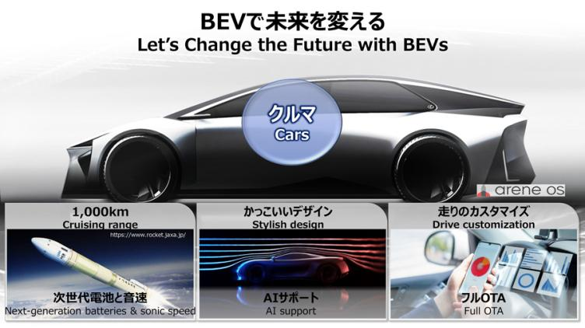
Figure: Indian technology Environment (De Mauro, Sestino and Bacconi, 2022).
Cultural factors using Hofstede model
Cultural aspects, according to Hofstede structure, are the communal values, beliefs, and behavioral patterns, which influence the tastes of consumers, their communication arrangements, and perception of their brands in a society.
India - Cultural Dimensions
India is a country with a high power distance, which means that the social structure is hierarchical, and societies are willing to accept unequal allocation of power in companies (Giraldo and Rosset, 2023). Family- and social network-level support is needed in purchase decisions, so Toyota must have marketing strategies that take such group interactions into consideration (Sigirci et al., 2022).
Advantage: Toyota can count on the support of celebrities and foster leadership but can mention respect towards authority and hierarchy openly. Referent relationships and groups, high family and community influence to purchasing decisions.
Disadvantage: Weak employee empowerment, reduced speed in decision making, cross rank communication barriers. Late buying on family consideration, marketing based on groups, which is difficult (Ye et al., 2024)
USA - Cultural Dimensions using Hofstede model
The US marketing campaigns leverage customer testimonials, user-generated content, and peer reviews to build trust, which aligns with American equality and horizontal communication (Leonisou, Gruber and Schlegelmilch, 2022).
Advantage: Employee empowerment, enhanced creativity, hastened decision-making, participative management. Individual route, self-reliance, independence, accessing individual shoppers easier.
Disadvantage: There is less acceptance to power, the difficulties with hierarchies, and it may also conflict with the Japanese management style. Low group loyalty, absence of brand loyalty, diminishing community influence.

2.4 Technological Factors
India
There has been a lot of change in India as the country has undergone a tremendous digital transformation due to telecommunications development and internet access, making it an opportunity to expand their connectivity and digital marketing (Pathak and Sharma, 2022). Nevertheless, the level of technological infrastructure differs in cities and rural locations, which means that Toyota will have to apply differentiation in market coverage (De Mauro, Sestino and Bacconi, 2022).
Unfavourable: Large urban-rural digital divide that hinders market reach, inconsistent technological foundation in states, reduced pace of high-tech automotive technologies compared to developed markets, less charging infrastructure for electric vehicles compared to developed market, reduced digital literacy in rural population curbing internet activity.
USA
The United States is most technologically innovative with automation, which means that Toyota can implement new technologies such as artificial intelligence, autonomous driving and telematics in cars (Menzies et al., 2024). The US has a large concentration of technology firms that offer partnerships and collaborations; through which Toyota can have access to the newest research and development provisions (Pascucci, Savelli and Gistri, 2023).
Favourable: Excellent technological infrastructure with connected car technologies, a robust research and development ecosystem, technology collaborations, good consumer adoption of technological advances in vehicles, well-established electric vehicle charging networks, leading technology firms to enable AI and self-driving partnerships, highly sophisticated digital marketing platforms to reach consumers in the target market (Ye et al., 2024)

2.5 Environmental Factors
India
India has also started to pay more attention to environmental sustainability by establishing laws that restrict emissions and raise fuel efficiency compared to its environmental stewardship philosophy (Nathaniel et al., 2023). The concentration of the government on the use of electric vehicles via different incentives and the creation of charging infrastructure can help Toyota sustainability mobility programs (Nathaniel et al., 2023).
Unfavourable: Insufficient electric vehicle charger systems nationwide, the initial prices of electric cars and power are more expensive than traditional cars, insufficient state support to create an electric charging system, low rate of movement to sustainable mobility, production of electric vehicles is based on coal-based electricity production, which undermines the environmental advantages of EVs, and not all states have identical policies on EVs.
USA
The US has strict policies regarding environmental policies in emissions and fuel economy, and the policies differ depending on states, especially in states with stricter policy, such as California (Nathaniel et al., 2023). The Toyota Company has been offered a chance through the environmental movement to market its sustainability programs as competitive advantages. With its strategic direction, the environmental focus in the US is in line with its commitment to carbon neutrality by 2050 and this will work in its favour (Randrianasolo and Semenov, 2022).
Favourable: Well-developed green movement and desire to have environmentally friendly products, established laws on emissions leading to innovation, increasing use of hybrid and electric vehicles, federal and state grants on EV purchases, stronger emission regulations in California therefore meeting the Toyota sustainability objectives, extensive use of charging systems to facilitate EV adoption, companies prioritizing green activities and fortifying brand reputation (Ye et al., 2024)

2.6 Legal Factors
India
The legal system of India comprises complicated labour legislation, corporate government acts, and competition acts that influence the working of Toyota and they need substantial expertise in the legal domain (Tan and Salo, 2023). The constantly changing legal environment with frequent amendments and regulations and policies changes requires one to monitor and change accordingly (Contractor and Lorange, 2023).
Favourable: Developed legal system with policies on foreign direct investment permitting 100 per cent FDI investment in the automobile industry, intellectual property protection regulations that promote technology transfer, government schemes such as Production Linked Incentive (PLI) scheme that boosts automobile production to increase trade relations, consumer protection laws that assure of fair business practice, and corporate governance laws that ensure transparency in business (Attard-Frost et al., 2023)
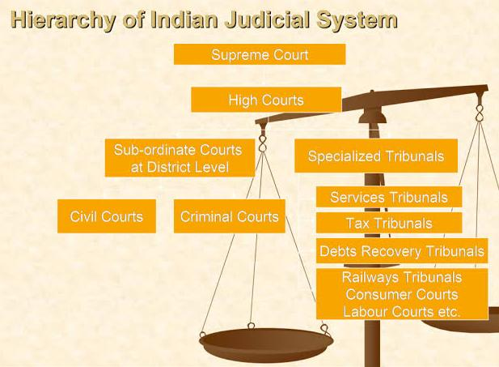
Figure: The legal system of India (Contractor and Lorange, 2023).
USA
The United States has a strongly developed legal framework consisting of thorough regulations on the safety, emissions, and marketing practices (Javalgi and Russell, 2018). The complexity of regulations is further enhanced by the state level differences in legal regulations, especially in states such as California, which have distinct environmental standards. The existence of well-organized industry associations and lobbying also impacts the legal environment in the way that Toyota needs to take an active part in the policy development (Zhou and Chen, 2023).
Unfavourable: The regulatory differences at the state level that demand changes in the products, complicated import tariff treatments that can challenge the cost competitiveness, Buy American strategies that lead to trade barriers among the foreign manufacturers, intense litigation environment with its associated legal risks, changing data privacy regulations with its implications to connected vehicle technologies, and high compliance fees in the face of regulations around the globe (Attard-Frost et al., 2023)
Similarities and Differences of the legal system of both countries
Factor | Similarities | India | USA
Political | Established democratic regimes, trade deals. | Benefits of PLI scheme, 100% FDI allowed. | State level regulatory differences, Buy American policies
Economic | Inflationary pressures, exchange rates | Emerging market, rising middle class | Great disposable income, saturation of the market
Social | Increasing automobile ownership desires | Young population, collectivist culture | Cultures Multicultural population, individualist culture
Technological | Digitalization, increase in connectivity | Urban-rural digital divide | Modern infrastructure, technology access
Environmental | Tough state-wide emissions laws | Development of sport, EV promotion | Strict state-level emission regulations
Legal | Strong regulatory frameworks, consumer protection | Complicated labour regulations, discrepancy in policies | State-level variations, litigious environment (Correia et al., 2023)

3. Cross-Cultural Analysis Using Hofstede Framework
Advantages and Disadvantages of Hofstede's Cultural Dimensions Model
Advantages | Disadvantages
Gives a systematic model of the differences in culture | Extrapolates complex cultures without regional and individual differences
Facilitates direct cross-cultural comparison based on standard dimensions | Practices assumption of cultures as being in the same state and does not assume evolution and globalization
Provides practical information in terms of advertising, branding and communication | On the basis of employee data about IBM, generalizability to larger populations is limited
Helps explain variations in consumer behaviour and purchase decisions | Ignores national dimensions not being uniform to all individuals (Attard-Frost et al., 2023)
Helps with operations, entering the market, and strategic planning | Fails to represent every culture such as religious or linguistic influences
Broadly accepted and tested by science | Constructed out of Western lenses, constraining applicability outside the west
Gives underpinning to the adjustment of the STP and 7Ps strategies | Ignores individual ethics and inclinations which happen to be against national inclinations

3.1 Power Distance
India
India ranks high on power distance, indicating the presence of a hierarchical social structure, and tolerance to unequal power distribution in organisations (Giraldo and Rosset, 2023). Toyota advertisements in India regularly include influential personalities and focus on the worldwide leadership and meticulousness of Toyota, which appeals to the attitudes of established power among the consumers (Leonisou, Gruber and Schlegelmilch, 2022).

Advantage: Toyota will have an opportunity to rely on the endorsement of celebrities and promote the idea of a massive leadership, a method that will openly refer to the respect to authority and hierarchy.
Disadvantage: Poor employee empowerment, less rapidity of decisions, communication blockages of the ranks.
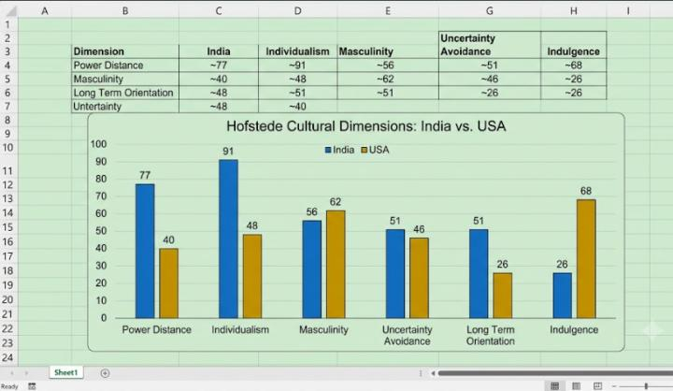
Figure: Hofstede cultural dimensions India USA (Leonisou, Gruber and Schlegelmilch, 2022).
USA
Power distance in the United States is much lower, so it is characterized by a preference to equal and less hierarchical relations on a social scale (Giraldo and Rosset, 2023). The US marketing campaigns used by Toyota capitalize on the concept of customer testimonials, user-generated content, and peer recommendations to develop trust, which corresponds well with the American culture of equality and horizontal communication (Leonisou, Gruber and Schlegelmilch, 2022).
Advantage: Gives employees more authority, enhances creativity, decision-making hastens, participative management.
Disadvantage: There is less acceptance to power, there is a challenge of hierarchies, and it may come against Japanese management style.

3.2 Individualism vs. Collectivism
India
India has a collectivist orientation indicating close community, kinship and devotion to social group (Ong, 2025). Collectivist orientation in India is a factor when making a purchase decision and the consumer has to have the support of the family members and social networks; therefore, Toyota needs to create marketing approaches to account for these group processes (Sigirci et al., 2022).
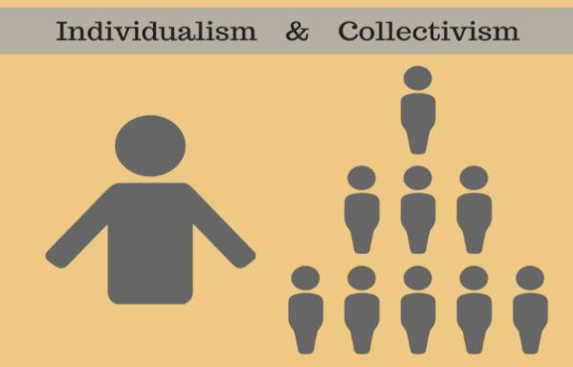
Figure: Individualism vs. Collectivism (Sigirci et al., 2022).
Advantage: A high family and community impact of buying decisions, referent groups and relationships.
Disadvantage: Delay in making purchases with a family consideration, complicated group-based marketing.
USA
The US is a highly individualist society with the focus put on personal success, independence and self-reliance (Ong, 2025). Toyota’s marketing communications emphasize individual success stories and the autonomy that ownership of the vehicles makes possible and appeal to American ideals of autonomy and autonomy (Sigirci et al., 2022).
Advantage: Find your own path, self-reliance, independence; relatively more comfortable to reach out to individual shoppers.
Disadvantage: Weak group loyalty, lack of brand loyalty, reduced community influence.

3.3 Masculinity vs. Femininity
Male Orientation in India
India has an average level of masculinity orientation, in which there is a balance of masculine and feminine values (Leonisou, Gruber and Schlegelmilch, 2022). The progressive gender roles of Indian society necessitate that Toyota makes sure marketing messages are more welcoming yet appealing to the conventional values (Ong, 2025).
Feminine Orientation in the U.S
The US is characterized by a somewhat masculine society, however, with a emphasis on success and with caring, quality of life, and elitacy towards the environment (Leonisou, Gruber and Schlegelmilch, 2022). Marketing of hybrids and electric vehicles is of particular interest to the company because of its appeal to the sense of environmental awareness and shared responsibility (Leonisou, Gruber and Schlegelmilch, 2022).
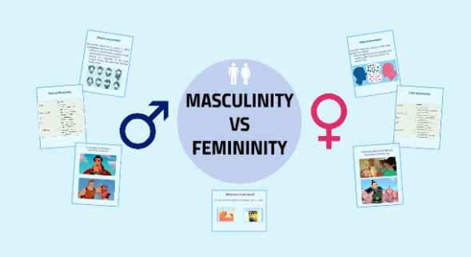
Figure: Masculinity vs. Femininity (Leonisou, Gruber and Schlegelmilch, 2022).

3.4 Uncertainty Avoidance
Moderate Uncertainty Avoidance in India
India has moderate uncertainty avoidance, which means that they are comfortable with uncertainty and ambiguity (Giraldo and Rosset, 2023). Uncertainty acceptance creates an opportunity to enter the Indian market with new models with less consumer resistance as compared to higher uncertainty avoidance cultures (Sigirci et al., 2022).
Increased Uncertainty Avoidance in the United States
Uncertainty avoidance is found to be higher in the United States, though, which means that people prefer structure and predetermined courses of action (Giraldo and Rosset, 2023). Higher uncertainty avoidance also affects the product development of Toyota, whereby they need to spend a lot of time educating the consumers before they can adopt the product in large numbers (Sigirci et al., 2022).
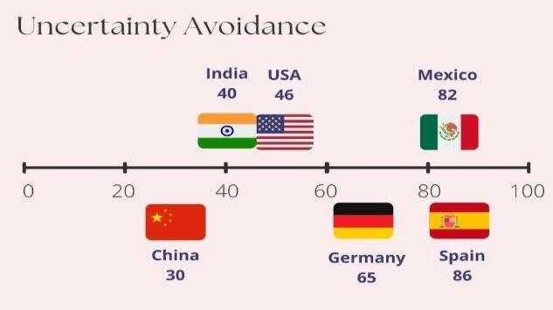
Figure: Uncertainty avoidance (Giraldo and Rosset, 2023).

3.5 Long-term Orientation
India- Long-term Orientation
India has demonstrated a high long-term orientation, which corresponds to pragmatic approach with appreciation of long-term planning and traditions (Filipovic and Arslanagic-Kalajdzic, 2023). The cultural tradition of the Indian population presupposes the marketing of Toyota to be respectful to the traditional culture but introduce innovative products (Randrianasolo and Semenov, 2022).
United States short-term Orientation
In the US marketing, Toyota emphasizes short-term gains of vehicle ownership, such as the pleasure of driving it and its sophisticated technological characteristics. The American orientation towards outcomes implies Toyota needs to focus on fast money and instant gratification in marketing (Randrianasolo and Semenov, 2022).

3.6 Indulgence vs. Restraint
Moderate Restraint in India
India has a moderate restraint with a focus on self-control and the restraint of gratification (Giraldo and Rosset, 2023). Toyota marketing in India focuses on the practical aspects such as reliability, safety and utility of the family unlike all the excitement. The restraint orientation implies that the marketing of Toyota should not be too extravagant but rather respectful and moderate (Pascucci, Savelli and Gistri, 2023).
Luxurious Culture in the U.S
The level of indulgence in the United States is high, as it promotes unrestrained satisfaction of human needs associated with pleasure in life (Giraldo and Rosset, 2023). The luxury culture allows Toyota to position the cars as the lifestyle goods that help to make the life of an individual happier and more fulfilling (Pascucci, Savelli and Gistri, 2023).

4. Segmentation, Targeting And Positioning (STP) Analysis

4.1 Segmentation Strategies
India
Demographic: Income (ENTRY: 3-6 lakh - Glanza;mid-range: 6-15 lakh - Innova; high-end: 15-plus lakh - Fortuner),
Geographic: Urban metros (Mumbai, Delhi - high-end showrooms), Tier-2 cities (Pune - value models), Tier-3/rural (inexpensive cars, good service network).
Psychographic: Family oriented (Innova Crysta - space, safety) , Status oriented (Fortuner - prestige), Value oriented (Glanza - fuel efficiency).
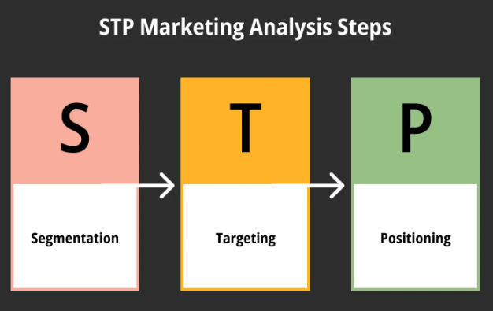
Figure: STP Analysis (Zhao, 2022).
USA
Demographic: (mass-market): Income (50-100k - Camry; 100-200k - Highlander), Age (25-40 old-fashioned - connected cars), (18-25 old-fashioned - social media marketing), ethnicity
Geographic: West Coast (EVs/ hybrids - Prius, bZ4X because of environmental focus), South (Trucks - Tundra, Tacoma),
Psychographic: Adventure lovers (Tacoma - off-road), Eco-attentive (Prius - sustainability), Tech-attentive (AI features - autonomous driving)

4.2 Targeting Strategies
India
The company focuses on young city professionals and families in metropolitan and Tier-2 cities which have high levels of vehicle ownership aspirations. The targeting strategy adopted by Toyota focuses on creating long-term relationships with this growing group of consumers (Sari et al., 2023).
USA
Toyota has a more differentiated targeting approach in the US, using multi-segment targeting among different demographic and psychographic segments (Zhao, 2022). Families are targeted in diverse SUVs and cars with safety in consideration. The targeted communications target consumers who are environmentally conscious regarding the offerings of hybrid and electric vehicles by Toyota (Leonisou, Gruber and Schlegelmilch, 2022).

4.3 Positioning Strategies
Perceptual Map: Toyota Positioning
India - Price (Low/High) vs Quality (Low/High)
Toyota is a premium quality and premium price product. QDR (Quality, Durability, Reliability) foundation. With Maruti Suzuki (low cost) and Hyundai (feature-rich) above in terms of reliability (Sari et al., 2023).
There exists a correlation between Price (Low/High) and Innovation/Sustainability (Low/High) in the United States.
Innovation and sustainability are led by Toyota. Leadership in beyond zero and hybrid technologies. A pragmatic leader of the EV transition, a competitor of Tesla (pure EV), Ford (heritage), Honda (reliability), (Leonisou, Gruber and Schlegelmilch, 2022).
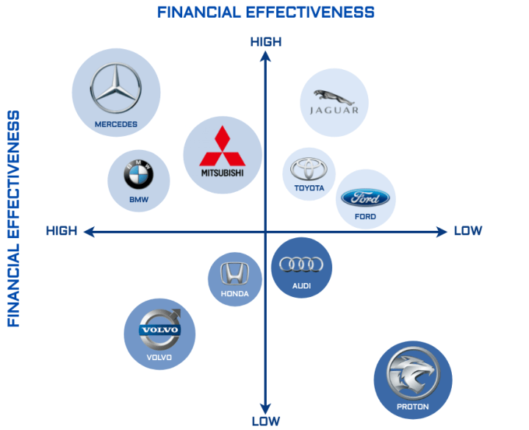
Figure: Perceptual Map: Toyota Positioning (Sari et al., 2023).
The similarities between India and the USA Positioning
Reliability and Quality Foundation: Both markets put Toyota on its core business philosophy which is the Quality, Durability and Reliability (QDR) philosophy that focuses on long term value, trust and proven durability as key brand attributes.
Premium Pricing and Safety Focus: In both markets, Toyota has a premium pricing (10-15% higher than the mainstream rivals) but with Toyota Safety Sense and smart safety systems as key messages to be emphasized to the family-oriented customers.
Hybrid Technology Leadership: The two countries make Toyota the leader in hybrid and sustainable mobility technology by using the credibility of the environmental factor and the promise made by the brand to become carbon neutral by the year 2050.

Differences
Aspect | India | USA
Core Statement | "Built for Indian roads, trusted for Indian families" | "Let's Go Places" with "Beyond Zero"
Key Differentiator | Quality, Durability, Reliability | Innovation, Sustainability
Cultural Appeal | Family, tradition, status | Freedom, lifestyle, adventure
Competitors | Maruti (affordable), Hyundai (features) | Tesla (EV), Ford (heritage), Honda (reliability)
Key Models | Innova (utility), Fortuner (status) | Prius (eco), Tacoma (adventure), Lexus (luxury)
Brand Personality | Traditional, dependable | Modern, innovative

5. International Marketing Mix (7ps) Analysis
Marketing Mix: Marketing Mix can be defined as the components and elements of marketing that are under control and a marketing strategy that a firm applies within its reach to achieve the desired reaction of the target market. It involves a holistic approach to the product, price, place, promotion, people, process, and physical evidence (7Ps) that interact and combine to meet customer needs and organizational goals (Nathaniel et al., 2023).
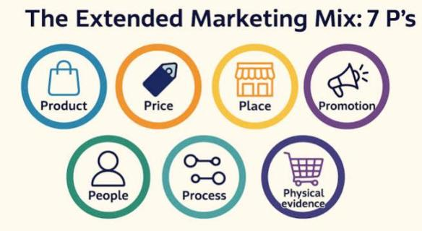
Figure: Marketing Mix 7ps (Nathaniel et al., 2023).
Similarities and Differences of Marketing Mix (7ps) Analysis
Similarities: Toyota has a similar philosophy of brand all around the world including the two markets and it is based on Quality, Durability, and Reliability (QDR). Both utilize high quality pricing (10-15% premium over competitors), franchise based networks of dealerships and digital platforms, and Integrated Marketing Communications. People strategy focuses on training of Toyota Production System, process management is with lean manufacturing, physical evidence approves premium positioning with modern facilities (Ye et al., 2024)
Differences: India opts to a great product localization with high family scaled Innova Crysta, as well as status and urban youth targeted Fortuner with elevated ground clearance and stronger cooling. It is also distributed through 400+ dealerships, pricing is value-based with FAME subsidies. Promotion will be based on the use of celebrity endorsement, festival campaign messages, and the family message. In USA, the localization is moderate and includes exclusively bZ4X EV, Camry sedans, and Tundra trucks (Attard-Frost et al., 2023)s
Pricing serves higher premium segments, which have been spread across 1,200+ dealerships over omnichannel strategies. Publicity focuses on Super Bowl advertisements, NASCAR and Beyond Zero campaigns. India has a hierarchical culture and employs 8,000 people, and USA employs 45,000 people with diversity initiative, integration of robotics and dealerships of experience (Correia et al., 2023)

5.1 Product Strategy
India
In India, Toyota is highly localised in terms of the way it goes about creating its product to meet the requirements of the Indian market (Sari et al., 2023). The firm has also introduced certain models that cater to the needs of the Indian family like the Innova Crysta that has a bulk interior (Rachmad, 2025b). India Toyota also modifies their vehicles to suit the Indian roads, such as increased ground clearance, better suspension systems, and better cooling systems in hot Indian climate. The company has a wide range of products with models such as compact cars like Glanza to upscale SUVs such as Fortuner and luxury vehicles such as Camry hybrid.
Examples of Product Strategy in India
Toyota Innova Crysta is distinctly made to suit the family needs of Indians with 7-8 seater capacity, rugged suspension to meet Indian road conditions, and improved cooling systems to meet the climatic conditions of tropics. Its reliability, safety facilities, and the ability to use it by a joint family have made it the favorite family car in India.
USA
The US product strategy involves a higher degree of standardisation of world Toyota models and cars are customised to US standards to comply with regulatory standards (Rachmad, 2025b). The company has also unveiled some hybrid and electric models, which are exclusive to the US market such as the bZ4X electric vehicle (Nathaniel et al., 2023). Toyota sells a diverse variety of cars in the US such as sedans such as Camry, SUVs such as Highlander and RAV4, trucks such as Tacoma and Tundra, the luxury cars through the Lexus brand. The product strategy focuses on high-tech, safety and performance to suit American consumer expectation.
Examples of Product Strategy in USA
Toyota Camry is the number one American market dealer as a seller of comfortable ride, reliable and fuel-efficient vehicles. The model complies with US safety regulations and has some high-tech features without compromising the international Toyota standards of quality, which are trusted by American consumers (Kumar and Brar, 2024).

5.2 Price Strategy
India
In India, Toyota adopts the concept of value-based pricing and writes its cars off as possessing a better value in terms of quality and reliability (Ijomah et al., 2024). The pricing by Toyota incorporates differentiation pricing in different models of the company such as lower cost compact motor vehicles to the rich life time luxury of sports utility vehicles (Kumar and Brar, 2024).
USA
The pricing strategy of the US is to give significantly higher prices to Toyota cars, which places the brand in middle to the very high quality segment (Rachmad, 2025a). It has also provided a range of financing and incentives to enable access to vehicles with a positioning of high prices (Kumar and Brar, 2024).
Factors Which Will Alter the price
India: The price of raw materials, GST, custom duties on imports, the INR/USD exchange rate volatility, inflation, competition: Maruti / Hyundai, and subsidies by FAME on EVs.
USA: Federal reserve interest rates, cost of materials and labor, CAFE compliance, import tariffs, consumption demand and inflationary pressures.
In both markets, Toyota will be required to change the prices depending on the factors of production costs, taxation, economic and competitive forces to ensure profitability and market share.

5.3 Place (Distribution) Strategy
India
The Toyota Company has built a strong distribution network in India that has more than 400 dealer outlets in over 240 cities (Filipovic and Arslanagic-Kalajdzic, 2023). The network of dealerships provides the test drive option, lease options, and after-sale services (Pascucci, Savelli and Gistri, 2023).
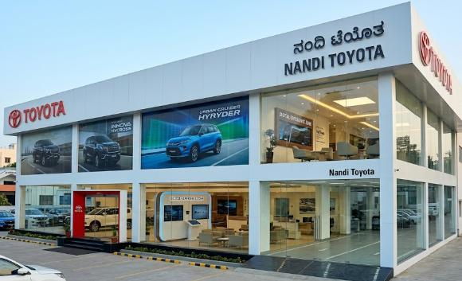
Figure: Toyota Dealership – India (Pascucci, Savelli and Gistri, 2023).
USA
In the US, Toyota has more than 1,200 dealerships in each of the states (Filipovic and Arslanagic-Kalajdzic, 2023). Toyota US distribution has progressed to incorporate omnichannel strategies wherein customers go online to research and buy cars. The dealership chain contains up-to-date plants that deliver customers with high-quality experiences (Pascucci, Savelli and Gistri, 2023).
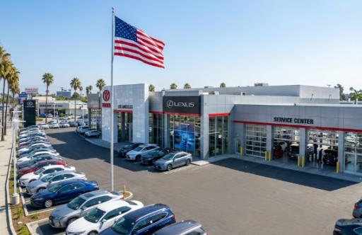
Figure: Toyota Dealership – India (Pascucci, Savelli and Gistri, 2023).
Channel of distribution
Toyota employs directs in the two countries. Direct channels consist of online booking applications, mobile apps and digital showroom whereas the indirect channels consist of authorized dealerships being the main channel as well as fleet sales to corporate clients.
In India, Toyota operates 400+ dealerships in 240 cities via Toyota Kirloskar Motor, and the online services with the mobile booking app. Toyota has 1,200 + dealerships in all 50 US states via Toyota Motor Sales USA and highly developed Omni-channel plans and regional distribution centers (Pascucci, Savelli and Gistri, 2023).
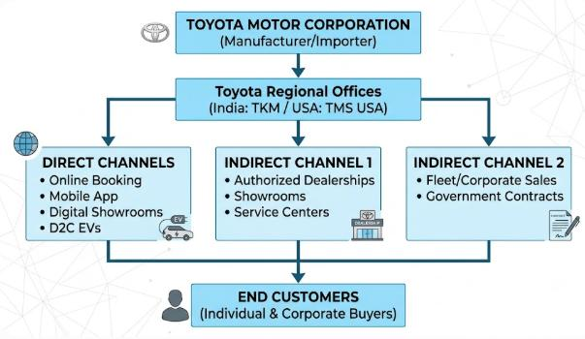
Figure: Distribution channel diagram (Ijomah et al., 2024).

5.4 Promotion Strategy
Promotion Strategy thrown into context:
Promotion strategy can be defined as the interaction that a company maintains with targeted consumers to inform, convince, and remind them about products and brands (Tanwar, Chaudhry and Srivastava, 2022).

Figure: Promotion Strategy (Tanwar, Chaudhry and Srivastava, 2022).
Integrated Marketing Communications (IMC):
Definitively Bekesy (1998, p. 307) defines the concept of integrated marketing communications (IMC). The strategic alignment of all promotional messages and channels is called Integrated Marketing Communications (IMC) that provides harmonious, transparent, and powerful brand communication through multiple touchpoints with a uniform brand message delivered by advertising, public relations, digital marketing, sales promotion, and direct marketing (Tanwar, Chaudhry and Srivastava, 2022).
Examples of promotion in India:
Toyota reaches out to Indian consumers through television commercials with celebrities in their ads such as Virat Kohli, digital campaigns on YouTube and Instagram, approach to influencers, Diwali promotions, and involvement of social media.
The examples of promotion in USA:
Some of the tools employed by Toyota include advertisements in Super Bowl, NASCAR, Let's Go Places, Beyond Zero campaigns, Tik Tok and Instagram marketing to the younger audience, as well as high profile adverts in American media (Pascucci, Savelli and Gistri, 2023; Rachmad, 2024).

5.5 People Strategy
Definition: The concept of people strategy is the process by which an organization recruits, trains, motivates and retains its employees in order to provide quality service and meet organizational goals (Rachmad, 2024).
India: People strategy in India specifically focuses on thorough training of the employees and the introduction of lean management practices (Rachmad, 2024). The people strategy is built around collaboration, respect to each other, and correspondence to corporate values (Sari et al., 2023).
USA: Toyota people strategy in the US has a highly trained staff in dealerships and service centres (Rachmad, 2024). Diversity and inclusion: Toyota invests in diversity and inclusion initiatives, which provides the company with a workforce representative of the cultural diversity of American consumers. One approach to the people strategy is continuous training and employee engagement programs (Tan and Salo, 2023).
Total Employees: There is a total of about 370,000 employees of Toyota international. Toyota Kirloskar Motor in India has an approximate of 8,000 workers both in the manufacturing plants and in the dealership. Toyota Motor North America has around 45,000 people working in the manufacturing, R&D, and dealership units in the USA (Toyota Global, 2023).
Training Programs: The countries have extensive training that involves Toyota Production System (TPS), customer service excellence, training of technical skills and training of leaders. India pays emphasis on lean management practice whereas USA stresses on T-TEN training and cross-cultural training of technicians.
Motivation Strategies: The motivational strategies of employees incorporate performance-related rewards, career advancement, recognition and involvement programs that promote teamwork and respect of human beings.
Customer Complaint Process: Toyota has a systematic complaint procedure: customers post their complaints and responses through dealership, Web-based portal or hotline; complaints are registered and classified; service unit investigates and responds; solution is given within the stipulated period; feedback is taken care of to improve, and follow-up is made to achieve satisfaction (Tan and Salo, 2023).

5.6 Process Strategy
India: The process approach of Toyota in India aims at effective production with the lean management practices (Edelman, 2023). The good schedule and fast turnaround of service fall under service processes. Process strategy applies to online processes such as online booking systems and customer ports (Pascucci, Savelli and Gistri, 2023).
United States: The US process approach of Toyota focuses on technology innovation and automation, and the use of robotics and AI (Edelman, 2023). The process strategy also involves continuous improvement programs that ensure that Toyota has a reputation of being reliable (Pascucci, Savelli and Gistri, 2023).

5.7 Physical Evidence Strategy
Definition: Physical evidence entails the physical components and the surrounding in which customers interact with a brand, such as facilities, online presence, and visual aids (Edelman, 2023).
India: Toyota physical evidence approach in India consists of building contemporary dealership buildings that represent the premium positioning (Edelman, 2023). This plan involves the richness of service centres, which are fitted with new diagnostic systems (Rachmad, 2025b).
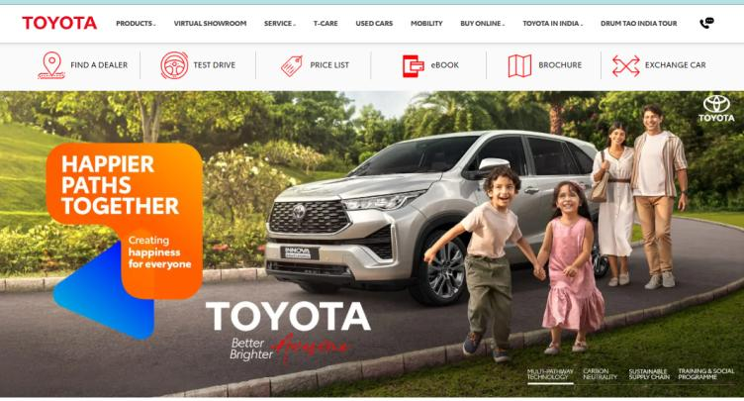
Figure: Toyota Website India (Edelman, 2023).
US: The US physical evidence plan of Toyota focuses on high-end and experiential dealerships that have innovative designs and interactive displays (Edelman, 2023). Physical evidence encompasses professional and contemporary facilities with better positioning. Service centres are equipped with modern equipment and experts (Zhao, 2022).
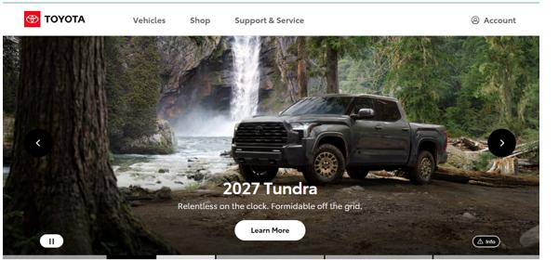
Figure: Toyota Website US (Zhao, 2022).

6. Market Entry Strategy Analysis: Toyota In India

6.1 Joint Venture Plan of entry
Why Toyota Chose Joint Venture
The joint venture also enabled Toyota to exploit the local networks, government relations and knowledge of the Indian business strategies that Kirloskar had and still retain control of technology. This approach reduced the risks and the costs of investment as compared to the fully-owned subsidiary (Contractor and Lorange, 2023).
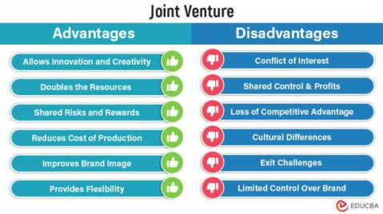
Figure: Joint Venture entry (Contractor and Lorange, 2023).
Partnership with Kirloskar Group
In 1997, Toyota initiated a joint venture with Kirloskar Group and started operating in India under the name Toyota Kirloskar Motor (Contractor and Lorange, 2023). This type of partnership enabled Toyota to take advantage of local knowledge and have a substantial control on operations and technology. The joint venture was an effective strategy to enter complicated markets with substantial regulations and cultural requirements (Rachmad, 2025a).
Advantages of Joint Venture: Toyota has acquired local knowledge, distribution outlets, unequivocal assault on financial hazards, headscarf asymmetry, refunded governmental status, brand trustworthiness, expedited applications, and comprehension of customer tendencies (Rachmad, 2025).
Disadvantages of Joint Venture: Toyota had conflicts with its cultures, limited strategic control, and issues with technology transfer, profit sharing, coordination issues, and possibility of partner’s conflict of interests (Zhao, 2022).

6.2 Manufacturing Investment Strategy
Greenfield Investment to produce
The Greenfield investment plan of Toyota in India involves building of manufacturing plants with high production capacity (Contractor and Lorange, 2023). The investment has helped to build the brand perception of Toyota in India, which shows an interest in the market (Nathaniel et al., 2023).
There are Strategic Advantages to Manufacturing Investment
Green field investment helped to give Toyota cost advantages due to local production and ability to react to market demand change in a rapid manner (Contractor and Lorange, 2023). The investment has enhanced the attachment of Toyota in India and has navigated it a long term presence towards future. The manufacturing investment has enhanced the brand image of Toyota in India (Nathaniel et al., 2023).
A strategic alliance will be worked out with Suzuki
Partnership to make small cars
The fact that Toyota partnered with Suzuki Motor Corporation to carry out its operations in India can be viewed as an important extension of one of the strategies through which the company will enter the Indian market (Contractor and Lorange, 2023). This partnership has helped Toyota launch such models as the Toyota Glanza and Urban Cruiser that use the expertise of Suzuki in the compact car market, but apply the Toyota quality criteria (Ijomah et al., 2024).
Advantages and disadvantages of the Suzuki Alliance
The strategic alliance allows Toyota to gain such advantages as the ability to utilize existing dealer networks and production sites (Contractor and Lorange, 2023). Toyota has countered these issues by having explicit agreements, preserving brand differentiation and enjoying cost benefits (Ijomah et al., 2024).

7. Ethical Marketing Evaluation

7.1 Ethical Marketing Practices
Greene initiatives are environmental and sustainable
Toyota has portrayed positive ethical marketing behaviour in terms of extensive environmental activities and sustainability messages (Nathaniel et al., 2023). The fact that Toyota is involved in community development programmes shows its adherence to ethical socially responsible practices outside the normal business operations (Edelman, 2023).
Equal Treatment and Openness
Toyota has been an ethical marketer by taking care of transparent advertisement and reflecting the true feature of their vehicles (Javalgi and Russell, 2018). The advertising used by Toyota is in line with advertising standards and therefore, the messages are honest and not damaging (Tan and Salo, 2023).
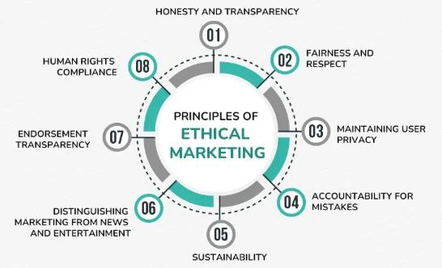
Figure: Ethical Marketing (Javalgi and Russell, 2018).

7.2 Unethical Marketing Practices
Misleading Emissions Claims
Although Toyota has been largely ethical in its practices, there were those cases of dubious marketing with regards to emission claims (Javalgi and Russell, 2018). Toyota has already dealt with these issues by making the advertisement more accurate, but the rest is not so simple (Leonisou, Gruber and Schlegelmilch, 2022).
Pricing Transparency Issues
There have been problems of pricing transparency, where the prices advertised do not include all the on-road costs (Javalgi and Russell, 2018). The firm has also been placing more emphasis on transparent pricing messages using online avenues, which offer a breakdown of the costs (Edelman, 2023).
Safety Recall Communications
The way Toyota handled the communication of the safety recalls has posed some ethical issues, in which the initial communication/actions of the company have been criticised as being slow (Javalgi and Russell, 2018). The reaction of Toyota has also been improved greatly in recall procedures and contact with consumers having created new guidelines on transparent communication (Tan and Salo, 2023).

8. Recommendations for Future International Marketing Strategies

8.1 Recommendations for India
Diversify Electric Vehicle Portfolio
Toyota would be better to quicken the electric vehicle launch in India with more EV models priced at affordable rates and work together with the government to build charging infrastructure (Nathaniel et al., 2023). Toyota needs to tap into international hybrid learning capacities by coming up with affordable EVs targeting the Indian market to build on range anxiety through innovations (Ijomah et al., 2024).

Figure: Diversify (Ijomah et al., 2024).
Strengthen Digital Engagement
Toyota needs to improve online communication with sophisticated platforms and individual customer experiences (De Mauro, Sestino and Bacconi, 2022). Toyota must establish all-inclusive digital ecosystems offering customisation, clear pricing and easy service reservation. The younger consumers should also be reached through the use of social media and influencer relationship by the company (Tanwar, Chaudhry and Srivastava, 2022).
Improve Availability of After Sales Service
The Toyota should enhance its Tier-2 and Tier-3 cities service network and offer mobile service units, enhancing customer convenience (Rachmad, 2025b). The firm ought to take advantage of technology to conduct predictive maintenance and proactive services messages (Edelman, 2023).

8.2 Recommendations for the USA
Speed up Electrification and Sustainability
Toyota must expedite electrification plans in the US, launching a greater number of electric vehicles throughout the product range (Leonisou, Gruber and Schlegelmilch, 2022). Toyota might also upscale marketing messages on EVs including apparent consumer education on the benefits and ownership factors (Nathaniel et al., 2023).
Strengthen Brand Loyalty
Toyota needs to invest in improving customer experience through all touchpoints, the creation of loyalty programmes and personalised communications (Ijomah et al., 2024). Toyota ought to use data analytics to achieve personalised customer experiences, such as personalised suggestions and tailor-made promotions. The firm ought to come up with all-encompassing loyalty programmes that offer value to those who own Toyota (Pathak and Sharma, 2022).
Leverage Advanced Technology
Toyota must hasten the process of exploring AD system technologies, build alliance with new solutions (Pathak and Sharma, 2022). Toyota needs to increase marketing communication on high technological features, promoting the consumers to know the advantages of self-driving technology (Menzies et al., 2024).

8.3 General Recommendations
Standardisation with Customisation
Toyota needs to adopt globally standardised core strategy but regionalised (Ijomah et al., 2024). Toyota ought to come up with a system of globalisation of those components which work in favour of uniformity across nations with local variations. The company ought to venture into cross-cultural marketing to learn the special market features (Giraldo and Rosset, 2023).
Ethical Marketing and ESG Integration
Toyota remains to be highly ethical in its marketing methods and consider the ESG in their strategies (Javalgi and Russell, 2018). The firm needs to think about establishing ethical marketing principles that would be used in all marketplaces (Leonidou, Gruber and Schlegelmilch, 2022).
Digital transformation and innovation
Toyota is encouraged to speed up the process of digital transformation and innovation by investing in more sophisticated technologies and digital marketing capabilities (Pathak and Sharma, 2022). The message about dedication to innovation must be conveyed via marketing efforts that will establish Toyota as a leader on technology (Menzies et al., 2024).

Figure: Strengthen Brand Loyalty (Menzies et al., 2024).

Section 2: Reflective Account

Gibbs Reflective Cycle

Description
In the beginning, I had a clear outline in my mind that would drive the analysis of Toyota Motor Corporation on a global scale, and particularly in two different nations – India and the United States. In the creation of my research, I paid close attention to the works of academic journals, industry reports, and trusted business publications to ensure that my research is grounded in theory and relevant in practice (Musa et al., 2024).
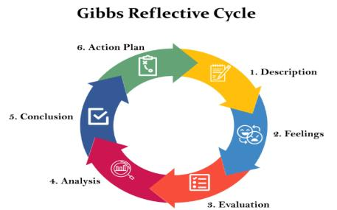
Figure: Gibbs Reflective Cycle (El Ghoul et al., 2023).
For this I used academic data collected through the Google Scholar, Scopus, Web of Science databases, as well as data from various industry reports including those of J.D. Power and the International Energy Agency. As it was a comparative analysis, I had to structure the information to ensure that both countries were adequately covered, and arranged the information into parallel frameworks.

I used PESTLE analysis during the analysis phase in order to study macro environment factors and Hofstede's cultural dimension to understand the difference in cross cultures. The use of these theories gave me a structure for thinking about the issue, and a way to understand the complex dynamics which were impacting the way that Toyota operated. The segmentation, targeting and positioning analysis as well as the 7Ps marketing mix evaluation helped to identify how Toyota have applied different marketing strategies to the varying market situations whilst keeping to the core brand (El Ghoul et al., 2023).

Feelings
When I first heard the topic and all the information that I could use, I was overwhelmed. It was difficult to organise and bring together various sources of information and I did not know if I was capable of drawing a coherent, thorough analysis from the sources. There was some self-doubt, especially in the challenge of working with academic concepts and on the ground application.
The ethical marketing discussion was a highly emotive one. As it is discussed about their environment friendly sustainable initiatives and the community development programmes by Toyota, I was impressed, but at the same time when some misleading claims for emissions reduction and pricing transparency were found I felt disappointed. This very feel of the subject matter helped me further comprehend the ethical issues that the multinational companies encounter (Musa et al., 2024).

Evaluation
The research methodology showed several strengths that helped me to conduct a good research. A wide range of countries were covered in both parts, and the different theoretical approaches provided a balanced perspective; likewise, the number of sources, comprising of academic journals, industry reports and reputable businesses and other publications, maximised the credibility of my results and added depth. Figures and illustrations aided in the understanding of the analysis and explanation of the complicated concepts.

The use of theory was good, but, was not quite as critical as I would like to have been. For example, I could have discussed criticism of Hofstede's cultural dimensions such as the inability to capture more complex elements of culture and the changes that occur over time. Moreover, more up-to-date theories like the ones on digital transformation and sustainability in international marketing could have been utilized for the analysis (Seelos, Mair and Traeger, 2023).

Analysis
In the course of conducting this research, I gained extensive knowledge on international marketing because of using various theoretical models. PEST analysis has educated me in the fact that the macro-environmental forces such as political stability, economic conditions, social demographics, technological advancement, environmental regulations, and legal frameworks have dissimilar effects on Toyota strategies of both India and USA. The cultural dimensions established by Hofstede have indicated that power distance, individualism and collectivism, uncertainty avoidance and long term orientation are the underlying factors that determine consumer-based behaviour, marketing messages, and brand positioning within every market.
STP analysis showed that the analysis needs different strategies using a different method depending on local people characteristics. The 7ps marketing mix model revealed how the product adjustment, pricing, channels of distribution, promotional policies, people management, service processes and physical demonstrations need to be proportioned globally to achieve success. The ethical marketing analysis revealed the need to be transparent, accountable and socially responsible in the global operations. I also found out that effective international marketing must be centred on the consistent branding of all markets and its implementation with the local experience, consistent process of adapting to the market environment, and direct application of the theoretical knowledge to the business environment (Seelos, Mair and Traeger, 2023).

Conclusion
The completion of this report enabled me to learn important research, analytical and academic writing skills which would be important to practice in international marketing. I gained capability to apply systematically to real business situations the theoretical frameworks of PESTLE, Hofstede dimensions of culture, STP and 7Ps. My skills as a comparative analyst improved, and it provides the ability to assess the marketing strategies in the markets of different cultures and in different economies. The process of evaluation of ethical marketing practices enhanced my critical thinking skills as it helped to determine what was right and what needed further enhancement (Menzies et al., 2024; Pathak and Sharma, 2022). I reinforced my ability to write academic works with appropriate referencing and formality in organizing a report and to provide evidence-based arguments.
Deadline keeping and organizing extensive information helped in me sharpening my time management skills. The relationship between culturally diverse understandings was enhanced and the value of cultural values on consumer behavior was appreciated. They were able to develop research skills by researching academic journals, industry reports, and company publications. I have also gained reflective practice awareness skills, meaning how my strengths and areas in which to enhance my future too are (El Ghoul et al., 2023; Pathak and Sharma, 2022).

Action Plan
In my reflective learning, I have pin-pointed some of the areas I need improvement on and created a tangible action plan. To improve my time management process, I will organize my study sessions, resolve big tasks into small steps, have weekly milestones, and go about the progress of the future project with the help of productivity tools such as Trello. To develop better referencing abilities, I will visit university APA and Harvard referencing workshops, referencing management software such as EndNote or Zotero, and practice active citation tracking as a way of preventing plagiarism.

To improve my academic English I would read more peer-reviewed journals, enlist Grammarly as an assistant in writing, attend academic writing workshops and have tutors review my writing style. To acquire business skills, I would seek internships in multinational firms, case study competition, involvement in professional marketing organizations, as well as subscribing to publications and other industry news. Furthermore, I will keep in pace with the latest trends of digital marketing, sustainability, and ethical business conduct, by undertaking online courses on Coursera and LinkedIn Learning. I will practice self-reflection on a long-term basis because I will use a learning journal to track advancements and define aspects of my development

References
Attard-Frost, B., De Los Ríos, A. and Walters, D.R. (2023) ‘The ethics of AI business practices: a review of 47 AI ethics guidelines’, AI and Ethics, 3(2), pp. 389–406. Available at: https://doi.org/10.1007/s43681-022-00156-6 (Accessed: 11 August 2026).
Contractor, F.J. and Lorange, P. (2023) ‘Competition vs. cooperation: a benefit/cost framework for choosing between fully-owned investments and cooperative relationships’, International Strategic Management. Routledge, pp. 203–216. Available at: https://www.taylorfrancis.com/chapters/edit/10.4324/9781315058993-21/competition-vs-cooperation-benefit-cost-framework-choosing-fully-owned-investments-cooperative-relationships-farok-contractor-peter-lorange (Accessed: 11 August 2026).
Correia, E., Sousa, S., Viseu, C. and Larguinho, M. (2023) ‘Analysing the influence of green marketing communication in consumers’ green purchase behaviour’, International Journal of Environmental Research and Public Health, 20(2), p. 1356. Available at: https://doi.org/10.3390/ijerph20021356 (Accessed: 11 August 2026).
De Mauro, A., Sestino, A. and Bacconi, A. (2022) ‘Machine learning and artificial intelligence use in marketing: a general taxonomy’, Italian Journal of Marketing, 2022(4), pp. 439–457. Available at: https://doi.org/10.1007/s43039-022-00057-w (Accessed: 11 August 2026).
Edelman, N.L. (2023) ‘Trauma and resilience informed research principles and practice: A framework to improve the inclusion and experience of disadvantaged populations in health and social care research’, Journal of Health Services Research & Policy, 28(1), pp. 66–75. Available at: https://doi.org/10.1177/13558196221124740 (Accessed: 11 August 2026).
El Ghoul, S., Guedhami, O., Mansi, S.A. and Sy, O. (2023) ‘Event studies in international finance research’, Journal of International Business Studies, 54(2), pp. 344–364. Available at: https://doi.org/10.1057/s41267-022-00534-6 (Accessed: 11 August 2026).
Filipovic, J. and Arslanagic-Kalajdzic, M. (2023) ‘Mirroring digital content marketing framework: capturing providers’ perspectives through stimuli assessment and behavioural engagement response’, European Journal of Marketing, 57(9), pp. 2173–2198.
Giraldo, O.F. and Rosset, P.M. (2023) ‘Emancipatory agroecologies: social and political principles’, The Journal of Peasant Studies, 50(3), pp. 820–850. Available at: https://doi.org/10.1080/03066150.2022.2120808 (Accessed: 11 August 2026).
Ijomah, T.I., Idemudia, C., Eyo-Udo, N.L. and Anjorin, K.F. (2024) ‘Innovative digital marketing strategies for SMEs: Driving competitive advantage and sustainable growth’, International Journal of Management & Entrepreneurship Research, 6(7), pp. 2173–2188.
Javalgi, R.G. and Russell, L.T.M. (2018) ‘International Marketing Ethics: A Literature Review and Research Agenda’, Journal of Business Ethics, 148(4), pp. 703–720. Available at: https://doi.org/10.1007/s10551-015-2958-9 (Accessed: 11 August 2026).
Kumar, A. and Brar, V. (2024) ‘Digital marketing and role of blockchain in digital marketing industry’, International Journal of Advanced Research and Interdisciplinary Scientific Endeavours, 1(7), pp. 383–387.
Leonidou, C.N., Gruber, V. and Schlegelmilch, B.B. (2022) ‘Consumers’ Environmental Sustainability Beliefs and Activism: A Cross-Cultural Examination’, Journal of International Marketing, 30(4), pp. 78–104. Available at: https://doi.org/10.1177/1069031X221128786 (Accessed: 11 August 2026).
Menzies, J., Sabert, B., Hassan, R. and Mensah, P.K. (2024) ‘Artificial intelligence for international business: Its use, challenges, and suggestions for future research and practice’, Thunderbird International Business Review, 66(2), pp. 185–200. Available at: https://doi.org/10.1002/tie.22370 (Accessed: 11 August 2026).
Musa, H.G., Fatmawati, I., Nuryakin, N. and Suyanto, M. (2024) ‘Marketing research trends using technology acceptance model (TAM): a comprehensive review of researches (2002–2022)’, Cogent Business & Management, 11(1), p. 2329375. Available at: https://doi.org/10.1080/23311975.2024.2329375 (Accessed: 11 August 2026).
Nathaniel, S.P., Solomon, C.J., Ajide, K.B., Ahmed, Z. and Fakher, H.A. (2023) ‘Striving towards carbon neutrality in emerging markets: the combined influence of international tourism and eco-friendly technology’, International Journal of Sustainable Development & World Ecology, 30(7), pp. 760–775. Available at: https://doi.org/10.1080/13504509.2023.2195831 (Accessed: 11 August 2026).
Ong, D. (2025) ‘State of Social Marketing in Malaysia: Challenges and Reflections of a Multicultural Nation’, Social Marketing Quarterly, 31(1), pp. 3–34. Available at: https://doi.org/10.1177/15245004241308657 (Accessed: 11 August 2026).
Pascucci, F., Savelli, E. and Gistri, G. (2023) ‘How digital technologies reshape marketing: evidence from a qualitative investigation’, Italian Journal of Marketing [Preprint]. Available at: https://doi.org/10.1007/s43039-023-00063-6 (Accessed: 11 August 2026).
Pathak, A. and Sharma, S.D. (2022) ‘Applications of Artificial Intelligence (AI) in Marketing Management’, 2022 5th International Conference on Contemporary Computing and Informatics (IC3I). IEEE, pp. 1738–1745. Available at: https://ieeexplore.ieee.org/abstract/document/10072425/ (Accessed: 11 August 2026).
Rachmad, Y.E. (2024) Good Governance in Sovereign Wealth Funds: A Case Study of Danantara. The United Nations Global Compact.
Rachmad, Y.E. (2025a) Danantara and Strategic Partnerships: Unlocking Indonesia’s Full Investment Potential. The United Nations Global Compact.
Rachmad, Y.E. (2025b) Danantara’s Ethical Investment Framework: A Model for Responsible Economic Growth. The United Nations Global Compact.
Randrianasolo, A.A. and Semenov, A.V. (2022) ‘Synergy Versus Trade-Off: The Influence of National Philanthropic Environment and Industry on the Relationship Between Research and Development and Corporate Social Responsibility’, Journal of International Marketing, 30(1), pp. 75–92. Available at: https://doi.org/10.1177/1069031X211054507 (Accessed: 11 August 2026).
Sari, D., et al. (2023) ‘The role of entrepreneurial marketing & innovation capability in the performance of SMEs during covid-19 pandemic: Evidence of MSMEs in West Java’, Cogent Business & Management, 10(1), p. 2194091. Available at: https://doi.org/10.1080/23311975.2023.2194091 (Accessed: 11 August 2026).
Seelos, C., Mair, J. and Traeger, C. (2023) ‘The future of grand challenges research: Retiring a hopeful concept and endorsing research principles’, International Journal of Management Reviews, 25(2), pp. 251–269. Available at: https://doi.org/10.1111/ijmr.12324 (Accessed: 11 August 2026).
Sigirci, O., Gegez, A.E., Aytimur, H. and Gegez, E.E. (2022) ‘Children in marketing: A review, synthesis and research agenda’, International Journal of Consumer Studies, 46(5), pp. 1594–1639. Available at: https://doi.org/10.1111/ijcs.12819 (Accessed: 11 August 2026).
Tan, T.M. and Salo, J. (2023) ‘Ethical Marketing in the Blockchain-Based Sharing Economy: Theoretical Integration and Guiding Insights’, Journal of Business Ethics, 183(4), pp. 1113–1140. Available at: https://doi.org/10.1007/s10551-021-05015-8 (Accessed: 11 August 2026).

Tanwar, A.S., Chaudhry, H. and Srivastava, M.K. (2022) ‘Trends in Influencer Marketing: A Review and Bibliometric Analysis’, Journal of Interactive Advertising, 22(1), pp. 1–27. Available at: https://doi.org/10.1080/15252019.2021.2007822 (Accessed: 11 August 2026).
Toyota Motor Corporation (2026) Toyota Motor Corporation. Available at: https://global.toyota/en/ (Accessed: 11 August 2026).
Ye, T., Xu, Z., Li, Y. and Allen-Zhu, Z. (2024) ‘Physics of language models: Part 2.1, grade-school math and the hidden reasoning process’, International Conference on Learning Representations. Available at: https://arxiv.org/abs/2407.20311 (Accessed: 11 August 2026).
Zhao, E.Y. (2022) Optimal distinctiveness: A new agenda for the study of competitive positioning of organizations and markets. Cambridge University Press. Available at: https://doi.org/10.1017/9781108990561 (Accessed: 11 August 2026).
Zhou, J. and Chen, F. (2023) ‘AI ethics: from principles to practice’, AI & SOCIETY, 38(6), pp. 2693–2703. Available at: https://doi.org/10.1007/s00146-022-01602-z (Accessed: 11 August 2026).

