

Technical report

Dylan de Jongh
ID:2501724
December 7th 2025

Contents
- Title page……………………………………………………………………………………………………1
- Content page………………………………………………………………………………………………2
- Introduction………………………………………………………………………………………………..3
- Health and Saftey with risk assessment…………………………………………………………..4
- Security risk matrix………………………………………………………………………………………5
  - Vulnerabilities in artificial intelegence……………………………………………………5
  - Lack of prioritization of cybersecurity…………………………………………………….5
  - Data theft form vehicle’s onboard system………………………………………………5
  - Risk matrix………………………………………………………………………………………..6
- The engineer’s role in society…………………………………………………………………………7
- Problem solving…………………………………………………………………………………………..8
- Team structure…………………………………………………………………………………………….9
- Conclusion……………………………………………………………………………………………….10
- Reference list…………………………………………………………………………………………….10

Introduction
In the technical report, many topics will be looked at but they will all be based around and look at cybersecurity. The cyber world has been a gift and a curse in modern as it has been what has helped connect us and devide us. However when more attention is payed to cybersecurity it helps build that bridge between people once again.In this report, certain content will be talked about like impacts of poor cybersecurity and general risks to the public. These topics and more will help provide an understanding about the importance of cyber security

Health and safety
Within engineering, health and safety are key aspects to consider in all activities to ensure they are safe and handled responsibly. Since starting at UWTSD, one of the first practical activities undertaken was an engine strip in the workshop. This involved disassembling and examining the engine’s internal components to understand how they function. This was all done with a variety of hand tools and lifting equipment that were only provided after being briefed on how they are meant to be used during this task. There was constant supervision to make sure all health and safety regulations were met because of all the manual-handling and mechanical hazards there were.

There are many pieces of legislation governing this activity. For Example, health and safety act of 1973 (HSWA) was established in the uk as the primary law of workplace health, welfare, and masking it everyone’s responsibility to protect the safety of workers and public from risks.it also creates states that there is a duty for employers and educational instructors to prevent students and staff from harming them selves with miss use of equipment or chemicals in the workplace

Here is a risk assessment for the activity:
Hazards: | Likelihood: | Severity: | Risk level: | Required PPE:
Incorect use of lifting equiptment | Medium | High | High | Safty boots and gloves
Cuts or impacts from tools | Medium | Medium | Medium | Safty glasses and gloves
Exposure to oils or solvents | Medium | Medium | Medium | Safty glaces and gloves
Manual handling of heavy components | High | Medium | High | Safty boots

Security Risk Matrix
Modern vehicles are becoming increasingly autonomous, showing the constant invitations being made in the automotive world. However, this makes modern vehicles more vulnerable to physical and digital security risks. These vulnerabilities affect many aspects like data integrity and vehicle integrity. Research made by the European Union Agency of Cybersecurity (ENISA) highlights a few risks in vehicle manufacturing.

Vulnerabilities in artificial intelligence (AI):

Modern vehicles are fitted with various technologies, which include artificial intelligence (AI) computer systems that can perform tasks typically requiring human intelligence, to help create a safer and more pleasant experience when driving. The AI in autonomous vehicles, or self-driving cars, is constantly at work helping with navigation and identifying objects on the road, such as signs, traffic lights, and other vehicles. However, with this reliance on AI, the system becomes vulnerable to intentional interference attacks, meaning deliberate attempts to disrupt the AI’s performance, such as alterations to signs, adding reflective materials, or extra paint on the road. (ENISA, 2022)

Lack of prioritisation of cybersecurity:

Companies that manufacture and produce vehicles have been found to be lacking in strong cybersecurity, and it was found that these companies' management prioritised other matters because they did not believe it was a board-level topic. Research has shown that a lack of management involvement leads to insufficient funding and then weak cybersecurity and other problems. (ENISA, 2022)

Data theft from the vehicle's onboard system:

Many vehicles on the road are full of personalised data, and in recent years, these autonomous vehicles have fallen victim to data theft. This is when the onboard system is infiltrated by a foreign party and steals sensitive information to do as they please. An example of this is when an attacker takes control of the target's assets and demands a ransom in return for the target's assets. This is known as ransomware. (ENISA, 2023)
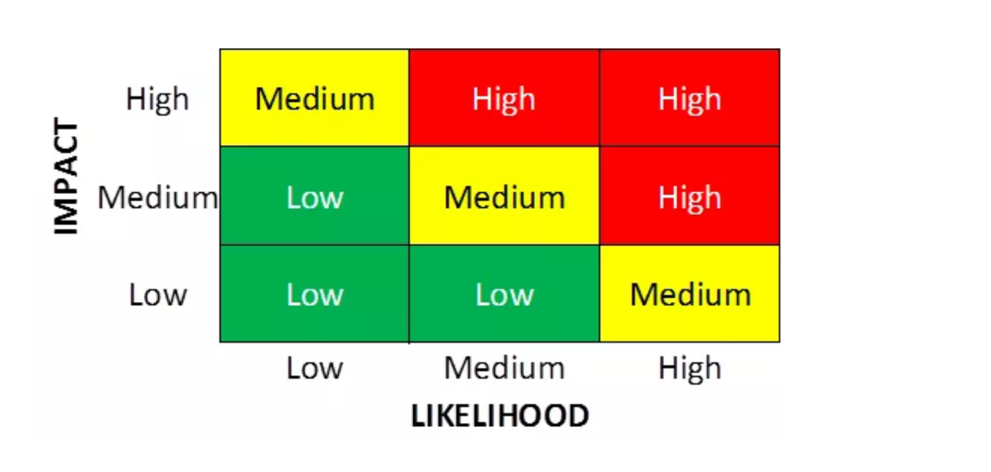

When looking at all these potential risks, we can categorise them using a simple risk matrix by looking at the likelihood of having one of these problems and the impact it would leave. Looking at each of the security risks named previously, we can put each in order of damaging potential. The most harmful security risk would be data theft from vehicle onboard systems. Regarding the data matrix, it would cause a high impact on the owner of the data, but it has a medium likelihood because most autonomous vehicles are equipped with reliable and safe systems that are extremely hard to break through and steal.

Engineers role in society

Chartered engineers play an extremely influential role in society, as they are responsible for many of the infrastructures and technologies that are used in day-to-day life, and this makes them solely responsible for the safety of the public. All charted engineers must follow a code of conduct to make sure all the decisions they make are professional, ethical, responsible, and align with public interest. There are many different organisations that publish their own codes of conduct, but they all set clear expectations of professional behaviour.

The Engineering Council of the UK follow four core ethical principles: honesty and integrity, respect for life, law, the environment and public good, accuracy and rigour, leadership and communication (Engineering Council, 2019). These principles are what engineers follow and use to help make ethical and proper decisions that protect the lives of many. Similarly, the Society of Operations Engineers (SOE) code of conduct states that all engineers must promote diversity, equality, and inclusivity, act honourably, faithfully and without bias, protect and respect confidentiality (SOE, 2022). It is an engineer's responsibility to be just and ethical, and these codes of conduct are strong representations of this code.

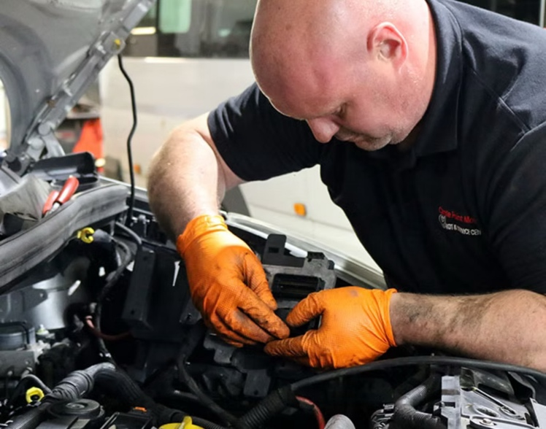
Motorsport engineers are faced with the struggles of balancing high performance and sustainability. In modern-day motorsports, the pursuit of the highest-performing vehicle has drawn our attention to the impacts being left on the planet due to high carbon emissions. To counteract this, organisations like Motorsport UK have been introducing sustainable fuels, energy recovery systems and minimising environmental impacts at racing events. Engineers must now make ethical choices when it comes to designing, ensuring that they are effective and environmentally friendly.

Problem solving
Engineers in industry encounter many issues on a regular basis. When issues occur, like problems during the development of a product or a mechanical issue with a piece of machinery, engineers are expected to be able to identify, evaluate, and resolve the problem with their team as effectively and efficiently as possible. A commonly used method is the engineering design cycle, which is defined as a series of steps taken and followed by the engineers to create and resolve the problem (ScienceBuddies, 2024).

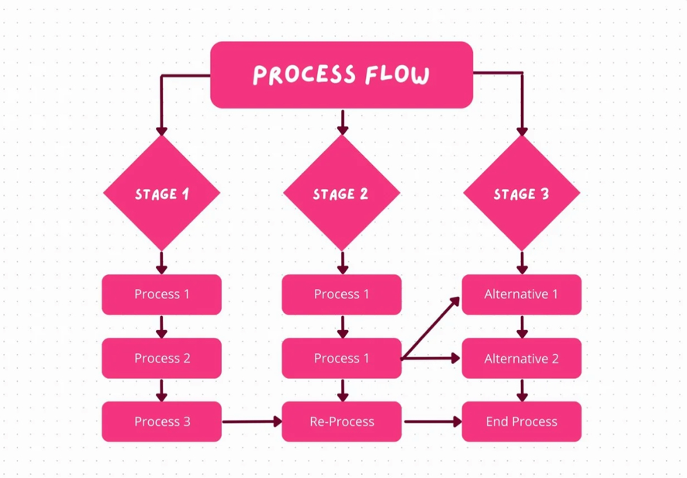
A widespread problem that engineering teams are faced with is quality and design flaws. This issue occurs when the initial design is produced and does not translate well after being manufactured, which can be caused by a lack of planning or not being critically tested, which then leads to costly redesigns and production delays. When this problem arises, it is the team's job to identify whether the problem was caused by a manufacturing error, poor choice in materials or incorrect design dimensions. An often-adopted method is the root cause analysis (RCA) technique, which is when engineers trace back their initial steps to the failure and undo the mistake. Tools such as the 5 whys diagram help evaluate the root problem by constantly asking “why?” By doing this, you peel away at the layers of the issue like peeling the layers of an onion (Turas, 2025).
Flow diagrams are another widely used tool that visually maps the process and decisions made. For example, a data flow diagram (DFD) is a type of flow diagram that uses standard symbols—such as rectangles for processes, arrows for data flow, and ovals for external entities—to illustrate how data moves through a system. Visually representing the process offers an uncomplicated way to manufacture a product and makes finding faults easier due to the simplicity of each step.

Team structure

Engineers must have a plethora of skills, but one that is essential skill is the ability to work with others as a team. Being able to work in a team environment helps build effective communication skills and improve social skills. During my studies and practical work, I had the opportunity to be involved in multiple team-based tasks, but one experience that stood out to me was the physics practical. During this practical and four other students had been tasked with create a complicated circlet we had never seen before and carry out the experiment, and getting exact results. During this practical, I had the chance to see how different people work, communicate, and solve problems in different environments.

The team structure we had used was a functional team structure where each person had their own role and responsibility based on their strengths and weaknesses. For example, the first student was tasked with constructing the circlet, the second focused on calculations, the third was tasked with capturing all the data produced, the fourth was focused on writing the method being used to carry out the practical, and I was tasked with putting all the information into a report. This structure was very beneficial for each member of the group because it let everyone focus on what they do best, increase efficiency, and reduce the chances of overlapping with one another.

However, as good as the structure was, there were still some negative aspects. For example, some members couldn’t do what they were tasked with doing without another member finishing their task. This meant there was less time to focus on our own tasks and instead the time was speaker trying to help the other members with their tasks. This also meant I needed additional time at the end to bring everything together and make sure everything was consistent.
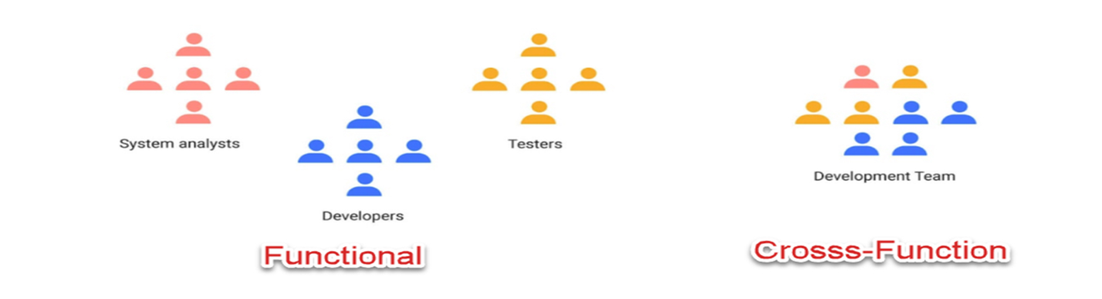
When looking back and doing research, I found that a more effective structure we could have used would have been a cross-functional team. A cross-functional team is a group of people from different functional areas that come together and work collaboratively to complete a common goal. (PlainView, 2025) This structure would have helped prevent any miscommunication and provided us with more time to produce better and more consistent results. In addition, it creates less of a stressful environment for each member of the group because of the extra support they’d get from one another.
Conclusion

Ciyber security is not something to be taken lightly, we have seen in our modern world that it helps us in day to day situation and will continue to do so in the feature. More companies are realizing how important it is and as engineers it must always be considered.

References

- https://www.enisa.europa.eu/news/enisa-news/how-to-secure-the-connected-automated-mobility-cam-ecosystem
- https://www.enisa.europa.eu/news/enisa-news/cybersecurity-challenges-in-the-uptake-of-artificial-intelligence-in-autonomous-driving
- https://www.enisa.europa.eu/publications/recommendations-for-the-security-of-cam
- https://www.enisa.europa.eu/sites/default/files/publications/ENISA%20Report%20–%20Recommendations%20for%20the%20security%20of%20CAM.pdf
- https://www.enisa.europa.eu/sites/default/files/publications/ENISA%20Transport%20Threat%20Landscape_RECAST2.pdf
- https://www.planview.com/resources/articles/lkdc-cross-functional-teams/
- https://learn.nes.nhs.scot/4791
- https://www.soe.org.uk/membership/join-online/code-of-professional-conduct.html
- https://www.engc.org.uk/resources-and-guidance/guidance-for-the-profession/ethical-principles
- https://www.motorsportuk.org/motorsport-uk-launches-sustainable-fuels-consultation/
- https://www.hse-network.com/health-and-safety-at-work-act-1974-explained/

