Marketing Essentials
BMIH4005
Marketing plan is written for

Hilton Hotel- East Midland Airport
Student Name: Rowshan Ara Chowdhury
Student ID: 2231044
Lecturer Name: Scott James

Table of Contents
Introduction 3
Situation Analysis 4
Objectives 5
Strategy 6
Tactics 7
Action 9
Control 10
Conclusion 11
References 12
Appendix 14
PowerPoint Presentation 14

Introduction
This marketing strategy for the UK Hilton East-midland Airport Hotel describes different strategies. It will be of assistance to the management team of the hotel in developing the business and brand. The plan will be directed by SOSTAC, the 4Ps, and Ansoff's Matrix. The analysis of the situation, the formulation of goals, the formulation of strategies, the application of tactics, the taking of actions, and the measurement and control of the results can all be aided by these frameworks. These frameworks will manage essential parts of hotel marketing and help with decision-making.
Word count: 93.

Situation Analysis
Company: A micro-study of Hilton East-midland Airport Hotel will be provided via a SWOT analysis (Hilton, 2023). The research will highlight the hotel's advantages, such as its standing, location, and customer service, as well as its weaknesses, such as its outdated infrastructure or meagre amenities. Threats like new competitors or economic downturns and opportunities like new travel patterns or partnerships will be emphasised.
Customers: Customer groupings, as well as their needs and preferences, will be identified through segmentation and targeting. Using SimilarWeb, customer profiles can disclose internet behaviour, booking trends, and preferences (Reidhead, 2020). The hotel will use this data to target various clientele groups and develop customised experiences to increase client satisfaction. Hotel can used customer email for advertise and offer some value packages for family or individual. Hotel can give free gift as a souvenir with hotel logos, so they can take home and remember the brand.
Competitors: Using a perceptual placement map, the Hilton East-midland Airport Hotel will be contrasted with its competitors. By mapping important characteristics and advantages, the hotel may identify its USP and distinctiveness (Zeng, 2021). By analysing competitors' pricing leadership, distinction, and emphasis, Bowman's strategy clock can assist the hotel in creating effective competitive strategies.
Partners: The Hilton East Midland Airport Hotel is aware of the value of B2B relationships, partnerships, and franchises (Ma, 2021). Strong industry ties can result in combined marketing efforts, new customer categories, and cross-promotion.
Climate: PESTLE does a macro analysis of the external environment. Factors related to politics, economy, society, technology, law, and the environment are assessed (Ma, 2021). The hotel will be able to modify its plans as a result of this research's identification of opportunities and difficulties related to market, industrial, regulatory, and social trends.
Marketing mix: Product, pricing, promotion, and place are all assessed as part of the marketing mix to make sure they are in line with business objectives and consumer preferences. This analysis will assess the hotel's pricing, marketing initiatives, and distribution strategies. To meet client needs and accomplish marketing objectives, it will identify areas for improvement and make changes to the marketing mix.
Word count: 353.

Objectives
The Hilton East-Midland Airport Hotel has set as its SMART target, for the upcoming fiscal year, a rise in market share of 10% (Kotler et al., 2020). Customers can be attracted to and kept with the help of targeted marketing. Enhancing the individual experience of each customer through personalization and superior service will be essential. Branding and communication strategies that are well thought out will also contribute to growth. The success of the hotel and its position in the market is directly attributable to the achievement of this marketing objective, which is specific, measurable, practical, pertinent, and time-bound.
Word count: 99.

Strategy
Hilton East-midland Airport Hotel will change its value proposition to improve its brand reputation and resolve unfavourable feedback (Jobber and Ellis-Chadwick, 2020). Ansoff's matrix will guide the hotel's strategy. Targeting new customer categories and geographic regions is the strategy. The hotel hopes to boost its brand reputation and word-of-mouth by reaching more people.
This technique requires marketing mix changes. To enhance client satisfaction, the hotel may add or upgrade amenities (Ghauri, 2014). Competitive pricing and additional client incentives can be implemented. Promoting the hotel's strengths, unique offerings, and good guest testimonials will counter unfavourable opinions. Targeted marketing strategies across channels will reach specific customer categories. The hotel's advantageous position near the airport will attract travellers.
Hilton East-midland Airport Hotel hopes to improve its brand reputation, attract new customers, and become the region's top hotel by aligning the marketing mix with the new value proposition and using Ansoff's matrix technique (Fill, 2019).
Word count: 152.

Tactics
The hotel will manage situational analysis difficulties using the RACE (Reach, Act, Convert and Engage) methodology.
Reach: The hotel will enhance its digital marketing and web presence to broaden its reach. To do this, the hotel's website must be optimised for search engines, its social media presence on Facebook, Instagram, and Twitter must expand, and targeted online advertising must be used to attract potential customers (Eid and Agag, 2020). By collaborating with travel websites and influencers, the hotel may reach a wider audience.
Act: The hotel will invite visitors to make reservations or inquiries. A faster booking procedure, clear and appealing calls-to-action on the website and social media platforms, and the presentation of only available online promotions or bundles are a few examples of how to do this (Chaffey and Ellis-Chadwick, 2019). To inspire confidence and boost conversions, the hotel can also use customer reviews.
Convert: The hotel will concentrate on turning visitors into reservations. Incentives or discounts for direct bookings, focused email marketing campaigns, and top-notch customer support throughout the reservation process can all be examples of this (Bowie et al., 2017). To draw customers, the Hilton East-midland Airport Hotel must effectively express its distinctive value proposition.
Engage: To increase client loyalty and repeat business, the hotel will prioritise engaging marketing strategies. Offering special loyalty programmes, developing a comprehensive customer relationship management (CRM) system to track visitor preferences and tailor upcoming mailings, and aggressively responding to client comments and inquiries on social media and review platforms are a few examples of how to achieve this (Chang, Ku and Chen, 2019). The hotel will remain top-of-mind for future travel requirements with the use of targeted email newsletters, blog postings, and social media updates.
Areas for improvement may be seen in the hotels social media, email marketing, and Similarweb results (Salem, 2020). The hotel might have posted inconsistently on social media, ignored opportunities for consumer participation, or run poorly-performing email marketing. The hotel will use social listening tools to actively monitor and respond to customer feedback, implement a content calendar to ensure regular and pertinent social media updates, optimise email campaigns with personalised content and compelling offers, and use Similarweb insights to enhance its online marketing strategies.
Word count: 367

Action
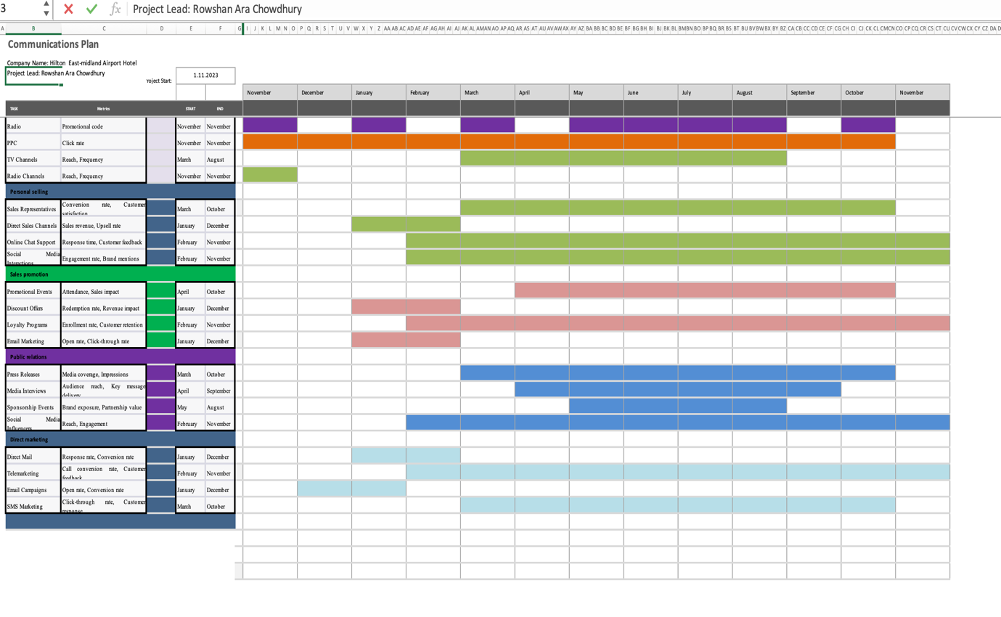The schedule for the marketing channels was influenced by several factors. First, we looked at the communication preferences of the target audience. These statistics came from market and customer surveys. Customer feedback, conversion rates, reach, and engagement were utilised to assess channel performance (Jones and Comfort, 2021). By taking into account market trends and best practices, our channels correspond to current marketing strategies. The schedule also considers seasonal patterns and significant occasions for our target audience. In addition to responding to the interests and behaviours of the target market, the channel calendar maximises reach, engagement, and conversions.

Control
The achievement of success will be judged by metrics and KPIs. These include increasing revenue and profits, acquiring new customers, analysing how customers feel about a brand, and keeping existing customers (Kotler et al., 2020). We will look into things like website traffic, conversion rates, how engaged people are on social media and campaign-specific metrics. Analysis of the marketing strategy and adjustments based on the data will be made easier with regular reports and analytics.
Word count: 76

Conclusion
The marketing strategy is threatened by competition, customer preferences, and a shifting business climate. We provide numerous solutions to get around these challenges. Keep an eye on market developments and consumer behaviour to remain flexible and change your marketing plan. Second, promote customer loyalty by providing customised service. Third, expand engagement and reach via digital media. Digital media is the most effective way to communicate with people modern deanage. Finally, spend money on market research to uncover fresh opportunities and improve audience segmentation. The Hilton East-midland Airport Hotel will be able to overcome these recommendations and expand responsibly.
Word count: 99.

References
Bowie, D., Buttle, F., Brookes, M. and Mariussen, A. (2017). Hospitality marketing. London: Routledge.
Chaffey, D. and Ellis-Chadwick, F. (2019). Digital Marketing: Strategy, Implementation and Practice. 7th ed. Harlow, England: Pearson.
Chang, Y.-C., Ku, C.-H. and Chen, C.-H. (2019). Social media analytics: Extracting and visualizing Hilton hotel ratings and reviews from TripAdvisor. International Journal of Information Management, 48, pp.263–279. doi:https://doi.org/10.1016/j.ijinfomgt.2017.11.001.
Eid, R. and Agag, G. (2020). Determinants of Innovative Behaviour in the Hotel Industry: A cross-Cultural Study. International Journal of Hospitality Management, 91, p.102642. doi:https://doi.org/10.1016/j.ijhm.2020.102642.
Fill, C. (2019). Marketing Communications : Engagement, Strategies and practice. 3rd ed. Harlow: Pearson.
Ghauri, P.N. (2014). International marketing. 4th ed. London: Mcgraw-Hill.
Hilton (2023). Hilton East Midlands Airport – Best Rates on Hilton.com. [online] Hilton. Available at: https://www.hilton.com/en/hotels/emahnhn-hilton-east-midlands-airport/?WT.mc_id=zINDA0EMEA1MB2PSH3GGL4INTBPP5dkt6MULTIBR7_121127567_1003528_p22393062835&&&gclid=CjwKCAjw1YCkBhAOEiwA5aN4Ae5NX3pgCZuy6-3yOECgFDMaUEfdB9jK4oc71cu3-rDgQH8fhtCEMxoCWYMQAvD_BwE&gclsrc=aw.ds [Accessed 8 Jun. 2023].
Jobber, D. and Ellis-Chadwick, F. (2020). Principles and practice of marketing. 9th ed. Maidenhead: Mcgraw-Hill Higher Education.
Jones, P. and Comfort, D. (2021). Modern Slavery Statements and Leading UK Hotel Companies. ATHENS JOURNAL OF TOURISM, 8(3), pp.147–162. doi:https://doi.org/10.30958/ajt.8-3-1.
Kotler, P., Armstrong, G., Harris, L.C. and He, H. (2020). Principles of Marketing. 8th ed. Harlow: Pearson.
Ma, R. (2021). Human resource management in multinational companies—— from the perspective of Hilton Hotels. E3S Web of Conferences, [online] 235, p.02058. doi:https://doi.org/10.1051/e3sconf/202123502058.
Reidhead, C. (2020). Impact of Organizational Culture on Employee Satisfaction: A Case of Hilton Hotel, United Kingdom. [online] papers.ssrn.com. Available at: https://papers.ssrn.com/sol3/papers.cfm?abstract_id=3563546.
Salem, R. (2020). Design and evaluation of nearly zero energy buildings and their viability post-2013s UK climate conditions: a collaborative research with The Chartered Institution of Building Services Engineers and Hilton. [online] repository.uwl.ac.uk. Available at: http://repository.uwl.ac.uk/id/eprint/7784/ [Accessed 7 May 2023].
Smith, P.R. and Zook, Z. (2020). Marketing communications : integrating online and offline, customer engagement and digital technologies. 7th ed. London: Koganpage.
Zeng, L. (2021). Analysis of Hilton Worldwide Hotel Group’s Transnational Operation Strategy. Academic Journal of Business & Management, [online] 3(11). doi:https://doi.org/10.25236/AJBM.2021.031104.

PowerPoint Presentation



