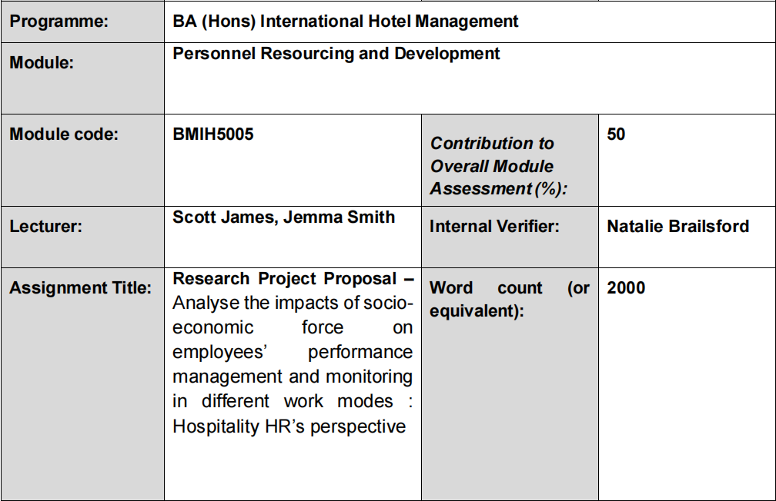

Module title: Personnel Resourcing and Development
Module code: BMIH5005
Lecturer’s name: Scott James, Jemma Smith
Name: Ella Daniela Mirea
Student ID: 2246573

Table of Contents
1. Introduction and Background 3
2. Literature Review 4
2.1. Socio-economic Factors Affecting the Hospitality Industry 4
2.2. Work Mode Advancement 5
2.3. Societal Shifts 7
2.4. Marriott Hotel Monitoring System 7
3. Evaluation and Conclusion 8
3.1. Main Findings 8
3.2. Recommendations 9
References 10

1. Introduction and Background
Marriott International, Inc. was established in 1927 and it is one of the largest international chains of hotel and related services that operates a network of more than 8000 units in 139 countries and territories around the globe; it operates more than 30 categories of hotels. Playing a major role in the global hospitality industry with its dedication to superior service, innovation, and responsible practices, Marriott has about 177,000 employees globally (Statista, 2024). It initiated the strategic plan of the company to enter worldwide markets that not only offer a variety of products and services but also aim at diversifying customer services through technology integration ensuring its organizational perspectives and finding ways to involve the society (Shastri, 2024). There are several issues affecting the hospitality industry due to factors such as socio-economic factors and these include challenges such as lack of employees, volatility in the market, and shifts in consumer demands and preferences (Ghani et al., 2022). Therefore, the World Travel and Tourism Council (WTTC) Global Research 2018 revealed that Travel & Tourism is a global industry as it recorded a 50.4% decline in its contribution to the GDP in 2020 owing to the impacts of the COVID-19 outbreak which shows that this sector is capable of contraction in the face of economic adversity. To this effect, it becomes imperative for workforce management to develop innovative ways of addressing these challenges for sustainability (WTTC, 2021). The current trends of early retirement and the entry of young personnel into the labor market mean that flexibility at work is becoming desirable (Boeri et al., 2021). According to the International Labor Organization (ILO) global report (ILO, 2023) on the state of the workforce, the workplace is gradually diversifying globally meaning there is a need to address them as they emerge. Business cycles and overall changes in the supply and demand for manpower affect the number of employees and available human resources (ILO, 2023).
Given the fast-growing context of the hospitality industry, human capital management and its focus on performance, contribute significantly to service quality management and organizational effectiveness (Manoharan & Singal, 2019). The purpose of this research proposal is therefore to explore the possibility and viability of adopting different work modes amongst which are hybrid work office-based flexible work and traditional office work at Marriott Hotels. In this case, the present study aims to consider the effects of socio-economic factors, which influence the hotel’s employee performance management and monitoring for improved workforce productivity and engagement.

2. Literature Review

2.1. Socio-economic Factors Affecting the Hospitality Industry
Social factors like changing age structure and generations’ expectations notably affect an employee's expectations in areas like flexibility of work and career progression (Chung & Van Der Lippe, 2018). As reported by the U. S. Bureau of Labor Statistics, the labor force was predicted to continue aging, with the median age of the American workforce approximately 42 years old by 2026, the percentage of employees aged 65 and over is expected to increase to 3 years, stressing the importance of maintaining jobs suitable for employees of this age because of the aging population in the United States (BRAGA, 2023). Such a demographic change means that today’s hospitality organizations such as Marriott must be able to address the aging worker’s needs, whereby they might need workplace accommodations due to health or caregiver issues. Also, Deloitte made a survey in which 75% of the workers of the young and middle age are in favor of having a flexible work schedule, highlighting more generation demand for the flexibility of work-life balance. These generational differences show that younger employees place a strong value on flexibility and independence regarding their work, which can influence job satisfaction levels and factors relating to employee turnover (Deloitte, 2023). Therefore, Marriott can use this knowledge of talent management and talent acquisition to provide work schemes or structures, such as hybrid and flexible working arrangements, which can be preferred by these generations.
Indicators such as growth rates of gross domestic product and trends in the labor market influence staffing and resource civilization in hospitality organizations. The World Bank brought out a global GDP growth rate of 5.6% declined slightly in 2021, largely attributed to the post-pandemic economic rebound that impacted employment and investment made towards training and education of the employees (World Bank, 2022). These levels of growth in the economy can facilitate the growth and training of the employees within the hospitality companies by improving the quality of their service. However, fluctuations in labour market rates recoveries, for instance, the 4.8% unemployment rate in the hospitality industry forecasted by the U. S. Bureau of Labor Statistics for the year 2021 highlights the need for enhancement of flexibility in managing human resources effectively (Bureau of Labor Statistics, 2021). In changing times, organizations need to strategically build staff while at the same time upholding organizational culture and motivating employees across the firms.
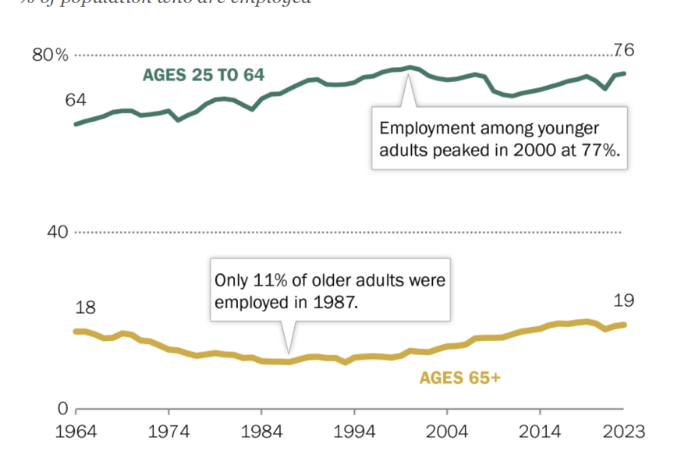
Figure 1: Age Trend in Hospitality Sector (BRAGA, 2023)
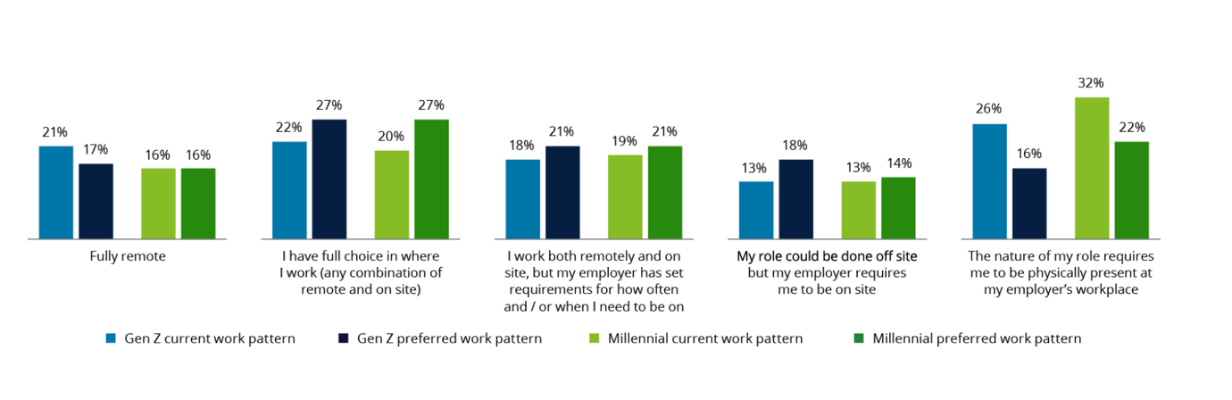
Figure 2: Deloitte Work Mode Survey (Deloitte, 2023)

2.2. Work Mode Advancement
The industry of hospitality over the past five years has also witnessed a shift in work mode because of technological features, consumer findings, and significant eventualities including COVID-19. Working from home has now gained popularity, especially for back-office employees while organizations are implementing measures of both onsite and remote working to provide flexibility while ensuring they closely work onsite (Huang et al., 2021). Temporary employment has trended as has on-demand staffing for informal positions in cleaning services, temporary events organization, and particularly for independent consultants in marketing, and IT among others. Current policies encourage cross-training and multi-skilling and promote a diverse type of workforce wherein employees handle various roles and employers focus on training their workforce. Some new advanced roles that primarily align with customer experience include experience concierges and guest encounter specialists with an emphasis on guest hospitality (Coe et al., 2010).
Technological advancements arising out of significant socio-economic trends make remote working and facilitate the use of digital workplace applications and tools, which allow hybrid and flexible working models (Battisti et al., 2022). In the report by McKinsey & Company, 85% of companies said they had stepped up the use of technology amid the pandemic to sustain remote and hybrid working formats (Mckinsey, 2023). Examples of such advancements include modern and efficient communication media, efficient project management media, and efficient use of data analytical tools in the management and effort estimation of projects (Mckinsey, 2023). This could make a beneficial difference in productivity and employee morale since it grants flexibility while not suffering the loss of organizational performance.
Marriott Hotels, as a leading global hotel chain, has also been experiencing transformations of work modes in the recent five years, which has become common in the field of hospitality. Marriott has adopted flexibility in working, including remote or a mix of remote and physical workplaces in such a way that its back-office personnel work remotely while others are present physically but with flexibility (Marriott, 2022). The company also has adopted the Gig economy as it hires cleaning services and event attendants through staff sourcing apps; it hires marketing and information technology specialists for one-time tasks. Marriott has adopted various measures such as Self-Check-in/Check-out kiosks, Chatbots, and artificial intelligence in its operations to improve customer satisfaction and operations (Goldstein, 2023).
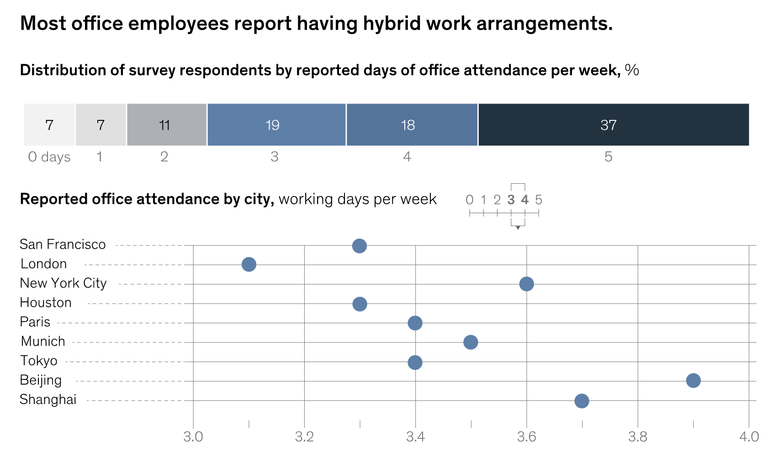
Figure 3: Hybrid Work Arrangements (Mckinsey, 2023)

2.3. Societal Shifts
The social changes that reflect ideas of sustainability and corporate responsibility are the factors to shape the involvement of employees and organizational culture changes (Hameed et al., 2019) so that they are aligned with the agenda of Marriott’s sustainability goals and its corporate worth. Nielsen's report in 2021 shows that 73% of customers across the globe are willing to change their consumption patterns to reduce the negative impacts on the environment, meaning that employees also hold sustainable practices at their workplaces dearly (Nielsen, 2022). There is also a societal expectation of organizations to adopt the sustainable use of energy, hence Marriott’s goal of reducing carbon emissions by 30 percent before 2025 will help instill a sense of responsibility among the workers (Marriott, 2023).

2.4. Marriott Hotel Monitoring System
Marriott Hotels uses several approaches to ensure that the management of employees now and then and across different work modes of operation is effective. There are major strategies, one of which is the identification of measures and goals of manufacturing performance commonly referred to as key performance indicators (KPI) (Marriott, 2023). These metrics are particular to the positions that are held by the employees and to the nature of the work they perform. For individuals working from home, productivity is measured by the delivery of assignments, punctuality in delivering projects, and case review ratings. On the other hand, on-site staff performance is compared in terms of the guest satisfaction, the room utilization rate, and the amount of revenue. This means that corporate performance is maintained at certain levels and all the workers including those in distant stations are taken through some standard behaviors (Marriott, 2022). Human resource management is a vital aspect of Marriott’s operation, and it relies heavily on technology. To enforce task accomplishment, the company employs different digital resources for surveillance purposes. Employees who work from home require monitoring and organizing software such as time tracking, project management tools, and communication software to monitor the progress made and keep the operations running smoothly. Another important element of Marriott’s management is regular performance reporting and providing feedback. Managers organize and facilitate these sessions for employees to review objectives, concerns, and opinions, and to receive feedback. For employees who are enabled to work from home, this is achieved through virtual check-ins through video conferencing applications (Marriott, 2022).

3. Evaluation and Conclusion

3.1. Main Findings
This research proposal analyses the applicability of three types of work models at Marriott Hotels: the hybrid model, the flexible model, and the traditional office working. The purpose of the research is to find how socioeconomic factors affect employee performance management and monitoring to enhance workforce productivity and engagement. The nature of work and human capital is now becoming more dynamic due to socio-inverse factors which include age demographics, and the generation gap in determinants of employees’ expectations concerning work flexibility as well as career advancement. The fact of increased employment in the population and the need for flexible work hours underlines the problem of variable working conditions. Other factors related to the economic system include the GDP rates and other financial benchmarks as well as the labor market conditions. Increased adaptability in work environment escalation and the innovative changes in consumer pull factors have led to the escalation in the adoption of remote and hybrid work modes. Marriott has applied work flexibility by engaging in working from home and hybrid working scenarios, adopting technology advancements for remote and hybrid working, and on-demand staffing senses, particularly for hiring cleaners and event services. Organizational communication technologies such as machines and software ensure that remote and hybrid working ensure an adequate level of productivity and morale of employees.

3.2. Recommendations
- Flexible working processes should be extended, for instance, providing hybrid or remote working possibilities again for different employees’ preferences within Marriott. This approach can reduce turnover while increasing the level of satisfaction with the job, especially among the youth and highly skilled personnel.
- Marriott management should ensure that the organization continues with its learning culture by conducting frequent training sessions, especially for distinctive work environments. This helps inform employees on necessary changes expected to happen in their working areas or any advancement in technology (Slavković & Slavković, 2019).
- Taking into consideration the fact that the company operates in a highly competitive industry, with numerous employees available, regularly conducting surveys and engagement initiatives would help Marriott gain an insight into the employees’ concerns and have plans on how to get around them to enhance satisfaction and retention level. To this effect, there is a need for enhanced feedback mechanisms to ensure that employees receive reasonable feedback to show that they are valued in their organization (Slavković & Slavković, 2019).

References
Battisti, E., Alfiero, S., & Leonidou, E. (2022). Remote working and digital transformation during the COVID-19 pandemic: Economic–financial impacts and psychological drivers for employees. Journal of Business Research, 150, pp. 38–50.
Boeri, T., Garibaldi, P., & Moen, E. R. (2021). In medio stat victus: Labor Demand Effects of an Increase in the Retirement Age. Journal of Population Economics, 35(2), pp. 519–556.
BRAGA, D. (2023). 1. The growth of the older workforce . Available at: https://www.pewresearch.org/social-trends/2023/12/14/the-growth-of-the-older-workforce/
Chung, H., & Van Der Lippe, T. (2018). Flexible Working, Work–Life Balance, and Gender Equality: Introduction. Social Indicators Research, 151(2), pp. 365–381.
Coe, N. M., Jones, K., & Ward, K. (2010). The Business of Temporary Staffing: A Developing Research Agenda. Geography Compass, 4(8), pp. 1055–1068.
Deloitte. (2023). It's not a stretch: Gen Z and millennials want flexibility and balance . Available at: https://action.deloitte.com/insight/3375/its-not-a-stretch-gen-z-and-millennials-want-flexibility-and-balance
Goldstein, J. (2023). Marriott International Provides a Model for the Workplace of the Future With Their Hospitality-Infused Global Headquarters . Available at: https://www.gensler.com/blog/marriott-hq-workplace-of-the-future
Ghani, B., Zada, M., Memon, K. R., Ullah, R., Khattak, A., Han, H., Ariza-Montes, A., & Araya-Castillo, L. (2022). Challenges and Strategies for Employee Retention in the Hospitality Industry: A Review. Sustainability, 14(5), pp. 2885.
Hameed, Z., Khan, I. U., Islam, T., Sheikh, Z., & Khan, S. U. (2019). Corporate social responsibility and employee pro-environmental behaviors. South Asian Journal of Business Studies, 8(3), pp. 246–265.
Huang, A., De La Mora Velasco, E., Marsh, J., & Workman, H. (2021). COVID-19 and the future of work in the hospitality industry. International Journal of Hospitality Management, 97, pp. 102986.
ILO. (2023). World Employment and Social Outlook Trends 2023. Available at: https://webapps.ilo.org/wcmsp5/groups/public/---dgreports/---inst/documents/publication/wcms_865332.pdf
Manoharan, A., & Singal, M. (2019). Organizational effectiveness in hospitality: Managers perspectives. International Journal of Hospitality Management, 80, pp. 123–125.
Mckinsey. (2023). How hybrid work has changed the way people work, live, and shop . Available at: https://www.mckinsey.com/mgi/our-research/empty-spaces-and-hybrid-places-chapter-1
Marriott. (2023). Marriott International, Inc. - Climate Change 2023. Available at: https://serve360.marriott.com/wp-content/uploads/2023/09/CDP-Climate-2023-vHsm2.pdf
Marriott. (2022). Marriott International Provides an Update on Development Progress in 2021 and Overview of Key Trends Currently Shaping Hospitality Development . Available at: https://news.marriott.com/news/2022/01/20/marriott-international-provides-an-update-on-development-progress-in-2021-and-overview-of-key-trends-currently-shaping-hospitality-development
Nielsen. (2022). The changing climate of sustainability has reached a critical moment . Available at: https://nielseniq.com/global/en/insights/analysis/2022/the-changing-climate-of-sustainability-has-reached-a-critical-moment/
Slavković, A., & Slavković, V. (2019). The importance of training in contemporary organizations. MenadžMent U Hotelijerstvu I Turizmu/Menadžment U Hotelijerstvu I Turizmu, 7(2), pp. 115–125.
Statista. (2024). Marriott International - statistics & facts. Available at: https://www.statista.com/topics/1872/marriott-international/#topicOverview
Shastri, A. (2024). The art of marketing hotels; marketing strategy of Marriott International. Available at: https://iide.co/case-studies/marketing-strategy-of-marriott-international/
WTTC. (2021). WTTC research reveals global Travel & Tourism sector suffered a loss of almost US$4.5 trillion in 2020 due to the impact of COVID-19 . Available at: https://wttc.org/news-article/global-tandt-sector-suffered-a-loss-of-almost-us4-trillion-in-2020

