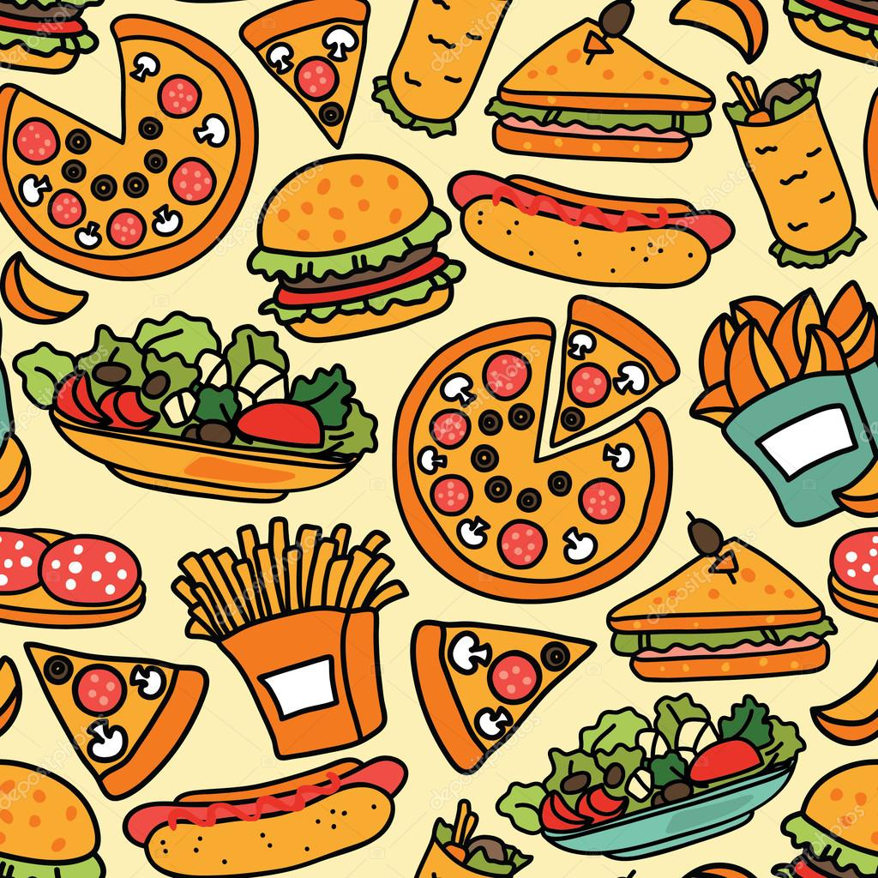
Timing
Breakfast Time: 6 AM to 12 AM
Lunch Time: 12 PM to 5 PM
Dinner Time: 8 PM to 12 PM
Open for 24/7

Hotel Trinity
Address:
53 Knights Bridge Green
London, UK, SX1V9Q3
+44 (0) 334 575 8888
Breakfast Items
Crêpe Mix
mix with sweet savoury pancakes, batter for family
Easy Prawn and Egg
easy prawn and egg on toast with chives to finish
Poached Egg
Soft fried Egg on some oats
Fruit Cookie
prepars with with yogurt and fruit avoiding masala flecks
Carrot Cack
Nutmeg, cinnamon, carrots, raisins flavors on it with full energy pack
Pancake
Fruit jam, honey, flour, egg, vanilla essence
Banana Smoothie
Cream, banana, blueberry, redberry, protein powder, nutty powder, serving with toast.
Eggy Cheese
Made with Eggs, cheese, regular toast, sandwich, tomatoes, avocadoes
Chocolate Porridge
Dates, oats, corn flecks, chocolate, wafer
Egg Muffins
Salmon, Egg, Bacon, Ham mixed and baking process
Vegetables Cake
Mixed vegetables, onions, green chillis, piper, mint slice
Soft-scrambled eggs
soft-scrambled pillowy eggs with coffee
Migas
pan fried Corn tortillas with whipped egg, spices
Granola with Figs, Almonds and Coconut
combine with and oil, oats, honey, chopped nuts and dried fruit.

Menu Items
- We are exploring a complete menu chart to our valuable customers. We provide the quality and healthy food.
- Compared to 4-star hotels, we are offering low prices of food.
- We are now offering 25% discounts on all main launch and dinner items. Others is 15% at this moment. For the new decoration and accommodation, this offer will exist for 3 months.
- We are providing online food delivery service based on social media platforms. Valuable Customers may book the food on Facebook Page, WhatsApp, and Instagram. Or they can directly call us over phone.
- Our restaurant is open for 24 hours and food delivery also.
- We are committed to provide foods within 30 minutes.
- We accept all kinds of payment system- card, cash, PayPal, mobile banking, account
- Customers may return foods if they find any issues on them. They will get an apology gift for free. We accept customer review and comments.
- We solve any kind of food complains as soon as possible.
- We offer £5 for the delivery charge. But it varies based on the distance.
- We always provide 2 pairings of masala drink for our special appearance
- We provide 2 pairings of red wine for our selected special dishes.
- A takeaway service option is also available in our hotel.

Trinity Special Dish

Butter Chicken
pan-fried Chicken with spiced tomato sauce.
Peas and Cooked Cottage Cheese
It’s made up of peas, masala, tomato sauce over paneer
Beetroot & Blackberry Cured Salmon
beetroot and berries on crackers

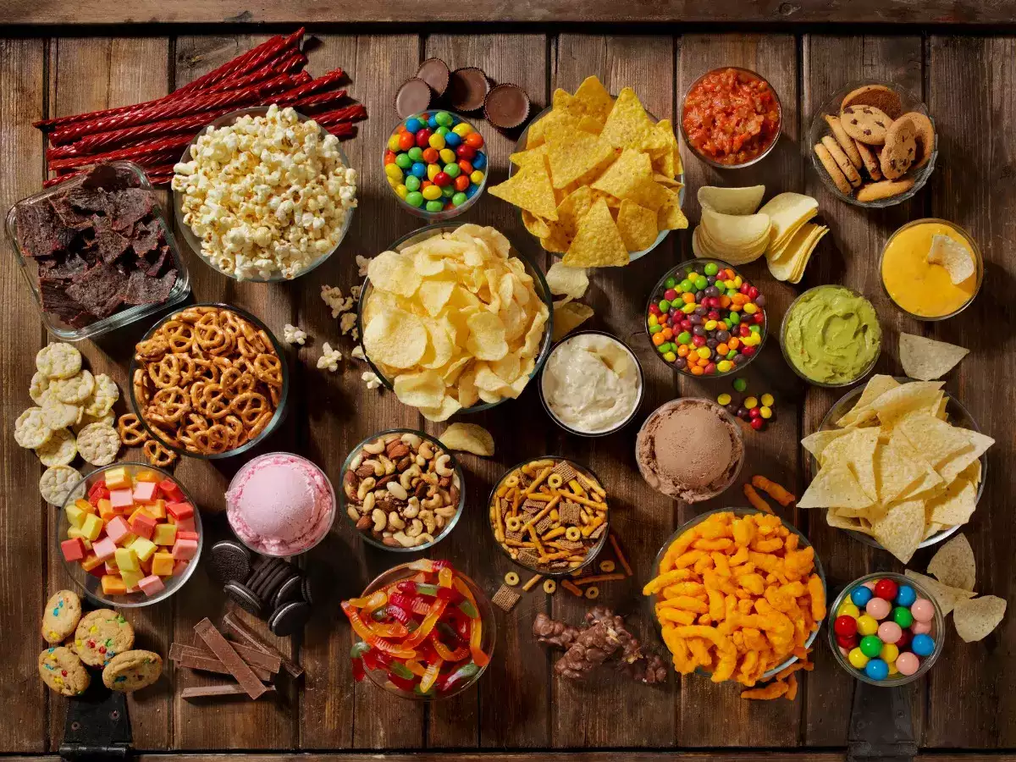
Main Course (Lunch & Dinner)
Lentil soup
thyme, lentils, Chicken or vegetable stock
Mediterranean pasta
tinned salmon, capers, Whole-wheat pasta
Tuna bell pepper boats
red bell pepper, Greek yogurt, Tinned tuna
Lemon Chicken
Garlic, chilli Lemon, chicken, dried and some juice
Chettinad Fish Fry
pan-fried Garlic, surmai fish, fennel, cumin, curry leaves and tomatoes
Keema Biryani
Ginger and milk, raisins, onions, meat, garlic minced, almonds yogurt
Mutton Do Pyaaza
generous number of crunchy onions with yogurt and a burst of spices.
Chicken Bukhara
juicy chicken pieces simmered in luscious gravy of tomato puree
Set Menu 1
4 chicken curry, fried rice, French fry, Chinese vegetables, soft drinks
Set Menu 2
Chicken BBQ 2-piece, rice, lentil makhana, salad
Set Menu 3
rice, chilli chicken two pieces, fried fish, soft drinks
Set Menu 4
poached egg, rice, cheesy vegetable salad, grill chicken, soft drinks
Set Menu 5
Fried rice, potato paste, prawn paste, vegetable paste

Chicken Items
Bean sprouts chicken
Chicken Masala
Teekha Murg
Murg Malaiwala
Spicy Tangy Kadhai Chicken
Chana Aur Khatte Pyaaz Ka Murgh
Masaledar Chicken Lollipop.
Burrito
Finger-lickin
Nugget
Butter chicken
Pita
Taco
Barberton chicken
Tenders
Broccoli
Cashew
Curry
Kung Pow
Sesame
Teriyaki
Tikka
Backhendl
Bamboo chicken
General Tso
Ginger

Barbecue chicken

Kerala Chicken Roast. ...
Chicken Chettinad. ...
Chick Filet
Colonel Sanders
Fajita
Dumpling
Tandoori

Side Dish
French Fries
Onion Rings
Wedges
Mashed Potato

Wines
Red Wine
White Wine
Rose Wine

THANK YOU
Note: We offer every kind of food. Those who are meat lovers, vegetarians or only love seafood can visit here and order your desired menu from our hotel. Additionally, please let us know if any of you have allergy reactions to any item or food. Then we will make the dishes in a custom way. At the same time, we'll do everything we can to make you feel at ease in every way.

Soup
Thai Soup
Chicken Soup
Mushroom Soup
Creamy Mushroom Soup
Seafood Soup
Onion Soup

Snacks Item
Chicken Wings
Potato Wages
Naga Wings
Cheesy pasta
Nachos
French Fry
Yogurt Fuchka
Nutty Wages
Baked Protein Chips
Chocolate Flavored Keto Cups
Cashew Coconut Cookie
Pineapple Rum
Keto Cereal
Fruit Yoyos
Strawberry Custard
Apple Chips,
Banana Chips
Coconut Chips
Seeds Cookie

Soft Drinks
USA ginger ale
Swedish Julmust
German fassbrause
Japanese Calpis
Fanta melon soda
ice cubes cola
Mountain Dew
Appletise
Barq’s
Fresca
Glaceau
Minute Maid
7 Up
Dr Pepper
Sun Drop
Sunkist
Schweppes

Salad
Caesar Salad
It’s Mixed salad of Mustard, pepper, Romaine lettuce, olive oil, lemon juice croutons, salt, sauce in a covered feature
Green Salad
It’s made with greens like arugula, iceberg lettuce and spinach
Greek Salad
it’s made of A salad of sliced crumbled feta, red onion, cucumbers, olives, red bell pepper, tomatoes
Niçoise Salad
Seasonal Vegetables, Niçoise olives, tomatoes, hard-boiled eggs, tuna are the mail ingredients
Cobb Salad
Avocados, cheese lettuce, vinaigrette, grill chicken, boiled eggs, tomatoes, Roquefort, and red wine.
Wedge Salad
blue cheese, iceberg lettuce and bacon are main ingredients

Dessert Items
Apple and butterscotch pie
Almond and date cake
honey cheesecake
Tiramisu
Chocolate Sheet Cake
Mint Oreo Cake
Sour Cream Doughnuts
Lemon Bars
Blueberry Cheese Cake
Red Velvet Cheese Cake
Plain Fruit Cake

Coffee Items
Espresso
Red Eye
Black Eye
Long Black
Cappuccino
Flat White
Cafe Latte
Vienna
Iced Coffee

Tea Items
Black Tea
White Tea
Masala Tea
Mint Tea
Green Tea
Lemon Tea

References
Bhati, D. and Raghuvanshi, R., 2020. Nutritional Quality Evaluation of Popular Indian Fried Snacks Based on Cowpea. International Journal of Current Microbiology and Applied Sciences, 9(9), pp.650-655.
Bhavsar, S., 2017. Modified dessert recipe NUTRI DESSERT (Carrot Oatmeal Muffins) for Diabetes Mellitus. Journal of Medical Science and Clinical Research, 05(05), pp.21724-21727.
Miller, K. and Vernarelli, J., 2014. Nutrient intakes among the ten most common breakfast food types (810.6). The FASEB Journal, 28(S1).
Neumark-Sztainer, D., MacLehose, R., Loth, K., Fulkerson, J., Eisenberg, M. and Berge, J., 2012. What's for dinner? Types of food served at family dinner differ across parent and family characteristics. Public Health Nutrition, 17(1), pp.145-155.
S.B., I., 2022. Estimation of Natural Radioactivity in some Popular Drinks in Nigeria and its Radiological Effect. JOURNAL OF MEDICAL CORNVUS, pp.1-5.
Sathishkumar and Kulkarni, V., 2020. Physicochemical and sensory quality of meat in commercial native chicken, backyard native chicken, commercial broiler and spent layer chicken. Journal of Meat Science, 15(2), pp.6-11.
Sittisingh, U., 2018. Experiential Learning: Food Choices of Thai Local Mixed Dish and One Plate Dish among College Students. SSRN Electronic Journal,
Szubart, T., 2018. On Types of Coffee. DeRose's contextualism as an anti-sceptical strategy. Analiza i Egzystencja, 44, pp.61-81.
Yoo, Y. and Jung, H., 2019. Tea Concept and Tea Types Reflected in World Zen Tea Products. The Korean Tea Society, 25(4), pp.32-39.

