Michael Leather
Level 5 Undergraduate
BA International Development and Global Politics

Brief On A Policy For The United Nations Migration Management

Introduction

The purpose of this brief is to focus the United Nations, (UN), on its current approach to its policies procedures, or lack of, and on how it manages migrants. It will investigate why there is a lack of policies it has in respect to migrant management in dealing with current trends and the affects that is having in its relationship with the member states, how it can better align with them in developing a modern decisive migrant policy that will assist better management. It will highlight the issues that could and should be dealt with within the organisation and assist that re-alignment by suggesting ideas that are more comparable with the modern World.
Scrutiny of the UN approach to migration is because it has become apparent that the UN does not have an organisation or policy to specifically deal with migration. “The legal and normative framework pertaining to international migration cannot be found in a single document”, (Koser, 2014, p668). It can be argued this because it has allowed the recognition, and focus, of the difference between a refugee and a migrant to become clouded. It is important in forming the nucleus of a migration policy for to recognise the difference between the two; The simple definition is that a migrant is someone who chooses to move, and a refugee is someone who has been forced from their home, (Eldridge, 2022).

Background History to Global Migration Management

In a report, published by the UN in 2014 on Migration and Human Rights, it best describes the reasons for migration as:
The mobility of people across international borders dates back to the creation of borders themselves, and the vulnerability of non-nationals is not a new phenomenon. While many migrants move to take advantage of increased opportunities out of genuine, free and informed choice, many others are compelled to move as a result of poverty, lack of decent work, social exclusion, generalized violence, persecution, human rights violations, armed conflict, xenophobia and environmental degradation. In the absence of sufficient regular migration opportunities, migrants can be forced to resort to irregular migration channels including seeking out the services of smugglers or even falling prey to traffickers. (United Nations, 2014, P7).
In addition to those reasons as the motivator for migration, Robert McLeman has highlighted a modern cause; That of migration due to climate change and the possibility of large population displacements brought on by the increasing occurrence of droughts, the possibility of rising sea levels and other extreme weather events, (McLeman, 2011, p169), although some of these may well come under the title of Internal Displaced Persons, (IDP) who remain within state borders.
It is estimated that there were 214 million international migrants in the world in 2008, which was an increase of 40 million in the first decade of the 21st century, and double that of 1980, (Koser, 2014, p670). This does not include the 20 to 30 million persons subject to irregular migration as reported by the International Organisation For Migrants, (IOM), (IOM a, 2011). The great migrations are seen in the 21st century not as a driving force for social change but as an anarchic social force like a mismatched tile that cannot find its place in the larger mosaic, (Livi-Bacci, 2010, p2), and the fault of this mismatch in terms of global governance lies with the UN.

The Problem

In 1948, the newly formed UN approved a Universal Declaration of Human Rights, (UDHR), which composed of 30 articles that affirmed unalienably a list of human rights. At the time it was wholly appropriate following the horrors of World War Two. Pertinent to this brief was article 13 which stated that “everyone has the right to leave any country, including his own, and to return to his country”, (United Nations, 1948). Probably due to the image that the UN wanted to portray at the time, even though the document encourages states to invoke it through their own state legislation, nowhere did the document acknowledge member state borders and precedence. The declaration addressed the issues at the time, but the World has changed and it is now 2024!! The ambiguity of Article 13 to align itself with state members in respect of the approach to migration management whilst balancing border security, cost on the domestic economies against the plight of human suffering, contradicts the issues of migrant management.
Recognising there was an issue with refugees/migrants, in 1951 an organisation was formed called the United Nations High Commission For Refugees, (UNHCR). Under their umbrella, refugees and migrants have been addressed under the same banner. Alexander Betts sums up the situation by pointing out that during the organisation’s development, it has become increasingly difficult to apportion institutional responsibility for migration and displacement. At the outset, it stood alone in dealing with displacement and migration and in an environment that had relatively few international organisations, there were clear divisions of inter-agency divisions.
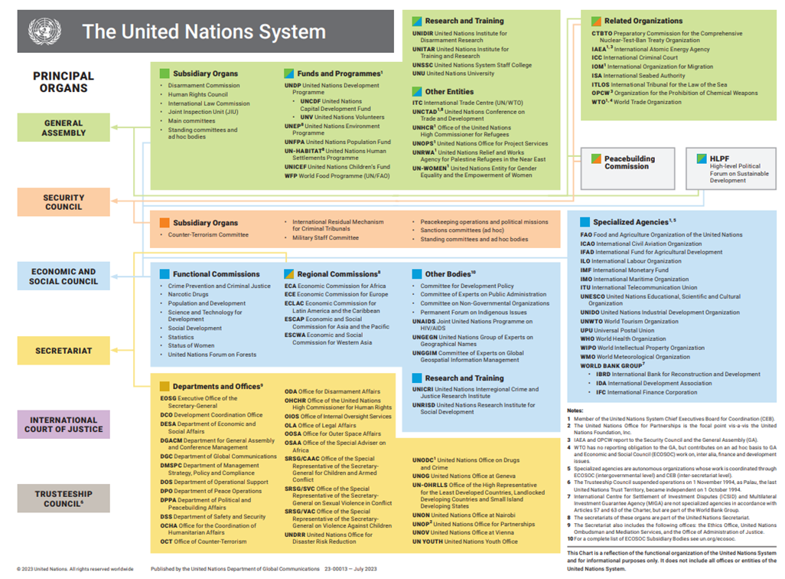

Figure 1. UN Organisation Chart Showing the UNHCR department within the Organisation.
Since then, a plethora of international institutions have arisen dealing with human rights, peacekeeping, humanitarianism and development to name a few and this has caused overlaps with contradictions which undermined international cooperation in relation to global migration governance. Nowhere is this more evident than with the overlap between the emerging migrant situation and refugees “in the area of spontaneous arrival asylum”. (Betts, 2011, pp 239-241). The organisation has grown exponentially to its current size and is buried in the organisation within a multitude of others as well as being overwhelmed with multiple departments operating in numerous locations, as shown in figures 1 and 2. To further highlight the size of the task expected of the UNHCR, it maintains strategic partnerships with more than 900 partners including non-governmental organizations (NGOs), governmental institutions and United Nations agencies, (UNHCR a, 2024). This complex organisation and administrative enclave needs to be seriously streamlined by separating their work with migrants from those of refugees, therefore allowing for better and more centrally focused migration management.

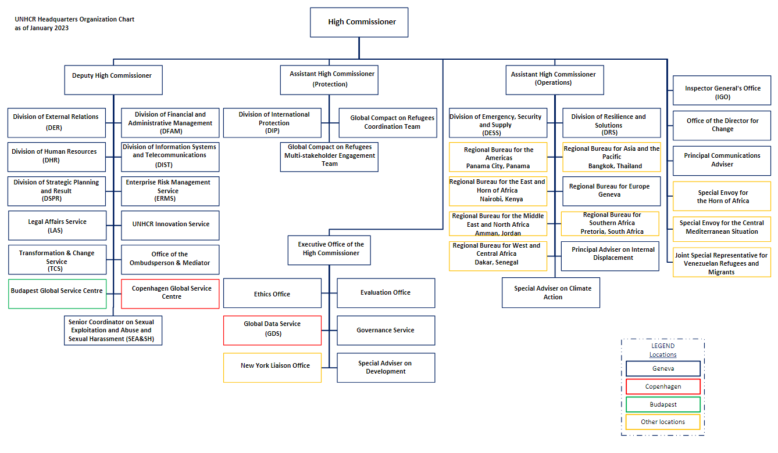
Figure 2. UNHCR Organisation Chart as at 2023.

As an example, a search of the UNHCR specific website for policies and procedures, revealed that in the category of reports and procedures, there were 13,145 available documents but no keyword searches available for the word ‘migration’, (UNHCR b, 2024).
Another fundamental development that could have but did not address the lack of representation of the migration policy deficiencies was the formulation of the 17 Sustainable Development Goals, (SDG’s), with a total of 139 targets and a set of 330 preliminary indicators in 2015 that have a shelf life until 2030, (Hak et al). Throughout all 169 targets there is only one to be found in SDG 10, “Reduced Inequalities”, Section 10.7, which calls to “facilitate orderly, safe, regular and responsible migration and mobility of people, including through the implementation of planned and well managed migration policies”, (United Nations b, 2015). The collective vision of the SDG’s is a vision of ‘leave No One Behind’ but the SDG’s have failed to include an indicator for migrants despite 60 million abandoning their homes in 2014, (Merino,2023, p1). It is argued that the indicators used to measure progress with SDG 10 are conceptually unclear and therefore insufficient to improve the migration framework, (Merino, 2023, p2). Furthermore, there is a thesis that there is an economic focus within the SDG’s that measures migrant contribution in terms of economic cost and their effect on the economic growth paradigm rather than on the people themselves and this globalised view’s dependency on it leaves out questions about rights, entitlement and dignity of the migrants themselves. This economic focus reflects the main stakeholder’s interests and therefore fails to elaborate on issues to protect migrants and reiterates the common perception that promoting economic development in the developing countries will reduce the migration to the developed countries, (Merino, 2023, pp3-4).
There is the previously mentioned IOM, but this is only a partner to the UN family and operates outside the UN’s sphere, making any attempts to coordinate migration management a logistical hurdle. Formed in 1951 through a USA / Belgium initiative, it was mandated by European governments to assist in the resettlement of people displaced from World War Two, it now boasts an annual operating budget of 3Bn US dollars. It currently, amongst other data announces on its website that it has helped to return 54,000 migrants and +100,000 trafficked persons in 2012, (IOM b, 2024). Whilst any assistance is applauded, 54,000 is not a great return on 3Bn US Dollars which does not include any of the donated project costs.

The Way Forward

The United Nations is an administrative monster and there is no mileage in introducing another arm of this organisation and forming definitive policies for migrants only for it all to be enveloped into the ether of the UN bubble. As the UN is the foundation for subsidiary agencies and departments, it is incumbent that revision of those foundations take place before another extension is built. Currently the governance of international migration within the institutional structures of the United Nations presents a somewhat inconsistent picture. It would be prudent to initially consider the formation of a technical and working panel on migration and human rights to facilitate a norm-based discussion, share information and establish common understandings on cross-cutting issues, particularly those which are not being adequately considered within existing UN governance forums, (UNHCR c, 2014). It should be acknowledged that The IO has not been ignorant to the need for better migrant management when the Secretary General acknowledged the migrant challenges and set up the Global Commission For International Migration whose report of 2005 recognised “The international community has failed to realize the full potential of international migration and has not risen to the opportunities and challenges of migration.”, (OHCHR ,2005, p1). Within the report it has ceded a lot of the responsibilities back to the states albeit there were no current plans to introduce a formal global governance system for international migration which would involve the establishment of new international legal instruments or new agencies, (OHCHR, p3). The summary report is full of positive comments and findings that would make a solid foundation for a future policy and was instrumental in the formation of the Global Migration Group, (GMG), in 2006 and its heir apparent in 2018, the United Nations Network On Migration, (UNNOM). As of late 2021, this group currently has several thematic working groups producing subject specific documents, (UNNOM, 2021). This is commendable and due consideration should be given to evolve this set up into a long-awaited agency with a vision statement and umbrella policy to oversee all migration management. An ongoing UN reform process would provide a window of opportunity to realize this momentum through a revision of current institutional arrangements.

Recommendations

These recommendations are by no means exclusive to the process of producing a migration policy and forum to administer it and are expected to act more as seeds to the succession of this brief in the search for a
systematic, coherent and coordinated international approach to protecting the human rights of all migrants.

- The UN re-draft the 1948 Bill of Human Rights, specifically Article 13, to a vocabulary that reflects a modern representation of the Global environment with an acknowledgement of the state’s sovereignty whilst maintaining the ethos of its original form.
- Review and implement austerity measures by reducing the duplicity of involvement of multi agencies whose aims are synonymous within all missions, with the objective of reducing costs and therefore releasing funds that could be better directed to oversee a developed migration management policy.
- The formation of an International Organisation, (IO), or the adoption of an existing IO under the UN umbrella that is separate from all other IO’s, specifically dedicated to migrants and the subsequent issues, with the remit to form and submit resolutions that address the subject matter on a global governance level that allows a maintained flow of migrants within state-controlled parameters.
- Identify the overlaps within the current institutional architecture that at times undermine an integrated, coherent and effective response to the opportunities and challenges presented by international migration. These different institutional approaches to the same issue cause divergence and even conflict and creates frequent competition for limited funds to achieve the same goals. (OHCHR, 2005, p5).
- Develop a set of human rights indicators, specifically concerned with migrants and migration with a focus on the most vulnerable. The indicators could be targeted to inform emerging debates related to the Post-2015 UN Development Agenda. (UNHCR c, 2014, p43)
- Introduce a set of international normative binding standards with which states have to provide service provision and technical assistance offering support on such issues as pre-departure orientation, migrant worker recruitment, medical screening, assistance with the provision of travel documents, facilitation of family reunification.
- Implement a state-controlled biometric system to register all migrants that do not have destination country origins into those countries but by which entry would not exclude them because of personal denomination but under the provision that violation of any state’s criminal offences that carry custodial incarceration would facilitate immediate expulsion to the country of origin. This recommendation is made that it would assist in the reduction of such issues as human trafficking and economic migrants and add incentive to integrate with destination countries.
- Encourage, formulate and enhance access to secure, legal visa and passport frameworks with all state members that are cost effective to those that seek rights-based admissions.
- States address the conditions that promote irregular migration by providing additional opportunities for regular migration by taking action against employers who engage migrants with irregular status, (OHCHR, 2005, p7).
- Greater efforts should be made to create jobs and sustainable livelihoods in developing countries, so that the citizens of such states do not feel compelled to migrate. Developing countries and the industrialized states should pursue economic policies and implement existing commitments that enable this objective to be achieved. (OHCHR, 2005, p6)
- That the implementation of all measures recommended by time specific in their conclusion.

Word Count 2353 Without References and Title Block.

References
Eldridge, Alison., (2022), What’s the Difference Between a Migrant and a Refugee? Encyclopaedia Britannica, https://www.britannica.com/story/whats-the-difference-between-a-migrant-and-a-refugee.
(Accessed 22nd April 2024).
Betts, Alexander., (2011), The Impact of Global Migration Governance on UNHCR. The Migration-Displacement Nexus: Patterns, Processes, and Policies, Khalid Koser and Susan Martin, (ed) 1st ed., New York, Berghahn Books, pp. 239–59. JSTOR file:///G:/University/Global%20Governance/Betts-ImpactGlobalMigration-2011.pdf (Accessed 24th April 2024).
Tomáš Hák, Svatava Janoušková, Bedřich Moldan, (2016), Sustainable Development Goals: A need for relevant indicators, Ecological Indicators, Volume 60, 2016, Pages 565-573, https://www.sciencedirect.com/science/article/ (Accessed 27th April 2024).
International Organisation For Migrants a, (2011), World Migration Report, Switzerland, https://publications.iom.int/books/world-migration-report-2011 (Accessed 21st April 2024).
International Organisation for Migrants b, (2024), Migration Management, https://www.iom.int/migration-management (Accessed 23rd April 2024).
Koser, Khalid, (2014), Refugees And Migration, International Organisation And Global Governance, Edited Weiss, Thomas and Wilkinson, Rorden, (ed) 1st edition, ch 50, p670, London, Routledge, 2014.
Livi-Bacci, Marissimo, (2010), A Short History Of Migration, Translated by Carl Ipsen 2012, Cambridge, UK. Polity Press.
McLeman, Robert, and Brown, Oli. Climate Change and Human Migration, The Migration-Displacement Nexus: Patterns, Processes, and Policies, Khalid Koser and Susan Martin, (ed), 1st ed., Berghahn Books, 2011, pp. 168–96. JSTOR, http://www.jstor.org/stable/j.ctt9qcgrf.16. (Accessed 20th April 2024).
Merino, A. M., (2023), Migration And Development Journal 12.1, Can SDG 10.7 Transform The World By 2030? https://researchportal.northumbria.ac.uk/ws/portalfiles/portal/125110435/Can_SDG_10.7_transform_the_World_by_2030_To_publish.pdf (Accessed 23rd April 2024).
OHCHR, (2005), Summary Report Global Commission For International Migration. https://www.un.org/en/development/desa/population/migration/events/coordination/4/docs/P09_GCIM.pdf (Accessed 25th April 2024).
UNHCR a, (2024), About UNHCR, https://www.unhcr.org/uk/about-unhcr/our-partners/non-governmental-organizations (Accessed 23rd April 2024).
UNHCR b, (2024), Policies and Procedures, https://www.unhcr.org/uk/search?search=policies%20and%20procedure&ss_field_categories_list[]=3 (Accessed 23rd April 2024).
UNHCR c, (2014), Improving Human Rights-Based Governance Of International Migration, Human Rights And Migration, MigrationHR_improvingHR_Report.pdf Accessed 24th April 2024.
United Nations, (1948), Universal Declaration Of Human Rights, https://www.un.org/sites/un2.un.org/files/2021/03/udhr.pdf Accessed 25th April 2024.
United Nations a,(2014), Migration And Human Rights, Improving human rights-based governance of international migration, https://www.ohchr.org/en/documents/tools-and-resources/improving-human-rights-based-governance-international-migration-2014 (Accessed 21st April 2024).

United Nations b, (2015), Sustainable Development Goal 10, https://www.un.org/sustainabledevelopment/inequality/ (Accessed 24th April 2024).
United Nations Network On Migration, (2021), Policy Documents, https://migrationnetwork.un.org/policy-documents (Accessed 24th April 2024).

