

Programme: BA Developing Leadership and Management

Module: Creativity and Innovation

Module code: BMSW5013

Module Lead: Chris Wilkin
Assignment Title: Sustainable Community Innovation - The Seren Coffi Case
Student Name: Florina Dinitica

Student ID: 2321857

Date: 31 March 2026

AI Acknowledgement - This report used an AI language tool in a limited way during the early idea-development stage of Part 2. It was used to explore possible directions for the proposed innovation and generate alternative suggestions for consideration. Any outputs produced were reviewed critically and not adopted uncritically. The final analysis, evaluation, conclusions and written discussion presented in this report are my own.

Executive Summary

This report examines the challenges facing Seren Coffi, an independent café experiencing operational decline despite continued customer demand. It focuses on the role of creativity and innovation within a capitalist business environment, paying particular attention to the tension between financial sustainability, ethical values and community identity.
The report proposes a revised innovation approach based on a low-cost, community-led model designed to reduce pressure on staff while rebuilding customer engagement. The suitability of this approach is evaluated through Lewin’s Force Field Analysis and supported by the Business Model Canvas.
The second part of the report reflects critically on the use of AI in developing the idea further. It argues that AI can support early-stage idea generation, but that its suggestions need to be assessed carefully against human judgement, organisational context and practical constraints. Overall, the report concludes that innovation at Seren Coffi should focus less on expansion and more on restoring operational stability while preserving the café’s distinct community value.

CONTENTS

Part 1 – Innovation Analysis Report 3
Introduction to the Organisation and the Innovation Issue 3
Critical Analysis of Creativity and Innovation in Capitalist Business Growth 4
The Strategic Importance of Creativity and Innovation 4
Capitalist Business Models and Innovation Tensions 4
Innovation Barriers for Small and Medium-Sized Enterprises 5
Implications for Seren Coffi 5
Explanation of the Proposed Innovation Concept 6
Overview of the Proposed Innovation 6
Application of the 4Ps of Innovation Framework 6
Application of Business Model Canvas 7
Creativity Process Used to Develop the Innovation 8
Innovation Viability – Lewin’s Force Field Analysis 9
Driving Forces Supporting Innovation 9
Restraining Forces Limiting Innovation 10
Evaluation 10
Organisational Climate and Innovation Support 10
Part 2 – Applying AI to Develop the Innovation 12
Introduction to AI Use in Innovation Development 12
AI-Generated Recommendations for the Innovation 12
Critical Evaluation of AI Recommendations 14
Challenges and Successes When Using AI 15
Reflection on the Use of AI 16
Main Findings 16
Overall Conclusion 17
References 18
Appendix 22

Part 1 – Innovation Analysis Report

Introduction to the Organisation and the Innovation Issue
Seren Coffi is an independent café based in Cardiff that combines speciality coffee with a strong commitment to community, ethical values and local identity. Unlike larger chain cafés that rely on standardised formats and scale efficiencies, Seren Coffi has built its reputation around authenticity, careful sourcing and meaningful customer experience. This reflects a wider shift within the hospitality sector, where consumers increasingly value social responsibility, local character and a sense of connection alongside product quality. From an innovation perspective, this also suggests that businesses are increasingly competing through experience and value creation rather than through product alone, a point strongly reflected in the innovation literature (Tidd and Bessant, 2020; Trott, 2016).
Despite these strengths, the case study shows that Seren Coffi is facing significant operational challenges. Although customer demand remains present, the business is struggling with slow service, delayed decision-making, reliance on volunteers, reduced customer engagement and unresolved equipment issues. These problems sit alongside rising costs, stronger competition from larger chains and growing staff fatigue. Rather than indicating a lack of demand, this suggests that the core issue lies in operational sustainability and in the effectiveness of the café’s current approach to innovation.
This distinction is important. Seren Coffi does not lack identity, purpose or customer interest. Instead, it appears to lack a practical and sustainable innovation approach that aligns with its values, limited resources and current constraints. The case also places clear boundaries on possible solutions: leadership, governance structures and suppliers cannot be changed, and the remaining £2,000 should be treated as a supporting resource rather than the main driver of change.
This report therefore explores how creativity and innovation can be applied to address Seren Coffi’s operational challenges without undermining the values that define the business. It critically examines creativity and innovation within a capitalist business context, develops a realistic innovation proposal grounded in the case, and evaluates its viability using relevant models and theory. The report also reflects on the use of AI in developing the idea further, considering both its potential benefits and its limitations.

Critical Analysis of Creativity and Innovation in Capitalist Business Growth

The Strategic Importance of Creativity and Innovation
Innovation and creativity are widely recognised as important drivers of business competitiveness and long-term economic growth. Creativity refers to the generation of novel and useful ideas, while innovation involves turning those ideas into practical applications that create value for organisations and their stakeholders (Trott, 2016). In highly competitive sectors such as hospitality, innovation is not optional but necessary, as businesses must adapt continuously to changing customer expectations and market conditions. However, this perspective assumes that all organisations have equal capacity to innovate, which is not the case for small businesses with limited financial and managerial resources.
Innovation research also suggests that long-term success cannot be achieved through operational efficiency alone. Businesses must continue to develop new value propositions that distinguish them from competitors and create meaningful customer experiences (Tidd and Bessant, 2020). In the café and hospitality sector, this may involve redesigning service processes, introducing new offerings, or creating distinctive customer environments that strengthen brand identity.
Contemporary innovation literature recognises that innovation extends beyond technology and can include organisational, experiential and business model change (Foss, 2015). However, in Seren Coffi’s case, innovation has already been attempted through poetry nights and community events, which were later discontinued because of operational strain. This suggests that creativity alone is not enough. Without a workable operational model, innovation can increase pressure on the business rather than improve performance.

Capitalist Business Models and Innovation Tensions
Although innovation is often promoted as a driver of economic growth, its application within capitalist business systems can create clear tensions. Traditional capitalist models tend to prioritise efficiency, scalability and profit maximisation, which means that innovations that increase revenue or reduce costs are often favoured over those that prioritise community or social value (Turner, 2020).
Research suggests that organisations operating within capitalist frameworks must balance competing priorities, including financial performance, stakeholder expectations and long-term sustainability (Porter and Kramer, 2011). Businesses pursuing socially oriented or community-based innovation may therefore face pressure to prioritise short-term financial outcomes over broader forms of value creation.
This tension is visible in the case study itself. Seren Coffi is reluctant to adopt cost-saving measures such as changing suppliers or standardising prices, despite rising costs. While that approach is ethically consistent, it also contributes to financial instability and shows the limits of value-driven models within capitalist constraints. Smaller businesses often depend on innovation and differentiation to remain competitive, but they must do so with far fewer resources than larger firms (Manners-Bell and Lyon, 2022). This highlights a key limitation of capitalist innovation models, as they often fail to account for organisations that prioritise social and community value over profit maximisation.

Innovation Barriers for Small and Medium-Sized Enterprises
Small businesses often face structural barriers when trying to innovate. These can include limited access to capital, operational constraints and restricted managerial capacity, all of which reduce the ability to experiment with new approaches (Trott, 2016). Research also highlights the importance of organisational culture in supporting innovation, as businesses that encourage experimentation, learning and collaboration are more likely to generate new ideas than those focused mainly on routine operations (Tidd and Bessant, 2020). At the same time, modern consumers increasingly expect memorable experiences rather than purely functional services, which places extra pressure on smaller firms to create engaging environments and emotionally resonant brands (Pine and Gilmore, 2011). In Seren Coffi’s case, these barriers are clearly visible in the delayed replacement of essential equipment, reliance on volunteers and limited operational capacity, all of which restrict both efficiency and innovation potential.

Implications for Seren Coffi
For Seren Coffi, innovation represents an opportunity to strengthen its competitive position while reinforcing its identity as a community-oriented business. Adopting more sustainable approaches to customer engagement, service design and value creation could help the café differentiate itself from larger competitors while building stronger relationships with its customers.

Explanation of the Proposed Innovation Concept

Overview of the Proposed Innovation
In response to the competitive and operational challenges that were identified from the case study, the proposed innovation is centred on transforming the café into a community-driven experiential platform that combines specialty coffee with participatory cultural and social activities. The innovation aims to strengthen the café’s differentiation by positioning it not merely as a place to purchase a cup of coffee but also a local hub for creative engagement as well as participation and shared experiences. The main concept involves a ‘Community Experience Programme’, in which the café regularly hosts community-oriented activities such as art exhibitions featuring local artists, live music sessions, and creative workshops and social discussion events. While the café has previously implemented community events this suggests that the discontinuation due to staff fatigue and operational pressure is indicative that the issue is not the lack of creativity but the lack of a sustainable execution model.
Coming from an innovation management perspective this particular approach can reflect a shift towards experience-based value creation where businesses compete not only through products and services, but also through creating memorable experiences that foster emotional connections within customers (Pine and Gilmore, 2011). Research suggested that businesses that are able to encourage customer participation in service environments can strengthen loyalty and also generate strong community relationships (Prahalad and Ramaswamy, 2004).

Application of the 4Ps of Innovation Framework

The proposed innovation can be analysed using the 4Ps of Innovation Framework which is able to classify innovation according to four very specific dimensions that are - product, process, position and paradigm (Tidd and Bessant, 2020). The framework is widely used in innovation management literature in understanding how businesses transform.
Product Innovation – These are able to refer to the changes in products and services that a business can offer. In the context of Seren Coffi, the innovation introduces a new type of service offering in which the café experience is extended beyond traditional food and beverage consumption and it also includes creative activities and cultural experiences.
Process Innovation – Process innovation can involve changes in how products or services are created and delivered. In the case study context this would help in introducing new operational processes in managing and coordinating the community activities with the regular café services. This can allow the café in integrating community programming into the daily operations while maintaining service efficiency. Process innovation often particularly is valuable for small businesses because they improve resource utilisation and enables it in delivering different offerings without increasing cost (Manners-Bell and Lyon, 2022).
Position Innovation – This kind of innovation can refer to changes in how a product or services perceived within the market. For the case study business, the proposed innovation would help position the café from being simply a hospitality venue to becoming a community cultural hub. This repositioning strategy can strengthen the brand differentiation by appealing to consumers who value community involvement and authenticity (Porter and Kramer, 2011).
Paradigm Innovation – This involves changes in underlying mental models that shape how a business operates. In the context, innovation represents a shift from viewing the café solely as a commercial business and then viewing it from a community platform perspective that is able to generate social and economic value. This perspective aligns with broader developments in innovation research that emphasises the importance of business models that are capable of generating multiple forms of value for different stakeholders (Foss, 2015).
Implementation here however will require careful planning and resource management in ensuring that the additional activities remain operationally viable.

Application of Business Model Canvas
Aspects | Application to Seren Coffi
Key Partners | Local artists; community members; volunteers; existing ethical suppliers
Key Activities | Coffee service; provide space; enable customer-led events; minimal coordination
Key Resources | Café space; brand identity; basic equipment; community participation
Value Proposition | Community-owned café experience, authentic, ethical, low-cost engagement
Customer Relationships | Informal; participatory, co-created experiences, low staff dependency
Channels | Physical café; noticeboards; word-of-mouth; social media
Customer Segments | Local residents; students; creatives; ethically aware customers
Cost Structure | Rent; utilities; wages; minor repairs; limited event costs
Revenue Streams | Coffee and food sales; voluntary contributions; event-based income; increased dwell spend

Creativity Process Used to Develop the Innovation

The development of the proposed “Community Experience Programme” for Seren Coffi can be examined through established creativity and innovation theories. The development of this idea was directly influenced by the observed failures within the café including declining event frequency along with staff fatigue and decreased operational efficiency. These issues highlighted the need for a model that reduces managerial involvement rather than focusing on expansion.
Creativity within businesses is typically defined as the production of novel and useful ideas while innovation is able to represent successful implementation of those ideas with business context (Amabile, 1996). In the case study context, the innovation concept emerged from analysing how the café could differentiate itself from multinational companies while also trying to maintain its very strong community-oriented identity that it already has.
An influential approach of understanding creativity in businesses is Design Thinking which emphasises empathy with users as well as iterative idea development and experimentation (Brown, 2008). Research suggests that customer centred innovation strategies can significantly improve differentiation in context to hospitality industries (Ottenbacher and Harrington, 2007).
An important concept over here is Open Innovation which is able to highlight how businesses can benefit from incorporating knowledge and ideas from external stakeholders (Chesbrough, 2014). In context to the case study business potential collaborations can include local artists as well as musicians and community groups who can contribute in context to exhibitions as well as workshops and cultural events. This particular approach reflects increasing importance of collaborative innovation networks in contemporary businesses (West and Bogers, 2014).
Creative research also emphasises the importance of diverse perspectives in generating innovative ideas. Studies demonstrate that businesses that encourage collaboration between different stakeholders are more likely in generating novel solutions (Hargadon and Bechky, 2006). Also, innovation in service businesses is often dependent on experiential differentiation within which businesses compete by creating engaging environments and memorable interactions (Pine and Gilmore, 2011). Hospitality businesses that successfully create unique experiences can strengthen the emotional connections that help build strong brand loyalty (Verhoef et al., 2009).
Finally, research on small business innovation is able to highlight the advantage of organisational flexibility. Smaller businesses often possess fewer bureaucratic constraints which then allow them in experimenting with new ideas and adapting quickly to the market feedback (Damanpour and Aravind, 2012).

Innovation Viability – Lewin’s Force Field Analysis

For evaluating the feasibility of implementing the proposed renovation, Force Field Analysis originally developed by Kurt Lewin and can provide structured methods for analysing factors that then support or hinder organisational changes (Burnes, 2004). The model identifies both driving forces that encourage innovation and restraining forces that might obstruct its implementation.

Driving Forces Supporting Innovation
A range of different forces support the introduction of Community Experience Programme.
Primarily, contemporary consumers increasingly prioritise experiential consumption which then values memorable interactions on social engagement over purely functional services (Pine and Gilmore, 2011).
Secondly, the business here already possesses a community focused brand identity which is closely aligned with the proposed innovation. Research is suggested that innovations aligned with organisational identity are more likely in being successfully adopted (Baregheh, Rowley and Sambrook, 2009).
Thirdly, the concept of co creation within which consumers actively participate in creating value can become important in innovation strategy in service industries (Prahalad and Ramaswamy, 2004). Encouraging customers and local creatives in contributing to events and activities can then strengthen loyalty and create strong community relationships.
Fourth, the small independent café can compete effectively with multinational chains by emphasising local authenticity and also personalised experiences which are very difficult for standardised corporate models in replication (Euromonitor International, 2023).

Restraining Forces Limiting Innovation
Despite the positive drivers there are barriers that limit the implementation as well. One challenge over here is the resource constraints as a small business typically has limited financial and managerial capabilities in investing in innovation initiatives (OECD, 2018). Event management and coordination might require additional time and effort. Operational complexities can increase as managing events alongside regular café operations can create scheduling issues (Ottenbacher and Harrington, 2007). The engagement level might be different at different times and research has suggested that innovation often requires ongoing experimentation before achieving consistent results (Schumpeter, 1934).

Evaluation
Overall, the driving forces are able to support the innovation in appearing strong particularly because they build on the existing brand entity of the café and respond to the broader consumer trends. Through the introduction of innovation gradually and evaluating customer feedback the business can reduce risk. Unlike previous initiatives the proposed innovation is able to reduce operational pressure by shifting responsibility to customers and community participants which directly address the root causes of failure in the existing model.

Organisational Climate and Innovation Support

Successful implementation of innovation is very strongly influenced by business climate as well as leadership behaviour. Organisational climate can refer to the shared perceptions as well as the cultural norms that are able to shape how employees approach creativity as well as risk taking and even collaboration (Anderson, Potočnik and Zhou, 2014).
Research indicates that businesses characterised by psychological safety are more likely in encouraging innovation because employees feel comfortable in sharing ideas and experimenting with the new approaches (Edmondson and Lei, 2014). Leaders play a very important role in establishing such environments by supporting experimentation and also encouraging learning from failure.
Seren Coffi, as a small business, is advantageous in this context because the smaller structure often facilitates open communication and rapid decision-making (Bessant and Tidd, 2015). Entrepreneurial businesses frequently demonstrate strong innovation potential due to their ability to adapt and respond quickly to consumer feedback.
Another important factor over here is organisational learning which is important for reflecting on experiments and adapting practises over time (Argyris and Schön, 1996). The analysis of feedback from customers and community participants over here will help the business in continuously refining the Community Experience Programme.
Innovation capability can also be strengthened through external networks and also partnerships. Collaboration with artists as well as community organisations and also cultural groups can allow businesses in accessing new knowledge and creativity resources (Powell and Grodal, 2005). These networks can stimulate new ideas while also strengthening the role of the café in local community.
Finally, the study is able to emphasise that businesses that are seeking in sustaining innovation must be able to balance creativity with operational discipline which will then ensure that the new initiatives remain financially viable while also supporting the strategic goals that are long-term in nature (Christensen, 1997). Seren Coffi as a business can foster a supportive organisational climate while also carefully managing resources. This will be very important in ensuring that the proposed innovation is able to contribute in sustainable business growth.

Part 2 – Applying AI to Develop the Innovation

Introduction to AI Use in Innovation Development

AI tools are increasingly used in businesses to support creativity and decision-making and even innovation development. AI driven systems can analyse large volumes of information as well as identify emerging patterns for generating ideas that might not immediately occur through traditional brainstorming (Brynjolfsson and McAfee, 2017).
For this assessment, AI (a large language model) was used in a limited way to help explore and shape the innovation idea that was introduced in the earlier Seren Coffi report. The original concept focused on creating a Community Experience within the café, where the space could be used for local creative events, small workshops, and cultural activities, either inside the café or in collaboration with the local community. The intention behind this idea was to make the café feel more engaging and inclusive, while also strengthening its identity as a community-focused business.
The AI tool was used to explore potential improvements to the concept by generating additional ideas related to customer experience as well as operational design and even potential business model adjustments of strengthening customer engagement and differentiating the business from large multinational coffee chains.
Research indicates that human and AI collaboration can enhance creativity by combining conceptual idea with human judgement and also contextual understanding (Jarrahi, 2018). Also, studies are able to suggest that AI systems can act as cognitive partners in innovation process by expanding the range of possible solutions that can be considered during strategic decision making (Davenport and Ronanki, 2018).

AI-Generated Recommendations for the Innovation

Presenting the original innovation concept that was developed to the AI system resulted in several additional recommendations that were generated that could potentially strengthen the planned Community Experience Programme at Seren Coffi. The recommendations primarily focus on improvement of customer engagement as well as expansion of business model and integrating digital tools.
One of the recommendations here involved the introduction of a digital community platform that is linked to the events programme of the café. AI suggested that creating a simple online platform or mobile application within which consumers could view upcoming events or register for the workshops and also interact with local artists or performers could be valuable. Research also highlights that integrating online and offline experiences can significantly strengthen customer engagement (Verhoef et al., 2021).
One of the other recommendations that was generated by the system was developing collaborative partnerships with the local creative professionals. For example, the suggestion highlighted that the café could provide temporary exhibition space for artists or even organise creative workshops that are led by local experts. Innovation research is able to emphasise that collaborative networks can play a very important role in generating new value propositions (Powell and Grodal, 2005).
Another suggestion over here was very much focused on the potential introduction of a community loyalty programme that was linked to event participation. Studies on customer experience management indicate that loyalty programmes can significantly increase repeat visits and strengthen emotional connections (Lemon and Verhoef, 2016).
AI system also suggested implementation of micro events as well as themed evenings as a practical way of managing operational complexity. I think it was an incremental approach that is very much aligned with innovation research that suggests how experimentation and iterative testing can be helpful for businesses in refining new initiatives (Ries, 2011).
Finally, a number of ideas highlighted the potential of hybrid creative experiences, where digital technologies are integrated with in-store events to enhance engagement. This aligns with research on digital innovation ecosystems, which suggests that the convergence of physical and digital experiences is becoming increasingly significant in cultural sectors (Nambisan et al., 2017).
While AI was able to suggest developing a digital platform for supporting event engagement it can be said that the recommendation may be somewhat unrealistic in the context of the case study business. The case is able to highlight financial limitations that includes dependence on remaining 2000 GBP budget and the inabilities of replacing essential equipment. As a result investing in digital infrastructure might divert resources away from urgent needs.
Overall, the AI generated recommendations expanded the original innovation concept by introducing additional digital engagement opportunities.

Critical Evaluation of AI Recommendations

While the AI generated recommendations expanded the scope of the original practice related to the innovation of Community Experience Programme, it is very important to critically evaluate the practical relevance of these suggestions within the specific organisational context. Innovation management research is able to emphasise that new ideas must be assessed not only for creativity but also for feasibility (Bessant and Tidd, 2015).
Several of the recommendations that were provided appear to be valuable. The suggestion to develop stronger collaborative partnerships with local artists as well as creative professionals aligns very closely with the existing community-oriented brand identity for the café. Research indicates that collaborative innovation networks can significantly strengthen the creative capacity of small businesses by providing access to external knowledge as well as expertise (Chesbrough, 2014).
Also, the proposal to introduce smaller micro events and also themed evenings appear both realistic as well as strategically very much appropriate. Incremental innovation strategies are very widely recognised as effective approaches for all businesses that must be able to manage limited resources while experimenting with new ideas (Trott, 2016).
However, I must say that there were some recommendations that might present some practical challenges for implementation. As an example, the idea of developing a digital community platform or mobile application can require financial investments and also technical expertise that might go beyond the capabilities of a small independent café. Studies concerning digital transformation are able to highlight that while digital tools can enhance engagement, small businesses can often struggle with implementation (Westerman, Bonnet and McAfee, 2014).
Another limitation over here concerns the AI suggestion of implementing a community loyalty programme that is linked to event participation. While loyalty programmes can strengthen community relationship, their design and management can require planning for ensuring that rewards remain financially sustainable (Lemon and Verhoef, 2016).
Broadly speaking the usage of AI itself can introduce certain analytical limitations. Systems of AI can often generate recommendations by analysis of patterns in existing data rather than by understanding specific organisational and cultural contexts (Dwivedi et al., 2021). Nevertheless, research also suggests that AI can be particularly valuable during early innovation stages by expansion of a range of different ideas and encouragement to businesses, considering the alternative approaches (Cockburn, Henderson and Stern, 2018). In the case study context, the AI system successfully generated several useful solutions that could complement the original innovation concept.

Challenges and Successes When Using AI

Reflecting on the process of interacting with the AI system there were several benefits and challenges that became very much evident. Coming from a positive perspective AI proved very highly effective in generating a wide range of potential ideas within a short time frame. By analysing information about innovation strategies and also customer experience management the system was able to suggest additional approaches that expanded the original Community Experience Programme.
One of the major advantages of using AI in this particular context was the ability of supporting idea generation and creative exploration. Studies suggest that AI systems can enhance the organisational creativity by providing alternative perspectives and prompting users in reconsidering established assumptions (Haefner et al., 2021). In this context the AI recommendations encourage consideration of digital engagement strategies and also hybrid physical to digital experiences that had not been fully explored in the original innovation concept.
However, there were several challenges that also emerged during this particular process. One limitation over here was that some AI generated recommendations appeared somewhat generic and also not fully tailored to the specific organisational context. This is able to reflect a broader limitation of AI systems which depend on generalised knowledge patterns rather than detailed understanding of the ideal environments which a business like this can operate in (Dwivedi et al., 2021).
Another issue over here was the need to carefully interpret and refine the outputs. While the system generated useful suggestions the ideas required significant human judgement for evaluating their feasibility and also strategic relevance. This reinforces the research suggests that most effective usage of AI in business can happen when human expertise and AI capabilities are complementing each other (Wilson and Daugherty, 2018). The overall experience of using AI helped in understanding how it can act as a powerful creative support tool but outputs do not always critically adapt to human needs.
A major limitation was observed when the AI tended to generate solutions that assume scalability options and resource availability which is not the case for the case study business. This includes limited finances along with operational fatigue.

Reflection on the Use of AI

Integration of AI tools into the innovation development process provided very valuable insights that enhanced the original Community Experience Programme.
The analysis was able to demonstrate that several AI generated suggestions were both relevant as well as practical and particularly the ones that were related to small scale events and community collaboration. These were recommendations that aligned closely with the existing brand identity of the café and also operational capabilities that then suggested that AI can be useful to for supporting idea refinement as well as innovation development.
However, the evaluation also highlighted important limitations such as the requirement of significant financial and technological resources that might not be realistic for a small independent business. Overall, the experience is able to suggest that AI does play an important role in supporting innovation processes by expanding a range of different ideas that are already considered and making them more effective. Future innovation projects within the business can therefore benefit from adopting a collaborative approach of human and AI.

Main Findings

The analysis of Seren Coffi has revealed that the business is not failing due to the lack of customer demand but due to internal operational inefficiencies and resource constraints. Despite there being strong community engagement and ethical positioning it can be said that the café is now struggling with slow decision making along with staff fatigue and difficulties in sustaining previously implemented initiatives such as social programmes and events.
The evaluation of creativity and innovation is able to highlight innovation activities were introduced, but they were not operationally sustainable which indicated the issue lies in the execution. Also, there was tension between maintaining ethical values and achieving financial stability which created a challenge within a capitalist business environment.
Assessment of the proposed innovation has been able to demonstrate that future strategies must prioritise simplicity and sustainability which focuses on the reduction of staff work overload. The application of Force Field Analysis is able to confirm that while there are very strong drivers of innovation there are also internal barriers.
Finally, the evaluation of the AI LLM suggestions was able to indicate that while AI can support idea generation the recommendations can somewhat lack contextual awareness which can require critical evaluation.

Overall Conclusion

In conclusion, the café is primarily driven by internal inefficiencies rather than lack of demand. The analysis was able to demonstrate that previous innovation efforts failed due to the unsustainable execution rather than having weak ideas. The proposed community-led model offers a more viable approach by reducing the operational pressures while preserving the identity of the café. However, the success of the business depends on consistent participation and also careful management. The evaluation of the AI suggestions highlights the value of AI as a supportive model, but it is limited due to a lack of contextual awareness. Overall sustainable innovation in this context can require simplicity as well as adaptability and also a better balance between operational practicality and community values.

References

Amabile, T.M. (1996) Creativity in context. Boulder: Westview Press.
Anderson, N., Potočnik, K. and Zhou, J. (2014) ‘Innovation and creativity in organizations: A state-of-the-science review, prospective commentary, and guiding framework’, Journal of Management, 40(5), pp. 1297–1333. Available at: https://doi.org/10.1177/0149206314527128
Argyris, C. and Schön, D.A. (1996) Organizational learning II: Theory, method and practice. Reading, MA: Addison-Wesley.
Baregheh, A., Rowley, J. and Sambrook, S. (2009) ‘Towards a multidisciplinary definition of innovation’, Management Decision, 47(8), pp. 1323–1339. Available at: https://doi.org/10.1108/00251740910984578
Bessant, J. and Tidd, J. (2015) Innovation and entrepreneurship. 3rd edn. Chichester: Wiley.
Brown, T. (2008) ‘Design thinking’, Harvard Business Review, 86(6), pp. 84–92.
Brynjolfsson, E. and McAfee, A. (2017) Machine, platform, crowd: Harnessing our digital future. New York: W.W. Norton.
Brynjolfsson, E., Rock, D. and Syverson, C. (2019) ‘Artificial intelligence and the modern productivity paradox: A clash of expectations and statistics’, The Economics of Artificial Intelligence: An Agenda, pp. 23–57. Available at: https://www.nber.org/papers/w24001
Burnes, B. (2004) ‘Kurt Lewin and the planned approach to change: A re-appraisal’, Journal of Management Studies, 41(6), pp. 977–1002. Available at: https://doi.org/10.1111/j.1467-6486.2004.00446.x
Chesbrough, H. (2014) ‘Managing open innovation’, Research-Technology Management, 57(1), pp. 20–27.
Christensen, C.M. (1997) The innovator’s dilemma: When new technologies cause great firms to fail. Boston: Harvard Business School Press.
Cockburn, I.M., Henderson, R. and Stern, S. (2018) ‘The impact of artificial intelligence on innovation’, NBER Working Paper. Available at: https://doi.org/10.3386/w24449 (Accessed: 6 March 2026).
Damanpour, F. and Aravind, D. (2012) ‘Managerial innovation: Conceptions, processes and antecedents’, Management and Organization Review, 8(2), pp. 423–454.
Davenport, T.H. and Ronanki, R. (2018) ‘Artificial intelligence for the real world’, Harvard Business Review. Available at: https://hbr.org/2018/01/artificial-intelligence-for-the-real-world (Accessed: 6 March 2026).
Dwivedi, Y.K. et al. (2021) ‘Artificial intelligence (AI): Multidisciplinary perspectives on emerging challenges, opportunities and agenda for research’, International Journal of Information Management, 57. Available at: https://doi.org/10.1016/j.ijinfomgt.2019.08.002 (Accessed: 6 March 2026).
Edmondson, A.C. and Lei, Z. (2014) ‘Psychological safety: The history, renaissance, and future of an interpersonal construct’, Annual Review of Organizational Psychology and Organizational Behavior, 1, pp. 23–43.
Euromonitor International (2023) Consumer foodservice trends report. London: Euromonitor.
Foss, N.J. (2015) Business model innovation: The organisational dimension. Oxford: Oxford University Press.
Haefner, N., Wincent, J., Parida, V. and Gassmann, O. (2021) ‘Artificial intelligence and innovation management’, R&D Management, 51(5), pp. 509–523. Available at: https://doi.org/10.1111/radm.12458 (Accessed: 6 March 2026).
Hargadon, A.B. and Bechky, B.A. (2006) ‘When collections of creatives become creative collectives: A field study of problem solving at work’, Organization Science, 17(4), pp. 484–500.
Jarrahi, M.H. (2018) ‘Artificial intelligence and the future of work: Human-AI symbiosis in organisational decision making’, Business Horizons, 61(4), pp. 577–586. Available at: https://doi.org/10.1016/j.bushor.2018.03.007 (Accessed: 6 March 2026).
Lemon, K.N. and Verhoef, P.C. (2016) ‘Understanding customer experience throughout the customer journey’, Journal of Marketing, 80(6), pp. 69–96. Available at: https://doi.org/10.1509/jm.15.0420 (Accessed: 6 March 2026).
Manners-Bell, J. and Lyon, K. (2022) Logistics and supply chain innovation: A practical guide to disruptive technologies and new business models. 2nd edn. London: Kogan Page.
Manners-Bell, J. and Lyon, K. (2023) Logistics and supply chain innovation: A practical guide to disruptive technologies and new business models. 3rd edn. London: Kogan Page.
Nambisan, S., Lyytinen, K., Majchrzak, A. and Song, M. (2017) ‘Digital innovation management: Reinventing innovation management research in a digital world’, MIS Quarterly, 41(1), pp. 223–238. Available at: https://doi.org/10.25300/MISQ/2017/41:1.03 (Accessed: 6 March 2026).
OECD (2018) SME and entrepreneurship policy in perspective. Paris: OECD Publishing.
Ottenbacher, M. and Harrington, R.J. (2007) ‘The innovation development process of Michelin-starred chefs’, International Journal of Contemporary Hospitality Management, 19(6), pp. 444–460. Available at: https://doi.org/10.1108/09596110710775127
Pine, B.J. and Gilmore, J.H. (2011) The experience economy. Boston: Harvard Business Review Press.
Porter, M.E. and Kramer, M.R. (2011) ‘Creating shared value’, Harvard Business Review, 89(1–2), pp. 62–77.
Powell, W.W. and Grodal, S. (2005) ‘Networks of innovators’, in Fagerberg, J., Mowery, D.C. and Nelson, R.R. (eds.) The Oxford handbook of innovation. Oxford: Oxford University Press.
Prahalad, C.K. and Ramaswamy, V. (2004) ‘Co-creation experiences: The next practice in value creation’, Journal of Interactive Marketing, 18(3), pp. 5–14. Available at: https://doi.org/10.1002/dir.20015
Ries, E. (2011) The lean startup: How constant innovation creates radically successful businesses. New York: Crown Publishing.
Schumpeter, J.A. (1934) The theory of economic development. Cambridge, MA: Harvard University Press.
Tidd, J. (2018) Managing innovation: Integrating technological, market and organisational change. 6th edn. Hoboken: Wiley.
Tidd, J. and Bessant, J. (2020) Managing innovation: Integrating technological, market and organisational change. 7th edn. Hoboken: Wiley.
Trott, P. (2016) Innovation management and new product development. 6th edn. Harlow: Pearson.
Turner, E. (2020) Be less zombie: How great companies create dynamic innovation, fearless leadership and passionate people. Chichester: Wiley.
Verhoef, P.C., Broekhuizen, T., Bart, Y., Bhattacharya, A., Dong, J., Fabian, N. and Haenlein, M. (2021) ‘Digital transformation: A multidisciplinary reflection and research agenda’, Journal of Business Research, 122, pp. 889–901. Available at: https://doi.org/10.1016/j.jbusres.2019.09.022 (Accessed: 6 March 2026).
Verhoef, P.C., Lemon, K.N., Parasuraman, A., Roggeveen, A., Tsiros, M. and Schlesinger, L.A. (2009) ‘Customer experience creation: Determinants, dynamics and management strategies’, Journal of Retailing, 85(1), pp. 31–41. Available at: https://doi.org/10.1016/j.jretai.2008.11.001
West, J. and Bogers, M. (2014) ‘Leveraging external sources of innovation: A review of research on open innovation’, Journal of Product Innovation Management, 31(4), pp. 814–831. Available at: https://doi.org/10.1111/jpim.12125
Westerman, G., Bonnet, D. and McAfee, A. (2014) Leading digital: Turning technology into business transformation. Boston: Harvard Business Review Press.
Wilson, H.J. and Daugherty, P.R. (2018) ‘Collaborative intelligence: Humans and AI are joining forces’, Harvard Business Review. Available at: https://hbr.org/2018/07/collaborative-intelligence-humans-and-ai-are-joining-forces (Accessed: 6 March 2026).

Appendix

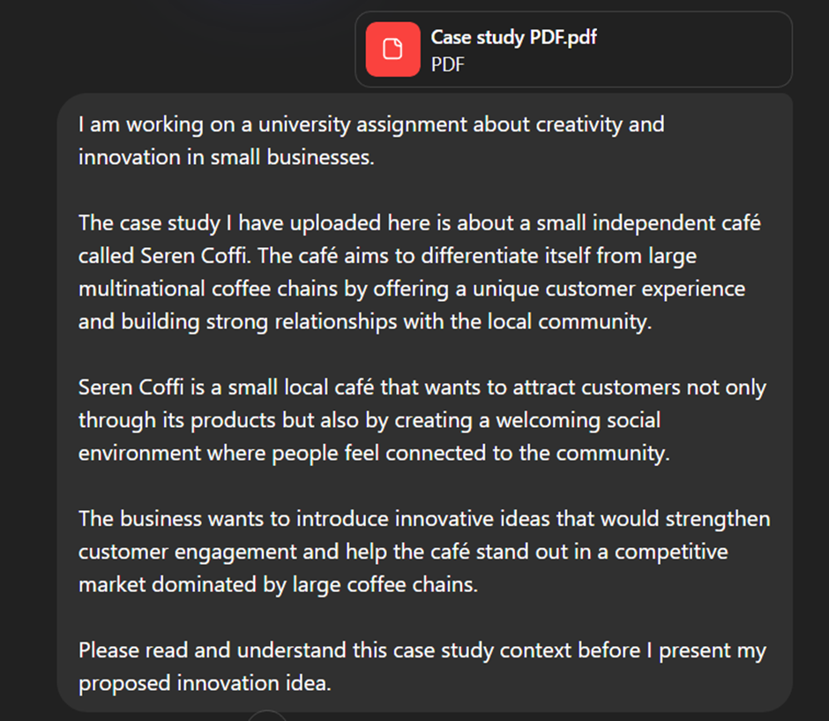
Figure 1- Prompt 1
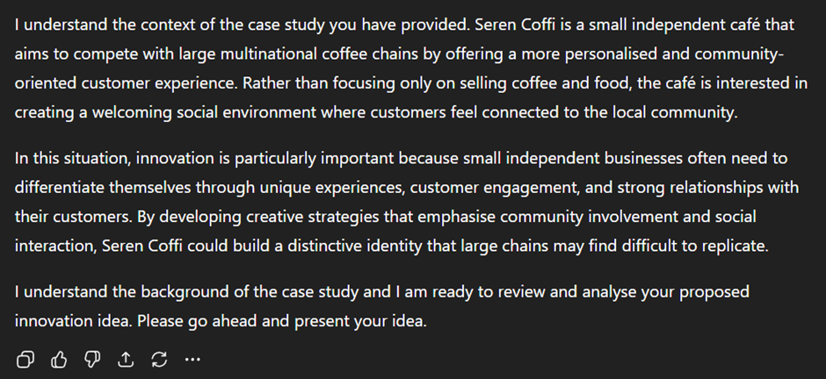
Figure 2 - AI LLM Response to Prompt 1

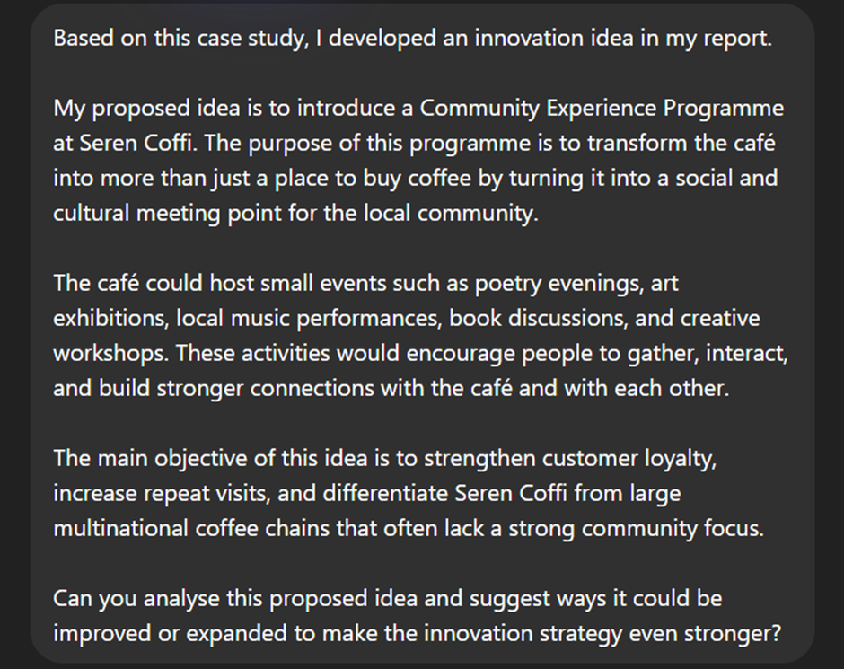
Figure 3 - Prompt 2
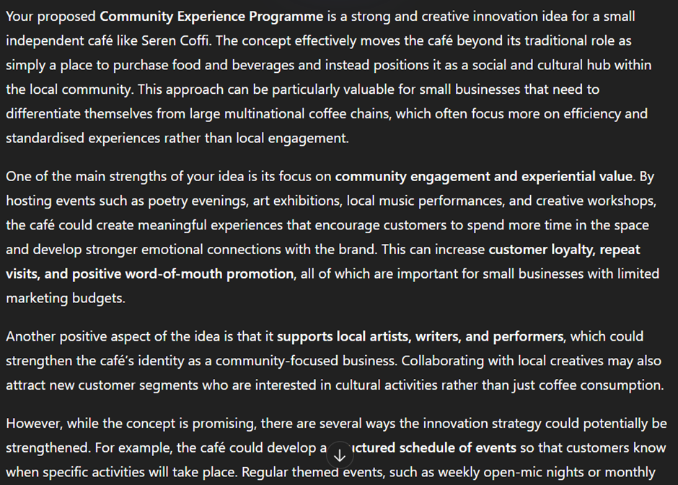
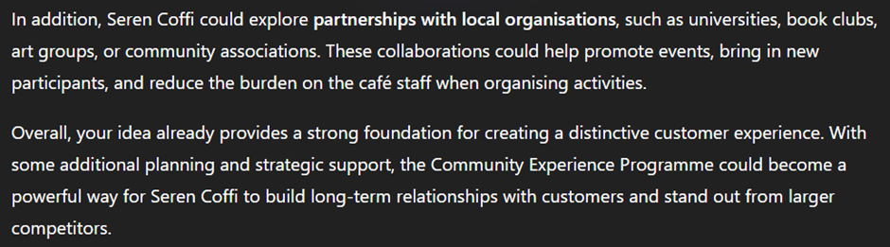
Figure 4 - AI LLM Response to Prompt 2
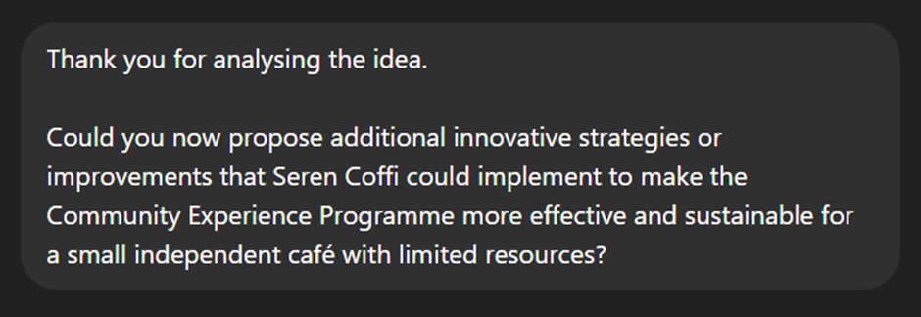
Figure 5 - Prompt 3
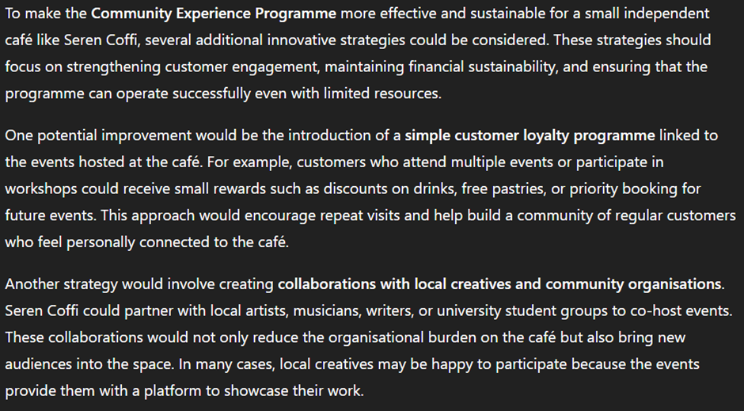
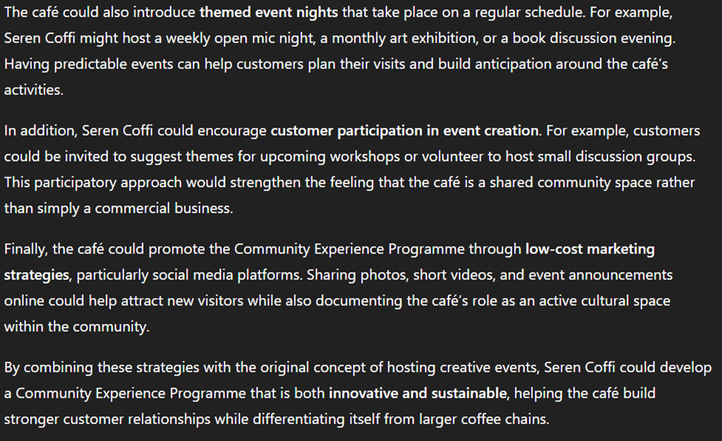
Figure 6 - AI LLM Response to Prompt 3
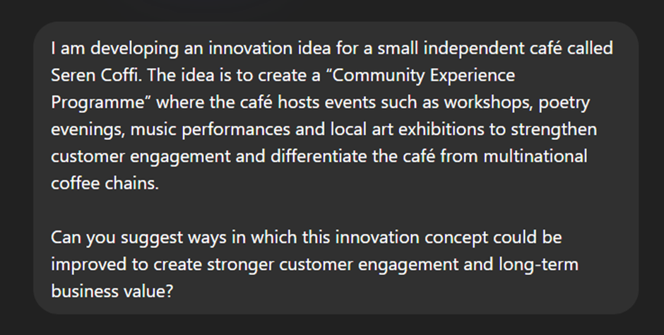
Figure 7 - Prompt 4
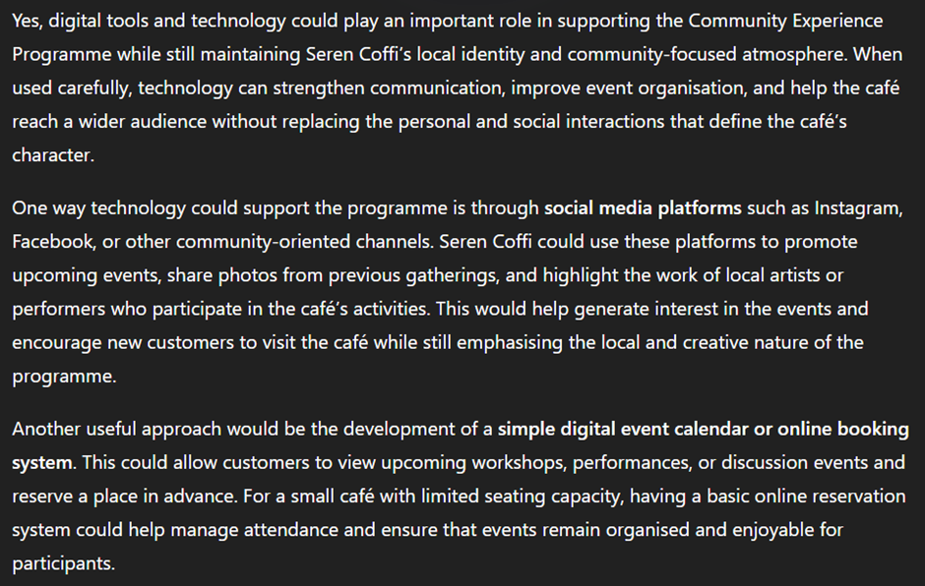
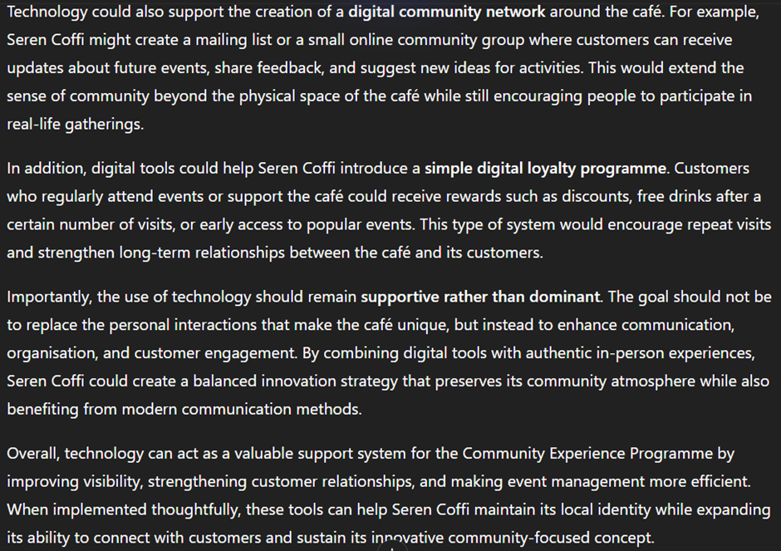
Figure 8 – AI LLM Response to Prompt 4

