

A report focussing on a:

Client Letter and Draft BEP

Prepared for:

Gavin Traylor

Created by:

Rhydian Preece

Word Count (Excluding BEP and References) – 1338 words

Date Completed:
April 29th, 2021
Table of Contents – Client Letter
Page Number
- Introduction 4

- What is BIM? 4

- BIM Level 2 5
  - Understand and follow the BIM protocol 5
  - Create a Level 2-ready project plan 6
  - Collaborate and Co-ordinate 6
  - Share data securely 7
  - Speak the same language 7
  - Use COBie in your project 7
  - Pass on the baton 7
  - Plan for a smooth handover 7
  - Information Delivery Cycle Diagram 7
4.0 References 9

Table of Contents – BIM Execution Plan (BEP)
Page Number
BIM Execution Plan (BEP) 11
- Project Information 11

- Management 11
2.1 Roles, Responsibilities, & Authorities 11
2.2 Major Project Milestones 13
2.3 PIM Deliverable Strategy 13
2.4 Survey Strategy 13
2.5 Existing Legacy Data 14
2.6 Approval of Information 14
2.7 PIM Authorization Process 14

3.0 Planning and Documenting 15
3.1 Project Implementation Plan 15
3.2 Agreed Processes for Collaboration & Information Modelling 15
3.3 Task Information Delivery Plan 15
3.4 Master Information Delivery Plan 16

4.0 Standards, Methods, and Procedures 16
4.1 Volume Strategy 16
4.2 PIM Origin and Orientation 16
4.3 File Naming Convention 17
4.4 Object Naming 17
4.5 Agreed Construction Tolerances 18
4.6 Drawing Sheet Template 18
4.7 Annotations, Dimensions, Abbreviations, and Symbols 18
4.8 Attribute Data 18

5.0 IT Solutions 20
5.1 Software Versions 20
5.2 Exchange Formats 20
5.3 Process and Data Management Systems 20

1.0 Introduction
The following letter will be to highlight my understanding of the requirements of BIM level 2. Firstly, one shall outline what BIM is and then go into further detail, explaining what BIM level 2 is and how information will be shared, coordinated, and managed through the appropriate standards.
2.0 What is BIM?
The Little Book of BIM (2021) define BIM as “BIM is a collaborative way of working underpinned by digital technologies. It uses a shared digital representation of an asset to facilitate design, construction, and operation processes to form a reliable basis for decisions. Greater efficiencies can be realized due to significant pre-planning during the design and construction phases, providing comprehensive information at handover stage”. A lot of people mistake BIM for being a software when it is not, it is a process that can improve the design and construction process in many ways. Nancy Reyes (n.d.) states that “there are five significant benefits of BIM in the design and construction process”. Those being:
- Cost and resource savings.
- Greater efficiency and shorter project lifecycles.
- Improved communications and coordination.
- More opportunities for prefabrication and modular construction.
- Higher quality results.
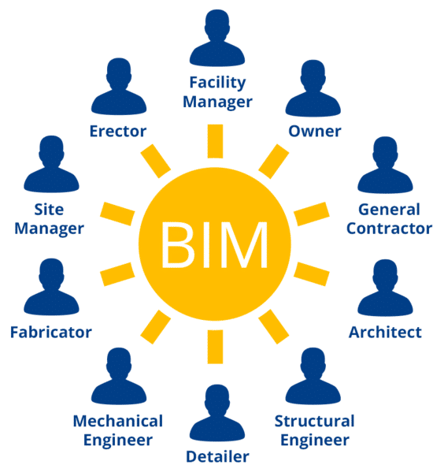
Figure 1 – BIM Layout of disciplines
In my opinion, the best part about BIM is how it brings all the disciplines together. Instead of so many different drawings for each division, BIM lets everyone view the model with their respected design and allows the different workers to comment on whether something is wrong with the design or if they want something changed. Everyone will be working together and more efficiently. Communication is key in BIM which is why all disciplines are connected on the project and can communicate ideas or problems back to each other.
3.0 BIM Level 2
The diagram shown below is the one used by most professionals when trying to describe the different levels of BIM that we work at. For this project, we are working at BIM level 2 and this letter will indicate everything included at this level. BIM level 2 “involves developing building information in a collaborative 3D environment with data attached but created in separate discipline models” Designing Buildings 2021. This is a simple explanation of what BIM level 2 entails but there is much more in-depth information that can be outlined to explain it.
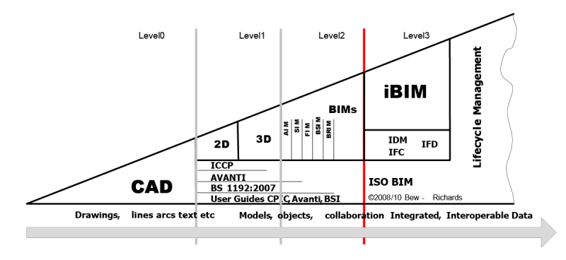
Figure 2 – The different levels of BIM
All information in this following section highlighting the key elements of BIM Level 2 will be provided by Autodesk BIM 360 (c.2016) unless referenced otherwise. The key elements of BIM Level 2 are:
- Understand and follow the BIM protocol
- Create a Level 2-ready project plan
- Collaborate and Co-ordinate
- Share data securely
- Speak the same language
- Use COBie in your project
- Pass on the baton
- Plan for a smooth handover
3.1 Understand and Follow the BIM Protocol
The BIM Protocol is a legal addendum that is outlined in every government project contract which outlines the BIM requirements for the project. If someone wants to work on a project, they need to understand and comply with all the requirements. According to McPartland (2017), the “protocol puts in place specific obligations, liabilities and associated limitations on the use of those models”.
3.2 Create a Level 2-Ready Project Plan
The start of the project plan for BIM level 2 is done by responding to the Employer’s Information Requirements (EIR) under BS EN ISO 19650-1:2018 sec 5.5. The EIR is the information that that will be required by the employer from their internal team and from suppliers to develop the project and for the operation of the completed built asset. To respond to the EIR, a BIM Execution (BEP), Master Information Delivery Plan (MIDP), and a Task Information Delivery Pan (TIDP) must be prepared. Information on the MIDP and TIDP can be found in the appended BEP.
3.3 Collaborate and Co-ordinate
During the project’s life, team members will need to store, manage and exchange complex information, to do this you’ll have to use a CDE or Common Data Environment. A CDE is a digitally shared workspace where everyone involved in the project will store and exchange project data. The CDE is like a single data point and is intended to help people manage the project development process. The CDE however will require a structured approval process.
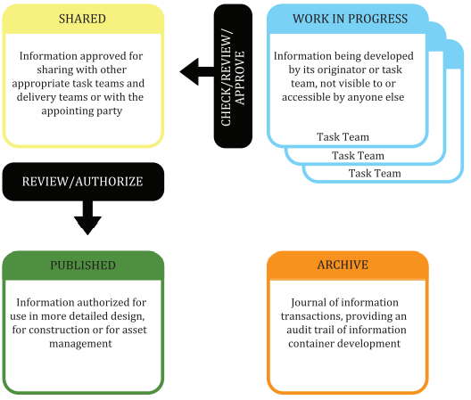
Figure 3 – Diagram of the CDE
Under BS EN ISO 19650-1:2018 sec 12, there are four states of the CDE being work in progress, shared, published, and archive. The work in progress state is used for information while it is being developed by its task team. Then information goes through a check/review/approve transition where the information is compared against the information delivery plan and against agreed standards, methods, and procedures for producing information. Then the shared state is to enable constructive and collaborative development of the information model within a delivery team. Another review stage where the information is compared against the relevant information requirements for coordination, completeness, and accuracy. The published state then allows information that has been authorized for use. The final stage is an archive where information is stored that has been shared and published during the information management process. Types of information that can be stored in the CDE are geometrical models, databases, schedules, pdf documents, scans, photos, videos, etc.
3.4 Share Data Securely
It’s important that another standard is followed during the project life that ensures data is being shared securely. That standard is ISO 19650-5 provides technical security considerations on how to safely share project data, related to the nature of the client and project. This means that controls will be in place that ensures information is being shared securely. The software being used will provide controlled access to information stored in the CDE and can track and manage activity.
3.5 Speak the Same Language
Everyone working on this project will know where all types of data live, what it is, and where to find it, and so a unified classification system will be put in place that provides a ‘common language’.
A system such as Uniclass will be put in place that is compatible with BIM Level 2.
3.6 Use COBie in Your Project
COBie is a Construction-Operations Building Information Exchange.
COBie can be represented as a central spreadsheet where primarily non-graphical data can be securely stored, shared, and updated throughout the construction project. This information will eventually be passed onto the client to help support the operations and maintenance of the building. COBie can also be used to verify that your data meets the requirements of the project.
3.7 Pass on the Baton
Once the project has finished, the project data will be delivered back to the client. The project data can include an as-constructed Asset Information Model which is developed through the stages of the information delivery cycle. This type of model will include necessary information to help those managing and maintaining the building more efficiently.
3.8 Plan for a Smooth Handover
The Soft Landings policy outlined by the Government will ensure that the facility operational team is involved from the beginning of the project and will continue supporting them for a predetermined length of time post-handover. These are the people that will be managing and maintaining the building once it's finished, so by including them from the start of the project, they will know the building inside and out which will make the handover process much easier.
3.9 Information Delivery Cycle Diagram
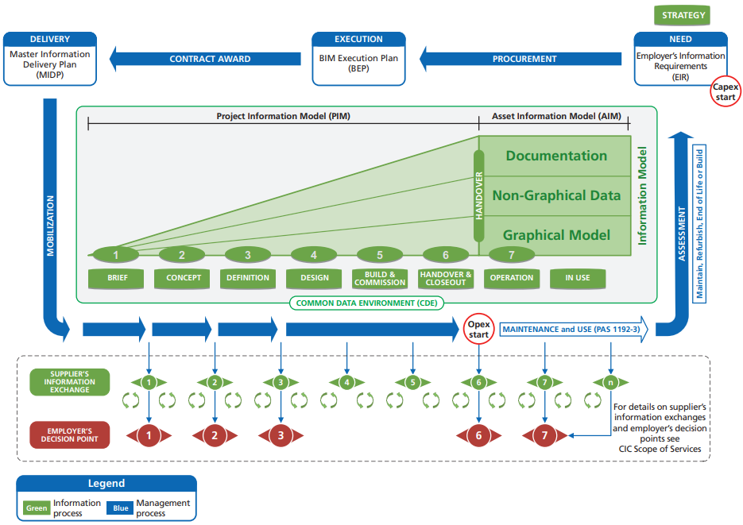
Figure 4 – Information Delivery Cycle Diagram
The diagram shown above outlines the information delivery cycle. This is at the heart of the BS EN ISO 19650-2:2018 sec 13 standard which provides a logical framework to produce information at different stages of the whole building lifecycle. The culmination is the Asset Information Model from which the operational phase of a building’s life can be optimised.
I sincerely hope this letter has provided you with sufficient information on BIM and given you confidence that we have a good understanding of the requirements of BIM Level 2 for this project.

4.0 References
- Autodesk BIM 360 (c.2016) – What is BIM Level 2?...Glad you asked. AUTODESK BIM 360.

- British Standards Institution (2018) – BS EN ISO 19650-1. Organization and digitization of information about buildings and civil engineering works, including building information modelling (BIM) - Information management using building information modelling - Part 1: Concepts and principles. Available at: https://shop.bsigroup.com/ProductDetail?pid=000000000030333754 [Accessed 26 April 2021].

- British Standards Institution (2018) – BS EN ISO 19650-2: Organization and digitization of information about buildings and civil engineering works, including building information modelling (BIM) – Information management using building information modelling - Part 2: Delivery phase of the assets. Available at: https://shop.bsigroup.com/ProductDetail?pid=000000000030420198 [Accessed 26 April 2021].

- BSI (2021) – Little book of BIM 2021. BSI. Page 3.

- Designing Buildings 2021 – BIM Level 2. Designingbuildings.

- Figure 1 – BIM layout of disciplines. [Online]. [Accessed 26 April 2021]. Available from: https://power.buellcenter.columbia.edu/essays/beyond-business-usual-bim-and-future-public-works

- Figure 2 – The different levels of BIM. [Online]. [Accessed 26 April 2021]. Available from: https://biblus.accasoftware.com/en/bim-maturity-levels-from-stage-0-to-stage-3/

- Figure 3 – Diagram of the CDE. [Online]. [Accessed 26 April 2021]. Available from: BS EN ISO 19650-1:2018 sec 12.

- Figure 4 – Information Delivery Cycle Program. [Online]. [Accessed 26 April 2021]. Available from: Transition guidance to BS EN ISO 19650.

- International Organization for Standardization (2020) – ISO 19650-5: Organization and digitization of information about buildings and civil engineering works, including building information modelling (BIM) — Information management using building information modelling — Part 5: Security-minded approach to information management. Available at: https://www.iso.org/standard/74206.html. [Accessed 26 April 2021].

- McPartland (2017) – What is the CIC BIM Protocol? Thenbs.

- Nancy Reyes (n.d.) – Top 5 Benefits of BIM Construction. HMC Architects.

- Rossiter (2016) – There’s no BIM like home. Bimblog.house.

BIM Execution Plan (BEP)

This BEP template has been taken from Rossiter (2016). I have filled in information where possible to suit my project, however, some information is from the BEP template as this is only a draft. An EIR has not been given so some of the information stated will be in response to a given EIR.

Notes

This draft BIM Execution Plan (BEP) document has been structured using the headings described within BE EN ISO 19650-2:2018.

Where information has been provided for guidance it will appear in blue.

Note: Further clarification on any of the terms and definition used within this document can be found using the BRE BIM Terminology Tool, located here: https://www.bre.co.uk/bim-terminology.jsp

1.0 Project Information
The information provided below shall be used throughout this project and included where appropriate on any deliverables produced. The information provided in this table is put in place to satisfy the EIR.
Project Name: | Ysgol Bae Abertawe
Project Number: | 5010
Project Description: | Delivery of a ‘state of the art’ infant school in Swansea
Site Name: | Ysgol Bae Abertawe
Site Description: | Omitted to protect personal information
Facility Name: | Ysgol Bae Abertawe
Facility Description: | Omitted to protect personal information
Table 1 - Project Information

2.0 Management
This section of the BEP covers the requirements of BS EN ISO 19650-2, SECTION

2.1 Roles, Responsibilities, & Authorities
The purpose of this section is to define specific information management responsibilities.
Outlined below are the individuals and their respective organisations undertaking Information Management Responsibilities, as outlined within BS EN ISO 19650-2, TABLE
Name | Company | Role | Resources | Contact Information
Rhydian Preece | RJP Ltd | Client | Client1 | Rhydpreece@outlook.com
Jim Burton | RJP Ltd | Architectural | Arch1 | Jimburton@outlook.com
Gabriel Williams | RJP Ltd | Mechanical | Mech1 | Gabwilliams@outlook.com
Eric Morgan | RJP Ltd | Electrical | Elect1 | Ericmorgan@outlook.com
Table 2 - Project Contacts
The following Employer’s Representative responsibilities apply to each individual as follows:
Responsibility | Resource
Capture Key Decision Points | Client1
Produce Plain Language Questions | Client1
Capture Required Standards, Methods, and Procedures | Client1
Ensure the Appointment of a Project Information Manager | Archx`1*
Review the Supplier Information Exchanges against the EIR | Client1
Table 4 - Employer's Representative Responsibilities
The following Project Information Manager responsibilities apply to each individual as follows:
Responsibility | Resource
Enable Information Exchanges through a CDE | **
Maintain and Receive Information Into the Information Model | Arch1
Enable Integration and Coordination of Information | Arch1
Configure Information for Project Outputs | Arch1
Populate the Information Exchange Format | Arch1
Accept/Reject Information Exchanges | Arch1
Table 5 - Project Information Manager Responsibilities
The following Project Delivery Manager responsibilities apply to each individual as follows:
Responsibility | Resource
Assure Delivery of Information Exchanges | Arch1
Confirm Suppliers Ability to Deliver Information Requirements | ***
Accept/Reject Information Exchanges | Arch1
Table 6 - Project Delivery Manager Responsibilities

The following Lead Designer/Contractor responsibilities apply to each individual as follows:
Responsibility | Resource
Coordinate Delivery of all Design Information | Arch1
Manage Information Development and Information Approvals | Arch1
Confirm Design Deliverables | Arch1
Overall Lead for Configuration Management | Arch1
Confirm Status and Approve Information for Issue | Arch1
Approve Design Changes Proposed to Resolve Clashes | Arch1
Table 7 - Lead Designer/Contractor Responsibilities
The following Task Team responsibilities apply to each individual as follows:
Responsibility | Resource  Architectural | Resource  Mechanical | Resource  Electrical
Production of Design Outputs Related to Specific Tasks | Arch1 | Mech1 | Elect1
Issue Approved Information | ** | ** | **
Direct the Production of Information in compliance with SMP | Arch1 | Mech1 | Elect1
Direct the Production of Information Using Agreed Systems | Arch1 | Mech1 | Elect1
Confirmation that Information is Suitable for Issue | Arch1 | Mech1 | Elect1
Manage Spatial Coordination on behalf of the Task Team | Arch1 | Mech1 | Elect1
Propose Resolution to Coordination Clashes | Arch1 | Mech1 | Elect1
Develop Constituent Parts of the Information Model | Arch1 | Mech1 | Elect1
Production of Project Outputs | Arch1 | Mech1 | Elect1
Table 8 - Task Team Responsibilities
* This document confirms the successful deferral of an Employer’s Representative responsibility to the supply chain. This will be in response to the EIR.

2.2 Major Project Milestones
The purpose of this section is to confirm the project milestones.
Project Milestones will be indicated on the MIDP when made available. In line with the exchange of information in response to the EIR.

2.3 PIM Deliverable Strategy
The purpose of this section is to define what deliverables will be exchanges at each major project milestone.
Following review of the exchange of information requirements in response to the EIR, scheduled below are the deliverables that will be exchanged at each major project milestone. Any additional items that have been included (shown in red) are to satisfy the Client's Strategic Purposes in response to the EIR.
 | Brief & Planning | Model Generation
Graphical Models |  | Native Discipline Models  Federated IFC Model
Non-graphical Data |  | Federated COBie
Documentation | BIM Execution Plan | Site Plans, Floor Plans, Elevations, Sections, Door Schedule, Window Schedule
Table 9 - PIM Deliverable Strategy

2.4 Survey Strategy
The purpose of this section is to identify how survey information will be received/exchanged.
All surveys undertaken on this project will utilise the origin and coordinate convention outlined within section 4.2, to the units and tolerances identified within section 4.6, and will be accessible to the authoring software identified within section 5.2.
Scheduled below are the intended surveys to be undertaken.
Survey Method | Delivery Format | Details, Notes:
Manual ‘Disto’ Survey | DWG | Layers to Comply with BS EN ISO 19650-1:2018 & Uniclass 2015
Table 10 - Survey Strategy

2.5 Existing Legacy Data
The purpose of this section is to identify available existing asset data.
Following the review of existing documentation available scheduled within in response to the EIR, information will be extracted and formatted to suit integration into the information model.

2.6 Approval of Information
The purpose of this section is to confirm the approval process when issuing information.
Prior to the issue of any information, the individual(s) responsible for confirming suitability and approval of information identified within section 3.1 will undertake the following steps:
- Check deliverable for compliance to SMPs; – Section 4
- If applicable, check deliverable for dimensional accuracy;
- If applicable, check deliverable for spatial coordination; – Section 3.2
- If applicable, check deliverable for sufficient attribute data;
- Sign Checker box;
- Check deliverable for completeness to satisfy the purpose of issue;
- Update suitability code;
- Update Revision code; and
- Sign Approver box.
If non-conformity is identified during the process, the deliverable will be rejected. Rejected deliverables will be amended by the information author and the approval process will be reset & repeated.

2.7 PIM Authorization Process
The purpose of this section is to confirm the authorisation process when receiving information.
It is assumed that the person responsible for the review of supplier information will undertake the following steps prior to authorization:
- Confirm ability to assess deliverable against IT Constraints; - in response to EIR
- Check deliverable against the Exchange of Information table; – in response to EIR
- Review deliverable appropriateness against the Client Strategic Purposes; – in response to EIR
- Update suitability code; and
- Update Revision code.

Following the issue of information, authorization must be completed within five (5) working days to prevent programme delays.

3.0 Planning and Documenting
This section of the BEP covers the requirements of BS EN ISO 19650-2:2018 (Add section)

3.1 Project Implementation Plan
The purpose of this section is to confirm that the capability of the supply has been considered.
Due to the nature of this project, no other organisations have been appointed.
As such no Project Implementation Plan has been produced. Should any organisations be appointed, they will be assessed for their capability in response to the EIR and recorded on the PIP.

3.2 Agreed Processes for Collaboration & Information Modelling
The purpose of this section is to confirm how information will be exchanged and managed.
To satisfy the Client Strategic Purposes in response to the EIR, graphical and non-graphical information will be developed in accordance with the required attribute data outlined within section 4.9. To the LOD & LOI specified with the Responsibility Matrix.
All deliverables will be developed progressively in accordance with the Master Information Delivery Plan (MIDP), utilising the software and formats outlined within section 5.1 & section 5.2 respectively.
Through sequential development of information in accordance with the MIDP, and approved in compliance with section 2.6, a Clash Avoidance strategy will have been implemented. Therefore, negating the need to Clash Detect.
The file naming, suitability, and revision convention outlined within BS EN ISO 19650-1:2018 will comply in response to the EIR, and the process and the data management process as shown within section 5.3 will be used.
Models and Deliverables will be placed onto a designated GoogleDrive folder to the viewing, access, and authorisation of information.
To satisfy the data security requirements in response to the EIR, FF&E Graphical model and associated COBie data will be excluded from this exchange. In response to the EIR, training requirements have been identified to view, access, or authorise information based on the above collaboration processes.

3.3 Task Information Delivery Plan
The purpose of this section is to confirm the production of the Task Information Delivery Plans.
For ease of readability, the Task Information Delivery Plans (TIDP) have not been included within this document. TIDPs are available on request.

3.4 Master Information Delivery Plan
The purpose of this section is to confirm the production of the Master Information Delivery Plan.
In response to the EIR, a Master Information Delivery Plan (MIDP) will be produced.
The Development of the MIDP will be done through collaboration with other team members to ensure that the minimum amount of information required by them to produce their deliverables has been identified as ‘dependants’.

4.0 Standards, Methods, and Procedures
This section of the BEP covers the requirements of BS EN ISO 19650-2:2018 (Add section)
In response to the EIR, all identified standards have been included within section 4.0 of this BIM Execution Plan. Any additional standards have been identified below

4.1 Volume Strategy
The purpose of this section is to define any specified geometric subdivision within the project.
Volume strategy has been defined within the file naming convention within section 4.3.

4.2 PIM Origin and Orientation
The purpose of this section is to define the common origin point for spatial coordination.
Due to the requirements to protect personal information in response to the EIR, OS grid references will not be used. The project base point will be the external side boundary of the front garden wall as shown below, set to 0,0. The project FFL will also be set to 0 with all other figures (including the project base point) to be set relative to this value.
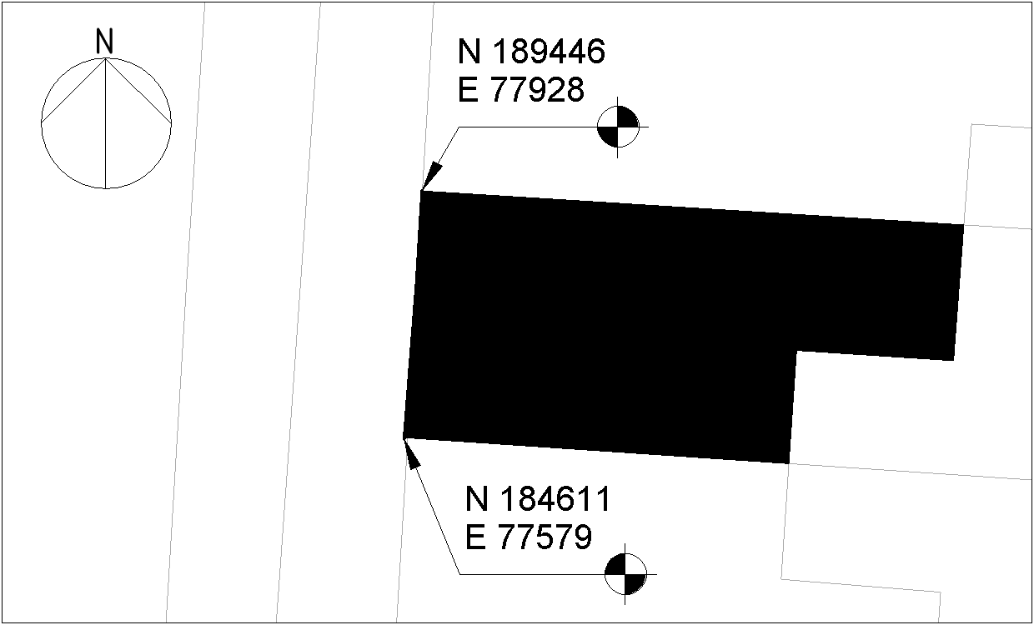
Figure 1 - Project Base Point
CHANGE TO MY BASE POINT
Additional information will be used to populate the table below when available.
Reference | Position
Ground Floor FFL | 0 (mm)
Project Base Point | 00000 N, 00000E (mm)
Building Point 1 | 192364.7 N, 265976 E (mm)
Building Point 2 | 192364.7 N, 265976 E (mm)
Table 11 - Origin and Orientation Values

4.3 File Naming Convention
The purpose of this section is to confirm the file naming convention.
In response to the EIR, all deliverables will be named in accordance with BS EN ISO 19650-1:2018
Specified below are the permitted values for each field.
Project Number | Originator | Volume | Level | File Type | Role | Classification  (optional) | Number
5010 | RJP | xx | GF | DR | A |  | 1001
5010 | RJP | xx | GF | DR | S |  | 1001
 |  |  | 02
 |  |  | ZZ
Table 12 - File Naming Values
In addition to complying with BS EN ISO 19650-1:2018, section the number field will be further distinguished through the use of a Uniclass 2015 top-level code for the first two digits and one of the following series numbers for the third digit:
Series | Drawing
xx1xx | Plans
xx2xx | Elevations
xx3xx | Sections
xx4xx | Large-Scale Views
xx5xx | Details
xx6xx | Schedules & Diagrams
Table 13 - File Numbering Convention

4.4 Object Naming
The purpose of this section is to confirm the object naming convention.
In response to the EIR, all objects produced will be named in accordance with BS 8541-1.
Specified below are the permitted values for each field.
Source | Type | SubType
Author,  Manufacturer | See Ifc[Type] | See ...TypeEnum  See product name
Table 14 - Object Naming Values
All objects types shall also be named following the following convention: [...TypeEnum]Type[Number] e.g DoorType01.

4.5 Agreed Construction Tolerances
The purpose of this section is to confirm the construction tolerances to be adhered to.
All produced information shall consider the tolerances outlined within ISO 5601.

4.6 Drawing Sheet Template
The purpose of this section is to specify and standard drawing sheet templates.
All drawings produced for this project shall utilise the ISO 5457 compliant drawing sheet provided.
All deliverables shall include the following ISO 7200 compliant title block.
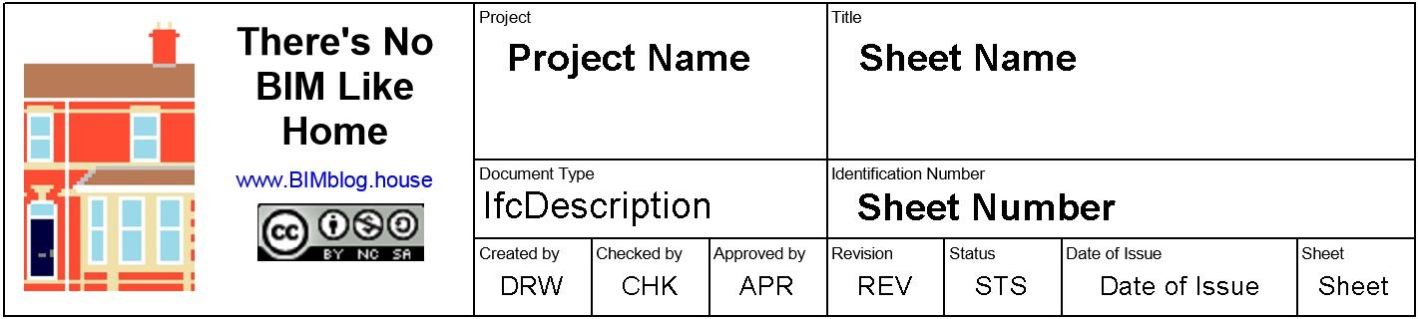
PLACE MY TITLEBLOCK

4.7 Annotations, Dimensions, Abbreviations, and Symbols
The purpose of this section is to define references for Annotations and Symbology.
All Annotations, dimensions, and symbols for this project will comply with BS 8541-2.
All Abbreviations used will be sourced from the BRE BIM Terminology Tool http://www.bre.co.uk/bimterminology.jsp. Any abbreviations not sourced within this tool will be scheduled below:

Term | Acronym | Definition
Table 16 - Project Terms

4.8 Attribute Data
The purpose of this section is to define the attribute data to be exchanged.
In response to the EIR, all Employer specified attribute data has been identified and shall be delivered where appropriate. In addition, in response to the EIR, the expected attribute data within BS 1192-4 shall also be delivered where appropriate.
Only a single classification code shall be included on each object which describes its primary function. Classification shall be included in the Attribute ClassificationRefForObjects.
When exchanging project information the Revision and Status code out convention outlined in the diagram below shall be applied as attribute data to all files. D codes shall be exclusively for unapproved information exchanged to aid in at-risk preparatory work. Information with a D code status shall not be referenced to generate any deliverables.
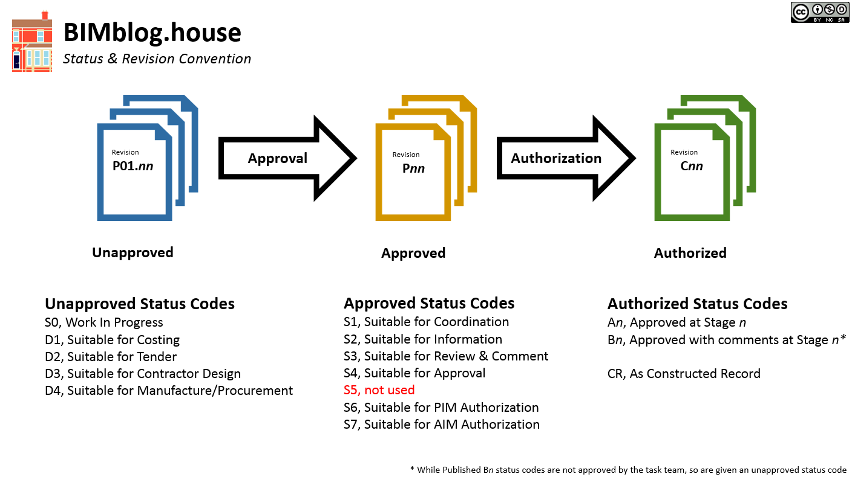
When inputting geometry information the following convention shall be complied with:
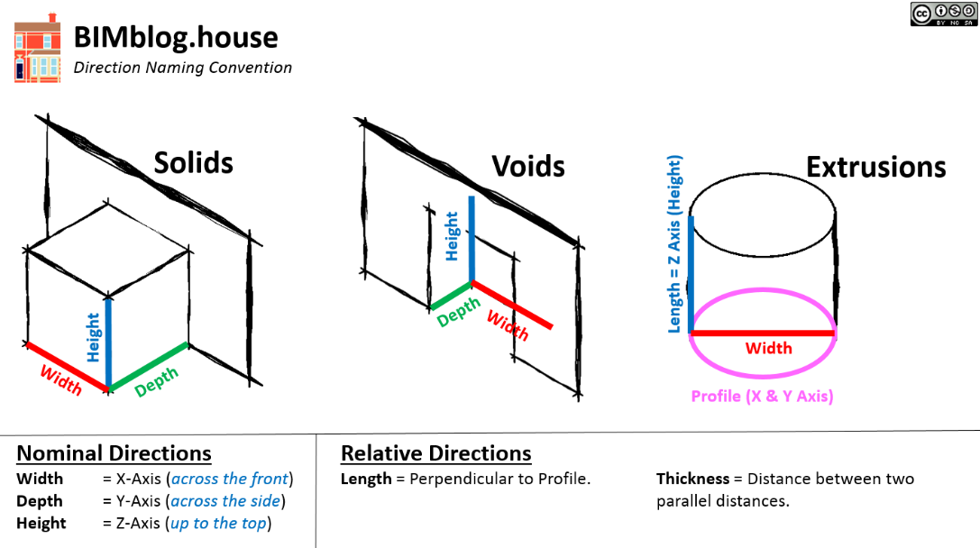

5.0 IT Solutions
This section of the BEP covers the requirements of BS EN ISO 19650-2:2018 (Add section)

5.1 Software Versions
The purpose of this section is to confirm the software and version to be used throughout the project.
Only the software outlined in the table below will be used to generate project deliverables.
No software shall be upgraded beyond the versions specified below without consent of the individual undertaking the Project Information Management responsibilities outlined within Section 4.1.
Company | Purpose | Software | Version
Autodesk | 2D Modelling | AutoCAD | 2021
Autodesk | 3D Modelling & Creating of Drawings | Revit | 2021
CodePlex | Federation & IFC Export | xBIM | 2.4.1.29
Table 17 - Project Software

5.2 Exchange Formats
The purpose of this section is to define the exchange formats to be used throughout the project.
The following exchange formats will be used throughout the project.
Export Software | Format | Version
AutoCAD | .dwg | 2021
Revit | .rvt | 2021
Revit | .ifc | 2021, 2x3
xBIM | .xls | COBie-UK 2021
Revit | .pdf | -

5.3 Process and Data Management Systems
The purpose of this section is to confirm the Data Management Systems utilised.
No Data Management System will be utilised on this project
Data will be managed and transferred in line with the following diagram:


