Study Skills Reflection
As the title of this module was ‘study skills’, I decided to research the topic ‘time management’ and this assignment will reflect the research I presented. Before starting the presentation, I felt nervous and according to Amalia and Ma’mun (2020) nerves can be a result in bad experiences, no preparation, the fear of making an error and the lack of confidence. I feel that I was nervous due to my confidence and the worry of making faults, however, knowing that only my lecturers will be viewing the recording reassured me.
As I was presenting with PowerPoint Coach, it provided me feedback on how well I portrayed myself and one of the strengths was that I had a good pace. Although I was feeling nervous throughout, I spoke approximately 130 words per minute which was deemed appropriate according to the feedback. According to the data, I also used inclusive language. I avoided biases, slang terms, and any other terminology that might be misused to discriminate against groups of individuals (Forsey, 2022). Personally, I feel that another strength of my presentation was that I took my time, which allowed me finish just in the time mark and if I messed up, I would have time to retrack calmly without stressing about the time running out.
As well as strengths, Coach also gave me feedback on my weaknesses. One of these was that I used too many filler words such as ‘umm’ and ‘uhh’ and that I should take a small pause and breath to calm myself down instead. This may be because I was nervous doing the presentation which may have made me lose track of what I wanted to say next. Another weakness of my presenting was that I repetitively used the word ‘also’, and instead use equivalent to it such as ‘furthermore’. Based on the feedback, I need to work on my pronunciation of a few words for instance ‘reduces’ and ‘strategies’ and I will practice these ready for upcoming presentations. Moreover, the feedback tells me that the tone of my voice was just above monotone which is a big weakness because if every presenter speaks with the same tone, we would all sound identical and we would not stand out to the audience (Muluk and Cingi, 2023). Furthermore, when watching the video back, I noticed that I was cutting out sometimes, and this may be because of how low my tone was when speaking and my microphone may not have caught what was being said, so in the future, this is something I need to work on. Throughout the presentation, my body language was a mix of good and bad and Coach gave me feedback on how to present with positive body language. I should keep good eye contact by keeping my gaze forwards, keep a clear view by not touching my face and stay close enough to the camera. This may be because I was nervous when recording which may have led to me moving too much which can be seen as negative body language. When reflecting on my presentation, I identified another area for improvement, and this was that I was relying too heavily on reading directly from the slides. I should instead change the wording, giving the impression that I am prepared and not simply reading the information from the slides.
Throughout the recording, I had encountered a few challenges. One of these challenges was because PowerPoint Coach was running in the background and when feedback was given, there would be a beeping sound and the feedback would pop up on the side, correcting me on what I should be doing. This then diverted my attention and caused me to lose focus slightly. One big challenge that I came across was when I started a sentence without looking at my notes to remind me of what was to come on the slide, and when the point appeared on the slide, it did not match up with what I was saying, making me retrack and start the sentence again. But I didn’t worry about this as it was towards the end of the presentation, and I knew I still had plenty of time to complete the recording. As I had cue cards in front of me to guide me with the presentation, I was able to do the presentation smoothly. However, I did lose track of where I was on the cue cards, resulting in me making a big pause and used a filler word.
Looking at the feedback given to me, it is evident that there are several areas for improvement that I need to work on for future assignments. Filler words is one area that I need to stop and to do this, Coach tells me I need to relax. Zandan (2018) states that in order to stop filler words, I need to replace them with short pauses and to do so, I should organise my thoughts and control my nerves, which I will focus on for my next assignments. Another skill I would do differently would be to talk more confidently and to accomplish this, I need to make sure that the tone of my voice is strong and deep, but also inviting and experienced so that the audience notices (Muluk and Cingi, 2023). Another area where I aim to enhance my presentation skills is by researching synonyms for frequently used words, including “because” and “also”, and this is essential to ensure that my presentation is varied and avoids reputation.
To conclude this reflection on my presentation skills, I have found out that I need to work on many skills such as reducing filler words, changing the tone of my voice to keep the audience engaged, to stop repetitive language and reading off slides. This will then effectively prepare me for future assignments that include presentations.

Coach feedback:
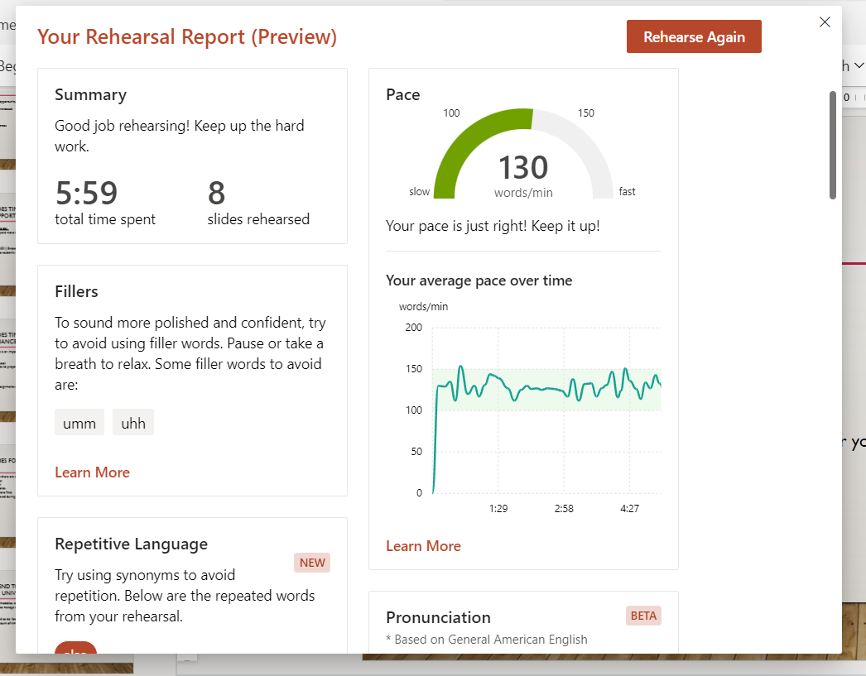
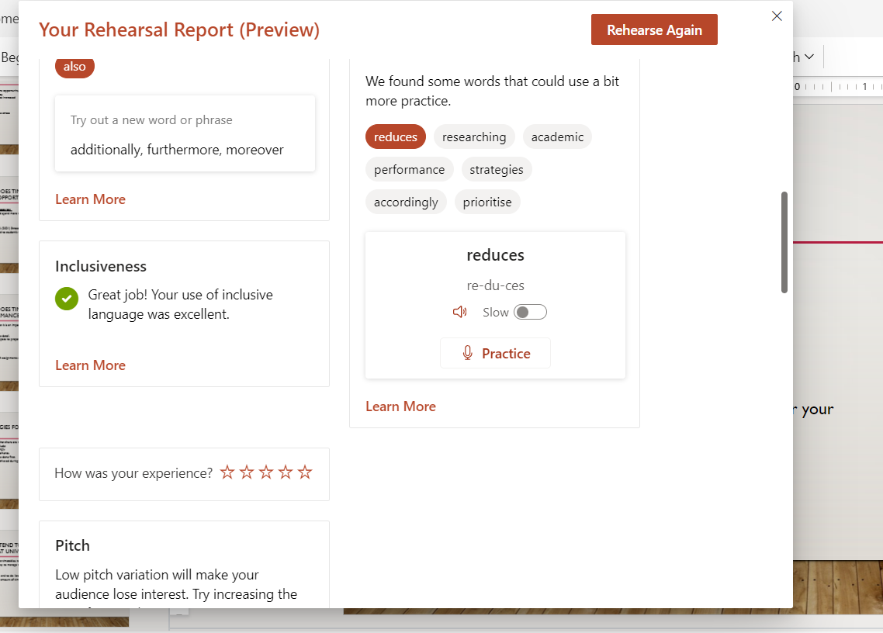
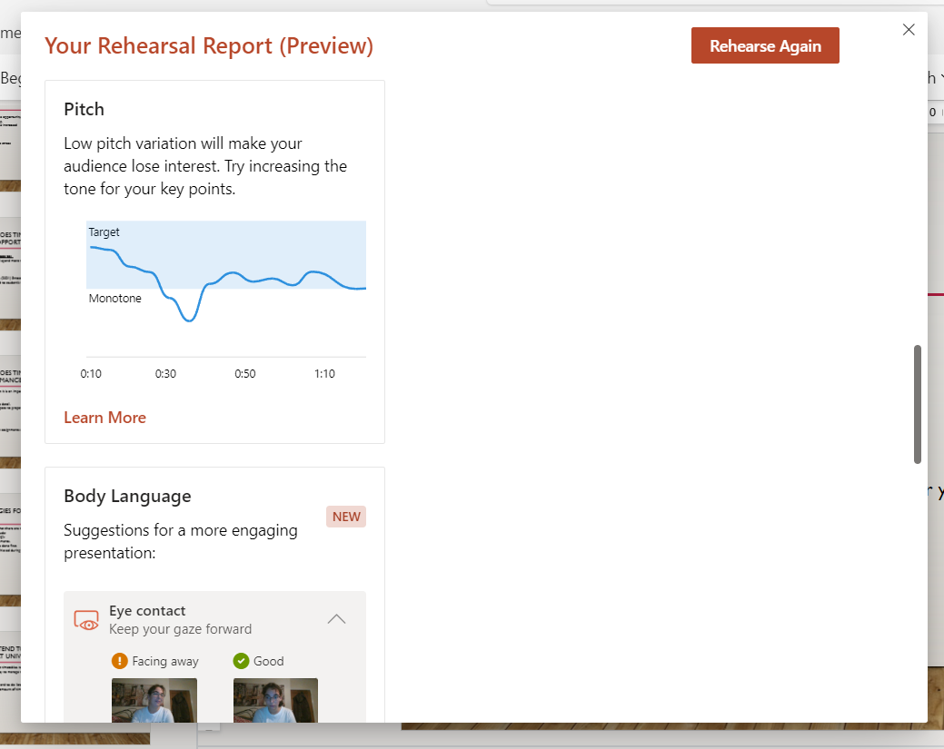
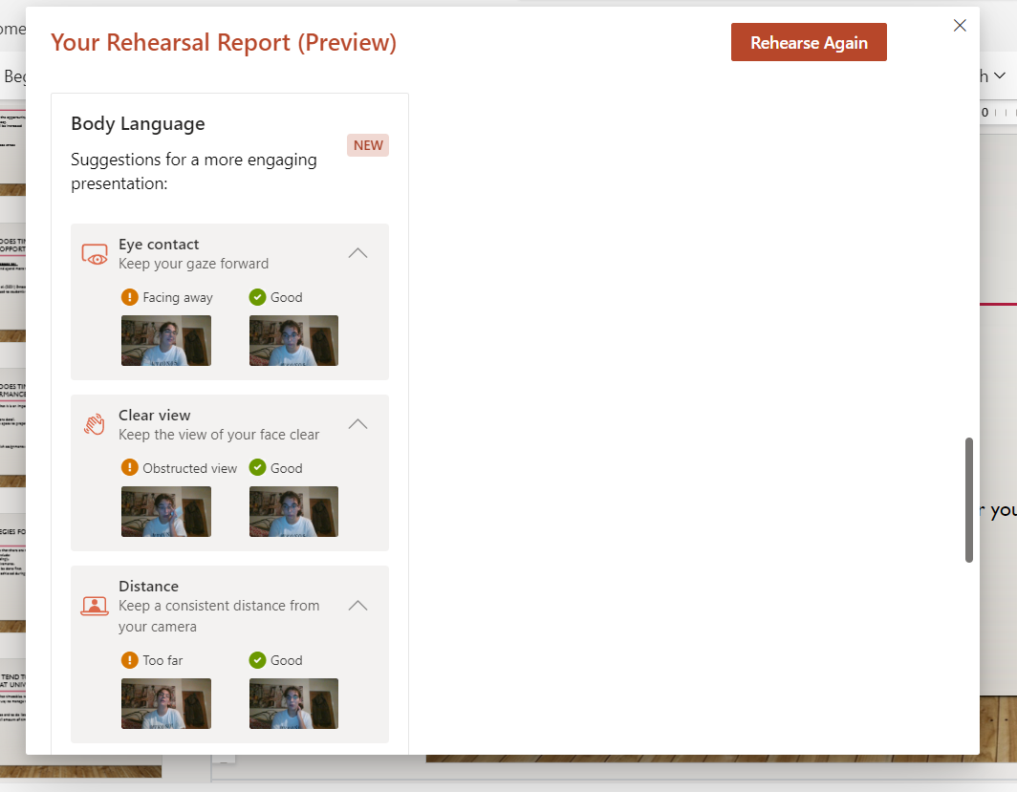
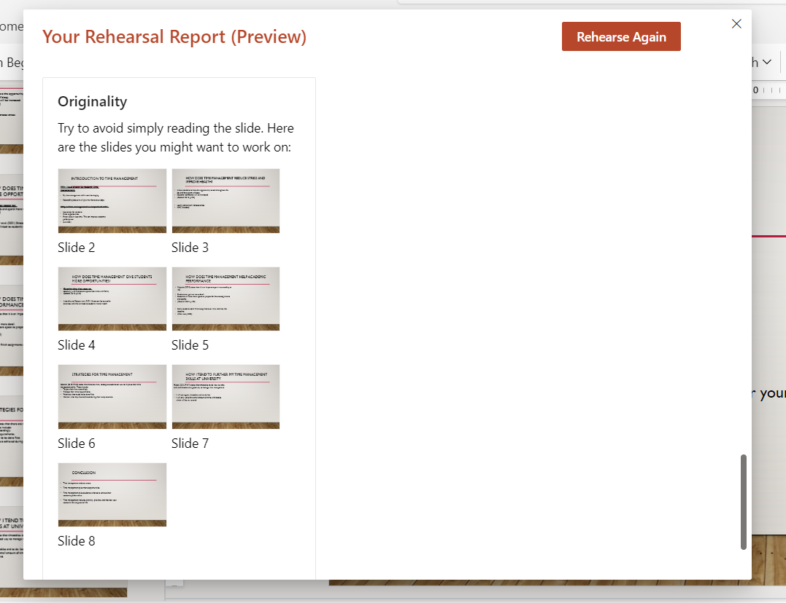

Presentation link:
https://uowtsd.sharepoint.com/teams/EducationStudiesLevel4Carmarthen_GRP-Shelby-JoMabe/Shared%20Documents/Recordings/New%20channel%20meeting-20231021_201226-Meeting%20Recording.mp4?web=1

Reference list:
Amalia, L.A. and Ma’mun, N. (2020) ‘The Anxiety of EFL Students in Presentation’, Elite Journal, 2(1), pp. 1-126. Available at: https://www.elitejournal.org/index.php/ELITE/article/view/31 (Accessed: 24 October 2023).

Forsey, C. (2022) Inclusive Language: How To Use and Promote It at Your Organisation. Available at: https://blog.hubspot.com/marketing/inclusive-language (Accessed: 24 October 2023).

Muluk, N.B. and Cingi, C. (2023) ‘Tone of Voice, Word Choice, Dress, Behaviour and Timing’, Improving Online Presentations, pp. 133-128. Available at: https://doi.org/10.1007/978-3-031-28328-4_12

Zandan, N. (2018) How to Stop Saying “Um,” “Ah,” and “You Know”. Available at: https://hbr.org/2018/08/how-to-stop-saying-um-ah-and-you-know (Accessed: 26 October 2023).

