
MSc Public Health and Social Care in Practice
Community Care and Management of Longer-term Conditions (LCHS7003)
Component 1: Information Booklet of Long-term Condition Management
Student Name: Raj Nileshbhai Panchal
Student ID: 2539936

Lecturer: Muhammad Khan

Words: 3302

Table of Contents
1. Introduction and Scope 4
1.1 Definition of COPD 4
1.2 Purpose of the Booklet 4
2. Epidemiology and Burden 5
2.1 Worldwide Prevalence 5
2.2 UK Prevalence 5
2.3 Burden on the Public Healthcare 6
3. Aetiology & Risk Factors 7
3.1 Biological Risk Factors 7
3.2 Psychological Risk Factors 8
3.3 Social Risk Factors 8
4. Impact on Individuals & Families 8
4.1 Physical Domain 9
4.2 Psychological Domain 9
4.3 Social Domain 9
4.4 Coping and Adaptation 10
5. Evidence-Based Treatments & NHS Services 10
5.1 Evidence-Based Clinical Management 10
5.2 NHS Integrated Respiratory Services 12
5.3 Supported Self-Management 12
5.5 Multidisciplinary COPD Services 12
6. Models & Frameworks for Improved Outcomes 13
6.1 NHS Comprehensive UK Model 13
6.2 WHO's ICCC Framework as the International Model 13
6.3 Critical Evaluation 14
Strengths 14
Limitations 14
7. Local & National Policy Implications 14
7.1 National Policy Implications 14
7.2 Local Policy Implementation 15
8. Recommendations 15
9. Conclusion 17
References 18

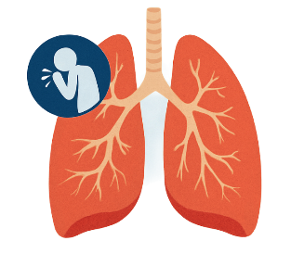
1. Introduction and Scope

1.1 Definition of COPD
C
hronic Obstructive Pulmonary Disease (COPD) is a progressive long-term respiratory condition characterised by persistent airflow limitation that causes breathing difficulties and is not fully reversible. Chronic Obstructive Pulmonary Disease, also known as COPD, is considered a common lung disease causing restricted airflow and breathing problems. It is also sometimes called emphysema or chronic bronchitis. The condition is typically caused due to significant exposure to noxious particles or gases (WHO, 2024). Smoking, alongside air pollution, are the most common cause of COPD and people affected with COPD are known for being at a higher risk of other health problems.

1.2 Purpose of the Booklet
This booklet will focus on primary care physicians, nurses, along with community respiratory teams that are involved in the front-line management of COPD. The purpose of this booklet is to improve continuity of care through integrated and multidisciplinary approaches that are responsible for bridging primary, secondary, alongside community services. It is essential to note that despite physiological management being central, a biopsychosocial understanding is critical as COPD is also responsible for imposing a substantial burden that extends far beyond just lung function decline, affecting physical capacity, mental health, along with social participation and family dynamics of the affected individual (Mathur and Singh, 2024). This makes effective care coordination significant as it can also help in reducing exacerbations, along with hospital admissions, in addition to improving quality of life by addressing such interconnected domains.
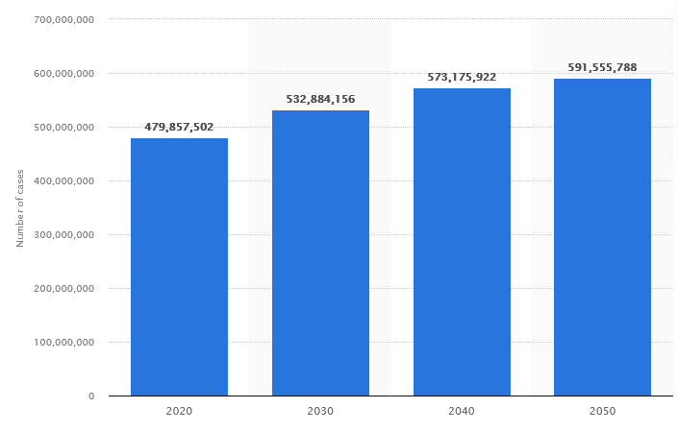
COPD Cases are Rising Worldwide
(Source: Stewart, 2026)

2. Epidemiology and Burden

2.1 Worldwide Prevalence
COPD is recognised as one of the leading causes of morbidity and mortality worldwide. The global burden of COPD continues to increase because of population ageing, continued tobacco use, environmental pollution, and occupational exposures. COPD is also one of the leading causes of death worldwide. In 2021, around 3.52 million deaths were caused by COPD (Stewart, 2021). The majority of these deaths are known to occur in hospitals. The increasing number of COPD cases worldwide highlights the need for effective prevention, early diagnosis, and long-term disease management strategies to reduce the growing global health burden.

2.2 UK Prevalence
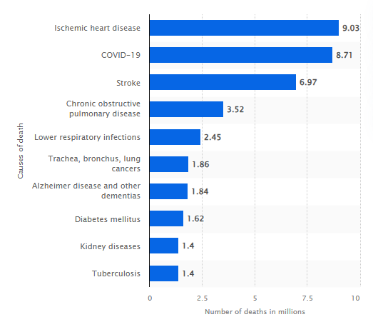
COPD is known for representing a major public health challenge in the UK. According to Stone et al. (2023), prevalence in England was estimated between 4% and 10%, with a prevalence of 5% for men and 3% for women aged middle age and upwards. COPD is also majorly underdiagnosed, as the majority of cases are identified only at advanced stages (Filippou et al., 2025).
Respiratory diseases, such as COPD, are also responsible for enhancing the economic burden on the NHS, as they cost the NHS approximately £1.9 billion each year (Trueman, 2017). COPD also accounts for around 10% of emergency hospital admissions in the UK annually, while contributing to higher readmission rates (Morton et al., 2019). It is also essential to note that the all-cause 30-day readmission rate within the NHS in England was 7%, with a gradual increase of 0.01% per month between 2004 and 2010 (Harries et al., 2017). These findings demonstrate that COPD remains one of the most resource-intensive long-term respiratory conditions managed by the NHS, emphasising the importance of early diagnosis and coordinated long-term care.
Leading causes of death worldwide in 2021
(Source: Stewart, 2021)

2.3 Burden on the Public Healthcare
It is also essential to consider the socioeconomic burden associated with COPD. Beyond its direct impact on respiratory health, COPD places considerable pressure on health and social care services through repeated hospital admissions, long-term pharmacological treatment, pulmonary rehabilitation, community care, and ongoing multidisciplinary management.
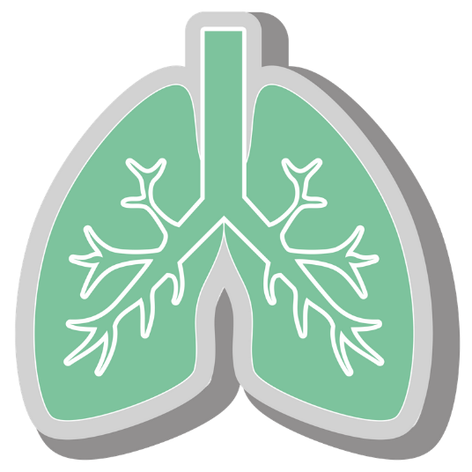
As a result, recognising these challenges, the NHS has prioritised integrated respiratory care through multidisciplinary teams, pulmonary rehabilitation programmes, virtual wards, community respiratory services, and early intervention strategies aimed at reducing avoidable hospital admissions and improving patients' quality of life (NHS England, 2019; NHS England, 2024b).

3. Aetiology & Risk Factors
The Biopsychosocial Model provides a useful framework for understanding the multifactorial causes of COPD because the disease develops through the interaction of biological, psychological and social determinants rather than a single causative factor.

3.1 Biological Risk Factors
The primary pathophysiology of COPD is known for involving chronic inflammation, which results in leading to various structural changes, such as small airway disease, also known as obstructive bronchiolitis, along with parenchymal destruction, commonly known as emphysema. This leads to significant airflow limitation, which is also not fully reversible (Agarwal, Raja and Brown, 2023). Cigarette smoking is considered the root cause of COPD in patients, leading to oxidative stress, along with other factors, such as protease-antiprotease imbalance and persistent inflammation (Boukhenouna et al., 2018). There are also other contributors, such as genetic factors, including alpha-1 antitrypsin deficiency, along with occupational exposures and air pollution, in addition to recurrent infections (WHO, 2024).

3.2 Psychological Risk Factors
There are various behavioural theories, such as the Health Belief Model, which is known for helping in interpreting patient motivation for smoking cessation (Pribadi and Devy, 2020). The model is known for positing that behaviour change significantly depends on perceived susceptibility to harm, such as worsening breathlessness or even exacerbations, along with perceived severity of consequences, in addition to perceived benefits of quitting, such as better symptom control. According to the model, behaviour change also depends on cues to action, along with self-efficacy (Alyafei and Carr, 2024). In the case of COPD patients, diagnosis is often considered a "teachable moment" when patients may be more receptive to smoking cessation advice, thus motivating cessation when supported by counselling, along with pharmacotherapy (Jiménez-Ruiz et al., 2015).
Thus, clinicians are required to assess such constructs, which will be helpful in tailoring interventions. They could also combine motivational interviewing with nicotine replacement or even varenicline for overcoming barriers, in addition to building self-efficacy.

3.3 Social Risk Factors
Beyond biological mechanisms and behavioural determinants, social and environmental factors also contribute significantly to the development and progression of COPD. Despite the primary driver being smoking, there are other contributors, such as poor housing, low income, occupational exposure to harmful chemicals, dusts or biomass fuels, that are known for exacerbating the risk of COPD (Williams et al., 2022). There is also evidence of health inequalities, with higher prevalence and worse outcomes observed in northern England and deprived communities (Whittaker et al., 2025).

4. Impact on Individuals & Families
The Biopsychosocial Model is able to provide a comprehensive framework for understanding COPD's effects, along with enhance care by furthering self-management, reducing psychological distress and promoting a person-centred approach (Gonçalves et al., 2025).

4.1 Physical Domain
The most common symptoms of COPD are difficulty breathing, chronic cough (sometimes with phlegm), fatigue, and diminished exercise tolerance (WHO, 2024). Airflow limitation, along with hyperinflation results in leading to increased work of breathing, in addition to various systemic effects, including skeletal muscle dysfunction (Gea et al., 2015). It is also essential to note that acute exacerbations of COPD are known for intensifying the symptoms, such as sudden worsening in airway function and respiratory symptoms in patients, which frequently leads to emergency hospitalisation, along with further deconditioning (MacIntyre and Huang, 2018). Progressively, such limitations result in eroding functional status, along with restricting daily activities, such as walking, dressing or even household tasks. It also contributes to a downward spiral of inactivity, along with significant muscle weakness.

4.2 Psychological Domain
It is also essential to mention the high prevalence of anxiety and depression, as these are often linked directly to the panicking experience of breathlessness, in addition to the constant fear of suffocation or even sudden exacerbations (Rahi et al., 2023). Such comorbidities are able to increase symptom perception through a frightening cycle, in which anxiety leads to worsening dyspnea, which further fuels anxiety, while at the same time also reducing treatment adherence and motivation for self-management. There are also several cognitive impacts, such as having difficulties concentrating due to hypoxia or fatigue, which also has the potential to impair daily activities (Jing and Mao, 2026).

4.3 Social Domain
Patients with COPD exacerbations are often known for experiencing social isolation, which primarily arises from acute muscle dysfunction, leading to functional disability and diminished mobility (Ferrante and Cohen, 2023). This could also lead to loss of employment or reduced productivity, which results in financial strain, along with role changes within the family, significantly diminishing self-esteem.
Various carers, often partners or adult children, are also known for facing significant burden, such as emotional stress, along with physical demands of assistance, in addition to disrupted personal lives (Miravitlles et al., 2015). The progressive nature of COPD often requires family members to assist with daily activities, medication management, transportation to healthcare appointments, and emotional support, thereby increasing caregiver burden and affecting the wellbeing of the entire household. There is also stigma linked with smoking-related aetiology, which is able to compound emotional distress, thus leading to reluctance to seek further support (Lozano et al., 2020).

4.4 Coping and Adaptation
There are various Coping and Adaptation theories, including elements of Roy’s Adaptation Model, which are able to explain adjustment to chronic breathlessness (Jennings, 2019). Patients are known for employing problem-focused coping such as pacing activities, using inhalers, or emotion-focused coping, such as acceptance, along with seeking support. It is essential to note that positive coping strategies, along with social support, are able to reduce psychological distress. On the other hand, negative coping, such as avoidance, denial or high symptom burden, is able to exacerbate the situation (Tian et al., 2025). Adaptation is known for involving the modification of behaviours, environment, alongside expectations for achieving mastery over symptoms (Schrijver et al., 2022). Families also play a significant role as supportive dynamics are able to facilitate better adjustment, while on the other hand, strained relationships result in increasing isolation. These findings highlight that successful long-term COPD management requires not only medical treatment but also psychological resilience, family involvement, and multidisciplinary support to enable patients to adapt effectively to the challenges of living with a chronic respiratory condition.

5. Evidence-Based Treatments & NHS Services
The Chronic Care Model is known for structuring long-term COPD management as it emphasises proactive and planned care over reactive approaches (ACT Center, 2024). The key components of the model are as follows:

5.1 Evidence-Based Clinical Management
Clinicians adhere closely to the 2018 updated NICE NG115 guidelines (NIH, 2019). Diagnosis confirms with post-bronchodilator spirometry as the presence of a documented post-bronchodilator FEV1/FVC < 0.7 increased the probability of a COPD diagnosis significantly according to research by Moffett, Halpern and Weissman (2025). Pharmacological management is also stepwise, with short- and long-acting bronchodilators, such as beta-agonists and muscarinic antagonists forming the foundation, along with inhaled corticosteroids being added for patients with frequent exacerbations or asthma-COPD overlap (Geffen et al., 2023). There are also several additional interventions, such as annual influenza and pneumococcal vaccinations, along with smoking cessation support, in addition to assessment for long-term oxygen therapy for patients with hypoxaemic conditions. It is also essential to regularly review inhaler technique.
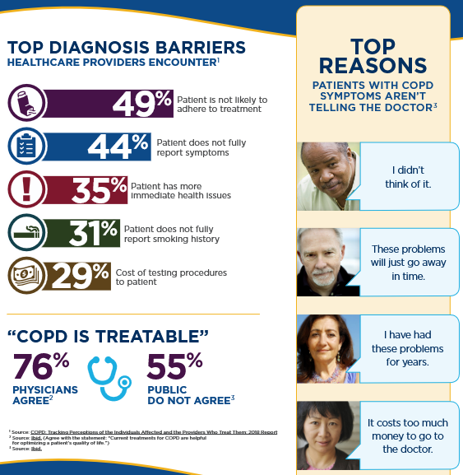
Top Diagnosis Barriers to COPD
(Source: National Heart, Lung and Blood Institute, 2022)

5.2 NHS Integrated Respiratory Services
Integrated Care Systems, along with Integrated Care Partnerships, are known for facilitating seamless coordination across primary, secondary and also various community services (van der Feltz-Cornelis et al., 2023). There are also multidisciplinary teams of various respiratory physicians, specialist nurses, physiotherapists, pharmacists, along with dietitians and occupational therapists who are responsible for optimising overall care pathways, including virtual wards, community respiratory teams, in addition to rapid-access clinics for managing exacerbations closer to home (NHS England, 2020).

5.3 Supported Self-Management
Central to COPD management is empowering patients by providing tailored education, written personalised action plans regarding recognising and managing exacerbations, in addition to robust smoking cessation programmes that combine pharmacotherapy with behavioural support (Schrijver et al., 2022; Stead et al., 2016). These interventions closely align with the principles of Self-Management Theory by equipping individuals with the knowledge, confidence, and practical skills required to actively manage their condition and reduce avoidable exacerbations.
5.4 Pulmonary Rehabilitation
Pulmonary rehabilitation is recognised as an effective exercise and education programme designed for people with lung disease who experience symptoms of breathlessness. It primarily focuses on tailored physical exercise, together with information that assists people in understanding and managing their condition more effectively. Pulmonary rehabilitation is included as a key intervention within the NHS Long Term Plan (NHS England, 2017). This is significantly supported by the literature and has been shown to improve health status, reduce dyspnoea, improve psychological wellbeing, and reduce healthcare utilisation and hospitalisation (Arnold, Dolezal and Cooper, 2020). People with stable COPD and a score of 3 or above on the MRC dyspnoea scale are recommended for referral to pulmonary rehabilitation programmes by NICE (NICE, 2023).

5.5 Multidisciplinary COPD Services
Multidisciplinary clinics are known for enabling holistic assessment, such as inhaler optimisation, along with national support for addressing obesity or cachexia (McDonald et al., 2022). Those are also known for enabling psychological screening, along with advance care planning (Haines et al., 2018). Primary care is known for delivering routine annual reviews that are aligned with various Quality and Outcomes Framework indicators (NHS England, 2024a). Community teams, on the other hand, focus on providing PR, along with home-based support, in addition to early exacerbation management. Secondary care is known for focusing on handling cases that are complex or unstable. There is also rapid access to community services, including the Hospital at Home or virtual ward models, which are able to effectively prevent unnecessary admissions (NHS England, 2024b).
These evidence-based interventions significantly align with the principles of CCM, resulting in promoting sustained improvements in various clinical outcomes, along with patient experience and system efficiency.


6. Models & Frameworks for Improved Outcomes

6.1 NHS Comprehensive UK Model
In the UK, the House of Care is a framework that is able to help practice teams and organisations adopt a care and support planning approach for people living with long-term conditions (BHF, 2015). It is known for visualising the “house” with the patient-clinician conversation at the centre, which is also further supported by informed patients, along with competent teams, in addition to organisational systems. There are also the Integrated Care Boards, along with Integrated Care Partnerships, that are known for enabling coordinated COPD pathways (Jerjes and Harding, 2024).

6.2 WHO's ICCC Framework as the International Model

Whereas, globally, there is the WHO Innovative Care for Chronic Conditions framework (ICCC), which is known for expanding on CCM as it incorporates the community, policy, alongside health system levels. The framework is also known for promoting proactive and population-based care while at the same time also emphasising prevention, partnerships, in addition to patient empowerment (WHO, 2026). This also helps in transitioning from acute-focused to integrated models.

6.3 Critical Evaluation

Strengths
The House of Care, along with the WHO ICCC framework, is known for improving overall coordination, in addition to reducing care fragmentation. Both frameworks are also known for promoting person-centred planning, in addition to supporting equity by addressing various social determinants. Both frameworks focus on encouraging proactive and population-based approaches that are known for aligning well with various ICS structures, thus having the potential to improve overall outcomes when properly implemented.

Limitations
However, it is essential to note that policy implementation is quite inconsistent across ICBs. This is due to the variation in funding, along with workforce shortages in respiratory specialists, in addition to community teams hindering overall scale-up. It is also essential to note that sustainability significantly depends on consistent investment. There is a critical need for robust evaluation, along with adaptation to various local contexts.

7. Local & National Policy Implications

7.1 National Policy Implications
The Long-Term Plan of the NHS is known for placing essential priority on respiratory care. It has set ambitions for earlier diagnosis, along with reducing emergency admissions, in addition to a transition towards community-based management of long-term conditions such as COPD (NHS England, 2019). This results in aligning with wider goals of integrated care, alongside prevention. A cornerstone of clinical practice is the NICE NG115, as it is known for providing evidence-based recommendations on various factors, such as pharmacological and non-pharmacological management, diagnosis, in addition to referral criteria (NICE, 2019).
The UK’s Quality and Outcomes Framework is known as the world’s largest pay-for-performance scheme in primary care. It rewards general practices financially for delivering interventions, along with achieving patient outcomes by using evidence-based indicators that are developed by NICE. The indicators also include maintaining COPD registers, along with annual reviews that incorporate breathlessness assessment, among many more (Forbes et al., 2017). These result in driving structured care and data collection.

7.2 Local Policy Implementation
At the local level, Integrated Care Boards (ICBs), Integrated Care Systems (ICSs), community respiratory teams, Primary Care Networks (PCNs), pulmonary rehabilitation services, and Hospital at Home or virtual ward services are responsible for implementing these national policies within local communities. Through multidisciplinary collaboration and coordinated respiratory pathways, these local services ensure timely diagnosis, continuity of care, early intervention, and improved management of COPD closer to patients' homes.
Various personalised care models that are known for being grounded in House of Care principles are able to support such national priorities as those that promote shared decision-making, along with individualised care, in addition to improved self-management. They are also known for contributing directly to various targets that are aligned with improving outcomes in various long-term conditions and reducing health inequalities. This is essential in various deprived communities, in which there are worse COPD outcomes. It is essential for implementing effective local implementation within various Integrated Care Boards for translating policy into effective and measurable improvements in both system sustainability and patient experience.

8. Recommendations
Based on the findings this booklet is providing the following actionable recommendations that are based on the Chronic Care Model principles of self-management support, delivery system design, and decision support. These recommendations will be useful in improving overall COPD care:
- It is recommended to significantly improve pulmonary rehabilitation referral pathways equipped with automatic triggers. For example, the trigger could be activated when the MRC dyspnea scale is more than or similar to 3, or following exacerbation. On the other hand, for maximising uptake and benefits, it is also suggested to ensure timely access in community settings.
- It is also recommended to integrate routine mental health screening based on anxiety, alongside depression, into various annual reviews. These can be conducted using various validated tools, which are also suggested to be supported by transparent and rapid referral pathways to various psychological services.
- It is also suggested to focus on developing or expanding local rapid-response exacerbation teams. These teams are recommended to include virtual wards, along with various community respiratory services, which will help in making early intervention and symptom management possible at home, in addition to preventing avoidable hospital admissions.
- Another recommendation is to significantly improve data sharing, along with interoperability across various Integrated Care Systems, which will help in supporting proactive case finding, risk stratification, in addition to population health management.
- It is also recommended to focus on investing in targeted training, particularly for primary and community teams. These trainings should be based on biopsychosocial assessment, along with motivational interviewing, in addition to behaviour change methods for improving overall personalised care delivery and also empowering patients.
If such recommendations are prioritised, it will be possible to encourage more integrated, proactive, along with equitable COPD services.

9. Conclusion
It can be stated that in order to gain sustainable COPD outcomes, integrated and person-centred care is significant. It will be possible for health professionals to significantly reduce burden, properly address inequalities, along with improving lives by embedding the Biopsychosocial Model, various evidence-based interventions such as pulmonary rehabilitation, supported self-management, in addition to robust coordination via the NHS Comprehensive Model of Personalised Care and the WHO Innovative Care for Chronic Conditions (ICCC) Framework. It is also essential to note that ongoing policy alignment, along with multidisciplinary collaboration, will help in better driving overall continuity and value in the NHS. Overall, strengthening multidisciplinary collaboration, patient empowerment, and personalised care will be essential for improving long-term outcomes and enhancing the quality of life of individuals living with COPD.

References
ACT Center (2024). The Chronic Care Model. [online] Center for Accelerating Care Transformation. Available at: https://www.act-center.org/application/files/1616/3511/6445/Model_Chronic_Care.pdf [Accessed 30 Jun. 2026].
Agarwal, A.K., Raja, A. and Brown, B.D. (2023). Chronic obstructive pulmonary disease (COPD). [online] National Library of Medicine. Available at: https://www.ncbi.nlm.nih.gov/books/NBK559281/ [Accessed 30 Jun. 2026].
Alyafei, A. and Carr, R.E. (2024). The Health Belief Model of Behavior Change. [online] National Library of Medicine. Available at: https://www.ncbi.nlm.nih.gov/books/NBK606120/ [Accessed 30 Jun. 2026].
Arnold, M.T., Dolezal, B.A. and Cooper, C.B. (2020). Pulmonary rehabilitation for chronic obstructive pulmonary disease: Highly effective but often overlooked. Tuberculosis and Respiratory Diseases, 83(4), pp.257–267. doi:https://doi.org/10.4046/trd.2020.0064.
BHF (2015). Person-Centred Care and the House of Care. [online] British Heart Foundation. Available at: https://www.bhf.org.uk/for-professionals/healthcare-professionals/innovation-in-care/person-centred-care-and-the-house-of-care [Accessed 30 Jun. 2026].
Boukhenouna, S., Wilson, M.A., Bahmed, K. and Kosmider, B. (2018). Reactive Oxygen Species in Chronic Obstructive Pulmonary Disease. Oxidative Medicine and Cellular Longevity, [online] 2018, pp.1–9. doi:https://doi.org/10.1155/2018/5730395.
Eisner, M.D., Blanc, P.D., Omachi, T.A., Yelin, E.H., Sidney, S., Katz, P.P., Ackerson, L.M., Sanchez, G., Tolstykh, I. and Iribarren, C. (2009). Socioeconomic status, race and COPD health outcomes. Journal of Epidemiology & Community Health, 65(1), pp.26–34. doi:https://doi.org/10.1136/jech.2009.089722.
Ferrante, L.E. and Cohen, A. (2023). All the Lonely People: Social Isolation and Loneliness in Chronic Obstructive Pulmonary Disease. Annals of the American Thoracic Society, 20(12), pp.1703–1704. doi:https://doi.org/10.1513/annalsats.202309-833ed.
Filippou, I., Spyratos, D., Tsiouprou, I., Chloros, D., Michalopoulou, D. and Sichletidis, L. (2025). Diagnosed and underdiagnosed cases of COPD in the primary care setting: Differences and similarities. Journal of Family Medicine and Primary Care, 14(8), pp.3406–3411. doi:https://doi.org/10.4103/jfmpc.jfmpc_1878_24.
Forbes, L.J., Marchand, C., Doran, T. and Peckham, S. (2017). The role of the Quality and Outcomes Framework in the care of long-term conditions: a systematic review. British Journal of General Practice, [online] 67(664), pp.e775–e784. doi:https://doi.org/10.3399/bjgp17x693077.
Gea, J., Pascual, S., Casadevall, C., Orozco-Levi, M. and Barreiro, E. (2015). Muscle dysfunction in chronic obstructive pulmonary disease: update on causes and biological findings. Journal of Thoracic Disease, [online] 7(10), pp.E418–E438. doi:https://doi.org/10.3978/j.issn.2072-1439.2015.08.04.
Geffen, van, Tan, D.J., Walters, J.A. and Walters, E.H. (2023). Inhaled corticosteroids with combination inhaled long-acting beta2-agonists and long-acting muscarinic antagonists for chronic obstructive pulmonary disease. The Cochrane library, 2023(12). doi:https://doi.org/10.1002/14651858.cd011600.pub3.
Gonçalves, B., Lusher, J., Cund, A., Sime, C. and Harkess-Murphy, E. (2025). Understanding the psychosocial burden of living with advanced COPD in context of palliative care: A mixed methods study. Journal of Health Psychology. doi:https://doi.org/10.1177/13591053251316504.
Haines, A., Perkins, E., Evans, E.A. and McCabe, R. (2018). Multidisciplinary Team Functioning and Decision Making within Forensic Mental Health. Mental Health Review Journal, [online] 23(3), pp.185–196. doi:https://doi.org/10.1108/mhrj-01-2018-0001.
Harries, T.H., Thornton, H., Crichton, S., Schofield, P., Gilkes, A. and White, P.T. (2017). Hospital readmissions for COPD: a retrospective longitudinal study. npj Primary Care Respiratory Medicine, 27(1). doi:https://doi.org/10.1038/s41533-017-0028-8.
Jennings, K.M. (2019). The roy adaptation model: A theoretical framework for nurses providing care to individuals with anorexia nervosa. Advances in Nursing Science, [online] 40(4), pp.370–383. doi:https://doi.org/10.1097/ans.0000000000000175.
Jerjes, W. and Harding, D. (2024). Enhancing primary care through integrated care pathways: a convergence of theory and practice. Frontiers in Health Services, 4. doi:https://doi.org/10.3389/frhs.2024.1432901.
Jiménez-Ruiz, C.A., Andreas, S., Lewis, K.E., Tonnesen, P., van Schayck, C.P., Hajek, P., Tonstad, S., Dautzenberg, B., Fletcher, M., Masefield, S., Powell, P., Hering, T., Nardini, S., Tonia, T. and Gratziou, C. (2015). Statement on smoking cessation in COPD and other pulmonary diseases and in smokers with comorbidities who find it difficult to quit. European Respiratory Journal, [online] 46(1), pp.61–79. doi:https://doi.org/10.1183/09031936.00092614.
Jing, Y. and Mao, S. (2026). COPD and cognitive impairment: a review of associated factors and intervention strategies. Frontiers in Psychiatry, 16. doi:https://doi.org/10.3389/fpsyt.2025.1714708.
Lozano, P., Thrasher, J.F., Forthofer, M., Hardin, J., Shigematsu, L.M.R., Arillo Santillán, E. and Fleischer, N.L. (2020). Smoking-Related Stigma: A Public Health Tool or a Damaging Force? Nicotine & Tobacco Research, [online] 22(1), pp.96–103. doi:https://doi.org/10.1093/ntr/nty151.
MacIntyre, N. and Huang, Y.C. (2018). Acute Exacerbations and Respiratory Failure in Chronic Obstructive Pulmonary Disease. Proceedings of the American Thoracic Society, [online] 5(4), pp.530–535. doi:https://doi.org/10.1513/pats.200707-088et.
Mathur, S. and Singh, P. (2024). Chronic Obstructive Pulmonary Disease: Lifestyle Impact. International Journal of Preventive Medicine, [online] 15. doi:https://doi.org/10.4103/ijpvm.ijpvm_297_23.
McDonald, V.M., Harrington, J., Clark, V.L. and Gibson, P.G. (2022). Multidisciplinary care in chronic airway diseases: the Newcastle model. ERJ Open Research, [online] 8(3). doi:https://doi.org/10.1183/23120541.00215-2022.
Miravitlles, M., Peña-Longobardo, L.M., Oliva-Moreno, J. and Hidalgo-Vega, A. (2015). Caregivers’ burden in patients with COPD. International Journal of Chronic Obstructive Pulmonary Disease, [online] 10, pp.347–356. doi:https://doi.org/10.2147/copd.s76091.
Moffett, A.T., Halpern, S.D. and Weissman, G.E. (2025). The effect of a post-bronchodilator FEV1/FVC < 0.7 on COPD diagnosis and treatment: a regression discontinuity design. Respiratory Research, 26(1). doi:https://doi.org/10.1186/s12931-025-03198-6.
Morton, K., MacNeill, S., Sanderson, E., Dixon, P., King, A., Jenkins, S., Metcalfe, C., Shaw, A., Chalder, M., Benger, J., Hollingworth, W., Calvert, J. and Purdy, S. (2019). Evaluation of ‘care bundles’ for patients with chronic obstructive pulmonary disease (COPD): a multisite study in the UK. BMJ Open Respiratory Research, [online] 6(1). doi:https://doi.org/10.1136/bmjresp-2019-000425.
National Heart, Lung and Blood Institute (2022). COPD: Better Talk Means Better Treatment Infographic | NHLBI, NIH. [online] www.nhlbi.nih.gov. Available at: https://www.nhlbi.nih.gov/resources/copd-better-talk-means-better-treatment-infographic [Accessed 30 Jun. 2026].
NHS England (2017). NHS England, Pulmonary Rehabilitation. [online] NHS England. Available at: https://www.england.nhs.uk/ourwork/clinical-policy/respiratory-disease/pulmonary-rehabilitation/ [Accessed 30 Jun. 2026].
NHS England (2019). NHS England Respiratory Disease. [online] NHS England. Available at: https://www.england.nhs.uk/ourwork/clinical-policy/respiratory-disease/ [Accessed 30 Jun. 2026].
NHS England (2020). NHS England» Expanding our workforce. [online] England.nhs.uk. Available at: https://www.england.nhs.uk/gp/expanding-our-workforce/ [Accessed 30 Jun. 2026].
NHS England (2024a). NHS England» Quality and Outcomes Framework Guidance for 2023/24. [online] www.england.nhs.uk. Available at: https://www.england.nhs.uk/long-read/quality-and-outcomes-framework-guidance-for-2023-24/ [Accessed 30 Jun. 2026].
NHS England (2024b). Virtual Wards Operational Framework. [online] England.nhs.uk. Available at: https://www.england.nhs.uk/long-read/virtual-wards-operational-framework/ [Accessed 30 Jun. 2026].
NICE (2019). Chronic Obstructive Pulmonary Disease in over 16s: Diagnosis and Management | Guidance and Guidelines | NICE. [online] NICE. Available at: https://www.nice.org.uk/guidance/NG115 [Accessed 30 Jun. 2026].
NICE (2023). Quality statement 4: Pulmonary rehabilitation for stable COPD and exercise limitation | Chronic obstructive pulmonary disease in adults | Quality standards | NICE. [online] nice.org.uk. Available at: https://www.nice.org.uk/guidance/qs10/chapter/Quality-statement-4-Pulmonary-rehabilitation-for-stable-COPD-and-exercise-limitation [Accessed 30 Jun. 2026].
NIH (2019). Chronic Obstructive Pulmonary Disease. [online] Nih.gov. Available at: https://www.ncbi.nlm.nih.gov/books/n/nicecg101/ [Accessed 30 Jun. 2026].
Pribadi, E.T. and Devy, S.R. (2020). Application of the Health Belief Model on the intention to stop smoking behavior among young adult women. Journal of Public Health Research, [online] 9(2). doi:https://doi.org/10.4081/jphr.2020.1817.
Rahi, M.S., Thilagar, B., Balaji, S., Prabhakaran, S.Y., Mudgal, M., Rajoo, S., Yella, P.R., Satija, P., Zagorulko, A. and Gunasekaran, K. (2023). The Impact of Anxiety and Depression in Chronic Obstructive Pulmonary Disease. Advances in Respiratory Medicine, [online] 91(2), pp.123–134. Available at: https://pmc.ncbi.nlm.nih.gov/articles/PMC10037643/.
Schrijver, J., Lenferink, A., Brusse-Keizer, M., Zwerink, M., van der Valk, P.D., van der Palen, J. and Effing, T.W. (2022). Self-management interventions for people with chronic obstructive pulmonary disease. Cochrane Database of Systematic Reviews, 2022(1). doi:https://doi.org/10.1002/14651858.cd002990.pub4.
Stead, L.F., Koilpillai, P., Fanshawe, T.R. and Lancaster, T. (2016). Combined pharmacotherapy and behavioural interventions for smoking cessation. The Cochrane database of systematic reviews, [online] 3(3), p.CD008286. doi:https://doi.org/10.1002/14651858.CD008286.pub3.
Stewart, C. (2021). Leading causes of death worldwide 2021 | Statista. [online] Statista. Available at: https://www.statista.com/statistics/1488587/leading-causes-of-death-worldwide-2021/ [Accessed 30 Jun. 2026].
Stewart, C. (2026). Number of COPD cases forecasts worldwide | Statista. [online] Statista. Available at: https://www.statista.com/statistics/1493740/copd-cases-forecasts-worldwide/ [Accessed 30 Jun. 2026].
Stone, P.W., Osen, M., Ellis, A., Coaker, R. and Quint, J.K. (2023). Prevalence of Chronic Obstructive Pulmonary Disease in England from 2000 to 2019. International Journal of Chronic Obstructive Pulmonary Disease, Volume 18(18), pp.1565–1574. doi:https://doi.org/10.2147/copd.s411739.
Tian, X., Yi, L., Liu, X., Zuo, F., Shang, H., Zhang, J. and Ren, Y. (2025). Relationship Between Social Support, Symptom Burden, Dyspnea, Perceived Stress, Perceived Stigma, Coping Styles, and Psychological Distress in Patients with Stable COPD: A Structural Equation Model. International Journal of COPD, [online] Volume 20, pp.2183–2198. doi:https://doi.org/10.2147/copd.s521786.
Trueman, D. (2017). Estimating the economic burden of respiratory illness in the UK Estimating the economic burden of respiratory illness in the UK. [online] Available at: https://www.asthmaandlung.org.uk/economic-burden-report [Accessed 30 Jun. 2026].
van der Feltz-Cornelis, C., Attree, E., Heightman, M., Gabbay, M. and Allsopp, G. (2023). Integrated Care pathways: a New Approach for Integrated Care Systems. The British Journal of General Practice, 73(734), p.422. doi:https://doi.org/10.3399/bjgp23X734925.
Whittaker, H., Kramer, A., Hatam, S., Cook, S., Scully, S., Turner, H., Bolton, T., Kallis, C., Busby, J., Heaney, L.G., Sheikh, A. and Quint, J.K. (2025). Incidence and prevalence of asthma, chronic obstructive pulmonary disease and interstitial lung disease between 2004 and 2023: harmonised analyses of longitudinal cohorts across England, Wales, South-East Scotland and Northern Ireland. Thorax, p.thorax-222699. doi:https://doi.org/10.1136/thorax-2024-222699.
WHO (2024). Chronic obstructive pulmonary disease (COPD). [online] World Health Organisation. Available at: https://www.who.int/news-room/fact-sheets/detail/chronic-obstructive-pulmonary-disease-(copd) [Accessed 30 Jun. 2026].
WHO (2026). Innovative Care for Chronic Conditions - IRIS. [online] Who.int. Available at: https://iris.who.int/bitstreams/4aea436e-9fc6-4e1f-a0c5-9d57a9213b21/download [Accessed 30 Jun. 2026].
Williams, P.J., Cumella, A., Philip, K.E.J., Laverty, A.A. and Hopkinson, N.S. (2022). Smoking and socioeconomic factors linked to acute exacerbations of COPD: analysis from an Asthma + Lung UK survey. BMJ Open Respiratory Research, [online] 9(1), p.e001290. doi:https://doi.org/10.1136/bmjresp-2022-001290.

