Module title: Professional and Career development
Module code: BMSW 4005
Lecturer: Crisford Chogugudza

Task 3- Reflective portfolio



Mariana Simona Pacuraru
1918143

Contents
Introduction 3
1.Skills and competences 4
2.Key skills for future employment 6
3.Module topics 10
Conclusion 13
References 14

Introduction

The key goal of this self-evaluation study is to assess my progress over the course of the semester and determine which skills I need to develop the most and examine the topics I learned in this module. It is mostly based on my own skill development and ideas gained through the module and lectures. I will do a SWOT review of my abilities and shortcomings, as well as a possible professional development curriculum and how I plan to accomplish it.
This paper discusses the rationale for considering reflection as an ability that can assist a student in not only seeking work, but also succeeding in it. It is crucial to realize that reflection is an important component of both higher-education learning and the workplace's higher-quality dimensions.

1.Skills and competences

PERSONAL DEVELOPMENT PLAN

A professional development plan (PDP) is a way for people to share knowledge about the skills they've been working on and want to improve (Beausaert, S. A., Segers, M. S., & Gijselaers, W. H,2011).
Objectives
1) | Time management | Increase confidence in the skill | Taking lessons,  Using the 4 D strategy, reading books on how to improve time management |  | Family,tutor,colleagues
2) | Communication | Visible increased confidence in the skill | Learn how to apply the skill on each area of communication |  | Family,collegues,tutor
3) | Computer literacy | Increase confidence and expanded knowledge in Microsoft Software | Take a free online or-in person computer course. Practice them regularly |  | Use of computer
4) | Report writing | Successful submission of a report,  good marks | Explore different types of report writing,reading books on how to improve this skill. |  | Use of Microsoft software
 | My specific learning objectives | Success criteria | How will I achieve this | Target date | Resources required
JOHARY WINDOW
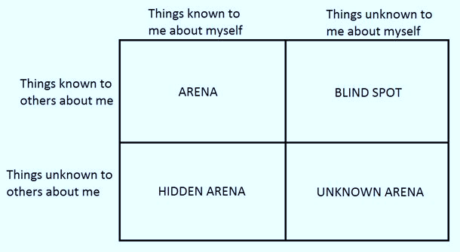
MBA Skool Team (2018)

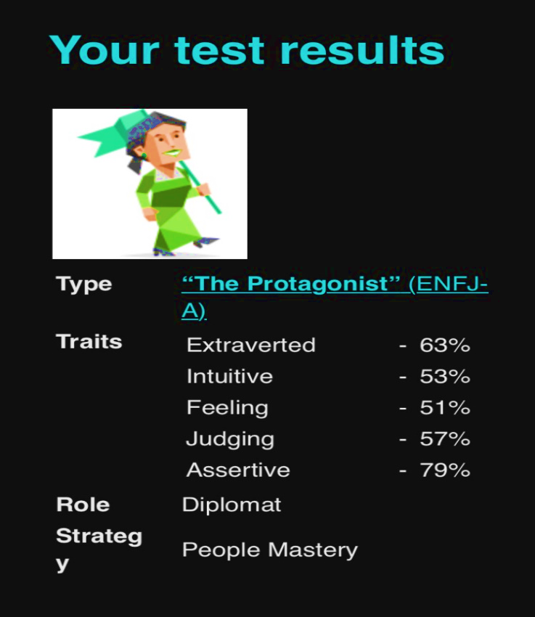
This module gave me the opportunity to learn about some of the resources I can use to develop my self-awareness. We spoke about Johari Window, personality tests, and learning styles among these methods.
Accordint to Newstrom, J. W., & Rubenfeld, S. A (1983), Johari Window is a psychological tool that portrays the connection between what one knows and what one doesn't about oneself and others. It has been used as a model for classroom lessons in its original form since its introduction in 1955. When completely implemented, this interpersonal communication model not only enhances managers' knowledge of the value of soft skills, it also assists them in building a creative and immersive learning.
https://www.16personalities.com/free-personality-test

2.Key skills for future employment

According to Yorke and Knight (2004 a), employability is a set of achievements – skills, understandings, and personal characteristics – that make graduates more likely to find jobs and succeed in their fields, benefiting themselves, society, and the economy.
Skills required for future employment:
- Learning methods that are active and efficient.
- Problem-solving with a high level of difficulty.
- Analysis and critical thinking.
- Resilience, stress tolerance, and adaptability.
- Originality, imagination, and initiative.
- Social influence and leadership.
- Reasoning, problem-solving, and concept design.
This section will describe and detail any personal strengths and weaknesses that will aid or impede my ability to effectively complete this plan. Also, what opportunities are available to assist me in succeeding, as well as what external threats or obstacles could obstruct my progress.

(S)trenghts
Organizational skill
I am an excellent organizer and team player. I would build on ideas with other group members in group work, and as a team leader, I will usually delegate tasks to group members so that everyone enjoys the tasks they are given.
Organizational skills involve preserving structure and order, increasing efficiency, and prioritizing tasks that must be performed immediately over those that can be delegated or removed entirely.
Procrastination, clutter, miscommunication, and inefficiency are all poor job practices that can be avoided by having good organizational skills.
Managers are looking for workers who can not only keep their work and desks organized, but also adapt to the organisation.
Time management

Self-control is something I'm really good at. I am able to manage my time easily and complete tasks without feeling pressured. I typically write down all of the tasks I need to complete and prioritize them according to their value and timeliness. Then I'll put them on my calendar so I'll know exactly what to do next and when.
Good time management means evaluating what you want to get out of life and successfully achieving these goals. Time management does not mean that you must be busy all of the time; rather, it implies that you use your time as you see fit, which could include a lot of daydreaming and doing nothing. Effective time management leads to more relaxation, less anxiety, more pleasure, and more accomplishment (Flashman, R. H., & Bradley, L. A. 1984).

IT skill

Not only do I have advanced programming knowledge, but I can even use specialized software.Given the high demand for graduates in Information Systems (IS) and Information Technology (IT), it is important that curricula in IS and IT programs meet employer needs. IS and IT educators are continually challenged to keep their courses and curriculum important to the business world while still keeping up with the industry's new and evolving technological changes (Janicki, T., Cummings, J., & Kline, D. M. 2014).

(W)eaknesses

My communication skills are poor. I'm an introvert who struggles to make friends. I get anxious when I have to speak to strangers.
In the past, I've had a habit of rushing through one project before moving on to the next. In a crowded workplace, this would eventually create problems. I'm aware that in the future, I'll have to be more comfortable swapping focus when it's needed.
The amount of work that was expected of me at the start of my career overwhelmed me. I had a hard time arranging things, and as a result, I slacked on some tasks because I couldn't commit enough time to them.
I've found my workload to be much more manageable after attending a few time-management sessions, and I'm definitely working on it.

(O)opportunities

I'll search for a part-time job through our school's "future" to acquire new skills and develop my resume.
Online courses – A wide range of programs offer online courses in technical areas as well as subjects that aid in the development of transferrable skills.
Volunteering will help me improve my skills while still allowing me to explore my values and goals, all of which are important to consider as I progress in my career.

(T)hreats

The global virus pandemic is having a significant effect at work. The economic and social disruption endangers the long-term livelihoods and well-being of millions of people, in addition to endangering public health.
Deducing insights from recent downturns to predict how the job market will adjust in the months ahead is difficult given the unique existence of the COVID-19 recession. The complexities of the COVID-19 recession could turn out very differently based on existing data. Vacancies have remained strong, and job-finding rates have remained steady – for both the marginally unemployed and those who have been laid off permanently (Gallant, J., Kroft, K., Lange, F., & Notowidigdo, M. J. 2020).
Another possible future challenge to jobs is automated technology. Companies prefer them because they can save prices, do certain work faster than humans, and boost productivity.

3.Module topics

PDPs

During this workshop, I learned how to identify the skills and expertise required for successful work, demonstrate preparation for employability and personal growth by identifying personal strengths and areas for improvement, set career targets, and create a personal action plan.
A professional development plan (PDP) is a tool that allows an employee to concentrate on, record, and present his or her goals for potential development.
In assessment cycles, PDPs are used to present details about the competencies that the employee has been working on and aims to improve more. A new research report on the efficacy of PDPs was published, which included 54 empirical studies (Beausaert et al. 2011). The review's results found that a number of supporting factors affect how workers respond to a PDP. The degree to which the employee uses the PDP as a learning and contemplation instrument is a required individual requirement, considering the reflective existence of the PDP. Second, the PDP acts as a starting point for conversations with the supervisor or mentor, who offers direction, promotes reflection, and motivates the employee to learn. As a result, the supervisor's function as an input source and motivator is a critical background requirement for a PDP's success ( Beausaert, S., Segers, M., & Gijselaers, W. 2011).

Self awareness

In this session, I learned a few main concepts about self-awareness. I've found some tools that can assist me in increasing my self-awareness. The Johari window, personality tests, and a more detailed look at learning style were among the resources I discovered.
The successful recognition, retrieval, and storing of information about oneself is referred to as self-awareness (Morin, 2006). Feelings, autobiographical retrieval, sense of agency, and personality characteristics are only a few of the self-domains and corollaries (e.g., self-esteem, self-regulation, death awareness, self-conscious emotions). Importantly, self-awareness includes all internal mental states (private self-aspects) like thoughts, desires, sensations, and attitudes, as well as external characteristics like physical appearance, mannerisms, and actions (public self-aspects) (Morin, Alain, 2011).
Self-evaluation processes, according to Dunning (1999; Sedikides & Strube, 1997), have a broad range of effects on inspired cognition, including attribution, social comparison, attribute definition, and social perception. Creativity is another example of the integration of self-evaluation motivations and cognitive processes, though it is less well studied. Self-evaluation has been shown in many studies to suppress creativity (Amabile, 1996; Szymanski & Harkins,1992).

Exploring Employment trends and opportunities

I learned about some of the steps I can take while looking for suitable jobs in this class. I was able to identify several activities that would help me increase my chances of finding the right job.
Career development takes on new significance in the sense of employability demands in the information economy. In this context, increased mobility, a dynamic work environment, and increased workplace job support are all seen as characteristics of a modern career. Both of these characteristics emphasize individual and self-management in terms of professional development. Personal characteristics have less of an impact on job development than modern career growth variables. Having a versatile mindset is a strong predictor of career development and networking potential. Furthermore, employees who work for a business that has good mobility options (as determined by the employer) are more engaged in job searching and career management. Employees' plans to advance their careers within the organization make them perform higher on capacity, inspiration, and job control reflections. When employees are faced with a career transition away from their current position, they are more likely to depend on their skills (Kuijpers, M. A. C. T., & Scheerens, J. 2006).

Employment regulations

Countries with strict labour laws have higher proportions of employers reporting these rules as drastic constraints on a global scale. Labour regulations, on the other hand, do not affect all companies in the same way. Medium-sized companies are the ones that are hit the hardest in terms of market and growth opportunities. Similarly, discriminatory labour actions affect creative companies overwhelmingly. Companies subjected to strict regulations also spend more in training and use temporary labour more frequently, according to the data.
Similarly, restrictive labour policies hurt innovative companies significantly. Companies subjected to strict regulations also spend more in training and use temporary labour more frequently, according to the data. When labour laws make hiring and firing prohibitively costly, small companies rely on temporary staffing, while medium and large businesses, as well as creative businesses, rely more on on-the-job training.

Conclusion

I was able to understand the meaning, relevance, and usefulness of the concepts I learned in this module, as well as apply them in real life. Based on my thorough analysis, I created a list of the most in-demand employability skills. I created a personal SWOT analysis based on employability skills, as well as a self-assessment questionnaire, which I learnt from the internet and from personal experience and which helped me become more self-aware.
Jobs with a good degree would, without a doubt, have an excellent starting point, and a good degree allows staff to pursue employment. Companies, on the other hand, want even better from their graduate workers; they want employees who can bring value to the enterprise and place it in an unbeatable position in the face of fierce competition I want to find a good job in a fast-paced job market after I graduate. With proper guidance, motivation, and reflection, I develop high-level core skills such as organizational and coordination, communication, problem-solving, and self-management, as well as employability skills for real-world careers, planning, and innovating. All of these skills are essential now and in the future.

References

Beausaert, S. A., Segers, M. S., & Gijselaers, W. H. (2011). Using a personal development plan for different purposes: Its influence on undertaking learning activities and job performance. Vocations and Learning,

Beausaert, S., Segers, M., & Gijselaers, W. (2011). The use of a personal development plan and the undertaking of learning activities, expertise-growth, flexibility and performance: The role of supporting assessment conditions. Human resource development international, 14(5), 527-543.

Doyle, A. (2018). Top Organizational Skills Employers Value with Examples. Retrieve from https://www. the balancecareers. com/organizational-skills-list-2063762.

Flashman, R. H., & Bradley, L. A. (1984). The Successful Person’s Guide to Time Management.

Gallant, J., Kroft, K., Lange, F., & Notowidigdo, M. J. (2020). Temporary unemployment and labor market dynamics during the COVID-19 recession (No. w27924). National Bureau of Economic Research.

Helyer, R. (2007). What is Employability?: reflecting on the postmodern challenges of work-based learning. Journal of Employability in the Humanities.

Janicki, T., Cummings, J., & Kline, D. M. (2014). Information technology job skill needs and implications for information technology course content. Information Systems Education Journal, 12(6), 59.

Kuijpers, M. A. C. T., & Scheerens, J. (2006). Career competencies for the modern career. Journal of career development, 32(4), 303-319.

MBA School Team (2018).Johary Window .[web] https://www.mbaskool.com/business-concepts/human-resources-hr-terms/6720-johari-window.html accessed:02/04/2021

Morin, Alain, 2011. Self-recognition, theory-of-mind, and self-awareness: What side are you on? Laterality (Hove), 16(3), pp.367–383.

Newstrom, J. W., & Rubenfeld, S. A. (1983, March). The johari window: A reconceptualization. In Developments in Business Simulation and Experiential Learning: Proceedings of the Annual ABSEL conference (Vol. 10).

Silvia, P. J., & Phillips, A. G. (2004). Self-awareness, self-evaluation, and creativity. Personality and Social Psychology Bulletin, 30(8), 1009-1017.

