

MODULE CODE: Digital Skills for Personal Development and Business Growth BMSW4008

ASSESSMENT COMPONENT: PORTFOLIO

STUDENT NAME: Asara Ben-Saoud

STUDENT NUMBER:2515050

LECTURER: Philippa Fitzgerald

DATE:03/12/2025

Contents
Task 1 3
Assessment of Digital Skills 3-5
References 6
Task 2 7
LinkedIn Learning Certificates for Office365 7
Task 3 7-9
Essay on Relevance of Excel in professional and personal life. 7-9
References 10
Task 4 11
7 Minute Reflective Presentation 11-16

AI acknowledgment, I used Chat GPT to proofread my assignment and gave me some tips for improvement.

Task 1: Assessment of Digital Skills
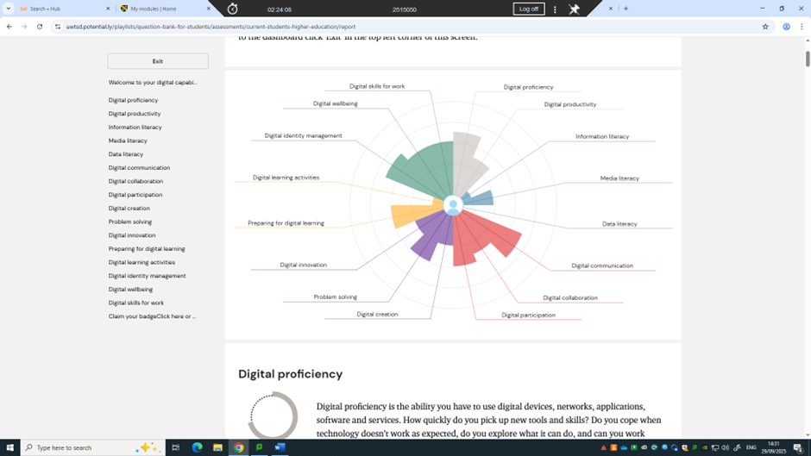
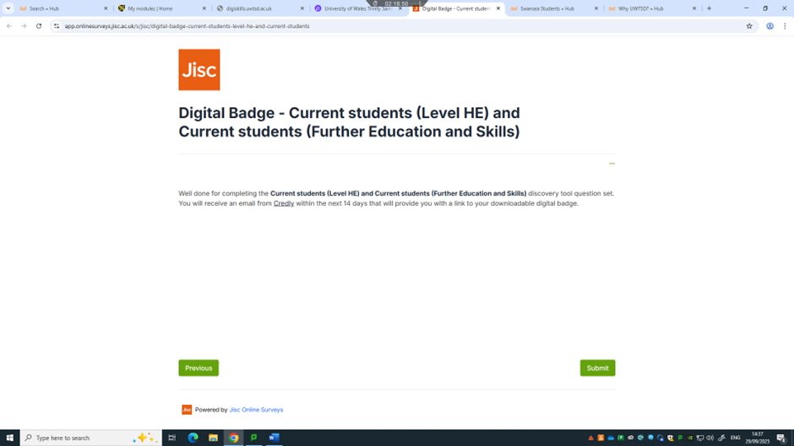

Since September 2025, I have been developing my digital skills at university, and this has significantly increased my confidence with technology. The lectures have taken me from basic tasks, like navigating learning platforms, to more advanced tools, such as AI, while also teaching me to use technology responsibly. Over the months, I have not only gained technical skills but also improved my organisation, communication, and awareness of ethical digital practices (Anderson, Ogruk Maz & Bell, 2025).
The first lecture focused on Moodle, the university’s learning platform, and introduced the JISC Digital Capability Self-Assessment. Through Moodle, I learned how to access study support, download Microsoft Office for free, submit assignments using Turnitin on HWB, and navigate additional learning resources. Completing the JISC assessment allowed me to identify my strengths and gaps in digital literacy, and I was awarded a JISC digital badge, which motivated me to improve specific skills. This combination of learning and assessment highlighted how essential digital literacy is for managing deadlines, organising tasks, and independently progressing in my studies (Getenet et al., 2024).
Next, we explored Outlook and email management. I learned to organise emails, set reminders, and schedule meetings using calendar invitations. These skills, although simple, have already helped me manage my time more effectively and reduce stress by keeping track of tasks. Research suggests that developing digital organisation and communication skills is critical for academic engagement and success in online learning (Bruckhaus et al., 2024).
One of the most engaging lectures focused on AI tools, including ChatGPT and Notebook LM. We discussed their responsible use in line with university guidelines. I realised that AI is not simply a shortcut for completing assignments; it is a tool that must be used thoughtfully and ethically. For instance, I have used ChatGPT to proofread my work, improving clarity and grammar while ensuring my original ideas remain intact. Learning about AI literacy—including safe, effective, and ethical use of AI—has become increasingly essential for higher education students (Walter, 2024; Wessels, 2025).
Later lectures focused on Microsoft Word and PowerPoint. In Word, I learned to embed images and videos and save my work on OneDrive, making my documents more professional and accessible from any device. In PowerPoint, I added animations, transitions, multimedia, and recorded presentations. These skills allowed me to present information creatively and clearly, enhancing both my learning and that of my peers (Smith & Storrs, 2023).
The Excel lecture was particularly valuable, as I learned to perform calculations, use functions like SUM and AVERAGE, and create a household budget spreadsheet. These practical tasks demonstrated how classroom learning can be applied in real-life scenarios. Additionally, we created survey QR codes and embedded them in PowerPoint presentations to collect peer feedback. This exercise highlighted how digital tools can facilitate collaboration and engagement in academic settings (Anderson, Ogruk Maz & Bell, 2025).
The final lecture introduced LinkedIn Learning, where I created a professional profile, connected with peers, and earned certificates for completing Office 365 courses. This experience showed me how digital tools can support career development, networking, and lifelong learning, reinforcing the idea that digital literacy extends beyond academic tasks into professional growth (Bruckhaus et al., 2024).
Reflecting on the past few months, my digital literacy has improved considerably. I am now confident using various software tools, organising my work efficiently, communicating online, and applying AI responsibly. Importantly, I recognise that digital literacy is not only about technical competence but also about using tools creatively, effectively, and ethically (Walter, 2024; Wessels, 2025).
Overall, this series of lectures and practical exercises has provided me with both technical skills and a broader understanding of how digital tools support academic and professional success. Completing the JISC self-assessment and earning a badge has given me a benchmark for my progress, motivating continuous learning and responsible use of technology (Getenet et al., 2024; Anderson, Ogruk Maz & Bell, 2025). I now feel well-prepared to apply these skills in my studies and future career while maintaining awareness of ethical and effective digital practices.

References
- Anderson, T.D., Ogruk Maz, G. & Bell, III, T.J. (2025) ‘Enhancing Digital Literacy in Higher Education: A Comprehensive Analysis of Digital Skill Development Among College Students’, Journal of Higher Education Theory and Practice, 25(3).
- Bruckhaus, A.A., Bennett, A., Brawer Cohen, M., Sinclair, M., Ramirez De La Cruz, G., Ragusa, G. & Duncan, D. (2024) ‘Evaluation of students’ digital literacy through an immersive university–high school collaboration’, Frontiers in Education, 9, Article 1429893.
- Getenet, S., Cantle, R., Redmond, P. & Albion, P. (2024) ‘Students’ digital technology attitude, literacy and self-efficacy and their effect on online learning engagement’, International Journal of Educational Technology in Higher Education, 21, Article 3.
- Smith, E.E. & Storrs, H. (2023) ‘Digital literacies, social media, and undergraduate learning: what do students think they need to know?’, International Journal of Educational Technology in Higher Education, 20, Article 29.
- Walter, Y. (2024) ‘Embracing the future of Artificial Intelligence in the classroom: the relevance of AI literacy, prompt engineering, and critical thinking in modern education’, International Journal of Educational Technology in Higher Education, 21, Article 15.
- Wessels, B. (2025) ‘Developing an AI framework for learning in higher education: a humanities perspective from English Literature’, International Journal of Educational Technology in Higher Education, 22, Article 65.

Task 2: LinkedIn Learning Certificates for Office365

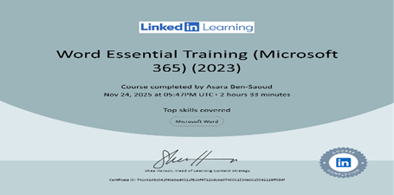

Task 3: Relevance of Excel in professional and personal life.

Introduction
Microsoft Excel remains one of the most widely used digital tools for managing, analysing, and presenting data across academic and professional settings. Its combination of accessibility, flexibility, and advanced analytical capabilities makes it valuable for students, managers, and organisations alike (Handley, 2022; MrExcel, 2024). Over time, Excel has evolved from a basic spreadsheet program into a powerful analytical platform, supported by tools such as Power Query, Power Pivot, dynamic arrays, and automation features that enable deeper data insights (Deloitte UK, 2023). As workplaces place increasing emphasis on digital competency and evidence-based decision-making, Excel proficiency has become a fundamental component of digital literacy. However, the strengths of Excel are balanced by notable risks when spreadsheets are poorly controlled, insufficiently documented, or not audited effectively (EuSpRIG, 2024). These challenges highlight the importance of responsible use and governance.

Developing Digital Skills
Digital capability develops through a mixture of self-reflection, guided learning, and hands-on practice. Tools such as the JISC Digital Capability Self-Assessment allow users to evaluate their current strengths and limitations in spreadsheet management, formula use, and data interpretation (Camms Group, 2023). This self-assessment provides a structured starting point, helping users understand which skills require improvement and how to prioritise learning.
Training platforms like LinkedIn Learning offer targeted courses on Excel and Office 365, providing users with instruction in essential concepts such as formulas, functions, pivot tables, and charts (MrExcel, 2024). These courses not only introduce new skills but emphasise efficiency, good design habits, and repeatable workflows. By learning how to structure data tables properly, create dynamic ranges, and apply validation techniques, users gain a stronger foundation for more advanced data work.
Practical application is equally important. Tasks such as creating personal budgets, analysing academic datasets, or developing financial projections for organisations demonstrate how Excel operates in realistic scenarios (Handley, 2022). Working with real data reinforces classroom learning, helping users understand how formulas interact, how errors occur, and why clarity and documentation matter. Combining structured learning with practical experience allows individuals to develop both technical skill and awareness of the risks associated with spreadsheet-based decision-making (Camms Group, 2023).

Data Analysis in Excel
Excel contains a wide range of features designed for data analysis. Fundamental functions such as SUM, AVERAGE, COUNT, IF, and logical operators allow users to analyse datasets quickly and reliably (Handley, 2022). More advanced lookup and reference tools like XLOOKUP, INDEX, and MATCH support efficient data retrieval across multiple tables, reducing the need for manual cross-checking.
Pivot tables and pivot charts enable users to summarise large quantities of information, identify trends, and create meaningful comparisons. These features link naturally with conditional formatting, which highlights anomalies and draws attention to significant values. Together, they turn raw datasets into structured insights.
Power Query significantly expands Excel’s analytical scope by allowing users to import, clean, merge, and transform datasets from numerous sources. Power Pivot moves Excel closer to business-intelligence systems by creating relationships between tables and supporting measures for deeper analysis (Deloitte UK, 2023). These capabilities give users the flexibility to conduct complex data modelling without requiring expensive specialised software.
However, as spreadsheets grow in complexity, they also become more vulnerable to errors. Broken links, incorrect formulas, misplaced data, or inconsistent formatting can undermine entire analyses. Without defined processes for validation, documentation, and version control, decision-makers may rely on flawed outputs, increasing organisational risk (Riskonnect, 2024). For this reason, high-quality data governance is essential.

Budgeting and Forecasting
Excel is heavily used for budgeting and forecasting because it provides flexible and adaptable tools for modelling financial scenarios. Users can build spreadsheets that project income, expenses, and resource needs, and can adjust variables to understand how different scenarios affect outcomes (Camms Group, 2023). Features such as Scenario Manager, Goal Seek, and data tables make it easier to evaluate alternatives and support strategic planning.
Despite its usefulness, financial modelling in Excel presents risks. Forecasts often involve complex formulas, multiple sheets, and dependencies that make the spreadsheets prone to error. Small organisations without specialist expertise may be particularly vulnerable to miscalculations or structural weaknesses in models (Operis Analysis Kit, 2024). To reduce these risks, organisations must apply governance frameworks, such as consistency checks, peer reviews, and documented assumptions. Effective controls increase the reliability of financial forecasts and ensure that decisions are based on accurate, validated data (Deloitte UK, 2023; Riskonnect, 2024).

Reporting, Communication, and Decision-Making
Excel plays a key role in communicating insights to stakeholders. Charts, dashboards, and summary tables enable users to translate complex datasets into clear, visually engaging formats (Handley, 2022). Dynamic elements such as slicers, timelines, and conditional formatting further enhance interpretability. Automation techniques using macros or basic VBA streamline routine reporting tasks and promote consistency across reporting cycles (MrExcel, 2024).
However, spreadsheet-related errors remain widespread. EuSpRIG (2024) highlights how a lack of auditing, poor documentation, and ineffective version control contribute to significant organisational mistakes. High-profile cases reported by The Guardian (2024) show that even small spreadsheet errors can lead to major operational disruptions, data loss, or financial misreporting. These incidents underline the need for structured governance practices such as model classification, auditing procedures, and secure version management.

Advantages
Accessibility: Excel is widely available and familiar to students, professionals, and organisations (Handley, 2022).
Flexibility: It accommodates simple calculations as well as detailed modelling and analysis (MrExcel, 2024).
Advanced Analytics: Tools such as Power Query, Power Pivot, and dynamic arrays expand Excel’s analytical potential (Handley, 2022; MrExcel, 2024).

Challenges
Error-prone: Manual inputs, formula mistakes, and inconsistent design create risks (Riskonnect, 2024).
Governance Needs: Complex spreadsheets require structured oversight, documentation, and validation (Deloitte UK, 2023).
Risk Exposure: Poorly controlled spreadsheets may lead to financial or operational failures (The Guardian, 2024).

Practical Applications
SMEs: Useful for budgeting, forecasting, and analysis when specialist tools are unavailable (Operis Analysis Kit, 2024).
Students: Supports research, data analysis, simulations, and academic reporting (Camms Group, 2023).
Managers: Enables scenario modelling, performance tracking, and decision support through dashboards (Camms Group, 2023; Operis Analysis Kit, 2024).

Conclusion
Excel remains a vital tool for data analysis, modelling, budgeting, reporting, and decision-making (Handley, 2022; MrExcel, 2024). Its expanding capabilities increase both its usefulness and the need for strong governance. Practices such as auditing, validation, documentation, and version control reduce risks and promote accuracy (Deloitte UK, 2023; EuSpRIG, 2024). With ongoing skill development and responsible spreadsheet management, Excel continues to serve as a cornerstone of digital competence in academic and professional environments (Handley, 2022; MrExcel, 2024; Riskonnect, 2024).

esra excel assignment

References:
- Camms Group (2023) From Excel to Excellence: Managing Spreadsheet Risk in Organisations [online]. Available at: https://cammsgroup.com/wpcontent/uploads/2023/10/From-Excel-to-Excellence-eBook-NA.pdf (Accessed: 02 December 2025).
- Deloitte UK (2023) Spreadsheet controls: Are your spreadsheets exposing your organisation to unmitigated risks? Available at: https://www.deloitte.com/uk/en/services/risk-advisory/blogs/2023/spreadsheet-controls-are-your-spreadsheets-exposing-your-organisation-to-unmitigated-risks.html (Accessed: 27 November 2025).
- EuSpRIG (2024) Proceedings of the EuSpRIG 2024 Conference – Spreadsheet Productivity & Risks. Available at: https://eusprig.org/wp-content/uploads/eusprig-proceedings-2024.pdf (Accessed: 27 November 2025).
- Handley, P. (2022) Hands-On Financial Modeling with Excel for Microsoft 365. 2nd edn. Birmingham: Packt Publishing.
- MrExcel (2024) MrExcel 2024: Igniting Excel Mastery.
- Operis Analysis Kit (2024) ‘8 Common Spreadsheet Risks and Solutions’ [online]. Available at: https://www.operisanalysiskit.com/modelling-insights/8-common-spreadsheet-risks-and-solutions (Accessed: 29 November 2025).
- Riskonnect (2024) Why Managing Risk with Spreadsheets is Risky. Available at: https://riskonnect.com/en-gb/risk-management-information-systems-en-gb/why-managing-risk-with-spreadsheets-is-risky (Accessed: 27 November 2025).
- The Guardian (2024) Microsoft Excel’s bloopers reel: nearly 40 years of spreadsheet errors. Available at: https://www.theguardian.com/technology/2024/oct/28/microsoft-excels-bloopers-reel-40-years-of-spreadsheet-errors (Accessed: 30 November 2025).

Task 4: power point presentation






