

MODULE CODE: ACUA6002

BIG DATA

Lecturer Name: Terry Walcott

Name: Octavian Cristian Libotean

Student ID: 1815958

Table of Contents
I. Introduction - 3 -
II. Characteristics of big data - 3 -
A. Volume - 3 -
B. Variety - 4 -
C. Velocity - 4 -
III. Role of big data in small firms - 4 -
A. Big data significantly reduces costs overall - 4 -
B. Big data increases revenue and sales - 4 -
C. Big data improves pricing decisions - 4 -
D. Big data improves pricing decisions - 4 -
E. Big data improves pricing decisions - 4 -
F. Small business big data analytic - 4 -
G. Big data tools for small business - 4 -
H. How can small businesses use Big Data - 5 -
IV. Various type of data - 5 -
V. Tools and Technologies - 6 -
A. SAS Sentiment Analysis - 6 -
B. Storage Data and Framework Tools - 6 -
C. Extraction and Data filtering Tools - 7 -
VI. Recommendations and Implementations - 7 -
VII. Benefits and Advantages of Big Data for warehouse - 7 -
VIII. Integration and Implementation - 8 -
IX. Results and Discussion - 8 -
X. Conclusion - 9 -
References…………………………………………………………………………………….........-10-

List of figures:
Figure1......................................................................................................................................... ...................-8-
Figure 2.................................... .......................................................................................................................-8-
Figure 3....................... ……………………………………………………………………………………...-8-
Figure 4 …………………...………………………………………………………………………………...-8-
Figure 5 …………………...………………………………………………………………………………...-8-
Figure 6 ……………………………………………………………………………………………………..-9-
Figure 7 ……………………………………...……………………………………………………………...-9-
Figure 8 …………………………………………………………..…………………………………………-9-
Figure 9 ……………………………………………………………………………………………………..-9-
Figure 10.……………………………………………………………………………….…………………...-9-

Big Data Model and Warehouse for Pestron Foods

Introduction
Big Data is a large-scale yet exponential rate time-developed data collection. It is so vast and expensive that it is not stored or processed efficiently by any traditional database tools. Big data is also a statistic but of enormous size. The popularization of social communication and daily data generation devices, especially via the Internet, has led to increased generated data. The fact is that competitive pressure does not suffice to produce internal data in-house. However, it requires all the relevant information available on the Web, such as social media, for maintaining. This data is particularly interesting for analysts, particularly those who are trying to deal with business analytics. Although, for conventional decision-making assistance the big data, the features of those data present challenges. Traditional data warehouses are not sufficient for stocking such large-scale data because RDBMSs support database warehouses that don't work well with big data owing to their volume, range, and framework. Because the trends show an increase in unstructured/structured data ratio up to 4-5 times [1] in favour of big information, there are clear changes and adjustments that need to be made to really get meaningful information. Hundreds of customers are now the leading large data suppliers. The province of News and technology multi - national corporations Web properties are no longer large data; firms in almost every sector jump on a big data car. These include energy, pharmaceuticals, utility companies, telecom, insurance, retail, financial and public services. We have data storage facilities primarily for operational sources that use interpersonal technology. Big data comes from comparatively recent data sources, including such social networks, public disclosures, public domain subject matter and via departments or subscription services, files and emails that include structured or unstructured messages, digital devices, and sensors including locational Smartphones, Weather and hyperspectral data. Many of the information businesses and individuals is therefore not collected or stored for long-term analyses and insight gains are missed [1-4]. Many companies do not keep their big data because of the large volumes of data, and do not realize any value. Big companies who really want to advantage from big data also have to incorporate these innovative types of information with current organizational data and blend the insight they gain into their emerging business processes and business operations. Unstructured data are the most rapidly growing data type, for instance imaging, sensors, satellite tracking, video, papers, log files and email data files. This unorganized analytical space has several methodologies to address. The techniques have prevalent scale-out, elasticity and highly scalable character traits. As a part of Apache Hadoop's project MapReduce is a contemporary approach to the development of unstructured data with Hadoop Disported File System (HDFS) and HBase. To analyse the impact of the worldwide communication systems and track how nations have enhanced their linkages over the years, it is vital to measure the internet quality. This requires the pursuit of new computational techniques which provide enlightening analysis of the networking quality and strategies of the countries. Even serious questions such as "What is the global speed of Internet connection worldwide? "They are difficult to answer because many data have to be collected, processed and analysed further [5-8].

characteristics of big data
The following attributes can define large data:

Volume
The Big Data name itself is linked to an enormous size. In assessment is essential out of data, the size of the dataset plays a vital role. Furthermore, it depends on the volume of the data regardless of whether particular data can be called a big data or not. Therefore, 'Volume' is one feature that needs to be taken into consideration when dealing with big data solutions.

Variety

Species related to homogenous and structured, and unstructured data sources. Over the past few days, its only data sources regarded in most applications were formulas and database systems. Data is currently included in the evaluation applications . for instance of emails, photographs, videos, monitoring systems, PDFs, audio, etc. This range of unstructured data presents some problems in processing, collection and analysis.

Velocity
The term "velocity" refers to the speed at which data are generated. How quickly the data is produced and packaged to meet the requirements, determines the promising value of the data.
Big Data Velocity addresses how fast data is generated from sources such as existing systems, application logs, systems, social media network websites, detectors, mobile platforms etc. The information flow is large and ongoing.

role of big data in small firms
Many small enterprises think that big data they are all too small. This is far from true, as large enterprises and bigger companies need big data to succeed. Data gives business owners an insight into the efficiency and profitability of their services. Thankfully, large-scale tools and alternatives on the market are convenient to small enterprises with tighter budgets and smaller employees. Some of these tools monitor website users' behavior. Others can help monitor and process customer calls, reveal incoming trends, caller demographics, and common telephone difficulties.

Big data significantly reduces costs overall
The key to reducing small enterprises' costs is efficiency. Big data gives small companies the information they need to identify inefficiencies in their operations and thus resolve these problems. For instance, data can indicate that customers do not want to buy gift wrap during checkout. This might lead a small company to remove this offer and stop inventing supplies for donation wrap – resulting in a reduction in operating costs [9].

Big data increases revenue and sales
Big data gives small companies important insights into their customers' beliefs and buying behavior. Business owners can comprehend with this data how to customize their services and products to provide customers essentially what they like, resulting in further sales.

Big data improves pricing decisions
The way in which small business prices its products and services can significantly affect whether they prosper or not. Data tools help evaluate corporate finances and determine how pricing is compared to its competitors. Utilizing data, small companies can identify whether prices should be raised or lowered and verify that price levels align with competing companies.

Big data improves pricing decisions
Big data gives small companies the time to capitalize on local customers' predilections. Data tools remove the deviations and provide insight into buying behaviour by zooming in to a local market. Small businesses will be able to make a personal touch and have a significant position if they know how their people feel and what they do not like. Data instruments sort through shoppers' digital activities — eliminating much of the paddle shifters work required by small companies.

Big data improves pricing decisions
Social media and big data have combined to produce social media mining processes and needs, similarly to data harvesting but restricted to Facebook, Twitter, Instagram, LinkedIn, and other social platforms. Social media mining refers to collecting and analysing data on social media users to get the results regarding purchase behaviour, interests, responses to deals, and promotions. These findings can help to develop specific marketing efforts for particular marketing sectors. Data tools and technologies can support a small business to establish its platforms for social media [10].

Small business big data analytic
Large and varied data analyses are used to examine large and diverse data sets or big data to disclose important information that can support informed decisions taken by small enterprises. Small companies can evaluate customer loyalty through large data analytics. Information about these data points can reveal certain buying behaviors that can maintain the current customer and increase purchases. Big data analytics are also used to identify the value and influence on the price of the customer. This is crucial as not all customers are equally created, and some of them might not have been worth pursuing. This measure relates to the cost of buying customers —

Big data tools for small business
As Big data and analysis offer numerous advantages, it is crucial for small companies to find an individual possesses that is favorable for their needs. Some instances of tools that are easy to use and inexpensive include:
- Data integration tools: Many other small companies have multiple locations of data. Data inclusion techniques can connect every data source and provide enterprises with excellent connectivity to and transformation of all datasets. CRM systems, software for a business model, web traffic, sales mechanisms, and a range of other source materials may be included as a source of data.
- Data preparation tools: The fact is that all these small companies spend more time cleaning up and not analyzing data. Data preparation devices can rotate this, allowing companies to focus rather than prepare analytics. Business users need not worry about rebooting, rectifying, and merging information sets with these tools.
- Data quality tools: Since not all data are of top standard, tools for data quality are extremely valuable. They can deduct, validate, and standardize data to ensure accurately, fully, and consistently for small companies. These tools provide much crucially relevant and trustworthy insight.
- Data governance tools: Data management is referred to as the process and data management accessibility, usability, and security. It contributes to improved data better data comprehension. The data management tools enable small companies to realize their data's value quickly.

How can small businesses use Big Data
Small companies may have a more comprehensive overview of their customers – how it tends to make others tick, how they buy, how they want to shop, why people switch, what they buy, and what causes them to recommend others a company. By analyzing the customer feedback to enhance a product or service, businesses can also interact and participate with the customers better. Classical in-house data are useful data sources [11-12].
- Identifying trends: Finding and monitoring behaviors and shapes helps us assess what is going on, how the performance of a business and services will change over time, and what the change will lead to. Again, till recently, the 'Good Instinct' often led to move in the right direction analysis. Big data are now drawing up much of the guesswork. The trends are flickering every day across Facebook and Twitter, making it easier to find out what people want than ever before. Data are being collected and used by providers such as Trendera and Pattern Hunter to answer specific business questionnaires. Customer behavior can be measured microscopically in retail, online and traditional.
- Checking out the competition: Your competitive advantage in the past was confined to industry clamor or internet sites or shops of rivals. Some people might pretend to be customers to learn much about a product or service from a competing product. But nowadays, you don't have to leave your office to find out how competition works; financial data is easily obtainable, Google Trends provides insight into a product or a product's notoriety, and social media analyses can show how often a company is named and patients think. Once more, Twitter is an especially transparent starting point. Can you start comparing all information you collect to your brand?
- Improving operations: In addition, big information is being used more and more to optimize business processes and daily work. You can use that data to improve and generate efficiency gains with any corporate process that generates data (for instance, machinery on a manufacturing process, sensors on cars, customer orders systems). Machinery, vehicles, and techniques can be 'intelligent' for the manufacturing or industrial enterprises, which means people can be connected, data activated, and their social standing constantly reported to each other. Organizations can gain accessibility in their operational activities in real-time and seek ways to improve efficiency by analyzing these data.
- Recruiting and managing talent: Data may help you find qualified talent, select the right recruitment channels for established customers, and make employee engagement. Most businesses create a wealth of data relating to human resources: figures on absences, data on profitability, review of career development and data about staff satisfaction. In addition, firms can now enter much more than was previously unavailable data: data from recruitment agencies, ID badge device data, social media data and so on. All this documentation can be analyzed to provide insights which were never available in the past.
- Tweaking your business model: Data can indeed be component of the business model, which results in terms of creativity to create revenue. For obvious reasons, Facebook is free of charge for consumers but has created repeat purchase traditionally. Now, by having made specific material accessible to companies, the company capitalizes on the large volume of data accessible to its users. Some of these data are free, but you have to pay some of them and create a new Facebook revenue stream. Small enterprises can now monetize their data by offering value added services or selling information to customers or intermediaries [13-15].

various type of data

- Structured: Any information which can be saved, accessed, and filtered in a fixed format is referred to as 'structured' data. Over time, computer programming has achieved a more successful development of technologies for working with and deriving value from this type of data (where the format is well known in advance). These days, even so, we anticipate problems when a large number of such information grow in the rage of numerous zettabytes. Structured data is the simplest to analyse but before having to process it necessitates little or no preparation. A user might have to clean and parse data to only the relevant points. However, it will not have to be construed or too thoroughly converted before an accurate inquiry can be done. The streamlined process of fusion of business data with transactional is one of the main advantages of using structured data. As relevant data dimensions are usually described, and particular elements are uniformly prepared, all the sources must be compatible with very little order to prepare.
- Unstructured: Any unidentified form or structure data is categorized as amorphous. Aside from the large size of the unstructured information, processing these data to receive income postures various challenges. Typically, an unstructured data source with a combination of advanced text files, photos, videos, etc., is a non-structuring example. Organizations now have abundant information available, but sadly they don't know how and when to derive value from it because it is raw or unstructured. An implementation to access the message that it extracts is the hardest part to analyses unstructured data. This means trying to translate it into a structured form of data more often than not. The specific features of how this is accomplished differ from format to format and with the ultimate purpose of the test. Methods such as text parsing, usage of natural languages and the development of material hierarchies through taxonomy are common. Almost generally, the scan, interpretation, and contextualization processes are combined in a complex algorithm.
- Semi-Structured: Semi-structured data may include both data forms. Half-structured data can also be seen as organized but is not delineated in relation DBMS, for example, by a Table Definition. The information provided in an XML file is an exemplification of semi-structured data. Half structured data links structured to unstructured data. This probably equates into big information with an attachment of metadata. This may be the gathered inherent information (including such time, position, device ID or e-mail address) or a linguistic tag affixed to the information later on. Semi-structured divides the gap between structured and unstructured data that can create an enormous asset with the right data. The IA training and machine training can be informed by combining trends with metadata. There is no set scheme for semi-structured data. It can be both an advantage and a contest. It can be harder to work on just because efforts are needed to say what every data point appears to mean to the application. However, this also means that there are no understanding of the term limits in structured ETL data.

tools and technologies

A dataset that increases at a very rapid rate can be referred to as "large data." And the storage and processing of this data becomes challenging. Big data is continuously rising from just a few TB of data to many PBs of data. Some hold, scour, sharing, visualization, and analytics troubles are therefore present. Therefore, big data analytics employ state-of-the-art techniques used in big data sets and several tools were being used for big data analytics. The techniques for the same intent can be classified into various stages of the Big Entire data center as shown in Table I. This is based about their use and execution.
- Data collection tools: There really is no question that a lot of large data tools are available on the market today. The most widely recognized are Semantria, Opinion Crawl, OpenText, and Tracker.
- Semantria: Semantria offers us a unique service to collect different information from different customers. And then, the analysis process conscientiously applies to produce much more valuable and beneficial insights. Trend lines are very helpful, and other patterns are identified that are helpful for success. Semantria is a tool that combines different text analytics powerfully. Users can benefit from these advantages: gathering more reliable, operative insights. Semantria's features are quickly adaptable, proven approach, feature extraction, categorization, clustering, display, 10+ languages.
- Open text: The Sentiment Classification subsystem is Open text. It is a special type of motor used to determine different qualitative trends in categorization. It is also used to assess feeling gestures in the form of text. The assessment is first and foremost conducted at the themes, sentence, and manuscript levels. Its primary function is to recognize whether text components are reasonable.
- Tracker: Tracker is a tool for gathering information. It utilizes its computerized feel approach to evaluate the specific keywords supervised by users and then to make decisions. The feeling with the document in question can be positive, neutral, or negative. In the Trackur algorithm, social site monitoring and news can be used to collect data through patterns and a computerized sentiment analysis.

SAS Sentiment Analysis
SAS is also a viewpoint analysis tool that extracts feelings in real time instantly. This task is accomplished by combining different techniques of statistical analysis. These considered to generate are based on the natural linguistic rule. Some computerized reports show the different patterns and demonstrate their reactions in detail. Users can improve their models properly and make different classification-related modifications with ongoing assessments.
- Opinion Crawl: Opinion Crawl, an online tool that is used for current events as a sentiment. It allows different visitors to assess the Web feeling from a particular subject such as a business. The user can enter a subject that he/she wishes to evaluate and obtain an ad-hoc assessment on the subject. For each individual subject, the user will get a pie chart showing the real-world feeling. A list of news headlines is also available, some pictures related to the topic. These ideas allow users to check that the feeling, i.e., positively, or negatively, derives from what kind of issues.

Storage Data and Framework Tools
Stored in datasets are captured data that may be structured or unstructured. Some databases are designed to maintain large data. Several framework structures such as Apache, Oracle etc. have been developed, and they are used to fetch, and method data stored on such archives as analytical tools. Some of the followings are:
- Apache Hadoop: MapReduce is one of the Big Data analytics, which would unite the enormous volume of data from multiple sources. Apache Hadoop is an open-source service that delivers batch processing solely. Hadoop has been impacted by Map Reduce for Google first. The entire program is divided into different of sections in the Map Reduce application platform. These parts are small. These little pieces were also known as fragments. These pieces can be performed on any cluster system.

Extraction and Data filtering Tools
A few real data filtering and extraction techniques are used. These instruments are very useful in obtaining useful Information”. The following are:
- Mozenda: Mozenda offers a technology that allows users to capture unstructured Internet information, either using code (SaaS and on-site options) or as a service provider. The technique of mechanical means mining data or collecting data from Wide World wide web is Internet scraping.
- Octoparse: It is the last word method for extracting information (web locomotive, directional data movement, and scraping of information). With the Addressing Internet scratching tool, you can switch the entire network into a structured format. To achieve automatic internet scraping, the Octoparse team has not stopped their pace in providing additional information that is accessible and ready for all.

recommendations and implementations

The development and multiplication of sophisticated technology have a major effect on net business management. Once in a lifetime, mom and pop businesses can rely on traditional tools, like in-house networking and proven promotional strategies for small businesses to keep little to no technological budget. Nevertheless, with sophisticated tech currently offered at the public consciousness, certain of these varied skills are now imperative for all small enterprises to not fall short of their competitors. The accessibility and significance of big data is the most important thing. A recently published research has shown that the transition from the dominance of large to small and medium enterprises – a group of large amounts of data that can be utilized for advanced analyses – is according to Financial Today. The Discern study notes that productivity has become increasingly important when return on investments emerge as one of the industry's hottest mottoes. The development of technology has also made access to these data more seamless and affordable. The Discern President and Ceo Officer Brad Smith told the news source that "data is soon to become a vital source of capital-and-labour." "The data will help small company to meet the level and reintroduce the local seller's days knowing everything about you, purchasing preferences and promotional activities that are adapted to your individual needs, utilizing smartphone and mobile data." The new data meritocracy: How big data will revolutionize small business and consumers' lives is also the report's main focus. As according ZDNet, the democratization of big data places higher productivity on small companies, connecting and engaging with customers on an unfeasible level before. The news source further notes that Big Data necessitates more than just numerical and statistical collection. In fact, it includes functional advanced analytical systems to provide valuable insight into the markets, consumers and competitors. Before plunging into it, small companies should consider reading the complexities of big data [14-16].

benefits and advantages of big data for warehouse

It is important to remember that Big Data alone will do little for your company. The appropriate software methodically extracts large data sets from different sources so that trends, trends, and correlation coefficient can be found in these data. The best analytical tools give you a more detailed view of your business activities and consider replacing many hand-operated data analysis methods.
- Big data cuts costs: big data can significantly reduce your organization by recognizing costly procedures and redundant business processes. You can find regions to scale up and down with the recent numbers. And it can have long-term financial advantages. Real efficiency gains in deep learning depend on your small business' size and scope. The expense capacities of big data analysis are shown, however, by real-world examples. For instance, when a real estate agency incorporates big data into its business strategy, it cuts demand by 15 percent after comparing maintenance costs with other suppliers.
- Improve customer service: better customer service is provided with big data drives. You can explore how customers think and act – and make adjustments to your company – in real-time with perspectives into your customers' base. Custom customer service based on big data analysis will help you deepen your contact with customers and deliver customized sales-driven service. "Big data is ready to help marketers reach potential customers in reasons businesses can only understand," writes corporate journalist Allen Bernard for CIO.com. „Conflicting customers can soon see company’s not using analytics voting in their pocketbooks."
- Identify (and solve) problems: With big data all these nagging queries can finally be answered: why do customers quit their cars? When is it likely that customers buy? Data analysis tools can provide valuable insights into customers' behavior while they keep moving through the sales funnel. While data analyses are not a precise science, they offer you the solutions to handle various complicated problems in your small business. You can solve problems related to providers, shareholders, and other customers and track customers. You have an overview of their business in 360 degrees with real-time findings and can make intelligent decisions in the first place.
- Increase in revenue: big data in various ways increases income. Data analysis gives you lots of in-depth information in the life cycle of customers, and new ways of encouraging sales can be identified. Good information could lead to the decision to launch or broaden a new product, which can be lucrative. On ordinary, businesses incorporating big data start generating an 8% rise in profits. Do the same, but this year it may be your small business' best investment for the future.
- Manage your team: big data also helps to manage your small company's team. For instance, you can school district that offers you one of the most significant employees who need additional funds or training. Even though analytic systems produce insights that boost your productivity and ensure employees are happy. "In identifying the relation between performance and commitment, the value that big data gives to protecting workers is," says Happy, employee involvement website. "Why or how do people get involved in what they do, how does it transform into planned outcomes, and how can you strengthen them?"

Integration and implementation

Because when Big Data universes and the conventional data store intersect, they probably won't merge shortly. Believe of a database like just an organization or a budgeting process as a recording system for data analytics. These networks are usually organized and for specific purposes optimized. Moreover, these recording systems are usually highly centralized. Inescapable enable enterprises to use data warehouses to handle the form of organized and provides the results that characterize recording systems. These data stocks will remain capable of analyzing key data, patterns and so on for business analyzers. The development of information technology, however, both challenges the role and provides a complementary approach to the database system. In the world of Big Data, in which the news sources have not (essentially) been purged or segmented, operations and maintenance and structured information have to communicate. Firms frequently realize that they have a business need for combining their contemporary enterprise sources of data and conventional data warehouses with less organized, evaluated big data sources. A hybrid model that supports conventional method of big data can help to achieve these business objectives and big data is integrated with warehouse for Pestron Foods stores that is illustrated in Fig.1. [17].

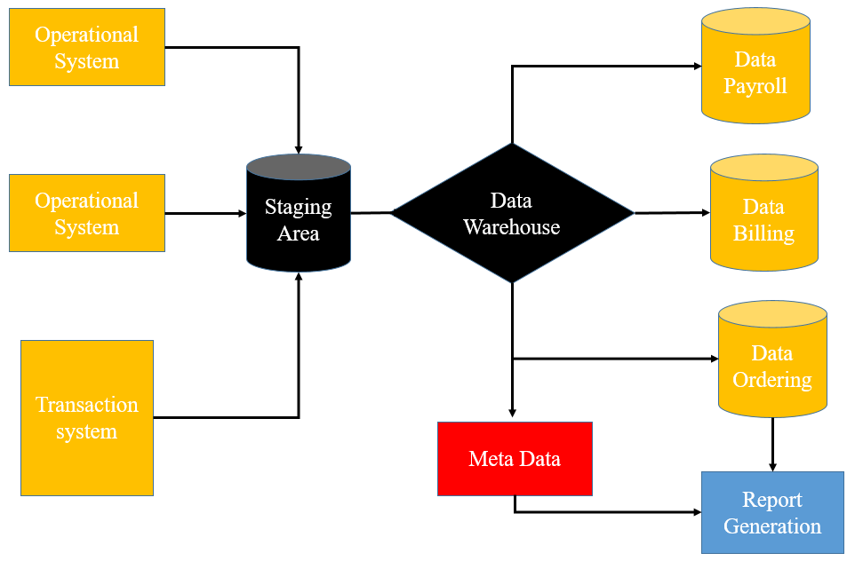

Fig.1. The diagram shows a typical way for warehouse and smart data streams

RESULTS AND DISCUSSION

Data of the PESTRON FOODS stores are from different locations and sales by gender wise that are analyzed by using Knime.
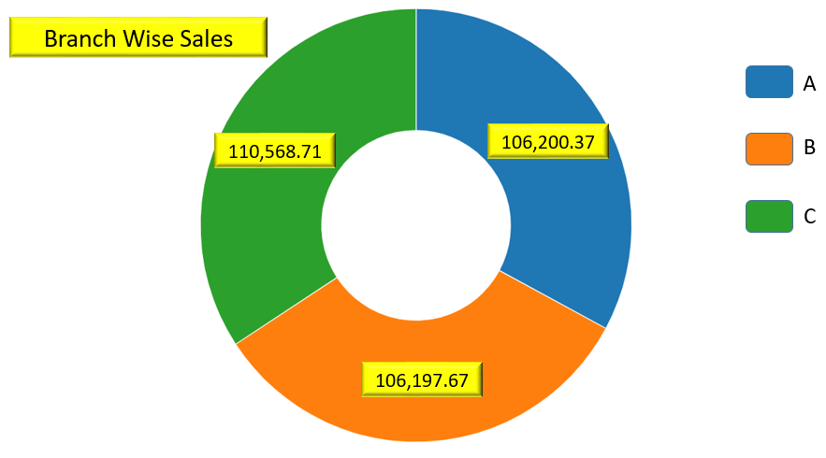
Fig.2. The branch wise sales
Fig. 2. The branch wise sales with different three region.
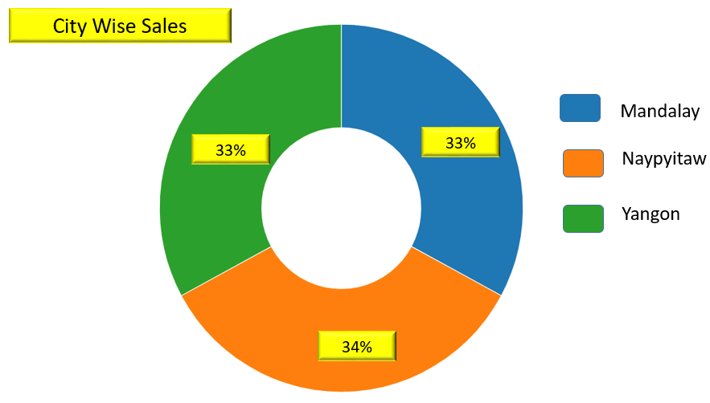
Fig.3.Represents the city wise sales

The city wise sales are analyzed in Fig.3.
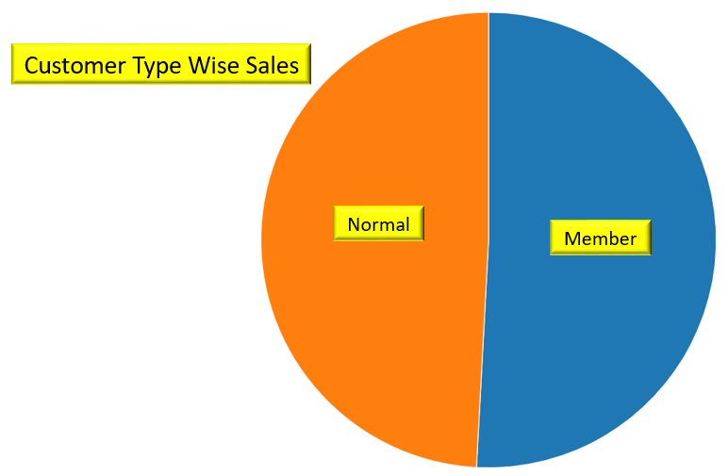
Fig.4. Represents the customer type sales

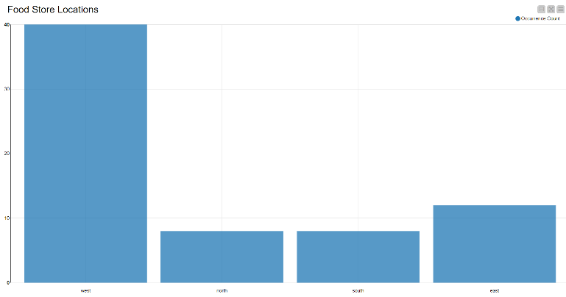

Fig.5. Shows the food store locations

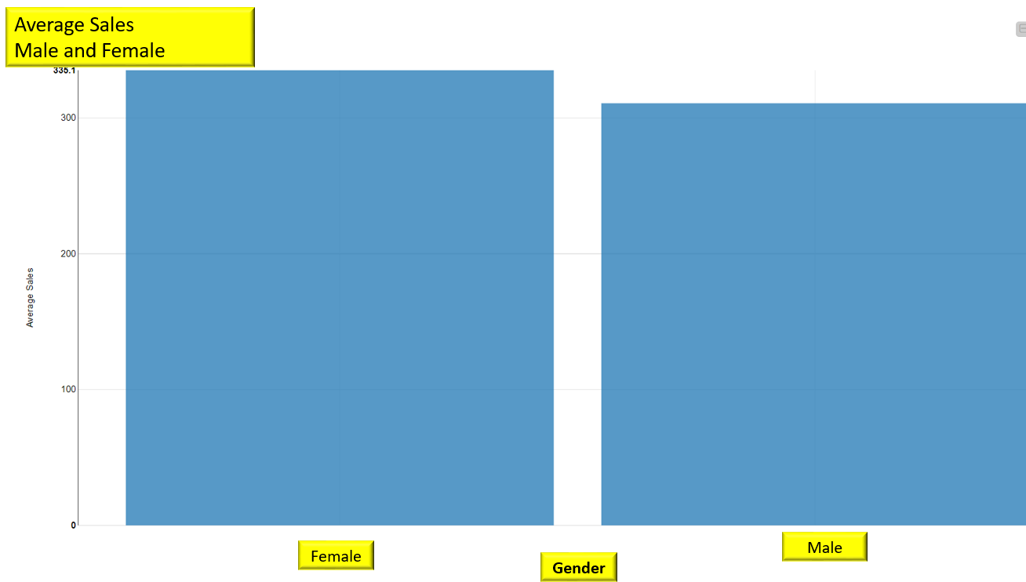

Fig.6.Shows the average sale records

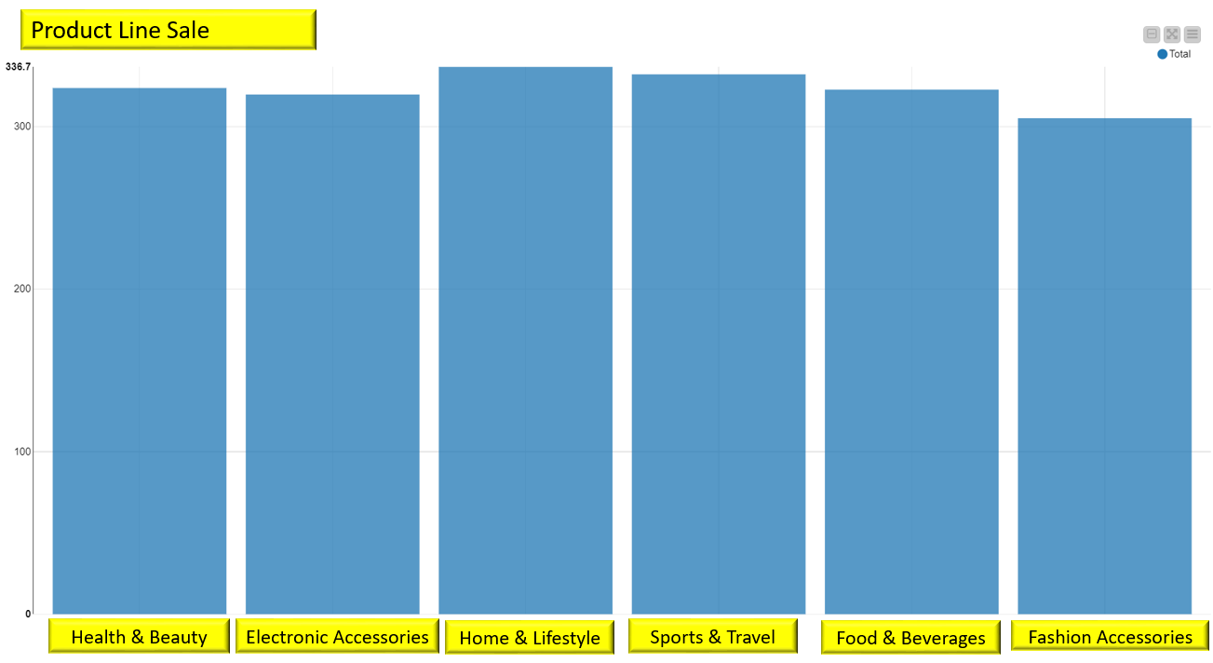
Fig.7. The product line sales
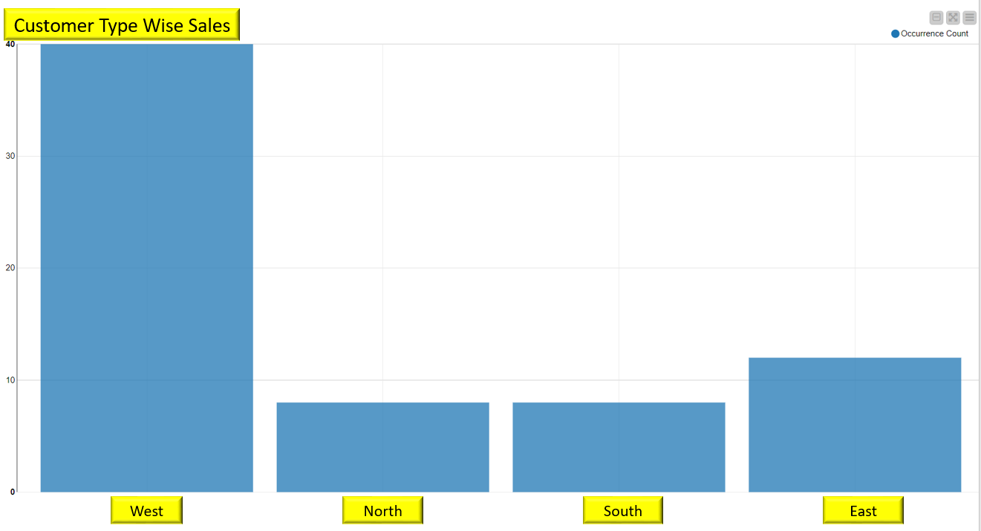

Fig. 8. Customer type wise sales

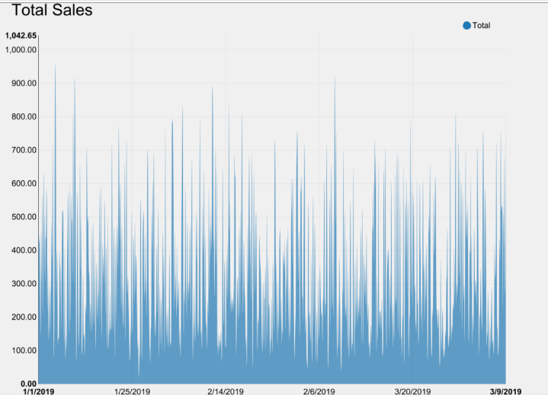
Fig.9. Total sales

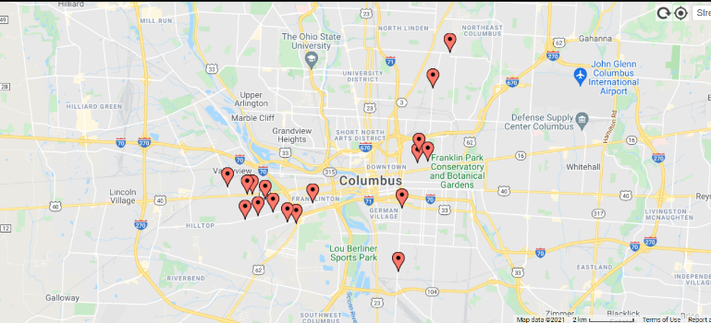
Fig.10. Shows the location

conclusion
This document provides an overview of the principles and the technology used in studies to bridge and combine the difference respectively traditional data warehouses and Big Data. Although Big Data has characteristics that make it difficult to enter the data warehouse, it is good to have them do so. They are not entirely incompatible with conventional data storage and should not be considered differently. Whether research methods reign supreme or the orientation the investigation will take is still unsure, but it will remain that way. It will not be substituted by totally different constructs or systems that were some of the possible outcomes in terms of data warehousing. A symbiotic relationship of the conventional database system and more appropriate solutions are the most likely possibility in Big Data Analytics of Preston food stores (sales by location wise, sales by gender wise), where big data finally provide extra analyses and enhance current investigations. However, a lot of simplification, i.e., failing to fully support the process map and not the Hierarchs, is defective in some of the associated high that have brought about large computational improvements. Although it has an excellent effect and results, over-simplification can have undesirable effects when encounters to standard benchmark are employed.

References

- Dehdouh, K., Bentayeb, F., Boussaid, O., & Kabachi, N. (2015). Using the column oriented NoSQL model for implementing big data warehouses. International Conference on Parallel and Distributed Processing Techniques and Applications (PDPTA’15), 469–475.
- Galvão, J., Leon, A., Costa, C., Santos, M. Y., & López, Ó. P. (2020). Towards Designing Conceptual Data Models for Big Data Warehouses: The Genomics Case. In Lecture Notes in Business Information Processing (Vol. 402, pp. 3–19.
- Vardarlier, P., & Silahtaroglu, G. (2016). Gossip Management at Universities using Big Data Warehouse Model Integrated with a Decision Support System. International Journal of Research in Business and Social Science (2147-4478), 5(1), 1–14.
- Sebaa, A., Chikh, F., Nouicer, A., & Tari, A. K. (2018). Medical Big Data Warehouse: Architecture and System Design, a Case Study: Improving Healthcare Resources Distribution. Journal of Medical Systems, 42(4).
- Dehdouh, K., Boussaid, O., & Bentayeb, F. (2020). Big Data warehouse: Building columnar NoSQL OLAP cubes. International Journal of Decision Support System Technology, 12(1), 1–24.
- Santos, M. Y., Martinho, B., & Costa, C. (2017). Modelling and implementing big data warehouses for decision support. Journal of Management Analytics, 4(2), 111–129.
- Abdelhedi, F., Ait Brahim, A., & Zurfluh, G. (2018). Formalizing the mapping of UML conceptual schemas to column-oriented databases. International Journal of Data Warehousing and Mining, 14(3), 44–68.
- Vieira, A. A. C., Dias, L., Santos, M. Y., Pereira, G. A. B., & Oliveira, J. (2020). Supply chain risk management: An interactive simulation model in a big data context. In Procedia Manufacturing, Vol. 42, pp. 140–145.
- Nogueira, M., Galvão, J., & Santos, M. Y. (2020). A data modelling method for big data warehouses. In Lecture Notes in Business Information Processing, Vol. 381 LNBIP, pp. 85–98.
- Vieira, A. A. C., Dias, L. M. S., Santos, M. Y., Pereira, G. A. B., & Oliveira, J. A. (2019). Simulation of an automotive supply chain using big data. Computers and Industrial Engineering, 137.
- Nimmagadda, S. L., Reiners, T., & Wood, L. C. (2018). On big data-guided upstream business research and its knowledge management. Journal of Business Research, 89, 143–158.
- Sudaryanto; N, Slamet Sudaryanto; B, F. (2018). Desain Model Integrasi Data Terstruktur (Heterogen) untuk Mendukung Analisis Big Data Kesehatan. Seminar Nasional Industri Dan Teknologi (SNIT), Politeknik Negeri Bengkalis, 217–226.
- Barkhordari, M., & Niamanesh, M. (2018). Chabok: a Map-Reduce based method to solve data warehouse problems. Journal of Big Data, 5(1).
- El-Seoud, S. A., El-Sofany, H. F., Abdelfattah, M., & Mohamed, R. (2017). Big data and cloud computing: Trends and challenges. International Journal of Interactive Mobile Technologies, 11(2), 34–52.
- Ramos, C. M. Q., Martins, D. J., Serra, F., Lam, R., Cardoso, P. J. S., Correia, M. B., & Rodrigues, J. M. F. (2017). Framework for a hospitality big data warehouse: The implementation of an efficient hospitality business intelligence system. International Journal of Information Systems in the Service Sector, 9(2), 27–45.
- Vieira, A. A. C., Dias, L. M. S., Santos, M. Y., Pereira, G. A. B., & Oliveira, J. A. (2019). Supply chain hybrid simulation: From Big Data to distributions and approaches comparison. Simulation Modelling Practice and Theory, 97.
- Costa, E., Costa, C., & Santos, M. Y. (2019). Evaluating partitioning and bucketing strategies for Hive-based Big Data Warehousing systems. Journal of Big Data, 6(1).

