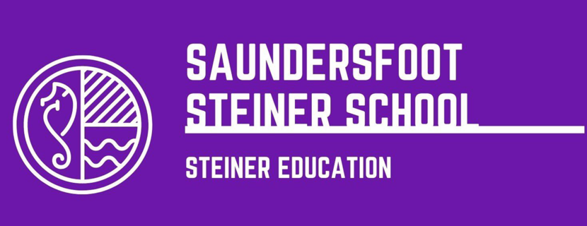

PROSPECTUS

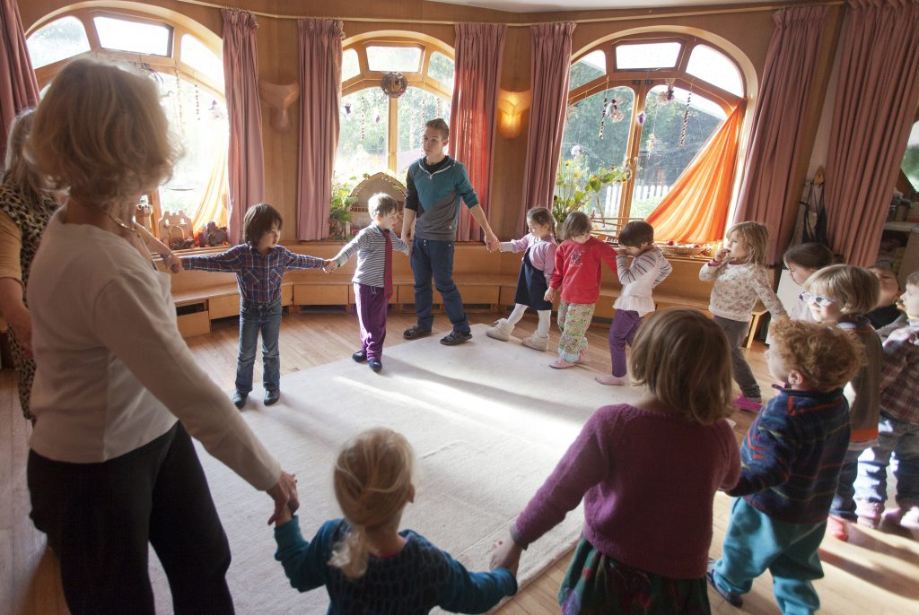
Steiner Waldorf School Fellowship Ltd (2020)

“The need for imagination, a sense of truth and feeling of responsibility – these three forces are the very nerve of education” – Rudolf Steiner (Unkown)

Saundersfoot Steiner School.

Here at Saundersfoot Steiner School we feel it is our duty to produce critical learners, who have the ability to question the world around them and to ensure that pupils can form and develop their own opinion. We are different to the traditional ‘schooling’ system as we see school as a chance to give pupils an opportunity to express themselves artistically and take a creative approach to learning, whereas the national state schools can be seen to create robots rather than develop the learners.
To be successful in today’s society children need to think and learn in a critical manner. As Botta (2012) details that Paulo Freire believes that today’s education system is structured in such a way that it limits pupils from doing this. Therefore, we go against the grain and with the pedagogy of Steiner we create critical independent thinkers.

What is a Steiner School?
Steiner Schools are classed as being fully comprehensive and co educational. We take pupils in an age range of 3 to sometimes eighteen. Our curriculum is based on the ideas of Rudolf Steiner of creating an environment which allows individuals to move through education freely in an unhurried manner. The Steiner Waldorf Schools Fellowship Ltd. (2020) describes how adaptable the Steiner Education is and has been. For more than 80 years Steiner Education has been adapted throughout Europe. We have a reputation for producing well rounded individuals who can cope in an ever changing and demanding world like today.
Steiner Waldorf Schools Fellowship Ltd (2020) states that a Steiner school aims to produce an effective and creative learning environment in which pupils can move through their education at a pace best suited to them. Dr. Ashley (2005) states that Steiner schools offer a full curriculum that aims to covers the full National Curriculum subjects. As a Steiner school we aime to integrate science, art and religion into our lessons as much as possible.
Independent School Parent (2020) details that Steiner schools follow a multi sensory and multi disciplinary approach to education. This aims to have an effect on the whole child and engage them in learning and developing.

Why choose a Steiner School?
Parents should choose our Steiner School for many beneficial reasons for their child. For example, the children will have one teacher from their very first day at age 3 right up to the age of 13 before they decide to take their exams. This would give the children a chance to form relationships and create a sense of belonging within their classroom environment. This pedagogy allows for educators to be respected and listened to as well as giving back respect and patience to the pupils. Dr Ashley (2005) explains how this buildup of a relationship allows for a sense of security within the safe learning environment. The use of the same teacher throughout pupil's educational journey allows for the same routines year after year creating a consistent learning process, as well as the teacher being able to adapt each learning experience to each pupil’s individual learning styles.
10 key reasons why you should choose a Steiner School. (taken from the Steiner Waldorf Schools Fellowship Ltd). (2020)
Creativity – We encourage the use of drawing and painting during our lessons to allow our pupils the opportunity to stretch their artistic skills and express themselves. We also encourage creative arts such as drama, poetry and expressive movement to bring out emotions and expressions, thus allowing the pupils to develop further.
Continuity – We use the same class tutor and teach in block sessions of two hours every morning. In these two hours we focus on our main subject. This could be English, Math’s, History etc. We do this so pupils only need to focus on one subject at time and can delve deeper into the subject.
Activity – We believe that structured movement is an essential part of education. It helps for students to develop physically and release endorphins. Our timetable is very active and consists of activities such as gymnastics, sports, indoor games, this could include activities such as indoor cricket or games circuits. We also produce drama productions of a variety of plays and shows.
The Individual and Society – By producing a family like environment we wish to encourage pupils to have a voice and use their social and emotional skills to develop and connect with others in a variety of ways. We like to produce a family like environment where the pupils can excel and be themselves within our environment. By creating this kind of environment, we hope that the pupils can develop skills such as empathy to use in life and connect with people on spiritual levels.
Inclusion and Differentiation – We guide and educate our pupils in a whole class teaching approach with combined individualized learning plans. We focus on the imagination to engage learners and work with the strengths and weakness of the group as a whole. We like to work to different levels of the class to allow for all pupils to reach their full potential. Older children are often encouraged to help mentor the younger children to create a sense of responsibility.
The Spoken Word – We use drama productions and spoken stories of all cultures to bring them to life and educate our pupils of the world. We often speak of stories and act them out as opposed to reading them. We find doing it this way will keep the pupils more engaged and they are more likely to remember the information if they become a part of acting it out.
Age-appropriate – Our lesson content is linked to the child’s emotional and intellectual development. We feel it is vital that education is not rushed. Formal education begins at age six in our Steiner Schools. Not too soon, not too late. We have to have respect and patience of the developmental journey.
Assessment – We do not assess our pupils in the way that formal educators do with the use of testing’s. We like to observe each pupil’s personal qualities are observed rather than tested. Not measured but monitored closely to see key development milestones as opposed to formal education testing. The traditional use of testing can cause added stress and pressure which is not needed.
Excellence – We teach and expect with the top standards and best efforts from pupils are expected. Teachers and staff are hard work and determined and we expect the same response back from our pupils. Nothing more nothing less.
Context – Steiner Schools are part of the world’s largest group of independent schools in the world. there are currently over 1000 Steiner Schools and over 2000 early years settings across the world. In many European countries Steiner Waldorf education is being introduced in state education as more and more people are seeing the benefits. There are currently 27 Steiner Schools in the UK and Ireland and your child could be attending one of them.
General Information.
The Saundersfoot Steiner School is an alternative school that offers a different style of education for pupils aged between 3 and 16. The school offers a Steiner based curriculum that allows learners to flourish and develop to their best of abilities. As a school we aim to put a lot of emphasis on a creative approach to learning and creating critical thinkers.
The Steiner based curriculum offers a chance for all pupils to develop a love of learning and learn at their own development pace. Steiner Waldorf Schools Fellowship Ltd (2020) state that this type of education is a tried and tested method and is now becoming part of state education in many European Countries.
The Steiner Waldorf Schools Fellowships (2020) details how our Steiner education works for all children whatever their academic background or class as well as ethnicity or religion. We take pride in understanding the different phases of development and work to suit the child’s current development stage. We want for children to gain a love for learning and therefore, to take a genuine interest in their learning. We work with imagination constantly throughout our curriculum and see it as a vital part of learning.

Our pedagogy is a tried and tested method which can be seen around Europe as it is being introduced into state schools. As detailed by the Steiner Waldorf Schools Fellowship Ltd. (2020)

Steiner education aims
The Steiner Waldorf Schools Fellowship LTD. (2011) details the core aims of Steiner education for our learners. We aim to set the standards for future learning and providing an opportunity for equality for all. We aim to lay a secure foundation for any future learning. Through our time with your children we will help them to develop with their social and emotional skills to be able to better use them in their daily life.
We aim to create freedom through thinking for our pupils so they can go on to excel in life and take advantage of any given opportunity. Oberski (2005) details how we, as a Steiner school, aim to focus on the imagination to create healthy thinkers later on in life. This allows for students to become well rounded individuals.
Edmunds (2004) describes Steiner educations prime objective is to guide children onto a creative and critical path to ensure that as adults they will bring this knowledge to their own life questions and scenarios to serve the function of the freedom of thinking and practice these skills they learn in Steiner Schools in the greater adult world.
We want to create enthusiastic pupils who are ready to learn and motivated to questions everything and be sure of who they are. We do not want to rush the inner development process of each pupils and understand that every pupil is different and develop at different speeds. As Edmunds (2004) describes how animals rush their development to an early end however, as humans we are restricted to a time process for our physical development, so as we move through the stages of physical development, we can take time to educate the sole and our inner spirit. Therefore, at out Steiner School we move at the pace of each child’s development process and take caution in allowing it to flow at its own unique pace.
How we support our pupils.
Steiner education is designed to support the child as a whole. This includes their physical and mental well-being as well as supporting them academically. Zepeda (2018) states how Steiner education focuses on education the ‘head, hands and heart.’ Here at Saundersfoot Steiner School that is exactly what we achieve. We do this by being there for about students whenever needed and having the same teacher allows for emotional bonds to be formed between pupil and teacher. Which in turn creates a better and safer environment for pupils to share and speak their minds. This allows pupils to have a voice and feel their own responsibility within their educational journey.
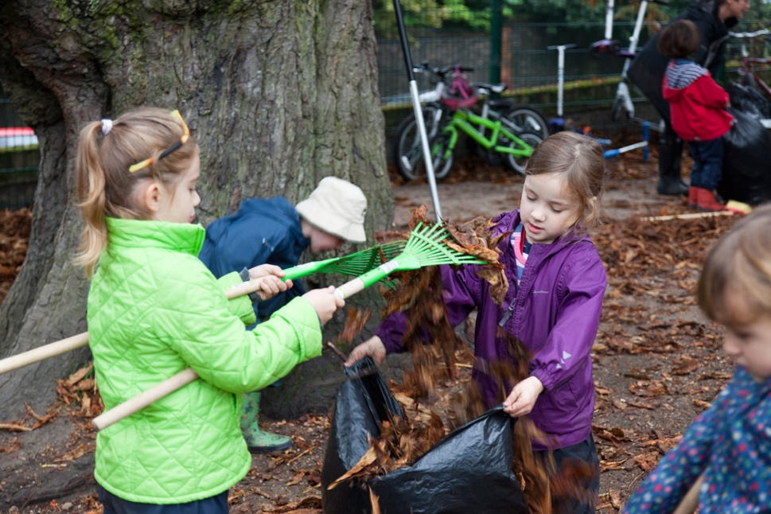
Our educators are in place to help pupils with their social, emotional, physical and cognitive developments. We are here to simply assist as opposed to forcing learning. We focus on more than the intellectual functioning of the child. It is important to value the child as a whole and not based primarily on their intelligence as Kim (2011) details when discussing the Steiner’s education system.
Steiner Waldorf Schools Fellowship (2020)
Newcombe (2020) describes how the philosophy behind our Steiner curriculum helps children to develop awareness and empathy for other children as well as a sense of their purpose and meaning in the world. We will support all our pupils through their educational journey, constantly developing and expanding their knowledge of the world around them.
Health and Well Being benefits.
Our Steiner School aims to creates socially confident individuals. Through our alternative curriculum with the emphasis on a more social environment than the traditional classroom. As a school community we aim to help pupils become thoughtful and unique students who can advocate themselves appropriately throughout life. Due to students having a level of comfort in the classroom environment it allows them to open up and feel a sense of trust during their schooling journey. Therefore, ensuring that pupils can disclose any concern they may have to their class teacher.
We are lucky enough to be located in a perfect position with our school in the heart of a woodland and only a 10 minute walk to the beaches of Saundersfoot. We take full advantage of these outdoor spaces and make the most of them no matter the weather. Teaching in these environments allows our children to engage fully with their surroundings. As Dewar (2019) states that outdoor experiences can be ‘exhilarating, fun and inspirational’. We hope that this gives the pupils the motivation to explore these spaces and be encouraged to learn within them.

Our class system.
Our pupils are divided into 3 groups within the whole school. The younger children are in the kindergarten where ages range from 3 to 6 years old. We like to have mixed ages in each individual kindergarten class. We do this so the older children can help and set an example for the younger children in the class. It also gives the older children a sense of responsibility as they help the class teacher and guide the younger pupils.
The lower part of the school has an age range of 6 to 14 and focus on artistic expression and the core subjects.
Finally, the upper part of the school has an age range of 14 to 16. These students focus on the main core lessons and creating critical thinkers. They are able to sit GCSE and A Levels if they wish to do so. These can be taught along side the Steiner curriculum.
Steiner Curriculum; What we teach.
Kindergarten – As detailed by the Steiner Waldorf Schools Fellowship Ltd (2020) we focus on developing artistic students who have their own identity and can think for themselves. This would allow pupils to flourish through life as they go on to find themselves more as they move through life. We have a big emphasis on developing physical coordination as well as social and cognitive skills. This would mean allowing pupils the chance to develop to the best of their ability and allow for a more positive and healthy life style.
Pre literacy skills and pre numeracy skills are introduced at kindergarten level through songs and dance as an introduction for more formal literacy and numeracy in lower skills. For more scientific skills the pupils can explore the natural world around them in our beautiful setting. Dewar (2019) details how by exploring the outdoor settings and having lessons spent outside children engage better with the teacher and have been seen to interact more in later life in outdoor settings instead of leading sedentary life styles.
Lower – when students move to lower school, they will meet their class teacher who they will have for the next 8 years. Having one teacher allows for relationships to be formed between student and teacher which has many benefits. Such as trusting the teacher more means the pupils would be more likely to open up to the teacher and feel like they are able to ask for help if they need it. Rimm-Kaufman(2010) states that it can also improve engagement within the classroom which goes on to effect attainment.
Block teaching of core subjects is carried out in the lower school with core subjects such as English, Maths, History, Geography, Physics, Chemistry and Biology for the older students and farming, gardening and building projects for the younger students to develop their sense and experience of the world.
Upper – In the upper part of the school the most formal version of education takes place. We value questions, discussion and criticism to encourage the enquiring mind. We want to get the most out of our learners and encourage them to be critical and think crucially of the world around them and be passionate in discussion and debates. Pupils are still encouraged to go outdoors and participate in outdoor learning as Engermann et al (2019) states that individuals who have grown up around less vegetation are at a 30% higher chance of stress related illnesses than those who have grown up around and experience the green outdoors.
Also offered in the upper section in the school are GCSE and A Levels offered along side the Steiner Curriculum. As the Steiner Waldorf Schools Fellowship (2020) states that Steiner students consistently gain results often higher than the national government average. This could be a result of our students being more self motivated to engage with a passion for learning and expanding their knowledge.
Students who opt to take additional languages often visit that chosen country in the upper part of school. For example, students who choose to study French as a foreign language will be given the opportunity to travel to France to expand and practice their vocabulary.
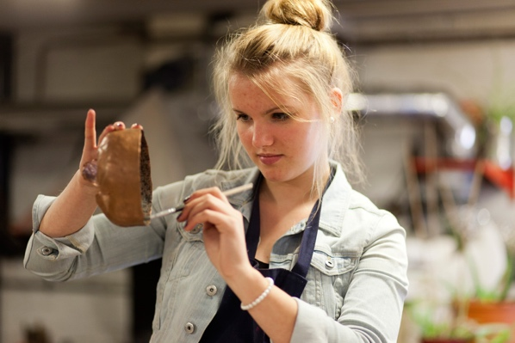
Pedagogy: How we teach and why we teach this way.
Kindergarten – for the younger children we focus on creating artistic individuals. We do this through the use of free play, songs, dance and often painting and crafts. This allows each individual learner to express themselves and use their imagination to create different play scenarios or pictures and stories. As De Haas (2014) details everything we think and do is all based on imagination. Our dreams and theories are all influenced by our imagination.
Steiner Waldorf Schools Fellowship (2020)
There are also many physical benefits to this method of teaching. The children will always be active and therefore it can have great benefits on their gross and fine motor skills allowing for better pen control and better muscle control in general.
Singing and dancing and preforming in drama productions can also improve children’s confidence which would allow them to go through life confidently and be sure of the path they are taking in life. As Cicek et al (2015) states the use of drama can increase a student’s self confidence and problem solving as they learn to love and believe in themselves more.
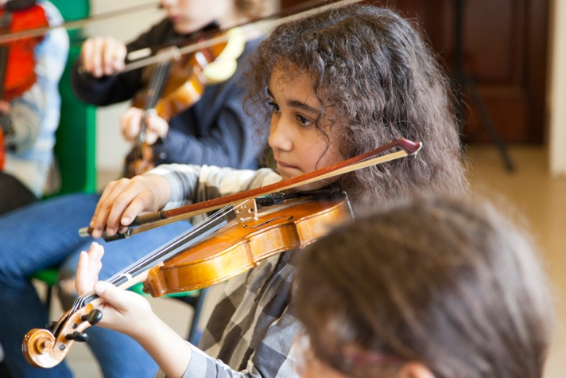
Lower – in the lower part of the school the pupils will be introduced to tenor one class teacher, who, as mentioned before will stay with the pupils for approximately the next 8 years to encourage and develop good learning habits. Children will begin to learn numerical songs by heart so when they begin their more formal number sums, they are able to recall the songs.
We also encourage our lower school children to play an instrument, such as the recorder to encourage their musical talents. The use of writing with pictures also encourages pupils to complete sentences before they begin to write them fully. They are able to draw what they are thinking as opposed to writing it, this allows them to begin to express themselves on paper.
Steiner Waldorf Schools Fellowship (2020)
The Saundersfoot Steiner School likes to use Rhymes and stories to keep the pupils engaged in the curriculum. In the lower school we like to gently bring in easy sums to prepare pupils for the next step in their nummary education and expand on the pupils spoken and vocabulary skills. We like to encourage the pupils to speak freely and publicly throughout the school to ensure that they would be comfortable doing it throughout their life outside of education.
Upper - Steiner School pupils produce consistent results in exam based subjects according to the Steiner Waldorf Schools Fellowships Ltd (2020). The exams are taught not to be the be all and end all of education. As the Independent School Parent (2020) details. Steiner focuses more on building pupil’s confidence as critical learners. Pupils are not forced to participate in exams and are primarily encouraged to be independent leaners.
We do not have any traditional text books in our school as we wish for the pupils to make them themselves. We also use a chalk and a black board instead of an interactive white board to keep the children grounded and not overtaken by technology.
We also believe it is best if the school is ran by a democracy of teachers as opposed to one head teacher. This allows for all teachers to have a say in the running of the school. Each child’s needs are discussed in turn when the teachers meet once a week to discuss the running of the school and any other matters that might arise. By running the school this way we can create a healthy relationship within the teaching community. This ensures that all staff feel valued and respected when we have to make arrangements and decisions that could affect them and their students.

Assessments
Here at the Saundersfoot Steiner School we want out students to enjoy education and not feel pressured into doing exams or any other kind of assessments. We feel it is important for the students to develop at their own pace and not to compare themselves to other students or worry about meeting certain grades as this can be added pressure.
We want to create a healthy and positive atmosphere where students can be themselves and flourish in the learning environment and grow as an individual and critical thinker.
Pupils in the upper school will be required to sit some exams and complete coursework if they choose to take the national curriculum GCSEs. However, we block teach our subjects and students sit the exam after each block and can therefore study one subject at a time as opposed to eight or more and sitting exams one after another.
School day
Our school day usually begin with group sessions of either singing, dancing or exercise. We do this to improve children’s physical and mental fitness. Elmagn (2016) states that regular physical activity can play a vital role in stress and anxiety relief and therefore would create positive, energetic and motivated students. There are also many physical benefits to group exercise in the morning as well as emotional benefits such as stronger muscle and bone strength which would benefit the pupils physical developments.
After this group sessions children will split into their usual classes where they will focus on their main lesson. As mentioned above they will focus on this subject for a number of weeks in what is known as a block teaching session. For GCSE and A Level Students exams can be sat after this block and then move onto the next. This allows for the exam based subjects to be spread out across the years as opposed to being sat in the space of a month like state education, which can be rather stressful for our students.
Break times are as follows:
Morning break
Lower school 10:45 – 11:15
Upper school 10:50 – 11:15
Lunch break
Lower school 12:45-1:35
Upper school 12:55-1:45
Afternoon break
Lower school 2:30-2:50
The upper school pupils often do not have a break time but if needed are free to take it at teacher discretion. A lot of our older pupils like to take the time to focus more on their chosen subjects as they are able to concentrate for longer periods of time.

Term Costs
Our term costs are to cover the expenses of running our school and we are a not for profit school. In the kindergarten fees start at £1000 for Kindergarten children and then will rise to £2500 for lower school children. When pupils move into the upper part of the school, specialist teachers are required and for this the term costs will rise to £3500 per term, per pupil. This is the average cost for a Steiner School as detailed by Curtis (2005).
We also offer same family discounts. Therefore, if there are multiple children from the same family attending the school, we can offer a discounted price for the younger children.

School Security.
It is vital that our pupils are kept safe at all times. Therefore, we have a system in place to ensure the safety of all our staff and pupils. Any visitors will be asked to sign in and out using the front desk and a pass will be made for them to have on them and visible at all times. This is also vital in the case of a fire or the need to evacuate the school so everyone inside can be accounted for after evacuation should it be needed.
Pupil registers will also be taken at the start of every main lesson to ensure that everyone is accounted for and any absences can be chased up immediately.
We aim to have a ratio of 1 adult to every 10 students to ensure that there are always enough adults on hand to help the children and monitor their safety.
We will also have a designated safe guarding officer that any pupil or staff member can disclose any matters safely and quickly to the individual to ensure they are acted up efficiently.

Safeguarding Statement.
The Saundersfoot Steiner School strives to create a safe environment. We have a variety of policies in place to promote and protect the welfare of our pupils. All staff that come in to contact with pupils have a responsibility to safeguard all pupils regardless of their age, academic performance ethnicity, disability or beliefs. We take our responsibility to the child extremely seriously and will follow all safeguarding policies.
For more information on our safeguarding policies please see our safeguarding section on our website. If any additional information is needed, please feel free to make an enquiry to our reception. This can be done via email or phone with the contact information available at the end of this document.

Potential extra costs.
We like to make the most of all opportunities however, there can often be some additional costs to these opportunities. For example, school’s trips usually require an additional cost to parents or carers and is often require up front or using a payment plan. These trips could include local field trips to places in the locality that could benefit students with their current subject in school. Or they could be further away and be abroad. For instance, each year our GCSE French class will take a trip to France to have the chance to use their French vocabulary. In previous years with enough interest we like to take students on more adventurous trips. This could include a few days away at an activity camp, such as Morfa Bay. Where students can work in teams and individually to complete activities.
These trips hugely benefit the pupils as they are able to put to practice what they have been learning in school. It is also good for their cognitive, social, physical and emotional well being as they learn to be away from family members, mix with other members of the public and put their skills to use in the wider world. We wish for all our students to be able to take advantage of these opportunities and will do what we can as a school to make it possible for all to use. This can be done through the use of payment plans and inclusion grants we have available to ensure that all pupils can take part no matter what their circumstances are.
We like to keep any extra costs as small as possible to ensure that all pupils can participate in the activities. Throughout the year pupils can fund raise and this money can be set aside in a kitty and used towards school trips or any supplied that are needed for the pupils education.
Pupil testimony –
Pupil A – ‘I enjoy being at this school. I am currently studying in year 7. I feel safe and secure in this school. The teachers listen to my concerns and answer my questions. I am encouraged to work well and rewarded and praised for my motivation’
Pupil B – ‘I like being able to study more creative subjects rather than the traditional subjects of geography. I feel like I can express myself more and be comfortable in my educational journey.’

Parent testimony -
Parent A – ‘My children have grown very curious and critical of the world around them. I feel very confident that my children are receiving an influential education that will set them up for life. My two children are in the lower and the upper part of the school.’
Parent B – ‘Communication from teachers is clear and effective. My child is valued and respected.’
Summary
Overall, here at the Saundersfoot Steiner School, we want to provide our pupils with the appropriate skills to form and develop their own opinions and be able to think critically of their surrounding world.
We feel it is vital to ensure that the opportunity is given for children to access an alternative education and be given the chance to develop at their own pace. Many writers have argued that our learner based interest approach to education is more effective than the traditional teacher led education as Armstrong (2012) details.
Many theorists such as Paulo Freire have spoken publicly about the benefits of this type of alternative education can provide and we are determined as a school to give pupils the opportunity to make the most of these benefits. Such as better social skills, more aware of their surrounding and interests as well as being a well rounded critical thinker.
We really do believe that your children will benefit from our holistic, child centered approach to education.
Contact information
For any additional information not listed above please feel free to contact our reception using the following:
Email us at -
Enquiries@saundersfootsteinerschool.ac.uk
Call us on –
01834 800000
Or feel free to pop into the reception to arrange a suitable time to meet with the appropriate staff members to discuss any concerns.

Reference List.
Armstrong, J.S. (2011) Natural Learning in Higher Education. University of Pennsylvania. Scholarly Commons. Available at https://faculty.wharton.upenn.edu/wp-content/uploads/2014/09/Natural-Learning-in-Higher-Education_2.pdf (Accessed on 10th October 2020)
Botta, J. D (2012) According to Paulo Freire, what purpose does education as it is structured today serve? eNotes Editorial. Available at https://www.enotes.com/homework-help/according-to-paulo-freire-what-purpose-does-354759 (Accessed on 8th October 2020)
Curtis, P. (2005) Explainer: Steiner Schools. Education Correspondent. The Guardian. Available at https://www.theguardian.com/education/2005/jun/30/schools.uk1 (Accessed on 8th October 2020)
De Haas, T. (2014) The Importance of Imagination. About my brain institute. Available at https://blog.aboutmybrain.com/the-importance-of-imagination (Accessed on 10th October 2020)
Steiner Waldorf Schools Fellowship Ltd (2020). Steiner Waldorf Education. Available at https://www.steinerwaldorf.org/steiner-education/what-is-steiner-education/(Accessed on 8th October 2020)
Dewar, G. PH.D (2019) Outdoor learning and green time. Parental Science. Available at https://www.parentingscience.com/outdoor-learning.html#:~:text=Brief%20nature%20walks%20can%20reduce,more%20motivated%20and%20self%2Ddirected.&text=Lessons%20held%20outdoors%20appear%20to,after%20they%20come%20back%20inside. (Accessed on 9th October 2020)
Dr Ashley, M. (2005) Can one teacher know enough to teach year six everything? University of Glamorgan. University of the West if England, Bristol. Available at http://www.ecswe.eu/wren/documents/Can_One_Teacher_Know.pdf (Accessed on 8th October 2020)
Edmunds, F. (2004) An Introduction to Steiner Education. The Waldorf School. Sophia Books. Forest Row.
Newcombe, R. (2020) The Steiner Education Approach. Early Childhood Education. Available at http://www.earlychildhoodeducation.co.uk/steiner-education-approach.html (Accessed on 9th October 2020)
Zepeda, C. (2018) Academic and Social Effects of Waldorf Education on Elementary School Students. California State University. Monterey Bay. Available at https://digitalcommons.csumb.edu/cgi/viewcontent.cgi?article=1276&context=caps_thes_all (Accessed on 9th October 2020)

