ACBA 6004 ASSESSMENT 1
ADVANced construction& Civil engineering technology
Lonye Browne (2114209)
UWTSD

Table of Contents
1. Introduction 2
2. Description of the Case Study Building 2
2.1 The Social Impact/Value of The Edge Hotel 7
2.2 The Environmental Impact of The Edge Hotel 8
2.3 The Economic Impact of The Edge Hotel 8
3. Investigation of the Case Study Building 8
3.1 Structural Approach 8
3.1 Cooling Strategies 10
3.2 Lighting Strategies 11
3.3 Materials Used 12
4. Assessment of the Case Study Building 12
4.1 Regulations 12
4.2 Good Attributes of the Case Study Building 14
4.3 Improvements 14
- Operational energy use 14
- Embodied energy/carbon 14
- Cost of Construction 15
- Cost of operations and maintenance 15
- End-of-life reuse/ recycling 15
- Other improvements 15
4.4 Offsite Manufacture 17
5. Conclusion 17
6. Reference List 19

Introduction
This paper will discuss The Edge Hotel, St. Vincent and the Grenadines including its purpose, usage, and other important architectural facts along with an assessment of the building’s impact socially, environmentally, and financially. It will include a description of the key principles used in the construction and the structural approach of the building with the aid of photos. Finally, there will be an assessment of the building outlining changes that could improve it to meet the current building regulations.

Description of the Case Study Building
The Edge Hotel
The Edge Hotel is a boutique hotel located in Level Gardens, Kingstown, St. Vincent and the Grenadines, West Indies with the coordinates 13.158396485165554, -61.22503442600146. The hotel is owned and was designed and constructed by structural engineer, Ashwa Stewart. The building is designed like a typical Caribbean home. Ashwa describes the architectural style of the building as Colonial Georgian as it has Caribbean touches such as porches, and it is uniquely built; no two houses are the same. The Edge was constructed in 2004 and operates as a hotel for locals and foreigners seeking temporary lodging or accommodation in the capital of St. Vincent. The Edge Hotel consists of four floors and has an internal floor area of 5,500 ft, an external area of 6,000 ft, and an external facade area (front only) of 1,200ft.
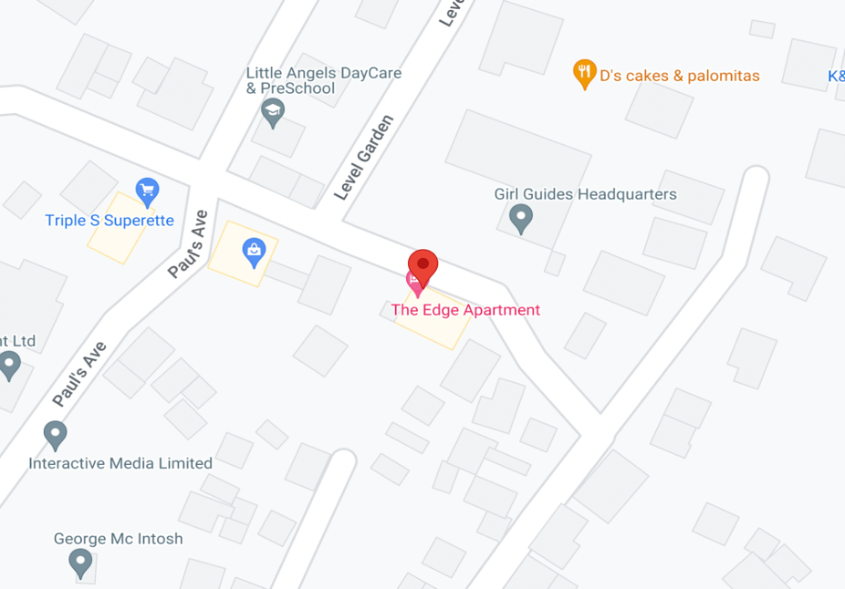
Figure 1 shows a dropped pin at The Edge Hotel (Google Maps, 2024)

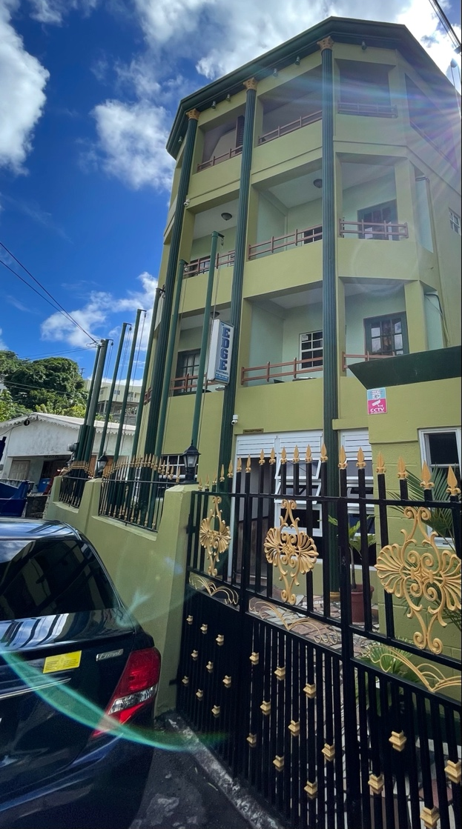
Figure 2 shows The Edge Hotel (Author, 2024)

Within its four floors, The Edge Hotel has nine (9) studio rooms available for accommodation, an office space (a converted accommodation room), a lobby, a powder room (for guests and workers), and a linen closet. The accommodation rooms are not numbered or lettered but are rather named after the Grenadine islands which make up the archipelago of St. Vincent and the Grenadines, adding to the character and homeliness of the hotel. The self-contained studio rooms consist of a kitchenette (fridge, microwave, kettle, washing up space), eating area, shower, toilet, closet, mirror, desk area, television, and bed(s). There is also a small security booth in the same yard adjacent to the building.

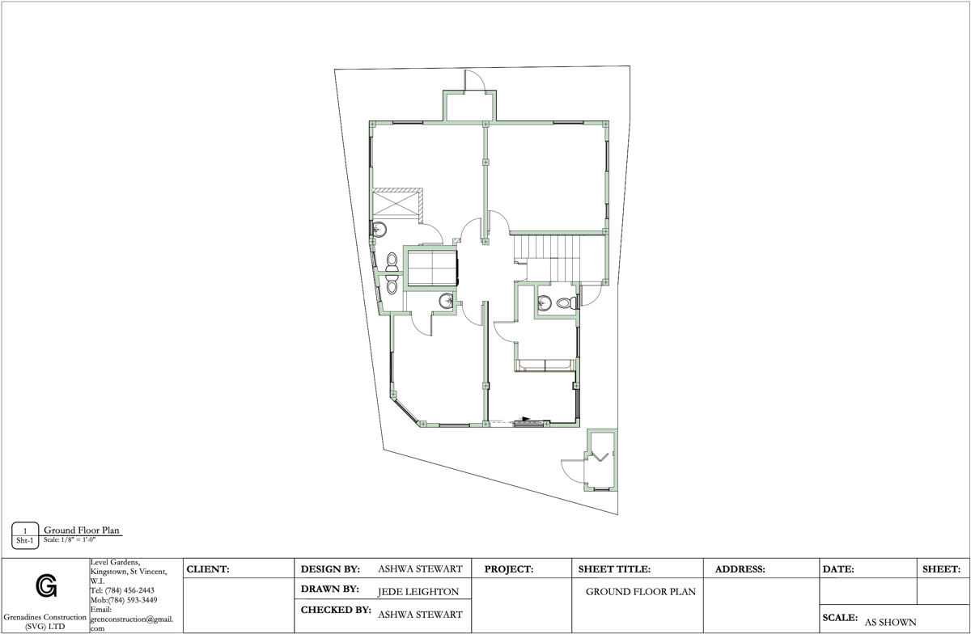
Figure 3 shows the ground-floor plan of The Edge Hotel (Grenadines Construction, 2023)

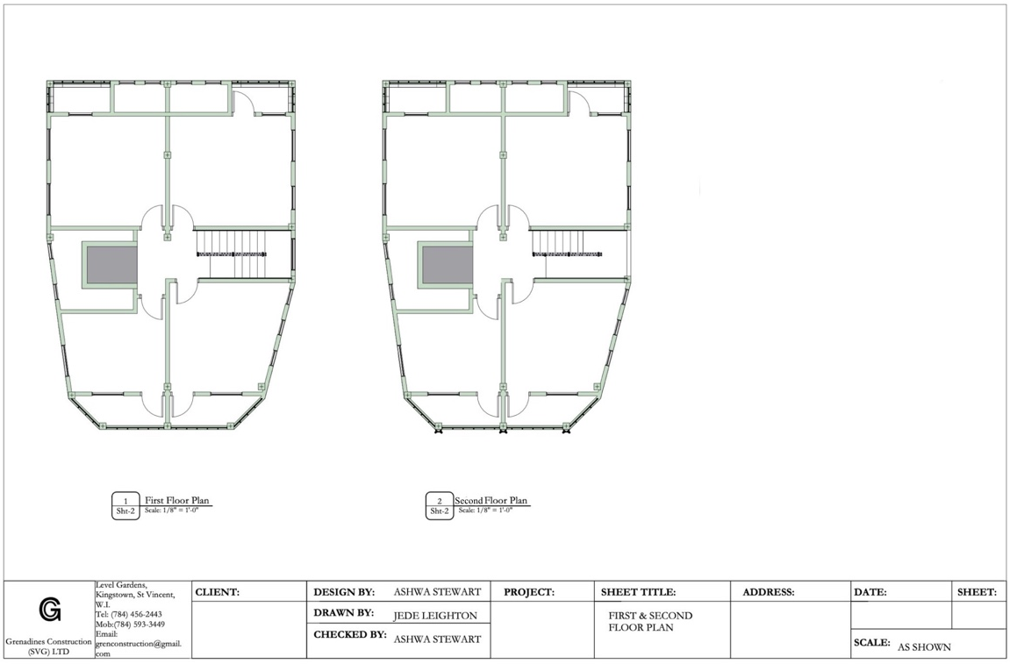
Figure 4 shows the first and second-floor plans of The Edge Hotel (Grenadines Construction, 2023)
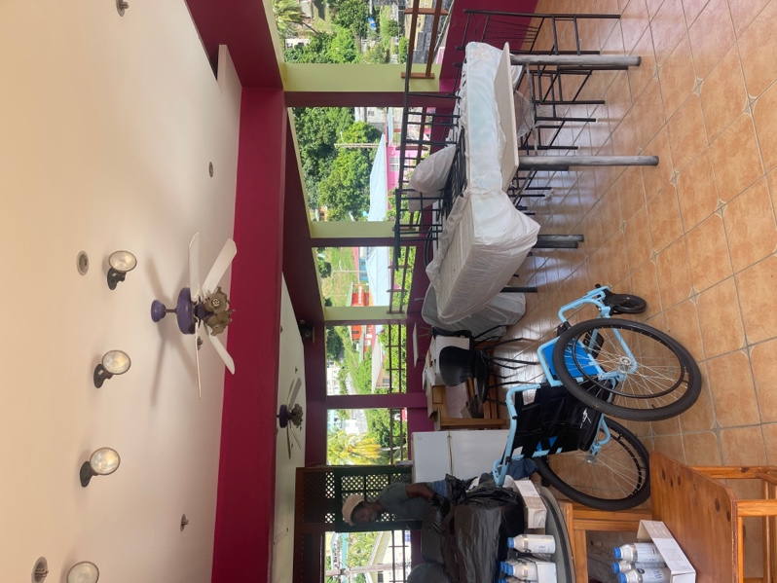
Figure 5 shows the third floor, the disused space. (Author, 2024)

On the ground floor are the lobby, powder room, linen closet, Palm Island (the converted office, and Mustique (double room). The first floor has Canouan (double room), Mayreau (double room), Petite Martinique (double room), and Young Island (single room). The second floor has rooms Bequia (double room), Carriacou (double room), Union Island (double room), and Petite St. Vincent (single room). Each hotel room is decorated with a clock in the shape of the island it is named after, along with a drawing and a synopsis of said island. The third floor is an open area with a restaurant, bar, and gym which are disused.
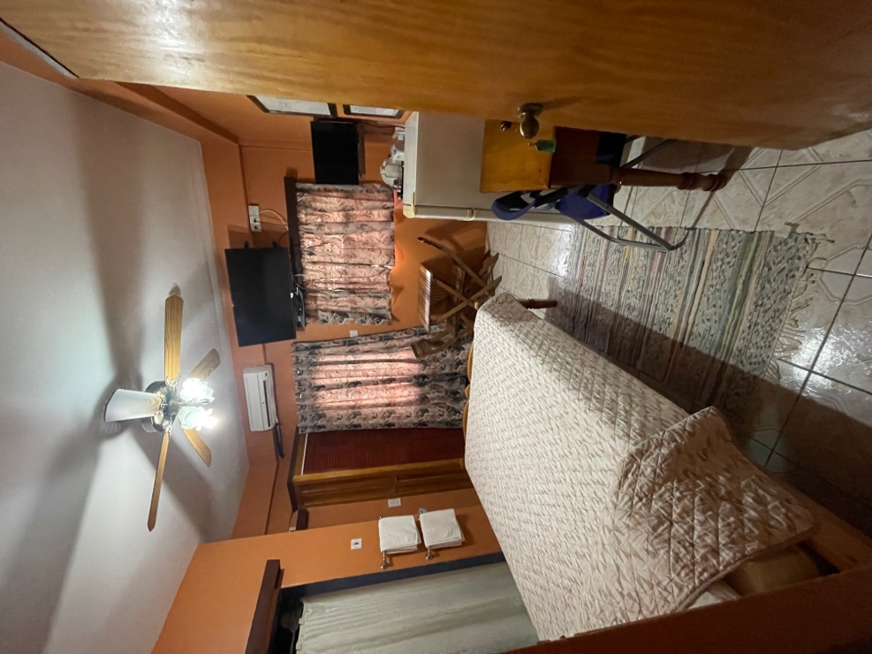
Figure 6 shows the room ‘Young Island’. (Author, 2024)

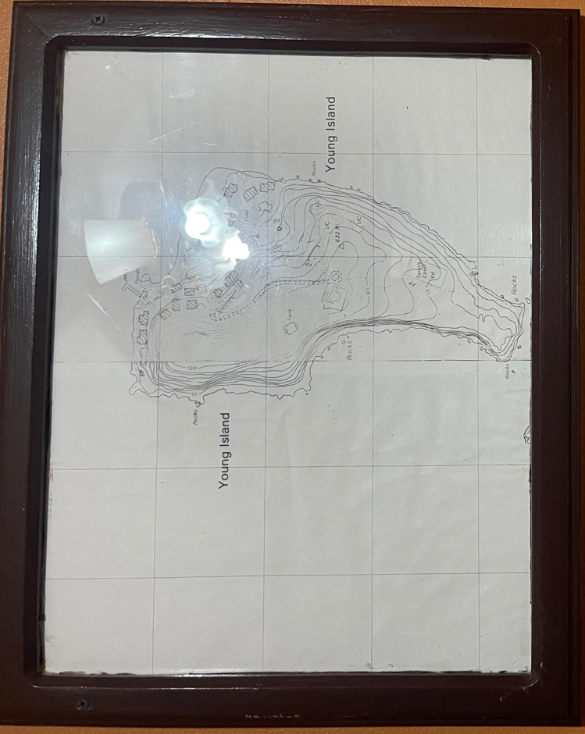
Figure 7 shows a framed map of Young Island (hung in the room). (Author, 2024)

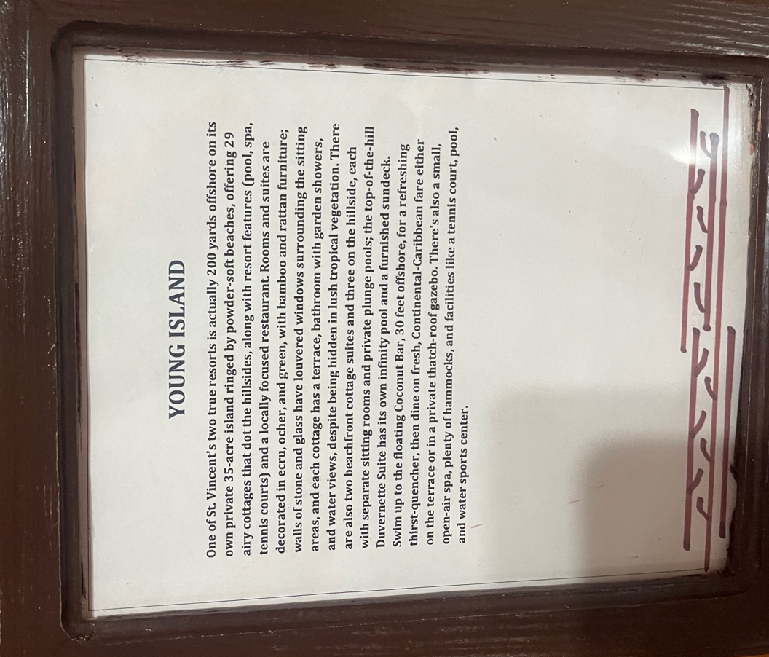
Figure 8 shows a framed synopsis of Young Island (hung in the room). (Author, 2024)

2.1 The Social Impact/Value of The Edge Hotel
The Edge is located a convenient 5-minute walk from the capital of St. Vincent, Kingstown. The Edge welcomes both foreign and local customers and experiences its busiest times during Easter, Christmas, and Carnival (June – July) Seasons. During the three peak seasons, foreigners, persons living in the Grenadines, and persons living far leeward or windward book the hotel so that they are closer to events and have a smaller distance to travel to and from the activities. During the off-peak, the hotel is occupied by patients of the orthopaedic practice nearby, who may stay overnight as the practice does not have inpatient facilities. The hotel is also booked by other persons from the Caribbean region who wish to attend the World Pediatric Project (WPP) for medical care, hosted by the Milton Cato Memorial Hospital (MCMH) in Kingstown St. Vincent and the Grenadines.

2.2 The Environmental Impact of The Edge Hotel
The past use of the land that the hotel currently sits on was a two-bedroom house, which is a massive increase in waste that the building produces due to a larger number of people in the same space. It also means that there is a higher energy and water consumption. The hotel is also located in a residential area but has since grown the commerciality, thus increasing the actual traffic in Level Gardens, meaning an increase in greenhouse gas emissions from vehicles. To be easy on the eyes, and somewhat blend into the environment, the structure is painted in green.

2.3 The Economic Impact of The Edge Hotel
When the hotel was built, Level Gardens was described as more of a suburban area, a residential area on the outskirts of a city. However, since the construction of the hotel, it has increased the commerciality of the area. The hotel has influenced the construction and operation of a warehouse, a lawyer’s office, and a doctor’s practice in the neighbourhood. The Edge has also influenced the price of land in Level Gardens, when the hotel was built the land was purchased for $15 XCD per square foot, today the land is sold at $50 XCD per square foot. The Edge Hotel also offers a lower rate than any other hotel within or close to Kingstown at $60 USD per night, and there is also a local rate for persons who present their Vincentian ID. The Edge Hotel contributes to the Gross Domestic Product (GDP) of St. Vincent and the Grenadines at an estimated gross of $16, 200 USD per month assuming full occupancy. The Edge also created jobs in 2004 during its construction, as well as creating jobs now during the operation of the hotel.

Investigation of the Case Study Building
The hotel was first being constructed as an extension of the two-bedroom house that occupied the land. Months into the construction, it was realized that the foundation was not solid and that the different members of the two-bedroom structure were just clad together using mortar. This observation led to the demolition of the entire structure, and a fresh start for The Edge Hotel.

3.1 Structural Approach
The plot of land was excavated six feet below ground and backfilled with stone, to install/pour the wide strip steel reinforced foundation. Steel-reinforced wide strip foundation was chosen by the structural engineer, as he thought it best to support the 4-storey building given the soil conditions. The location of the hotel is near a river where there is soft, clay-like soil, Construction Civil Tips (2010) says that wide strip foundations are best utilized in such conditions to spread the load of the building and maintain stability. Concrete is good in compression; therefore the steel reinforcement is placed in the foundation to increase its tensile strength (Reinforcement Products Online, 2022).

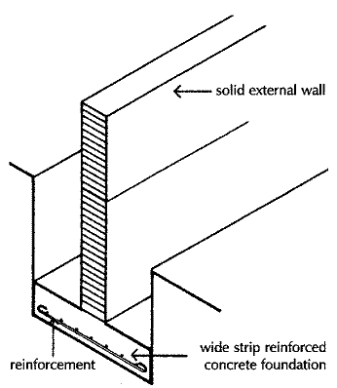
Figure 9 shows a wide strip foundation with steel reinforcement. (Civil Construction Tips, 2010)

St. Vincent and the Grenadines is subject to hurricanes and earthquakes and recently has had some tornado activity on the windward side, these factors influence the way structures are built as they must resist those external forces. Buildings are constructed using reinforced concrete, rather than timber frame.

The external and most internal walls of The Edge Hotel are six inches thick, while other internal walls such as the bathroom are four inches thick. All the walls are reinforced concrete and are built with concrete blocks with a vertical reinforcement of half-inch steel on the centres at twenty-four inches high, and every block pocket that has the reinforcement through it is filled with concrete. After a height of twenty-four inches is reached, lateral steel is attached to the vertical reinforcement using lacing wire and is embedded with mortar. A block structure by itself can crumble on its weight, especially in larger/taller structures so it is vertically reinforced to aid in resisting downward loads (increase its compressive strength). The horizontal reinforcement increases its tensile strength and combats external forces caused by wind or earthquakes. These two combined make the structure more durable and less susceptible to cracking, settlement and failure over its life span. (National Concrete Masonry Association, 2024)
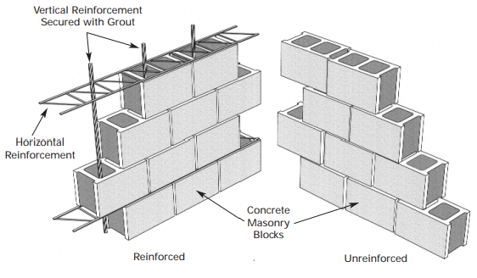

Figure 10 shows a concrete block steel reinforced wall (Office of Energy Efficiency and Renewable Energy, 2024)

3.1 Cooling Strategies
St. Vincent and the Grenadines like the rest of the Caribbean has two seasons, dry and rainy with barely any temperature changes all year. The climate is tropical with hot and humid conditions and can be even warmer from June to August (Climate Change Knowledge Makers, 2020). Due to the climate in St. Vincent, heating solutions are not considered, but rather how to keep a building cool and well-ventilated.

The Edge Hotel has used several methods to keep cool. Firstly, all the rooms have large 4x4 ft vertical sliding windows, to allow more breeze/wind in the rooms. The ceilings are ten feet tall to allow the room to feel cooler, the concept behind this is that cool air sinks and the hot air is pushed up; therefore, the higher the ceiling or the further away the hot air is from the occupant, the cooler they will feel. There are porches which the occupants can use to sit outside and feel the breeze without obstruction from walls or other structures, it also means that the door can stay open to let even more wind (than the window) into the room. The floors are tiled which feel much cooler on the feet in comparison to carpet, or wooden flooring. Each room is also equipped with a ceiling fan and an air conditioning unit to aid with cooling; when both methods are combined, the air conditioning produces cool air, and the fan can distribute and circulate it within the entire room.

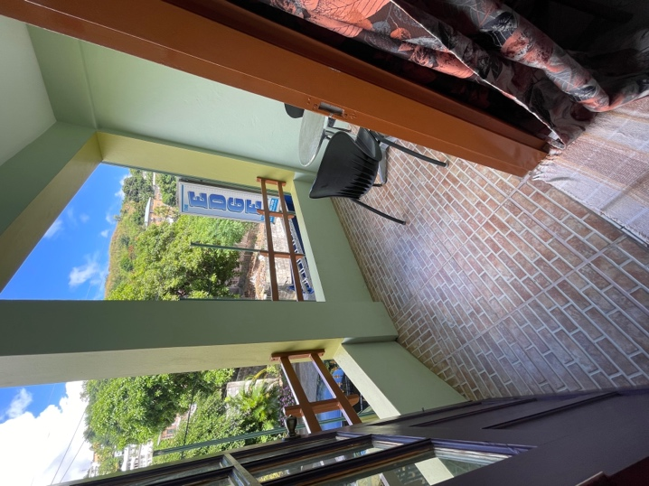
Figure 11 shows the porch of room Young Island. (Author, 2024)

3.2 Lighting Strategies
For lighting, the big windows allow natural light to come in during the day. The porch doors (with big glass) and the porches themselves are also sources of natural lighting. Besides those methods, there is artificial fluorescent lighting built into the ceiling fans. Additionally, there is a lamp by the bedside.
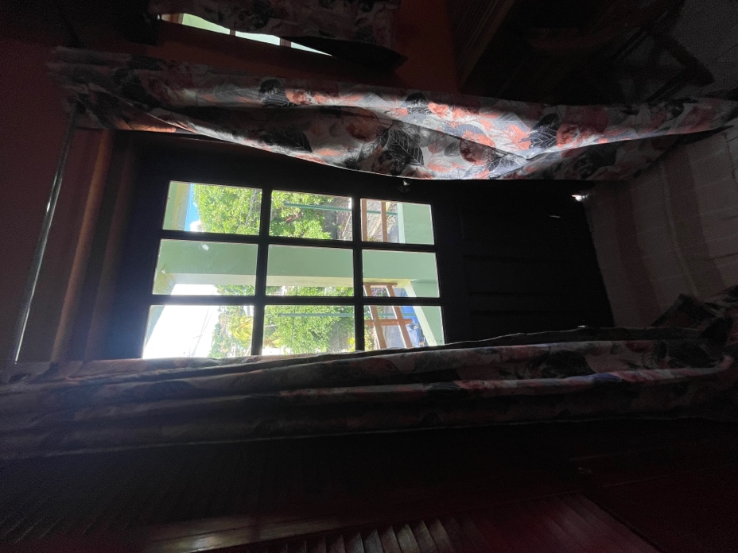
Figure 12 shows the door to the porch of room Young Island. (Author, 2024)

For security, all ground-floor windows have burglar bars which can hinder thieves from entering. The building is also fully fenced, with security cameras. There is also a small security booth from which the security guard operates.

3.3 Materials Used
The main materials which make up The Edge Hotel are concrete (stone, sand, and cement) and steel reinforcement, other materials include timber for the roof, windows, semi-gloss paint, wooden balusters, wooden doors with glass, and tiles. Some of the internal materials include wooden closets, wooden picture frames, wooden cabinets, wooden seating areas, wooden bed frames, wooden doors, tiles, ceramic toilets, wooden ceiling fans, metal towel racks, and metal curtain rods.

Assessment of the Case Study Building

4.1 Regulations
The recent changes in regulations relate to the ISO 14000 family concerned with environmental management, especially greenhouse gas emissions. The new standard, as of 2023 is ISO 14068-1 which focuses on climate change management and by extension the transition to net zero. ISO defines net zero as “a condition in which human-caused residual greenhouse gas emissions (GHG) are balanced by human-led removals over a specified period and within specified boundaries” and says that net zero is a crucial step towards a sustainable future. ISO 14068-1 gives guidance on how to achieve carbon neutrality by quantifying, reducing, and offsetting the carbon footprint by 2050.

To reach net zero, ISO provided a guideline which includes:
- Reducing emissions – this involves increasing energy efficiency, converting to low-carbon products and renewable energy sources, and developing waste-reduction strategies.

- Carbon offsetting- this is for emissions that cannot be reduced, the strategy is to purchase carbon credits from initiatives/projects that eliminate or drastically lower greenhouse gas emissions. The purchaser should aim to buy the same amount they emit.

- Transparency and accountability- this entails regularly monitoring and reporting GHG emissions to aid in companies tracking their progress toward achieving net-zero emissions and pinpointing areas for improvement.

- Stakeholder engagement- this strategy integrates workers, clients, investors, and the public in the effective execution of net-zero initiatives. This encourages a sustainable culture and motivates group efforts to reduce emissions.

- Equity and justice- the Sustainable Development Goals of the United Nations (UN) are in line with the Net Zero Guidelines. To protect the rights of the most vulnerable, climate action considers the effects of climate change and makes sure that opportunities and costs are distributed fairly. This is especially important for smaller nations such as St. Vincent and the Grenadines which is at risk due to climate change and is suffering the effects such as dying corals; larger nations must do their part in efforts to preserve the entire world.

4.2 Good Attributes of the Case Study Building
The Edge Hotel was built twenty years ago, and it is still structurally sound and standing. The building has excellent lighting, both natural and artificial, of which the artificial is fluorescent lighting and is energy efficient (Sustainability Victoria, 2023). Its strategies for cooling and ventilation are effective between the natural breeze and cooling from the air conditioning. In terms of energy use for the air conditioning units, the hotel is equipped with inverter units, which use up to thirty per cent less energy than regular units (TCL, 2023). The hotel is functional, and it has maximized the relatively small plot of land it was built on, as it goes four floors upwards increasing its area.

4.3 Improvements
Improvements to The Edge Hotel if it were to be built in the future, in the following aspects:
- Operational energy use: This refers to the energy consumed during the day-to-day operations such as cooling, lighting, appliances, and other activities. Improving the operational energy use is integral in reducing the environmental impact, and the overall sustainability of a building. (Chang & Wei, 2021)
The Edge can improve this by lowering its emissions such as the electricity bill, the bill is currently $2500 XCD per month (St. Vincent currently uses gas to generate electricity). The bill can be lowered by installing a solar-powered system to run the hotel for both electricity and hot water. Another strategy is to have cross ventilation in the rooms for better airflow, this can be done by putting louvres over the internal door for each room, which can reduce the need for the fan or the air conditioner.

- Embodied energy/carbon: This is the term used to describe the millions of tons of carbon emissions that are produced throughout the extraction, production, transportation, construction, and disposal of building materials. Some materials that contribute to embodied carbon emissions include insulation, steel, and concrete (Weir et al., 2023).
The Edge Hotel was built using mostly steel-reinforced concrete, which both concrete and steel contribute significantly to the negative effects on the environment (Obinna, 2023). Almost all the building materials (cement, sand, steel, timber) used in St. Vincent are imported from other islands like Guyana or Trinidad, which would increase their embodied energy. Timber has a lower embodied energy than reinforced concrete and is an excellent substitute for the framework of a building, however, timber structures are not insured in St. Vincent therefore, it can result in being a bad investment. One of the only methods to reduce the embodied energy of the hotel is to build the internal walls using plasterboard, drywall, or timber and add a sound-insulating layer.

- Cost of Construction: The Edge Hotel costed 1.56 million XCD to be produced. As aforementioned, the building was originally an extension of a two-bedroom house, and the extension and original structure had to be demolished due to the poor foundation. This failure contributed significantly to the costs, if constructing the building in the future, a thorough soil investigation is suggested to properly assess the ground conditions and initially design a suitable foundation. Costs can also be reduced by using plasterboard, drywall, or timber as the internal wall material.

- Cost of operations and maintenance: If constructing this hotel in the future, solar power will be implemented for electricity and water heating (while still maintaining power from the grid as there are periods of heavy rains and little sun). To reduce money paid out to workers, instead of a front-of-house worker, there can be a self-check-in service.

- End-of-life reuse/ recycling: The building can be rented out as separate office spaces for commercial use, this can work as each room is self-contained and has its utilities, therefore space does not have to be shared between different companies. If the building is demolished, the materials can be reused as backfill for another project.

- Other improvements: Some of these improvements include future plans that the owner has already ruminated on and has priced. Accessibility considerations such as an elevator because there is only one accessible room out of nine. For safety, use the large windows as a fire escape by attaching drop-down ladders near them. In terms of security, installing an automatic sliding door with an alarm/chime when it is opened, and installing a security system. In the porches, water does not drain properly and causes the doors to swell, there needs to be a slope to create runoff. The disused space on the third floor will be renovated into four other rooms to utilize the wasted space. Lastly, there will be an additional floor with amenities such as a pool, sauna and spa which would be available to the public by purchasing a day pass.
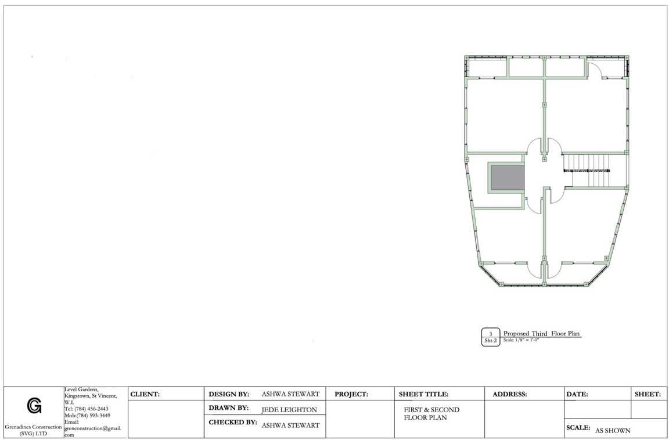
Figure 13 shows the proposed plan for the third floor. (Grenadines Construction, 2023)

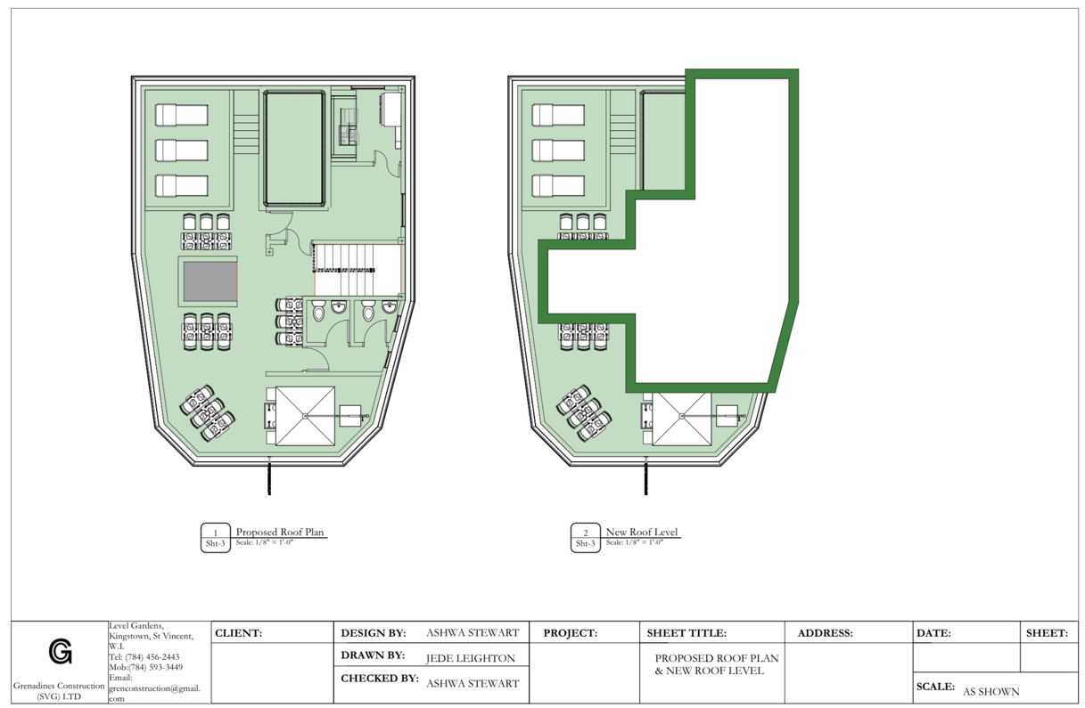
Figure 14 shows the proposed plans for the new roof level. (Grenadines Construction, 2023)

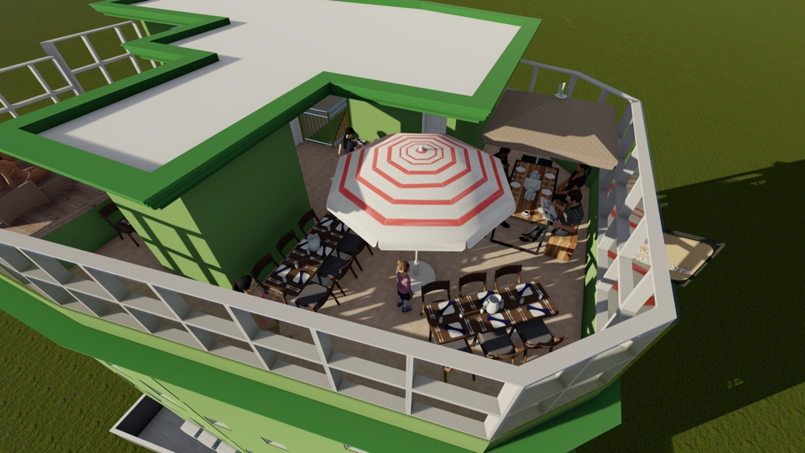
Figure 15 shows a visualization of the new proposed roof plan. (Grenadines Construction, 2023)

Offsite Manufacture
Offsite manufacture can be beneficial for the improvement using the solar power system. After the calculations to assess the type and volume of solar power needed, it can be sent off to the company so that the specific system can be produced. During this time, the work on-site can continue, and the system will be installed at the appropriate time, proving efficiency. When specific items are manufactured offsite, there is a more precise assembly of the components within a controlled environment, reducing the risk of errors in each component such as the panels, or the inverter.

Conclusion
The Edge Hotel is a twenty-year-old, four-storey building located in Kingstown, St. Vincent and the Grenadines. The hotel holds great social value to the community and has contributed significantly to the country’s Gross Domestic Product. The building was constructed using reinforced concrete to ensure structural integrity and longevity. It utilizes both natural and artificial cooling/ ventilation strategies and lighting strategies. Recent regulation changes are pushing to reach net zero by 2050 using strategies such as reducing carbon emissions. Building The Edge in the future, there are many improvements to be made to align with the current regulations. Solar power is a strategy to improve the hotel’s operational energy use, which can be easily facilitated through the use of off-site manufacturing.

Reference List
4-Step Guide to Backfilling Trenches and Foundations. October 4, 2022-last update. Available: https://www.bigrentz.com/blog/backfill-trench [December 30th, 2023].
CHANG, Y. and WEI, Y., 2021. Chapter 9 - The utilization of renewable energy for low-carbon buildings. In: J. REN, ed, Renewable-Energy-Driven Future. Academic Press, pp. 289-309.
Choose the right fluorescent lighting. August 2, 2023-last update [Homepage of Kerrwil Publications Limited], [Online]. Available: https://www.sustainability.vic.gov.au/energy-efficiency-and-reducing-emissions/save-energy-in-the-home/lighting/choose-the-right-fluorescent-lighting#:~:text=Fluorescent%20lighting%20is%20very%20energy,around%201000%20to%202000%20hours. [January 2nd, 2024].
Climate change management — Transition to net zero. 2023-last update [Homepage of International Organization for Standardization], [Online]. Available: https://products.ihserc.com/tmp_stamp/65041117/KKQZFHAAAAAAAAAA.pdf?sess=65041117&prod=CIS1 [January 6th, 2024].
CMU construction can be reinforced with vertical rebar and horizontal steel reinforcement (left) or unreinforced (right), depending on structural requirements. Jan 1, 2024-last update. Available: https://basc.pnnl.gov/images/cmu-construction-can-be-reinforced-vertical-rebar-and-horizontal-steel-reinforcement-left-or [January 6th, 2024].
Embracing net zero: a crucial step towards a sustainable future. Jan 1, 2024-last update. Available: https://www.iso.org/climate-change/embracing-net-zero [January 2nd, 2024].
GAREVSKI, M. and SHREYASVI, C., 2010. RECENT ADVANCES IN EARTHQUAKE RESISTANT CONSTRUCTION PRACTICES. Conference: Second National Conference on Structural Engineering and Construction Management, SECON’, 17.
Grenadines Island Group (Grenada). Nov 18, 2013-last update. Available: https://whc.unesco.org/en/tentativelists/5845/#:~:text=The%20Grenadines%20are%20a%20group,to%20Bequia%20in%20the%20north. [January 2nd, 2024].
JOINT REINFORCEMENT FOR CONCRETE MASONRY. Jan 1, 2024-last update. Available: https://ncma.org/resource/joint-reinforcement-for-concrete-masonry/#:~:text=It%20was%20initially%20conceived%20primarily,joint%20reinforcement%20or%20reinforcing%20bars. [January 6th, 2024].
MAKSYMOVA IRA, Apr 3, 2023-last update, Types of architecture: 12 architectural styles. Available: https://applet3d.com/architecture/types-of-architecture/ [December 30th, 2023].
OBINNA UBANI, Feb 26, 2023-last update, Carbon Footprint of Reinforced Concrete Structures. Available: https://structville.com/carbon-footprint-of-reinforced-concrete-structures#Optimisation_of_Reinforced_Concrete_Structures_for_Environmental_Impacts [January 2nd, 2024].
Saint Vincent and the Grenadines. 2024-last update. Available: https://www.google.com/maps/@13.1566444,-61.224995,226m/data=!3m1!1e3?entry=ttu [December 30th, 2023].
St. Vincent and the Grenadines. 2021-last update. Available: https://climateknowledgeportal.worldbank.org/country/st-vincent-and-grenadines/climate-data-historical#:~:text=Research%20Unit%20(CRU)-,St.,season%20from%20June%20to%20November. [January 6th, 2024].
Stewart A. (2024). The Edge Hotel. 2 Jan.
Stewart, A. (2023). The Edge Hotel. 27 Dec.
Strip Foundations: Everything You Need To Know. May 5, 2022-last update. Available: https://www.reinforcementproductsonline.co.uk/news/strip-foundations/ [December 30th, 2023].
WEIR, M., REMPHER, A. and ESAU, R., March 27, 2023-last update, Embodied Carbon 101: Building Materials. Available: https://rmi.org/embodied-carbon-101/#:~:text=Embodied%20carbon%20represents%20the%20millions,contribute%20to%20embodied%20carbon%20emissions. [January 2nd, 2024].
What is the Difference Between Inverter and Non-Inverter AC? Jan 16, 2023-last update [Homepage of HT Digital Streams Limited], [Online]. Available: https://www.tcl.com/global/en/blog/what-is-the-difference-between-inverter-and-non-inverter-ac#:~:text=Inverter%20Air%20Conditioners%20are%20much,to%20maintain%20the%20desired%20temperature. [January 6th, 2024].
Wide Strip Foundation. Dec 4, 2010-last update. Available: https://civilconstructiontips.blogspot.com/2011/06/wide-strip-foundation.html.

