SMACCS CARE HOME
SESSION OBJECTIVES AND OUR TEAM

BENEFITS OF TEAM WORKING
Student Name: Michael Abak (Leader) Student Number: 1917009
Module Code: BMSW4002
Module Title: Effective Team Working and Communication
Lecturer: Afzal Munna
STAGES OF TEAM DEVELOPMENT
Student Name: Sophie Albangbe
Student Number: 1916094

TEAM ROLES
Student Name: Carolina Nhongerayi Student Number: 1917006

MANAGING CONFLICTS
Student Name: Shelly-Ann Williams
Student Number: 1916052

SUCCESSFUL TEAM DEVELOPMENT

Student Name: Crizanta Duarte Alvarenga De Barros
Student Number: 1913506



INTRODUCTION

A team refers to a group of people who work together on tasks with the aim of achieving a known goal (Maund et al 2017) and teamwork is work carried out by several individuals with everyone contributing a part (Rosenfeld, 2012)

Michael Abak (Leader) – 1917009

BENEFITS OF TEAMWORK
- Productivity is increased because tasks are shared amongst employees bearing in mind the ability and strengths of each employee.
- When more hands are joined efficiently in the quest for a common goal the goal is easily achievable.
- Two heads working together can perform better than one (Brennan, 2015)
- Innovation is stimulated through the joining of ideas (Shipton et al., 2005) thereby creating practical solutions by brainstorming in sessions which boost confidence.
- System of support is created based on trust, reliability, and guidance so that
employees can concentrate on the goal.
- Team spirit created through this improves work efficiency. (Oster, 2015)

Michael Abak (Leader) – 1917009

BENEFITS OF TEAMWORK
- Overworked, confused, and stressed employees are more likely to make mistakes that is detrimental and costly to the Business.
- My team working together in this presentation decreases my work limit.
- My team’s morale is boosted through working together to achieve a common goal
because people feel the need to belong and be appreciated.
- The contributions of an employee that leads to recognition and job satisfaction impacts positively on turnover rate making it lower.
- Collaborating multiskilled employees enable flexibility.
- Productivity increases and improved work life balance is attained.
- Strong and enduring relationships have been formed in my team, and communication is easier, and more open while also encouraging each other.

Michael Abak (Leader) – 1917009

BENEFITS OF TEAMWORK
- Trust, confidence, and bonds have been built through teamwork which establishes an environment of comfort and confidence.
- New skills learnt through collaboration enhances career progression.
- Reduce errors (Fernandez et al, 2008)
- Synergistic energy is created by the combined power of a group of employees working together as a team
- Attracts new talent and forging of alliances.
- Learn how to resolve conflict.
- Sharing of risks and reduce errors

Michael Abak (Leader) – 1917009

ADVANTAGES & DISADVANTAGES OF TEAMWORK

ADVANTAGES
- Diverse ideas
- Shared mindset (Haas and Mortensen, 2020)

DISADVANTAGES
- Blaming each other when problems occur
- Collision of ideas
- Unbalanced sharing of work
- Domineering team leader
- No commitment (Maund et al 2017)

Michael Abak (Leader) – 1917009

WHO IS TUCKMAN? WHY THIS THEORY?

Bruce Wayne Tuckman was an American Psychological Researcher who worked in the file of group dynamics. In the year of 1965, he studied the development stages of teamwork and formulated his 5-stage model of teamwork that initiates from the time where the group first meets and ends once the project is completed.



Sophie Albangbe – 1916094

STAGES OF TUCKMAN

- Forming: This stage involves the instance of orientation and getting further acquainted with each other
- Storming: This stage is marked by rising conflicts with emerging individualistic personalities leading to competition. It often signifies decrease in the team performance at this stage.

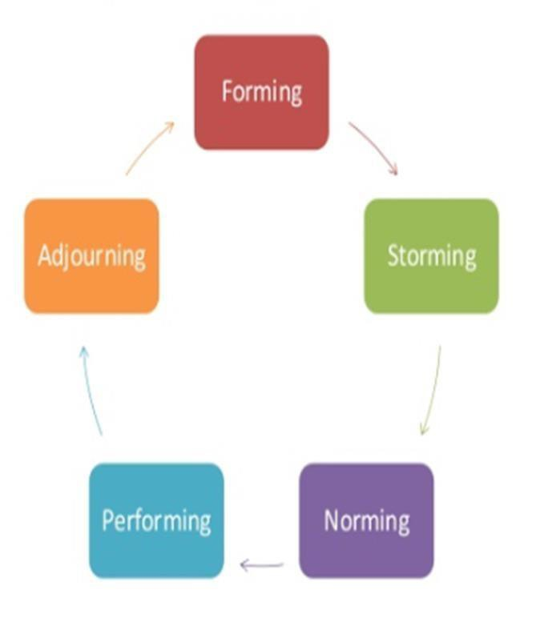

Sophie Albangbe – 1916094

STAGES OF TUCKMAN CONT.

- Norming: This stage signifies the resolve of conflict and emergence of unity. Interpersonal differences are resolved by this stage and cohesion and unity among the members strengthens
- Performing: In this stage consensus along will cooperation among the team members is well established and team is characterized being mature, organized and even functioning
- Adjourning: This stage emphasized on wrapping up the final tasks and documents the efforts given and the outcomes acquired.

Sophie Albangbe – 1916094

ADVANTAGES & DISADVANTAGES

BENEFITS:
The model clarifies every specific stages of teamwork development. The theory enables to learn about the reason of conflict as well as find resolution for the same to complete the allotted tasks successfully.

DISADVANTAGES:
Researchers argued that the complexity of human characteristics do not enable movement in between the stages in a linear progressive manner. Certain groups might move to the storming stage and make it directly to preforming stage.

Sophie Albangbe – 1916094

CRITICISM OF THE MODEL.
CRITICISM: The theory we based on small numbers of individuals giving their personal experience related views on team formation. Most of the peer reviewed studies executed could not align the outcomes with Tuckman’s theory therefore failing to prove his theory.

Sophie Albangbe – 1916094

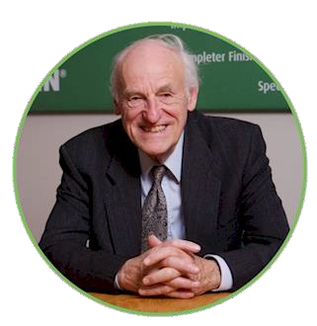
BELBIN’S TEAM ROLES
Meredith Belbin developed his team roles during the 1970’s(Belbin, n.d.)
Step 1
- Identify personality types and preferred style of working.

Step 2
- Put these people of different personality types into teams and ask them to perform difficult tasks involving teamwork.
From these experiments 3 different groups of behaviour were
identified.
Over time 9 distinct team roles were identified (3 roles per group) (Tools, n.d.)

Source: https://www.belbin.com/about/dr- meredith-belbin/

Carolina Nhongerayi – 1917006

THOUGHT ORIENTED ROLES

Plant (PL) | Monitor evaluator ME) | Specialist (SP)
Strengths  - Always creating new & innovative ideas  - Usually introverted &  enjoys working alone  - Solves difficult problems  Weakness  - Takes criticism badly  - Tendency to forget & not work within constraints they have been given e.g deadlines /budgets | Strengths  - Great critical thinkers  - Great at analyzing ideas & options that others create. (Plants)  - Notices all options & judges accurately  Weakness  - Lacks drive and the ability  to motivate others  - Sometimes slow to come to decisions | Strengths  - Dedicated  - Has knowledge to do a  specialist job  - Plays crucial role  Weakness  - Can dwell on technicalities  - Could overload you with too much information (Anon, n.d.)

Carolina Nhongerayi – 1917006

ACTION - ORIENTED ROLES
Shaper (SH) | Implementer (IMP) | Complete finisher (CF)
Strengths  - Extroverted  - Challenges team members  to improve  - Enjoys stimulating ideas and solving problems  - Considers all possibilities  - Motivated by challenges & overcoming obstacles  Weakness  - Can become argumentative & offend other team members. | Strengths  - Reliable  - Get the job done  - Organized  - Ability to convert ideas into action plans  Weakness  - Can be resistant to change | Strengths  - Detail focused  - Ensures projects are  thoroughly completed  - Pushes the team to get things done  Weakness  - Worry to get things done on time  - Sometimes takes perfectionism to the extreme(Anon, n.d.)

Carolina Nhongerayi – 1917006

PEOPLE - ORIENTED ROLES
Co-ordinator (CO) | Team worker (TW) | Resource Investigator (RI)
Strengths  - Takes on role of team leader  - People tend to go to them  when issues arise  - Great listeners  - Co-ordinates & Delegates day to day activities of team  Weakness  - Tendency to offload share of work onto others | Strengths  - Ensures that team is  working well together  - Good listeners  - Good negotiators  - Sacrifices for the team  Weakness  - Can be indecisive in situations & tends to avoid confrontations. | Strengths  - Thinks out of the box.  - Extroverted.  - Seeks opportunities and develops contacts.  Weakness  - Tendency to be too optimistic.  - Tendency to lose interest quickly. (Anon, n.d.)

Carolina Nhongerayi – 1917006


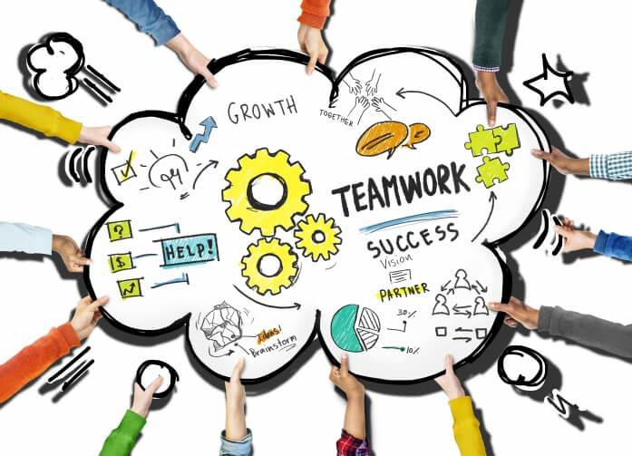
WHY USE BELBIN’S MODEL?

As Team member
- You can use it to develop yourself as a better team member.

As a leader
- You can use it to create new teams in a more balanced way.
- You can use to manage differences with the existing team(Tools, n.d.)

Source: https://www.sandler.com/blog/6-benefits-of-teamwork-in-the-workplace/

Carolina Nhongerayi – 1917006

ACKNOWLEDGE CONFLICT
- Firstly the conflict needs to be acknowledged by the manager and then discuss the problem .
- Rules have to be established to maintain respect to enable both parties to open up comfortable to speak on what caused the conflict.
- This will give both parties an understanding from each others perspective which will highlight what caused the conflict.
- Tuckman’s theory talks about effective leadership can be developed by providing the right tools to analyse current leadership strengths and by giving support coaching.

Williams – 1916052
Shelly-Ann

LISTEN CAREFULLY
- This involves listening to both parties attentively to understand the issue and have each individual to agree on what the issue is.
- Respect one another’s point of view also be open minded and refrain from interrupting each other.
- Questions has to be asked for each party to open up on what transpired between both of them. Show empathy (Courtain and Glowacz, 2018)

Williams – 1916052
Shelly-Ann

DISCUSS IMPACT
- This involves analysing and identifying which areas of conflict to work on to solve
- As well as understanding which area of conflict that is important to each individual and effectively create a plan within a reasonable timeline.

Williams – 1916052
Shelly-Ann

MAKE A PLAN
- In this step, this process is to identify points of agreement and disagreement to make a plan that will suit both parties.
- This involves effective communication and teamwork, which is the key to work together to discuss various ways on how to draft a plan and agreeing on a plan that will work best for both parties.
- Bruce Tuckman’s theory 1965 on team development is what is used to make a plan that will benefit both parties.
- Bruce’s theory consist of forming, storming, norming and performing

Williams – 1916052
Shelly-Ann

MAKE A PLAN - BRUCE TUCKMAN’S THEORY
- Forming looks closely at each individual role within conflict and agreeing on the objective the plan to move forward
- Storming looks at the challenges individuals will have to face each and compromises that can be made
- Norming looks at how individuals work well together to make decisions and develop work styles
- Performing focuses on achieving the objectives that was set in place on the forming stage. Looks at the conflict that is solved and how the individual were able to work their differences out together

Williams – 1916052
Shelly-Ann

FOLLOW THROUGH PLAN
- This involves arranging to meet in a place where there will be less distraction.
- Discuss the plan that was made step by step along with timeline to see if there has been any improvement or recommendation made.

Williams – 1916052
Shelly-Ann

TEAM WORKING
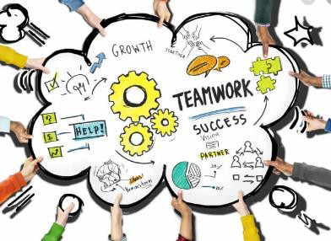
- The collaborative effort of people who intend to work together to achieve a purpose is called teamwork (Maslin- Prothero, and Bennion, 2010).
- It is a group of interdependent individuals working together for a common goal.
- Teamwork is considered better and more effective than individual work.

Crizanta Alvarenga De Barros– 1913506

TEAM WORKING SKILLS
- Communication skills
- Problem-solving skills
- Facilitation skills
- Conflict resolution
- Influencing skills

Crizanta Alvarenga De Barros– 1913506

TEAM WORKING THEORIES
- The Hierarchy of Needs
- Rubin, Plovnick, and Fry's GRPI Model of Team Effectiveness
- The T7 Model of Team Effectiveness
- The Lencioni Model

Crizanta Alvarenga De Barros– 1913506

SUCCESSFUL TEAM DEVELOPMENT
- A clear sense of direction
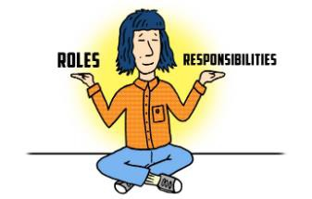
- Clear responsibilities
- Talented team members
- Efficient operating procedures
- Constructive interpersonal associations
- Constructive external associations
- Active reinforcement systems

Crizanta Alvarenga De Barros– 1913506

CONCLUSION
TEAM - The collaborative effort of people who intend to work together to achieve a purpose is called teamwork (Maslin-Prothero, and Bennion, 2010).

Due to space constraints not all the benefits and theories have been documented here, however, the option exists for you to kindly go through our list of references for further information. You can also email my team after the presentation if you have any further queries and we will respond accordingly.

Thank you

Michael Abak (Leader) – 1917009

REFERENCES
- Haas, M. and Mortensen, M., 2020. The Secrets Of Great Teamwork. [online] Harvard Business Review. Available at: <https://hbr.org/2016/06/the-secrets-of-great- teamwork> [Accessed 13 August 2020].
- Maund, A., Schriek, M. and Tinkler, P., 2017. Certificate in Higher Education. London: SAGE publications Ltd, p.7.
- ÖSTER, S. 2. T. J. o. S. F. i. O. T. J. o. S. F. i. O. I. 7. p. 7.-2., 2015. Solution-Focused approach in a team working with social welfare benefits in social service. The Journal of Solution Focus in Organizations The Journal of Solution Focus in Organizations. InterAction, 7(1), pp. 7-23.

REFERENCES
- Brennan, A. E. J., 2015. When two heads are better than one: Interactive versus independent benefits of collaborative cognition. Psychonomic Bulletin & Review, Volume 22(4), pp. 1076-1082.
- Fernandez, R., Kozlowski, S., Shapiro, M. and Salas, E., 2008. Toward a Definition of Teamwork in Emergency Medicine. Academic Emergency Medicine, [online] 15(11), pp.1104-1112. Available at: <https://onlinelibrary-wiley- com.ezproxy.uwtsd.ac.uk/doi/epdf/10.1111/j.1553-2712.2008.00250.x> [Accessed 15 August 2020].
- Rosenfeld, R., 2012. Teamwork. Otolaryngology–Head and Neck Surgery, [online] 148(1), pp.1-2. Available at: <https://journals-sagepub- com.ezproxy.uwtsd.ac.uk/doi/pdf/10.1177/0194599812468849> [Accessed 16 August 2020].

REFERENCES
- Shipton, H., Fay, D., West, M., Patterson, M. and Birdi, K., 2005. Managing People to Promote Innovation. Creativity and Innovation Management, [online] 14(2), pp.118-
128. Available at: <https://onlinelibrary-wiley- com.ezproxy.uwtsd.ac.uk/doi/epdf/10.1111/j.1467-8691.2005.00332.x> [Accessed 15 August 2020].
- Shipton, H., Fay, D., West, M., Patterson, M. and Birdi, K., 2005. Managing People to Promote Innovation. Creativity and Innovation Management, [online] 14(2), pp.118-
128. Available at: <https://onlinelibrary-wiley- com.ezproxy.uwtsd.ac.uk/doi/epdf/10.1111/j.1467-8691.2005.00332.x> [Accessed 15 August 2020].

REFERENCES
- Anderson, A. and Isacsson, B.B., 2016. The correlation between group coherence and productivity.
- Kiweewa, J.M., Gilbride, D., Luke, M. and Clingerman, T., 2018. Tracking growth factors in experiential training groups through Tuckman’s conceptual model. The Journal for Specialists in Group Work, 43(3), pp.274-296.
- Natvig, D. and Stark, N.L., 2016. A project team analysis using Tuckman's model of small-group development. Journal of Nursing Education, 55(12), pp.675-681

REFERENCES
- Anon., n.d. The Nine Belbin team roles. [Online] Available at: https://www.belbin.com/about/belbin-team-roles/ [Accessed 10 08 2020].
- Belbin, n.d. Dr. Meredith Belbin. [Online] Available at: https://www.belbin.com/about/dr-meredith-belbin/ [Accessed 05 08 2020].
- Tools, M., n.d. Belbin's Team Roles. [Online] Available at: https://www.mindtools.com/pages/article/newLDR_83.htm [Accessed 13 08 2020].

REFERENCES
- Available at: https://hrdailyadvisor.blr.com/2013/06/24/6-steps-to-conflict-resolution- in-the-workplace/ [Accessed. 12th July 2020]
- https://www.businessballs.com/team-management/tuckman-forming-storming- norming-performing-model/
- COURTAIN, A. and GLOWACZ, F., 2018. ‘Youth’s Conflict Resolution Strategies in their Dating Relationships’. Journal of Youth and Adolescence, [online] 48(2), pp.256-
268. Available at: https://link-springer- com.ezproxy.uwtsd.ac.uk/article/10.1007/s10964-018-0930-6 [Accessed 16 August 2020].

REFERENCES

- Bowers, L., Nijman, H., Simpson, A. and Jones, J., 2011. The relationship between leadership, teamworking, structure, burnout and attitude to patients on acute psychiatric wards. Social Psychiatry and Psychiatric Epidemiology, 46(2), pp.143-148.
- Carlock, R.S., 2012. Assessment tools for developing and leading effective teams.
- Curşeu, P.L., Kenis, P., Raab, J. and Brandes, U., 2010. Composing effective teams through team dating. Organization Studies, 31(7), pp.873-894.
- Freitas, F.A. and Leonard, L.J., 2011. Maslow's hierarchy of needs and student academic success. Teaching and learning in Nursing, 6(1), pp.9-13.
- Gilley, A., Gilley, J.W., McConnell, C.W. and Veliquette, A., 2010. The competencies used by effective managers to build teams: An empirical study. Advances in Developing Human Resources, 12(1), pp.29-45.

REFERENCES

- Gilley, J.W., Morris, M.L., Waite, A.M., Coates, T. and Veliquette, A., 2010. Integrated theoretical model for building effective teams. Advances in Developing Human Resources, 12(1), pp.7-28.
- Jackson, D., Sibson, R. and Riebe, L., 2014. Undergraduate perceptions of the development of team-working skills. Education+ Training.
- Maslin-Prothero, S.E. and Bennion, A.E., 2010. Integrated team working: a literature review. International journal of integrated care, 10.
- Nancarrow, S.A., Booth, A., Ariss, S., Smith, T., Enderby, P. and Roots, A., 2013. Ten principles of good interdisciplinary team work. Human resources for Health, 11(1), p.19.
- West, M.A., 2012. Creating effective teams. Eff Teamwork Pract Lessons from Organ Res.

REFERENCES

- West, M.A., 2012. Effective teamwork: Practical lessons from organizational research. John Wiley & Sons.
- Woodhead, V., 2011. How does coaching help to support team working? A case study in the NHS. International Journal of Evidence Based Coaching & Mentoring.
- Xyrichis, A. and Ream, E., 2008. Teamwork: a concept analysis. Journal of advanced nursing, 61(2), pp.232-241.
- Yeager, K.L. and Nafukho, F.M., 2012. Developing diverse teams to improve performance in the organizational setting. European Journal of Training and Development.

Q & A

