International Financial Management

Islamic Finance Report

SBUS6113

Georgina Buckland 1404838

Anthony Burns

Executive Summary
While starting off with a brief introduction to IF, (Islamic Finance), for the purpose of this assignment, I have analysed the success of IF. By using global statistics to illustrate international growth of this form of banking, empirical evidence on individual regions has allowed me to identify specific countries of success. I have used GDP rates as indicators of each areas financial strength.
Following from this, I critically analysed IF by introducing some areas of weakness. From providing statistical findings, I have attempted to explain reasons as to why IF may have its limitations.
The 2008 recession has been used as evidence in my assignment to reveal how IF was less affected by an economic crisis than that of traditional banking. However, where evidence competes with this concept, I have included this data and provided explanations as to why this may be.
Finally, following my main findings write up, I have provided 2 recommendations for the future of IF and have rounded up with a conclusion as to what my overall findings reveal.

Contents
1.0 Introduction | 4
2.0 Main findings | 4
2.1 Success of IF | 4
2.2 Limitations of IF | 7
2.3 Resilience to Global Crisis | 9
3.0 Recommendations | 11
4.0 Conclusion | 11
5.0 References | 12

1.0 Introduction
‘With the Islamic banking market valued at over USD.66 trillion, combines with the estimated growth rate of up to 20% year on year, the need for human capital to bring Islamic finance to the level at which it deserves and meet its markets demands is higher than ever.’ (Ambrose, 2017) Sharia law is based on the Quran and the Prophet Muhammad and it advocates shared risk and justice. A chief variance from traditional banking is riba; money mustn’t generate money. IF looks to consider the economy as a whole, as appose to individual profits. Malaysia and Bahrain act as examples in the field, whereby they are signifying positive progress of IF. However, throughout this assignment, I also aim to provide somewhat of a critical viewpoint to assess if IF is susceptible to weaknesses. With statistical evidence and real case studies, I will also generate argument based on the degree in which IF is affected by economic peaks and troughs.

2.0 Main Findings

2.1 Success of Islamic Finance
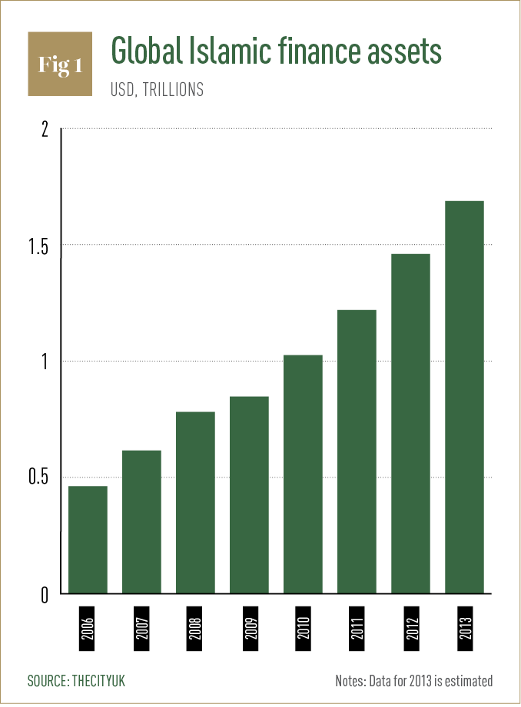
Figure 1

(Ghalaita, 2015)
Figure one reveals the extent of global growth of IF assets between 2006 to 2013. Although not as current as it could be, it visually represents how Islamic banking has sustained an perceptible increase. It seems impressive that in this 8 year period, global islamic finance assets have increased by just short of $1 trillion. The positive correlation signifies consistant progress. It is interesting to note that even in 2008, when the recession caused a global economic crisis, IF still prospered and showed positive signs of development.
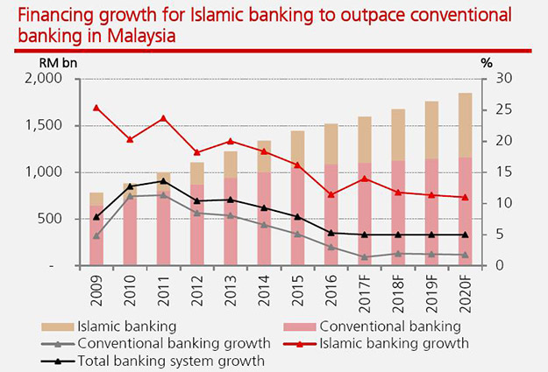
Figure 2

(Tuah, 2017)
Having focussed on the rise in IF assets, let’s compare this to the degree of growth of conventional banking between 2009 and 2020 in Malaysia. Where the level of traditional banking starts comparatively minimal and continues to diminish even into the predicted future, IF institutions have ‘been enjoying a sustained period for growth.’ (King, 2015) Though IF appears to level out somewhat after 2017, it remains a consistent 8% above conventional banking while also outstripping the regional growth of the Islamic industry in the rest of the world. Sharia compliant banks in this country have exceeded global norms in relation to both asset growth and return on assets. ‘Regulatory support for Islamic finance in Malaysia has levelled the playing field for sharia-compliant lenders, offering clarity and stability. Encouragingly, stronger government support is also emerging from other Association of South-East Asian Nations.’ (Hisham, 2015)

Figure 3
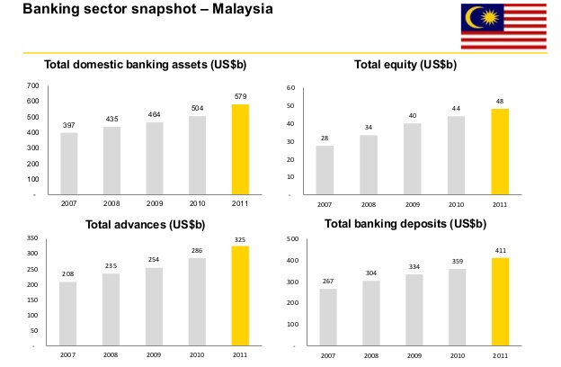

(Young, 2013)
Figure 3 demonstrates the deeper success of IF in Malaysia. It illustrates how in each identified factor, IF has stimulated growth and financial security within the country. Empirical evidence supports this concept. The CIA website, (Central Intelligence Agency, 2017), reveals that Malaysia’s current GDP purchasing power parity sits at $933.3 billion and is positioned an impressive 26th in comparison to the world. With strong correlations to Figure 3, Malaysia’s total domestic banking assets would increase every year, offering a stronger financial positioning per annum. Statistics also highlight the increase of GDP in recent years, where between 2015 to the current day, Malaysia’s GDP has increased from $845.6 billion which means a total increase of $87.7 billion.

Figure 4
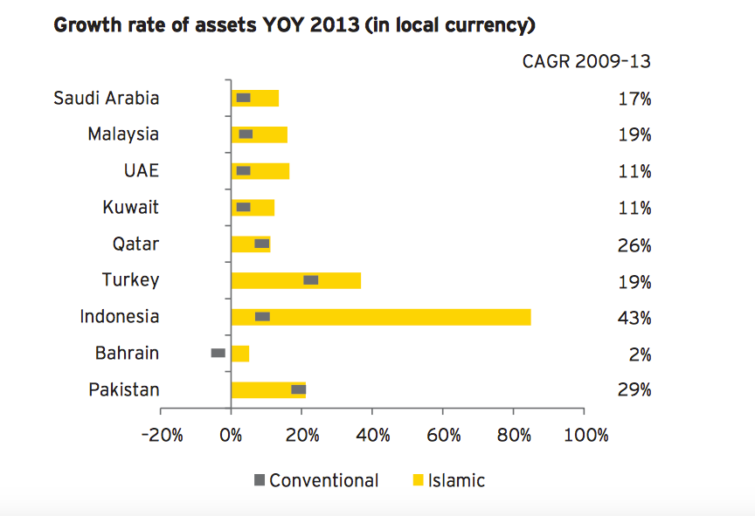

(Hirst, 2015)
This chart comparatively indicates the conventional banking and IF growth rate of individual regions. It is interesting to see how that of conventional banking only makes for a small proportion of banking. Bahrain is the only country where conventional banking is actually demonstrating a negative growth rate of assets in 2013. Bahrain does well to offer a less prescriptive legislative model for IF which therefore ‘allows institutions to align their business with rapidly fluctuating global trends’. (Innovation Enterprise, 2017) Perhaps the continued development of IF institutions provide a reason for the country’s consistently increasing GDP real growth rate. Bahrain currently holds a 3.8% rate, which is an increase of 0.9% from 2015. (Central Intelligence Agency, 2017)
In 2013, Indonesia’s growth rate of assets accounted for 43% of the overall Mena countries. As the world’s largest Muslim majority country, it seems fitting to enable more choice to Muslims; ‘to bank in a Shariah-compliant way, they no longer need to sacrifice the convenience, products and services they have been used to in the past.’ (Global Business Guide Indonesia, 2013) Since 2013, the country’s GDP real growth has recurrently improved and it stands today in 7th position globally. (Central Intelligence Agency, 2017) However, Indonesia faced a challenge when recognising that IF institutions do not have the degree of regulatory and supervisory guidelines like that of conventional banking. ‘They lack standardisation and harmonisation between different jurisdictions.’ (Piesse, 2016) Perhaps this in itself is a weakness of IF and can act as a limitation and barrier to further growth and introduction of Islamic banking into new markets.

2.2 Limitations of Islamic Finance
Shariah laws are not fully mature yet and therefore some factors to IF are still open to interpretation. For this reason, perhaps IF is a platform that companies can utilize to stay more stable in such a volatile economy, as demonstrated by figure 1, but until there is a consensus on Shariah laws, this form of finance is not yet fully effectual. Nevertheless, measures have been introduced in an attempt to overcome this. Malaysian government saw the need to harmonise sharia regulations. ‘The 2013 Islamic Financial Services Act, helped to reduce some of the uncertainty that existed between the courts, the central bank and sharia advisory council, and to provide more clarity.’ (Lee, 2013) It seems more salient now than ever that continuous improvement of the environment is key to strengthening IF for the future.

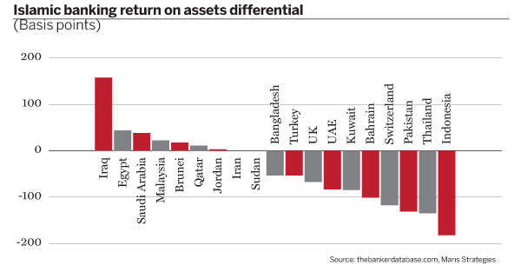
Figure 5

(Alexander, 2012)
Unlike past figures, Figure 5 actually illuminates a negative aspect of IF. The majority of Mena countries on this graph are actually making a loss on ROA. Perhaps this is a reason why the share of Islamic banks in Pakistan in comparison to the global Shariah compliant banking assets is only 1%. However, ‘total assets of Shariah-compliant banks in the country increased 21.9% to Rs2.48 trillion in the year ended June 30, 2018. With this, the market shares of Islamic banking assets surged to 12.9% in the overall banking industry compared to 11.6% in June last year.’ (Siddiqui, 2018)
Where Pakistan is doing well to recognise and address areas for enhancement, perhaps there is a superior weakness of IF that is somewhat harder to overcome. It has been suggested by that there are key factors to ensure sustainability for IF. One of these factors is the need for high quality, Shariah based products that avoid haram. (Reserve, 2018) The expenses required by Islamic Institutions can be considerable. Due to this, ‘the pace of innovation of new Islamic financial products may be considerably slower than that of conventional products. This may make IF less able to compete with conventional financial and may make it restrict its activities to smaller, niche markets.’ (Moinuddin, 2017)

2.3 Resilience to Global Crisis
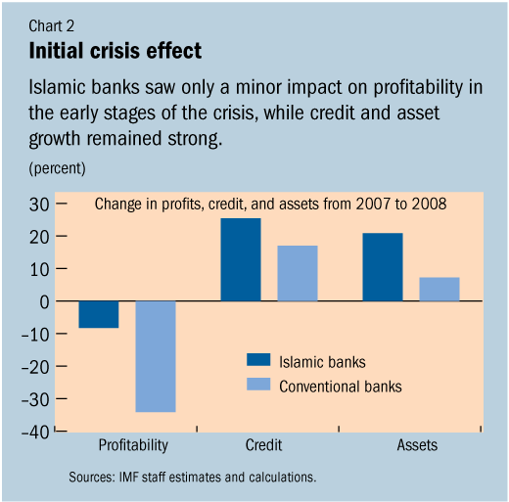
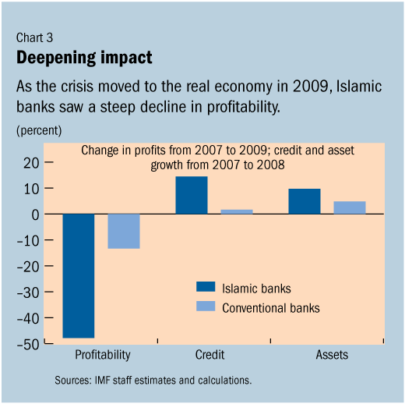
Figure 6 Figure 7

(International Monetary Fund, 2010)
In 2008, we faced the recession. Using this as an example, it seems that perhaps IF could indeed have enabled institutions to tackle such an issue. I use the word tackle cautiously; statistics reveal that IF institutions were affected from this economic bust, however seemingly, not as severely as conventional banking. Under the Riba and Gharar, any products that a seller cannot deliver and does not currently possess are exempt from Islamic contracts. Under Sharia Laws, a direct link to assets, ‘is key to the acceptability of Islamic securities’. (Moinuddin, 2017) Figure 6 can be used to demonstrate the way in which this factor of IF protects customers against such trading, which had less resultant implications from the economic crisis. The graph reveals that between 2007 to 2008, although Islamic banks were subject to a loss in profitability, there was a staggering 25% difference between that of the conventional banking system.
However, we cannot ignore ‘issues may have arisen with regards to liquidity of the market as the Islamic financial sector is in the process of developing more fluid liquidity tools.’ (Moinuddin, 2017) Figure 7 reveals a dramatic change into 2009 statistics. With the global recession prolonging, even Islamic banking institutions started to feel the impact. Where the initial loss in profitability once remained at a controllable level, 2009 saw a huge decrease in profit; a 40% reduction in profits from the previous year.

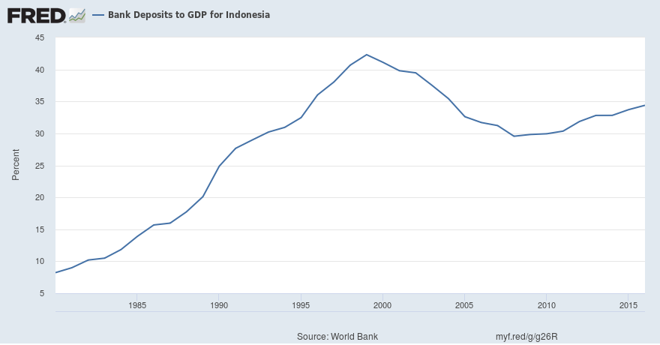
Figure 8

(FRED Economic Research, 2018)
Let’s now look at the GDP of Indonesia between 1985 to 2015. The country’s peak GDP was around 8 years prior to the recession and from this point onwards shows a deterioration. Although 2008 was the lowest GDP for Indonesia, I would argue that this steady, prolonged decline contradicts my previous findings.
Figure 9
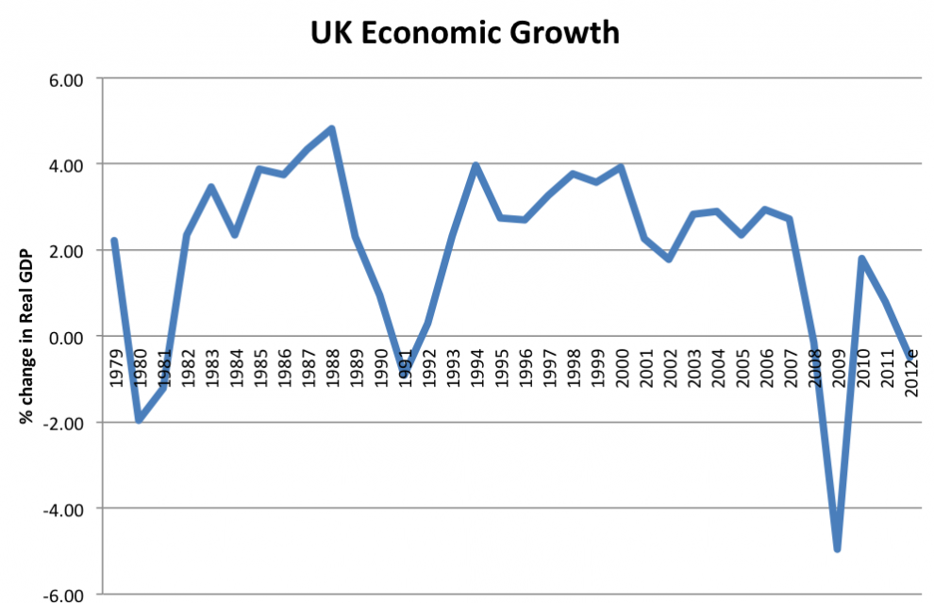
(Tejvan, 2016)
If we compare the GDP rates between Indonesia and the UK throughout the same time period, it is clear to see how the UK, under a traditional banking system, suffered a much greater loss during the time of the recession. The shared responsibility specifically involved with Mudaraba and Musharaka shifts most of the risk onto the clients. Resultantly, cooperation and trust are advocated in IF regions. ‘The ethical stance and fair dealing of Islamic finance virtues means that partnerships, business activity and profit creation comes from benefiting the community as a whole.’ (Moinuddin, 2017) It seems theorists have been reasonable to describe the ‘failure to maximise the benefits of our strategic partnerships under conventional banking’, (Moinuddin, 2017), which can deliver elucidation for the Figure 9 findings.

3.0 Recommendations
- The introduction of furthered regulations would help to outline the Shariah law to eliminate confusion or uncertainty. This would strengthen the environment in which IF could continue emerging based on consensus and harmony.
- Place more focus on IF in the future to reduce the effect of economic crisis. The introduction of IF in areas like the UK would, in practice help GDP and financial positioning stay more steady in a volatile economy and reduce overall disruption.

4.0 Conclusion
Overall, the growth of IF is comprehensible when reviewing its achievements. Malaysia and Indonesia are both prime examples of thriving GDP, where Pakistan is an example where further development is required. Empirical evidence reveals the capabilities of IF however, as a whole, some matters have been identified on an international level due to the lack of clarity of Shariah law. I have provided a recommendation that perhaps further regulations would provide clarification. Evidence suggests that although IF is not completely unaffected by economic changes, it is less susceptible to less disruption than traditional banking.

References
Alexander, P., 2012. The struggle to find the right Islamic banking model. The Banker.
Ambrose, 2017. Islamic Finance Market Size and Growth. Industry Directory.
Central Intelligence Agency, 2017. The World Factbook. [Online]
Available at: https://www.cia.gov/library/publications/resources/the-world-factbook/
[Accessed 11 December 2018].
FRED Economic Research, 2018. Total Gross Domestic Product for Indonesia. FRED Economic Research.
Ghalaita, J. B., 2015. The rise of the Islamic economy. World Finance; The Voice of the Market.
Global Business Guide Indonesia, 2013. The Outlook for Indonesia’s Islamic Banking Sector. Global Business Guide Indonesia.
Harran, A., 1993. Islamic Finance: Partnership Financing. 2nd ed. Indiana: Pelanduk Publications.
Hirst, T., 2015. These are the top 9 countries for Islamic finance. World Economic Forum.
Hisham, M., 2015. Maybank Islamic, Malaysia: s.n.
Innovation Enterprise, 2017. 5 Advantages Of Islamic Finance. Innovation Enterprise.
International Monetary Fund, 2010. IMF Survey: Islamic Banks: More Resilient to Crisis?. International Monetary Fund.
King, J., 2015. Malaysia's recipe for Islamic finance success. The Banker.
Lee, S., 2013. Malaysia’s new financial services regulatory framework. Financier Worldwide.
Moinuddin, C., 2017. An Introduction To Islamic Finance. 1st ed. s.l.:CIMA.
OpenTuition, 2018. ACCA F9 Lecture Notes – Sources of finance – islamic finance. [Online]
Available at: https://opentuition.com/acca/f9/acca-f9-lecture-notes-sources-of-finance-islamic-finance/
[Accessed 10 December 2018].
Piesse, M., 2016. Indonesia’s Plan for Global Islamic Finance Center Faces Challenges. The Edge of Risk.
Reserve, T. M., 2018. Key factors to Islamic finance success. The Malaysian Reserve.
Shahzad, M., 2016. Barriers to Service Quality in the Banks of Pakistan: A Comparative Study of Islamic and Conventional Banks. Business and Economics Journal.
Siddiqui, S., 2018. Pakistan’s share in global Islamic banking assets just 1%. The Express Tribune.
Tejvan, 2016. UK Recession of 1991-92. Economics Help.
Tuah, Y., 2017. Islamic finance: The unconventional but nascent financial system. Borneo Post Online.
Young, E., 2013. World islamic banking competitiveness report. SlideShare.

