Kwikee-Mart Analysis
Dewi Havard
HND Business Management
1807482

Executive Summary
I have done an introduction where I looked at what I will be looking at in the report. I then went to show different examples of Kwikee-Mart’s sales information and the areas that need work using Microsoft Excel functions IF, LOOKUP and PIVOT TABLE. After I looked at the day to day sales information and commented on the different functions on Microsoft excel I went and looked at data on weka and commented on any patterns in the data.

Introduction
I am a data analytics assistant that will be looking at sales information for Kwikee-Mart Office Supplies. I will be using Microsoft Excel for the day to day data and for data mining I will use Weka. I will be looking at Kwikee-Mart’s sales information and will point out areas that I think are good and also things that need work on.

Main Findings
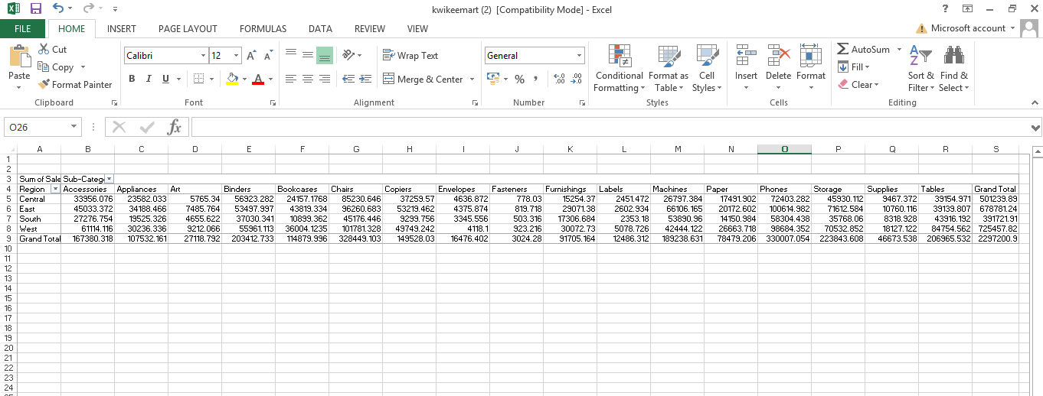
Pivot table

