Investigation into a land recovery method for uncrewed aerial targets
ACDA5012
Name: Owain Stuart Plant
Student Number: 1910280
Date: 24/03/2023
Major project proposal: Ordnance, Munitions & Explosives- Safety
Owain Stuart Plant (1910280)
University of Wales Trinity Saint David

Abstract
This assignment will discuss a project proposal put forward to find and implement a way to allow aerial targets to be recovered to land. It must also allow for the recovery area to be contained within MOD (Ministry of Defence) Aberporth range boundary, it must be conducted safely without any advertent effects from the carried OME (Ordnance, Munitions & Explosives) and avoid the magazines area. The proposal will firstly look at the background information followed by the problem at hand, aims and objectives. It will then look at the project design looking at the intended method for carrying out the work, the resource required, what the deliverables are and when they need to be completed by. It will also consider any ethical issues with an ethics form attached in the appendix.
Table of Contents
1. Introduction 2
2. Background 2
2.1. Problems at hand 2
2.1.1. OME issues 2
2.1.2. Topography of the range 3
2.2. Aims 3
2.3. Objectives 3
3. Project Design 6
3.1. Data Collection 6
3.2. Data Evaluation 6
3.3. Risks & Limitations 6
3.4. Ethical Issues 6
3.5. Resources Required 6
3.6. Planning 6
3.7. Costs 6
4. References 7
5. Bibliography 7
6. Appendix 8
6.1. Aerial target information 8
6.2. Resource required. 8
6.3. Ethics form 9
6.4. Gantt chart 0

Table of figures
Figure 2- Image of range boundry containment 3
Figure 5- Ethics form 14
Figure 6- Final project planning Gantt chart 15

Introduction
This assignment will give a project proposal to ensure that both the company and the university fully understand the scope of the work that is going to be carried out for the major project. When deciding on the chosen project it required many factors be considered, firstly that it could be completed in the required timescale. It also required that the project be within the authors area of expertise and approved by their employer. The content of the chosen project needed to be of a technical nature with all resources that are required be easily accessible and feasible. Given these factors the chosen project as seen on the title page is an investigation into land recovery method for uncrewed aerial targets

Background
The proposed project as discussed in the introduction is to look at the land recovery method for three different uncrewed aerial target systems at MOD (Ministry of Defence) Aberporth. It is required that the availability of the land recovery option for these systems at Aberporth be made possible, whilst ensuring it is contained within its boundary and the residual risk level does not change. These uncrewed aerial targets are used for a variety of different reasons including end-to-end weapons-release training roles, including surface-to-air and air-to-air, further information on aerial targets is in the appendix later in the assignment.
A literature review was carried out for previous work carried out in this area, the first area where research was carried out was into the manufacturer information. The information from the manufacturer for the three systems is for sea recovery from set altitudes which is not suitable for use, these sources of information haven’t been referenced due to their sensitivity.
Two Methodologies were found for land recovery one being the Manorbier methodology and the other being Hebrides methodology. [1] [2] These cannot be used due to them being unverified, unscrutinised and not having any providence behind them. There is similar work carried out in the space sector however this work was found to not be applicable, one example paper is the Mars Precision Landing Using Guided Parachutes by John McKinney and Charles Lowry. [3] Other information cannot be found due to this being new emerging technology with little research currently carried out in this area, the application is also unique meaning it requires a new methodology be created and tested.

Problems at hand
The reason for this investigation is when the system is recovered at sea it is a costly process which has a long turnaround time, requires many hours work, requires replacement of components due to contamination, and requires a vessel with personnel aboard be used to recover it. There are two main areas of investigation for this project these are the ordinance, munitions and explosives (OME) issues and the topography of the range.

OME issues
The other area requiring investigation and further knowledge with an assessment conducted is into the types of fuel that are used on these systems, the payloads it can carry, the method and system that is used to initiate the cut down process, effect of impact from free fall on the carried OME, effect of impact from fall from shoot on the carried OME, effect of a fuel fire on the carried OME if the fuel was to initiate. An investigation will also be carried out to look at the effect of what would happen to the stored OME if the system was to hit the magazine compound.

Topography of the range
The image shown below in figure 2 shows the range boundary for Aberporth range, this area is where the uncrewed aerial target must be contained within. As well as containment to the range boundary shown below highlighted in yellow is the magazine store which also requires avoidance.
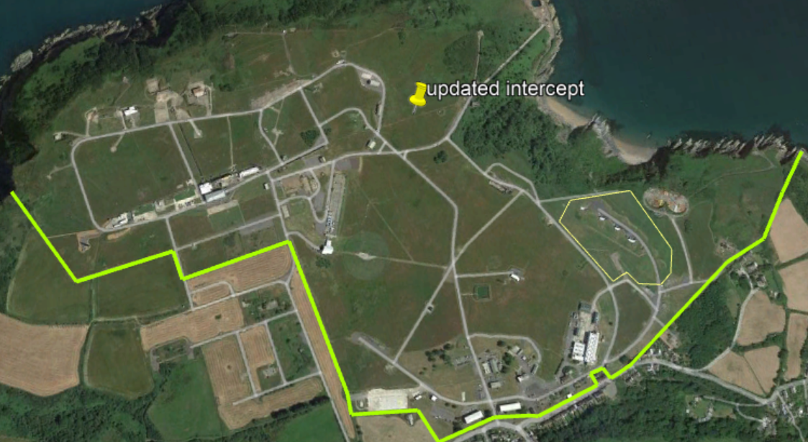
Figure 2- Image of range boundry containment

Aims
The first and most important aim is that the chosen method must be intrinsically safe and have the desired outcome every time with no room for error. The next aim is to prove the feasibility of land recovery for the three systems. Then the calculations will need to be refined with the drift distances plotted and have the method approved. It is then required that an investigation be carried out into the hazards associated with the fuel and OME carried when conducting land recovery. The final Aim once all of the work above is complete is to test the methodology with trials and the data gained reported on.

Objectives
The aims of the project above have objectives attached to them to ensure that they can be successfully delivered, these objectives are shown below in table 1.
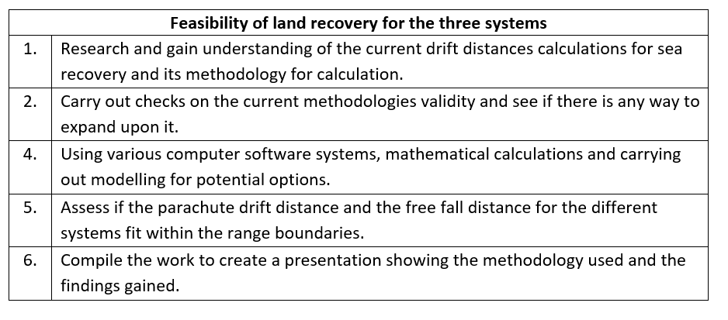
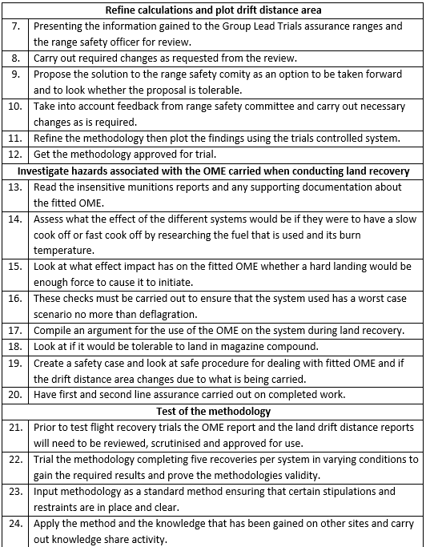
Table 1- Project objectives

Project Design
The first solution is not to do anything, the problem with this solution is the current system is very time consuming and costly with a better more efficient method required.

Data Collection
The data that will be collected is survey information, technical aircraft information, met data and IM certificates which will give the relevant outputs required described above. This output data will be peer reviewed and scrutinized at both first and second line assurance.

Data Evaluation
The chosen solution must work in accordance with or better than the system requirements set out previously. The data gained will be peer reviewed and approved by first and second line assurance prior to the test flights being carried out.

Risks & Limitations
There are many different risks and constraints that are associated with the various options these include both a safety risk and a commercial risk to the company that will need to be considered. Thorough work instruction and risk assessment will need to be created to ensure that all risks are taken into consideration and mitigated against as best as is possible. All personnel involved in its use of the chosen solution will have a good understanding of the risk assessment.

Ethical Issues
The ethical form for this project can be seen later in the assignment in the appendix under 9.1.

Resources Required
Initially the task requires work be carried out autonomously for the feasibility, after completion additional resource will then be required. A list of this required resource as well as equipment and software required is shown in section 6.2. in the appendix.

Planning
The planning for the project was done by using a Gantt chart showing the proposed timescales for the work to be carried out, this can be seen in section 6.4. in the appendix.

Costs
The costs associated with this project includes peoples time, software required and all equipment which will be covered by an overarching QinetiQ project known as the ARM (Air Range Modernization) program.

References

[1] | J. Sutherland, “Hebrides methodology- Construction of recovery trace in support of CATS operations,” QinetiQ, 2017.
[2] | E. Muirhead, “Manorbier Methodology- Launch, Recovery and general flying trip wires,” QinetiQ, 2020.
[3] | J. Mckinney and C. Lowry, “Mars Precision Landing Using Guided Parachutes,” American institute of aeronautics and astronautics, 2012.
[4] | Alexander street, Achieving SMART Goals, Melbourne: Seven Dimensions, 2013.

Bibliography
- Leveson, Nancy G, Engineering a Safer World, Cambridge: The MIT Press, 2016.
- Checkland, Peter, Gough. T, Scholes. J, “Soft Systems Methodology in Action,” The Journal of the Operational Research Society, vol. 42, no. 9, p. 818, 1991, doi: 10.2307/2583669
- Marder, M. (2011) Research Methods for Science, Cambridge University Press: Cambridge.
- Weaver, P. (2004) Success in Your Project: A Guide to Student System Development Projects, Prentice Hall: Harlow
- D. K. Hitchins, Systems engineering; a 21st century systems methodology., Portland: John Wiley & Sons, 2007.

Appendix

Aerial target information
Aerial target systems offer an opportunity to test multiple weapon systems with one affordable and reusable system. They can also fly a wide variety of speeds and have excellent manoeuvrability profiles, which offers a high degree of versatility. They can meet a wide variety of specific weapons system and training requirements by utilizing augmentation and payload devices. They are capable of carrying a combination of internal and external payloads including towed targets with chaff or flare attached, vector and scalar proximity scoring, electronic countermeasures, infrared (IR) augmentation as well as passive and active (RF) augmentation.

Resource required.
The people required are pilots, in flight safety officer, ground safety officer, range control, trials conducting officer, trials planner, project manager, technical lead, technical assurer, air traffic control, aerial targets, engineering, head of site, operations manager, trials assurance lead, range safety officer and aerial target technicians.
As well as the human resource required thee is other resource required to carry out this project these are a computer system, google earth, survey data and Microsoft software package to begin with. Once the first investigation is completed it will require the things used above as well as the trials control system, launch platform, three different aerial target systems, sea tracking marine radar, air tracking radar, range vessels, meteorological data, telemetry, radios communications, tracking radar boresight CCTV, non-tracking CCTV, display screens, hybrid tracking manager (HTP) and flight termination system (FTS).

Ethics form
Shown below in figure 5 is the OME ethics form.
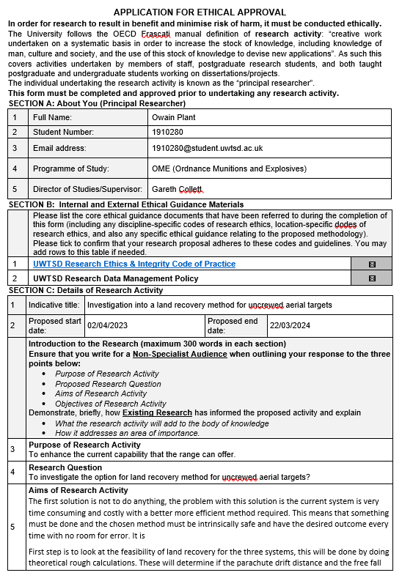
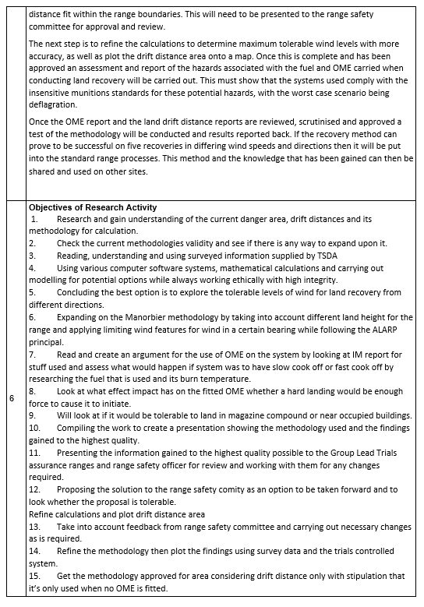
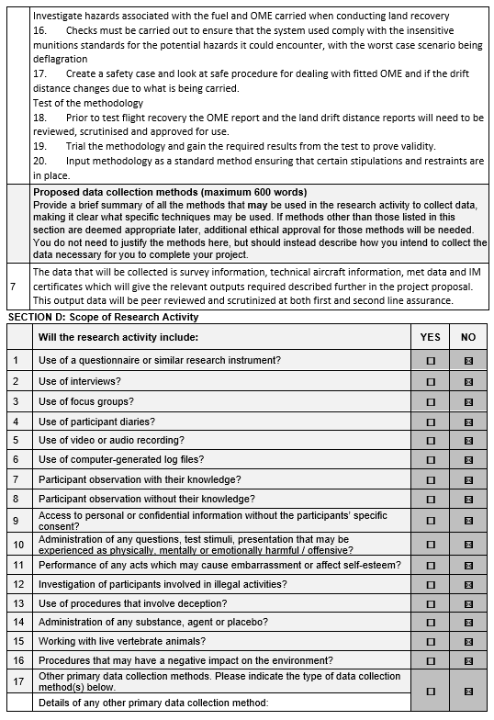
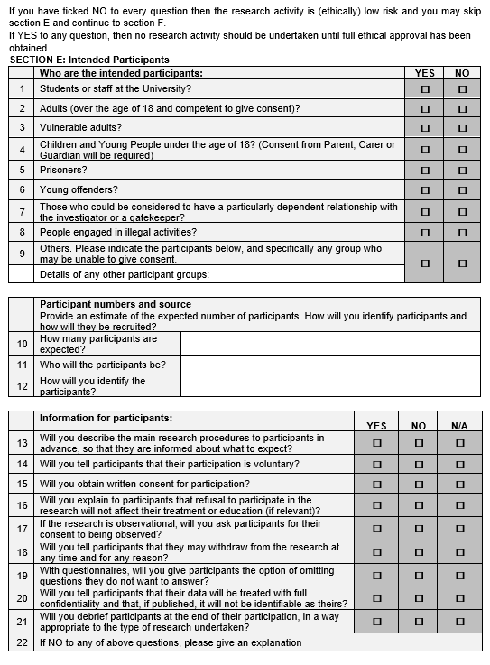
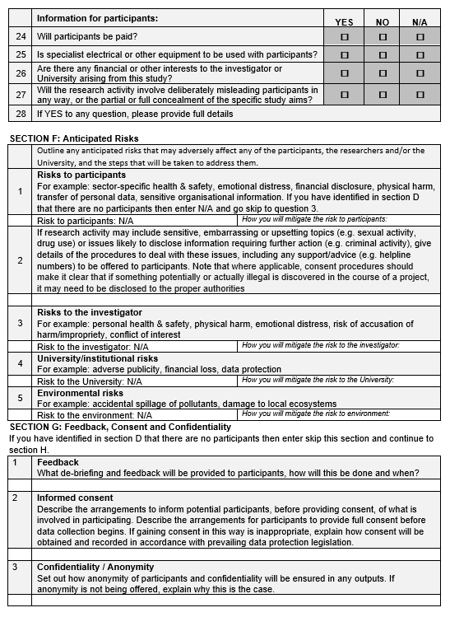
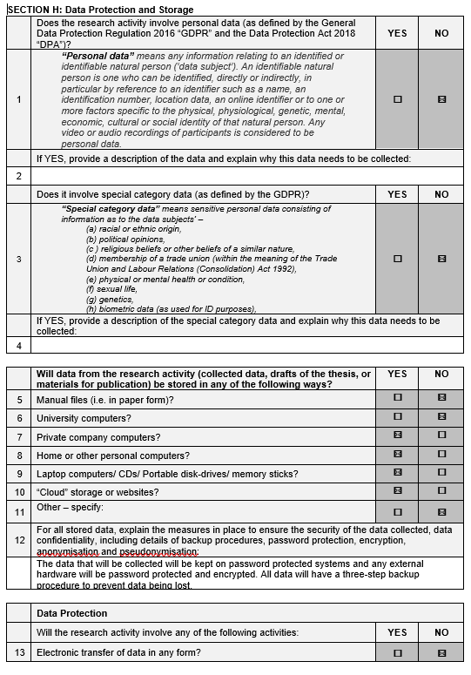
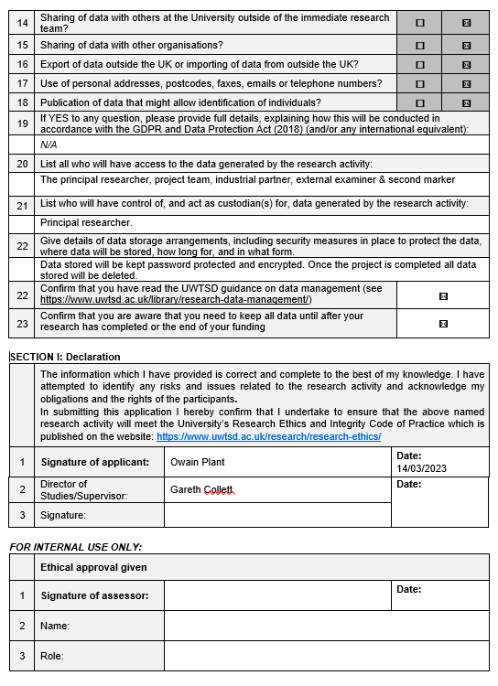
Figure 5- Ethics form

Gantt chart
The Gantt chart below shows a rough estimated breakdown of the time spent on each activity. These objectives were planned by using the SMART acronym method meaning they are specific, measurable achievable, relevant and time bound. [4]
Figure 6- Final project planning Gantt chart

