University of Wales
Trinity Saint David
School of Applied Computing

Title: Mobile Enabled Website utilising REST services (JSON)

Module: Web and Mobile Technologies
Code: ACCA 5031
Student: Martin Darzins
Student no.: 1909722
Programme: Computing Portfolio – Applied Computing: Year 2
Lecturer: Gaynor Thomas
Due Date: 21st January 2022

Acknowledgements
The author acknowledges the content from the current UWTSD Moodle module course Web and Mobile Technologies, the Website designed for Assignment 1 and the previous year works within Introduction to Web and Database Concepts.

Table of Contents
1 Acknowledgements ii
3 Introduction 1
3.1 Aims 1
3.2 Objectives 1
4 website 2
5 report 2
5.1 Introduction 2
5.2 Implementation 2
5.3 Concepts 4
5.4 Basics (indexMAD.html page) 5
5.4.1 Public JSON API (Joke) 6
5.4.2 Transitions (Panel) 7
5.5 Recognition (page 2) 9
5.5.1 Public JSON API (Meal) 10
5.6 Information (page 3) 12
5.6.1 Direct links to Multi-Media 13
5.6.2 Public JSON API (Weather) 13
5.7 Quotes (page 4) 15
5.8 Header & Footer 16
6 Conclusion 17
7 References 18
8 Report Planning Methodology 19

Figure 1 : Colour Palette (Coolors.com) 2
Figure 2 : Colours Selected [mad4.css] (ThemeRoller.com) 3
Figure 4 : Website Overview (4 pages) 4
Figure 5 : Screenshot – Basics (Home page) 5
Figure 6 : Screenshot – API [Joke](icanhazdadjoke.com) 6
Figure 7 : ConsumeJSONjoke.html (code) 6
Figure 8 : Result of Check (ConsumeJSONjoke1.html) 7
Figure 9 : Transition Panel (The Three F's) 7
Figure 10 : Screenshot (indexMADcode.html) Panel overlay code 8
Figure 11 : Transition to next page (Recognition) 8
Figure 12 : Code – Typical BACK and Transition Codes 8
Figure 13 : Screenshot – Recognition (page 2) 9
Figure 14 : Screenshot API [meal] (biriyani.anoram.com) 10
Figure 15 : ConsumeJSONmeal1.html (code) 11
Figure 16 : Result of Check (ConsumeJSONmeal1.html) 11
Figure 17 : Transition BACK to Home page (BASICS) 11
Figure 18 : Screenshot - Information (page 3) 12
Figure 19 : Direct links to Multi-Media 13
Figure 20 : Screenshot API[weather](goweather.com) 13
Figure 21 : ConsumeJSONweather1.html (code) 14
Figure 22 : Result of Check (ConsumeJSONweather1.html) 14
Figure 23 : Transition BACK to Home page (BASICS) 14
Figure 24 : Screenshot - Quotes (page 4) 15
Figure 25 : Transition BACK to Home page (BASICS) 15
Figure 26 : Headers 16
Figure 27 : Screenshot - Footer (copyright) 16
Figure 28 : Code - Footer (copyright) 16

Introduction

Aims
The aim of this report is to evaluate the concepts, principles, technologies and techniques used in the development of web and mobile applications, in relation to creating a (client and server side enabled) website.

Objectives
To design and implement Web & Mobile applications using Client/Server-side programming languages, to resolve a range of problems, through designed web pages, HTML (Hypertext Markup Language), CSS (Cascading Style Sheets) and JS (JavaScript) codes, along with the use of AJAX (Asynchronous JavaScript And XML) calls to REST (Representational State transfer) services in the form of JSON (JavaScript Object Notation), and JQuery Mobile
To develop a suitable website featuring Single Page Applications, Transitions, and Panels etc, implementing a ‘site style’ via the sue of JQuery ThemeRoller and making seamless AJAX data calls to public JSON API (Application Programming Interface) sites.

website
Please refer to the separately submitted (zipped) file, which contains the individual website folders/files for; images, ConsumeJSON, HTML, and JS codes utilised throughout this website, along with the required jquery-mobile, jquery-ui, jquery-mobile-theme downloads.

report

Introduction
This website is an extension to the fictitious website created in Assignment 1 and relates to a personal activity of Walking Football and will continue to be a valuable source of information and interest to those new (and familiar) to the sport, albeit in a different AJAX/JSON/ThemeRoller format.
The report section headings, screenshots and explanations will detail the website home (Basics) and landing pages (Recognition, Information and Quotes), detailing various User interactions and panel (The Three F’s) capabilities, as well as featuring AJAX calls to REST services JSON and uniform ThemeRoller styles. Not taking the PHP course elements, resulted in choosing the separate calls to different public JSON API method.

Implementation
This website piggy-backed on the Assignment 1 design and planning tools of a 2(two) dimensional illustration (Wireframe) technique. This was assisted by the use of Coolors.com, from which (after several comparisons) the best colour palettes were selected (mad4.css) and utilised throughout the website. Overall, this technique allowed the visualisation to be considered, constructing a uniform space and content look.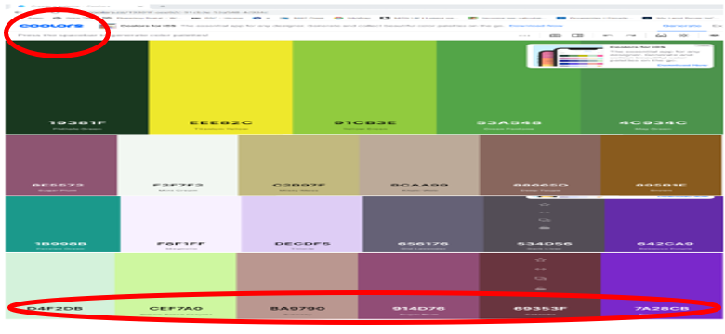
Figure 1 : Colour Palette (Coolors.com)
By incorporating the ThemeRoller global style function, a uniform site style has been obtained, the style itself was determined by establishing a palette of colour matches to the walking football images utilised within the website.

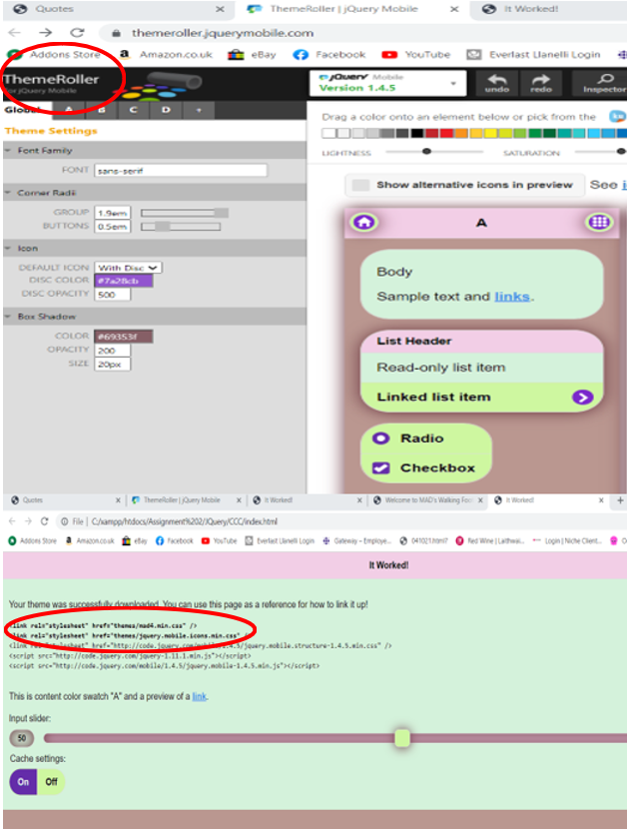
Figure 2 : Colours Selected [mad4.css] (ThemeRoller.com)

Concepts
The website developed details: Basics, Recognitions, Information and Quotes pages.
Via the ThemeRoller, JavaScript, JQuery mobile and AJAX/JSON call functions, each page has the ability to return to the Home (Basics) page, along with various seamless display of public APIs, relating to:
- Funny light-hearted joke of the day (icanhazdadjoke.com)
- Weather conditions in Swansea (goweather.com)
- Recommended meal, after the match (biriyani.anoram.com)
Further demonstration of the website’s mobile features include various:
- Football related images
- Transitions
- Panels
- Overall site style (ThemeRoller)
- Navigation
- Real-time Updates (via API AJAX calls)
- Validations (via ConsumeJSON files)
- Contact (Email & Social Media)
- Header & Footer (Copyright)
From these concepts the following 4 website pages were developed
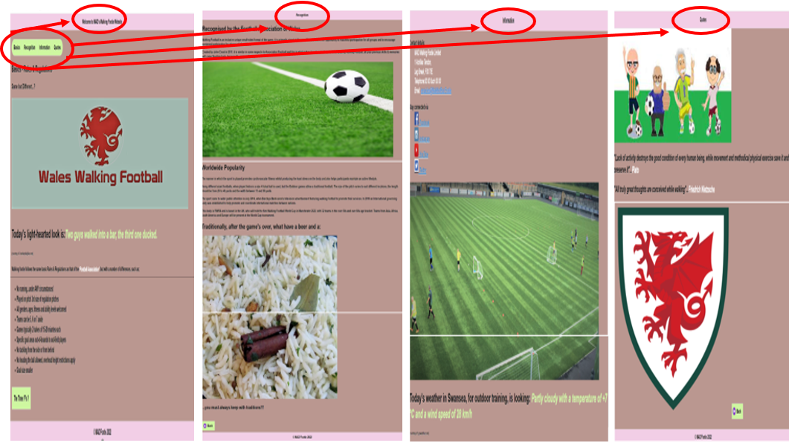
Figure 4 : Website Overview (4 pages)

Basics (indexMAD.html page)
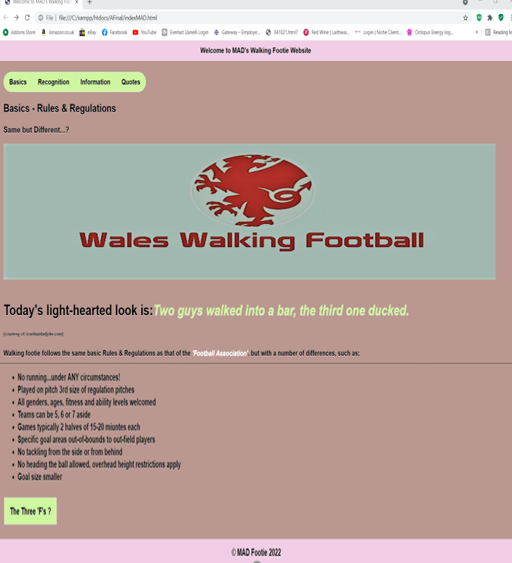
Figure 5 : Screenshot – Basics (Home page)

Public JSON API (Joke)
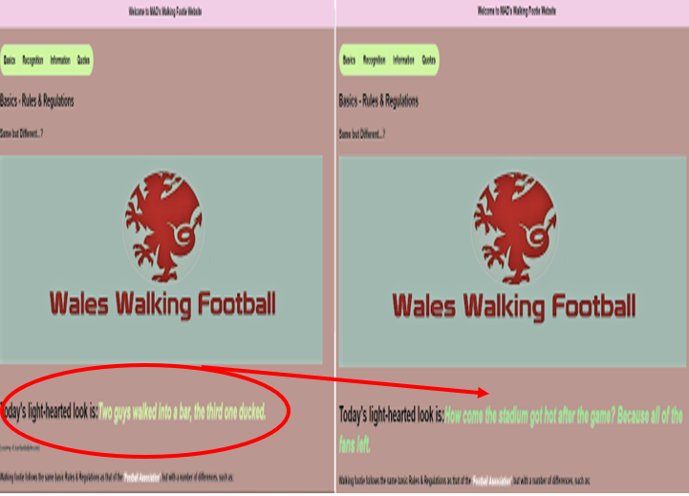
Figure 6 : Screenshot – API [Joke](icanhazdadjoke.com)
On localhost Refresh User will automatically receive a different humorous comment, on each occasion. The JSON code for humorous comment checked via ConsumeJSONjoke1.html and implemented via Javascript (joke1.js) into main html file (indexMAD.html) as message2.
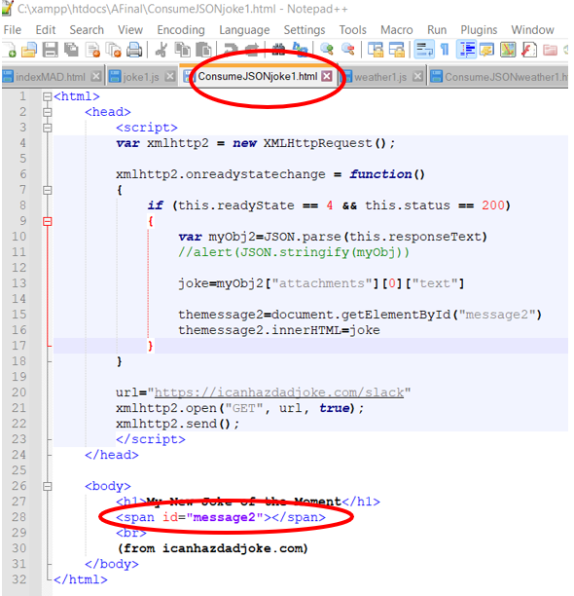
Figure 7 : ConsumeJSONjoke.html (code)
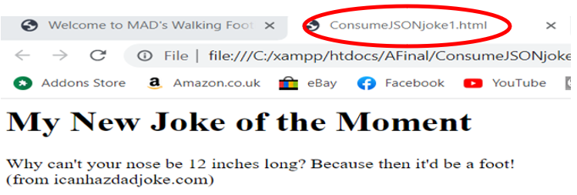
Figure 8 : Result of Check (ConsumeJSONjoke1.html)

Transitions (Panel)
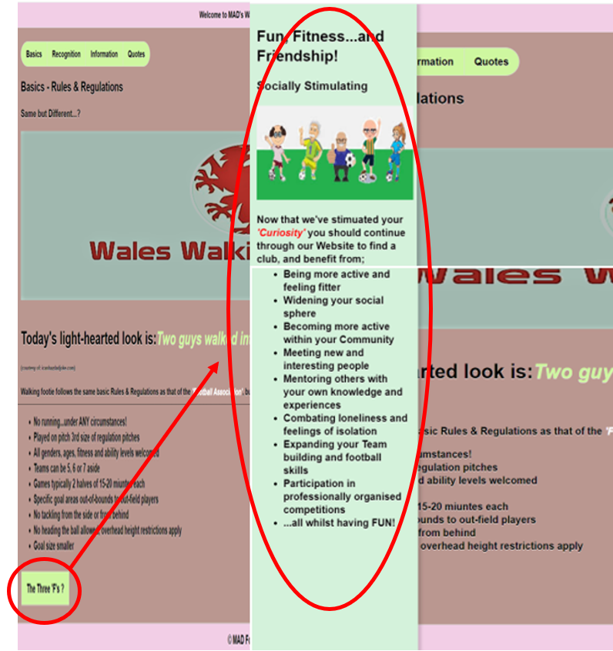
Figure 9 : Transition Panel (The Three F's)
On Click of The Three F’s button, Panel detailing additional information is shown (previously hidden). Using ThemeRoller function, when User hovers curser over button, button colour will change.
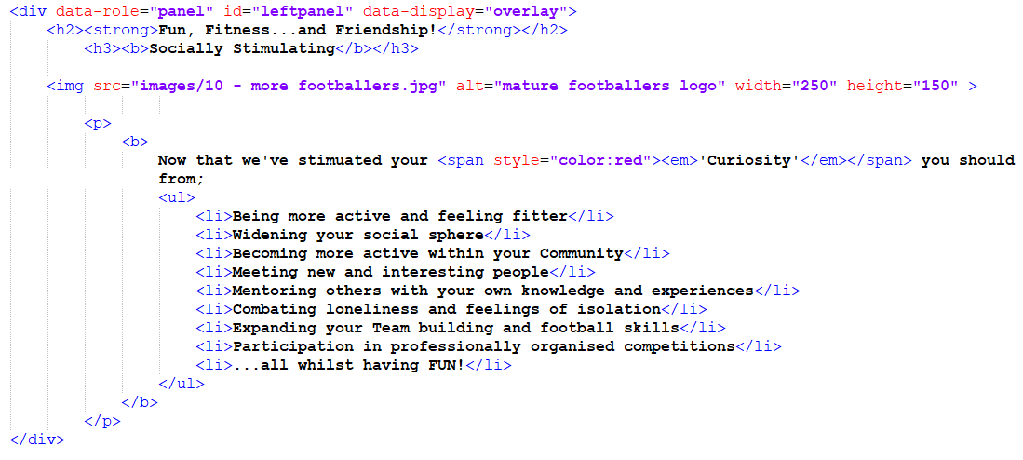
Figure 10 : Screenshot (indexMADcode.html) Panel overlay code
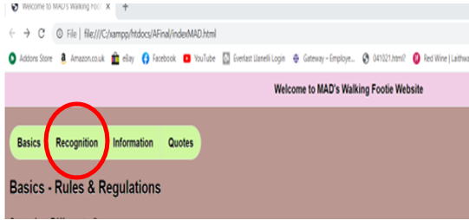
Figure 11 : Transition to next page (Recognition)
When Clicking the Recognition button, User is Transitioned to next page and throughout on hover, buttons change colour.
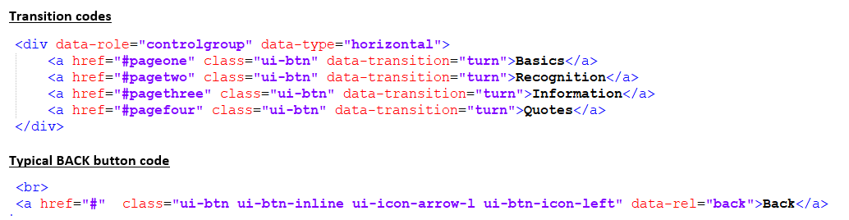
Figure 12 : Code – Typical BACK and Transition Codes

Recognition (page 2)
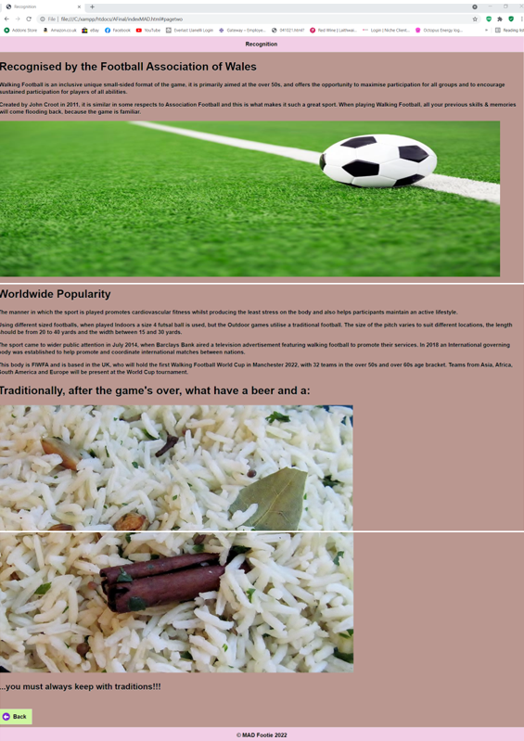
Figure 13 : Screenshot – Recognition (page 2)

Public JSON API (Meal)
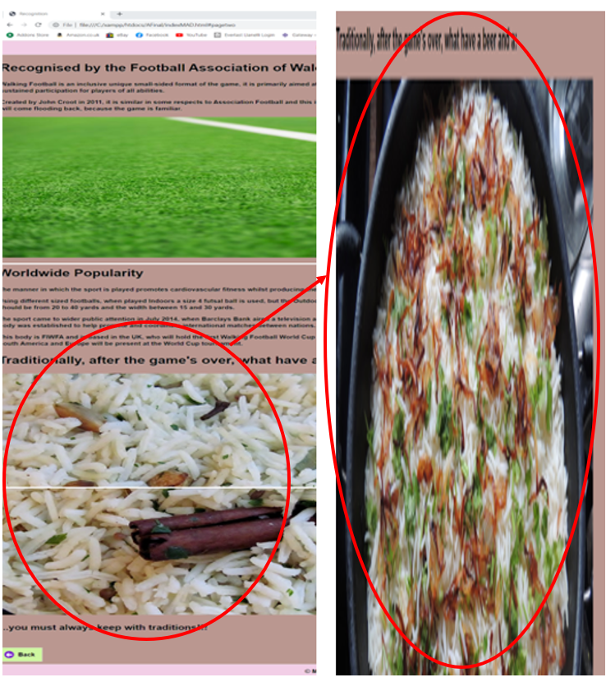
Figure 14 : Screenshot API [meal] (biriyani.anoram.com)
On localhost Refresh User will automatically receive a different biriyani Meal option on each occasion. The JSON code checked via ConsumeJSONmeal1.html and implemented via Javascript (meal1.js) into main html file (indexMAD.html) as message1.
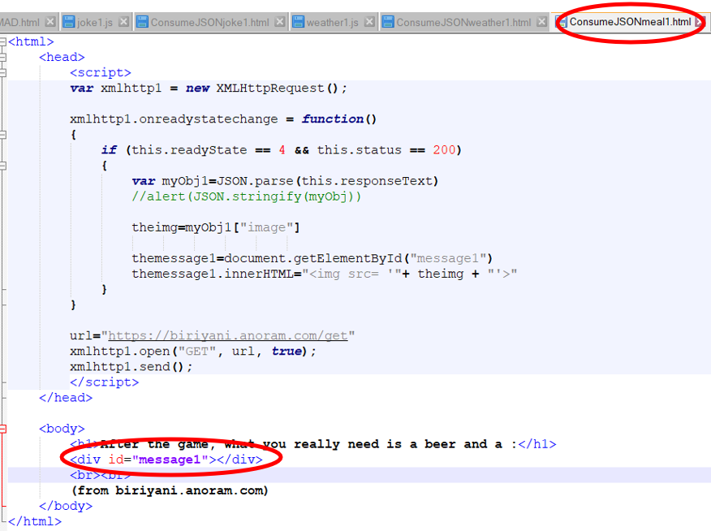
Figure 15 : ConsumeJSONmeal1.html (code)
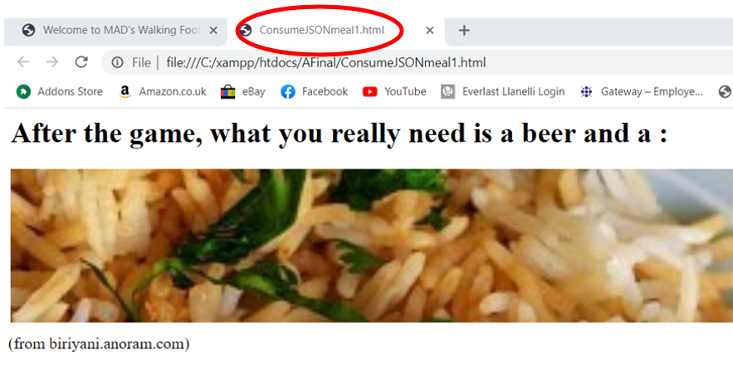
Figure 16 : Result of Check (ConsumeJSONmeal1.html)
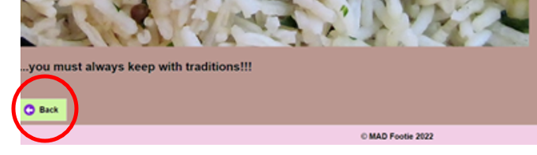
Figure 17 : Transition BACK to Home page (BASICS)

Information (page 3)
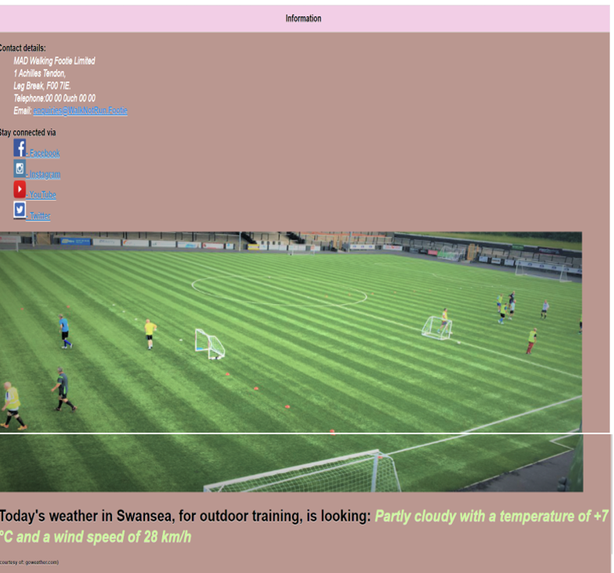
Figure 18 : Screenshot - Information (page 3)

Direct links to Multi-Media
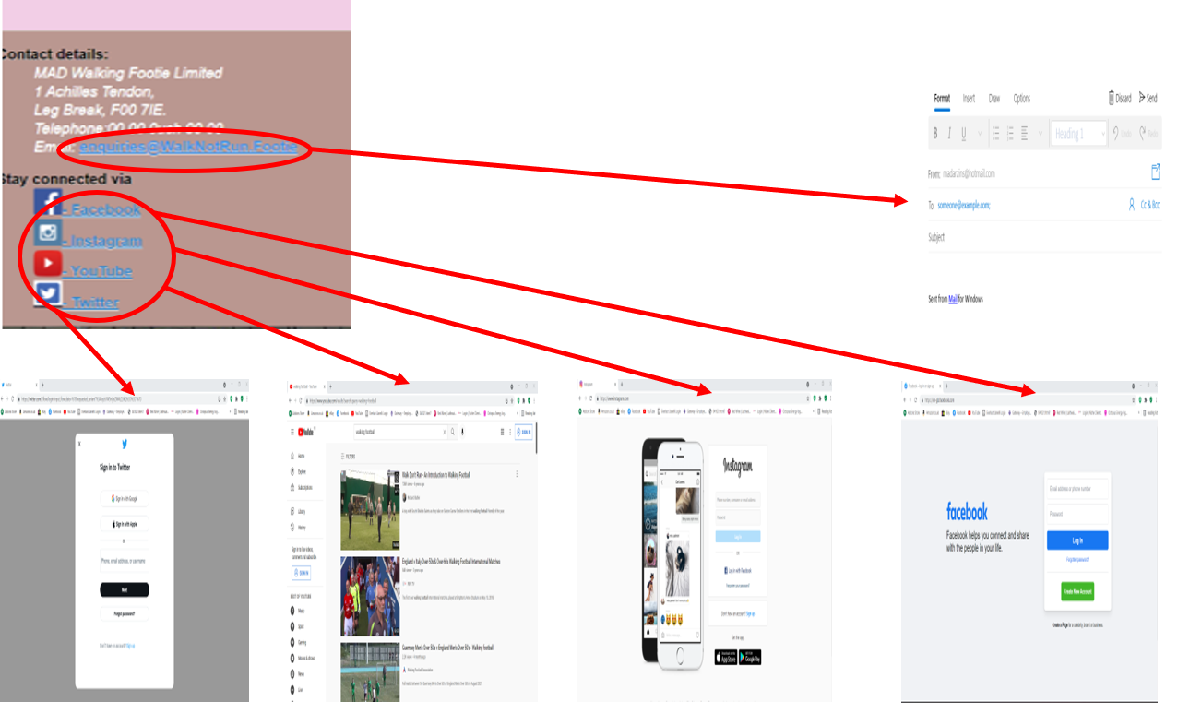
Figure 19 : Direct links to Multi-Media

Public JSON API (Weather)
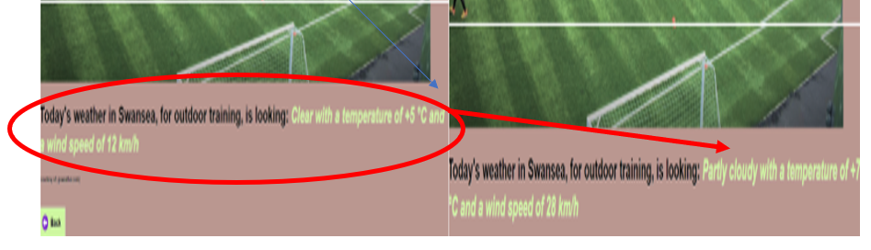
Figure 20 : Screenshot API[weather](goweather.com)
On localhost Refresh User will automatically receive an updated Weather condition for the Swansea area on each occasion. The JSON code checked via ConsumeJSONweather1.html and implemented via Javascript (weather1.js) into main html file (indexMAD.html) as message3.
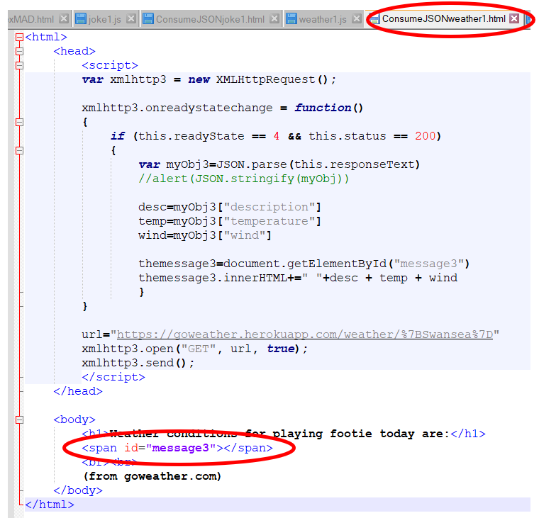
Figure 21 : ConsumeJSONweather1.html (code)
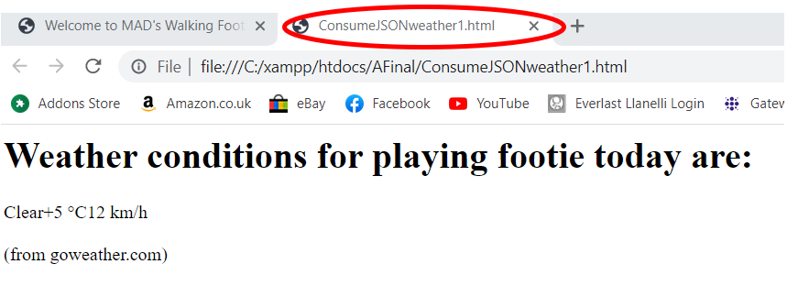
Figure 22 : Result of Check (ConsumeJSONweather1.html)
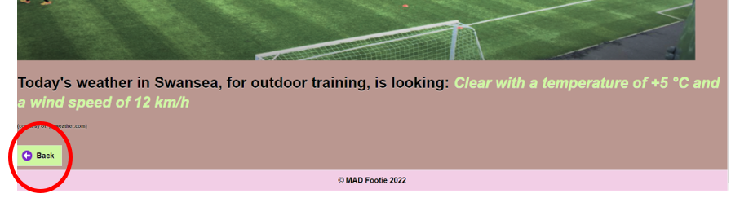
Figure 23 : Transition BACK to Home page (BASICS)

Quotes (page 4)
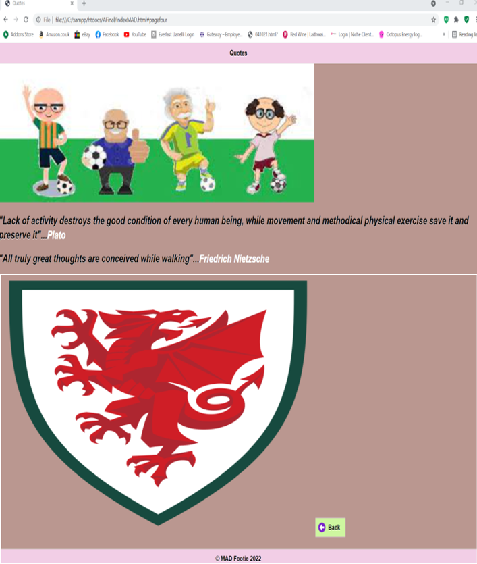
Figure 24 : Screenshot - Quotes (page 4)

Figure 25 : Transition BACK to Home page (BASICS)

Header & Footer
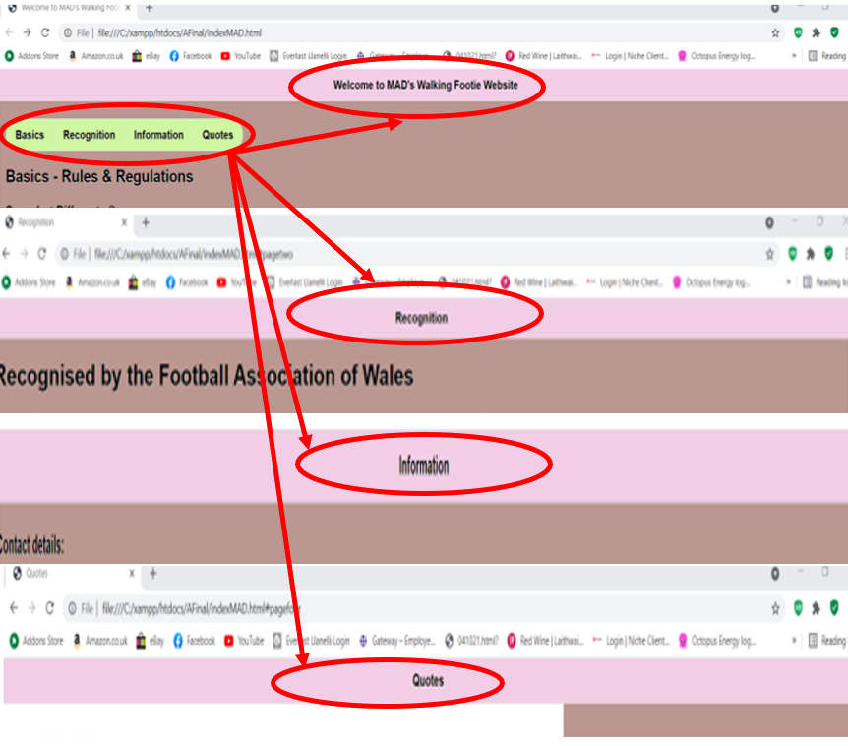
Figure 26 : Headers

Figure 27 : Screenshot - Footer (copyright)
Same footer details maintained throughout website.
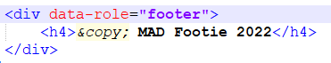
Figure 28 : Code - Footer (copyright)

Conclusion
The use of ThemeRoller and the various JSON API/AJAX calls seem to make a smoother more seamless User experience, when compared against Assignment 1, which was primarily CSS based.
Either way the content remains a good starting point for the uninitiated and whilst it offers an insight, general knowledge and a background flavour of what Walking Football is, the intent would be to enhance the details by linking the User to Walking Football clubs local to their address.
This would require greater knowledge of compatible API in relation to CORS (Cross-Origin Resource Sharing) along with PHP (Hypertext Pre-processor) a widely-used open-source general-purpose scripting language.
Further enhancements would see (from the club of their choice) League tables, Results, Fixtures, Events and a secure Payment method for becoming a member/subscriber.
Overall, the AJAX call interface gives the User a much more informed and current/live experience, but is subject to the availability, compatibility and updates being made by the respective public API sources, so cannot be fully relied upon.

.

Word count: 911 (excluding Title page and sections 1 - 3, and 7 - 8)

References

Images courtesy of:
- - https://www.facebook.com/CalneWalkBall/
- - https://www.activityalliance.org.uk/news/6070-game-on-football-foundation-launches-new-funds
- - https://www.stickpng.com/img/icons-logos-emojis/tech-companies/facebook-icon
- - https://www.dreamstime.com/search.php?srh_field=instagram+logo&s_il=y
- - https://pixabay.com/images/search/youtube%20logo/
- - https://www.shutterstock.com/search/twitter+logo
- - https://www.walkingfootball.com/
- - https://www.shutterstock.com/search/football+training+session
- - https://www.fawtrust.cymru/grassroots/participation/walking-football-wales/
- - https://www.facebook.com/CalneWalkBall/
- - https://logowik.com/wales-national-football-team-vector-logo-7306.html
- - https://seeklogo.com/vector-logo/275625/england-football
- - https://icanhazdadjoke.com/slack
- - https://goweather.herokuapp.com/weather/%7BSwansea%7D
- - https://biriyani.anoram.com/get

Report Planning Methodology
This Web and Mobile Technologies report assignment was completed by adhering to the following activities:
- Read and understand the report brief.
- Make plan (Gantt chart) including time management – planning/research most time consuming, catering for other exams.
- Create report format and style – using Moodle template example.
- Follow structure of:
  - Title Page
  - Acknowledgements
  - Introduction
  - Main Body
  - Reference
  - Appendices
- Define the problem and purpose of the report – decide assignment title, aims & objectives.
- Define audience – Lecturer/Tutor (Gaynor Thomas).
- Brainstorm (Mindmaps) and determine ideas to include.
- Research and gather information (Library, internet etc).
- Collect, sort, evaluate organise material.
- Complete references (as you go) during all research phases.
- Analyse research/material.
- Prepare outline drafts.
- Write the draft report, check spelling and grammar.
- Submit draft into Turnitin for similarity check.
- Incorporate changes into final redraft.
- Submit final report via Turnitin before 21st January 2022 3pm.

