Database Design
Local Dental and Orthodontic Surgery
Author: Gabor Jonas
Student number: 1705136
Module name: Information Engineering
Lecturer’s name: Beverly Holland
Date of submission: 09/05/2018

Table of Contents
1, Microsoft Visio Entity Relationship Diagram 3
2, Microsoft Access 4
2.1 Relationship Diagram 4
2.2 Forms 4
2.3 SQL 12
2.4 Output from reports 15

1, Microsoft Visio Entity Relationship Diagram

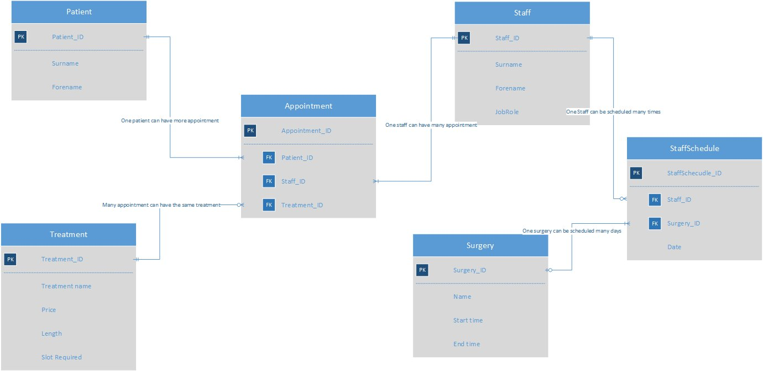
Figure 1 Microsoft Visio Entity Relationship Diagram

2, Microsoft Access

2.1 Relationship Diagram
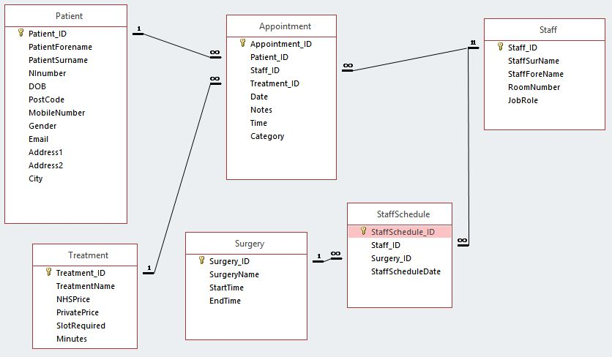
Figure 2 Microsoft Access Relationship Diagram

2.2 Forms

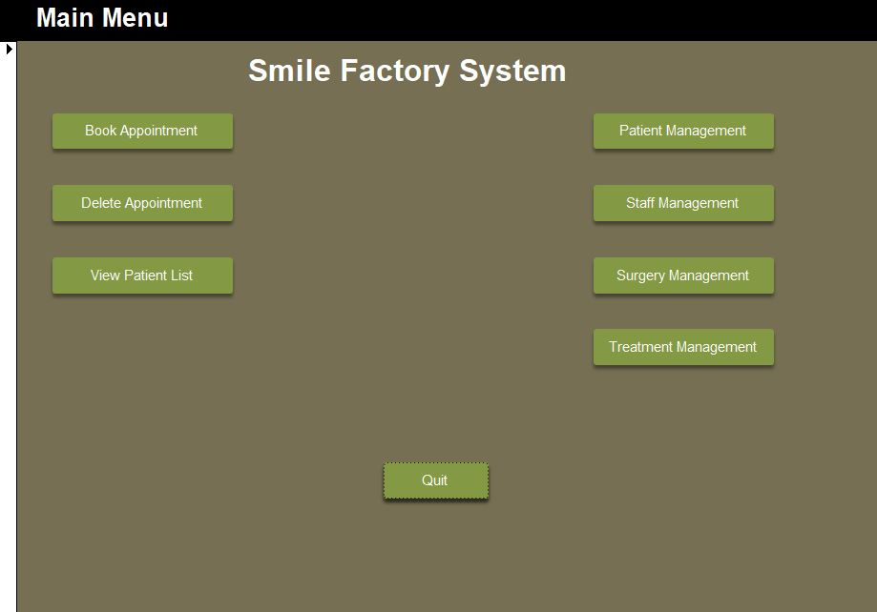
Figure 3 Main Menu

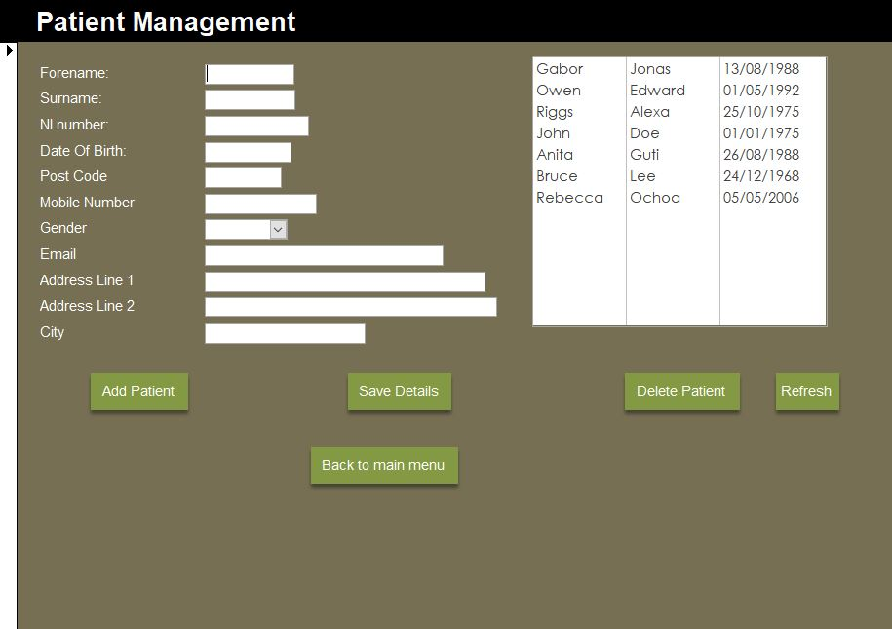
Figure 4 Patient Management

Adding new patient: click on Add Patient, type in details, clink on save details
Edit patient details: select patient from list, edit details, click save details
Deleting patient: select patient from list, click Delete Patient
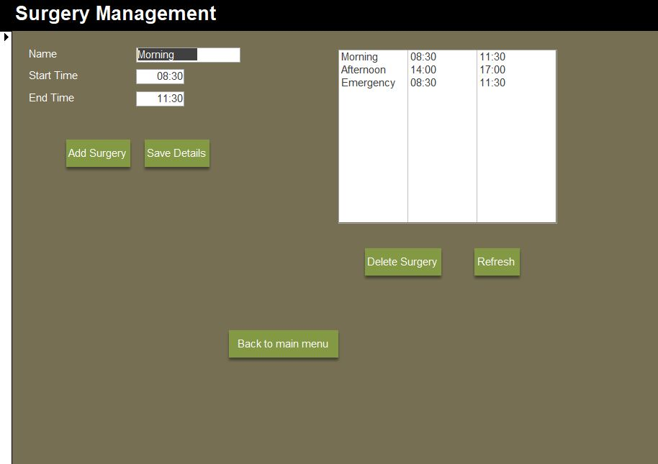
Figure 5 Surgery Management
Adding surgery: type in surgery details, click Save Details
Editing surgery: select surgery from list, edit details on the left, click Save Details
Deleting surgery: select surgery from list, click Delete Surgery
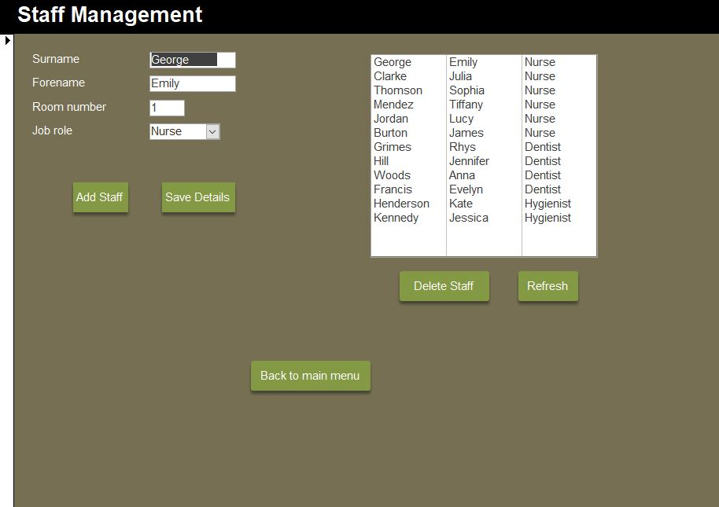
Figure 6 Staff Management
Adding staff: type in staff details, click Save Details
Editing staff: select staff from list, edit details on the left, click Save Details
Deleting staff: select staff from list, click Delete Staff
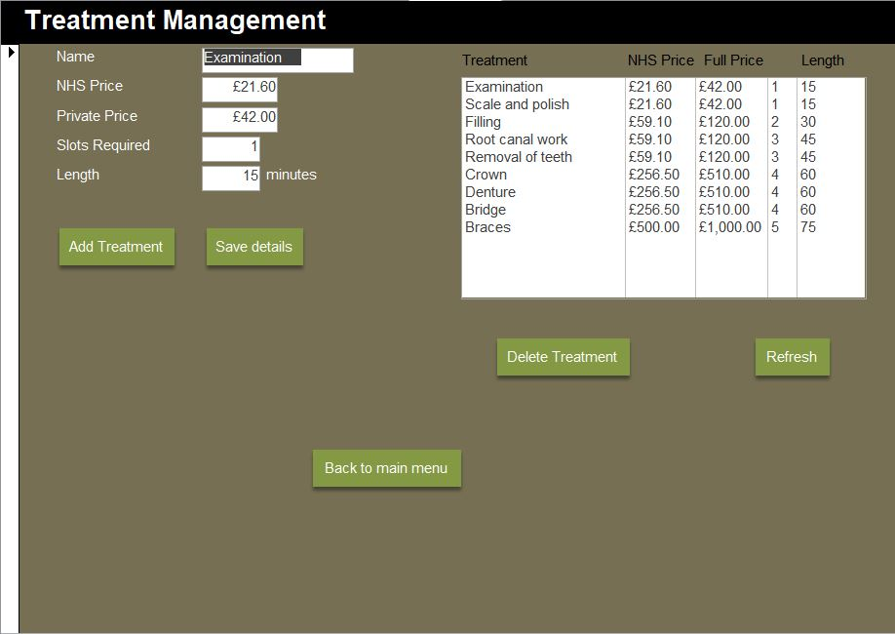
Figure 7 Treatment Management
Adding treatment: type in treatment details, click Save Details
Editing treatment: select treatment from list, edit details on the left, click Save Details
Deleting treatment: select treatment from list, click Delete Treatment

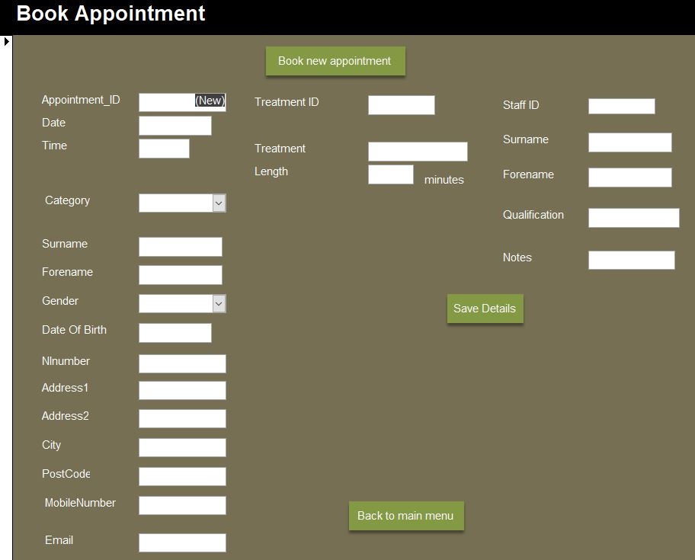
Figure 8 Book Management
Booking appointment: Type in patient details on the left, select treatment by typing in treatment id, select staff by typing in staff id, click Save Details
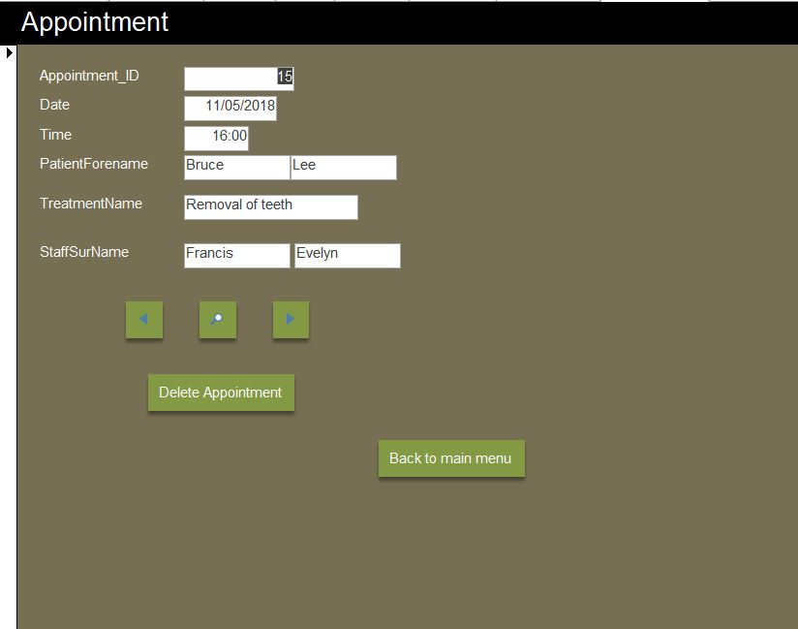
Figure 9 Deleting Appointment
Deleting appointment: to browse appointments click on the arrows, if the required appointment found, click Delete Appointment

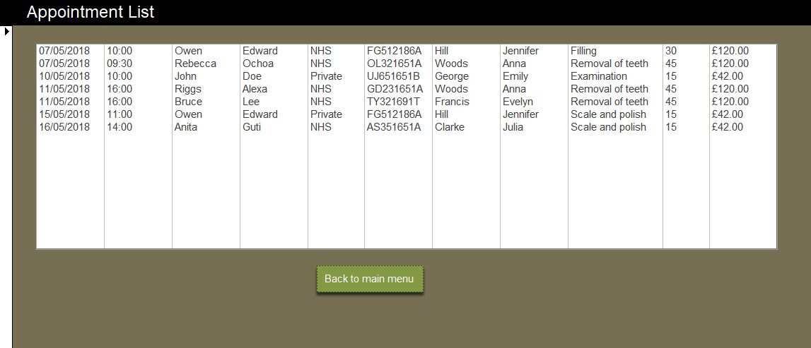
Figure 10 Appointment List
Appointments can be viewed in Appointment List menu
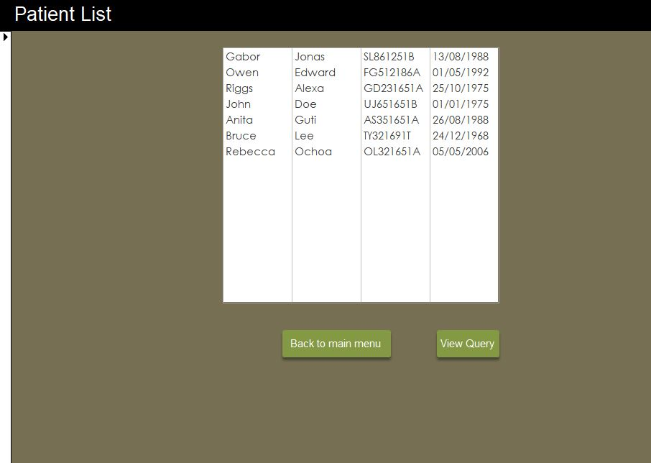
Figure 11 Patient List
Patient List can be viewed in Patient List menu

2.3 SQL

Appointment table
CREATE TABLE Appointment(
Appointment_ID AUTOINCREMENT PRIMARY KEY,
Patient_ID INT,
Staff_ID INT,
Treatment_ID INT,
AppointmentDate DATE,
Notes TEXT(255),
AppointmentTime TIME,
Category TEXT(7),
FOREIGN KEY (Patient_ID) REFERENCES Patient(Patient_ID),
FOREIGN KEY (Staff_ID) REFERENCES Staff(Staff_ID),
FOREIGN KEY (Treatment_ID) REFERENCES Treatment(Treatment_ID)
);

Patient table
CREATE TABLE Patient (
Patient_ID AUTOINCREMENT PRIMARY KEY,
PatientForename TEXT(15),
PatientSurname TEXT(15),
NInumber TEXT(9),
DOB DATE,
PostCode TEXT(7),
MobileNumber TEXT(11),
Gender TEXT(6),
Email TEXT(50),
Address1 TEXT(55),
Address2 TEXT(55),
City TEXT(20)
);

Staff table
CREATE TABLE Staff(
Staff_ID AUTOINCREMENT PRIMARY KEY,
StaffSurName TEXT(15),
StaffForeName TEXT(15),
RoomNumber TEXT(2),
JobRole TEXT(15)
);

Staff Schedule table
CREATE TABLE StaffSchedule (
StaffSchedule_ID AUTOINCREMENT PRIMARY KEY,
Staff_ID INT,
Surgery_ID INT,
StaffScheduleDate DATE,
FOREIGN KEY (Surgery_ID) REFERENCES Surgery(Surgery_ID),
FOREIGN KEY (Staff_ID) REFERENCES Staff(Staff_ID)
);

Surgery table
CREATE TABLE Surgery (
Surgery_ID AUTOINCREMENT PRIMARY KEY,
SurgeryName TEXT(20),
StartTime DATE,
Endtime DATE
);

Treatment table
CREATE TABLE Treatment(
Treatment_ID AUTOINCREMENT PRIMARY KEY,
TreatmentName TEXT(25),
NHSPrice CURRENCY,
PrivatePrice CURRENCY,
SlotRequired INT,
Minutes INT
);

Add record to Patient table
INSERT INTO Patient ( PatientForename, PatientSurname, NInumber, DOB, PostCode, MobileNumber, Gender, Email, Address1, Address2, City )
VALUES ("John", "Rambo", "Gr 12 16 51 C", "25/11/1999", "SA11 9CX", "07925964208", "Male", "rambo@hotmail.com", "8 Phoebe Road", "", "Swansea");

Add record to Staff table
INSERT INTO Staff ( StaffSurName, StaffForeName, RoomNumber, JobRole )
VALUES ("Benny", "Hill", "15", "Dentist");

Add record to Treatment table
INSERT INTO Treatment ( TreatmentName, NHSPrice, PrivatePrice, SlotRequired, Minutes )
VALUES ("Braces", "500", "1000", "5", "75");

2.4 Output from reports
Appointments
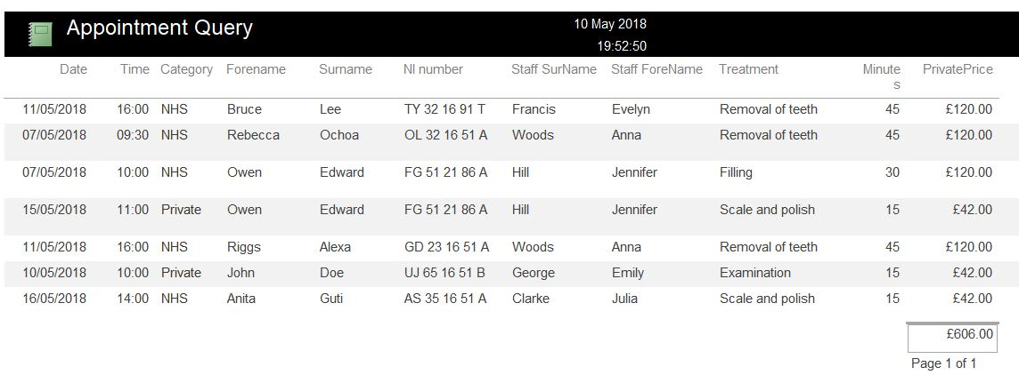
Figure 12 Appointments report
Patients
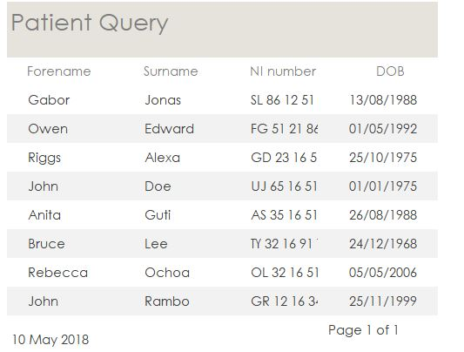
Figure 13 Patients report

Staff
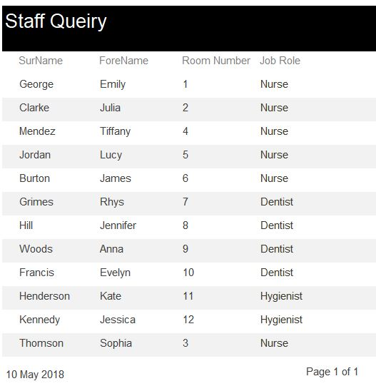
Figure 14 Staff report

Staff Schedule
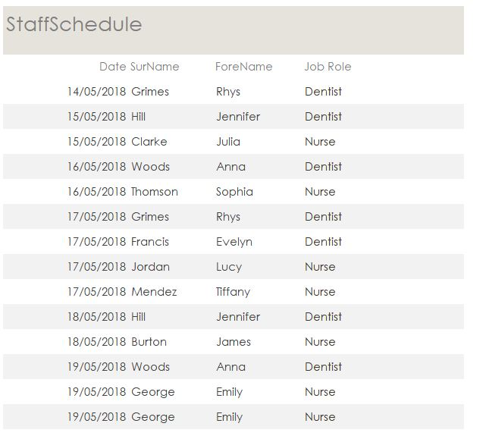
Figure 15 Staff Schedule report

Surgery
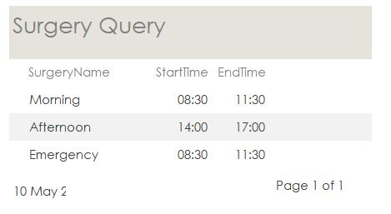
Figure 16 Surgery report
Treatments
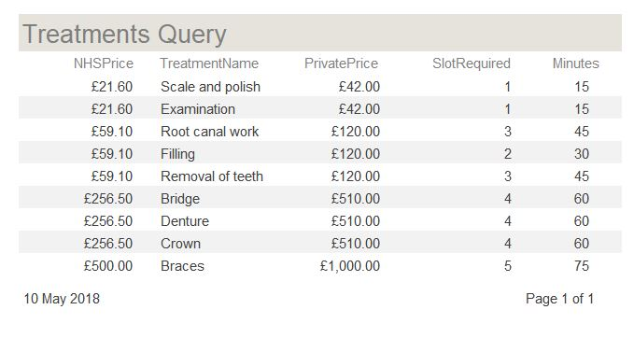
Figure 17 Treatments report

